YOUR PROJECT TITLE

Your Name (Banner ID)  
Your degree program, Your Department Name,  
[youremail@slu.edu](mailto:youremail@slu.edu)

|  |
| --- |
| Abstract:  Write down the abstract the summarizes the motivation behind your project, its importance/scope, well-defined research question(s) and/or objective(s), methods and results. It should not be more than 250 words.  Keywords: keyword1, keyword2, keyword3, keyword4, keyword5 |

# INTRODUCTION

All texts in a paragraph should be written with the style named “Paragraph”.

Clearly describe the problem that your project addresses. Explain why this problem is relevant, providing enough context for someone unfamiliar with the topic to understand its significance. Consider discussing the broader implications or potential consequences if this issue remains unresolved.

Define the specific aspects of the problem your project focuses on, outlining any limitations or exclusions that shape your research. Briefly review 3–4 key studies that have previously addressed similar problems, highlighting the insights they contributed. Discuss how these studies influenced your work, particularly noting any limitations or gaps they left unaddressed. Explain how your project aims to build upon or address these gaps, providing a clear rationale for your approach and demonstrating the relevance of your research in advancing the field.

Outline the main goals of your project. Identify the specific research questions or hypotheses guiding your study. Aim to make these objectives clear and measurable, so the reader knows what your project intends to accomplish or understand.

# METHODS

Describe the geographical area or context in which your study takes place. A map or spatial description may be beneficial here.

Figures should be full-page width and referenced in the text before appearing. Place each figure at the top of the page, followed by a concise caption with a figure number and brief description (e.g., “Figure 1: Map of Study Area”). Captions must clarify the figure’s purpose and include clear labels, axes, and legends. Ensure all figure references in the text use the assigned figure number (e.g., “as shown in Figure 2”) for easy navigation.

Provide an overview of the data used in your analysis. Include data sources, types of data, any preprocessing or cleaning steps, and the rationale for selecting these data sources. Be specific about variables, timeframes, and resolution, if applicable.

Tables should also span the full-page width and be referenced in the text before they appear. You can position each table anywhere at the page if it is introduced in the text. Use a concise caption immediately above (e.g., "Table 1: Sample Data Summary") that briefly describes the content. Ensure all columns have clear titles and that any additional labels or legends are easy to understand. In the text, refer to each table by its assigned number (e.g., "see Table 1") for easy reference.

Table 1: List of Data (this is just an example; you are free to use any table contents)

|  |  |  |
| --- | --- | --- |
| Data name | Data source | Description |
|  |  |  |
|  |  |  |

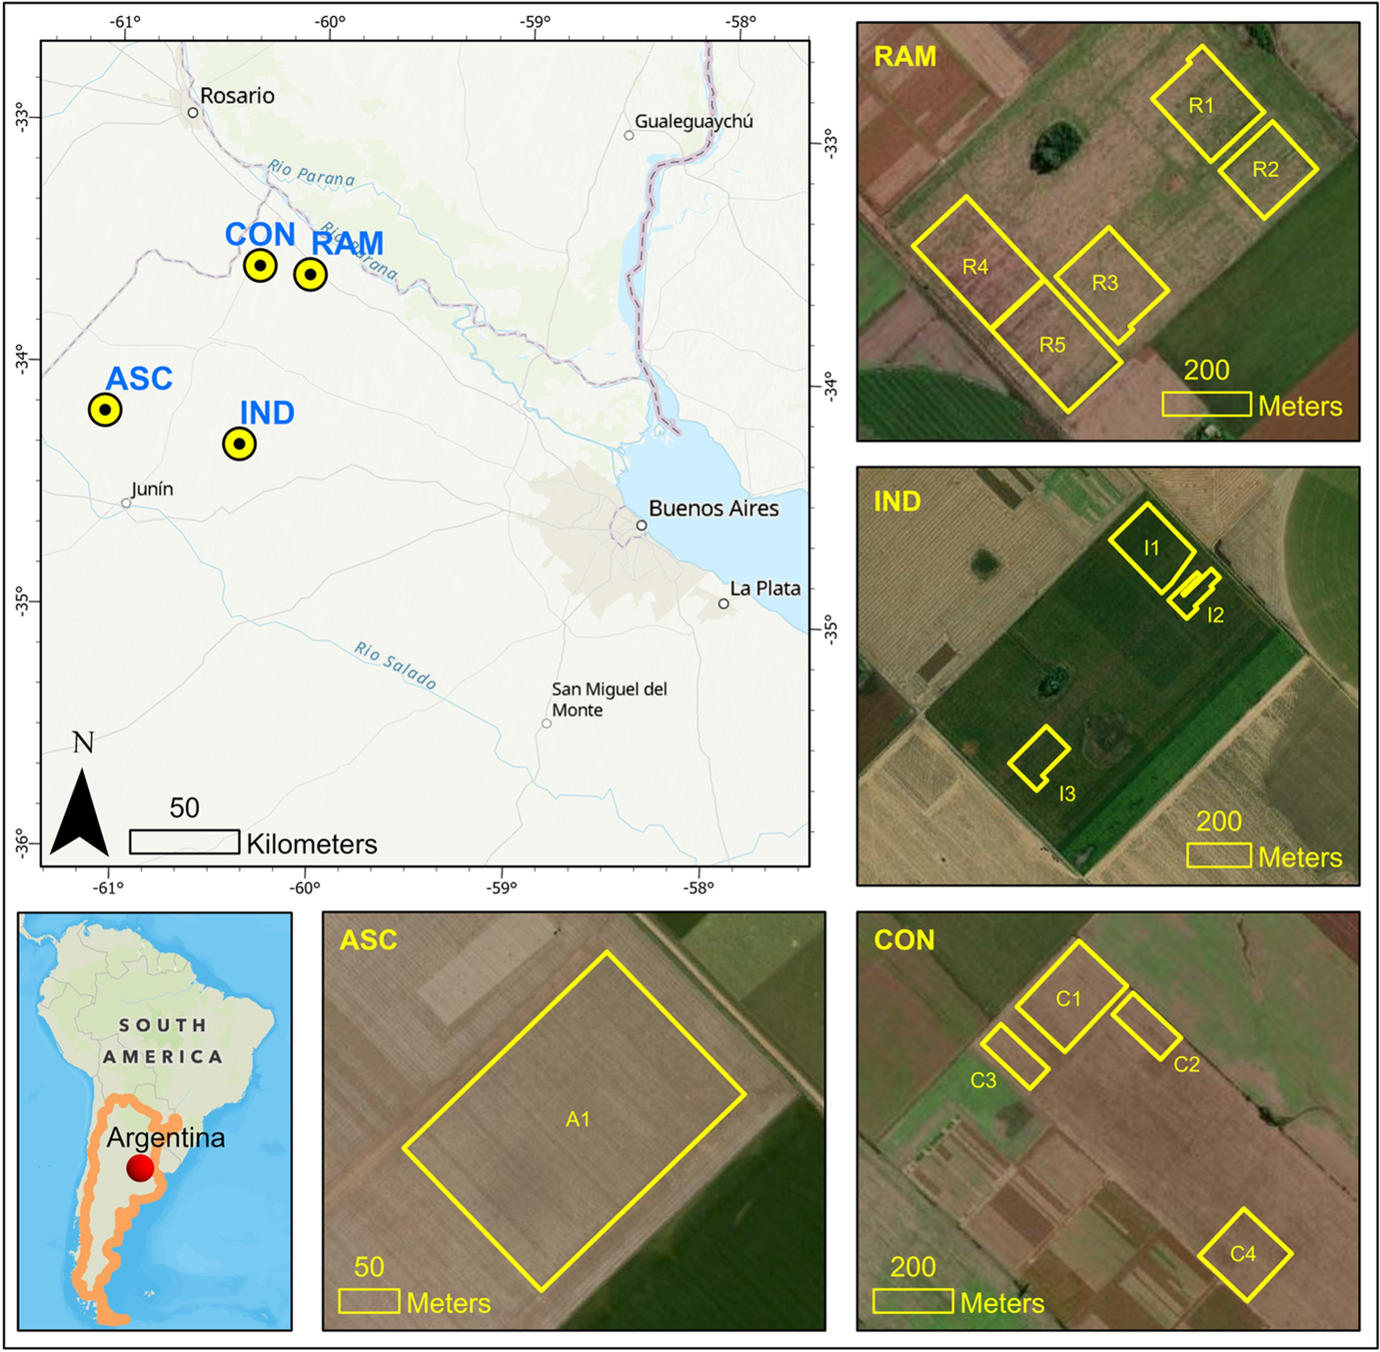

Figure 1: Location of the study area. Use appropriate citation in the caption if you need. For example, this figure was copied from Bhadra et al. (2023). Use full width of the page as figure width.

# Results

Summarize your main findings, focusing on those that directly address your objectives or research questions. Use visual aids (charts, maps, tables) where appropriate to illustrate key points. Clearly label each figure or table and provide interpretations of what they represent in relation to your study goals.

Write equations clearly and consistently, using proper mathematical notation. Use a numbered format for each equation (e.g., Eq. 1, Eq. 2) to allow for easy referencing in the text. For example. Eq. 1 explains the linear relationship between variable and .

|  |  |
| --- | --- |
|  | (1) |

where, and are the slope and the intercept of the linear system.

## Subsection Heading

Use Level 2 headings to organize the main text within each section, dividing it into logical subsections. Each subsection should focus on a specific topic or aspect of the section and provide a clear, cohesive discussion.

### More subsection heading

Use Level 3 headings if you need even for subsections. This is not encouraged but can be useful if you need one.

## In Text Citations

In-text citations should follow the author-year format (e.g., Smith, 2022) to ensure clarity and consistency. Always cite the source when presenting ideas, data, or direct quotes that are not your own. Common citation styles like APA, Chicago, and MLA use similar principles for author-year citations but differ in punctuation and formatting nuances. For this project, ensure consistency with your chosen style.

When incorporating citations directly into the text, you can refer to the author as part of the narrative, followed by the year in parentheses. For example: "Smith (2022) highlights the importance of geospatial analysis in modern environmental research."

# Conclusions

Recap the main insights from your study. Briefly restate your objectives and highlight how your results address them. Avoid introducing new information or details here; focus on summarizing key points already covered.

Discuss the potential impact of your findings within the context of the problem defined in the Background section. Describe how your conclusions could be applied, what they suggest about broader issues, or how they could inform future studies.

Mention any constraints or challenges encountered that may have impacted your results (e.g., data limitations, methodological limitations). Suggest areas for future research or improvements that could expand on your work.

# References

The references section should provide full details for every source cited in the text. Arrange the references alphabetically by the last name of the first author. Ensure every in-text citation corresponds to an entry in the references section and that formatting is consistent throughout. Use a citation management tool (e.g., Zotero, EndNote) to streamline this process if needed.

Bhadra, S., Sagan, V., Skobalski, J. et al. End-to-end 3D CNN for plot-scale soybean yield prediction using multitemporal UAV-based RGB images. Precision Agric 25, 834–864 (2024). https://doi.org/10.1007/s11119-023-10096-8

Smith, J. (2022). Geospatial Methods in Environmental Research. New York, NY: Academic Press.