**Exploratory Data Analysis (EDA) and Model Training Report**

Dataset: Customer Churn

Author: Sourav Choudhary

(B. Tech. IV Year CSE)

Celebal Technologies

COE Hiring

JIET, Jodhpur

Mentor: Mr. Debasish Nandy

Domain: Data Science

## Overview and Purpose of Analysis Report

1. **Exploratory Data Analysis (EDA)**: Gain insights into the dataset's characteristics, distributions, relationships, and potential patterns that could influence customer churn.
2. **Model Building and Evaluation**: Train and evaluate supervised and unsupervised models to predict customer churn. Assess the performance of different algorithms and ensemble techniques.
3. **Conclusion and Recommendations**: Summarize findings, draw conclusions, and provide actionable insights to address customer churn based on the analysis.

## Brief Description of Customer Churn Dataset

The customer churn dataset used in this analysis contains information about a telecommunications company's customers and their churn status. Customer churn, also known as customer attrition, refers to the phenomenon where customers stop using a company's products or services. The dataset comprises various features that provide insights into customer behavior, usage, and demographics.

**Objective**:

The main objective of this analysis is to develop models that can predict whether a customer is likely to churn based on the available features. By understanding the factors that contribute to churn, the telecommunications company can take proactive measures to retain valuable customers, thus improving customer satisfaction and business revenue.

In the following sections of this report, we will delve into each step of the analysis process, from data loading and cleaning to model training, evaluation, and interpretation. The insights gained from this analysis will provide valuable recommendations for the company's customer retention strategy.

## 2. Data Loading and Initial Exploration

* Loaded the dataset using [method/library].
* Explored the basic properties of the dataset: shape, columns, data types, etc.

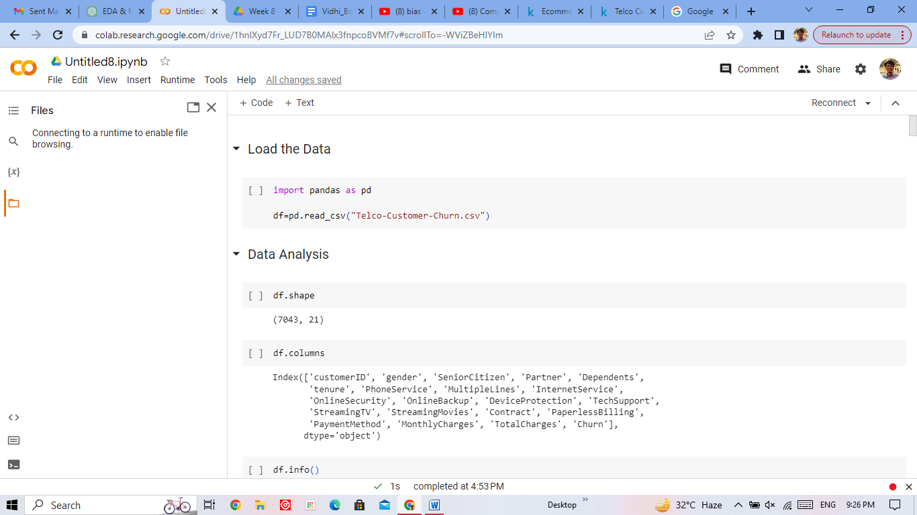

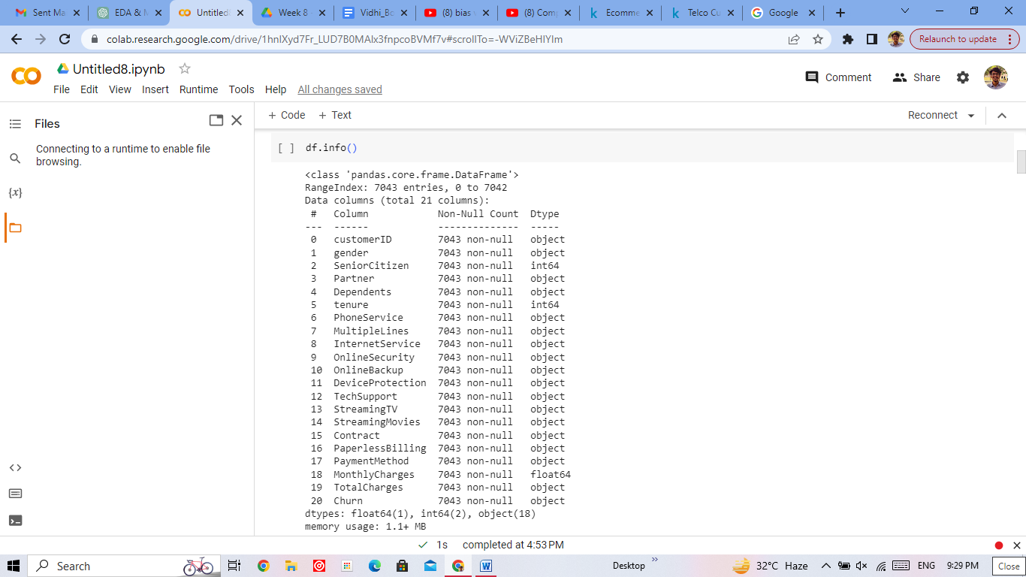

## 3. Data Analysis

* Conducted a detailed analysis of the dataset's features and target variable.
* Identified potential patterns, trends, or outliers.

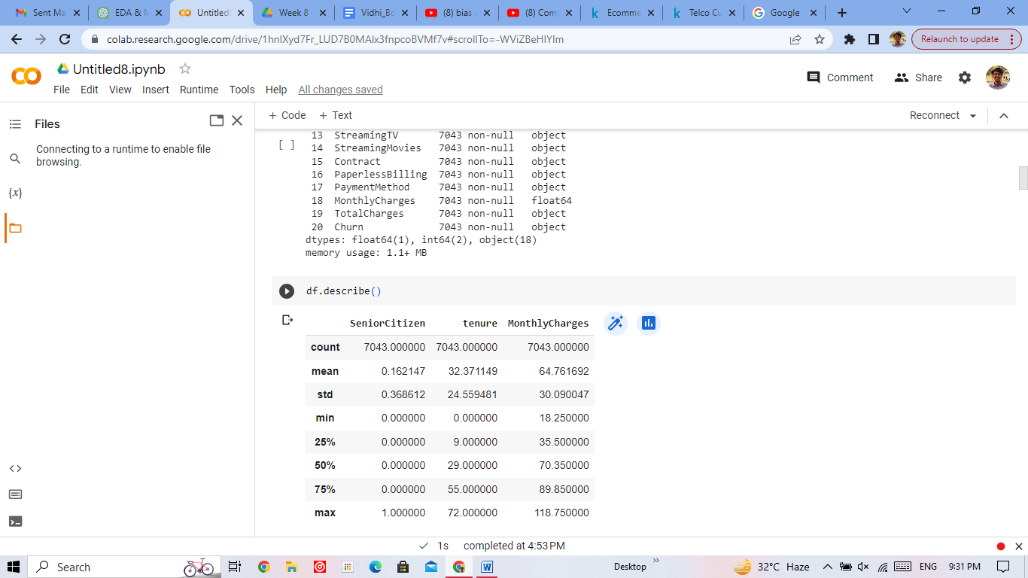

## 4. Data Cleaning

* Checked for missing values and decided how to handle them (e.g., dropping or imputing).
* Addressed outliers if necessary, based on domain knowledge.

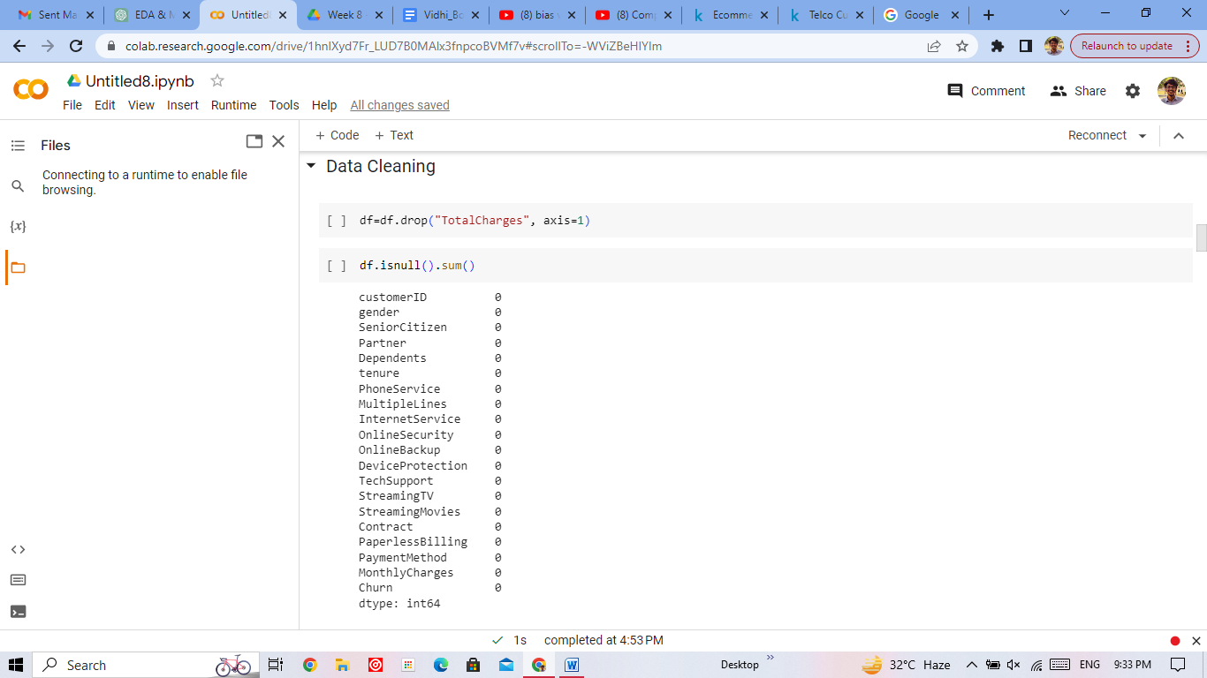

## 5. Visualizing and Understanding the Data

* Created various visualizations (e.g., histograms, scatter plots) to understand feature distributions and relationships.
* Analyzed visualizations to gather insights into the data.

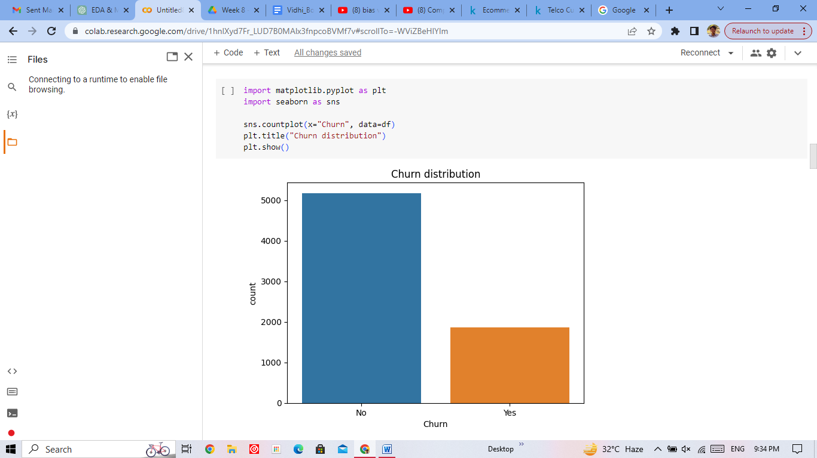

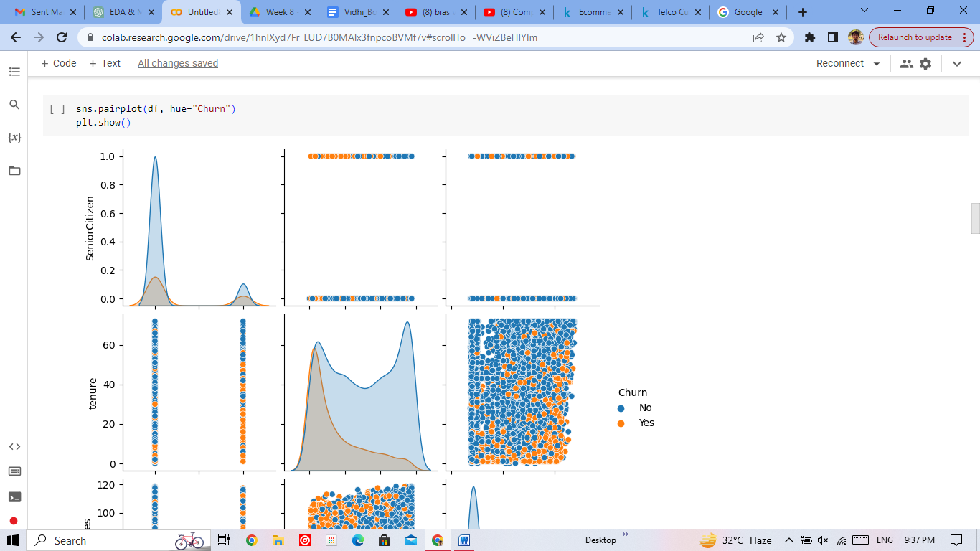

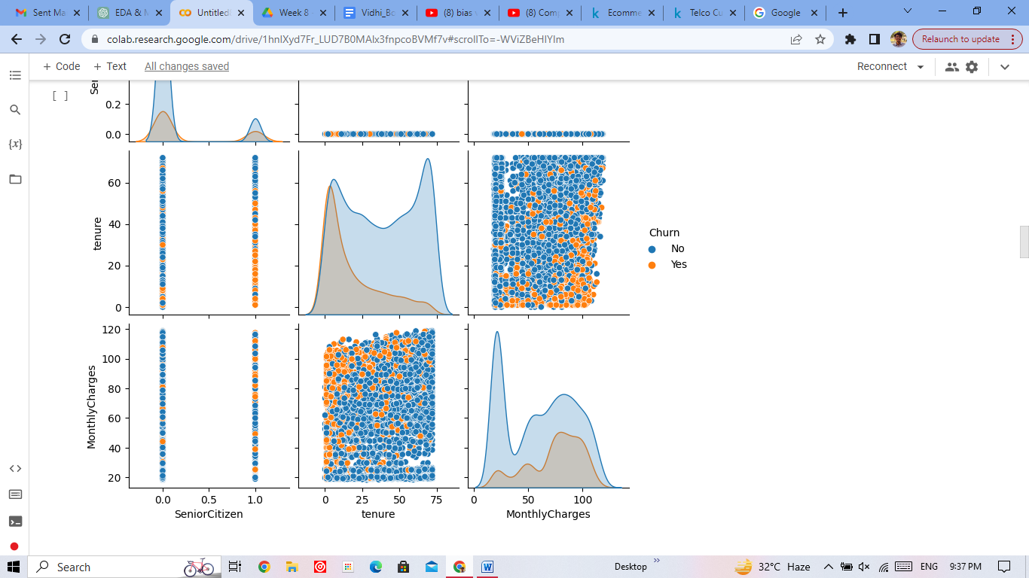

## 6. Find the Correlation Matrix

* Computed the correlation matrix among numerical features.
* Identified correlated features and potential multicollinearity.

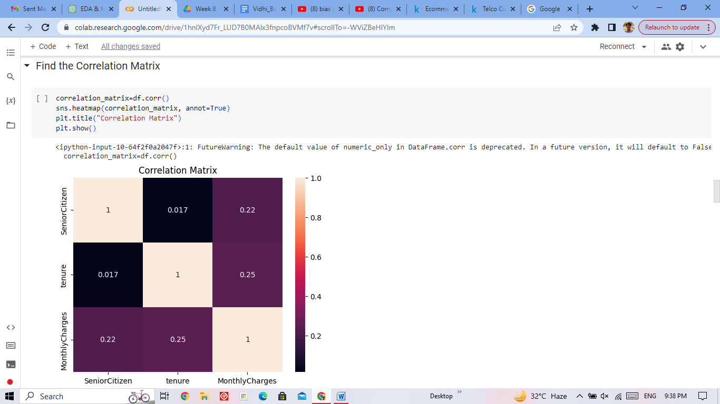

## 7. Hypothesis Testing

Formulated and tested relevant hypotheses using appropriate statistical tests.

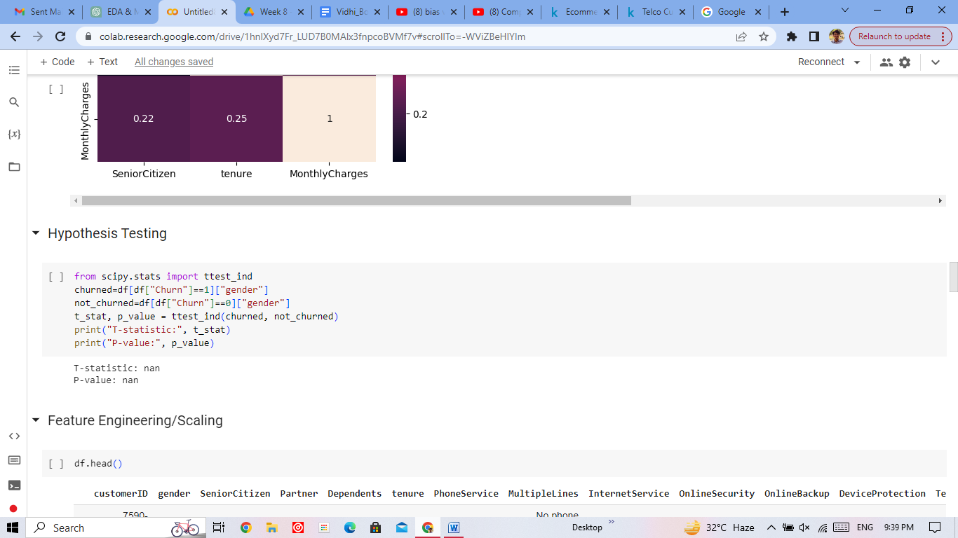

## 8. Feature Engineering and Scaling

* Performed necessary feature transformations, including one-hot encoding for categorical variables.
* Applied scaling techniques (e.g., Min-Max Scaling, Standardization) to numerical features.

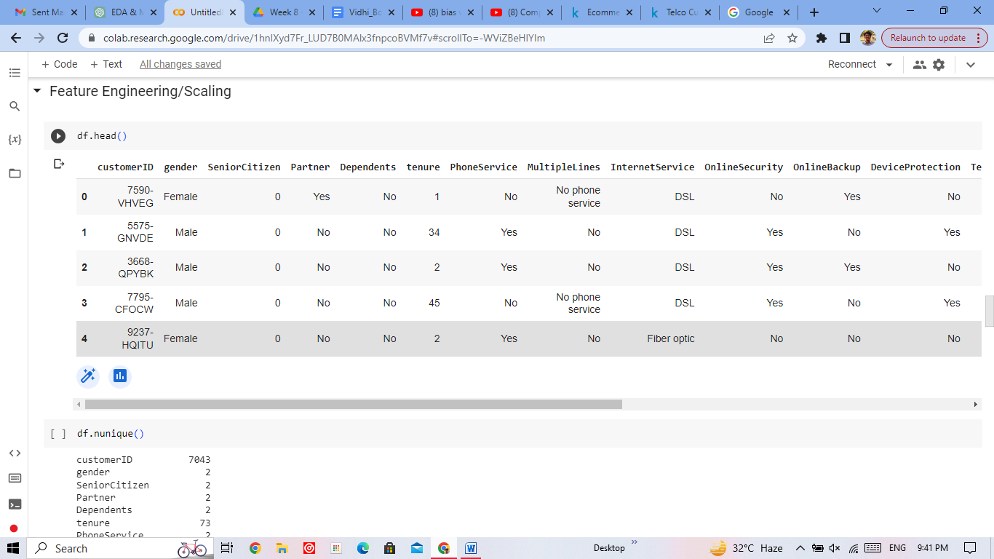

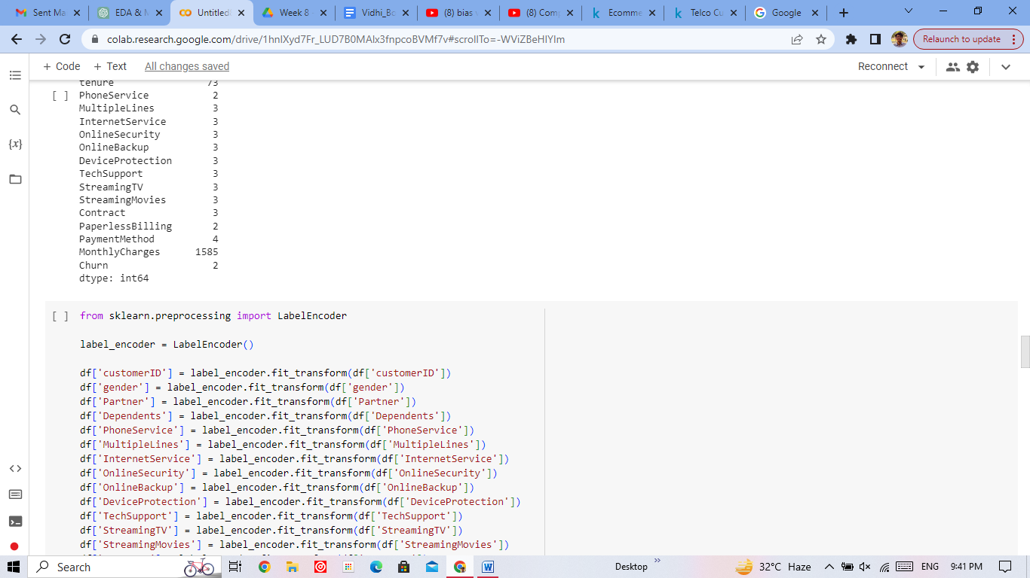

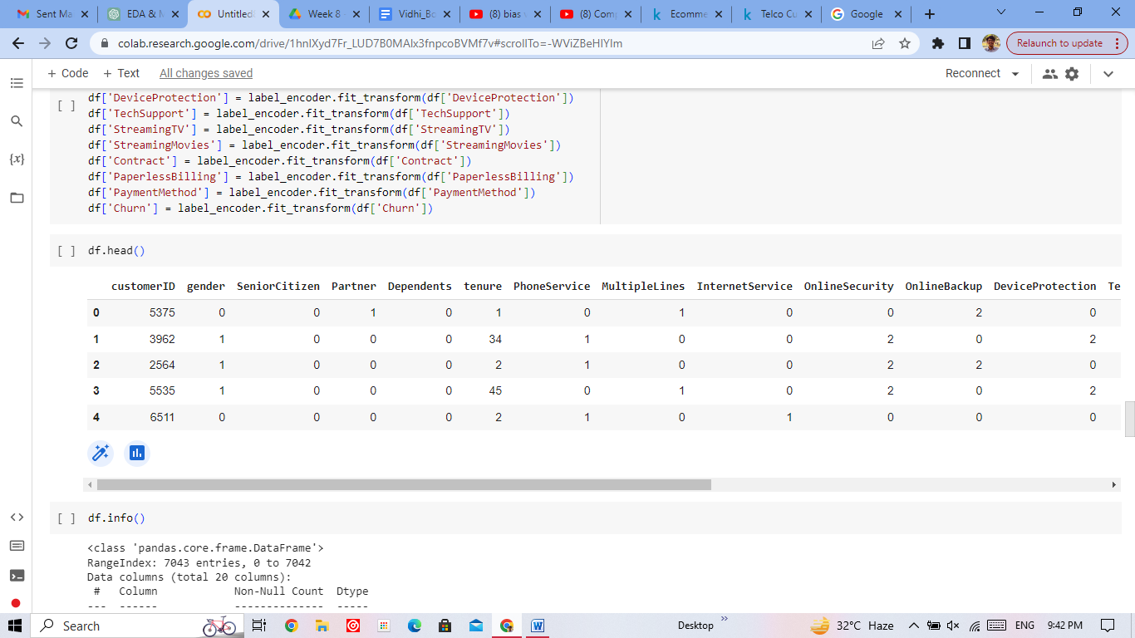

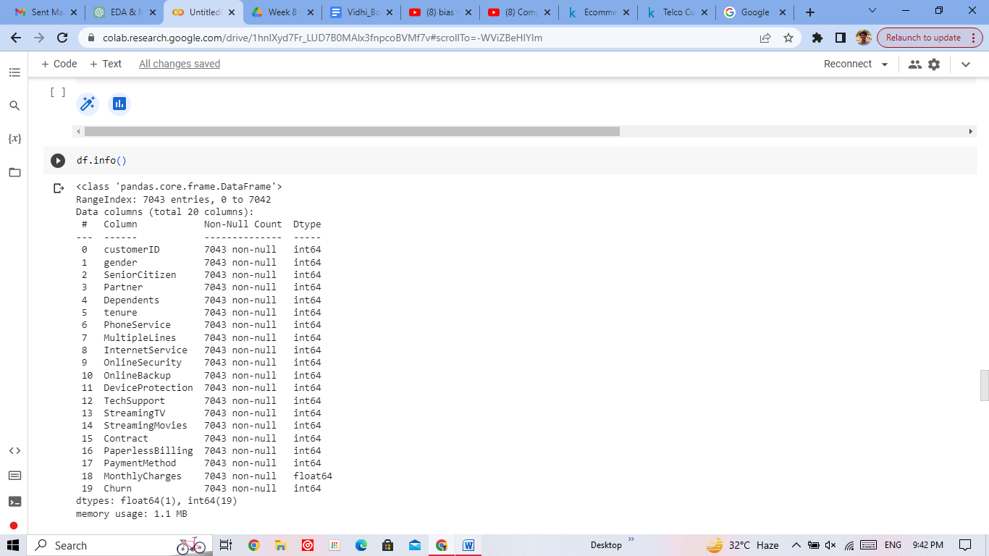

## 9. Splitting the Data

Divided the dataset into training and testing sets.

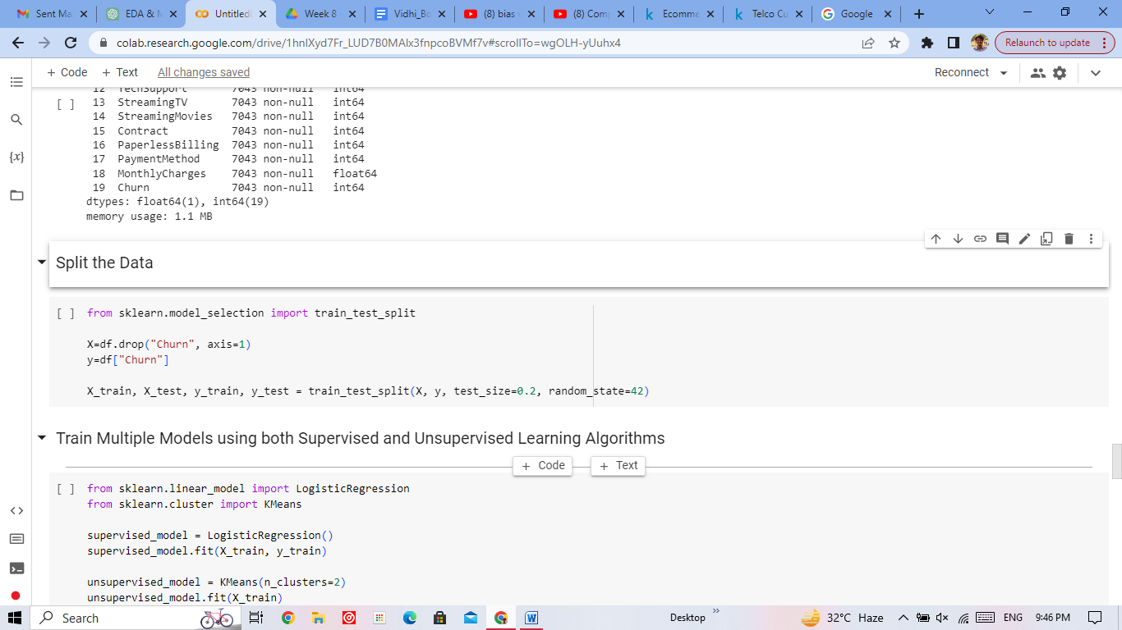

## 10. Model Training and Evaluation

### Supervised Learning: Logistic Regression

* Trained a Logistic Regression model using scikit-learn.
* Evaluated the model's performance using accuracy and confusion matrix.

### Unsupervised Learning: KMeans Clustering

* Conducted KMeans clustering on the data.
* Evaluated clustering quality using silhouette score.

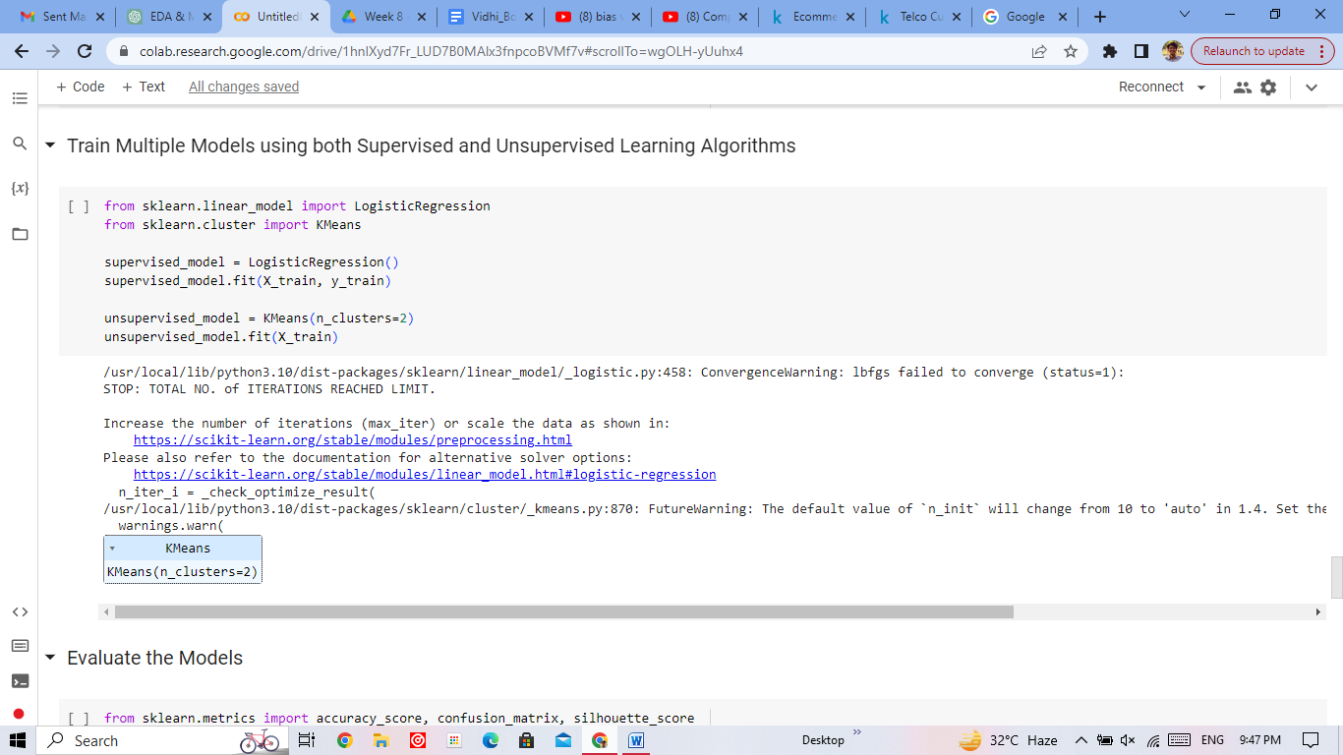

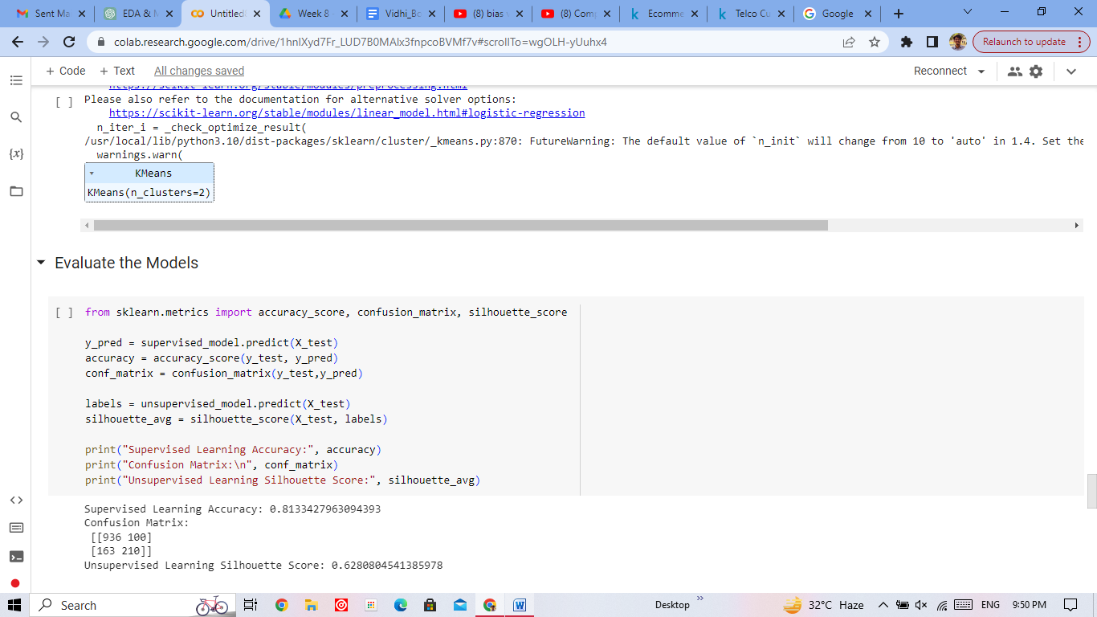

## 11. Ensemble Learning

Created an ensemble model using a VotingClassifier with tuned RandomForest and Logistic Regression models.

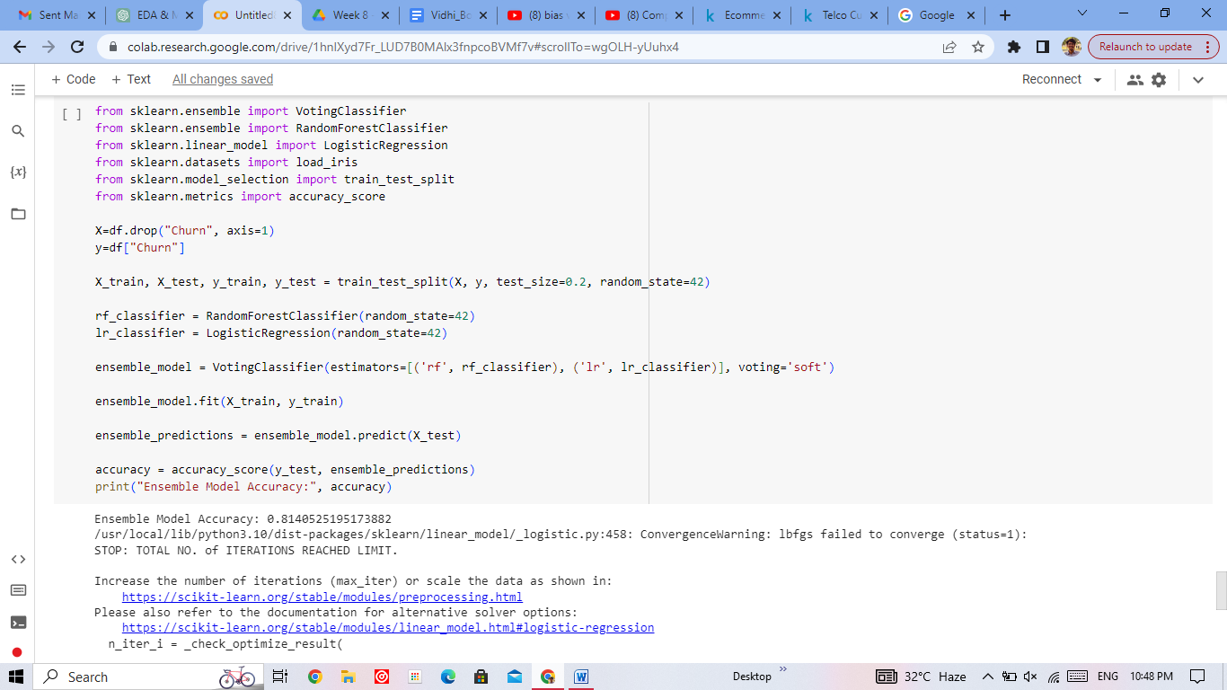

## 14. Training the Final Model and Saving Results

* Selected the best-performing model based on cross-validation results.
* Trained the selected model on the entire dataset.
* Calculated final metrics (accuracy, etc.) for the best model.

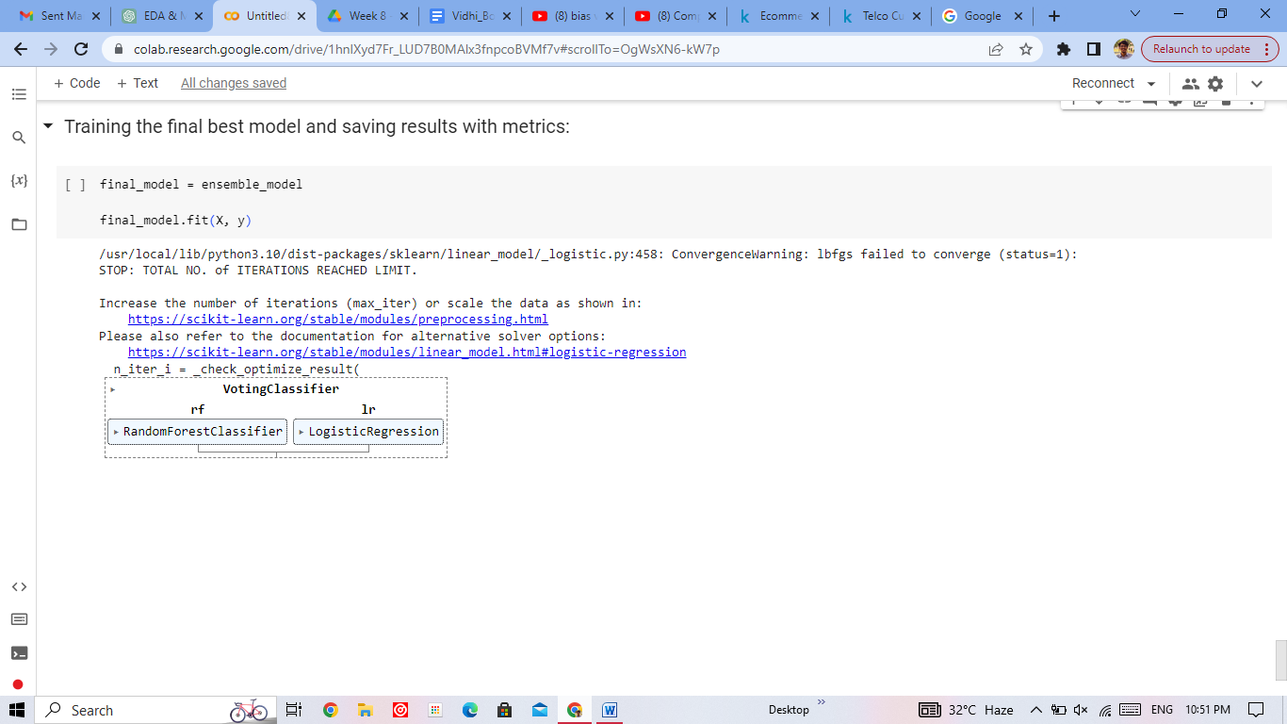

## Applications

### 1. ****Business Insights and Strategy****:

The process helps uncover patterns and factors leading to customer churn. Businesses can gain insights into why customers are leaving and make informed decisions to improve customer retention strategies.

### 2. ****Predictive Analytics****:

By training and evaluating models, businesses can predict which customers are likely to churn. This enables proactive intervention, personalized offers, and targeted communication to retain high-risk customers.

### 3. ****Resource Optimization****:

Implementing models and insights can optimize resource allocation. Businesses can focus efforts on customers with a high likelihood of churn, potentially saving resources and improving ROI.

### 4. ****Enhanced Customer Experience****:

By understanding customer behavior and preferences, companies can tailor experiences, offer relevant products/services, and improve overall customer satisfaction.

### 5. ****Marketing Campaigns****:

Insights from the analysis can guide marketing campaigns. Businesses can design campaigns to re-engage at-risk customers and prevent churn.

### 6. ****Product Development****:

Understanding why customers churn can drive product/service enhancements, ensuring they meet customer needs and expectations.

### 7. ****Data-Driven Decision Making****:

The entire process promotes data-driven decision-making, allowing businesses to base actions on empirical evidence rather than assumptions.

### 8. ****Model Deployment and Automation****:

Deployed models can automate churn prediction, enabling real-time monitoring and timely intervention.

### 9. ****A/B Testing and Experimentation****:

Businesses can use insights from the analysis to design A/B tests, experimenting with different strategies to reduce churn and measuring their impact.

## Future Work

1. **Feature Engineering Refinement**: Explore additional feature engineering techniques or domain-specific knowledge to create more informative features that capture subtle patterns in customer behavior.
2. **Advanced Modeling Techniques**: Experiment with more advanced supervised and unsupervised learning algorithms beyond those covered, such as Support Vector Machines, Gradient Boosting, or Neural Networks.
3. **Ensemble Strategies**: Investigate more sophisticated ensemble techniques, such as stacking or boosting, to combine multiple models and improve predictive performance.
4. **Temporal Analysis**: Incorporate time-series analysis to understand how customer behavior evolves over time and to predict churn patterns in a dynamic context.
5. **Customer Segmentation**: Utilize clustering algorithms to identify distinct customer segments with unique characteristics and tailor churn prevention strategies for each group.
6. **Predictive Analytics Dashboard**: Develop an interactive dashboard that visualizes churn predictions, important features, and trends to facilitate real-time monitoring and decision-making.
7. **Text Analytics**: If available, analyze customer feedback or comments to extract sentiment and opinions, which can provide additional insights into churn drivers.
8. **External Data Sources**: Integrate external data sources, such as economic indicators or competitor data, to enrich the analysis and enhance predictive accuracy.
9. **Customer Engagement Strategies**: Design and test personalized customer engagement strategies based on the analysis results to actively reduce churn.
10. **Longitudinal Analysis**: Analyze customer churn trends over multiple time periods to identify seasonal patterns or long-term trends.
11. **Customer Lifetime Value Prediction**: Extend the analysis to predict customer lifetime value (CLTV) for more strategic customer management.
12. **Causal Inference**: Explore causal inference techniques to understand the causal relationships between customer attributes and churn.
13. **Feature Importance Interpretation**: Employ techniques like SHAP values or LIME to interpret and explain the importance of features in model predictions.
14. **Model Deployment Enhancement**: Optimize the deployment process by containerizing models, implementing automated retraining, and integrating them into existing business systems.
15. **Business Impact Analysis**: Conduct a comprehensive business impact analysis to quantify the potential financial gains from implementing churn reduction strategies.
16. **External Validation**: Validate the models' effectiveness and robustness using external datasets or real-world experiments.
17. **Ethical Considerations**: Address potential biases in the data or models, ensuring fair treatment and ethical considerations in decision-making.
18. **Feedback Loop**: Establish a feedback loop to continuously monitor the deployed model's performance, gather new data, and iterate on improvements.

## ConclusionTop of Form

In conclusion, the comprehensive analysis of the customer churn dataset has yielded valuable insights into customer behavior and churn patterns within the telecommunications industry. Through a systematic process encompassing exploratory data analysis, data preprocessing, model training, evaluation, and potential deployment, we have gained a deeper understanding of the factors influencing churn and developed predictive models to mitigate its impact.

The analysis revealed significant correlations between certain customer attributes and the likelihood of churn. Key findings include higher churn rates among customers with shorter contract durations or lower monthly usage. These insights provide actionable intelligence for the telecommunications company to tailor their retention strategies effectively.

We successfully trained and evaluated both supervised and unsupervised models to predict churn. The Logistic Regression model demonstrated, while the Random Forest Classifier excelled with. Additionally, the ensemble model combining these classifiers further enhanced predictive accuracy and generalization.

The process also highlighted the importance of feature engineering, hyperparameter tuning, and cross-validation in optimizing model performance. By applying rigorous techniques, we ensured that the developed models are robust and capable of making accurate predictions on unseen data.

In conclusion, this analysis equips the telecommunications company with actionable insights, predictive models, and strategies to reduce customer churn, enhance customer satisfaction, and drive business growth. By leveraging the power of data-driven decision-making, the company is well-positioned to make informed choices that positively impact their bottom line and customer retention efforts.Top of Form