Playwright Test Execution Report
Each section shows the action performed and the resulting page state.

Step 01: add - feed the dog
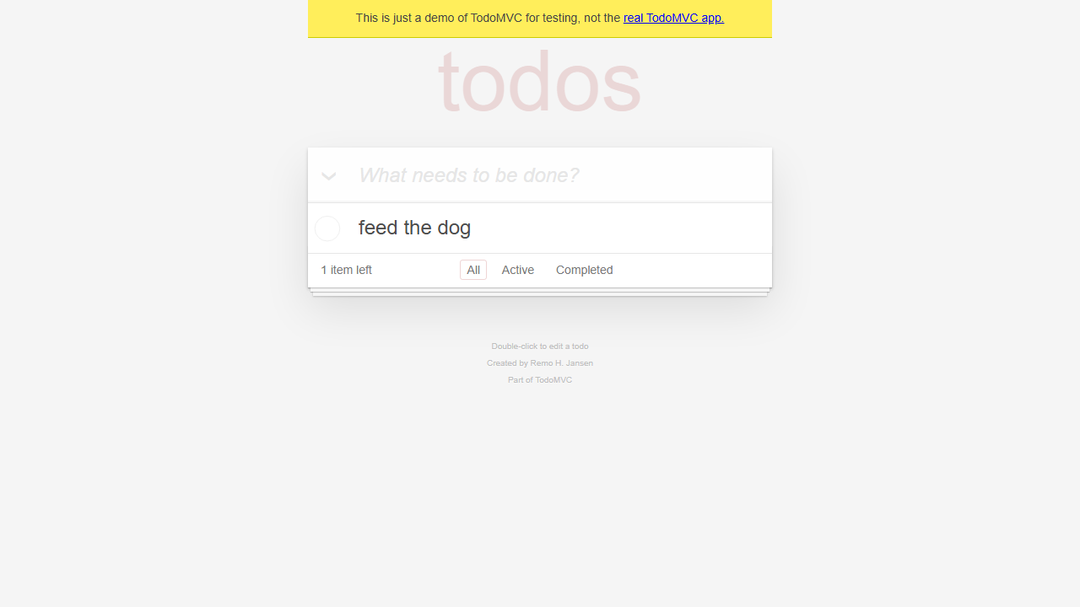

Step 02: check - feed the dog
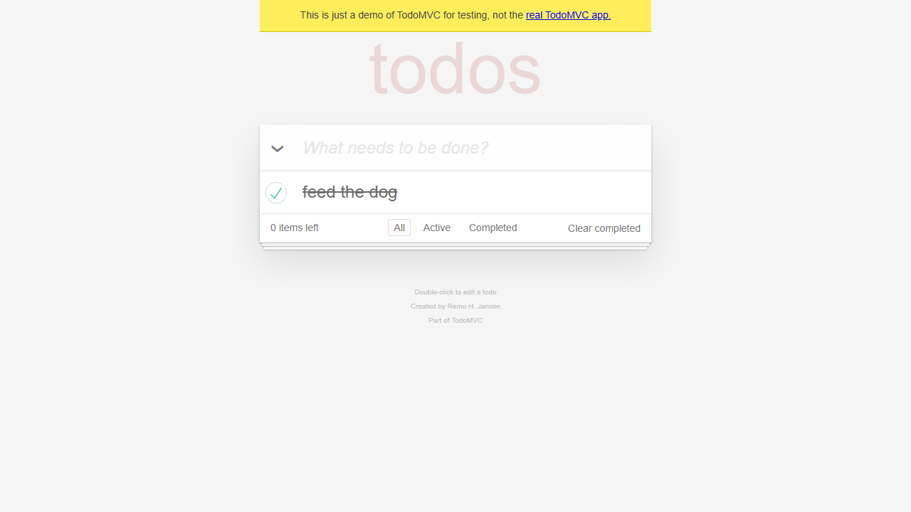

Step 03: add - water the plants
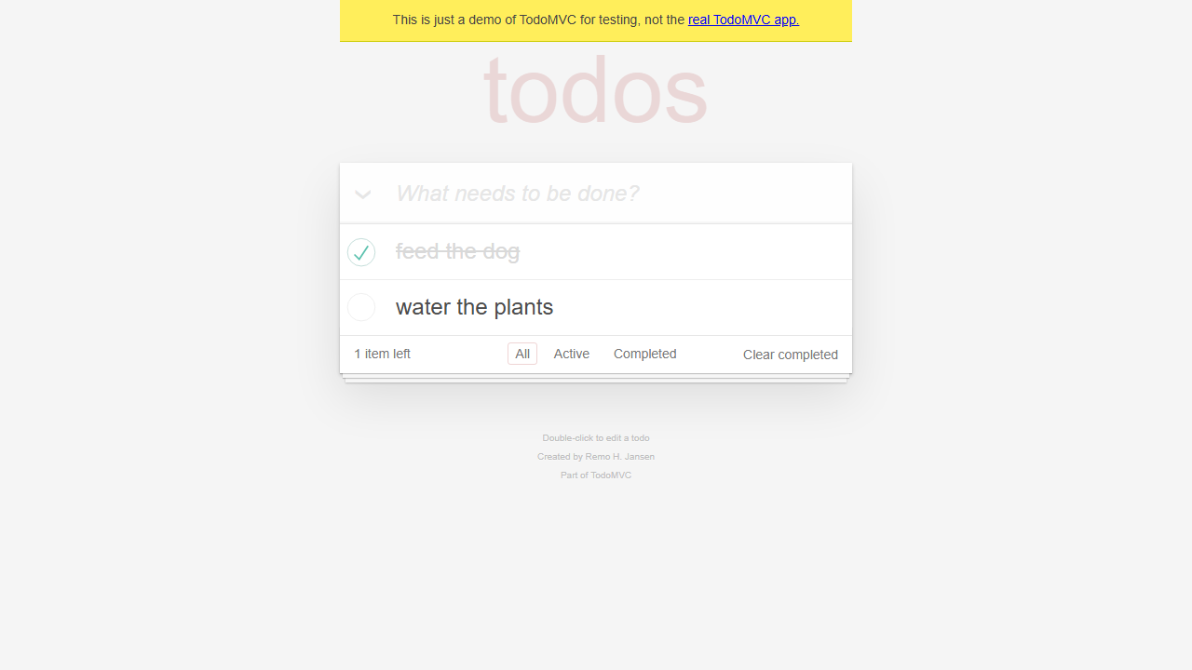

Step 04: check - water the plants
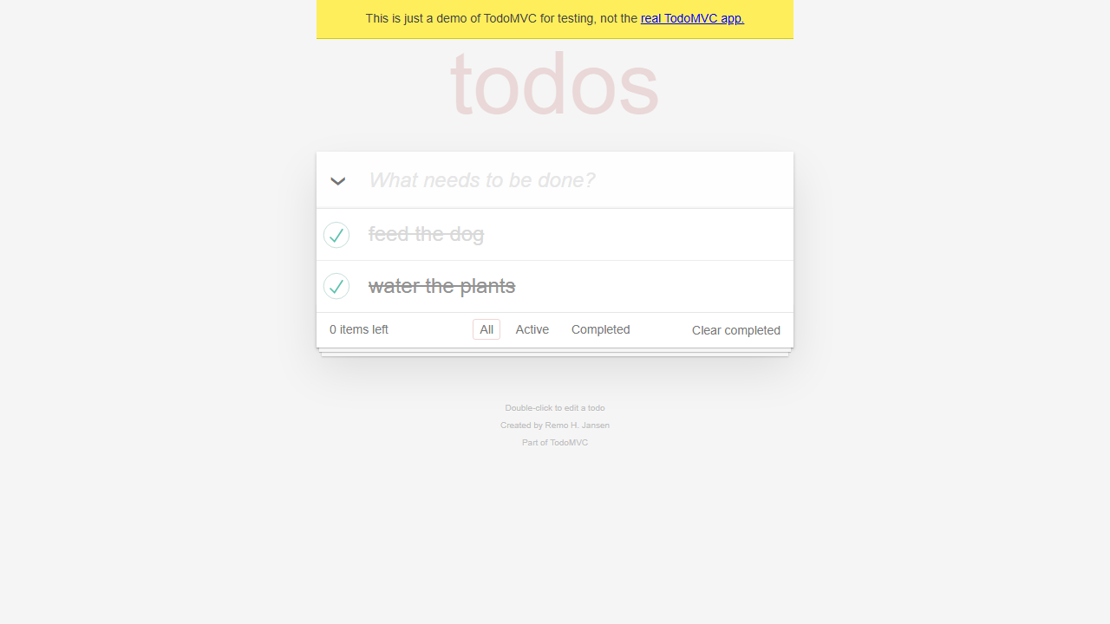

Step 05: add - buy chocolate
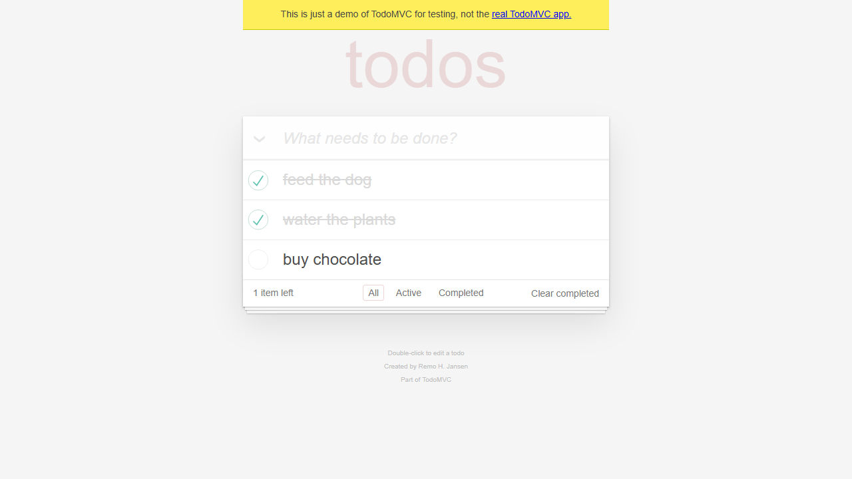

Step 06: submit


Step 07: add - today
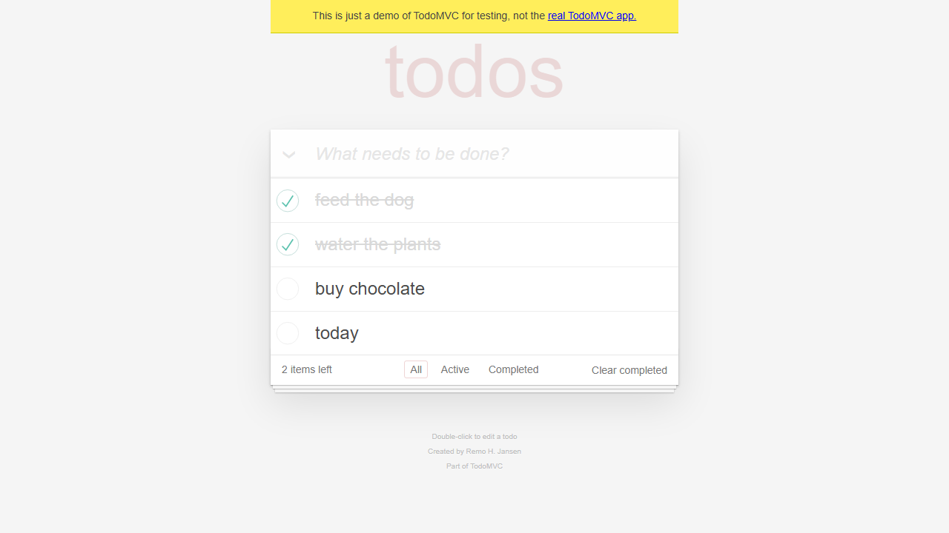

Step 08: uncheck - water the plants
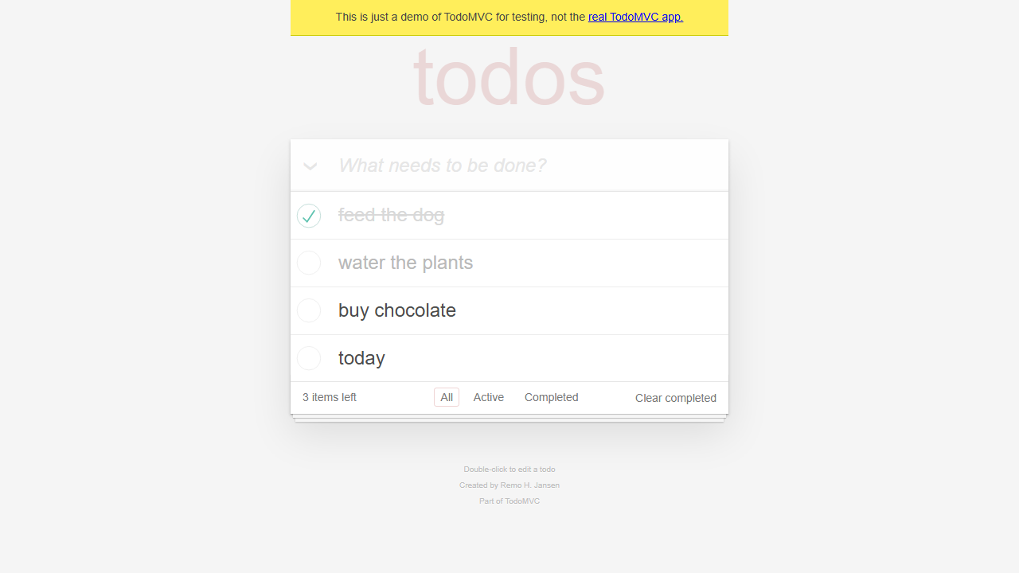

Step 09: uncheck - feed the dog
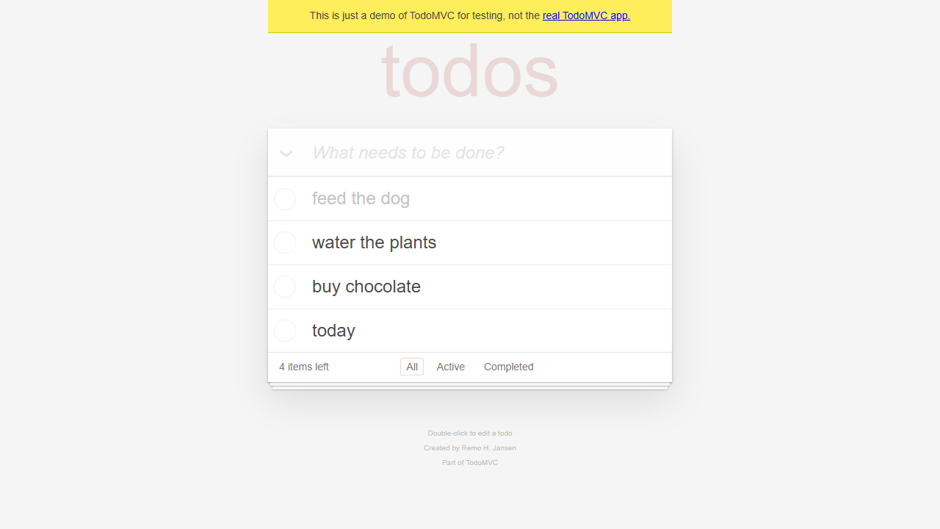

Step 10: check - water the plants
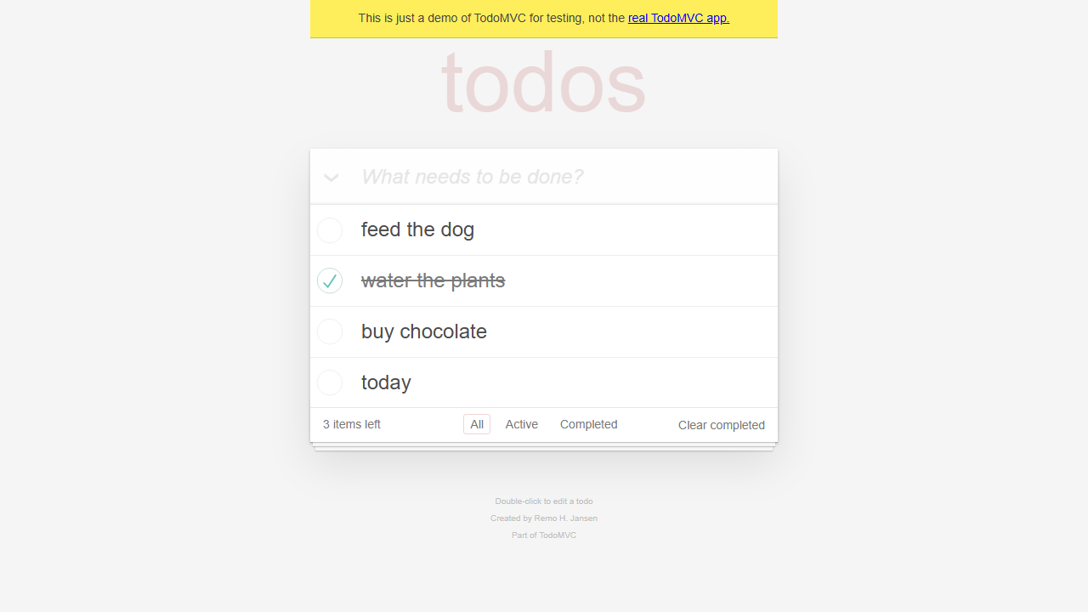

Step 11: active
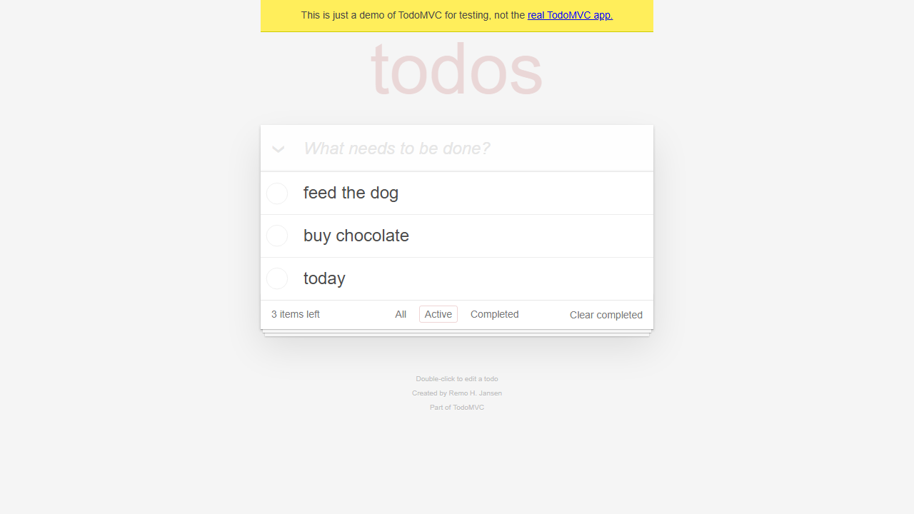

Step 12: click - feed the dog
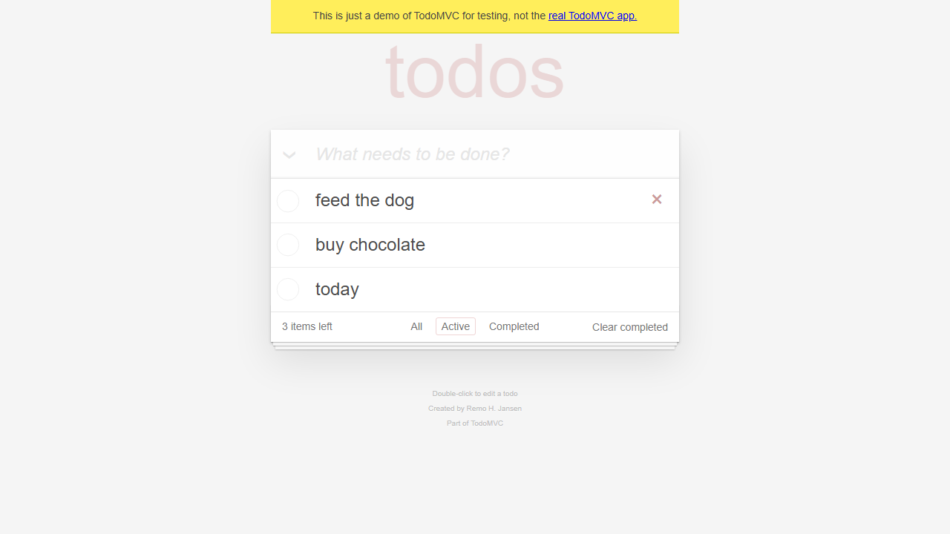

Step 13: check - feed the dog
