Assalamualaikum Sir,
- You advised me to learn ACO and GA from the YouTube channel The Ali Mirjalili. I have gone through the videos, but GA is taught by him in a paid Udemy course, which I am unable to access.
- You also instructed me to read the paper Optimal Path Planning Based on ACO in Intelligent Transportation. After carefully reviewing the paper multiple times, I found that the authors do not implement real-world traffic data directly. Instead, they model the problem in relation to Vehicle Routing Problems (VRP) and Vehicle Control Problems (VCP).
Their approach combines Genetic Algorithm (GA) and Ant Colony Optimization (ACO) with a reward-and-punishment mechanism. In their framework, a route with a lower pheromone level is interpreted as a congested path. To manage this, they introduce a reward system for selecting alternative, less congested routes and apply punishment for choosing highly congested ones.
In summary, the paper focuses on a simulation-based congestion management strategy rather than actual real-time traffic data, using GA–ACO hybrid optimization linked with VRP/VCP formulations.

🧠 How the Paper Tackles Congestion
The proposed solution is a hybrid algorithm called RA-GA-ACO, which blends:
- Reward and Punishment Mechanism (RA): Encourages selection of less congested routes by rewarding efficient paths and penalizing congested ones.
- Genetic Algorithm (GA): Optimizes route selection by evolving better solutions over time.
- Ant Colony Optimization (ACO): Mimics ant behavior to find optimal paths using pheromone trails, which are updated based on traffic flow and congestion levels.
Together, these components help:
- 🚗 Avoid congested routes by dynamically adjusting pheromone levels to reflect real-time traffic conditions.
- 🛣️ Distribute traffic load more evenly across the network.
- ⏱️ Reduce travel time and improve overall traffic efficiency.

Other papers links and related formulas in this paper are:
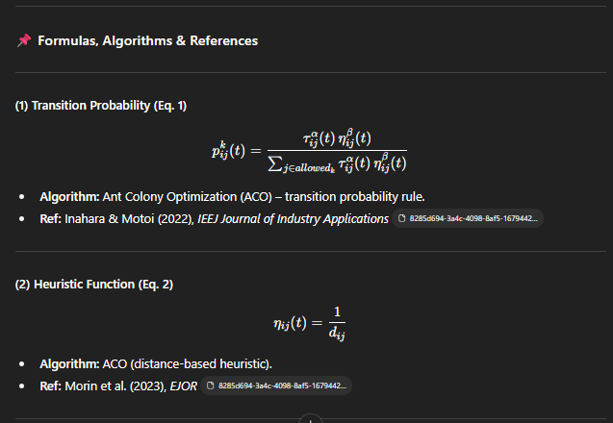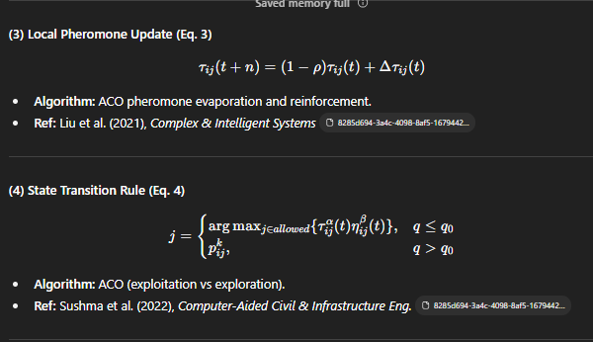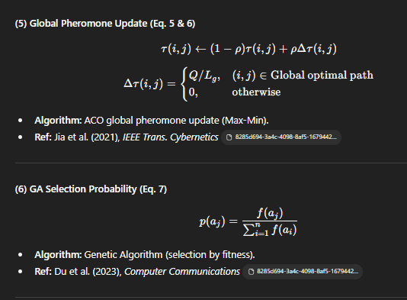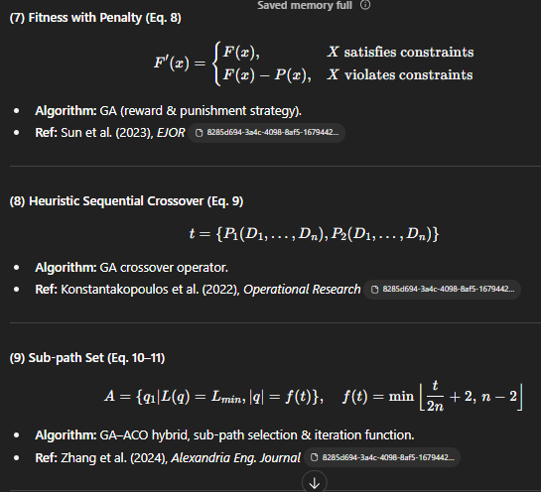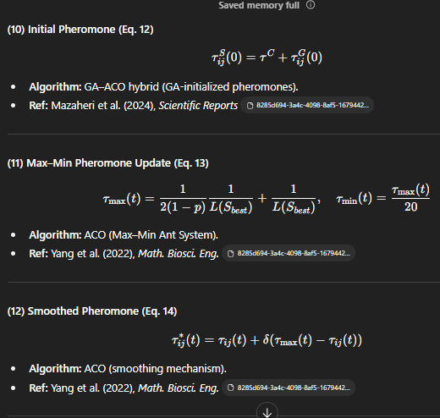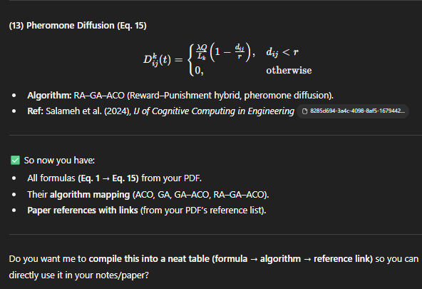

The links with formula I have given a pdf enclosed with it named (Algorithms_Formulas_Paragraph.pdf)

