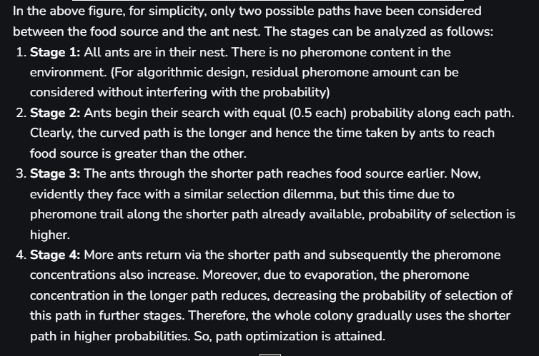

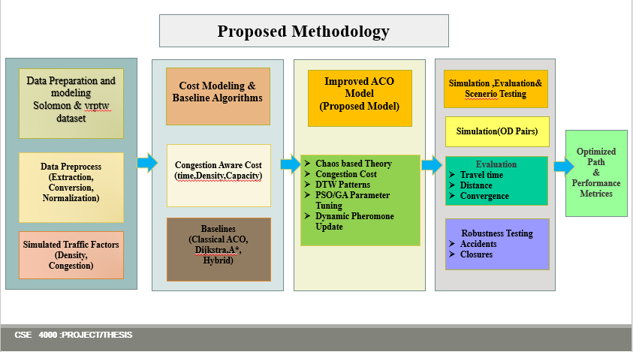

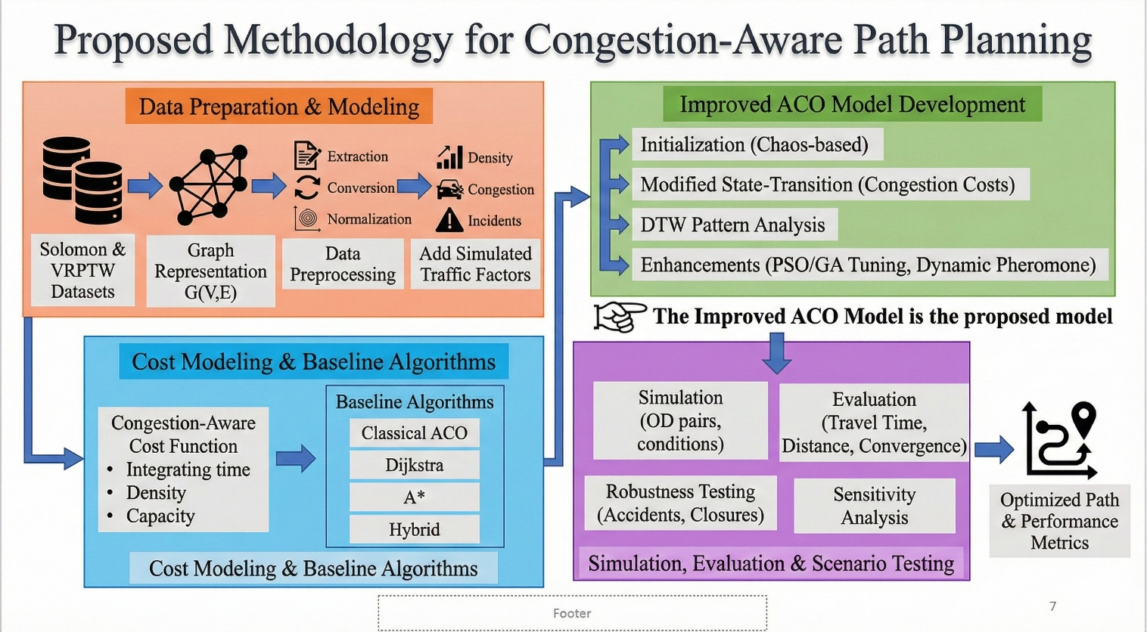

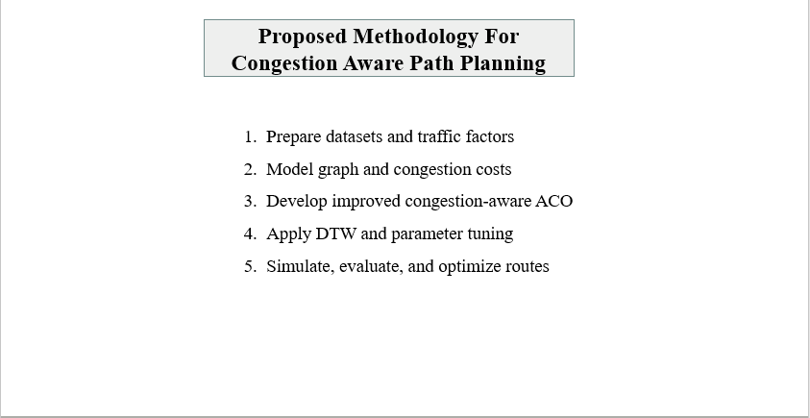

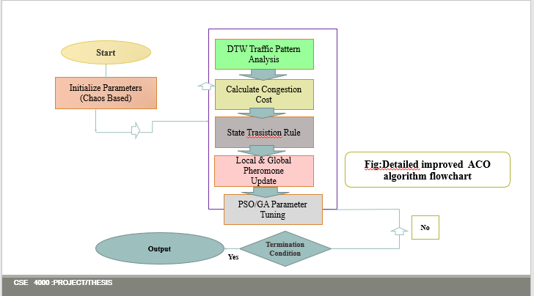

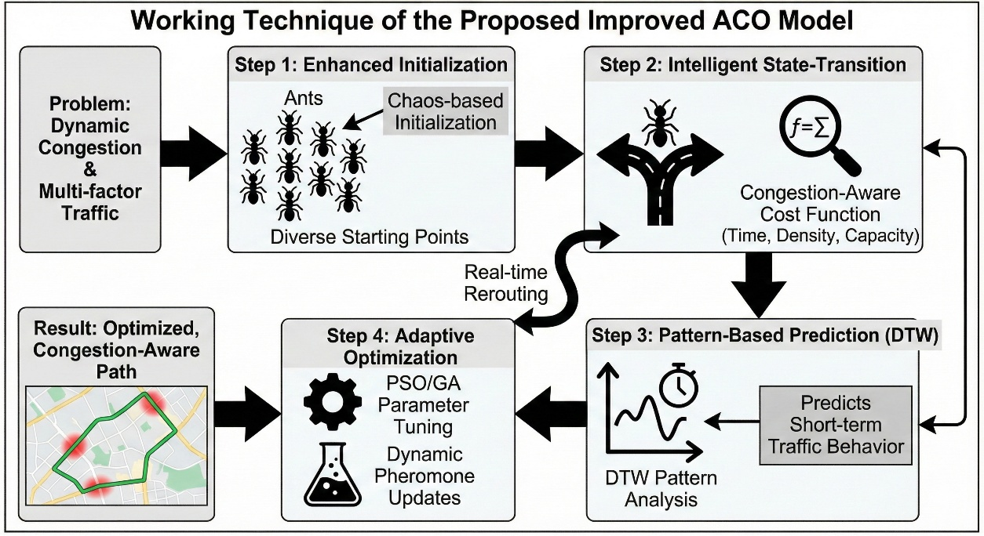

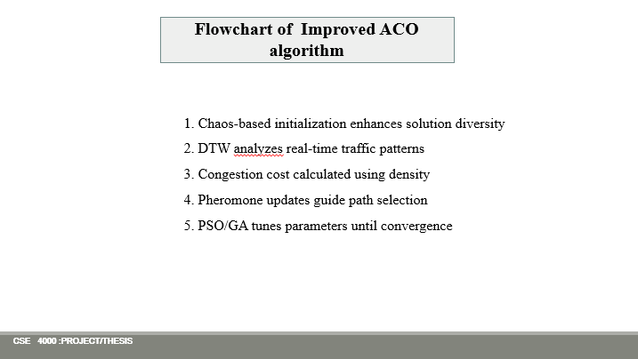
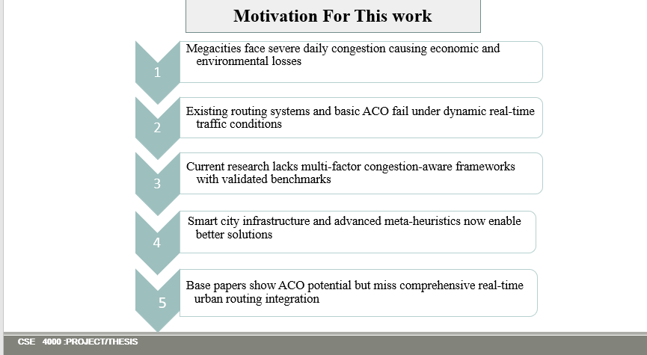

Optimizing real-Time Urban Navigation Under Dynamic Traffic and Road Disturbances

Here are short, precise, and very simple explanations you can say in viva or presentation:

Dynamic Time Window (DTW)
(Dynamic Time Warping – in your context)
- It is a method to compare traffic patterns over time
- It matches current traffic flow with past traffic patterns
- Even if traffic speeds change faster or slower, DTW can still compare them
In simple words:
👉 DTW helps the system understand how traffic is changing in real time.

Chaos Theory
- Chaos theory deals with systems that change unpredictably
- Small changes can cause big effects
- Traffic conditions behave like a chaotic system
In ACO:
- Chaos-based initialization creates more diverse paths
- It avoids early convergence to poor solutions
In simple words:
👉 Chaos theory helps ACO explore more routes and find better solutions faster.

One-line Viva Answers
- DTW: Used to analyze and match real-time traffic patterns.
- Chaos Theory: Used to improve diversity and avoid premature convergence.
If you want, I can also give:
- One-sentence board-level answers
- Bangla + English mixed explanation
- Where exactly you used them in your model
Just tell me 👍
DTW AND CHASO
Sure 👍
Here are very simple, real-life examples that are easy to remember and perfect for viva.

1️⃣ Chaos Theory – Simple Example

Real-life example (Very Easy)
Imagine:
- Two cars start from the same signal
- One driver slows down for just 2 seconds
- After a few minutes, a big traffic jam forms behind him
A very small change → causes a big effect.
👉 This is chaos.

In Your Project (ACO)
- If all ants start from the same route, they may get stuck in congestion
- Chaos-based initialization starts ants from slightly different paths
- This helps find better routes faster
One-line answer:
👉 Chaos helps ACO explore more paths and avoid early wrong decisions.

2️⃣ DTW (Dynamic Time Warping) – Simple Example

Real-life example (Very Easy)
Imagine:
- You go to university at 8 AM every day
- Some days traffic increases slowly
- Some days traffic increases very fast
Even though the pattern is same,
the speed of change is different.
DTW matches:
- Slow traffic day
- Fast traffic day
👉 DTW says: “These two traffic patterns are similar.”

In Your Project (Traffic)
- DTW compares current traffic data
- With previous traffic patterns
- Even if timing is different
One-line answer:
👉 DTW helps identify similar traffic behavior despite time differences.

Super Short Viva Version (Remember This)
- Chaos Theory:
Small changes create big effects; used to improve exploration.
- DTW:
Matches traffic patterns even if they change at different speeds.

If you want, I can also give:
- Diagram explanation
- Bangla + English example
- One-sentence answer only
Just tell me 😊

Perfect question 👍
I’ll explain each term in very easy, short, and precise way, then give you the overall workflow you can say in viva.

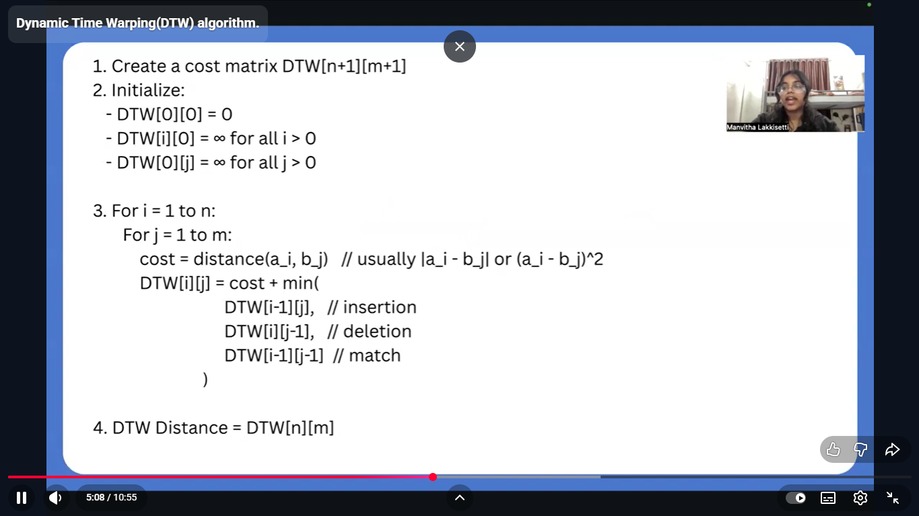

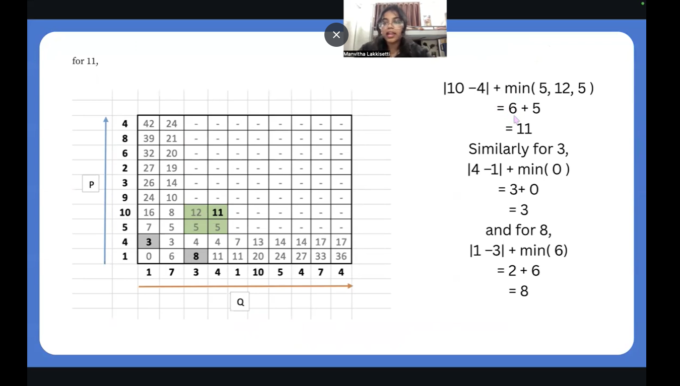

IACO FLOW CHART

1️⃣ State Transition Rule (Very Simple)
What it means:
It decides which road the ant will choose next.
How it works:
- Ant prefers roads with less congestion
- Ant prefers roads with more pheromone
- Ant sometimes explores new roads
In simple words:
👉 State transition rule = decision rule for choosing the next path.
One-line viva answer:
➡️ It controls how ants move from one node to another.

2️⃣ Local & Global Pheromone Update

Local Pheromone Update
- Happens while ants are moving
- Slightly reduces pheromone on the used road
- Encourages other ants to explore different paths
👉 Prevents traffic overload on one path.

Global Pheromone Update
- Happens after all ants finish
- Adds more pheromone on the best path found
- Helps future ants follow better routes
In simple words:
👉 Local update encourages exploration, global update strengthens best paths.
One-line viva answer:
➡️ Local update avoids congestion; global update reinforces optimal routes.

3️⃣ PSO / GA Parameter Tuning

What are parameters?
- Number of ants
- Pheromone importance
- Decay rate
Wrong values → poor results.

PSO (Particle Swarm Optimization)
- Inspired by bird flocking
- Tries different parameter values
- Gradually moves toward best solution
👉 PSO finds good parameter values faster.

GA (Genetic Algorithm)
- Inspired by natural evolution
- Uses selection, crossover, mutation
- Keeps improving parameters over generations
👉 GA searches globally for optimal parameters.

In simple words:
👉 PSO/GA automatically choose the best ACO parameters.
One-line viva answer:
➡️ Used to optimize ACO parameters automatically.

4️⃣ Overall Workflow of the Algorithm (Step-by-Step)
You can say this confidently 👇
- Start
- Initialize ACO parameters using chaos theory
- Analyze real-time traffic using DTW
- Calculate congestion cost for each road
- Ants select paths using state transition rule
- Apply local pheromone update
- Find best route and apply global pheromone update
- Tune parameters using PSO or GA
- Check termination condition
- If not satisfied, repeat
- Output the optimal route

Ultra-Short Summary (Best for Viva)
- State transition rule: decides next path
- Local pheromone update: encourages exploration
- Global pheromone update: strengthens best route
- PSO/GA: optimizes ACO parameters
- Workflow: initialize → analyze → select → update → optimize → output
If you want, I can also:
- Convert this into 1-slide explanation
- Give 1-line answers only
- Explain with a road example
Just tell me 😊
Good question 👍
Here is a very simple and clear explanation you can use in presentation or viva.

What does the second line mean?

“Custom ACO framework with multi-factor cost modelling”

Simple meaning:
- Custom ACO framework
👉 You are not using a ready-made ACO algorithm
👉 You will design your own ACO logic according to your problem
- Multi-factor cost modelling
👉 Route cost is not only distance
👉 It includes multiple factors, such as:
  - Traffic density
  - Congestion level
  - Travel time
  - Road condition
  - Disturbances (accidents, weather)

In one simple sentence (Best for Viva):
➡️ We design our own ACO algorithm where route cost depends on multiple traffic-related factors, not just distance.

Very short version (If teacher asks quickly):
➡️ Custom ACO means our own modified algorithm, and multi-factor cost means using several traffic parameters to calculate path cost.
If you want, I can also:
- Give a road example
- Convert this into Bangla + English
- Make it 1-line slide-ready
Just tell me 😊

Why use a Multi-factor ACO framework with congestion integration?

Simple answer:
Because real traffic is complex and distance alone is not enough to choose the best route.

Detailed but easy explanation:
A multi-factor ACO framework is used because:
- Shortest path ≠ fastest path
- A short road can be highly congested
- Traffic changes continuously
So instead of using only distance, we include multiple factors, such as:
- Traffic density
- Congestion level
- Travel time
- Road condition
- Disturbances (accidents, weather)
Congestion integration helps the algorithm:
- Avoid crowded roads
- Distribute vehicles across multiple paths
- Reduce travel time and fuel consumption

One-line viva answer (Best):
➡️ It is used to select routes based on real traffic conditions, not just shortest distance.

Ultra-short version:
➡️ To achieve realistic, congestion-aware and efficient routing.
If you want, I can also:
- Give a real-road example
- Convert it to Bangla + English
- Make it slide-ready (1 bullet)

What does “Pheromone updates guide path selection dynamically” mean?

Simple meaning:
- Pheromone = experience
- More pheromone → better route
- Less pheromone → worse route
Dynamically means:
👉 pheromone values are updated continuously based on real-time traffic changes, not fixed conditions.

Normal ACO vs Dynamic ACO (Your Model)

1️⃣ Normal ACO
- Pheromone is updated based on:
  - Distance
  - Path length
- Environment is assumed static
- Once a route becomes best, ants keep following it
- Cannot react quickly to:
  - Sudden congestion
  - Accidents
  - Traffic spikes
👉 Update is slow and static

2️⃣ Dynamic Pheromone Update (Your Model)
- Pheromone update considers:
  - Real-time congestion level
  - Traffic density
  - Road disturbances
- If a road becomes congested:
  - Its pheromone decreases immediately
- If a road becomes free:
  - Its pheromone increases
👉 Routes change dynamically with traffic

Key Difference (Very Important)
Aspect | Normal ACO | Dynamic ACO (Yours)
Environment | Static | Real-time
Update basis | Distance | Distance + congestion
Reaction to traffic | Slow | Fast
Congestion handling | Poor | Efficient

One-line Viva Answer (Best)
➡️ Normal ACO updates pheromone using static costs, while dynamic ACO updates pheromone using real-time congestion, allowing quick route adaptation.

Super Simple Example
- Morning: Road A is free → pheromone increases
- Suddenly accident happens → congestion increases
- Dynamic update reduces pheromone immediately
- Vehicles move to Road B
Normal ACO ❌ cannot react fast
Dynamic ACO ✅ adapts instantly

THESIS Word Meaning
Here’s a clear, concise breakdown of each word in your thesis title, explained in the context of your research:
1. Optimizing
Improving or making more efficient.
You are trying to find the best possible route (shortest time, least congestion) instead of just a feasible one.
2. Real-Time
Live or continuously updated.
Your system uses current traffic data (not historical averages) to make decisions as conditions change.
3. Urban Navigation
Route planning in city environments.
Focus is on city roads with intersections, signals, and high vehicle density, not highways or rural paths.
4. Dynamic Traffic
Traffic that changes over time.
You account for varying congestion levels (rush hour, accidents, events) rather than assuming static traffic.
5. Road Disturbances
Unexpected disruptions on the road.
Includes accidents, road closures, construction, weather effects—factors that suddenly alter road usability.
Full Meaning in Your Thesis Context:
You are developing a method to find the best live route in a city that adapts to changing traffic and sudden road problems, using an enhanced ACO algorithm to make decisions quickly and accurately.
How to Present If Asked:
“My title means I’m creating a system that continuously finds the fastest and most reliable route in cities by responding instantly to live traffic changes and unexpected road issues—moving beyond static navigation to a truly adaptive approach.”
This shows you understand not just the words, but the research problem and contribution clearly.

