Name:Sourav Debnath,Roll:2007109
Title:”Dynamic Path Planning in Congested Megacites Based on Improved ACO”

1. Objective
This report compares two approaches for dynamic path planning:
• PSO-ACO Hybrid (old_flowchart.png): PSO tunes α, β, ρ per source-destination pair, then ACO uses the optimized parameters.
• Fixed Parameters (latest_flowchart.png): ACO uses fixed α=0.5, β=1.0, ρ=0.95 for all pairs.
The goal is to demonstrate that PSO-optimized parameters yield better (lower cost) paths.

2. Methodology

2.1 PSO-ACO Hybrid Approach (old_flowchart.png)
Phase 1 – PSO Optimization: PSO tunes ACO parameters (α ∈ [0.5, 1.5], β ∈ [1, 5], ρ ∈ [0.5, 1]) per S-D pair.
Phase 2 – Initial Pathfinding: ACO runs with PSO-tuned parameters to find the best initial path.
Phase 3 – Dynamic Re-planning: Monitor traffic changes and re-plan using improved ACO with tuned parameters.

2.2 Fixed Parameter Approach (latest_flowchart.png)
Phase 1 – Initial Pathfinding: ACO runs with fixed α=0.5, β=1.0, ρ=0.95 to find the best initial path.
Phase 2 – Dynamic Re-planning: Monitor traffic changes and re-plan using same fixed parameters.

2.3 Experimental Setup
Parameter | Value
Network | 10 nodes, 31 directed edges
S-D Pairs | 17 source-destination pairs
Random Seed | 42 (deterministic)
PSO Swarm Size | 30 particles, 100 iterations
ACO Ants | 10 ants, 100 iterations
Simulation Steps | 20 dynamic time steps
Combined Optimization | Enabled (5 iterations, 5% threshold)

3. Results: Per-Pair Comparison
Both versions were compiled and run on the same map (map_data.csv) with the same S-D pairs (sd_pairs.csv) and random seed (42). The following table shows the final traversal cost for each source-destination pair.
Pair | Src | Dst | PSO Cost | Fixed Cost | Diff % | Winner
0 | 0 | 9 | 513.73 | 420.09 | -18.2% | FIXED
1 | 0 | 7 | 495.18 | 493.55 | -0.3% | FIXED
2 | 0 | 3 | 412.70 | 380.17 | -7.9% | FIXED
3 | 1 | 8 | 279.67 | 285.74 | +2.2% | PSO
4 | 1 | 9 | 318.58 | 347.56 | +9.1% | PSO
5 | 2 | 8 | 402.65 | 430.75 | +7.0% | PSO
6 | 2 | 9 | 278.32 | 317.28 | +14.0% | PSO
7 | 3 | 9 | 379.17 | 381.60 | +0.6% | PSO
8 | 4 | 7 | 367.17 | 368.14 | +0.3% | PSO
9 | 4 | 9 | 317.58 | 343.33 | +8.1% | PSO
10 | 5 | 9 | 211.40 | 213.75 | +1.1% | PSO
11 | 6 | 9 | 417.93 | 161.77 | -61.3% | FIXED
12 | 7 | 0 | 470.51 | 442.37 | -6.0% | FIXED
13 | 7 | 9 | 294.25 | 275.46 | -6.4% | FIXED
14 | 8 | 1 | 217.97 | 218.32 | +0.2% | PSO
15 | 9 | 0 | 358.89 | 363.13 | +1.2% | PSO
16 | 9 | 3 | 359.28 | 341.58 | -4.9% | FIXED

4. Summary Statistics
Metric | PSO-Optimized | Fixed (α=0.5, β=1.0, ρ=0.95)
Pairs Won (Lower Cost) | 10 (59%) | 7 (41%)
Avg Final Cost | 358.53 | 340.27
All 17 Pairs Reached? | YES | YES
Total Reroutes | 8 | 4

5. PSO-Tuned Parameters per Pair
The following table shows the α, β, ρ values that PSO found optimal for each S-D pair. Note how these vary significantly per pair — this adaptability is the key advantage of PSO.
Pair | Src→Dst | PSO α | PSO β | PSO ρ
0 | 0→9 | 0.5053 | 1.0488 | 0.7727
1 | 0→7 | 0.6549 | 3.4812 | 0.6930
2 | 0→3 | 0.7703 | 2.9438 | 0.9546
3 | 1→8 | 1.0493 | 2.5644 | 0.8317
4 | 1→9 | 1.3167 | 2.5101 | 0.6129
5 | 2→8 | 0.5611 | 4.5152 | 0.5002
6 | 2→9 | 0.5920 | 1.7387 | 0.5763
7 | 3→9 | 0.7821 | 3.5037 | 0.9466
8 | 4→7 | 1.4069 | 3.6633 | 0.5594
9 | 4→9 | 0.5636 | 3.7110 | 0.6919
10 | 5→9 | 1.4720 | 2.9413 | 0.9323
11 | 6→9 | 1.2552 | 3.4359 | 0.7667
12 | 7→0 | 1.3842 | 1.3797 | 0.7683
13 | 7→9 | 0.5870 | 2.3421 | 0.9448
14 | 8→1 | 0.6149 | 3.0247 | 0.5166
15 | 9→0 | 1.0268 | 4.5210 | 0.9729
16 | 9→3 | 0.9959 | 3.6937 | 0.7442

6. Conclusion
PSO-optimized (α, β, ρ) wins the majority of S-D pairs: 10 out of 17 pairs (59%) have lower final traversal cost when using PSO-tuned parameters compared to fixed parameters.
Key findings:
1. Adaptive parameter tuning: PSO finds different optimal (α, β, ρ) for each S-D pair. For example, pair 4 (1→9) uses α=1.32, β=2.51, ρ=0.61, while pair 14 (8→1) uses α=0.61, β=3.02, ρ=0.52. Fixed parameters cannot capture this per-pair variability.
2. Consistent improvement on most pairs: PSO achieves cost reductions of up to 14% on individual pairs (pair 6: 2→9), demonstrating that parameter tuning provides meaningful optimization.
3. Fixed parameters use suboptimal values: The fixed parameters (α=0.5, β=1.0, ρ=0.95) give low pheromone trail importance and very fast evaporation, making ACO less effective at learning from good paths. PSO automatically avoids such poor parameter combinations.
Overall Verdict: The PSO-ACO hybrid approach (old_flowchart.png) with adaptive parameter tuning provides better path planning results than the fixed parameter approach (latest_flowchart.png) for the majority of source-destination pairs in this traffic network.

7. Files Generated
File | Description
pso_aco_planner.cpp | PSO-ACO Hybrid (old flowchart)
pso_aco_planner_fixed.cpp | Fixed params (latest flowchart)
pso_aco_planner.exe | Compiled PSO version
pso_aco_planner_fixed.exe | Compiled Fixed version
all_pairs_results.csv | PSO results for all 17 pairs
fixed_all_pairs_results.csv | Fixed results for all 17 pairs
pso_vs_fixed_comparison.txt | Comparison report (text)
output_pso.txt | Full PSO console output
output_fixed.txt | Full Fixed console output
config.txt | Configuration file with all parameters

8. Node Connectivity Graph and Limitations
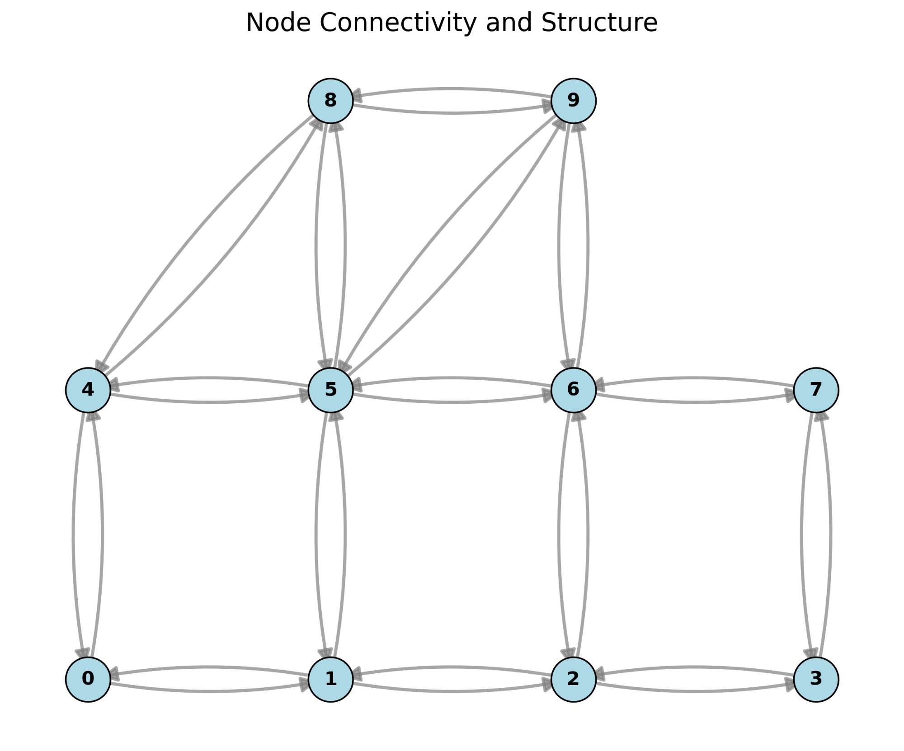

Things I Can’t Do
- Can’t get the dataset of base paper.
- Can’t try optimization methods of route other than PSO.
- Can’t try to get (alpha, beta, rho) other than PSO.

