Progress Update: Multi-Pair Route Network Optimization

What Was Updated
Previous work implemented the PSO-ACO dynamic path planner for a single source-destination (S-D) pair. The algorithm used PSO to tune ACO parameters (α, β, ρ), generated an initial best path, and dynamically re-planned when congestion thresholds (R_max, ΔR_max) were exceeded during simulation. This update extends that framework with three additions:
1.All-pairs routing: The algorithm now processes all 17 source-destination pairs from an input file (sd_pairs.csv), running independent PSO-ACO optimization and dynamic simulation for each pair.
2.Combined route optimization: An outer loop detects shared edges across routes, applies aggregate traffic penalties, and re-solves all pairs iteratively until costs stabilize (change < 5%). This captures real inter-route congestion that independent optimization ignores.
3.Network-level analysis: Edge and node usage frequencies are computed across all routes to identify congestion bottlenecks and critical intersections in the shared network.

Flowchart: Previous vs. Updated
Fig. 1 shows the original single-pair flowchart. Fig. 2 shows the updated flowchart extended with Step A (independent all-pairs loop) and Step B (combined route optimization outer loop).

Fig. 1 – Previous: Single S-D pair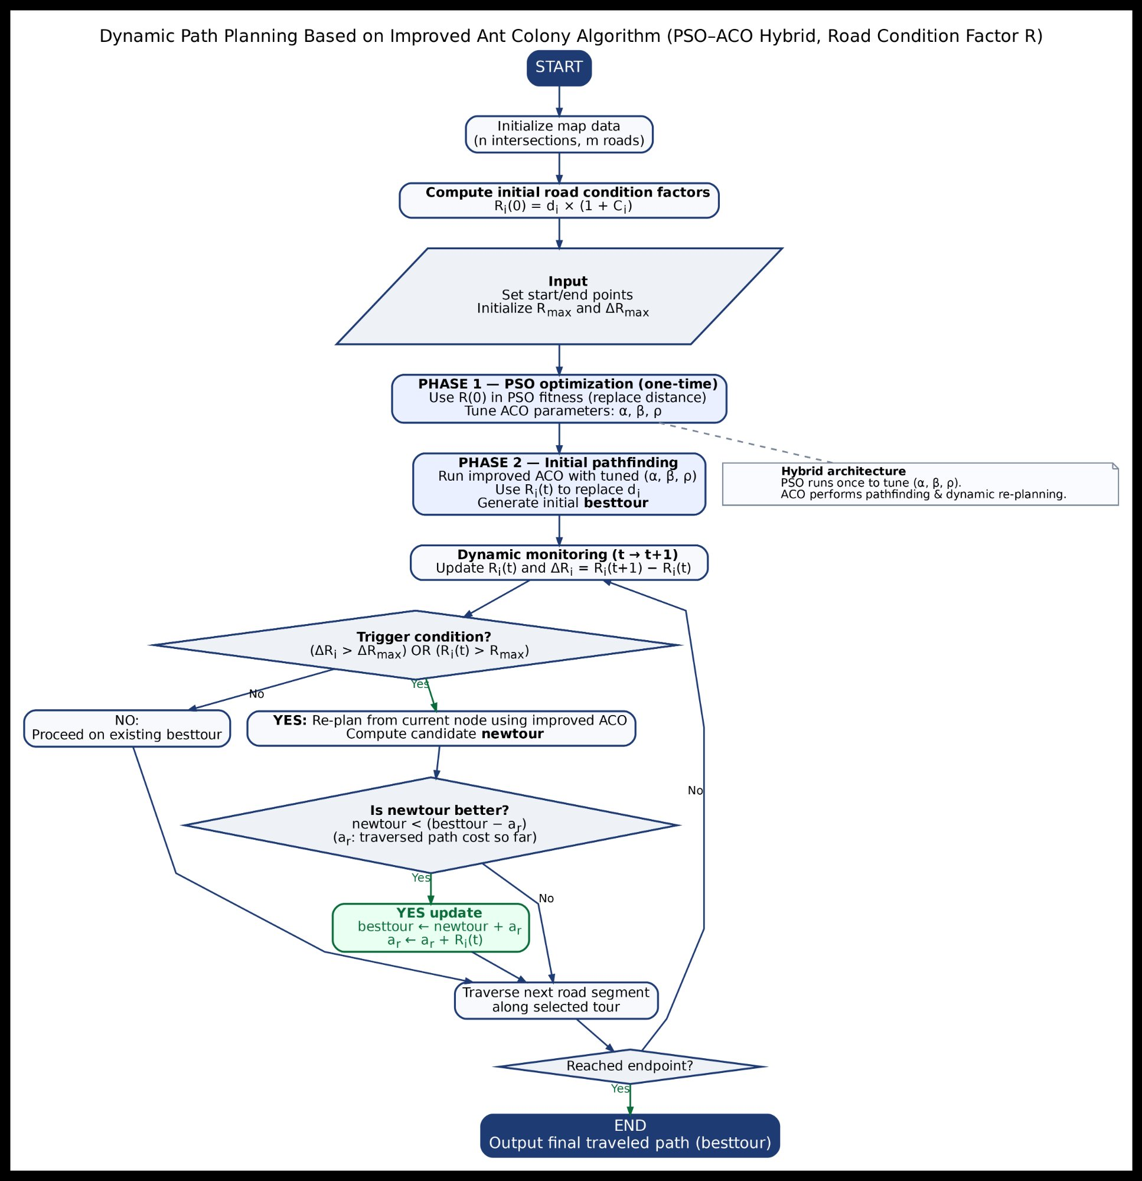ir flowchart. | 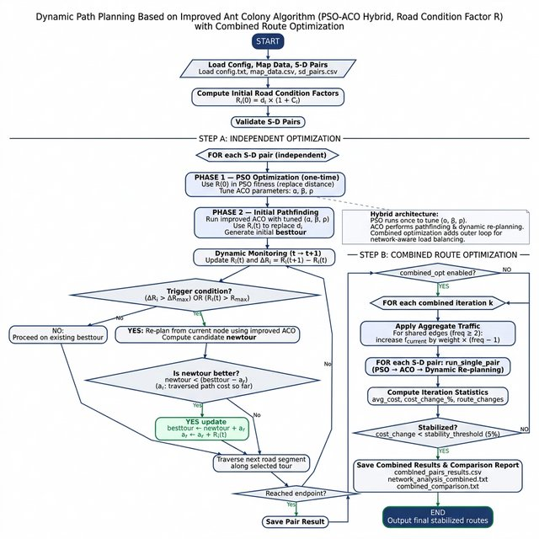  Fig. 2 – Updated: All-pairs + combined route optimization.

Methodology — What Was Added

A. All-Pairs Routing Loop (Step A)
The original three-phase algorithm (PSO tuning → ACO pathfinding → dynamic simulation) is now executed independently for every S-D pair in sd_pairs.csv. Each pair has a separate PSO run and ACO execution. Results — initial path, final path, cost, and reroute events — are saved to all_pairs_results.csv.

B. Combined Route Optimization Loop (Step B)
After all pairs are solved independently, the combined loop detects edges shared by 2 or more routes and penalizes their congestion:
C_i(t) += 0.3 × (freq_i − 1) for edges with freq_i ≥ 2
Updated road condition factors R_i(t) are recomputed, and all pairs are re-solved. The loop continues until the average cost change drops below 5% or 5 iterations complete. This simulates the real-world effect of multiple vehicles competing for the same road segments.

C. Network Analysis
Edge and node usage frequencies are computed across all stabilized routes. Edges used by ≥ 2 routes and nodes appearing in ≥ 3 routes are flagged as bottlenecks. These are exported to network_analysis.txt and network_analysis_combined.txt.

D. Algorithm Parameters
All parameters remain identical to the single-pair implementation (see Table I). No changes were made to PSO/ACO core logic — only the outer structure was extended.

TABLE I – Algorithm Configuration Parameters
Parameter | Value | Description
PSO Swarm / Iterations | 30 / 100 | Particle count & search steps
w / c1 / c2 | 0.7 / 1.5 / 1.5 | Inertia, cognitive, social weights
α / β / ρ range | [0.5,1.5]/[1,5]/[0.5,1] | ACO parameter search bounds
NUM_ANTS / ACO_ITERS | 10 / 100 | Colony size & iterations
R_MAX / ΔR_MAX | 150.0 / 5.0 | Congestion re-plan thresholds
SIM_STEPS | 20 | Dynamic simulation steps per pair
COMBINED_ITERS / Threshold | 5 / 5% | Outer loop max iters & stop criterion

Results and Analysis

A. Independent Optimization — All 17 Pairs
Table II shows the complete results. All 17 pairs reached their destination successfully (100%). A total of 7 dynamic reroutes occurred across all pairs. The average final route cost was 357.89. Pair P10 (5→9) achieved the lowest cost (194.94) via the direct edge. Pairs P2,P3, P4, P7, P8, P12, P15 each triggered one reroute due to mid-journey congestion spikes.

TABLE II – Independent Optimization: All 17 S-D Pairs
Pair | Src | Dst | Init Path | Final Path | Init Cost | Final Cost | Reroutes | Reached
P0 | 0 | 9 | 0→1→5→9 | 0→1→5→9 | 420.59 | 502.82 | 0 | YES
P1 | 0 | 7 | 0→1→5→6→7 | 0→1→5→6→7 | 475.00 | 488.25 | 0 | YES
P2 | 0 | 3 | 0→1→2→3 | 1→2→3 | 370.00 | 411.23 | 1 | YES
P3 | 1 | 8 | 1→5→8 | 5→8 | 252.50 | 274.12 | 1 | YES
P4 | 1 | 9 | 1→5→8→9 | 5→9 | 380.83 | 369.02 | 1 | YES
P5 | 2 | 8 | 2→1→5→8 | 2→1→5→8 | 362.50 | 393.82 | 0 | YES
P6 | 2 | 9 | 2→6→9 | 2→6→9 | 272.50 | 291.25 | 0 | YES
P7 | 3 | 9 | 3→2→6→9 | 6→9 | 372.50 | 426.12 | 1 | YES
P8 | 4 | 7 | 4→5→6→7 | 5→6→7 | 369.17 | 381.21 | 1 | YES
P9 | 4 | 9 | 4→5→9 | 4→5→9 | 314.75 | 353.68 | 0 | YES
P10 | 5 | 9 | 5→9 | 5→9 | 193.09 | 194.94 | 0 | YES
P11 | 6 | 9 | 6→5→9 | 6→5→9 | 310.59 | 317.84 | 0 | YES
P12 | 7 | 0 | 7→3→2→1→0 | 1→0 | 432.50 | 451.35 | 1 | YES
P13 | 7 | 9 | 7→6→9 | 7→6→9 | 267.50 | 290.65 | 0 | YES
P14 | 8 | 1 | 8→5→1 | 8→5→1 | 212.50 | 217.55 | 0 | YES
P15 | 9 | 0 | 9→8→4→0 | 4→0 | 350.59 | 372.30 | 1 | YES
P16 | 9 | 3 | 9→6→2→3 | 9→6→2→3 | 337.50 | 347.97 | 0 | YES

B. Network Bottleneck Analysis
Table III summarizes the most critical edges and nodes. Edge 5→9 is the single greatest bottleneck, shared by 5 routes. Node 5 is the most critical intersection, appearing in 10 of 17 routes. Node 9 appears in 9 routes as the most common destination. These hotspots directly inform the combined optimization penalty in Step B.

TABLE III – Network Bottleneck Analysis (Independent Optimization)
Edge (Top Shared) | Freq | Routes | Critical Node | Freq | Routes (sample)
5 → 9 | 5 | P0,P4,P9,P10,P11 | Node 5 | 10 | P0,P1,P3,P4,P5,P8...
1 → 5 | 3 | P0,P1,P5 | Node 9 | 9 | P0,P4,P6,P7,P9,P10...
6 → 9 | 3 | P6,P7,P13 | Node 6 | 7 | P1,P6,P7,P8,P11...
5 → 6, 6 → 7 | 2 | P1,P8 | Node 1 | 6 | P0,P1,P2,P5,P12,P14

C. Combined Route Optimization — Convergence and Comparison
The combined loop converged after 3 iterations with average costs of 356.60 → 387.43 → 370.40 (final change = 4.39%, below the 5% threshold). Table IV compares per-pair costs. Of 17 pairs, 4 improved under combined mode (most notably P11: 6→9 improved by 41.8%, switching from 6→5→9 to the direct edge 6→9 once bottleneck penalties redirected traffic) and 13 increased slightly — correctly reflecting aggregate traffic load on shared segments that independent optimization did not account for. Routes remained unchanged for 10 of 17 pairs.

TABLE IV – Per-Pair Comparison: Independent vs. Combined
Pair | Src | Dst | Indep Cost | Comb Cost | Δ% | Same Route? | Combined Path
P0 | 0 | 9 | 502.82 | 513.94 | +2.2% | NO | 1→5→9
P1 | 0 | 7 | 488.25 | 509.05 | +4.3% | YES | 0→1→5→6→7
P2 | 0 | 3 | 411.23 | 445.68 | +8.4% | NO | 2→3
P3 | 1 | 8 | 274.12 | 446.60 | +62.9% | NO | 1→0→4→8
P4 | 1 | 9 | 369.02 | 360.82 | -2.2% | NO | 1→5→9
P5 | 2 | 8 | 393.82 | 435.70 | +10.6% | NO | 2→6→5→8
P6 | 2 | 9 | 291.25 | 309.56 | +6.3% | YES | 2→6→9
P7 | 3 | 9 | 426.12 | 432.91 | +1.6% | YES | 6→9
P8 | 4 | 7 | 381.21 | 364.12 | -4.5% | YES | 5→6→7
P9 | 4 | 9 | 353.68 | 368.13 | +4.1% | YES | 4→5→9
P10 | 5 | 9 | 194.94 | 203.24 | +4.3% | YES | 5→9
P11 | 6 | 9 | 317.84 | 184.92 | -41.8% | NO | 6→9
P12 | 7 | 0 | 451.35 | 464.12 | +2.8% | YES | 1→0
P13 | 7 | 9 | 290.65 | 302.02 | +3.9% | YES | 7→6→9
P14 | 8 | 1 | 217.55 | 214.65 | -1.3% | YES | 8→5→1
P15 | 9 | 0 | 372.30 | 380.97 | +2.3% | YES | 4→0
P16 | 9 | 3 | 347.97 | 360.44 | +3.6% | NO | 9→6→7→3

D. Overall Summary
Table V summarizes the overall performance. The combined optimization increased average cost by 3.5% (357.89 → 370.40). This is expected: independent mode under-estimates congestion on shared edges by ignoring other routes. Combined mode corrects this, producing more realistic traffic-aware routes at a modest cost premium. The network became more balanced overall, with fewer overloaded edges.

TABLE V – Overall Performance Summary
Metric | Independent | Combined
Total S-D Pairs / Success | 17 / 17 (100%) | 17 / 17 (100%)
Average Route Cost | 357.89 | 370.40 (+3.5%)
Total Dynamic Reroutes | 7 | 7
Shared Edges (2+ routes) | 8 | 7
Critical Nodes (3+ routes) | 8 | 9
Pairs with Lower Cost in this mode | — | 4 / 17
Convergence Iterations | — | 3 (4.39% < 5%)

