RESEARCH PROGRESS REPORT
Thesis title: Dynamic Path Planning in Congested Megacity By Improved Ant Colony Algorithm with Vehicle-Aware, Pool-Based Alternative Path Planning Framework for Disruption-Resilient Routing in Dhaka
Roll:2007109

1. Purpose of This Revised Document
This report has been rewritten in a purely descriptive and step-by-step form because the current supervisor preference is to keep the work file focused on research planning rather than on flowcharts, posters, or programme-oriented presentation. Accordingly, this document gathers the major points discussed so far and turns them into one consistent methodological plan.
The present version therefore serves four purposes: first, it states the revised Dhaka research problem; second, it records the supervisor-directed modeling assumptions and constraints; third, it describes the planned method in a detailed sequence of steps; and fourth, it identifies literature-informed future work that can be brought into the next update without making unsupported claims about completed results.

2. Central Research Question and Problem Scope
The central research question is the following: when a route is suddenly blocked, a link is broken, or a protest or emergency closure appears in an unplanned megacity such as Dhaka, how quickly can vehicles be rerouted through category-wise feasible alternative paths?
This formulation deliberately goes beyond ordinary shortest-path planning under steady traffic. The revised research scope must explicitly incorporate road hierarchy, route width, road condition, vehicle-category feasibility, pair-level routing, network-level interaction, sudden disruption handling, and comparison among three online rerouting strategies. The document also treats the 0-to-9 example discussed earlier only as an illustration; the actual study must cover all relevant source-destination pairs rather than a single sample pair.

3. Vehicle Categories and Their Routing Implications
A major supervisor-directed change is that the framework must be vehicle-aware before any route is accepted as feasible. This means that path selection must first respect which roads are realistically usable for different vehicle classes and only then proceed to route optimization or rerouting.
Category | Vehicle Types | Routing Implication in the Dhaka Framework
Category 1 | Truck | Restricted to suitably wide major roads and selected connectors; cannot be assumed to use every road type.
Category 2 | Bus | Must follow predefined bus corridors and roads whose width and class are appropriate for bus movement.
Category 3 | Private car / Microbus | Can use more roads than trucks and buses, but still remains subject to width, access, and condition-based restrictions.
Category 4 | Rickshaw / Van / Bike | May use all route types unless an explicit restriction is later defined for a particular corridor or location.
The practical consequence of this categorization is that all source-destination planning and all rerouting decisions must be category-wise. A route that is feasible for a rickshaw or bike must not automatically be treated as feasible for a truck or bus. Likewise, bus movement cannot be assumed to use ordinary paths if those paths violate corridor restrictions or route-width constraints.

4. Road Hierarchy, Width, and Access Logic
The discussion further established that the Dhaka routing problem must distinguish between different road classes. These classes are important because route width and road role strongly influence whether a vehicle category can safely or realistically use a corridor.
Road Type | Interpretation | Typical Feasibility Meaning
Main route | Major corridor used for broad city movement | Typically more suitable for larger vehicles such as trucks and buses when allowed.
Link route | Intermediate connector between major roads and surrounding zones | May be feasible for larger vehicles if width and local conditions permit.
Sub route | Smaller connector within denser urban areas | More likely to be feasible for private cars and microbuses than for trucks or buses.
Mini route | Narrow local route or lane | Often appropriate mainly for small vehicles such as rickshaw, van, and bike unless explicit permission is later added.
In the proposed framework, path feasibility is therefore determined jointly by road class, route width, road condition, and vehicle category. Route width cannot remain an informal idea; it must be encoded so that the system can reject category-incompatible paths before route acceptance. Road condition must also influence route suitability because a physically narrow or degraded route may not be appropriate even if it appears connected in a graph representation.

4.1 Illustrative Node Structure and Edge Annotation Convention
To make the road-hierarchy, width, and access logic more concrete within the written report, the following figure presents a clean node-link representation of the study network. Each edge in the figure is annotated so that the reader can immediately understand the road type, the width of the road segment, and the vehicle categories that are allowed to use that edge. This figure is included only as an illustrative network representation for the work file; it is not a flowchart and it is not intended as a programming-oriented diagram.
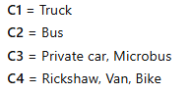
Vehicle category codes used in the edge annotations.
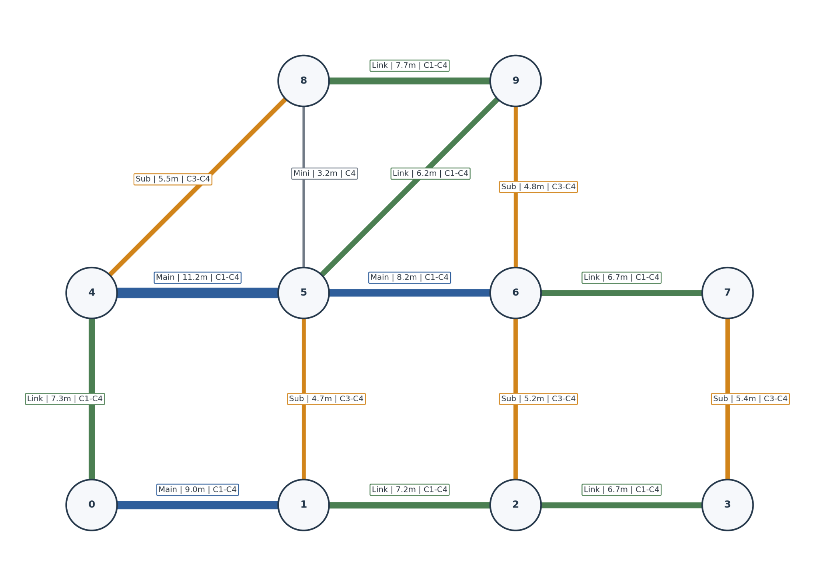
Figure 1. Illustrative node structure showing road type, edge width, and allowed vehicle categories on each road segment.
The label on each edge contains three pieces of information. First, the road type is written as Main, Link, Sub, or Mini. Second, the width of that road segment is written in meters, for example 8.0 m, 5.5 m, or 3.0 m. Third, the permitted vehicle categories are shown by the codes C1, C2, C3, and C4, where C1 denotes Truck, C2 denotes Bus, C3 denotes Private car / Microbus, and C4 denotes Rickshaw / Van / Bike.
1.An edge label such as “Main | 8.0 m | C1-C4” means that the segment is a main road, its width is 8.0 meters, and all four vehicle categories are allowed on that edge.
2.An edge label such as “Sub | 4.5 m | C3-C4” means that the segment is a sub route with 4.5-meter width and that only private car / microbus and rickshaw / van / bike are allowed on that edge.
3.In this way, the node structure visually supports the supervisor-directed requirement that route acceptance must depend on width, road type, and vehicle-category feasibility rather than on connectivity alone.

5. Why Dhaka Must Be Treated as a Category-Wise Rerouting Problem
The supervisor-directed framing assumes that Dhaka is not simply a uniform road network in which all vehicles move equivalently. Instead, it is a mixed and constrained urban system in which road hierarchy, road width, local congestion, sudden disruption, and vehicle-specific access together determine what constitutes a realistic alternative path. This is why the present research emphasizes category-wise feasible rerouting rather than a single generic shortest-path answer.
The earlier discussion also introduced comparable unplanned or congested megacity contexts that help motivate this treatment. Delhi, Jakarta, Karachi, and Metro Manila are useful illustrative examples because they show, in different ways, that dense urban networks often combine road hierarchy with vehicle-type restrictions or corridor-specific movement rules. In this document these cities are used only as motivating analogues for Dhaka and not as claims that Dhaka exactly copies any one of those systems.

6. Step-by-Step Planned Research Methodology
The supervisor asked that the work be described step by step and in detail. The following sequence therefore translates all major discussion points into a single ordered research plan. Each step is written as a methodological action rather than as a software diagram or presentation graphic.

6.1 Step 1 — Define the Dhaka study area and the working network boundaries
The first step is to decide which Dhaka subnetwork or pilot area will be used for structured analysis. At the present stage, a realistic Dhaka corridor view can be treated as a future-work pilot extraction rather than as a final georeferenced network. The purpose of this step is to define the intersections, corridors, and surrounding zones that will later be represented as nodes and links.

6.2 Step 2 — Identify source-destination pairs and the vehicle categories relevant to each pair
The next step is to specify the source-destination pairs that will be studied. These pairs must not be limited to one example such as 0 to 9. The earlier 0-to-9 case and the blocked 5-to-9 edge were only explanatory examples. The real evaluation must consider all relevant source-destination pairs across all relevant vehicle categories, because disruption may affect many trips simultaneously rather than only one trip.

6.3 Step 3 — Classify all roads by type, width, condition, and access suitability
After selecting the network, each road segment must be classified by at least four properties: road type, width, road condition, and vehicle-category suitability. This step is essential because the later routing stages must be able to distinguish main routes from link, sub, and mini routes, and also distinguish wide, moderate, and narrow corridors. Without this step, category-wise feasibility cannot be enforced in a meaningful way.
At this stage, any bus-specific corridor rule must also be recorded. In addition, fragile or historically sensitive corridors may later be assigned higher disruption priors. During earlier discussion, locations such as Shahbagh and Science Lab were mentioned only as illustrative examples of places where breakage or blockage risk may be higher. They should therefore be treated as configurable examples and not as hard-coded facts unless later supported by reliable data.

6.4 Step 4 — Define explicit access rules for each vehicle category
Once the roads have been classified, the study must define the access rules that determine whether a vehicle category may use an edge. Trucks and buses must not be allowed to use every corridor automatically. Buses must obey their predefined corridors. Private cars and microbuses may use a broader set of roads than trucks and buses, but they must still remain subject to width and access checks. Rickshaw, van, and bike may be treated as the most flexible group unless explicit restrictions are later introduced for a specific road or context.

6.5 Step 5 — Build category-wise feasible route options under steady-state conditions
The next step is to construct feasible steady-state routes for every source-destination pair under normal operating conditions. This means that before any sudden block is introduced, the system should determine which routes are feasible for each vehicle category after applying road type, width, road condition, and access constraints. The purpose of this stage is to establish a baseline network state that respects the real differences among vehicle classes.

6.6 Step 6 — Construct a five-path pool for each source-destination pair and vehicle category
A key concept from the earlier discussion is the pool. A pool is defined as a group of five alternative paths for the same source-destination pair and vehicle category. These five paths must be arranged from best to worst according to the selected routing criteria. Pool construction takes place under steady-state conditions before a disruption appears. In other words, the pool is not built only after a blockage; it is prepared in advance so that the system can respond more quickly when an actual disruption occurs.
This pool must remain category-aware. A truck pool, a bus pool, and a small-vehicle pool for the same source-destination pair may differ substantially because the feasible roads are different. The pool should also be robust enough to include meaningful alternatives rather than trivial variations of the same route. During future refinement, fragile links may receive higher prior caution during pool preparation so that the pool does not rely too heavily on corridors that are likely to become blocked.

6.7 Step 7 — Extend from pair-level pools to a combined network-level stable state
The framework is not limited to independent pair-level routing. After each pair-level pool and steady-state best route has been established, the study must also consider how multiple source-destination pairs interact at the network level. Shared corridors may become crowded or strategically important even before a sudden blockage occurs. The network-level stage is therefore required to represent a combined stable state in which the effects of multiple trips are considered together.

6.8 Step 8 — Monitor the network for sudden disruption events
After the steady-state pair pools and the combined network state exist, the framework must monitor for sudden disruption events. The discussion identified several relevant disruption types: a blocked edge, a broken link, a protest closure, or an emergency closure. These disruptions are important because they create the actual condition under which rapid alternative routing must be tested.

6.9 Step 9 — Identify which trips are affected when a disruption appears
When a disruption occurs, the next step is not to reroute blindly. Instead, the system must first identify the blocked edge or affected corridor, determine which source-destination pairs rely on that corridor, locate the relevant current positions of vehicles where needed, and record the affected vehicle category. This ensures that the comparison among the rerouting cases is carried out only for trips that are genuinely influenced by the event.

6.10 Step 10 — Evaluate Case 1: source-based rerouting
Case 1 represents the source-based reroute. In this case, once a blocked edge is identified, the edge is removed from the usable network and a new feasible route is planned again from the original source. This case represents a more global restart strategy. It is useful as a comparison because it does not assume that the vehicle is already close to the blocked area in operational terms.

6.11 Step 11 — Evaluate Case 2: current-position rerouting
Case 2 represents current-position rerouting. Here, the vehicle is assumed to have already progressed toward the blocked or congested area. The earlier discussion used an example in which a blockage occurs on edge 5 to 9 and the vehicle is already around node 5. In this case, the system should increase local weights around the congested or blocked area and replan from the current node or local current position rather than starting again from the original source. This case reflects the operational difficulty of reacting after partial traversal has already taken place.

6.12 Step 12 — Evaluate Case 3: pool-based rerouting (proposed method)
Case 3 is the proposed method. In this case, instead of performing a full rerouting search from scratch, the system queries the precomputed pool for the affected source-destination pair and vehicle category, removes infeasible candidates, and selects the best remaining feasible path. The pool is refreshed or repaired only when necessary. This method is intended to take advantage of steady-state preparation so that online rerouting effort is reduced after a sudden disruption.
Because the pool is ranked from best to worst in advance, the method is expected to find a feasible alternative more quickly than methods that recompute the entire decision space online. However, this remains a research hypothesis rather than a proven result, and it must be tested against Cases 1 and 2 across all relevant scenarios.

6.13 Step 13 — Compare all three cases using the same evaluation criteria
Once Cases 1, 2, and 3 are defined, the study must compare them on the same basis. The agreed comparison criteria are online reroute iterations, reroute time or online computation time, computation-power proxy, reroute success or feasible arrival, and final path cost. The computation-power term must be handled carefully. If direct hardware power is not available, the study should use a clearly labeled proxy such as CPU process time on a fixed platform rather than presenting an unsupported claim about actual electrical power consumption.

6.14 Step 14 — Update the pools and the network state after the disruption
After a disruption event has been processed and the three cases have been compared, the framework should update the pair-level pools and the combined network state. This step matters because one disruption may change the practical usefulness of later alternatives. Updating the state helps move the study from a one-time rerouting idea toward a more resilient and continuously adaptable routing framework.

7. Planned Metrics and Evaluation Logic
The evaluation logic must remain fully aligned with the supervisor’s discussion. First, all relevant source-destination pairs should be considered. Second, all relevant vehicle categories should be evaluated where applicable. Third, the comparison should include both pair-level and network-level behavior. Finally, the disruption comparison must cover more than one type of event so that the study does not become dependent on a single illustrative blockage.
Metric | Reason for Inclusion
Online reroute iterations | Shows how much online search or repair effort is required after a sudden disruption.
Reroute time | Shows how quickly the method can return a usable alternative path in an operational setting.
Computation-power proxy | Provides a careful, reproducible efficiency indicator when direct hardware power is unavailable.
Reroute success / feasible arrival | Checks whether the method still produces a category-wise feasible route that reaches the destination.
Final path cost | Shows the travel-cost quality of the chosen alternative after disruption.

8. Working Hypothesis
The supervisor-directed comparison must not claim a winner before measurement. The correct phrasing is therefore a hypothesis: the proposed Case 3 pool-based rerouting method is expected to reduce online rerouting iterations, reroute time, and computation-power proxy while preserving category-wise feasible rerouting. This statement must remain explicitly provisional until controlled experiments have been completed across all relevant pairs, categories, and disruption scenarios.

9. Detailed Future Work Informed by the Uploaded Literature
The uploaded literature suggests several next-step refinements that are consistent with the present thesis direction. These points belong to future work and should be presented as planned improvements rather than as completed contributions.
- Future versions can replace a width-only or class-only feasibility rule with a richer suitability model that also reflects road condition, side friction, divider or one-way limitations, and other corridor constraints before an edge is accepted as feasible [1].
- Steady-state pool construction can be strengthened by assigning configurable disruption priors to fragile links so that historically sensitive corridors receive additional caution without being hard-coded as facts [1].
- Destination-aware or adaptive visibility concepts may later be introduced in the route-generation stage so that the path-construction logic does not rely only on immediate local attractiveness [2].
- Partial route repair can be explored for Cases 2 and 3 so that only the affected part of a trip is updated after a blockage instead of recomputing everything from scratch [2].
- Local search and heavier refinement can remain mainly in the offline or steady-state stage so that emergency rerouting stays lightweight during sudden disruption [2].
- The study can gradually move from synthetic demonstration networks toward a Dhaka pilot-area extraction in which a selected real corridor view is converted into an interpreted node-link graph and later validated with GIS, OSM, or shapefile data [3].
This last point is especially important because it connects the methodological discussion to a realistic Dhaka subnetwork. In future work, a pilot area from Dhaka may be translated into intersections and links whose edges store road class, interpreted width class, access restrictions, and disruption-prior information. At the current stage, this should be described as a planned transition from illustrative network modeling toward a more realistic Dhaka-based network representation.

10. What the Next Supervisor Update Should Contain
Based on the full discussion so far, the next update should remain a methodological and research-planning document rather than a claim-heavy results report. It should clearly state the problem, the vehicle categories, the road hierarchy, the pool concept, the three rerouting cases, the evaluation metrics, the literature-informed future refinements, and the longer-term plan for Dhaka pilot-area graph extraction. It should also make clear that the work is being advanced step by step, with careful attention to realism, feasibility, and proper hypothesis-based evaluation.

11. References
[1] M. A. H. Akhand, M. A. Habib, M. A. S. Kamal, and N. Siddique, “Physarum-Inspired Bicycle Lane Network Design in a Congested Megacity,” Applied Sciences, vol. 11, no. 15, Art. no. 6958, 2021, doi: 10.3390/app11156958.
[2] A. S. B. Shahadat, M. A. H. Akhand, and M. A. S. Kamal, “Visibility Adaptation in Ant Colony Optimization for Solving Traveling Salesman Problem,” Mathematics, vol. 10, no. 14, Art. no. 2448, 2022, doi: 10.3390/math10142448.
[3] C. Wu, S. Zhou, and L. Xiao, “Dynamic Path Planning Based on Improved Ant Colony Algorithm in Traffic Congestion,” IEEE Access, vol. 8, pp. 180773–180783, 2020, doi: 10.1109/ACCESS.2020.3028467.

