RESEARCH PROGRESS REPORT
Vehicle-Aware, Pool-Based Alternative Path Planning Framework
for Disruption-Resilient Routing in Dhaka
Supervisor Review Draft — Focused on Supervisor-Directed Tasks and Planned Process
Important note: This version intentionally removes programme-generated results and keeps only the supervisor-directed requirements, the planned methodology, and the intended evaluation process.

1. Introduction and Supervisor-Directed Research Focus
This report has been revised to focus only on the tasks directed by the supervisor and the planned process for carrying them out. The document does not present programme-generated findings. Instead, it defines the research problem, the required implementation stages, the expected data and output structures, and the evaluation process that will be used to compare three rerouting strategies under sudden disruption in Dhaka.
Central research question: When a route is suddenly blocked, a link is broken, or a protest closes a road in an unplanned megacity like Dhaka, how quickly can vehicles be rerouted through category-wise feasible alternative paths?
- The revised work must go beyond best path selection under normal traffic.
- It must explicitly model road hierarchy, route width, road condition, vehicle-category feasibility, pair-level routing, combined network behaviour, sudden disruption handling, and comparison of Cases 1, 2, and 3.
- The detailed combined supervisor flowchart is treated as the authoritative process definition for the implementation.

2. Vehicle Categories, Route Hierarchy, and Access Logic
The supervisor directed that the routing framework must be vehicle-aware and route-aware before a path is accepted as feasible. The following categories and access rules guide all subsequent planning and rerouting stages.
Category | Vehicle Types | Supervisor-Directed Access Logic
Cat. 1 | Truck | Restricted to suitably wide major roads; cannot use every route type.
Cat. 2 | Bus | Must respect predefined bus corridors and suitable-width roads.
Cat. 3 | Private Car / Microbus | Can use more routes than trucks and buses, but still subject to width and access restrictions.
Cat. 4 | Rickshaw / Van / Bike | May use all route types unless an explicit restriction is configured.

Road Type | Meaning in the Proposed Dhaka Model
Main route | Major corridor suitable for larger vehicles and network-level movement.
Link route | Intermediate connector between main routes and secondary areas.
Subroute | Smaller connecting route with more limited suitability.
Mini route | Narrow local route typically suitable only for small vehicles unless explicitly permitted.

3. Illustrative Unplanned Megacity Contexts
To motivate why Dhaka should be treated as a vehicle-aware and route-hierarchy-aware rerouting problem, it is useful to note that comparable large and congested megacity contexts already use road classification and vehicle-specific access restrictions. This strengthens the rationale for including category-wise feasible routing in the proposed framework.
Highlighted context for discussion with the supervisor: Delhi, Jakarta, Karachi, and Metro Manila are useful illustrative megacity contexts because they combine road hierarchy with vehicle-type restrictions or corridor-specific access rules. They are included here as motivating analogues for Dhaka, not as exact one-to-one copies of Dhaka's system.
- Delhi: road hierarchy and street design practices distinguish arterial and local movement and reflect width and access limitations on different streets.
- Jakarta / Indonesia: formal road classes such as arterial, collector, local, and neighbourhood roads provide a direct analogy for road hierarchy constraints.
- Karachi: restrictions on smaller informal vehicles on major roads show that vehicle classes do not always have equal access to all corridors.
- Metro Manila: major-road restrictions affecting trucks and smaller vehicles demonstrate that route type and vehicle type are jointly managed in congested urban networks.
Supervisor-facing interpretation: these city examples are included only as illustrative motivation for the Dhaka problem setting. They should not be presented as a claim that Dhaka exactly copies any one of these systems.

4. Baseline Codebase and Extension Strategy
The current implementation baseline is the existing weekly_update_10 codebase. The intention is to extend that baseline carefully rather than discard the original improved-ACO structure. The baseline already contains the original dynamic path-planning work, and the revised work will preserve that backbone while adding vehicle-aware feasibility, pool-based rerouting, and disruption handling.
Existing File / Component | Role in the Baseline | How It Will Be Used in the Revised Work
pso_aco_planner.cpp | Original planner with dynamic replanning logic. | Used as the main structural reference for preserving the fine-grained ACO loop.
pso_aco_planner_fixed.cpp | Fixed-parameter comparison version. | Used as a baseline reference where fixed ACO behaviour is needed.
config.txt | Stores thresholds and planning parameters. | Extended so new vehicle, pool, and disruption parameters remain configurable.
map_data.csv | Stores edge-level network data. | Extended with road class, width, bus-corridor, and disruption-prior fields.
sd_pairs.csv | Stores source-destination pairs. | Retained and evaluated across all relevant vehicle categories.
generate_dataset.py | Creates the working dataset. | Extended to support the revised schema and controlled experiments.

5. Flowchart-Aligned Implementation Process
The planned implementation follows the combined supervisor flowchart stage by stage. The original detailed ACO logic is preserved, then extended with vehicle-aware feasibility, steady-state path pools, and online disruption response. The process is organised into top-level initialisation, Step A, Step B, and Step C.

5.1 Top-Level Initialisation
- Load configuration, map data, source-destination pairs, bus predefined corridors, and disruption priors.
- Compute initial road condition factors using R_i(t) = d_i × (1 + C_i).
- Validate source-destination pairs and build vehicle-feasible graph(s).
- Classify each edge by road type, route width, road condition, and historical disruption fragility.
- Define category-wise access rules for all four vehicle categories.

5.2 Step A — Independent Optimisation and Steady-State Pool Preparation
- For each source-destination pair and vehicle category, create a feasible subgraph after route-width and access filtering.
- Run the original improved ACO with fixed alpha, beta, and rho, using R_i(t) wherever the original logic allows.
- Generate the initial stable besttour without compressing away the original fine-grained ACO control logic.
- Create a pair-level pool P(s,d,v) containing exactly five feasible alternative paths, ranked from best to worst.
- Perform dynamic monitoring over time by updating R_i(t), local congestion, and pool feasibility.
- Keep the trigger condition explicit: trigger if Delta R_i exceeds a threshold, a blocked edge appears, the current besttour becomes infeasible, or a pooled candidate becomes infeasible.
- If the trigger is false, continue on the current besttour and keep the existing pool order.
- If the trigger is true, replan on the vehicle-feasible graph and/or query the pool to obtain a candidate newtour.
- Evaluate whether the candidate newtour is better and still feasible; if accepted, update besttour, running cost state, and pool order.
- Traverse the next road segment, check whether the endpoint has been reached, and then save the pair-level route, pool, and metadata.

5.3 Step B — Combined Route Optimisation and Network-Level Pool
- If combined optimisation is enabled, iterate over combined iteration k.
- Apply aggregate traffic on shared edges and increase shared-edge weights using a frequency-based rule while keeping category restrictions active.
- For each source-destination pair, re-run the single-pair logic as needed and update the pair pool if its ranking changes.
- Compute iteration statistics including average cost, cost-change percentage, route changes, and pool changes.
- Continue until the cost change drops below the stability threshold, with 5% as the default configurable target.
- Save the combined stable network, shared-edge usage, and network-level pool information.

5.4 Step C — Online Disruption Response and Case Comparison
- Detect sudden block, broken link, protest, or emergency closure events in real time.
- Identify blocked edges, all affected source-destination pairs, affected current positions, and vehicle categories.
- Run Case 1 (source-based reroute): remove blocked edge(s) and replan from the source on the vehicle-feasible graph.
- Run Case 2 (current-position reroute): increase weights around the blocked or congested area and replan from the current node or local position.
- Run Case 3 (proposed pool-based reroute): query the precomputed pool, discard infeasible paths, choose the best remaining feasible candidate, and refresh the pool only if needed.
- Compare all three cases across all relevant source-destination pairs and vehicle categories using online iterations, reroute time, computation-power proxy, reroute success, and final path cost.
- After the disruption event, update pair-level pools, update the combined network state, and output the updated routes, updated pools, and comparison report.

5.5 Combined Supervisor Flowchart
The following figure is included to keep the written plan visually consistent with the agreed supervisor flowchart.
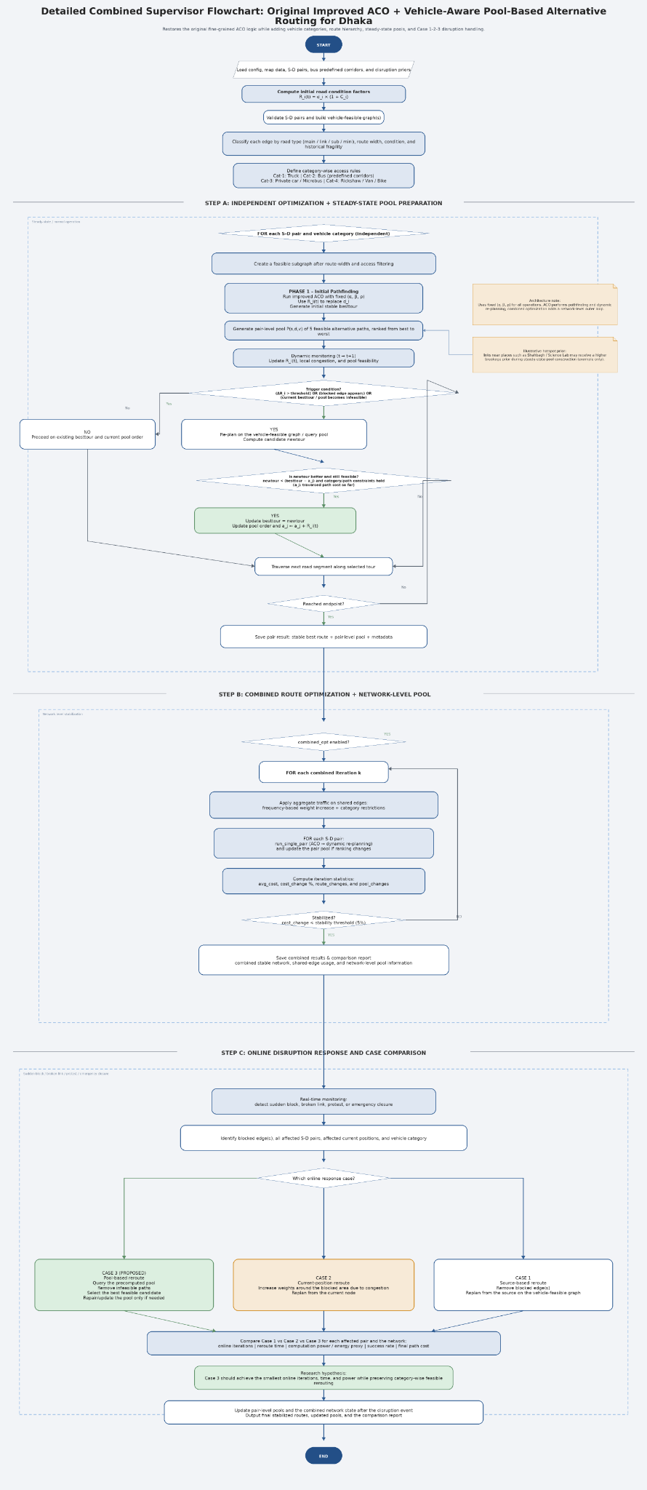
Figure 1. Detailed combined supervisor flowchart used as the authoritative process definition.

6. Required Data and Configuration Extensions
The revised Dhaka framework requires a richer edge schema and a more explicit set of configuration parameters. These additions are driven directly by the supervisor’s requirements and are necessary to enforce vehicle feasibility before routing decisions are accepted.
Field | Purpose
road_class | Stores whether an edge is a main route, link route, subroute, or mini route.
width_m | Stores route width so vehicle-category feasibility can be enforced.
road_condition | Stores edge condition and contributes to R_i(t).
category access flags | Store whether each vehicle category is permitted on the edge.
bus_corridor | Marks whether the edge belongs to a predefined bus corridor.
disruption_prior | Stores prior disruption probability or fragility for steady-state pool construction.

- Pool size should remain configurable, with 5 paths as the supervisor-directed default.
- Minimum width thresholds per vehicle category should remain configurable through the config file.
- Blocked-edge penalties and congestion multipliers should also remain configurable, not hard-coded.
- Illustrative fragile links such as Shahbagh or Science Lab should only be treated as high-risk examples if the data file explicitly encodes the disruption prior.

7. Planned Outputs and Experiment Process
The supervisor-directed version of the work is evaluated as a process plan rather than as a results document. The following output structure and experiment process are therefore framed as planned deliverables for controlled validation.
Planned Output | Purpose
pair_stable_routes.csv | Stores the stable route selected per source-destination pair and vehicle category.
pair_pools.json / pair_pools.csv | Stores the ranked pool of five alternatives per (s, d, v).
pair_metadata.csv | Stores metadata such as trigger counts, accepted reroutes, and category labels.
network_pool_analysis.txt | Summarises shared-edge usage and network-level pool behaviour.
case1_results.csv / case2_results.csv / case3_results.csv | Store the per-case rerouting outputs for comparison.
case_comparison_summary.csv | Aggregates online reroute metrics across all cases.
reroute logs | Provide detailed rerouting traces for Cases 1, 2, and 3.

7.1 Planned Experiment Process
- Evaluate all source-destination pairs across all relevant vehicle categories under steady-state conditions.
- Construct the pair-level pools and the combined network-level stable state before introducing disruptions.
- Define multiple disruption scenarios such as a blocked edge, a broken link, and a protest closure.
- For each disruption scenario, identify all affected pairs and run Cases 1, 2, and 3 independently.
- Record online reroute iterations, reroute time, CPU-time-based power proxy, reroute success, and final path cost.
- Aggregate the results for pair-level and network-level comparison while keeping reproducibility through fixed seeds and configuration-driven parameters.

8. Research Hypothesis and Next Steps
The supervisor-directed comparison does not assume a proven winner in advance. Instead, the proposed method is framed as a hypothesis that will be tested through controlled experiments across all relevant source-destination pairs, vehicle categories, and disruption scenarios.
Research hypothesis: the proposed Case 3 pool-based rerouting method is expected to reduce online rerouting iterations, reroute time, and computation-power proxy while preserving category-wise feasible rerouting. This remains a hypothesis to be validated experimentally and should not be presented as an already proven result.
- Keep the original improved ACO backbone intact, including the fine-grained Step A logic required by the supervisor flowchart.
- Use the local workspace first in Antigravity, and treat the GitHub path only as a reference when needed.
- Present the next supervisor update as a methodological plan with flowchart-aligned implementation status, not as a final results claim.

