Progress Report — Dynamic Path Planning in Congested Megacities (Improved ACO)
Sourav Debnath | Roll: 2007109 | Approach: PSO-ACO Hybrid vs Fixed Parameter ACO
Two ACO-based path planners compared on the same 10-node traffic network (17 S-D pairs, seed=42):
1.PSO-ACO Hybrid: PSO tunes α, β, ρ per S-D pair → ACO uses those optimized params.
2.Fixed ACO: ACO runs with static α=0.5, β=1.0, ρ=0.95 for all pairs.
Experimental Setup
Parameter | Value
Network Topology | 10 nodes, 31 directed edges
S-D Pairs Tested | 17 source-destination pairs
Random Seed | 42 (deterministic)
PSO Config | 30 particles, 100 iterations
ACO Config | 10 ants, 100 iterations
Dynamic Steps | 20 time steps
PSO Parameter Range | α∈[0.5,1.5] β∈[1,5] ρ∈[0.5,1]
Fixed Parameters | α=0.5 β=1.0 ρ=0.95
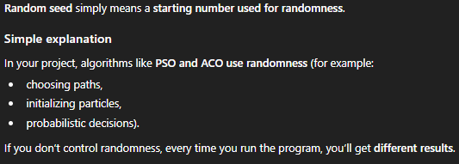
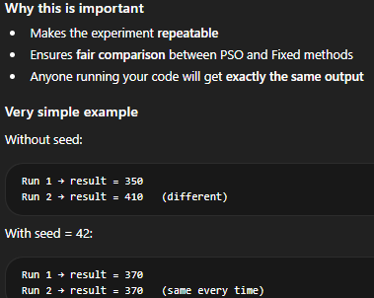

Per-Pair Cost Comparison
Green = PSO wins (lower cost)
Red = Fixed wins
Diff % from Fixed's perspective

# | Route | PSO Cost | Fixed Cost | Diff % | Winner
0 | 0→9 | 513.73 | 420.09 | -18.2% | FIXED
1 | 0→7 | 495.18 | 493.55 | -0.3% | FIXED
2 | 0→3 | 412.70 | 380.17 | -7.9% | FIXED
3 | 1→8 | 279.67 | 285.74 | +2.2% | PSO
4 | 1→9 | 318.58 | 347.56 | +9.1% | PSO
5 | 2→8 | 402.65 | 430.75 | +7% | PSO
6 | 2→9 | 278.32 | 317.28 | +14% | PSO
7 | 3→9 | 379.17 | 381.60 | +0.6% | PSO
8 | 4→7 | 367.17 | 368.14 | +0.3% | PSO
9 | 4→9 | 317.58 | 343.33 | +8.1% | PSO
10 | 5→9 | 211.40 | 213.75 | +1.1% | PSO
11 | 6→9 | 417.93 | 161.77 | -61.3% | FIXED
12 | 7→0 | 470.51 | 442.37 | -6% | FIXED
13 | 7→9 | 294.25 | 275.46 | -6.4% | FIXED
14 | 8→1 | 217.97 | 218.32 | +0.2% | PSO
15 | 9→0 | 358.89 | 363.13 | +1.2% | PSO
16 | 9→3 | 359.28 | 341.58 | -4.9% | FIXED
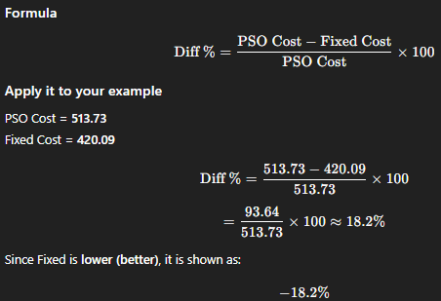

Summary Statistics
Metric | PSO-Optimized | Fixed (α=0.5, β=1.0, ρ=0.95)
Pairs Won (Lower Cost) | 10 / 17 (59%) | 7 / 17 (41%)
Avg Final Cost | 358.53 | 340.27
All 17 Pairs Reached? | YES | YES
Total Reroutes | 8 | 4
PSO-Tuned Parameters per S-D Pair
PSO adaptively selects different (α, β, ρ) for each route — key advantage over fixed params.

# | Route | α | β | ρ
0 | 0→9 | 0.5053 | 1.0488 | 0.7727
1 | 0→7 | 0.6549 | 3.4812 | 0.6930
2 | 0→3 | 0.7703 | 2.9438 | 0.9546
3 | 1→8 | 1.0493 | 2.5644 | 0.8317
4 | 1→9 | 1.3167 | 2.5101 | 0.6129
5 | 2→8 | 0.5611 | 4.5152 | 0.5002
6 | 2→9 | 0.5920 | 1.7387 | 0.5763
7 | 3→9 | 0.7821 | 3.5037 | 0.9466
8 | 4→7 | 1.4069 | 3.6633 | 0.5594
9 | 4→9 | 0.5636 | 3.7110 | 0.6919
10 | 5→9 | 1.4720 | 2.9413 | 0.9323
11 | 6→9 | 1.2552 | 3.4359 | 0.7667
12 | 7→0 | 1.3842 | 1.3797 | 0.7683
13 | 7→9 | 0.5870 | 2.3421 | 0.9448
14 | 8→1 | 0.6149 | 3.0247 | 0.5166
15 | 9→0 | 1.0268 | 4.5210 | 0.9729
16 | 9→3 | 0.9959 | 3.6937 | 0.7442

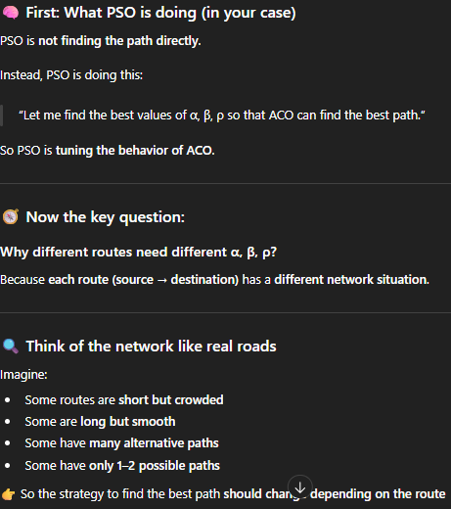
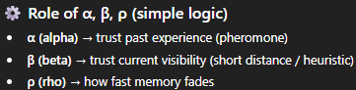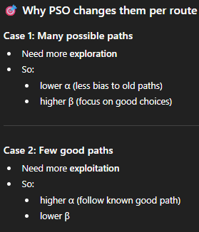
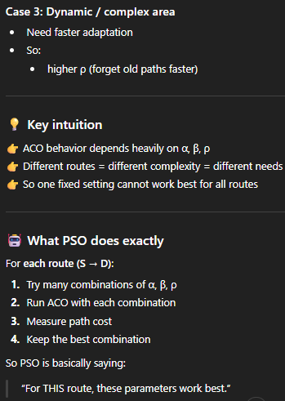
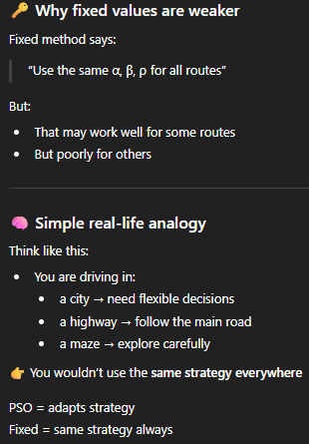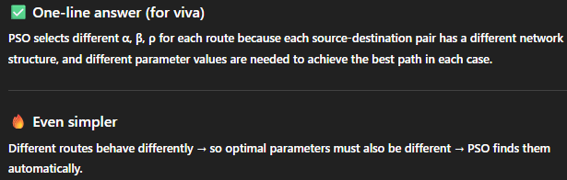

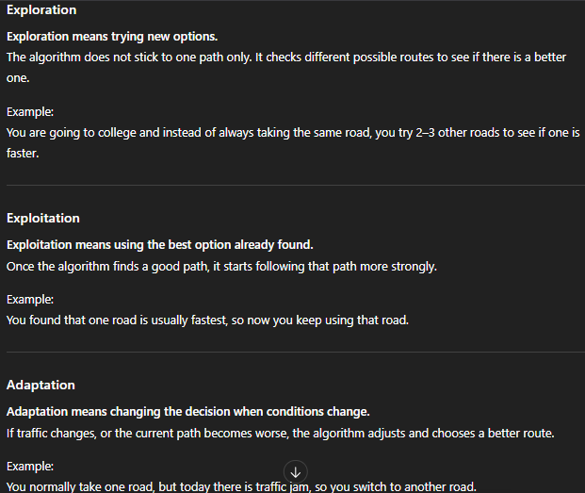

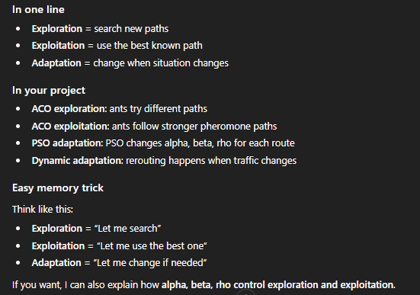
Network Graph — Node Connectivity
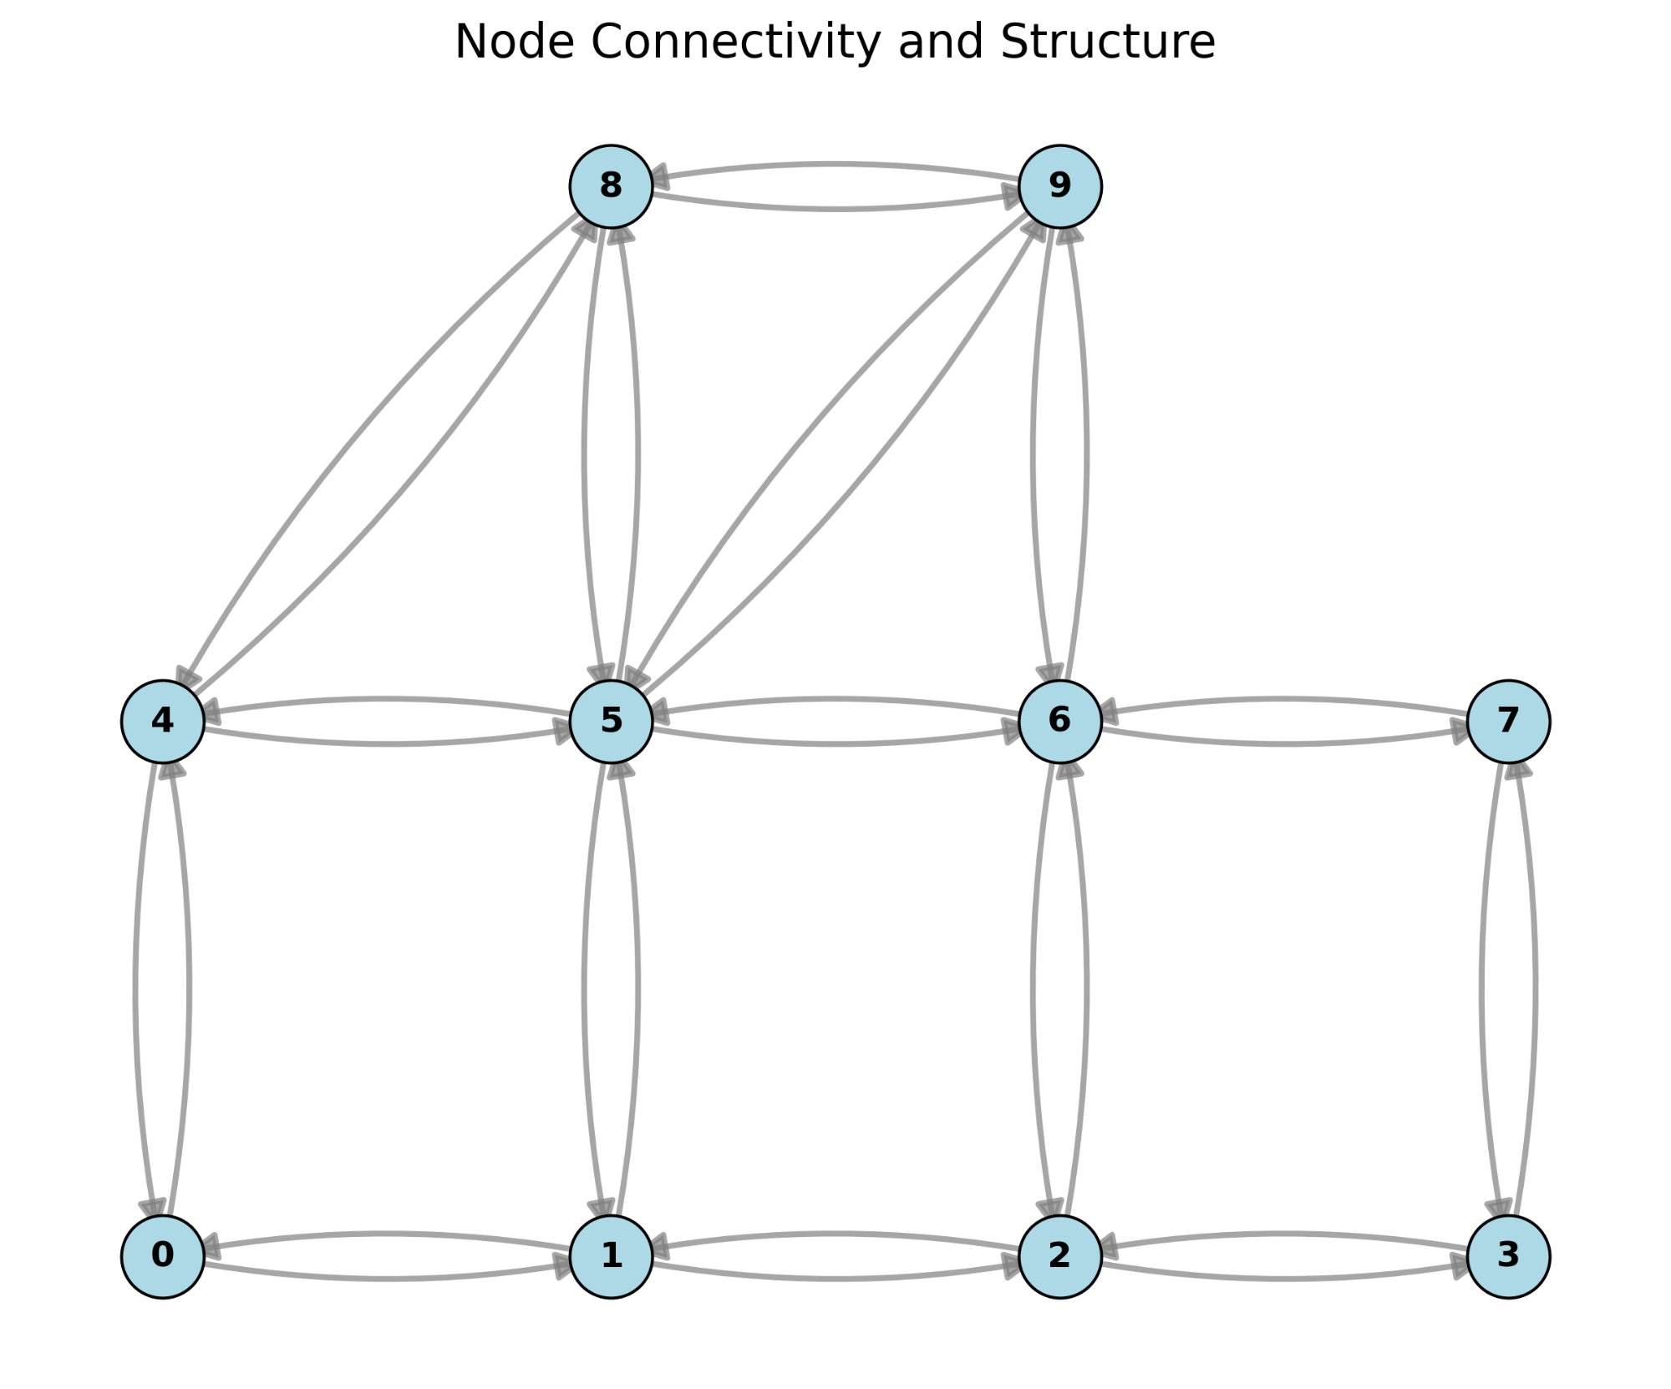
Key Findings
1.PSO wins 10 / 17 pairs (59%) with up to 14% cost reduction (pair 6: 2→9).
2.PSO adapts α, β, ρ per pair — fixed params cannot capture per-pair variability.
3.Fixed params (ρ=0.95) cause fast pheromone evaporation, reducing ACO learning efficiency.
4.Verdict: PSO-ACO hybrid outperforms fixed ACO for majority of S-D pairs.
Limitations / Things I Couldn't Do
1.Couldn't obtain the original dataset from the base paper.
2.Couldn't try route optimization methods other than PSO (e.g., GA, SA).
3.Couldn't explore other methods to tune (α, β, ρ) beyond PSO.

