#####################################

# Python Script: "**Project1.py**" #

#####################################

**Python Version:** 2.7

**Authors:** Sourav Samanta

Anudeep Reddy Gogulamudi

**Python Packages Used:** networkx (Version 1.10)

numpy

lpsolve55

pygraphviz

re

math

**Other Softwares:** graphviz-2.38

###########################################################

**Input Files:** 1. Any valid **.dot** format file is supported

Examples:

* hal.dot
* fir1.dot
* cosine1.dot
* cosine2.dot

2. Resource definition file

* rdf.txt

**Output Files:** 1. Formatted Output **.dot** files

* MLRC_ILP_FinalOutput.dot
* MLRC_ILP_FinalOutput_formatted.dot
* MRLC_ILP_FinalOutput.dot
* MRLC_ILP_FinalOutput_formatted.dot

2. Constraint files

* MLRC_ILP_Start_time_constraints.txt
* MLRC_ILP_Precedence_constraints.txt
* MLRC_ILP_Resource_constraints.txt
* MRLC_ILP_Start_time_constraints.txt
* MRLC _ILP_Precedence_constraints.txt
* MRLC _ILP_Resource_constraints.txt

3. Objective Function files

* MLRC_ILP_Objective_Function.txt
* MRLC_ILP_Objective_Function.txt

4. Other files

* ASAP.dot
* ALAP.dot
* Mobility.dot

##########################################################################

**Execution Steps:**

**1:** The Input .dot File and Resource definition file should be placed in the current directory

**2:** Choose options from Test Files or provide custom file in the User Interface

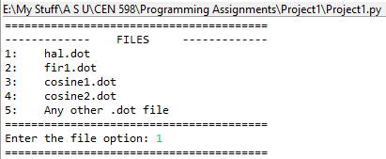

**3:** Choose from any algorithms

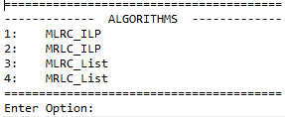

IF Option is 1 THEN algorithm is “**MLRC_ILP**” GOTO Step-4.1

ELSE IF Option is 2 THEN algorithm is “**MRLC_ILP**” GOTO Step-4.2

ELSE IF Option is 3 THEN algorithm is “**MLRC_List**” GOTO Step-4.3

ELSE Option is 4 THEN algorithm is “**MRLC_List**” GOTO Step-4.4

**4.1: MLRC_ILP**

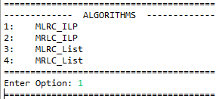

**a.** Displays a Summary of Information

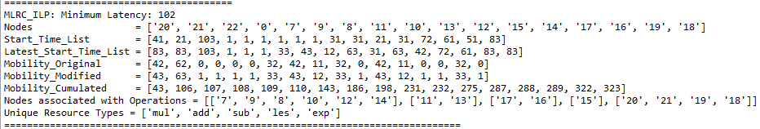

**b.** Enter the number of instances of various Resources

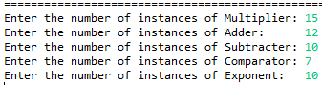

**c.** Displays the results of LP Solver

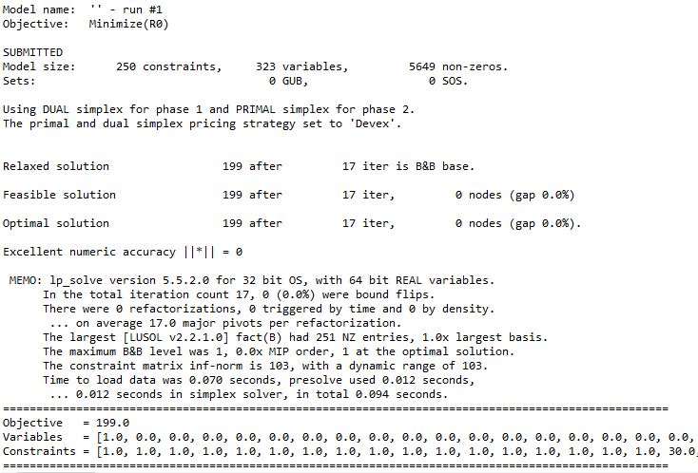

**d.** The following files are created:

The coefficients of *Start Time Constraints* are written into “***MLRC_ILP_Start_time_constraints.txt***”

The coefficients of *Precedence Constraints* are written into “***MLRC_ILP_Precedence_constraints.txt***”

The coefficients of *Resource Constraints* are written into “***MLRC_ILP_Resource_constraints.txt***”

The coefficients of *Objective Function* are written into “***MLRC_ILP_Objective_Function.txt***”

The final computed .dot file is written into “***MLRC_ILP_FinalOutput.dot***” and the formatted version is written into “***MLRC_ILP_FinalOutput_formatted.dot***”

**e.** The Output of the algorithm is displayed in the console:



**4.2: MRLC_ILP**

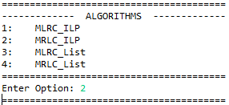

**a.** Displays a Summary of Information

**b.** Enter the Upper bound on the latency



**c.** Displays a Summary of Information

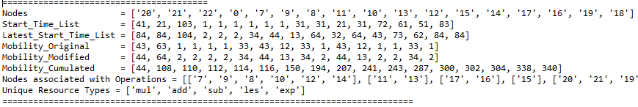

**d.** The following files are created:

The coefficients of *Start Time Constraints* are written into “***MRLC_ILP_Start_time_constraints.txt***”

The coefficients of *Precedence Constraints* are written into “***MRLC_ILP_Precedence_constraints.txt***”

The coefficients of *Resource Constraints* are written into “***MRLC_ILP_Resource_constraints.txt***”

The coefficients of *Objective Function* are written into “***MRLC_ILP_Objective_Function.txt***”

The final computed .dot file is written into “***MRLC _ILP_FinalOutput.dot***” and the formatted version is written into “***MRLC_ILP_FinalOutput_formatted.dot***”

**e.** LP Solver in progress

**f.** The Output of the algorithm is displayed in the console:

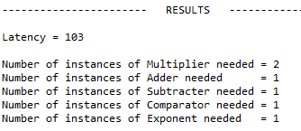

MRLC_ILP algorithm provides the minimum number of resources under a given latency.

**4.3: MLRC_List**

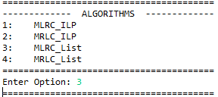

**a.** Displays a Summary of Information



**b.** Enter the number of instances of various Resources

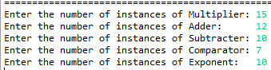

**c.** Displays the algorithmic computation with respect to each time step:

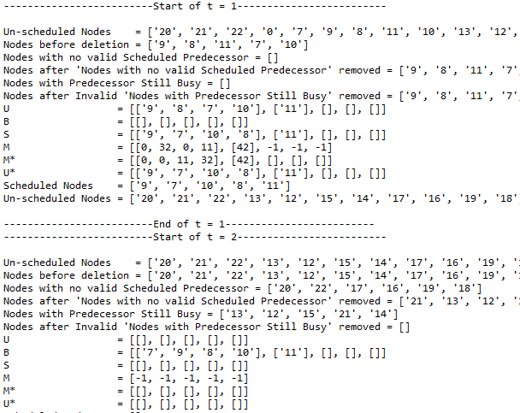

**d.** The Output of the algorithm is displayed in the console:

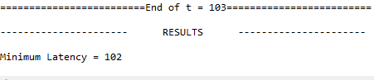

**e.** The following files are created:

The final computed .dot file is written into “***MLRC_List_FinalOutput.dot***” and the formatted version is written into “***MLRC_List_FinalOutput_formatted.dot***”

**4.4: MRLC_List**

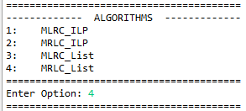

**a.** Enter the Upper bound on the latency



**b.** Displays the algorithmic computation with respect to each time step:

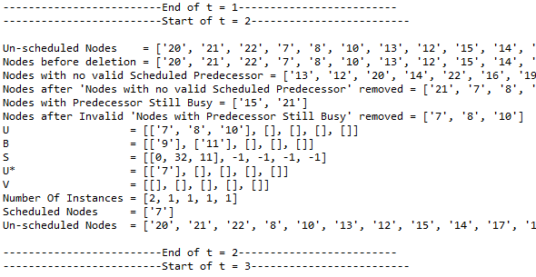

**c.** The Output of the algorithm is displayed in the console:

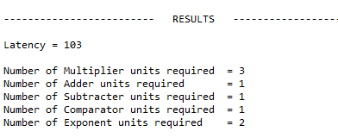

**d.** The following files are created:

The final computed .dot file is written into “***MRLC_List_FinalOutput.dot***” and the formatted version is written into “***MRLC_List_FinalOutput_formatted.dot***”

Sample Graph: The 1st number indicates the node number. 2nd indicates the operation. 3rd is time step along with mobility range.

