

**BHARATI VIDYAPEETH’S**

**INSTITUTE OF COMPUTER APPLICATIONS & MANAGEMENT**

(Affiliated to Guru Gobind Singh Indraprastha University, Approved by AICTE, New Delhi)

**Multimedia Technologies**

**(MCA-233)**

**Practical File**

**Submitted To: Submitted By:**

Dr. Saumya Bansal SOURAV GUSAIN (03511604422)

(Assistant Professor) MCA 3rd Sem, Sec 1

**INDEX**

|  |  |
| --- | --- |
| **S. No.** | **Problem Description** |
| **1** | Make a Pencil Model using Blender |
| **2** | Make a Sofa Model using Blender |
| **3** | Make a Smiley Model using Blender |
| **4** | Make a Candle Model using Blender |
| **5** | Create an animation of a bouncing ball using Blender |
| **6** | Create an animation of sliding wooden log making another small wooden block slide and eventually fall out of the platform |
| **7** | Create an animation of an arrow embedded into a circle revolving around its centre. |
| **8** | Create a model of a hammer. After modelling, add material and texture to it. |
| **9** | Create a model of lamp and render it. |

**Make a Pencil Model using Blender**

1. After initializing Layout window, click on ADD > MESH > CYLINDER in the sub-ribbon at topleft.
2. Edit the dimensions of the Cylinder in the ADD CYLINDER window at bottom-left
   1. VECTICES: 6
   2. RADIUS: 3.5 mm
   3. DEPTH: 7.5 in
3. ADD > MESH > CONE in the sub-ribbon at top-left
4. Roughly keep the CONE larger than the CYLINDER
5. Select the created CYLINDER and select MODIFIER PROPERTIES from the bottom-right panel with a Blue Wrench icon.

ADD MODIFIER > BOOLEAN

* 1. DIFFERENCE
  2. In Object, select the CONE

1. Select the created CONE and similarly

ADD MODIFIER > SOLIDIFY

* 1. Tune the THICKNESS slider until the inner CONE starts to ‘Sharpen’ the ‘Pencil’
  2. Use the OFFSET slider to fine tune the total length of the ‘Pencil’

1. Go back to the CYLINDER’S MODIFIER PROPERTIES, click drop down beside the BOOLEAN modifier and click APPLY
2. Delete the CONE from the Scene Collection in the up-right panel
3. Select the ‘Pencil’ and press TAB to enter the EDIT mode.
4. Select BISECT Tool and make a cut on the top of the cone of the ‘Pencil’ to create a division between the Wood and the Lead, adjust the cut to better represent the Lead.
5. In Edit mode and Wireframe view, select the different sections of the ‘Pencil’ and assign them a particular color from MATERIAL PROPERTIES > ‘+’ (To add a new material) > BASE COLOR
6. WINDOW > SAVE SCREENSHOT (EDITOR), Save image.

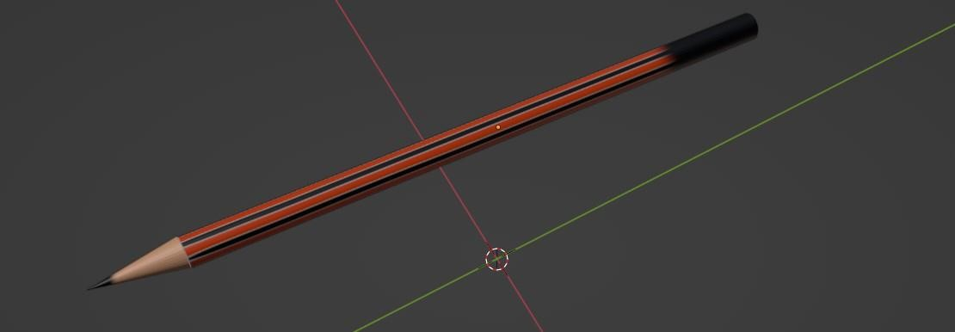

# Make a Sofa Model using Blender

**Steps:**

1. After initializing Layout window, click on ADD > MESH > UV SPHERE in the subribbon at top-left
2. Edit the dimensions of the CUBE in the ADD CUBE window at bottom-left
3. Select the SPHERE and press S > SHIFT + Z which transforms the SPHERE in X and Y axes, and make it elongated.
4. ADD > MESH > CUBE in the sub-ribbon at top-left
5. Roughly keep the CUBE larger than the elongated CUBE
6. Select the created elongated SPHERE and select MODIFIER PROPERTIES from the bottom-right panel with a Blue Wrench icon.

ADD MODIFIER > BOOLEAN

* 1. DIFFERENCE
  2. In Object, select the CUBE

1. Select the created CUBE and similarly

ADD MODIFIER > SOLIDIFY

* 1. Tune the THICKNESS slider until the inner CUBE starts to ‘divide’ the ‘Sofa’
  2. Use the OFFSET slider to fine tune the total height of the ‘Sofa’

1. Go back to the elongated CUBE MODIFIER PROPERTIES, click drop down beside the BOOLEAN modifier and click APPLY to keep half of it.
2. Select the different sections of the ‘Sofa’ and assign them a particular color from MATERIAL PROPERTIES > ‘+’ (To add a new material) > BASE COLOR
3. Select the camera and RIGHT-CLICK > SET CAMERA ACTIVE
4. Open VIEW tab from the up-right edge of the Editor, click on LOCK > CAMERA TO VIEW.
5. Position the camera as per the desired angle and distance
6. Select from the ribbon at top-left RENDER > RENDER IMAGE, Save image. WINDOW > SAVE SCREENSHOT (EDITOR), Save image.

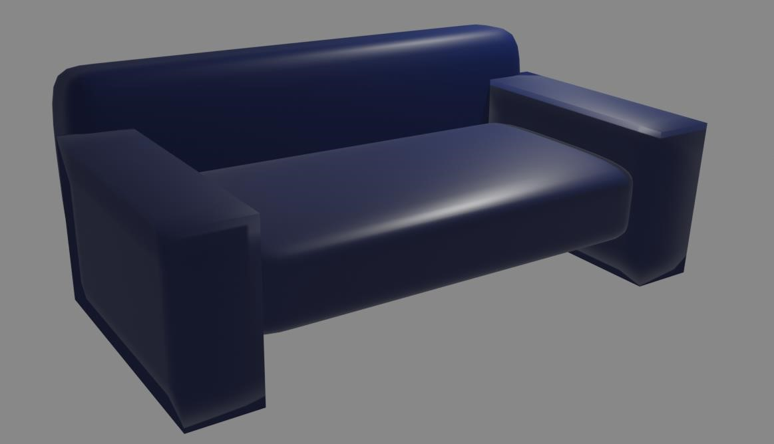

# Make a Smiley Model using Blender

1. After initializing Layout window, click on ADD > MESH > TORUS in the sub-ribbon at top-left or by pressing SHIFT-A
2. Edit the dimensions of the TORUS in the ADD TORUS window at bottom-left
   1. Major Radius: 1 m
   2. Minor Radius: 7 cm
3. ADD > MESH > TORUS from the sub-ribbon at top-left
   1. Major Radius: 75 cm
   2. Minor Radius: 7 cm
4. ADD > MESH > TORUS from the sub-ribbon at top-left
   1. Major Radius: 15 cm
   2. Minor Radius: 7 cm
5. In object view, RIGHT-CLICK on each Torus and Click on SHADE SMOOTH
6. ADD > MESH > CUBE in the sub-ribbon at top-left. Roughly keep the CUBE larger than the

TORUS

1. Select the created 2nd TORUS and select MODIFIER PROPERTIES from the bottom-right panel with a Blue Wrench icon.

ADD MODIFIER > BOOLEAN

* 1. DIFFERENCE
  2. In Object, select the CUBE

1. Select the created CUBE and similarly

ADD MODIFIER > SOLIDIFY

* 1. Tune the THICKNESS slider until the inner CUBE starts to ‘divide’ into a ‘Smile’
  2. Use the OFFSET slider to fine tune the total height of the ‘Smile’

1. Go back to the 2nd TORUS’S MODIFIER PROPERTIES, click drop down beside the BOOLEAN modifier and click APPLY to keep half of it.
2. Delete the CUBE from the Scene Collection in the up-right panel
3. Move the 2 small TORI in position of the ‘Eyes’ using the MOVE tool
4. Select the different sections of the ‘Smiley’ and assign them a particular color from MATERIAL PROPERTIES > ‘+’ (To add a new material) > BASE COLOR
5. Select the camera and RIGHT-CLICK > SET CAMERA ACTIVE
6. Open VIEW tab from the up-right edge of the Editor, click on LOCK > CAMERA TO VIEW.
7. Position the camera as per the desired angle and distance
8. Select from the ribbon at top-left RENDER > RENDER IMAGE, Save image. WINDOW > SAVE SCREENSHOT (EDITOR), Save image

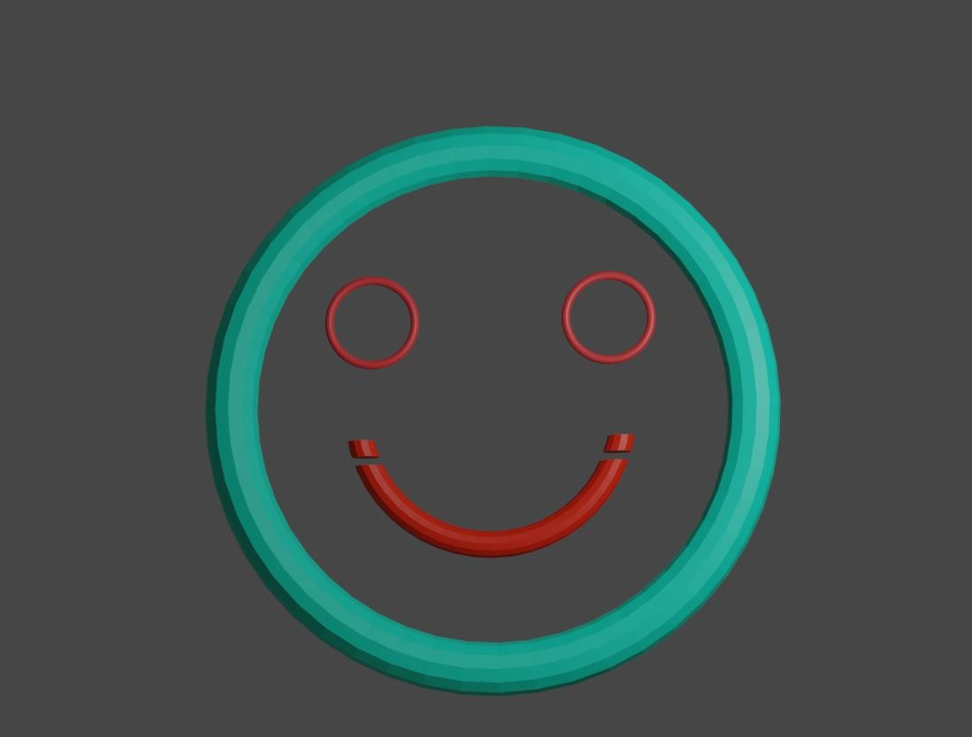

# Make a Candle Model using Blender

After initializing Layout window, click on ADD > MESH > CYLINDER in the sub-ribbon at topleft or by pressing SHIFT-A

1. Edit the dimensions of the CYLINDER in the ADD CYLINDER window at bottom-left a. Vertices: 200

The dimensions are up to you.

1. In Object Data Properties from the bottom-right panel with a Green Triangle icon, under

REMESH

* + 1. Mode: VOXEL
    2. Check Fix Poles, Volume. Uncheck call other
    3. Click REMESH repeatedly until no change is observed.

1. In object view, RIGHT-CLICK on the CYLINDER and Click on SHADE AUTO SMOOTH
2. Click the SCULPTING tab from the top ribbon, click the SCULPT mode
3. Use the CLAY STRIPS > SUBTRACT from the right panel under BRUSH SETTINGS
4. Flatten the top into a ‘Burning Candle’ that is with a ‘Valley’, mold a ‘Fault’ at one edge from where the ‘Wax’ is going to run down.
5. Use the BLOB and INFLATE brush to further make the edges prominent.
6. Run down 2-3 lines from the ‘Fault’ to show ‘Wax’ running down the walls.
7. Now for the ‘Base’, at the top-right of the editor click the drop down near ‘X Y Z’ a. Radial Z: 7
8. Use BLOB brush to make the Candle’s base
9. ADD > MESH > PLANE in the sub-ribbon at top-left. Roughly keep the PLANE under the

CYLINDER

1. Select the CYLINDER and select MODIFIER PROPERTIES from the bottom-right panel with a Blue Wrench icon.

ADD MODIFIER > BOOLEAN

* 1. DIFFERENCE
  2. In Object, select the PLANE

1. Select the created PLANE and similarly

ADD MODIFIER > SOLIDIFY

* 1. Tune the THICKNESS slider until the PLANE starts to ‘flatten’ the ‘Base’
  2. Use the OFFSET slider to fine tune the total height of the ‘Smile’

1. Go back to the CYLINDER’S MODIFIER PROPERTIES, click drop down beside the BOOLEAN modifier and click APPLY to keep half of it.
2. Delete the PLANE from the Scene Collection in the up-right panel
3. ADD > CURVE > BEZIER in the sub-ribbon at top-left. Roughly keep it in center of the

CYLINDER

1. Top-left ribbon, Click on EDIT > Preferences > ADD-ONS > Search for image as Planes > Uncheck and Check it
2. FILE > IMPORT > IMAGE AS PLANE to import your transparent ‘PNG’ of the ‘Flame’

Select the ‘Wick’ of the ‘Candle’ and assign it a Black color from MATERIAL PROPERTIES > ‘+’ (To add a new material) > BASE COLOR

1. Select the camera and RIGHT-CLICK > SET CAMERA ACTIVE
2. Open VIEW tab from the up-right edge of the Editor, click on LOCK > CAMERA TO VIEW.
3. Position the camera as per the desired angle and distance
4. Select from the ribbon at top-left RENDER > RENDER IMAGE, Save image.
5. WINDOW > SAVE SCREENSHOT (EDITOR), Save image.

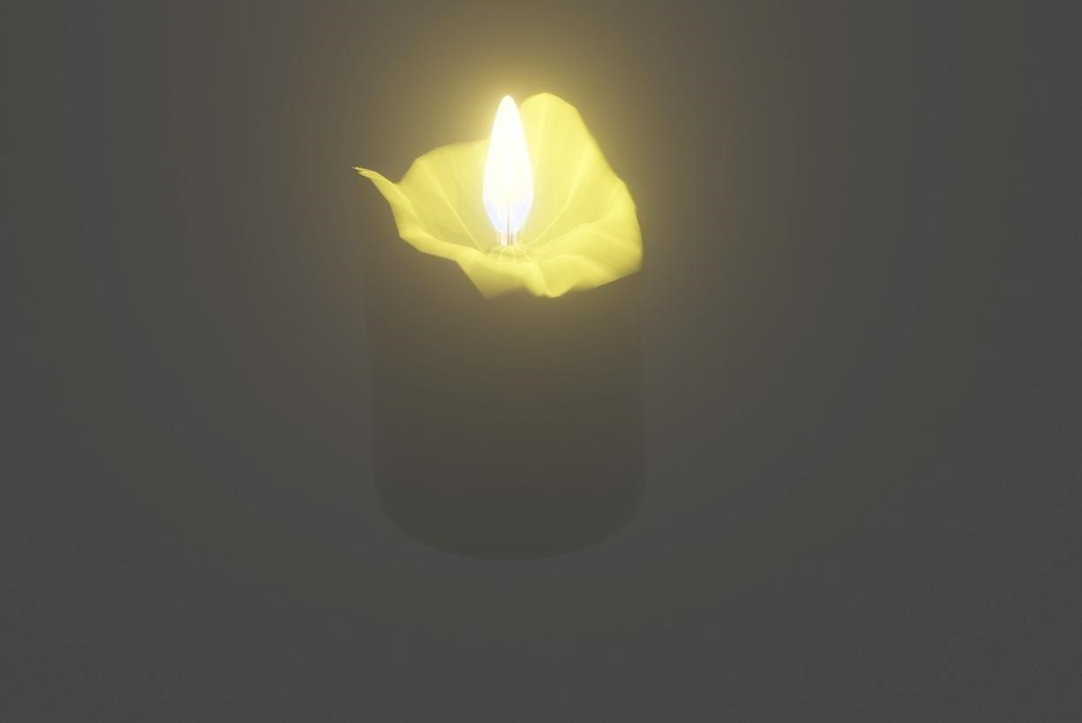

# Create an animation of a bouncing ball using Blender

**Steps:**

1. After initializing Layout window, click on ADD > MESH > PLANE in the sub-ribbon at topleft or by pressing SHIFT-A
2. Press S to resize the PLANE
3. In the PHYSICS PROPERTIES in the bottom-right panel with a blue planet orbit icon, click on COLLISION then under Softbody & Cloth
   1. Damping 0.1
   2. Thickness Outer 0.02
   3. Inner 0.2
   4. Friction 7
   5. Check ‘Single Sided’
4. ADD > MESH > UV SPHERE in the sub-ribbon at top-left. Roughly keep the SPHERE higher than the PLANE
5. In the PHYSICS PROPERTIES in the bottom-right panel with a blue planet orbit icon, click on Soft Body then under Cache
   1. Simulation Start 1
   2. End 250
   3. Cache Step 1
   4. Thickness Outer 0.02
   5. Bending 7
6. Select the SPHERE’S and select MODIFIER PROPERTIES from the bottom-right panel with a Blue Wrench icon.

ADD MODIFIER > SUBDIVISION SURFACE

* 1. LEVEL VIEWPORT 3
  2. RENDER 3
  3. Check OPTIMAL DISPLAY

1. Select the ‘Ball’ and the PLANE and assign them a particular color from MATERIAL PROPERTIES > ‘+’ (To add a new material) > BASE COLOR
2. Select the camera and RIGHT-CLICK > SET CAMERA ACTIVE
3. Open VIEW tab from the up-right edge of the Editor, click on LOCK > CAMERA TO VIEW.
4. Position the camera as per the desired angle and distance 11. Now, click BAKE.
5. Repeat this for another ball for maximum bounce.
6. Set the location of saving the video
7. Set output to FFmpeg
8. Select from the ribbon at top-left RENDER > RENDER ANIMATION

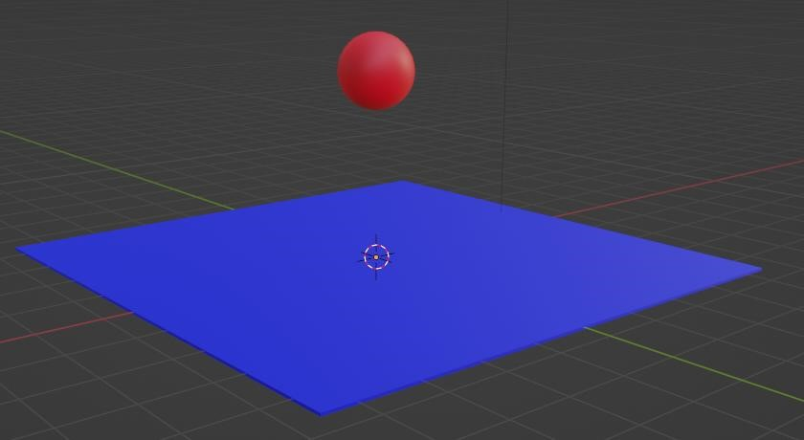

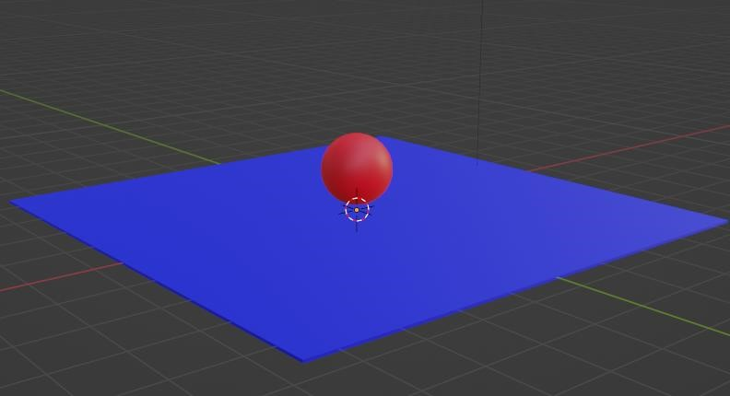

**Create an animation of sliding wooden log making another small wooden block slide and eventually fall out of the platform**

**Steps:**

1. After initializing Layout window, click on ADD > MESH > PLANE in the sub-ribbon at topleft or by pressing SHIFT-A
2. Press S to resize the PLANE
3. In the PHYSICS PROPERTIES in the bottom-right panel with a blue planet orbit icon, click on Rigid Body
   1. Type: Passive
4. ADD > MESH > CYLINDER in the sub-ribbon at top-left. Roughly keep the SPHERE higher than the PLANE
5. In the PHYSICS PROPERTIES in the bottom-right panel with a blue planet orbit icon, click on Rigid Body
   1. Type: Active
6. Copy and Paste these logs on top of each other.

Make one of them bigger with a greater Weight/Mass and higher than others.

1. Select the ‘Logs’ and the PLANE and assign them a particular color from MATERIAL PROPERTIES > ‘+’ (To add a new material) > BASE COLOR
2. Select the camera and RIGHT-CLICK > SET CAMERA ACTIVE
3. Open VIEW tab from the up-right edge of the Editor, click on LOCK > CAMERA TO VIEW.
4. Position the camera as per the desired angle and distance 11. Now, click BAKE.
5. Repeat this for another ball for maximum bounce.
6. Set the location of saving the video
7. Set output to FFmpeg
8. Select from the ribbon at top-left RENDER > RENDER ANIMATION

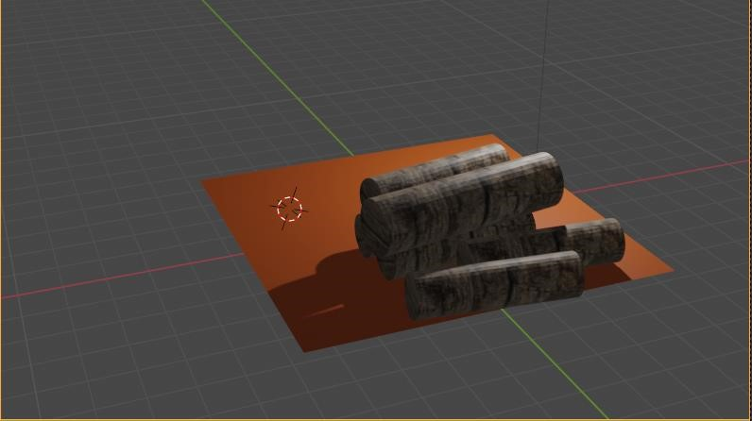

**Create an animation of an arrow embedded into a circle revolving**

**around its centre.**

**Steps:**

1. Start by creating a new project in Blender and entering into the 3D view. 2. Add a circle to the scene by going to "Add" > "Mesh" > "Circle"

1. Add an arrow by going to "Add" > "Mesh" > "Arrow".
2. Select the arrow and using the "Grab" tool move it until it is placed inside the circle.
3. Select the circle and using the "scale" tool, adjust the size of the circle and the arrow to your liking.
4. Now, select the circle and go to the "Object Modifiers" tab in the Properties window. Add a "Solidify" modifier and adjust the thickness of the circle as you wish.
5. Select the arrow and press "Shift+D" to duplicate it.
6. In the duplicated arrow go to the "Object Modifiers" tab in the Properties window and add a

"Shrinkwrap" modifier to make it conform to the shape of the Circle.

1. Next, go to the "Timeline" window, move the indicator to frame 0, and press "I" to insert a new keyframe. Move the indicator to the last frame of the animation and rotate the arrow around the Z-axis using the "Rotation" tool. Press "I" again to insert another keyframe.
2. Preview your animation by pressing the "Play" button on the Timeline, and adjust the rotation angle of the arrow as needed.
3. Finally, render the animation by going to "Render" > "Render Animation" or press "Ctrl+F12" and you can export

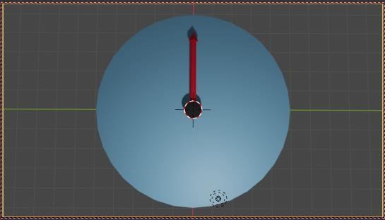

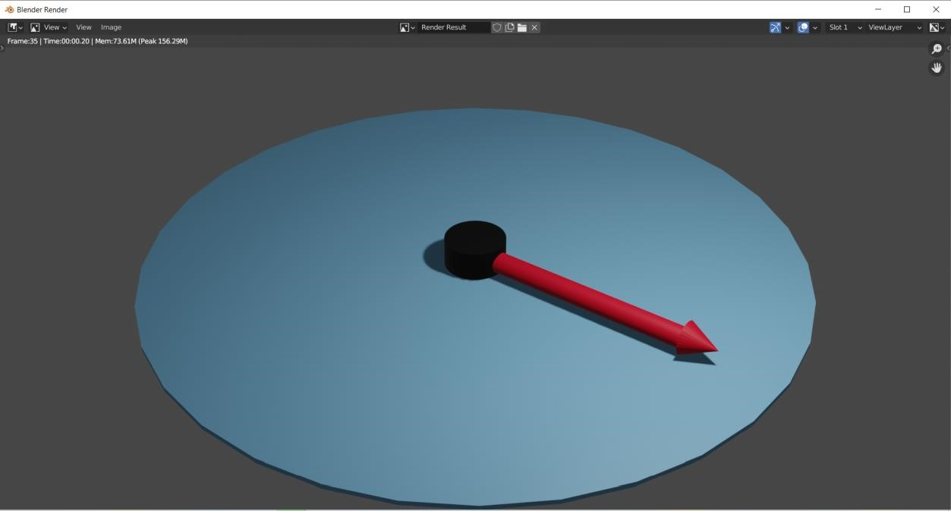

**Create a model of a hammer. After modelling, add material and texture to it**

**Steps:**

1. Start by creating a new project in Blender and entering into the 3D view.
2. Go to "Add" > "Mesh" > "Cube" to add a cube to the scene.
3. Use the "Grab" tool to adjust the shape of the cube to resemble the head of a hammer.
4. Add a cylinder by going to "Add" > "Mesh" > "Cylinder"
5. Position the cylinder at the top of the cube using the "Grab" tool and adjust its shape to resemble the handle of the hammer.
6. Go to the "Edit Mode" and select the top face of the cylinder and press "E" to extrude it to give the handle a thinner shape.
7. Next, go to the "Object Mode" and press "Shift+D" to duplicate the cylinder and position it at the bottom of the cube.
8. Scale down the duplicated cylinder and position it to resemble a metal ring that connects the head and handle of the hammer.
9. Go to "Material" settings in Properties window and add a new material, with the name of hammer.
10. Next, go to "Texture" settings, add an image as a texture and select the image for the material.
11. In the "Material" settings, adjust the settings such as color, roughness, and specularity to give the hammer a more realistic appearance.
12. Finally, use the "Lighting" and "Rendering" settings to illuminate and render your model to see the final result with texture.

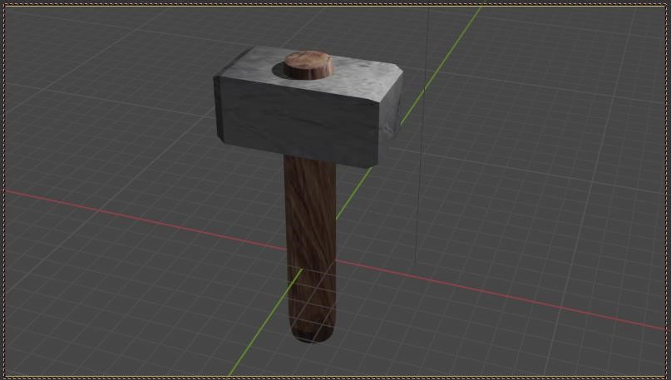

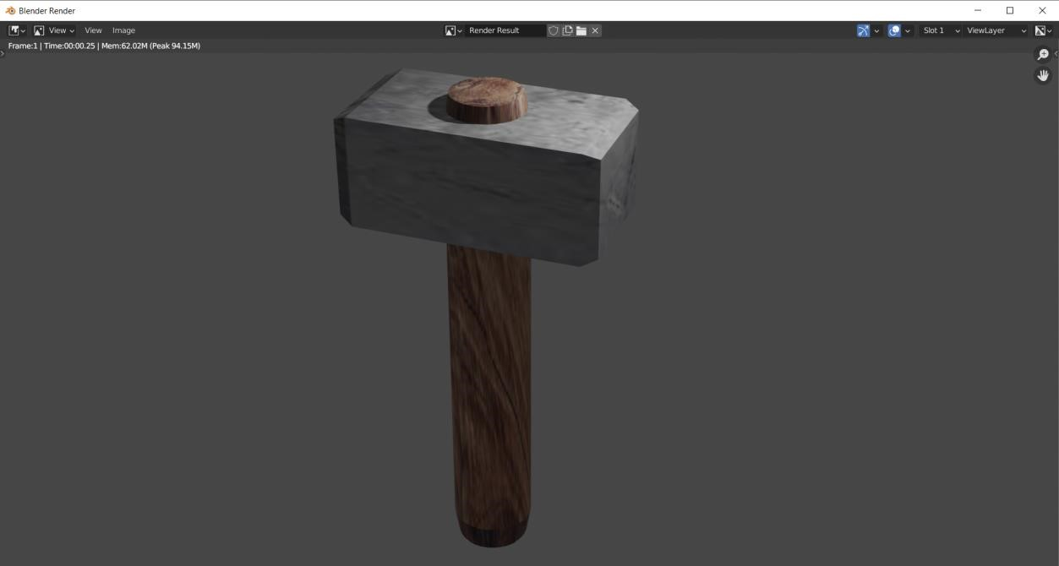

# Create a model of lamp and render it

**Steps:**

1. Start by creating a new project in Blender and entering into the 3D view.
2. Go to "Add" > "Mesh" > "Cube" to add a cube to the scene.
3. Use the "Grab" tool to adjust the shape of the cube to resemble the base of the lamp.
4. Add a cylinder by going to "Add" > "Mesh" > "Cylinder"
5. Position the cylinder at the top of the cube using the "Grab" tool and adjust its shape to resemble the lamp post.
6. Go to the "Edit Mode" and select the top face of the cylinder and press "E" to extrude it to give the post a thinner shape.
7. Next, go to the "Object Mode" and press "Shift+D" to duplicate the cylinder and position it at the top of the post.
8. Scale down the duplicated cylinder and position it to resemble the lampshade.
9. Add a point light by going to "Object" > "Light" > "Point Light"
10. Position the light inside the shade of the lamp to act as the bulb.
11. Go to the "Material" settings in the Properties window and add a new material to the lampshade and the base, you can set the color of the material to give the lamp the desired look.
12. Go to the "Render" settings, and change the settings as per your requirement
13. finally, render the image by pressing "F12" or by going to "Render" > "Render Image".

