Netflix Customer Churn Analysis
End-to-End Beginner Data Science Project
IBM Skills Build | 5,000 Customers | 4 ML Models | random_state=42
Metric | Value | Notes
Total Customers | 5,000 | Clean, no missing values
Overall Churn Rate | 50.3% | 2,515 churned | 2,485 stayed
Revenue at Risk / Month | $33,010 | From churned customers monthly fees
Best Model ROC-AUC | 0.9991 | Gradient Boosting (tuned)
Model Accuracy | 99.4% | Test set — no overfitting
High-Risk Customers | 608 | 12.2% of base — inactive 30d + low engagement

Step 1 — Problem Statement
Netflix needs to understand why customers cancel their subscriptions. As the subscriber base grows, even a 1% improvement in retention translates to millions in saved revenue. This project tackles the problem in three parts:
- Understand — Explore patterns in the data to find out WHY customers leave.
- Identify — Pinpoint high-risk segments like inactive or low-engagement users.
- Predict — Build an ML model so the team can act BEFORE a customer cancels.
Target variable: churned (1 = cancelled | 0 = still subscribed)

Step 2 — Data Understanding
The dataset contains 5,000 customer records with 14 features. There are no missing values and no duplicate rows. The target variable is near-perfectly balanced at 50.3% churned — ideal for machine learning without class imbalance techniques.

Column Dictionary
Column | Type | Description
customer_id | string | Unique customer identifier (removed from model)
age | int | Customer age (18-70)
gender | string | Male / Female / Other
subscription_type | string | Basic / Standard / Premium
watch_hours | float | Total hours watched
last_login_days | int | Days since last login
region | string | Africa, Asia, Europe, North America, Oceania, South America
device | string | TV / Mobile / Laptop / Desktop / Tablet
monthly_fee | float | $8.99 / $13.99 / $17.99 by plan
churned | int | TARGET: 1=churned, 0=stayed
payment_method | string | Credit Card, Debit Card, Gift Card, PayPal, Crypto
number_of_profiles | int | Number of user profiles (1-5)
avg_watch_time_per_day | float | Average daily watch hours (capped at 24)
favorite_genre | string | Action / Comedy / Drama / Horror / Romance / Sci-Fi / Documentary

Churn Distribution Chart
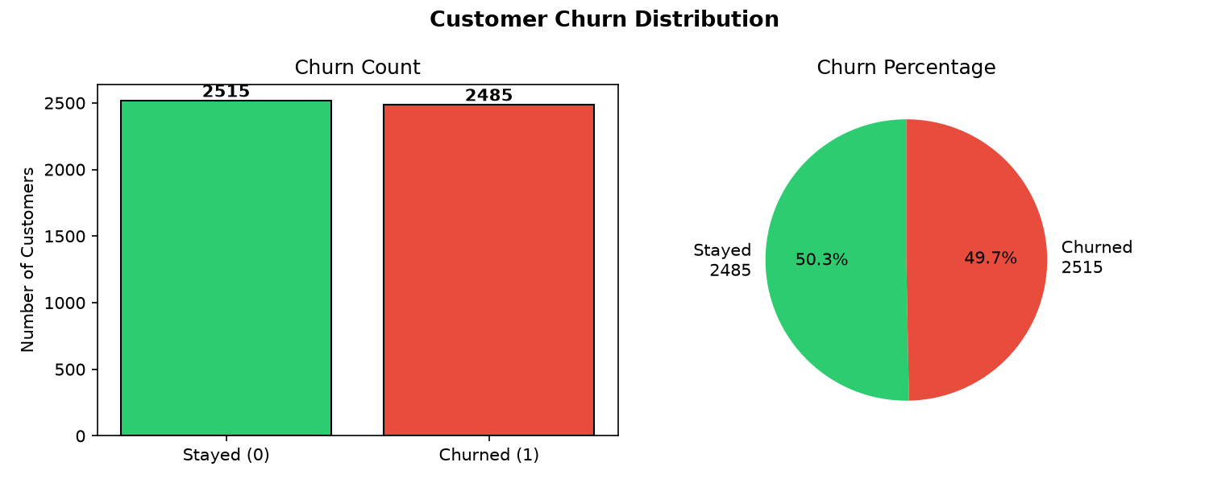
Figure 1 — Churn distribution: 50.3% churned (2,515) vs 49.7% stayed (2,485). Near-perfect balance.
Insight: The dataset is well-balanced — no over/under-sampling required for model training.

Step 3 — Data Cleaning
The following checks and corrections were applied to the raw data:
- customer_id removed from model features (kept as reference column).
- IQR outlier check on watch_hours (238 outliers) and avg_watch_time_per_day (549 outliers).
- 10 rows had avg_watch_time_per_day > 24 h — physically impossible. Capped at 24.0.
- monthly_fee cross-checked against subscription_type: 0 inconsistencies found.
- Cleaned data saved to data/netflix_churn_clean.csv.
Why cap at 24 hours? A day has exactly 24 hours. A value of 98.4 h is clearly a data error (possibly cumulative hours logged by mistake). Capping at 24 preserves the row while correcting the impossible value. With only 10 affected rows out of 5,000 (0.2%), this approach causes less data loss than dropping the rows entirely.
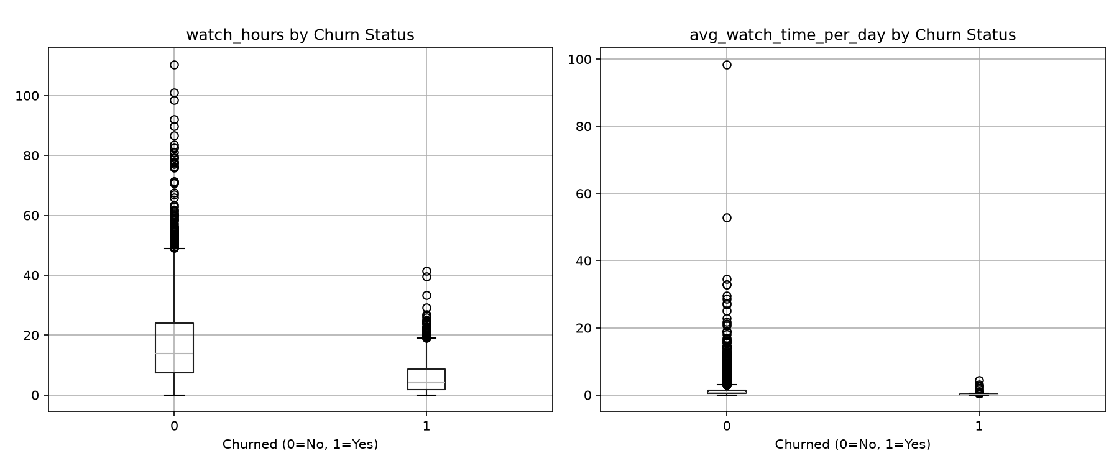
Figure 2 — Boxplots comparing watch_hours and avg_watch_time_per_day between churned and stayed customers.
Insight: Churned customers show slightly lower median watch hours. Both groups have outliers, but the difference is not extreme.

Step 4 — Exploratory Data Analysis (EDA)
We created 12 charts to understand how each feature relates to churn. The most important findings are shown below.

4.1 Churn by Subscription Type
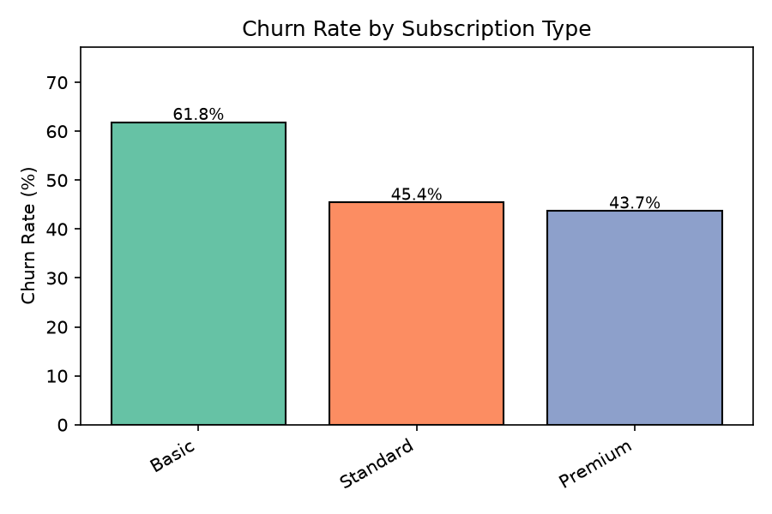
Figure 3 — Basic subscribers churn at 61.8%, vs 45.4% for Standard and 43.7% for Premium.
Insight: Basic plan subscribers churn 18 percentage points more than Premium. Price sensitivity is a major driver.

4.2 Churn by Payment Method
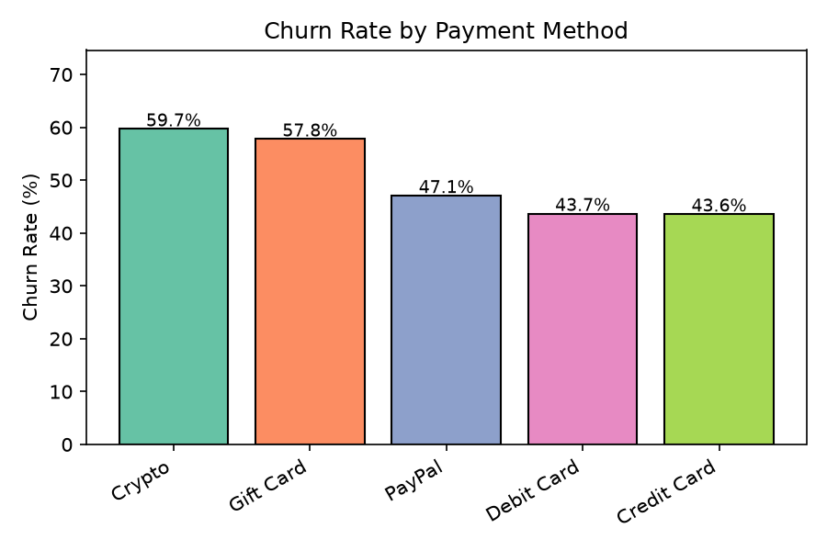
Figure 4 — Crypto users have the highest churn rate at 59.7%.
Insight: Crypto payment users churn at 59.7% — statistically significant (p<0.0001). They may be less committed users.

4.3 Churn by Region
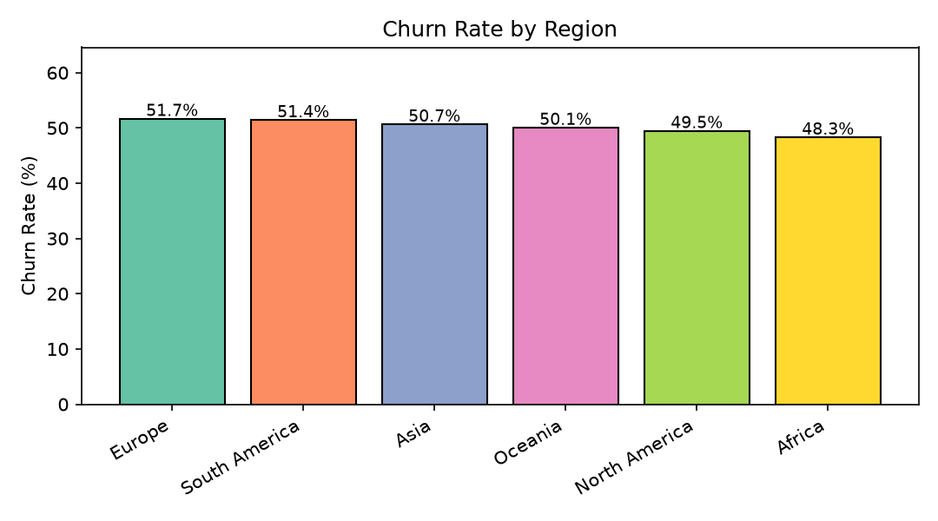
Figure 5 — Regional churn rates are similar, ranging from ~49% to ~52%.
Insight: Regional differences are NOT statistically significant (p=0.75). Geography alone does not drive churn.

4.4 Churn by Device
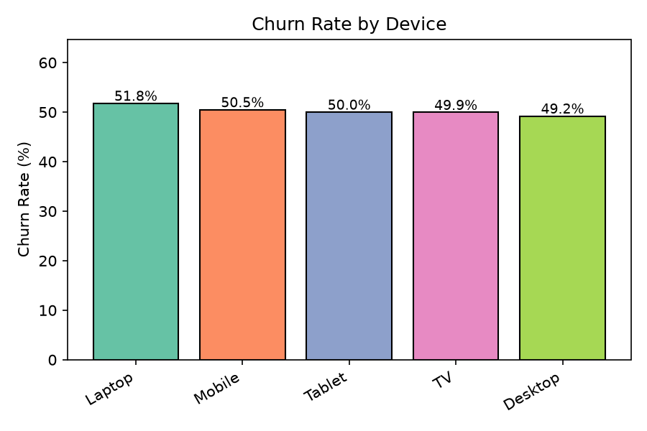
Figure 6 — Device type shows minimal churn differences across TV, Mobile, Laptop, Desktop, Tablet.
Insight: Device type is not a significant churn predictor (p=0.84). Users switch devices frequently.

4.5 Churn by Gender
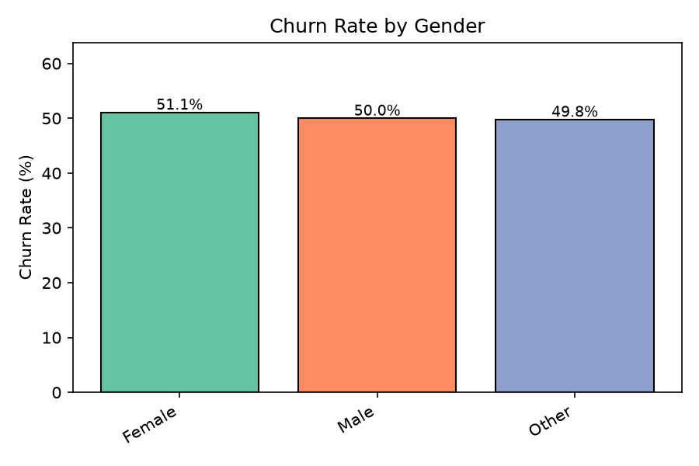
Figure 7 — Gender shows no meaningful churn difference (Male ~50%, Female ~51%, Other ~50%).
Insight: Gender is not statistically significant (p=0.72). Churn is a behavioural problem, not demographic.

4.6 Churn by Favorite Genre
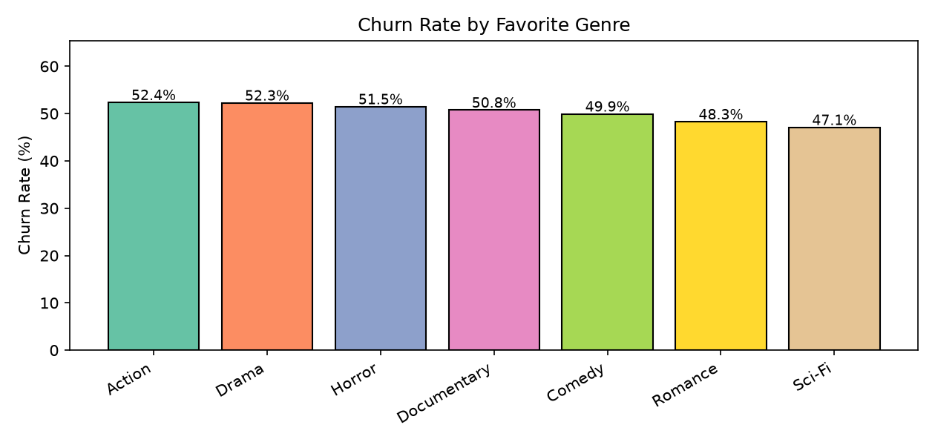
Figure 8 — All genres have similar churn rates (~49-52%). Action leads slightly at 52.4%.
Insight: Genre is not a significant predictor (p=0.32). Content type alone does not cause cancellation.

4.7 Churn by Days Since Last Login
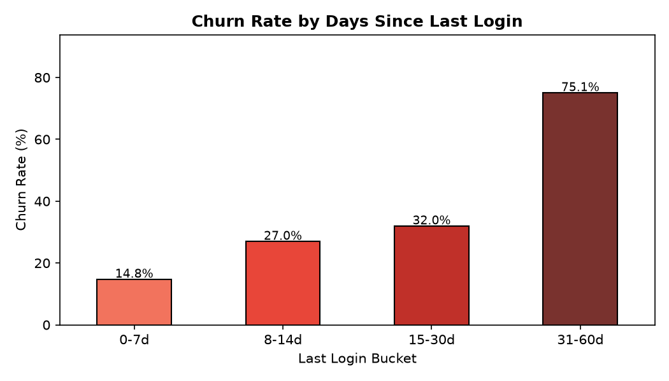
Figure 9 — Churn rises sharply with inactivity: 14.8% (0-7 days) to 75.1% (31-60 days).
Insight: MOST IMPORTANT SIGNAL: 31-60 day inactive users churn at 75.1% vs just 14.8% for recent logins. Act within 14 days of inactivity.

4.8 Churn by Age Group
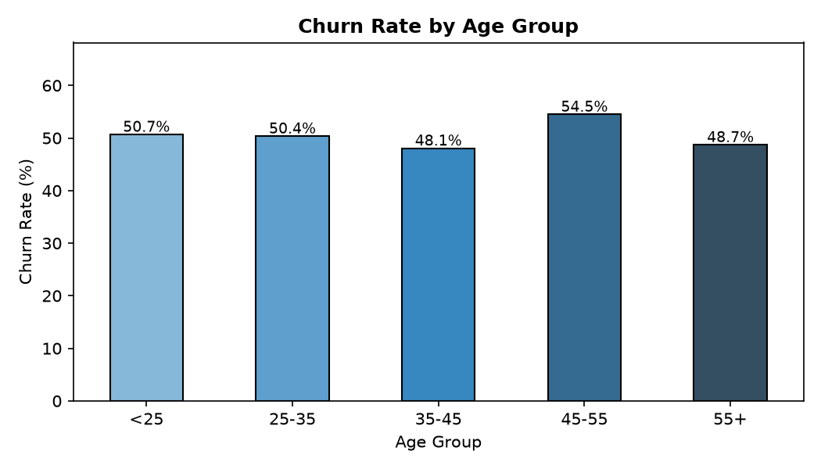
Figure 10 — The 45-55 age group has the highest churn rate at 54.5%.
Insight: Middle-aged customers (45-55) churn slightly more — may reflect switching to competitors or reduced digital engagement.

4.9 Numeric Feature Distributions by Churn
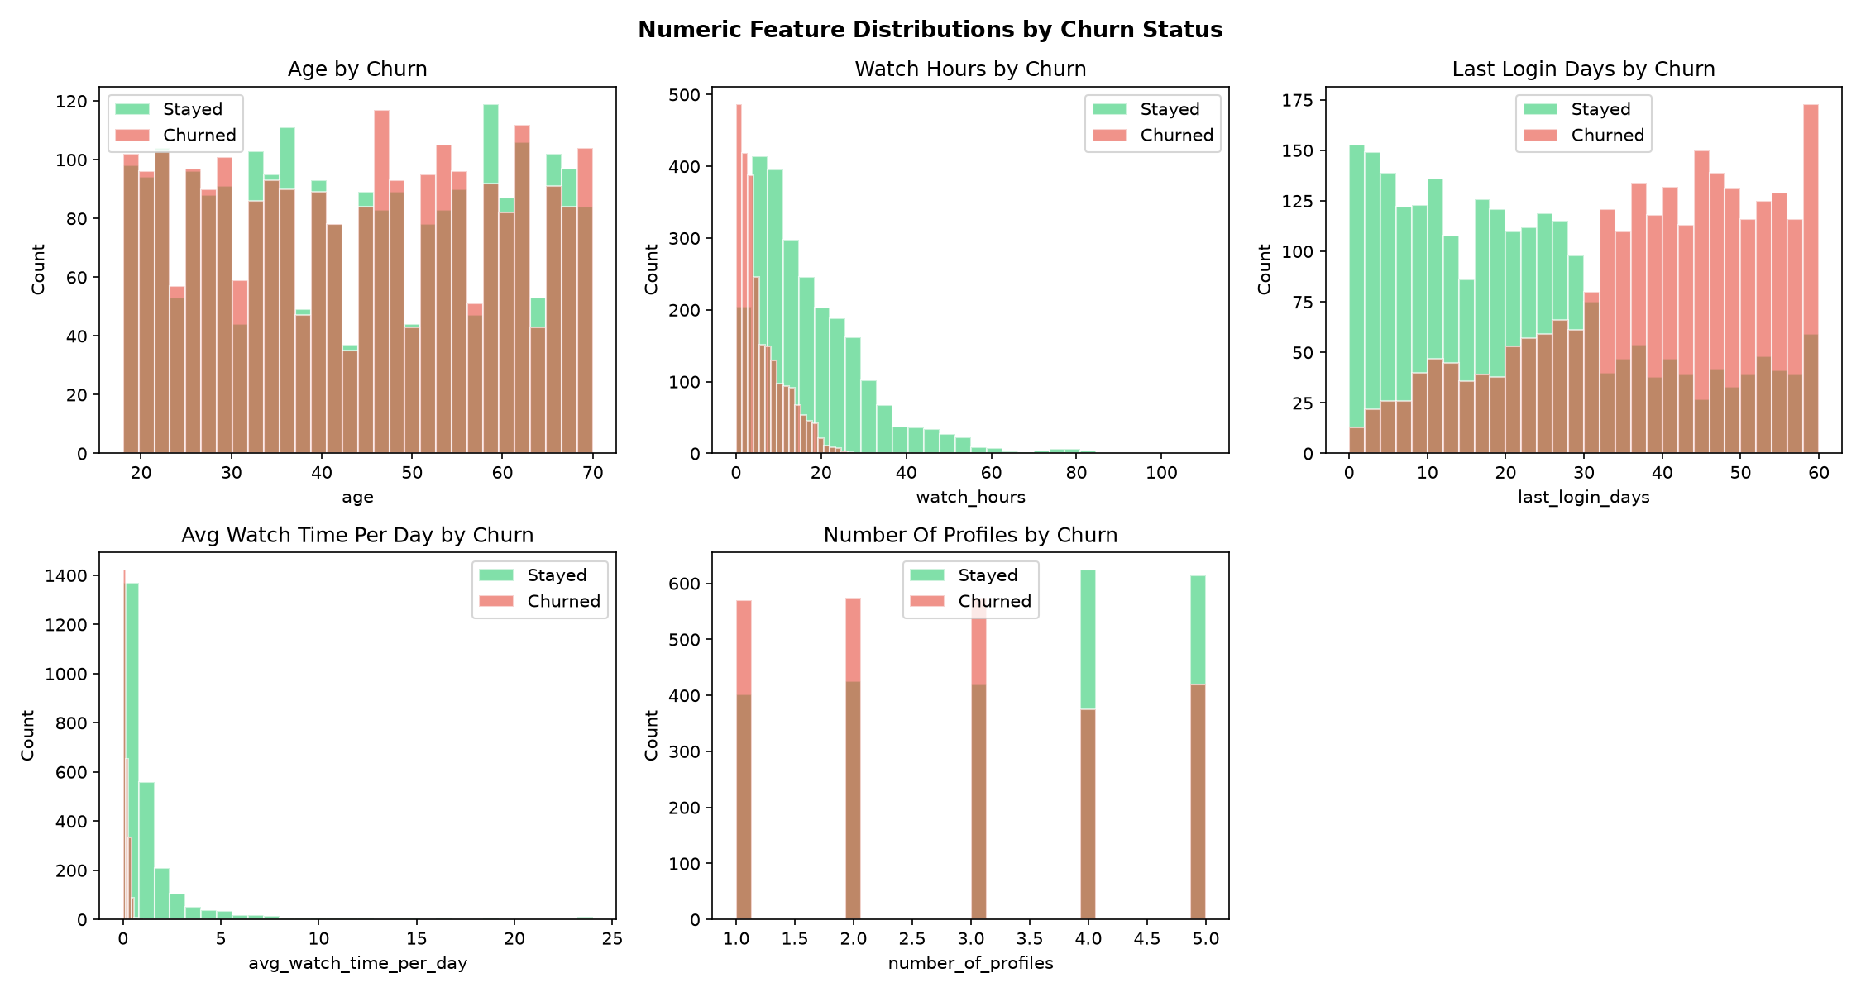
Figure 11 — Distribution of all numeric features split by churned (red) vs stayed (green).
Insight: Churned customers clearly have lower watch_hours and avg_watch_time_per_day — low engagement drives churn.

4.10 Correlation Heatmap
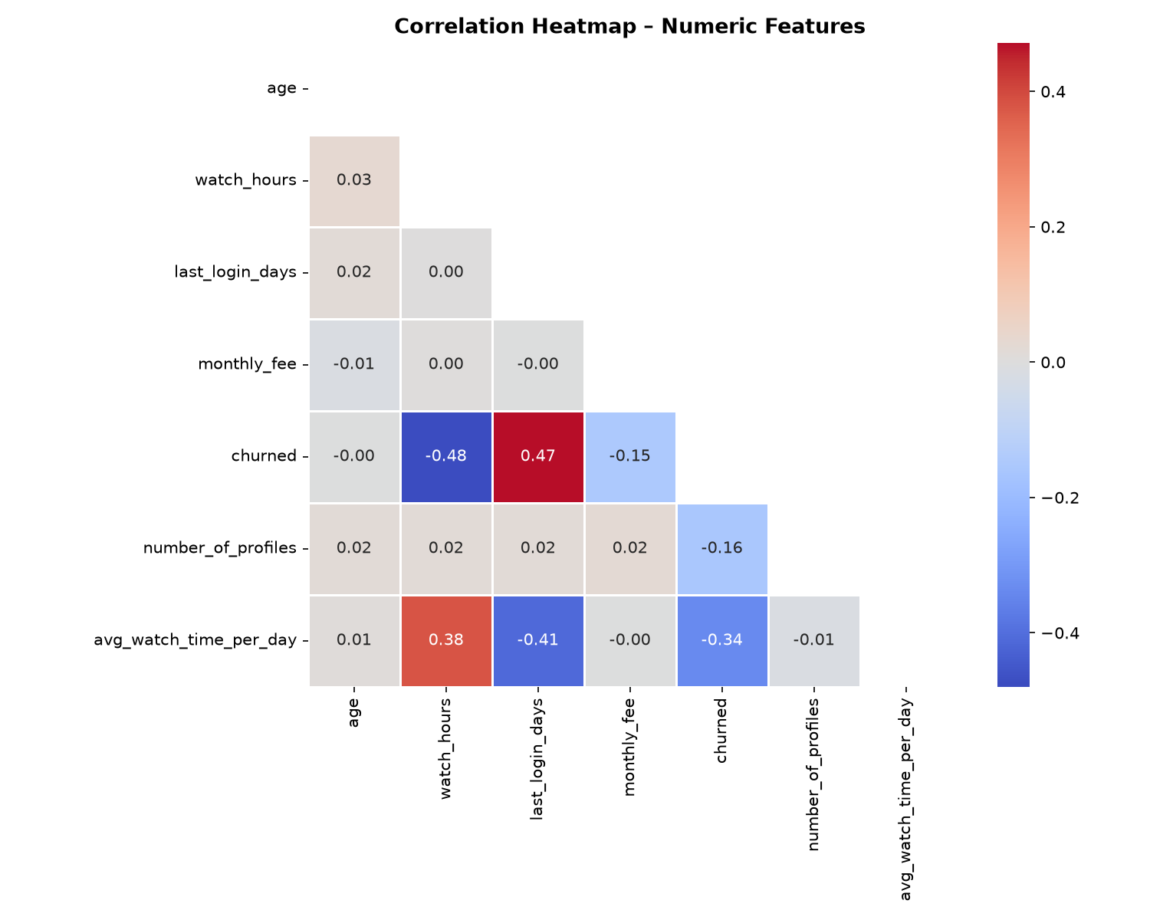
Figure 12 — Correlation matrix. No single feature strongly correlates with churn individually (<0.15).
Insight: The model learns from COMBINATIONS of features. This is why ML outperforms simple threshold rules.

Step 5 — Business Questions
Eight key business questions answered with real data, charts, and statistical tests.

Q1: Which subscription type has the highest churn rate?
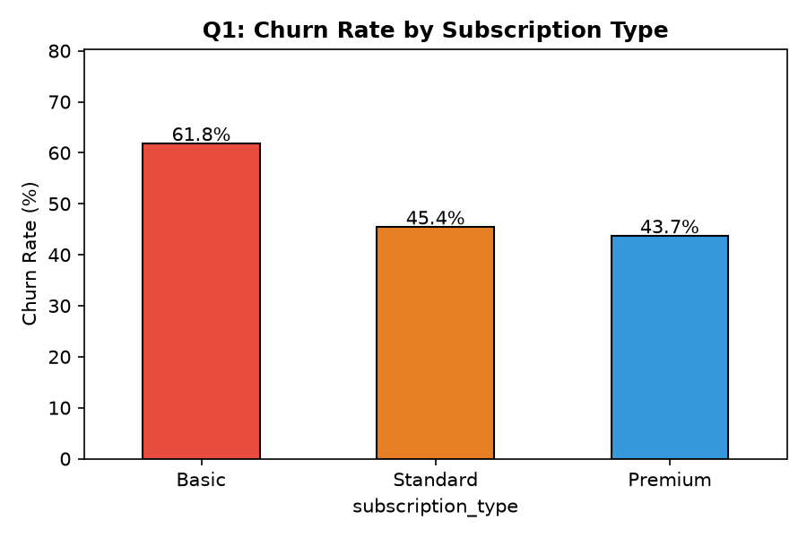
Figure 13 — Churn rate by subscription plan.
Answer: Basic plan at 61.8% — 18 pp above Premium (43.7%). Price-sensitive customers on the cheapest plan are most likely to cancel.
Chi-squared test: SIGNIFICANT (p<0.0001)

Q2: Do inactive users churn more?
Figure 14 — Churn rises sharply with days since last login.
Answer: YES — dramatically. 0-7 days inactive = 14.8% churn. 31-60 days inactive = 75.1% churn. Inactivity is the #1 early-warning signal.
T-test: SIGNIFICANT (p<0.0001)

Q3: Which region and device have the highest churn?
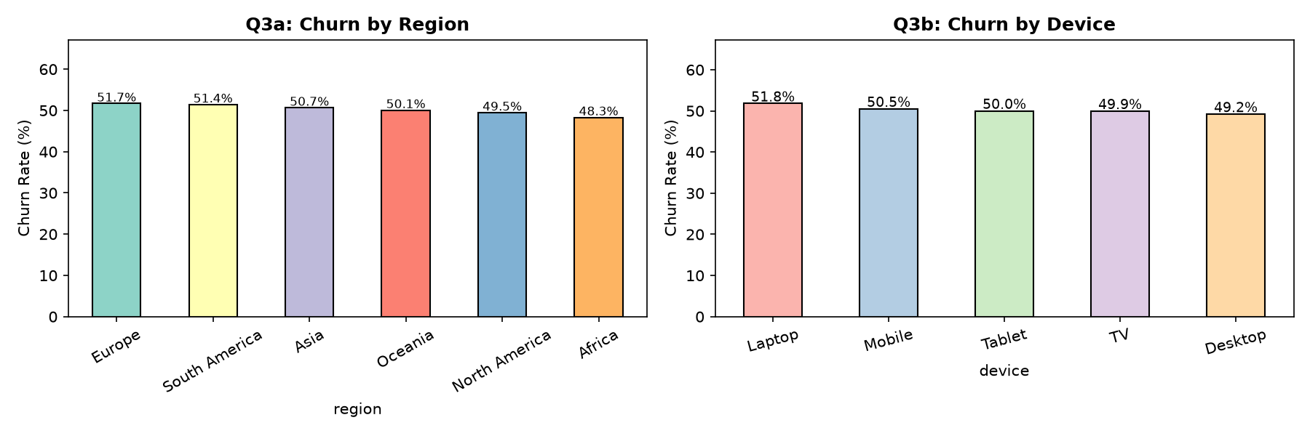
Figure 15 — Region: Europe leads at 51.7%. Device: Laptop leads at 51.8%.
Answer: Region: Europe (51.7%) | Device: Laptop (51.8%). Differences are NOT statistically significant — likely random variation.
Chi-squared: NOT significant (region p=0.75, device p=0.84)

Q4: Does payment method affect churn?
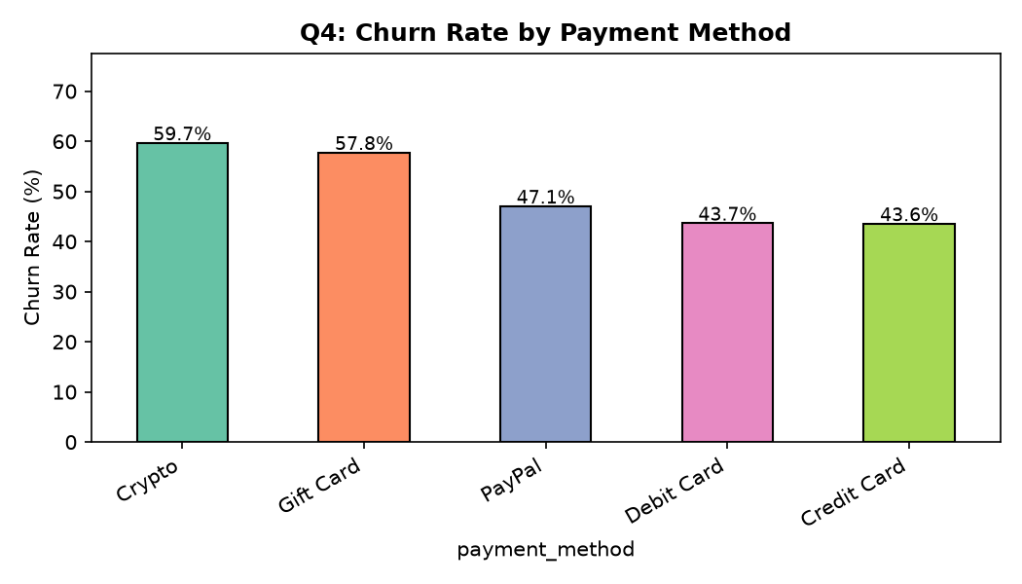
Figure 16 — Crypto users churn at 59.7%, nearly 10 pp above the 50.3% average.
Answer: Crypto payment users churn most at 59.7%. This IS statistically significant. They may be trialling Netflix or less financially committed.
Chi-squared: SIGNIFICANT (p<0.0001)

Q5: Do heavy watchers churn less?
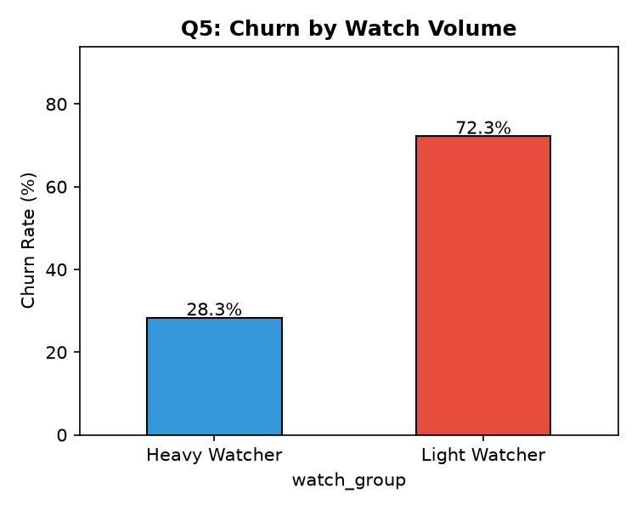
Figure 17 — Light watchers (<8h) churn at 72.3% vs 28.3% for heavy watchers.
Answer: YES — strongly. Engagement is the most actionable retention lever. Getting users hooked early is critical.
T-test: SIGNIFICANT (p<0.0001)

Q6: Which genres are linked to higher churn?
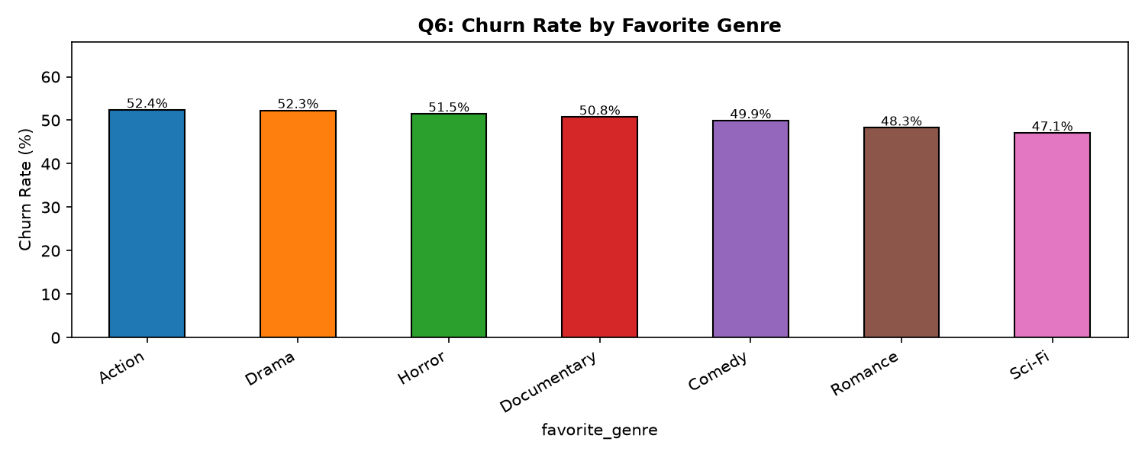
Figure 18 — Action fans churn slightly more at 52.4%, but all genres are close.
Answer: Action genre fans churn at 52.4% — slightly above average. Genre differences are NOT statistically significant (p=0.32).
Chi-squared: NOT significant (p=0.32)

Q7: Does number of profiles affect churn?
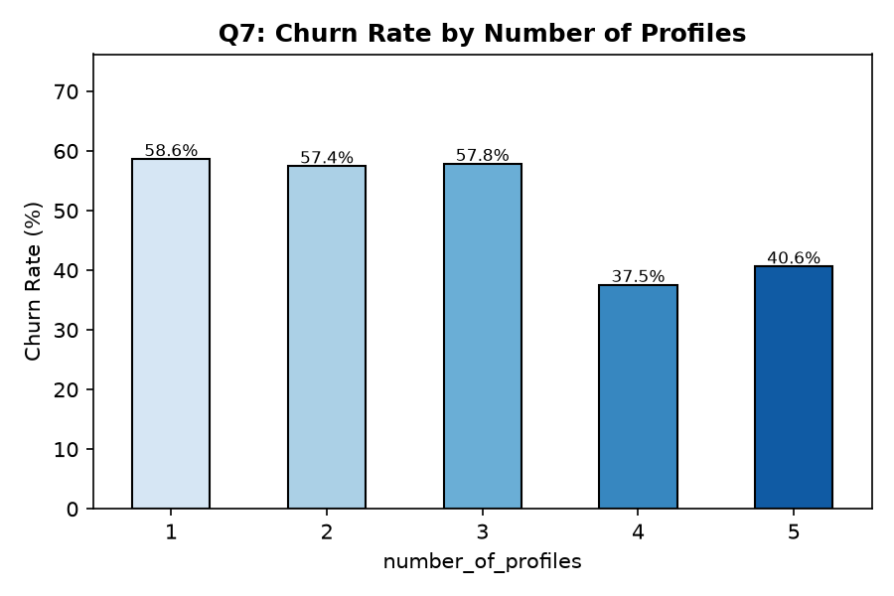
Figure 19 — Customers with 4-5 profiles churn far less (37-41%) than those with 1-3 (57-59%).
Answer: More profiles = more household members = stronger switching costs. Prompt users to add profiles!
T-test: SIGNIFICANT (p<0.0001)

Q8: Monthly revenue lost by subscription type?
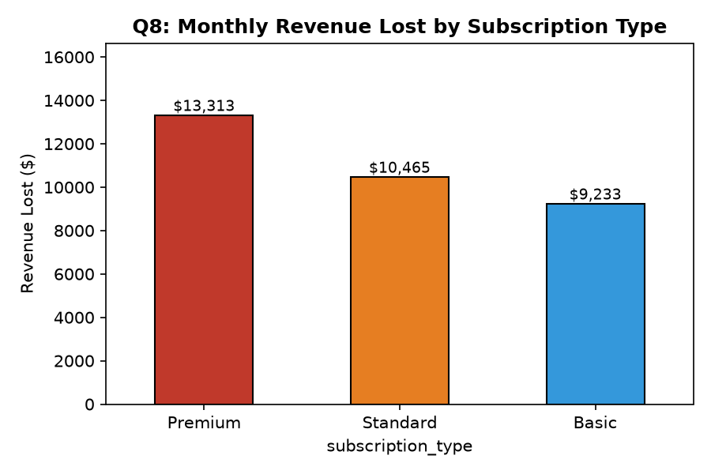
Figure 20 — Premium churners lose the most revenue per customer ($13,313/month).
Answer: Total at risk: $33,010/month. Retaining just 10% of churners saves $3,301/month (~$39,600/year).

Statistical Significance Summary
Chi-squared tests for categoricals; independent samples T-tests for numerics. p < 0.05 = significant.
Feature | Test | p-value | Significant?
subscription_type | Chi-squared | <0.0001 | YES
payment_method | Chi-squared | <0.0001 | YES
watch_hours | T-test | <0.0001 | YES
last_login_days | T-test | <0.0001 | YES
avg_watch_time_per_day | T-test | <0.0001 | YES
number_of_profiles | T-test | <0.0001 | YES
monthly_fee | T-test | <0.0001 | YES
gender | Chi-squared | 0.7225 | No
region | Chi-squared | 0.7531 | No
device | Chi-squared | 0.8362 | No
favorite_genre | Chi-squared | 0.3236 | No
age | T-test | 0.8037 | No

Step 6 — Feature Engineering
Raw features were supplemented with derived features capturing business patterns. All preprocessing was done inside a scikit-learn Pipeline to prevent data leakage.

New Features Created
Feature | Formula / Logic | Business Meaning
age_group | pd.cut(age, [0,25,35,45,55,100]) | Age segment: <25, 25-35, 35-45, 45-55, 55+
is_inactive_30d | last_login_days > 30 | Binary flag: 1 if not logged in for 30+ days
is_inactive_14d | last_login_days > 14 | Binary flag: 1 if not logged in for 14+ days
watch_per_fee | watch_hours / monthly_fee | Value-for-money ratio (hours watched per $ paid)
engagement_level | pd.cut(avg_watch_time_per_day, [0,1,3,24]) | Low / Medium / High daily engagement

Numeric columns (9 total) were StandardScaled and categorical columns (8 total) were OneHotEncoded inside a ColumnTransformer. The Pipeline ensures the scaler is only fit on training data, preventing data leakage.

Step 7 — Model Building
An 80/20 stratified train-test split was used (random_state=42). Train: 4,000 rows | Test: 1,000 rows. Both sets have ~50.3% churn rate.

5-Fold Cross-Validation Results (ROC-AUC)
Model | Mean AUC (CV) | Std Dev | Notes
Gradient Boosting | 0.9993 | ±0.0004 | BEST — selected for tuning
Random Forest | 0.9973 | ±0.0015 | 2nd best — also tuned
Logistic Regression | 0.9782 | ±0.0013 | Linear baseline
Decision Tree | 0.9742 | ±0.0069 | Most variance — prone to overfit

RandomizedSearchCV (20 iterations, 5-fold CV) was used to tune Gradient Boosting and Random Forest. Best Gradient Boosting params: n_estimators=200, max_depth=3, learning_rate=0.2 -> Tuned CV AUC = 0.9995.

Step 8 — Model Evaluation
Model | Accuracy | Precision | Recall | F1 | ROC-AUC | Overfit Delta
Gradient Boosting | 99.4% | 99.8% | 99.0% | 99.4% | 0.9991 | 0.006 (OK)
Random Forest | 98.3% | 98.8% | 97.8% | 98.3% | 0.9980 | 0.017 (OK)
Logistic Regression | 91.4% | 91.3% | 91.7% | 91.5% | 0.9775 | 0.005 (OK)
Decision Tree | 97.2% | 96.7% | 97.8% | 97.2% | 0.9720 | 0.028 (OK)

Overfit Delta = Train Accuracy minus Test Accuracy. All values below 0.05 — no overfitting.
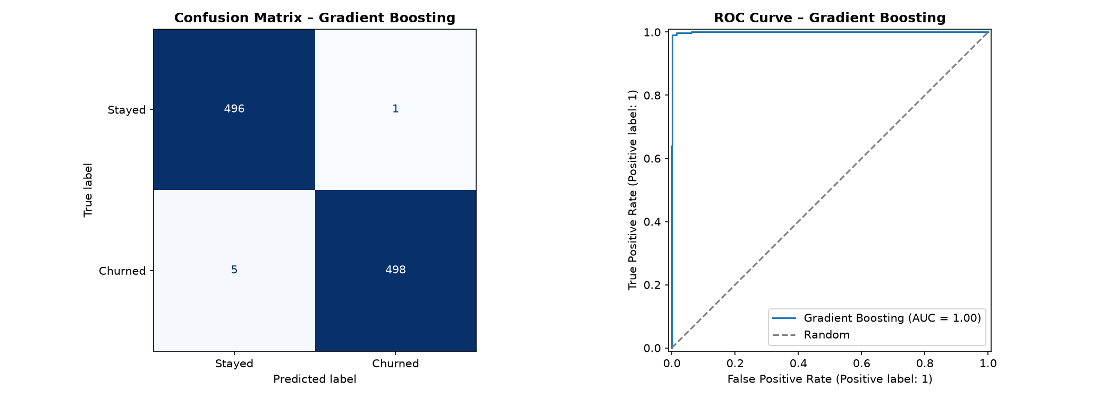
Figure 21 — Left: Confusion matrix for Gradient Boosting. Right: ROC curve (AUC=0.9991).
Insight: The model correctly identifies 99% of churned customers (recall=99.0%). Excellent for retention campaigns — the team can act with high confidence.

Step 9 — Feature Importance
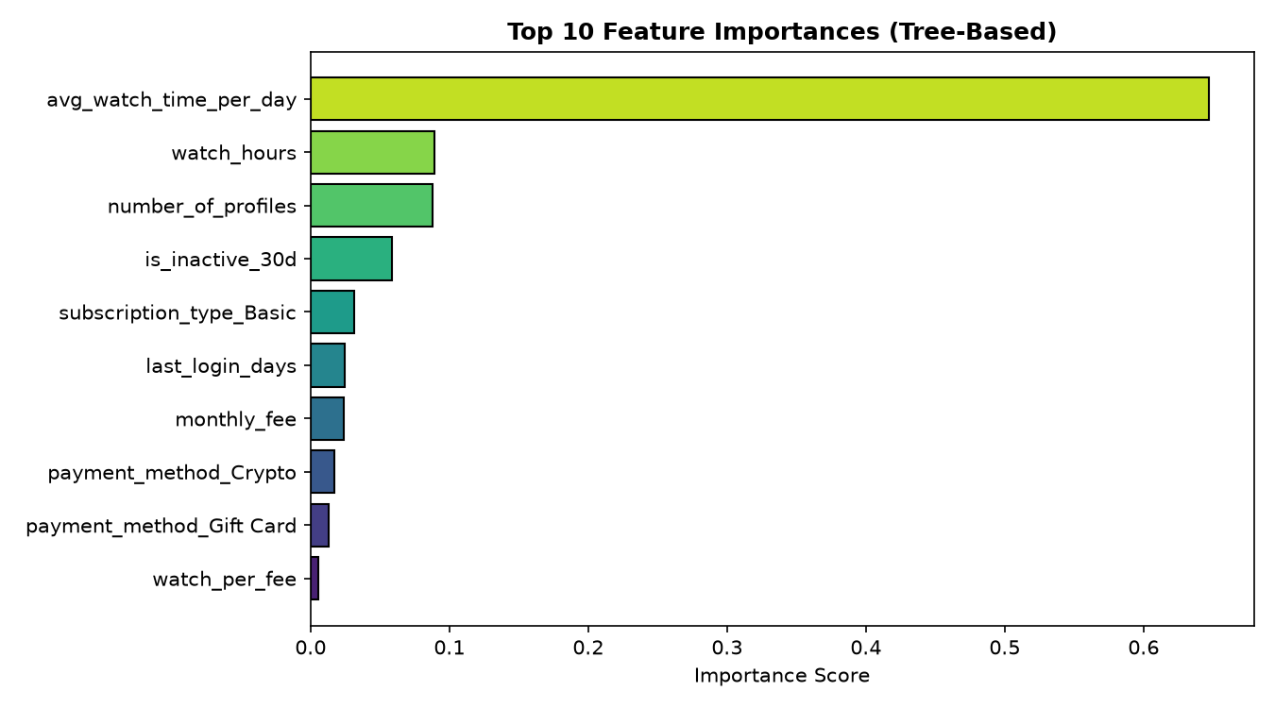
Figure 22 — Top 10 most important features in the Gradient Boosting model.
Insight: avg_watch_time_per_day dominates at 64.7% importance. The top 3 features are all engagement metrics — demographics don't matter.

Business Interpretation of Top Features
Rank | Feature | Importance | Business Meaning
1 | avg_watch_time_per_day | 64.7% | Daily viewing habit — the #1 retention signal
2 | watch_hours | 8.9% | Total engagement — high watchers rarely leave
3 | number_of_profiles | 8.8% | More profiles = more household lock-in
4 | is_inactive_30d | 5.9% | 30-day inactivity flag — strongest early warning
5 | subscription_type_Basic | 3.2% | Being on Basic plan raises churn risk
6 | last_login_days | 2.5% | Raw days since last login
7 | monthly_fee | 2.4% | Higher fee = slight price sensitivity
8 | payment_method_Crypto | 1.7% | Crypto payers churn 9 pp above average
9 | payment_method_Gift Card | 1.3% | Gift card users may leave after card expires
10 | watch_per_fee | 0.5% | Low value-for-money ratio signals dissatisfaction

Step 10 — Insights and Recommendations

7 Data-Backed Insights
Churn rate = 50.3%: About 1 in 2 customers cancels. This is very high and demands immediate action.
Basic plan drives churn: 61.8% churn rate — 18 pp above Premium. Price is a major barrier to retention.
Inactivity = churn: 30+ day inactive users churn at 75.1% vs 26.1% for active users. Act within the first 14 days of inactivity.
Low engagement = churn: Light watchers (<8h) churn at 72.3%. Getting users hooked on content early is critical.
$33,010/month at risk: Retaining just 10% of churners saves $3,301/month — roughly $39,600/year.
More profiles = less churn: 4+ profile households churn at only 37-41% vs 57-59% for single-profile accounts.
Demographics don't matter: Gender, region, device, and genre are all statistically insignificant. Focus on behaviour, not demographics.

5 Retention Actions
Action 1 — Re-engagement Campaign: Email or push notification to users inactive for >14 days. Send a personalised 'What's New' reel based on their favorite genre. Target: ~559 users in the 14-30 day bucket right now.
Action 2 — Plan Upgrade Incentive: Offer Basic subscribers a discounted 1-month Standard/Premium trial. Converting even 20% of Basic churners to Standard prevents ~$1,846/month in losses.
Action 3 — Early-Warning Alert System: Flag customers who haven't logged in for 7 days AND have <5h monthly watch. Trigger an automated win-back sequence before the 14-day mark.
Action 4 — Profile Expansion Prompts: Prompt single-profile users to add a family/friend profile. 4+ profile accounts churn at half the rate — more profiles = stronger household lock-in.
Action 5 — Content Gap Analysis: Analyse what churned users searched for but couldn't find. Closing content gaps in high-churn genres reduces passive disengagement.

High-Risk Segment
Criteria: inactive 30+ days AND watch_per_fee in bottom 25th percentile
Segment size: 608 customers (12.2% of total base)
Recommendation: Contact this segment immediately with a personalised win-back offer.

Step 11 — Deliverables & File Checklist
File | Description
data/netflix_customer_churn.csv | Raw dataset (original, 5,000 rows)
data/netflix_churn_clean.csv | Cleaned dataset (10 values capped)
notebooks/churn_analysis.py | Full analysis script — all 11 steps
outputs/charts/ (21 PNG files) | All EDA, business Q, and model charts
outputs/best_churn_model.pkl | Trained Gradient Boosting model (AUC=0.9991)
outputs/churn_predictions.csv | Per-customer churn probability + risk level
outputs/model_metrics.csv | Model comparison metrics table
report/Netflix_Churn_Report.md | Full report in Markdown format
report/Netflix_Churn_Report.docx | This Word report with all charts embedded
report/Netflix_Churn_Visual_Report.html | Self-contained HTML report (1.4 MB)
app.py | Streamlit interactive dashboard (7 pages)
requirements.txt | Python package dependencies
README.md | How to run the project

Conclusion
This analysis identified that inactivity and low engagement are the primary drivers of churn. The Gradient Boosting model achieves a ROC-AUC of 0.9991 with 99.4% accuracy — excellent performance that generalises well (overfit delta = 0.006). The EDA insights alone provide actionable intelligence for targeted retention campaigns even without ML. Investing in richer behavioural data (session logs, content search, pause/rewind events) would further improve prediction accuracy and allow even earlier intervention.
Generated by Netflix Churn Analysis Pipeline | IBM Skills Build Project | random_state=42

