NPM

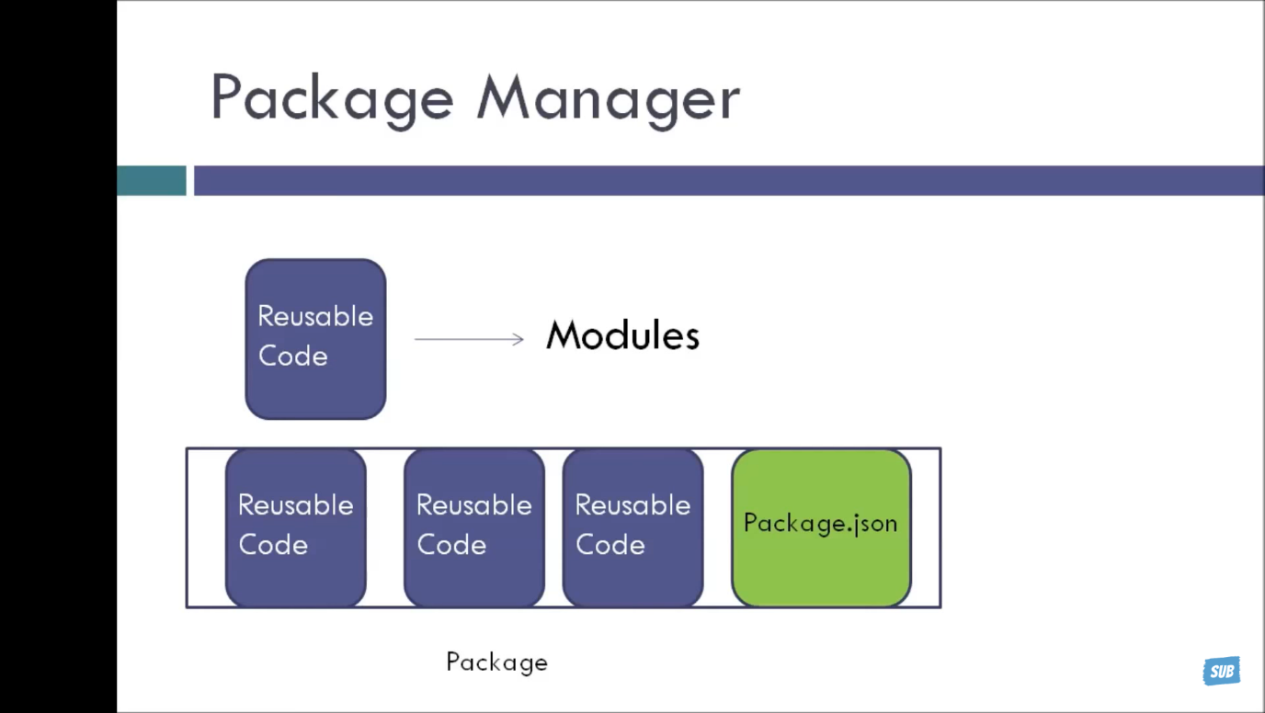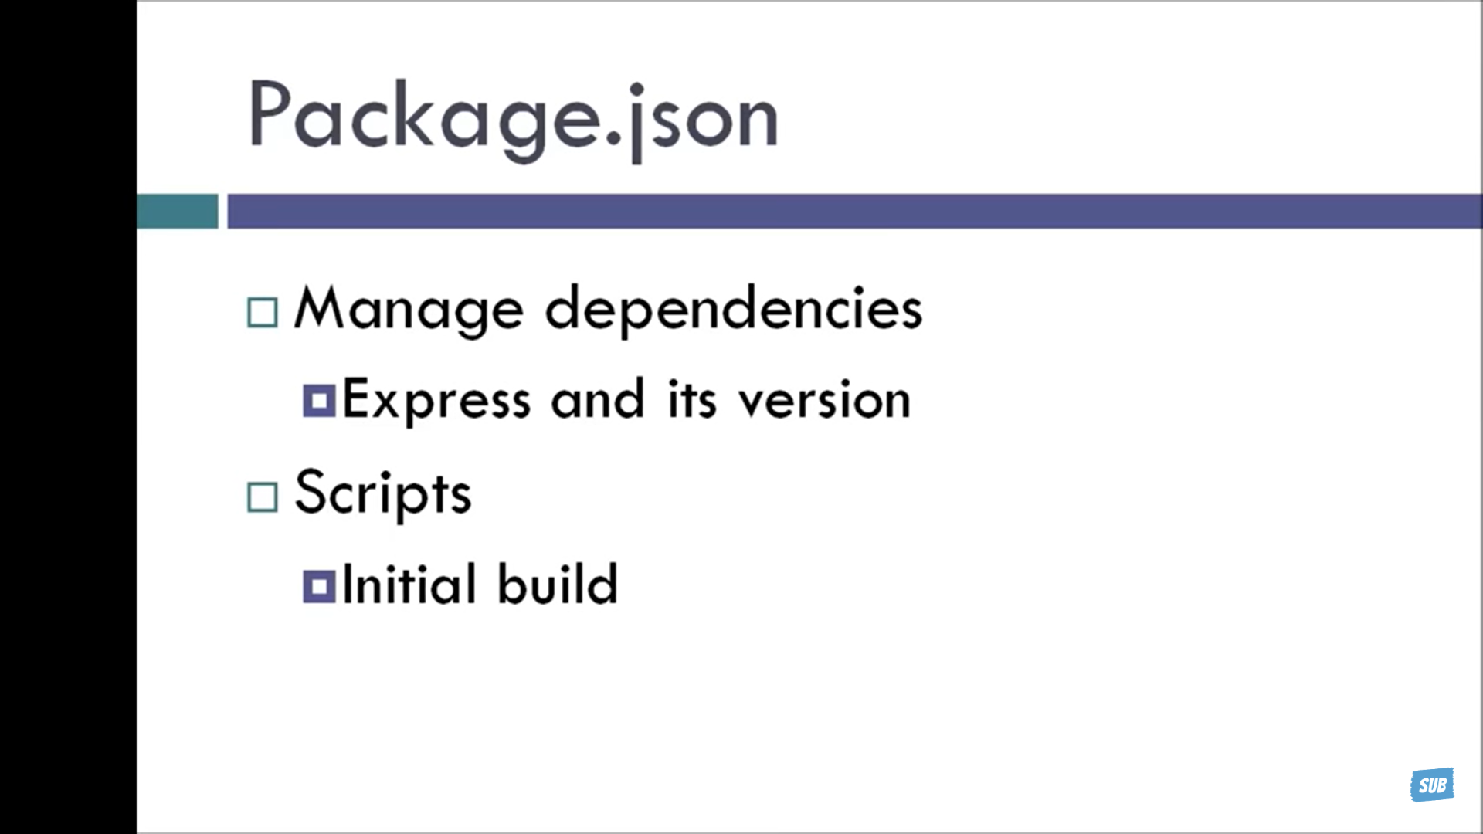

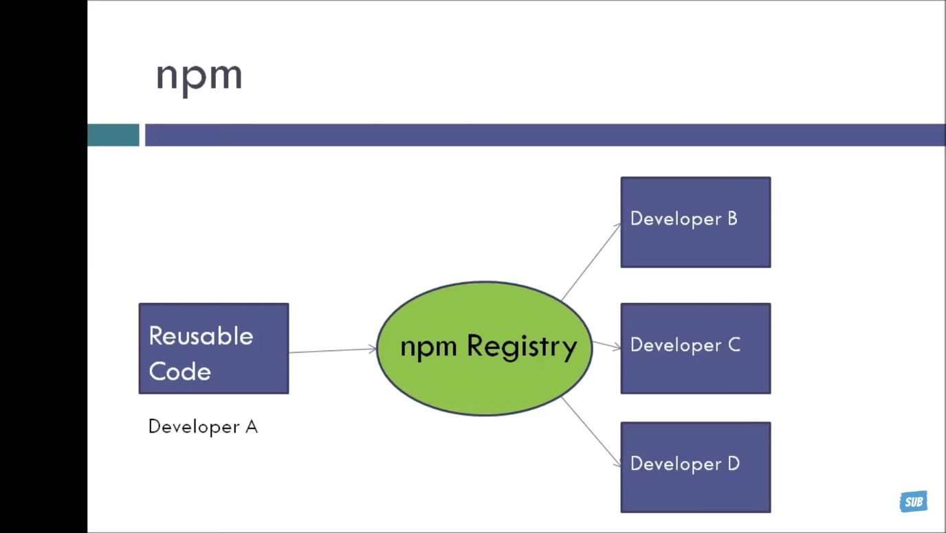

Creating package.Json:

Default package :

INSTALLING LOCAL PACKAGE :

* To install packages globally we use -g .
* Example : npm install moment -g
* The npm list command outputs installed packages and their dependencies of the current project as a tree

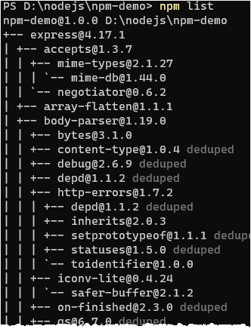

The npm ls is the shorter verison of the npm list command

Listing packages as a tree with a specified depth

To limit the depth of the dependency tree, you use the npm list with the --depth flag.

The following example lists all installed packages without their dependencies:

npm list --depth=0

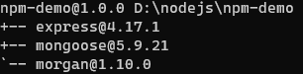

* Use the npm list to show the installed packages in the current project as a dependency tree.
* Use npm list --depth=n to show the dependency tree with a specified depth.
* Use npm list --prod to show packages in the dependencies.
* Use npm list --dev to show packages in the devDependencies.
* Use npm list --global to list the global packages.
* Use npm list --json to format the installed packages in the JSON format