Capacitive gestures is used to detect swipe gestures over multiple sensors.

Individual touches can also be registered.

The working example from

https://docs.google.com/document/d/1OTrTXFR14CP84z4LUM0RPAmTBjanlfKHe6ips4blU7o/edit

(see also // Example from https://playground.arduino.cc/Main/CapacitiveSensor/ )

Uses an external resistor for the RC measurement. The ‘baremetal’ version uses the internal pullup resistor on the raspberry pi.

TODO: combine the examples, make the detection more clear (comments and some nicer status).

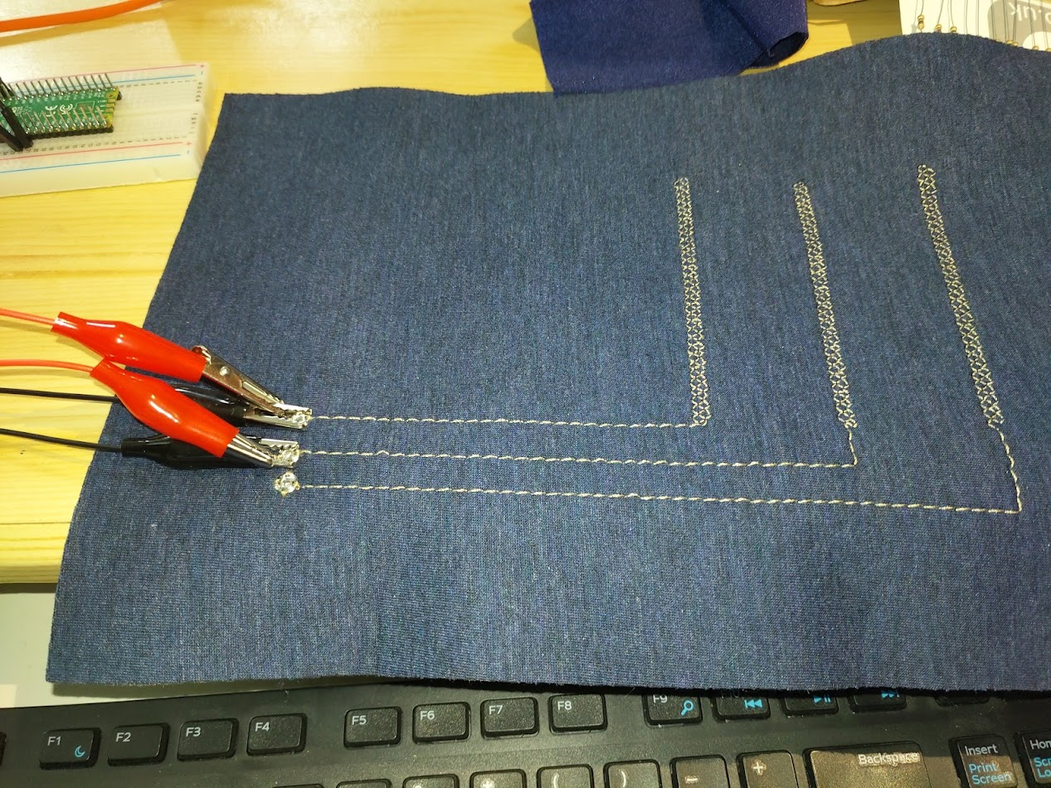

Note the two wires on every connection: black leads to an ‘INPUT_PULLUP’ digital port, red leads to an analog input.