# In this folder

Tested

GroveSpeaker – basic note playing on (grove) speaker, using delaytimes to define the pitch of the notes.

GroveSpeakerMelody – Music using the Arduino tone() function, piches.h holds the tone-height definitions.

Work in Progress

NeoPixelFader – play with NeoPixels – works partlially, the libraty tries to do smart to optimize timings, but that breaks animation effects.

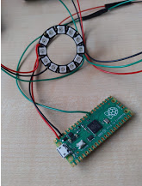

CapacitanceMeter – woks, used for strech sensor

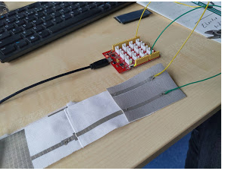

More comments and pictures needed here... working on that.