Adverse Drug Reaction Data Analysis
Illustrative pharmacovigilance case-report study

DATA STATUS: FULLY SYNTHETIC / EDUCATIONAL ONLY
The previously shared patient dataset does not provide a linked, complete record of medication exposure, symptom onset and adverse-event follow-up. Therefore, this report uses 72 deliberately simulated case reports. No results represent actual patients, observed drug safety signals, or estimates of medication risk.

1. Objective
Explore reported symptom frequencies, suspected medicines, symptom-onset intervals and severity categories; demonstrate a reproducible exploratory ADR workflow without asserting causation.

2. Dataset and methods
72 synthetic reports; six suspected medicines; one symptom per report; age, gender, start date, time to symptom onset, severity and an indicator for concomitant medicines. Counts are descriptive. Medicines were assigned equal numbers of reports by construction, so comparative reporting frequency cannot be interpreted as relative safety.

3. Symptom distribution
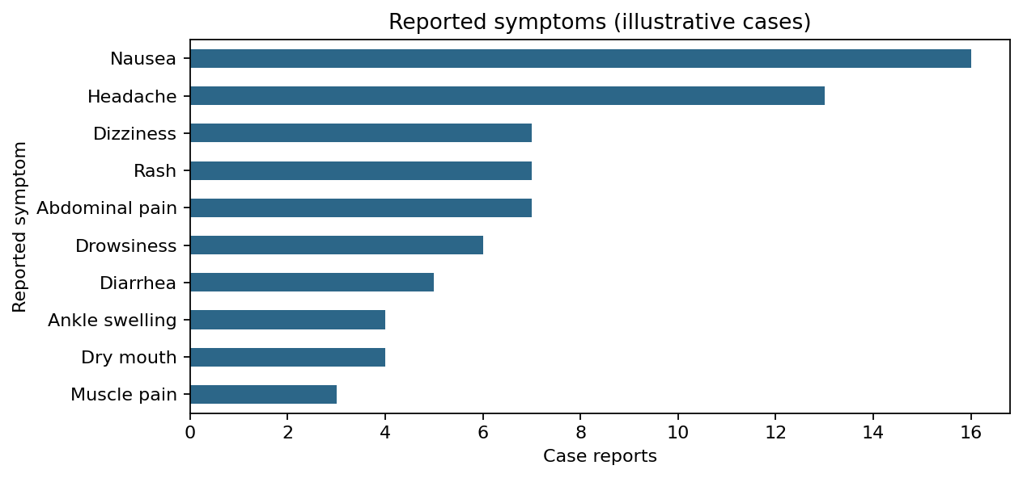
Counts of symptoms in the simulated case series.

4. Suspected medicine distribution
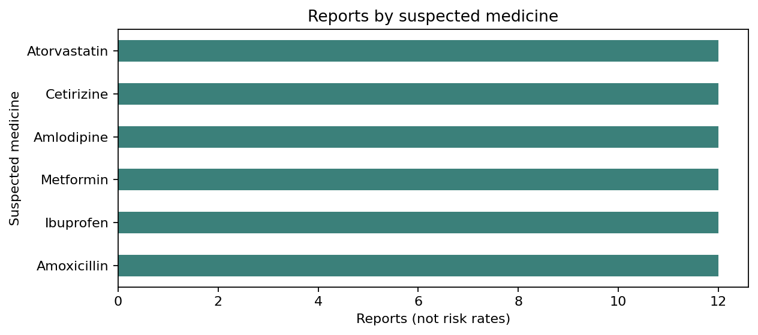
Equal report totals are a feature of dataset construction, not a clinical finding.

5. Onset timeline
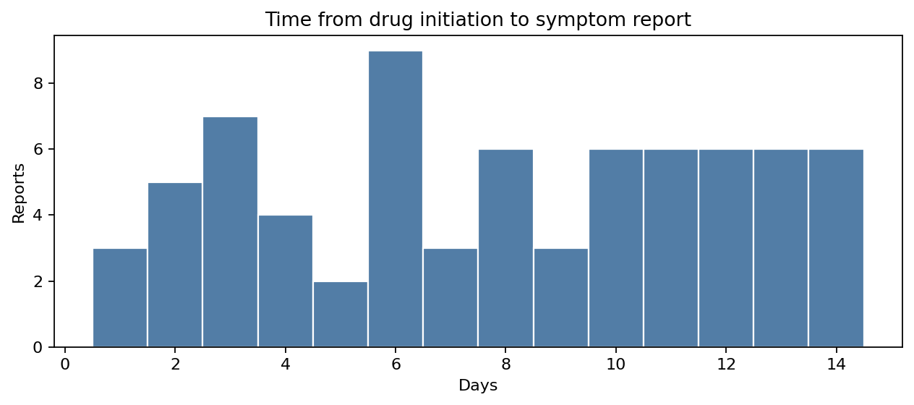
Days elapsed between simulated medicine initiation and symptom report.

6. Drug–symptom co-reporting
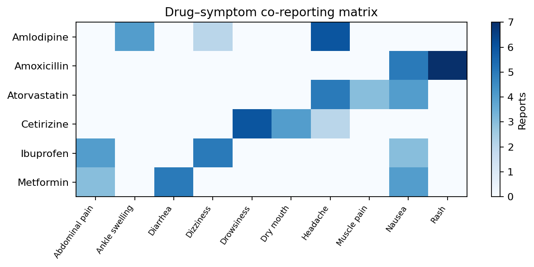
A co-reporting pattern is not evidence that the medicine caused the symptom.

7. Severity distribution
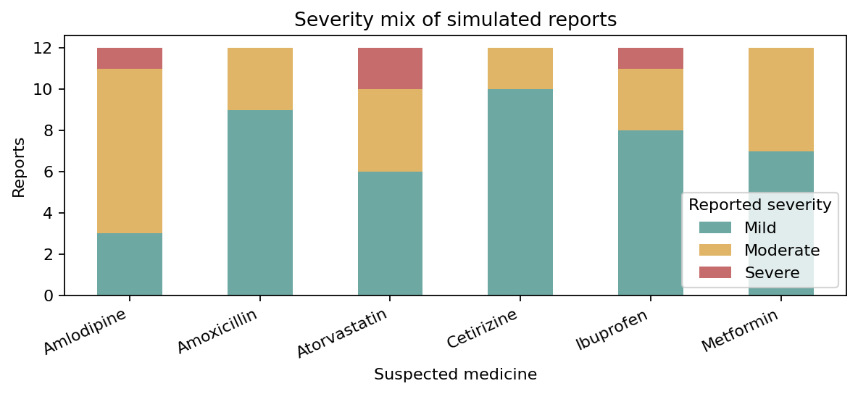
Severity is a simulated descriptive label; it is not equivalent to regulatory seriousness.

8. Interpretation and possible alternative explanations
- Temporal sequence: symptom onset after a drug start is necessary for many ADR hypotheses, but is insufficient to establish causality.
- Confounding: underlying illness, age, other medicines, dosing changes and prior medical history can explain symptoms.
- Reporting bias: case reports do not provide the number of exposed patients, so incidence, comparative risk and “highest-risk drug” cannot be calculated.
- Signal evaluation: a meaningful assessment would check expected reactions, dechallenge/rechallenge, competing diagnoses, dose, laboratory findings and seriousness.

9. Suggested real-world analytical workflow
- Obtain de-identified, consented or otherwise lawfully usable case data with drug exposure dates, symptoms, diagnosis, doses, concomitant medicines and outcomes.
- Standardize medicine names and code events using an accepted terminology (e.g., MedDRA where licensed).
- Perform data-quality checks, deduplication and case-level clinical review.
- Calculate reporting counts and onset summaries; if valid exposure denominators exist, calculate event rates with appropriate uncertainty.
- Use established causality assessment methods and pharmacovigilance signal-detection techniques only with suitable data and clinical oversight.

10. Conclusion
This demonstration shows how charts can organize suspected drug–symptom associations and onset patterns. It does not identify high-risk medicines or confirm ADR causation. Real-world safety conclusions require verified cases, exposure information, clinical assessment and careful control of bias.
Companion file: ADR_Synthetic_Case_Dataset.csv. All values are simulated and should not be presented as real clinical evidence.

