Healthcare Predictive Analytics
Drug Demand Forecasting with Python | Illustrative Project Report
DATA STATUS: SYNTHETIC / EDUCATIONAL — NOT REAL PATIENT OR PHARMACY RECORDS

1. Project objective
Predict total monthly medicine units sold from historical pharmacy sales, assess forecasting accuracy on later months, and compare a simple linear-regression model against a naive benchmark.

2. Dataset and preparation
Source: previously created Pharmacy_Sales_Synthetic_Dataset.csv. It contains 120 simulated medicine-month records (10 medicines × 12 months), with month, medicine, type, category, units, price and revenue. Monthly unit demand was calculated by summing Units Sold across medicines. Months were placed in calendar order, and month index (1–12) was used as the sole predictor. No missing-value imputation or external data were needed for this example.

3. Model development and validation
Algorithm: ordinary least-squares linear regression. Chronological training window: January–September (9 monthly totals). Untouched test window: October–December (3 monthly totals). Benchmark: predict the September total for each test month. Metrics: mean absolute error (MAE), root mean squared error (RMSE) and mean absolute percentage error (MAPE). This small holdout cannot establish production reliability.

4. Predictive performance
Method | MAE (units) | RMSE (units) | MAPE
Linear regression | 99.6 | 113.5 | 2.8%
Last-observed baseline | 299.7 | 336.6 | 8.4%
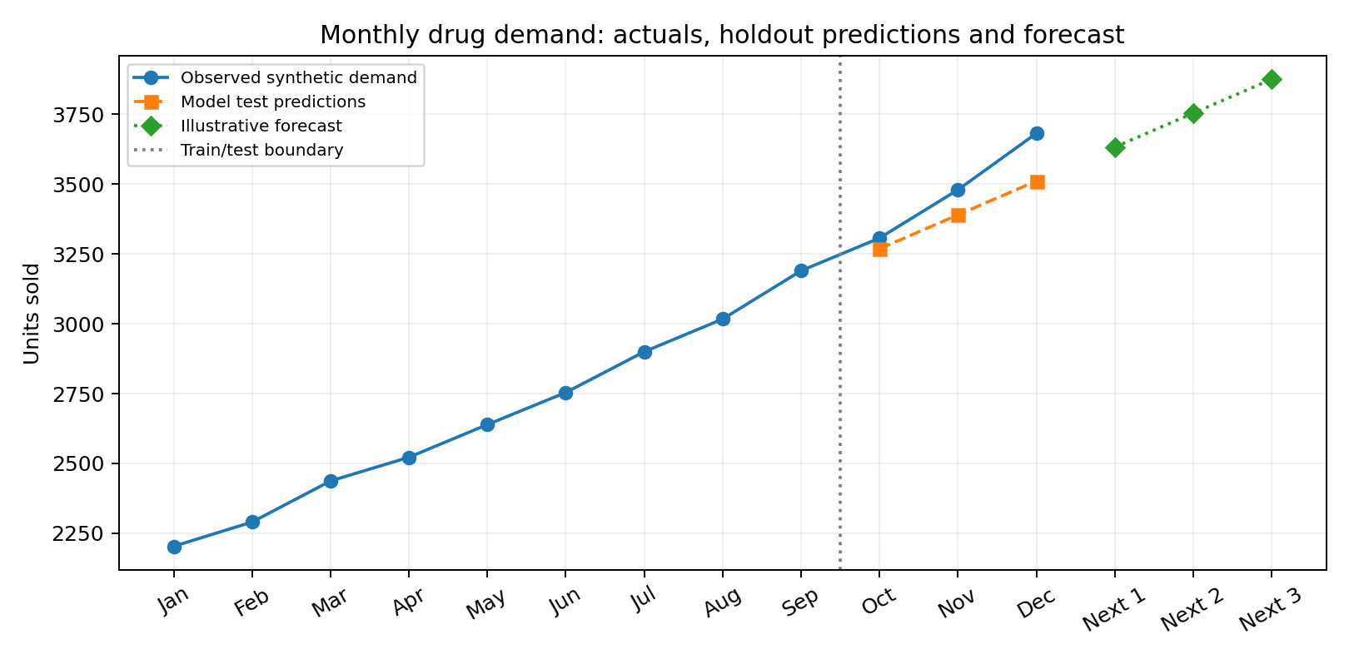
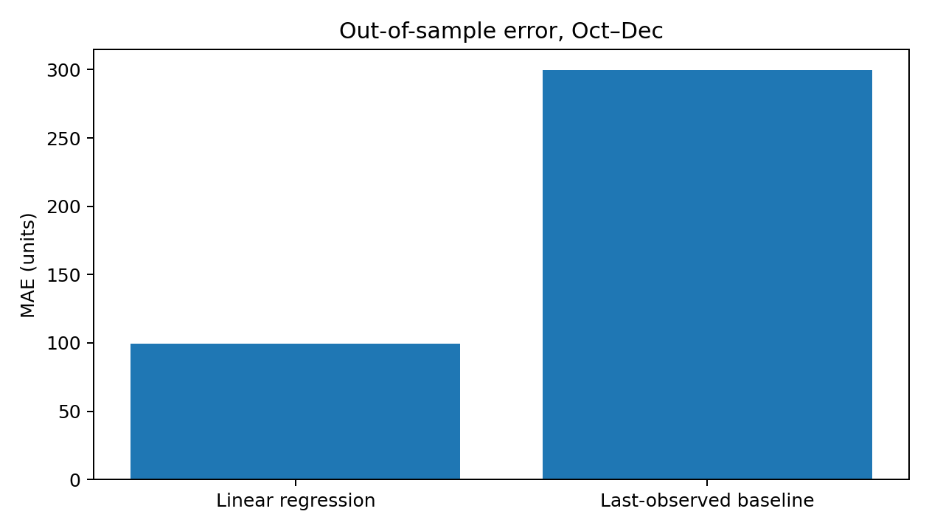

5. Month-by-month results
Month | Actual units | Predicted units
Oct | 3307 | 3269
Nov | 3480 | 3390
Dec | 3682 | 3511

6. Forward forecast (illustrative)
The model trained only on January–September is extrapolated to months 13–15 below. Forecasts are not inventory purchase recommendations.
- Next month 1: 3,633 units
- Next month 2: 3,754 units
- Next month 3: 3,876 units

7. Interpretation and limitations
Linear regression achieved a test MAE of 99.6 units, compared with 299.7 units for the naive baseline. The comparison is based on only three held-out months and simulated data; apparent accuracy may not generalize. A straight-line trend ignores seasonality, promotions, stockouts, epidemics, and differences among medicines. Aggregated forecasts cannot determine which drug to reorder.

8. Conclusion and next steps
This exercise demonstrates a reproducible end-to-end forecasting workflow: prepare monthly totals, split chronologically, train, benchmark, evaluate and visualize. For real deployment, collect at least 24–36 months of transaction-level records, forecast by medicine, use rolling-origin validation, incorporate stockouts and seasonality, and evaluate inventory impact before use.
Reproducibility: see Healthcare_Predictive_Analytics_Code.py and the source synthetic CSV.

