Pharmacy Sales & Drug Analysis
Illustrative analytics report • 12 months • 10 medicines
DATA STATUS: This report uses a clearly labeled synthetic pharmacy sales dataset. The previously supplied healthcare file contains patient-level information, not pharmacy transactions; therefore pharmacy sales, revenue, and branded/generic comparisons cannot be derived from it. All figures below demonstrate the requested analytical workflow and are not real pharmacy findings.

1. Objective and methodology
Evaluate top-selling medicines, monthly revenue and sales growth, branded versus generic performance, and therapeutic-category revenue. A reproducible synthetic dataset was constructed for January–December using 10 example medicines, assumed unit prices, and increasing monthly unit volumes. Revenue = units sold × unit price; monthly growth = (current-month revenue ÷ prior-month revenue − 1) × 100. Figures are descriptive, not forecasts.

2. Executive summary
- Total illustrative annual revenue: ₹212,773 from 34,421 units.
- Highest-volume medicine: Paracetamol 500 mg (4,985 units).
- Highest-revenue medicine: Augmentin 625.
- Revenue grew from ₹13,609 in January to ₹22,759 in December; this trend is built into the simulated data.

3. Top-selling medicines
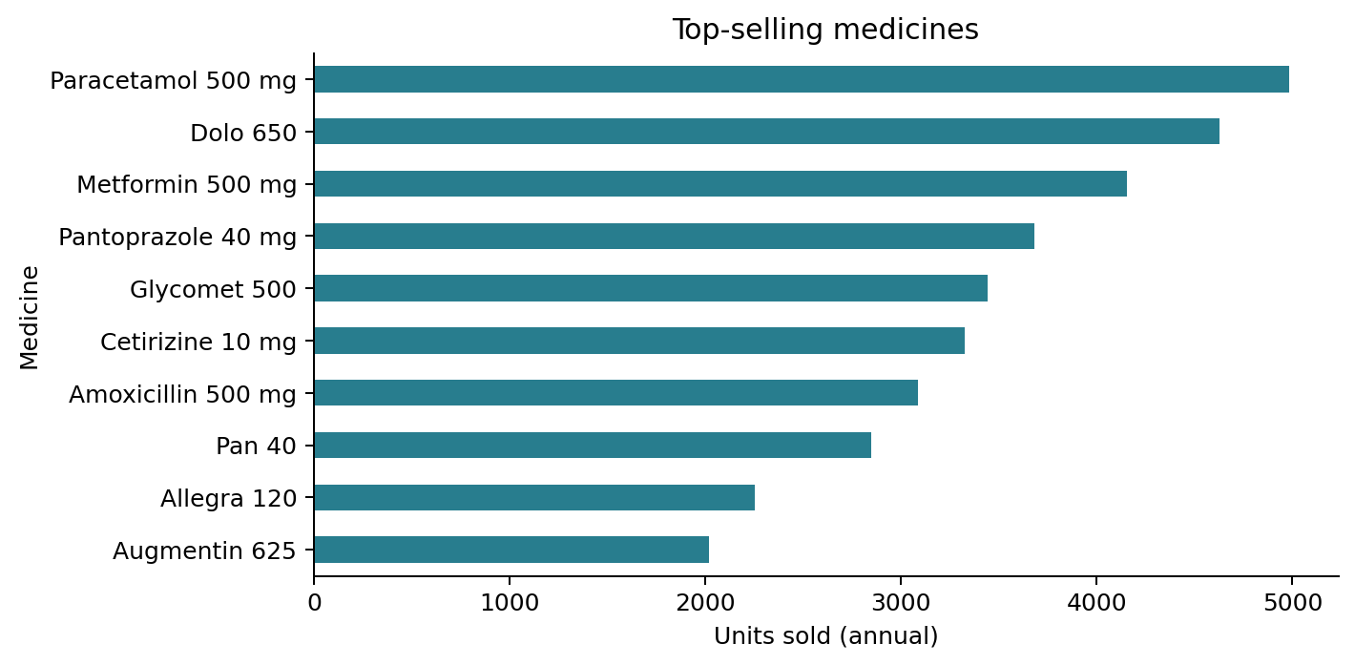
Figure 1. Annual medicine sales volume, ranked by units sold.

4. Monthly revenue trend
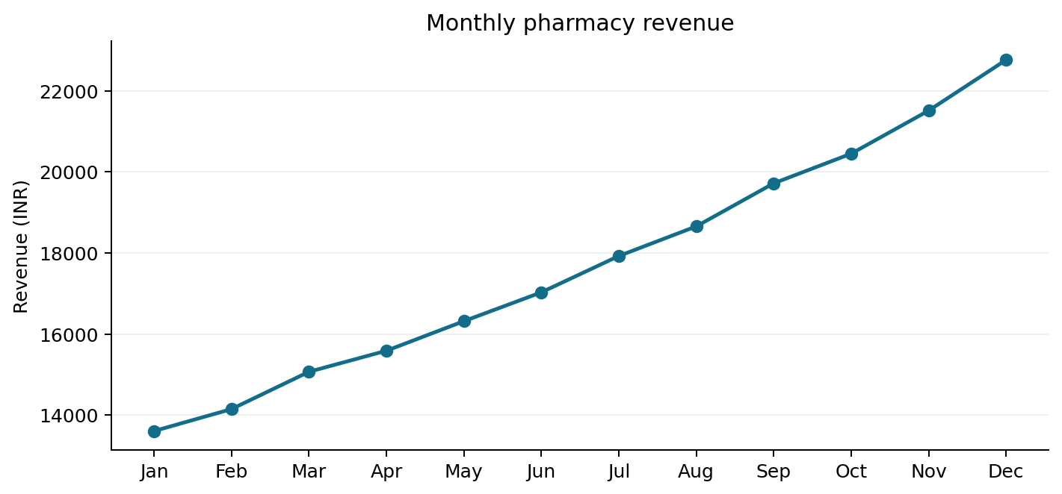
Figure 2. Monthly sales revenue in Indian rupees.

5. Month-on-month sales growth
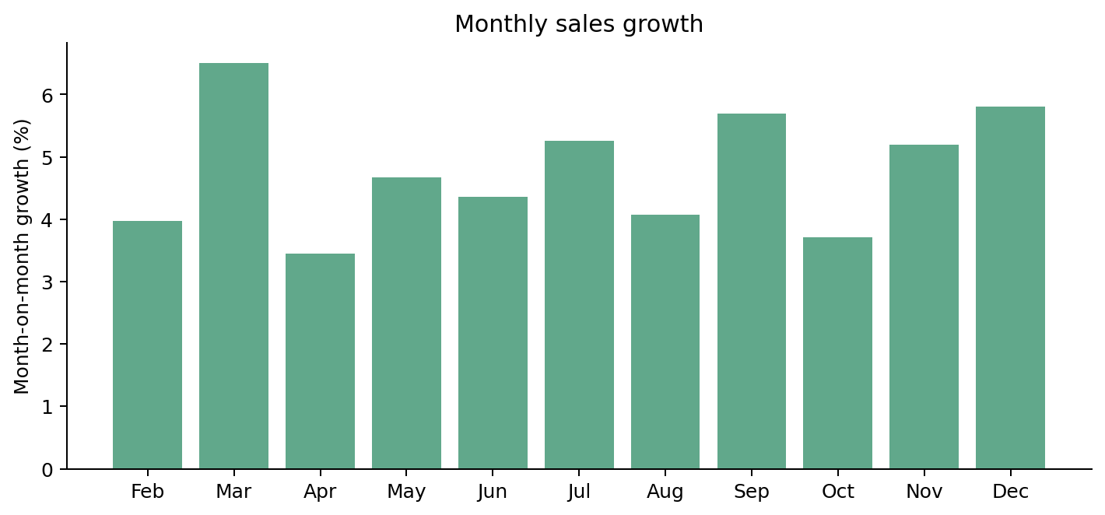
Figure 3. Percentage change in monthly revenue; January has no preceding comparison month.

6. Branded versus generic comparison
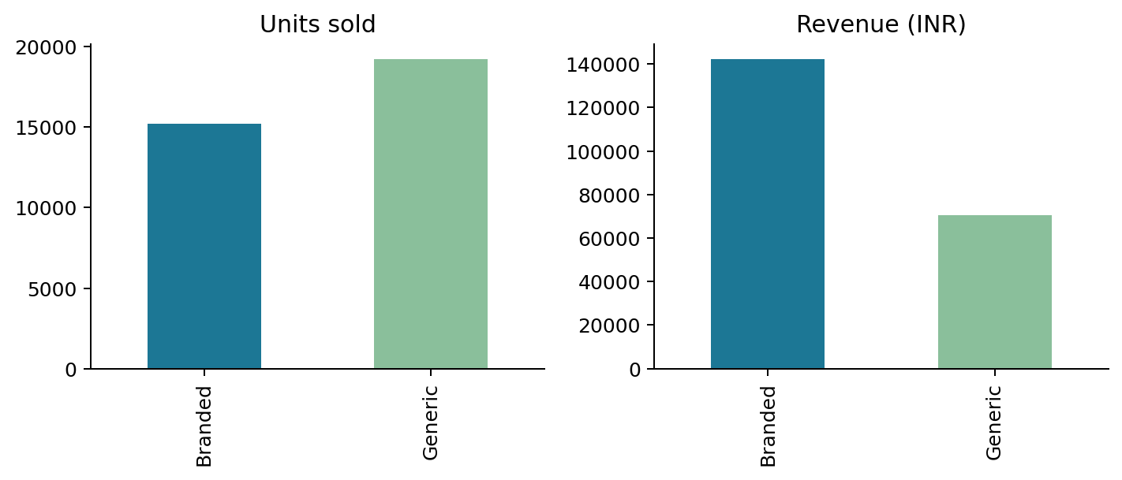
Figure 4. Branded and generic products compared on sales volume and revenue.
In this illustration, branded products represent 44.1% of units and 66.8% of revenue. Revenue share differs from volume share because assumed unit prices differ. These figures do not establish profit margin or clinical preference.

7. Revenue by therapeutic category
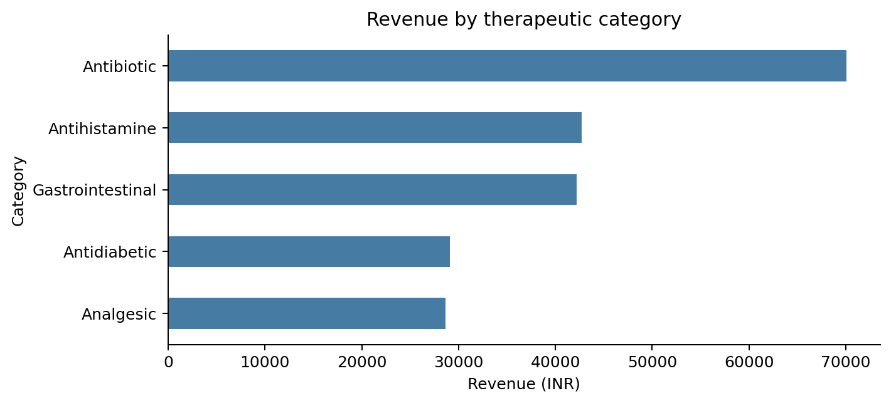
Figure 5. Revenue distribution across therapeutic categories.

8. Interpretation and limitations
The dataset demonstrates how transaction-level analysis can identify volume leaders, revenue contributors, category mix and growth patterns. However, increasing sales were imposed through the synthetic monthly multipliers. The dataset does not include costs, discounts, returns, stockouts, prescriptions, patient outcomes, or actual dispensing records. Consequently, it cannot support claims about real-world demand, profitability, medicine effectiveness, or population disease burden.

9. Recommendations and conclusion
For a real-world study, replace the example rows with de-identified pharmacy transaction records including date, product, brand/generic classification, quantity, net sale price, purchase cost, returns, and store identifier. Validate product names and classification, handle missing and duplicate transactions, and then recompute these charts. With real data, add gross margin, stock turnover, seasonality, and store-level comparisons.

Appendix: Sample data structure
Month | Medicine | Type | Units | Revenue (INR)
Jan | Paracetamol 500 mg | Generic | 319 | 797.50
Jan | Metformin 500 mg | Generic | 266 | 851.20
Jan | Amoxicillin 500 mg | Generic | 198 | 1,386.00
Jan | Pantoprazole 40 mg | Generic | 236 | 1,062.00
Jan | Cetirizine 10 mg | Generic | 213 | 426.00
Jan | Dolo 650 | Branded | 296 | 1,036.00
Jan | Glycomet 500 | Branded | 220 | 1,012.00
Jan | Augmentin 625 | Branded | 129 | 3,096.00
The full 120-row illustrative dataset is also provided as a separate CSV for transparent verification and reuse.

