FAST DELIVERY
  - Customer Experience & Operations Dashboard
Executive takeaway
The dashboard turns 5,000 customer reviews into a simple management view: identify the operational problem, find where it is happening, and decide what action should happen next.

Performance snapshot

5000 | 3.00 | 34.96 min | 2.97
Total Reviews | Average Rating | Average Delivery Time | Customer Service Rating
50.30% | 34.54% | 50.06% | 10
Order Accuracy | Negative Feedback | Out of Stock | Locations

01 SERVICE QUALITY | 02 DELIVERY | 03 AVAILABILITY
Order accuracy is 50.30% and negative feedback is 34.54%. This indicates a clear opportunity to improve the customer experience. | Average delivery time is 34.96 minutes. Location and order-type views help management isolate slower segments. | Out-of-stock is 50.06% in the supplied Power BI dashboard view. Inventory planning should therefore be a priority area.

What to do first
1. Investigate locations with high negative feedback and long delivery time. 2. Analyze incorrect orders by location and order type. 3. Review products frequently unavailable. 4. Use the Power BI slicers in weekly operational reviews.

The Dashboard at a Glance
Power BI is the recommended client-facing version because it combines KPI cards, charts, slicers and a geographic view in one interactive page.
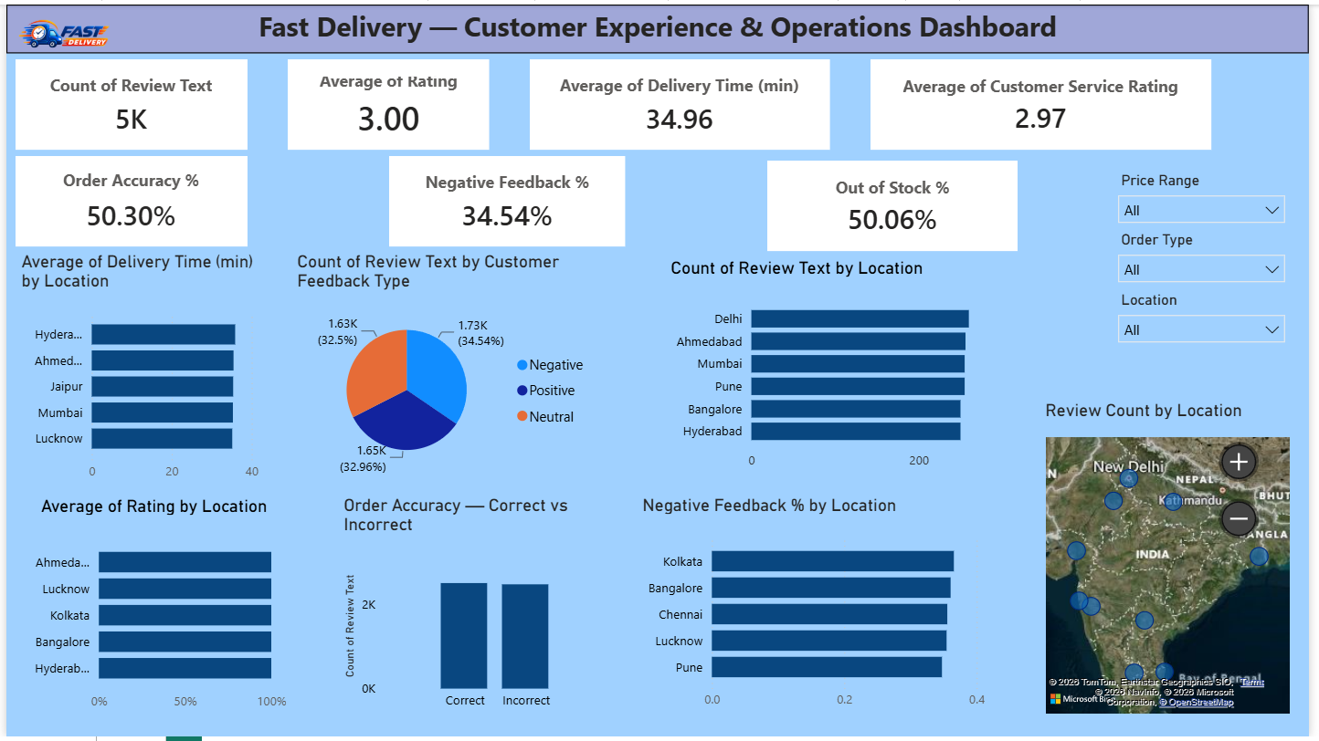
How management reads it
Step | What the dashboard shows | Management question
1 | KPI cards | What is the current overall performance?
2 | Location / order-type charts | Where is performance weaker?
3 | Feedback and accuracy views | What is causing customer experience risk?
4 | Slicers + map | Which segment or location should we investigate?
5 | Business action | What operational change should be assigned?
“Don’t just report the number. Use the dashboard to locate the problem, decide the action, and measure whether performance improves.”

From Business Problem to Business Action
The dashboard is valuable because each visual answers a management question and points toward a practical next step.
Business problem | Evidence / dashboard view | What the client should do
Slow delivery | Average Delivery Time by Location and Order Type. | Investigate high-time locations; review agent allocation, routes and process bottlenecks.
Incorrect orders | Order Accuracy — Correct vs Incorrect. | Review packing, item verification and order-confirmation steps; reduce repeat errors.
Negative customer experience | Negative Feedback % by Location + feedback distribution. | Prioritize locations with high negative feedback and review complaint/service themes.
Stock availability | Out of Stock KPI / product availability view. | Identify frequently unavailable products and improve replenishment planning.
Location performance | Location charts + map. | Compare locations and focus resources on the weakest-performing areas.
Management monitoring | KPI cards + Location, Order Type and Price Range slicers. | Use filters in weekly reviews to investigate specific segments and assign accountability

Recommended action plan
Priority | Action | Expected business outcome
HIGH | Investigate locations with the highest negative feedback and longest delivery time. | Better customer satisfaction and fewer complaints.
HIGH | Analyze incorrect orders by location and order type. | Higher order accuracy and fewer refunds / re-deliveries.
HIGH | Review products frequently marked unavailable. | Lower stock-outs and reduced lost-sales risk.
MEDIUM | Run a weekly Power BI review using Location, Order Type and Price Range slicers. | Faster decisions and clearer accountability.
MEDIUM | Track KPI movement after operational changes. | Evidence that corrective actions are actually working.

Presentation — The 30-Second Explanation
“This dashboard converts customer review data into operational decisions. Instead of only seeing thousands of reviews, management can immediately see delivery time, rating, order accuracy, negative feedback and stock availability. The location charts, map and slicers then help identify where the problem is. These findings can be used to prioritize delivery operations, order processing, customer service and inventory improvements.”
What is included
Component | Purpose | value
KPI cards | Total Reviews, Rating, Delivery Time, Customer Service Rating, Order Accuracy, Negative Feedback and Out of Stock. | Immediate performance snapshot.
Location charts | Delivery time, rating, review count and negative feedback by location | Find weak or high-risk locations.
Order-type analysis | Delivery time and order accuracy views by order type. | Identify operational differences between order categories.
Feedback distribution | Negative, Positive and Neutral customer feedback. | Understand overall customer sentiment mix.
Map | Review count by location. | Quick geographic view of activity.
Slicers | Location, Order Type and Price Range | Drill into specific business segments.

Recommended management loop
IDENTIFY | INVESTIGATE | ACT | MEASURE
Spot an abnormal KPI. | Filter location / order type and inspect the charts. | Assign a specific operational improvement | Compare the KPI after the change

Supporting Excel Version
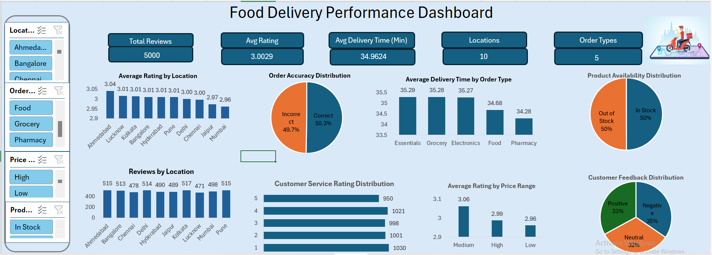
Recommended positioning for portfolio: Present Power BI as the main interactive solution and Excel as the supporting analysis version. The strongest story is not “I built a dashboard”; it is “I used customer-review data to identify operational risks and connect each risk to a management action.”

