INDIA SUPPLY CHAIN
PERFORMANCE & OPERATIONS REPORT
Management Edition | FY2024–FY2026 Dataset

Report Detail | Value
Analysis period | Feb 2024 – Jan 2026
Records analyzed | 10,000 transactions
Primary focus | Sales • Forecast • Logistics • Lead Time
Prepared from | India Supply Chain transaction dataset

CONFIDENTIAL • MANAGEMENT USE

01 | Executive Dashboard
This report converts the transaction-level supply-chain data into a management view of demand realization, transportation economics and service execution. The primary management signal is a persistent gap between forecast and realized sales, combined with actual lead times running above plan.
SALES VOLUME  72.70 M | FORECAST  77.35 M | ATTAINMENT  94.0%
TRANSPORT COST  ₹222.14 M | ACTUAL LEAD TIME  15.6 days | DELAY RATE  60.1%

Management Takeaways
- Demand realization: sales are 4.65 million units below forecast, equivalent to a 6.0-point attainment gap.
- Service execution: actual lead time averages 15.6 days versus 14.1 planned days, a +1.5-day variance.
- Transportation: the network spends ₹222.14 million, with average cost of ₹3.06 per sold unit.
- Network focus: plant and distributor-city concentration can be used to prioritize inventory, service and logistics interventions.

02 | Demand & Sales Performance
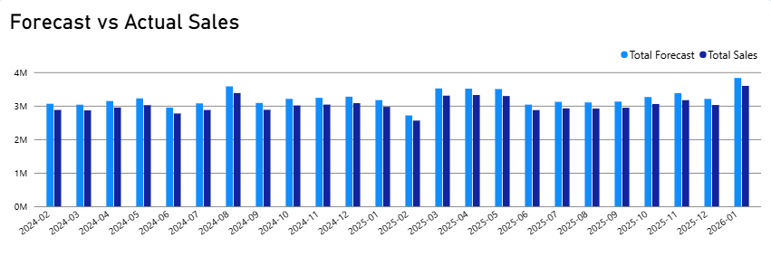
Forecast consistently remained above actual sales throughout the analysis period. Forecast reached its highest level of approximately 3.8 million units in January 2026, while actual sales reached approximately 3.6 million units. The lowest levels occurred around February 2025, with forecast at approximately 2.7 million units and actual sales at approximately 2.6 million units. The persistent gap between forecast and actual sales indicates an opportunity to improve forecast calibration and strengthen demand-conversion analysis.

03 | Manufacturing Network

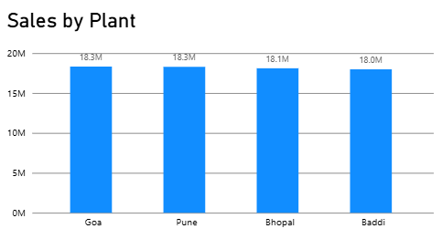
Plant | Sales | Transport Cost
PL4 – Goa | 18.32 M | ₹59.85 M
PL3 – Pune | 18.29 M | ₹53.69 M
PL2 – Bhopal | 18.11 M | ₹44.97 M
PL1 – Baddi | 17.98 M | ₹63.63 M

04 | Distributor Network

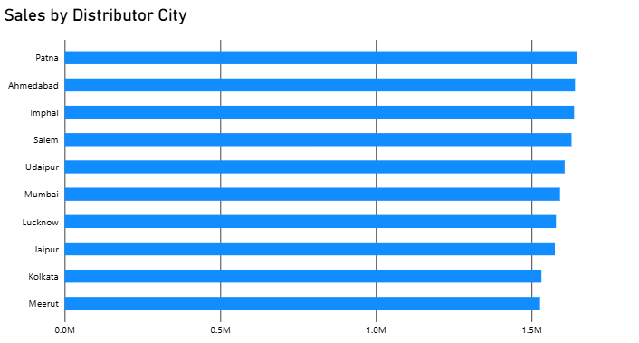

Distributor City | Sales | Transport Cost | Transactions
Patna | 1.65M | ₹5.85M | 225
Ahmedabad | 1.64M | ₹3.36M | 226
Imphal | 1.64M | ₹9.24M | 218
Salem | 1.63M | ₹5.74M | 217
Udaipur | 1.61M | ₹3.41M | 221
Mumbai | 1.59M | ₹3.03M | 214
Lucknow | 1.58M | ₹4.41M | 221
Jaipur | 1.57M | ₹3.85M | 223
Kolkata | 1.53M | ₹6.58M | 203
Meerut | 1.53M | ₹4.08M | 209

05 | Logistics & Service Reliability

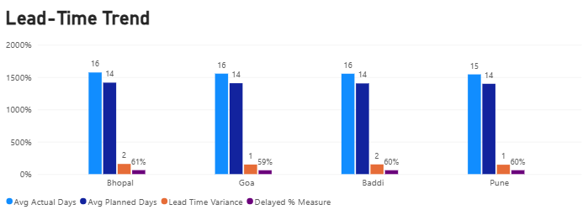

Plant | Planned | Actual | Variance | Delayed
Bhopal | 14.2 | 15.7 | +1.6 | 61.3%
Pune | 14.0 | 15.4 | +1.5 | 60.1%
Baddi | 14.0 | 15.5 | +1.5 | 59.7%
Goa | 14.1 | 15.5 | +1.5 | 59.4%

06 | Product Forecast Exceptions
The largest forecast gaps provide a practical exception list for commercial and planning teams. These gaps should be investigated against availability, pricing, channel coverage and forecast assumptions before corrective action.

Product ID | Forecast | Sales | Gap
P112 | 4.123M | 3.847M | 275.9K
P116 | 3.898M | 3.654M | 244.6K
P100 | 3.657M | 3.423M | 233.7K
P108 | 3.866M | 3.633M | 233.1K
P102 | 3.741M | 3.509M | 232.1K
P117 | 3.593M | 3.365M | 228.1K
P114 | 3.734M | 3.511M | 223.3K
P101 | 3.839M | 3.615M | 223.3K
P115 | 3.827M | 3.605M | 222.4K
P113 | 3.778M | 3.556M | 222.0K
P107 | 3.492M | 3.271M | 221.2K
P111 | 3.595M | 3.375M | 219.2K

07 | Management Action Plan
Priority | Workstream | Recommended Action
01 | Forecast governance | Check why actual sales are lower than the forecast.
02 | Lead-time control | Find delayed deliveries and improve delivery time.
03 | Cost Optimization | Find high transport costs and reduce them.
04 | Distributor prioritization | Focus more on cities with high sales.
05 | Exception management | Check large sales gaps, delays, and high costs regularly.

08 | Data & Methodology

I analyzed 10,000 transactions to understand sales, forecast, transportation cost, and delivery performance. I compared expected sales with actual sales and planned delivery time with actual delivery time. The report shows the main problems and areas that need improvement.

Appendix | Management Reference
Plant ranking by sales volume

Rank | Plant | Sales | Transport Cost
1 | Goa | 18.32M | ₹59.85M
2 | Pune | 18.29M | ₹53.69M
3 | Bhopal | 18.11M | ₹44.97M
4 | Baddi | 17.98M | ₹63.63M

