Veldra Insights — Monthly Launch Status
February 2026 edition · Prepared by Ana Delgado, Product Marketing · Issued March 1, 2026
Distribution: Diane Whitfield; launch core team

Executive summary
Veldra Insights closed February on track for general availability on March 15, with the beta cycle complete and paid media expanded following the mid-month budget revision. Final beta results landed just under target — NPS 47 against a goal of 50, with the waitlist at 4,820 — strong enough to proceed while we tighten onboarding. Two items remain on the critical path into March: legal sign-off on the pricing-page claims, and creative capacity, which is running lean through month-end due to the rebrand reallocation.

Key metrics
Metric | Current | Target | Status
Waitlist signups | 4,820 (Feb 23) | 5,000 | 🟡 On track
Beta NPS | 47 (n=214) | 50 | 🟡 Below target
Campaign budget | $275,000 | — | 🟢 Approved
Launch-sourced pipeline | $255,000 (Feb 28) | — | 🟢 Building

Pipeline trajectory
Launch-attributed pipeline has built steadily through the quarter as opportunities progress toward close.
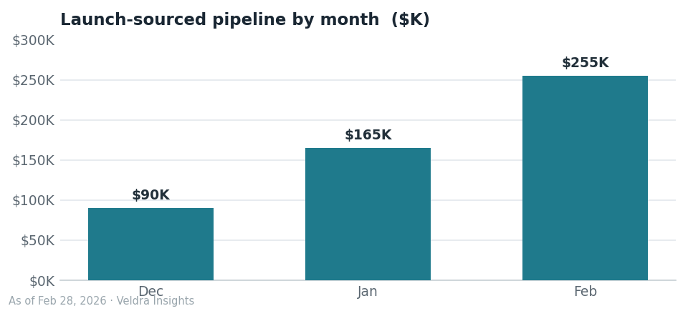

Workstream status
Workstream | Owner | Status | Note
Pricing page & legal review | Priya Raman / Tomas Keller | 🟡 In progress | Legal review of claims pending; required before publish
Press & analyst briefing | Ana Delgado | 🟢 Scheduled | March 8, 9:00am PT
Paid media | Ana Delgado | 🟢 On track | Expanded after Feb 12 budget increase
Localization (DACH) | — | ⚪ Deferred | Moved to wave 2 (targeted May) per January scope decision
Press kit assets | Lena Park | 🟡 At risk | Timeline tight given creative capacity
Creative capacity | Marcus Chen | 🟡 At risk | Operating at 3 through March (Marcus 50% on rebrand)

Risks & watch-items
- Legal review of pricing-page claims is not yet started as of this report; required before the page can publish.
- Creative capacity is reduced through March; the press-kit timeline is at risk.
- The creative agency contract renewal is on track for April.

Outlook — next 30 days
- General availability (GA): March 15, 2026, with the announcement at 9:00am PT.
- Press & analyst briefing: March 8, 2026.
- Waitlist nurture email sequence begins March 10.
- Final legal sign-off on pricing-page claims expected ahead of publish.

