Veldra Insights — Monthly Launch Status
March 2026 update · Prepared by Ana Delgado, Product Marketing · Issued March 10, 2026 (data as of March 10)
Distribution: Diane Whitfield; launch core team

Executive summary
General availability has moved to March 22, 2026 — a one-week extension agreed on March 6 with Diane Whitfield, on the grounds that the legal sign-off timeline and the rescheduled press briefing left insufficient runway for a clean launch on the 15th. The press & analyst briefing takes place today, March 10 at 9:30am PT, having moved from March 8 because of a venue conflict. Legal review of the pricing-page claims was held on March 6 with sign-off targeted for March 9; that sign-off is not yet confirmed in the record as of this report and remains the single blocking item, as the pricing page cannot publish without it. Beta results are final and unchanged (NPS 47, waitlist 4,820 at the last reading on Feb 23), and creative capacity remains lean through month-end, though the extra week gives the press-kit timeline some relief.

Key metrics
Metric | Current | Target | Status
Waitlist signups | 4,820 (Feb 23) | 5,000 | 🟡 On track
Beta NPS | 47 (n=214) | 50 | 🟡 Below target (final)
Campaign budget | $275,000 | — | 🟢 Approved
Launch-sourced pipeline | $255,000 (Feb 28) | — | 🟢 Building (Feb data)
GA date | March 22, 2026 | — | 🟡 Moved +1 week

Pipeline trajectory
Launch-attributed pipeline has built steadily through the quarter as opportunities progress toward close. The figures below close at February 28; no March reading was available at the time of this update.
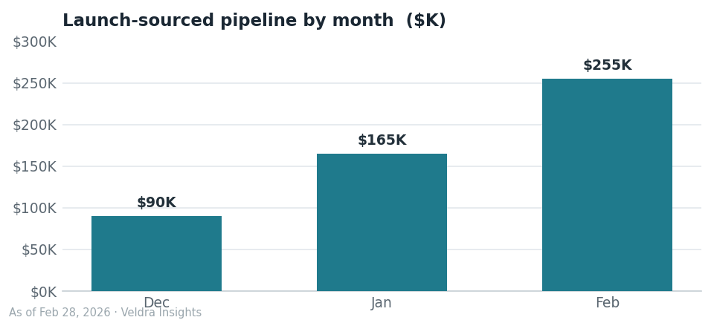

Workstream status
Workstream | Owner | Status | Note
Pricing page & legal review | Priya Raman / Tomas Keller | 🔴 Blocking | Review held Mar 6; sign-off targeted Mar 9, not yet confirmed
Press & analyst briefing | Ana Delgado | 🟢 Today | March 10, 9:30am PT (moved from March 8 — venue conflict)
Paid media | Ana Delgado | 🟢 On track | Expanded after Feb 12 budget increase
Localization (DACH) | — | ⚪ Deferred | Moved to wave 2 (targeted May) per January scope decision
Press kit assets | Lena Park | 🟡 At risk | Timeline tight; one week regained from the GA move
Creative capacity | Marcus Chen | 🟡 At risk | Operating at 3 through March (Marcus 50% on rebrand)
Launch collateral re-dating | Ana Delgado | 🟡 To do | FAQ, pricing page and waitlist emails still cite March 15

Risks & watch-items
- Legal sign-off on the pricing-page claims was targeted for March 9 and is not confirmed as of this report; the pricing page cannot publish without it. This is the critical-path item into launch week.
- Creative capacity is still reduced through March (Marcus Chen at 50% on the rebrand); the press-kit timeline remains at risk, though the one-week GA move adds runway.
- Customer-facing collateral — the FAQ draft, the pricing page and the waitlist email sequence — still references the old March 15 date and must be re-dated before publish.
- The waitlist was last measured at 4,820 on February 23; with no reading since, pacing to the 5,000 goal is unverified.
- The creative agency contract renewal is on track for April.

Outlook — next 30 days
- General availability (GA): March 22, 2026, with the announcement at 9:00am PT (moved from March 15 on March 6).
- Press & analyst briefing: today, March 10, 2026 at 9:30am PT.
- Confirm legal sign-off on the pricing-page claims, then publish the updated pricing page.
- Waitlist nurture sequence: final review this week; send dates to be re-timed against the March 22 GA.
- Refresh the waitlist and launch-sourced pipeline readings for the next update.

