Veldra Insights — Monthly Launch Status
March 2026 edition · Prepared by Ana Delgado, Product Marketing · Issued March 15, 2026
Distribution: Diane Whitfield; launch core team

Executive summary
Veldra Insights enters its final week before general availability, now set for March 22, 2026 after a one-week shift approved March 6 to give legal sign-off and the rescheduled press briefing enough runway for a clean launch. Legal cleared the pricing-page claims on March 9, removing the last blocker from the critical path, and the March 10 analyst briefing landed well, with two analysts requesting follow-up demos. The waitlist crossed 4,900 on March 11, closing in on the 5,000 target, and launch-sourced pipeline has grown to $310,000. The remaining watch-item is creative capacity: Marcus Chen’s 50% allocation to the corporate rebrand now spans the full runway to the new GA date, keeping the press-kit timeline tight.

Key metrics
Metric | Current | Target | Status
Waitlist signups | 4,900+ (Mar 11) | 5,000 | 🟡 On track
Beta NPS | 47 (n=214) | 50 | 🟡 Below target
Campaign budget | $275,000 | — | 🟢 Approved
Launch-sourced pipeline | $310,000 (Mar 13) | — | 🟢 Building

Pipeline trajectory
Launch-attributed pipeline has built steadily through the quarter as opportunities progress toward close.
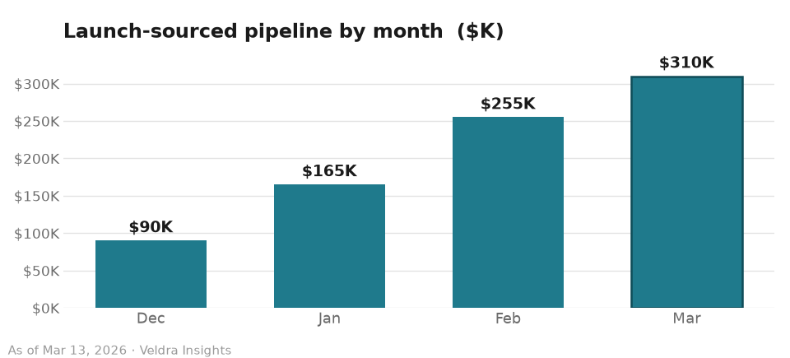

Workstream status
Workstream | Owner | Status | Note
Pricing page & legal review | Priya Raman / Tomas Keller | 🟢 Complete | Legal sign-off received Mar 9; pricing page cleared to publish
Press & analyst briefing | Ana Delgado | 🟢 Complete | Held Mar 10 (rescheduled from Mar 8); two analysts requested follow-up demos
Paid media | Ana Delgado | 🟢 On track | Expanded after Feb 12 budget increase; waitlist tracking to the 5,000 target ahead of GA
Localization (DACH) | — | ⚪ Deferred | Moved to wave 2 (targeted May) per January scope decision; wave-1 scope (US + UK) reconfirmed Mar 6
Press kit assets | Lena Park | 🟡 At risk | Timeline remains tight; creative capacity is constrained through the new Mar 22 GA window
Creative capacity | Marcus Chen | 🟡 At risk | Operating at 3 through March (Marcus 50% on rebrand), now spanning the full runway to the Mar 22 GA

Risks & watch-items
- GA moved one week to March 22, 2026 (approved Mar 6) to give legal sign-off and the rescheduled press briefing enough runway; wave-1 scope (US + UK) is unchanged.
- Creative capacity remains reduced through March — Marcus Chen’s 50% rebrand allocation now spans the full runway to the new Mar 22 GA — keeping the press-kit timeline at risk.
- Waitlist is close to but has not yet crossed the 5,000 target (4,900+ as of Mar 11).
- The creative agency contract renewal is on track for April.

Outlook — next 30 days
- General availability (GA): March 22, 2026, with the announcement at 9:00am PT.
- PR embargo holds through GA under the approved pricing-page claims; embargoed coverage begins ahead of the Mar 22 announcement.
- Waitlist nurture email sequence continues through GA, with signups tracking toward the 5,000 target.
- Press-kit assets finalized ahead of GA, with creative capacity constrained by the rebrand allocation through end of March.

