1. > Retrieve Specialist Details

1. Xml Response

<http://localhost:8080/getspecialistxml/fetchAllDetails>

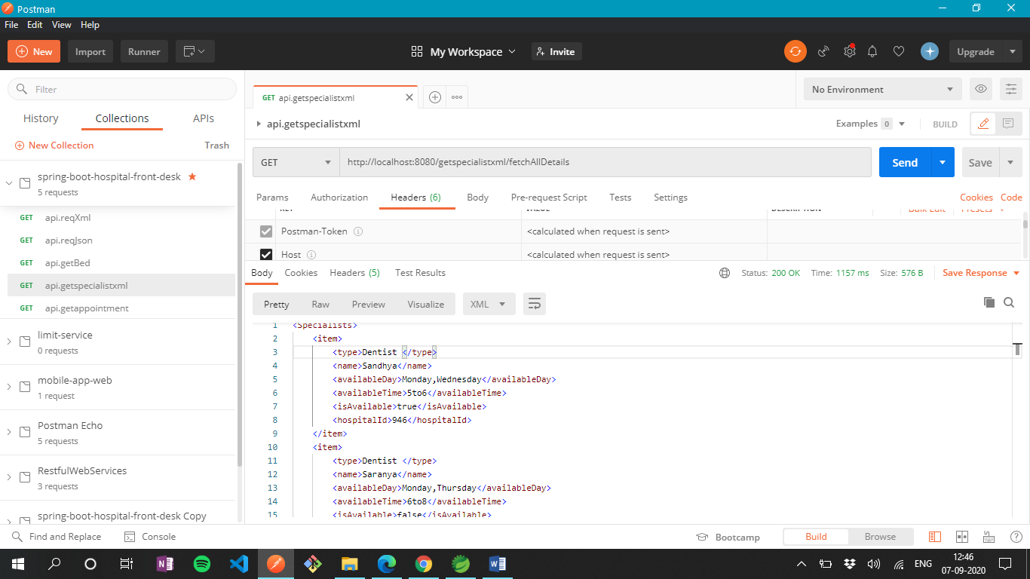

1. JSON Response

<http://localhost:8080/getspecialistjson/fetchAllDetails>

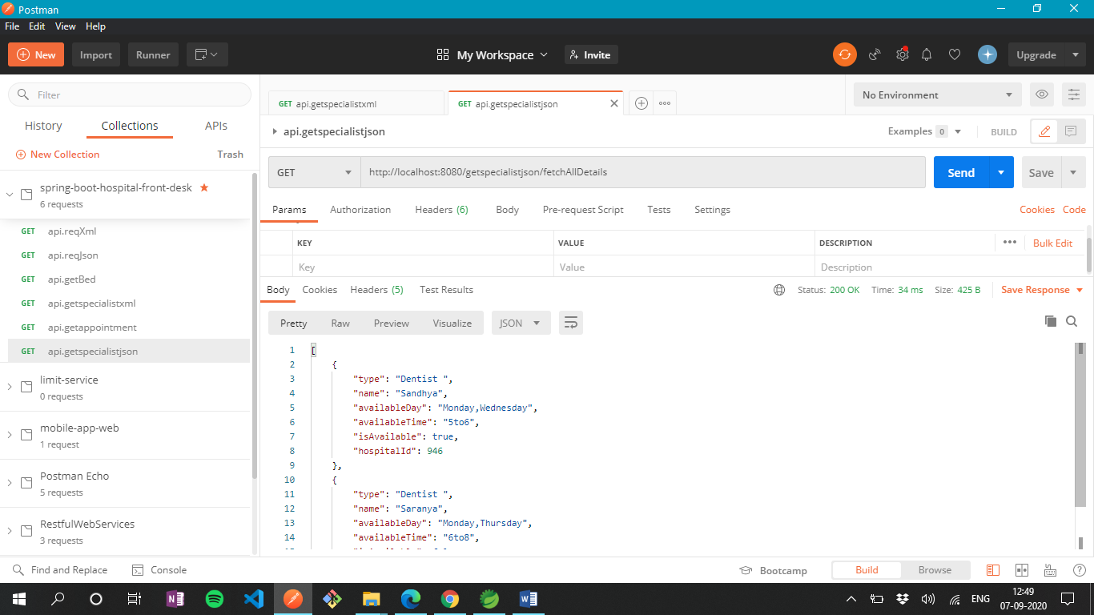

2. > Return new appointment

<http://localhost:8080/bookappointmentjson/Edward/Monday/Suganthi>

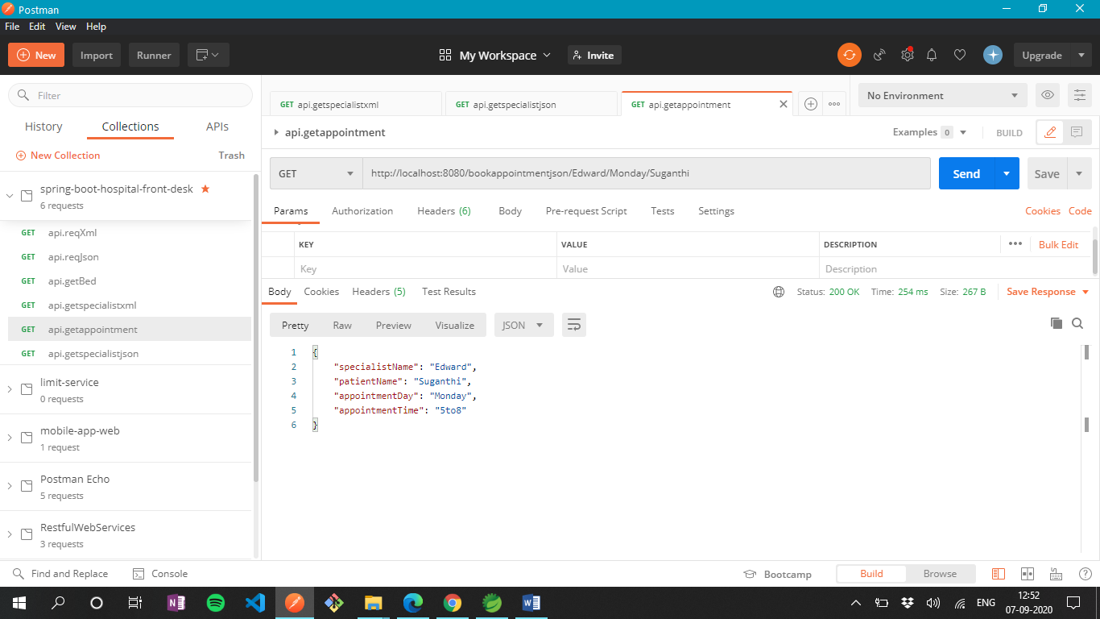

Exception:

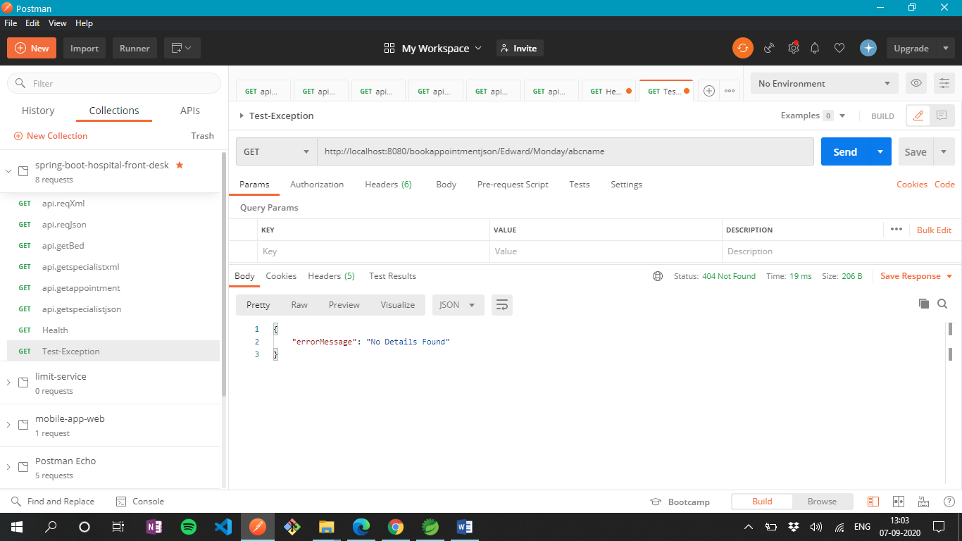

3.> No of beds available

<http://localhost:8080/getBedNumber/RIIMS>

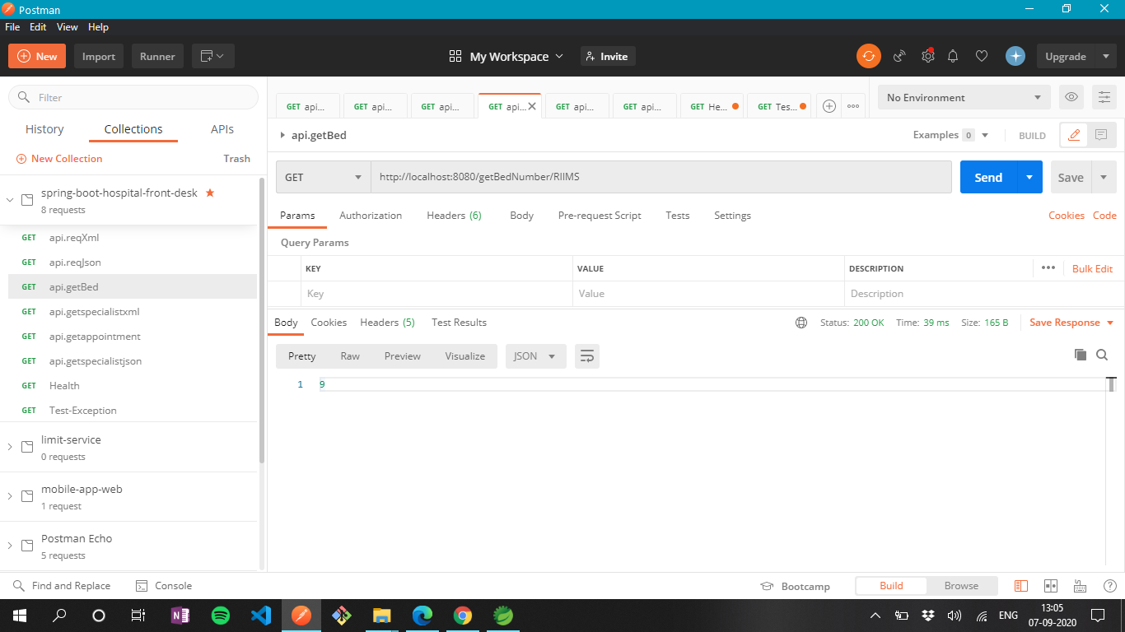

4.> REST Client

<http://localhost:8080/restXml>

<http://localhost:8080/restJson>

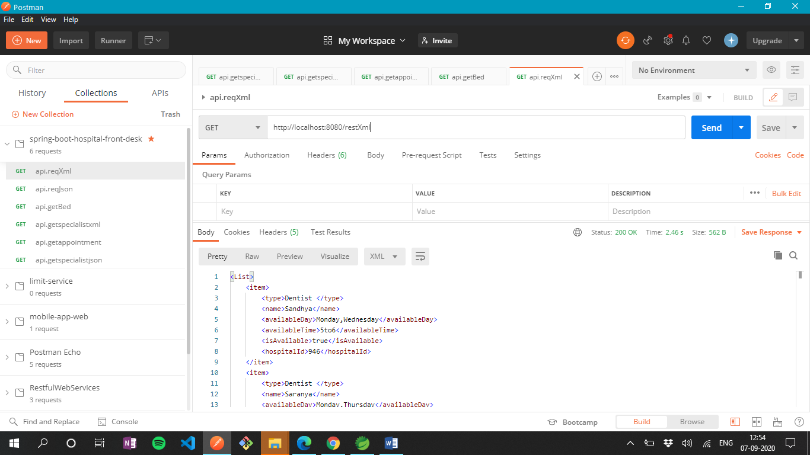

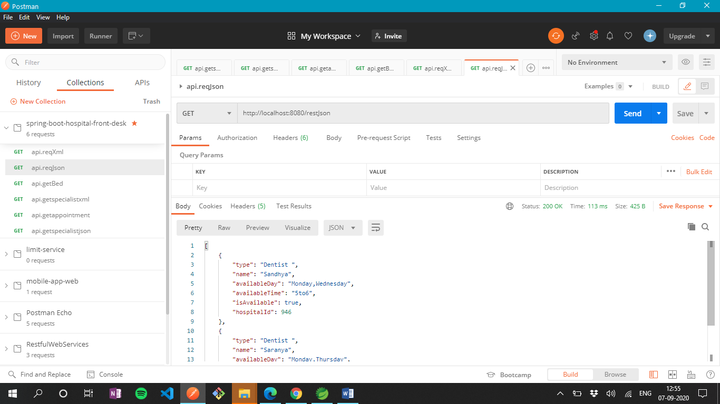

5> REST Actuator Endpoint

<http://localhost:8080/actuator/health>

