**IIEC RISE DOCKER TRAINING**

**PROJECT DOCUMENTATION AND CODES**

***PROJECT DESCRIPTION***:

In this project, a nginx webserver is being used to host a webpage on a specified port locally.

***ABOUT PROJECT***:

In this project a DevOps technology named Docker is used.

An officially launched container of nginx that was pulled from docker hub is used.

**Command for pulling the official image**: *docker pull nginx*

We can run the container in detached mode.

**Command used for running the nginx container:**

*docker run -dit --name docker_project -p 1125:80 -v /root/iiec_docker:/usr/share/nginx/html nginx*

-dit are flags that specify that the container will run in detached mode and will have an interactive terminal.

--name is the used for giving a suitable name to the container.

-p is to specify and expose the port we want to host the page on.

-v specifies the volume. It means we are providing the container the content of the folder /root/iiec_docker to the **default document root** of nginx i.e /usr/share/nginx/html.

After starting the container, we can see our hosted page by going to any browser and providing the IP Address of the host machine along with the port number.

Example: If IP is 192.166.0.70 and port number is 1125, the typing the following in the URL tab will show the page:

192.166.0.70:1125

Note: The machine in which you are opening the page must have **end to end connection**.

If you are viewing on your own machine where you launched the container then you can also use **localhost:1125** to view.

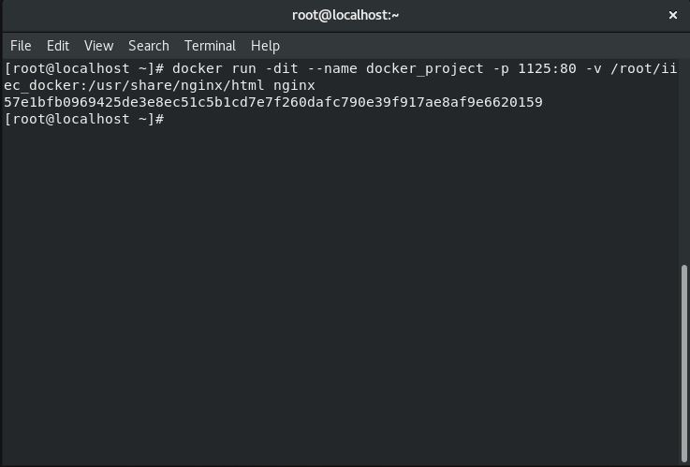Here are some snaps that will help for better understanding:

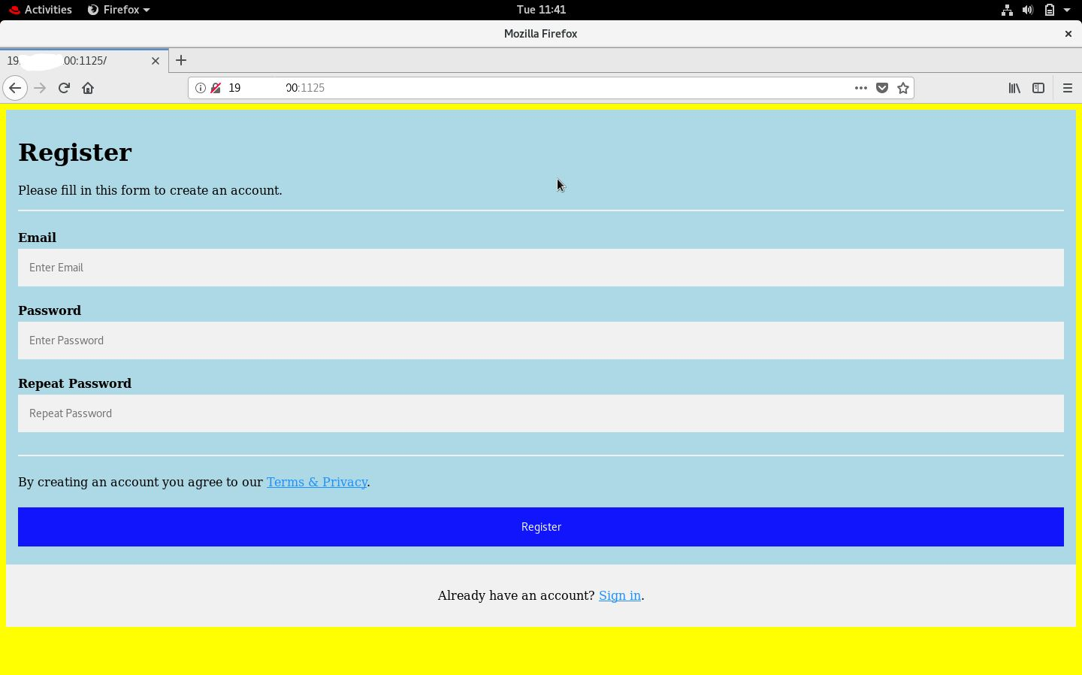

Thanks.

*Project Made By: SOURAV SARAF*

*Team : Debuggers United*

*IIEC ID: RISE 2020.44.5.1*