Service Discovery
If one MS calls another MS and has its url hostname and port in its config file in that scenario any changes in the hostname/port of the other server will lead to manual changes that needs to be made in the consuer MS.

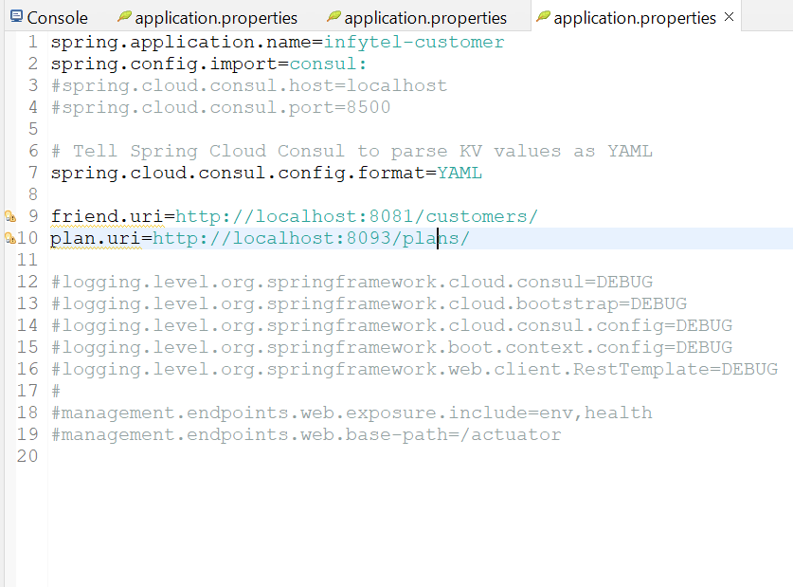

Look at the friend & plan uri in infytel-customer.
Infytel-customer MS currently makes call to the friend and family MS to get some data. If any details of infytel-friend-family MS or infytel-plan-uri MS changes then we need to comeback and manually make changes here.

To solve this problem we have Service Registry:

Service Registry
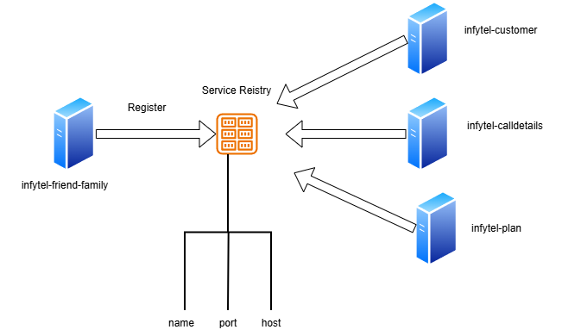

In Service Registry
- Each Microservices needs to register themselves with the central server known as Service Registry with details like names, host or ports etc.
- Thus, making themselves discoverable to the other services.
- If any of the MS changes it port or host there is no impact in other MS and the host port changes start reflecting.

Implementation
Currently as mentioned infytel-customer depends on application.properties to fetch uri and make api calls to infytel-plan or infytel-friend-family.

Step 1 : Add the dependency:
<dependency>
<groupId>org.springframework.cloud</groupId>
<artifactId>spring-cloud-starter-consul-discovery</artifactId>
<version>5.0.0</version>
<exclusions>
<exclusion>
<groupId>org.springframework.cloud</groupId>
<artifactId>spring-cloud-netflix-hystrix</artifactId>
</exclusion>
<exclusion>
<groupId>org.springframework.cloud</groupId>
<artifactId>spring-cloud-netflix-ribbon</artifactId>
</exclusion>
</exclusions>
</dependency>

Step 2: properties file changes
spring.cloud.consul.discovery.hostname=localhost

Step 3:
Autowire the client which is responsible to provide the proper uri in the layer (controller/service) & make a call via it to get all the instances of the app.

@Autowired
private DiscoveryClient client;

@RequestMapping(value="/customers/{phoneNo}", method=RequestMethod.GET, produces = MediaType.APPLICATION_JSON_VALUE)
public CustomerDTO getCustomerProfile(@PathVariable Long phoneNo) {
logger.info("phoneNo");
logger.info("Profile Request for customer" + phoneNo) ;
CustomerDTO custDTO = custService.getCustomerProfile(phoneNo) ;
// PlanDTO planDTO = new RestTemplate().getForObject(planUri + custDTO.getCurrentPlan().getPlanId(), PlanDTO.class) ;
List<ServiceInstance> planInstance=client.getInstances("infytel-plan");
if(planInstance!=null && !planInstance.isEmpty()) {
planUri = planInstance.get(0).getUri().toString() ;
}
PlanDTO planDTO = new RestTemplate().getForObject(planUri+"/plans/" + custDTO.getCurrentPlan().getPlanId(), PlanDTO.class) ;
custDTO.setCurrentPlan(planDTO);
logger.info(planDTO);

@SuppressWarnings("unchecked")
// List<Long> friends = new RestTemplate().getForObject(friendUri+phoneNo+"/friends",List.class);
List<ServiceInstance> friendInstance=client.getInstances("infytel-friend-family");
if(friendInstance!=null && !friendInstance.isEmpty()) {
friendUri = friendInstance.get(0).getUri().toString() ;
}
// List<Integer> friends = new RestTemplate().getForObject(friendUri+phoneNo+"/friends",List.class);
List<Integer> friends = new RestTemplate().getForObject(friendUri+"/customers/"+phoneNo+"/friends",List.class);
List<Long> friendsList= friends.stream().map(f-> {return Long.valueOf(f) ;}).collect(Collectors.toList()) ;
custDTO.setFriendAndFamily(friendsList) ;
return custDTO ;
}

