Report
Of
GenAI Powered Data Analytics
Submitted
To
School of Computer Science and Engineering
IILM University, Greater Noida, U.P.
In partial fulfilment of the requirement of degree of
B.Tech CSE

By
Roll Number of Student: 25SCS1003003220
Name of Student: SOURAV SINGH
Batch: 2026-27 (3rd Semester)

CANDIDATE’S DECLARATION
I, SOURAV SINGH do hereby declare that the internship report titled “GenAI Powered Data Analytics” has been completed by me to fulfil the requirement for the award of the degree of Bachelor of Technology in CSE. All the references have been quoted and I have not taken as such any material from any other source. I affirm to you that this report is my own and has not been submitted to any other institute for any degree/diploma requirement and further I shall be solely responsible for any kind of copyright violation in this regard.
Signature
Student Name: SOURAV SINGH
Roll No.: 25SCS1003003220

ACKNOWLEDGEMENT
I am using this opportunity to express my gratitude to everyone who supported me throughout the Internship Program. I am thankful for their aspiring guidance, invaluably constructive criticism and friendly advice during this work. I am sincerely grateful to them for sharing their truthful and illuminating views on a number of issues related to this work.
I express my gratitude to my parents for their blessings.
Signature
Student Name: SOURAV SINGH
Roll No.: 25SCS1003003220

TABLE OF CONTENTS
Cover Page ............................................................................................ i
1. Candidate’s Declaration ....................................................................... ii
2. Acknowledgment .................................................................................. iii
3. Internship Completion Certificate ....................................................... iv
4. Project Description .............................................................................. 1
4.1 Introduction .................................................................................... 1
4.2 Organization Profile ........................................................................ 1
4.3 Problem Statement ......................................................................... 2
4.4 Project Objectives .......................................................................... 2
4.5 Scope of the Project ....................................................................... 3
4.6 Technologies and Tools Used .......................................................... 3
4.7 System Architecture ....................................................................... 4
4.8 Methodology .................................................................................. 4
4.9 Expected Outcomes ........................................................................ 5
4.10 Certificates of completion and other communication mail proof ..... 6
5. Bibliography/References ..................................................................... 7

3. Internship Completion Certificate
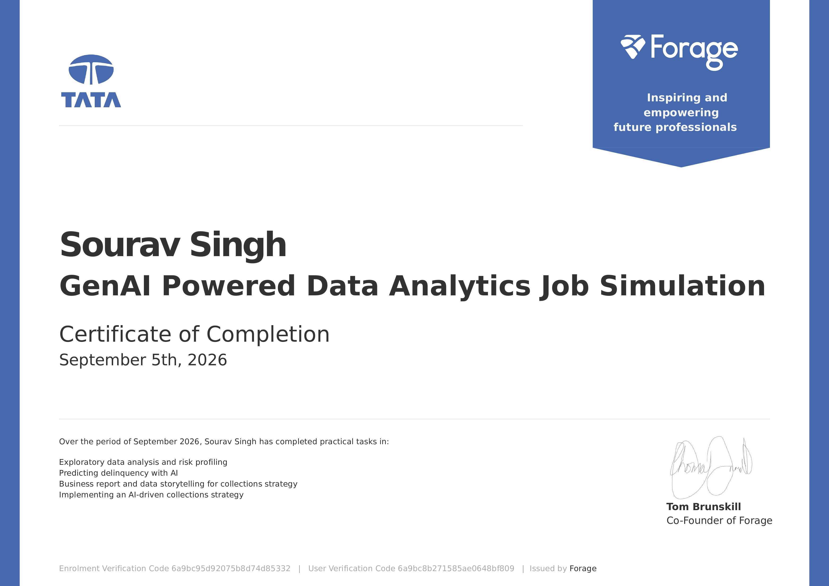

4. Project Description
4.1 Introduction
The purpose of this project was to evaluate the Geldium Finance dataset, identify underlying risk patterns, and outline data cleaning strategies to prepare for delinquency prediction modeling. Using GenAI-powered data analytics, the goal was to identify high-risk segments, core predictors of delinquency, and develop a strategic framework for early collections intervention without relying on linear modeling.
4.2 Organization Profile
This internship experience was facilitated by Forage, an education technology platform that hosts virtual work experience programs. Forage partners with leading global companies to provide students with simulated, real-world tasks. The scenario provided involved Geldium Finance, a simulated lending organization requiring an AI-powered collections strategy.
4.3 Problem Statement
Geldium Finance manages a lending portfolio where delinquent accounts represent a critical financial risk. However, traditional linear indicators, such as raw credit score or income, demonstrate virtually zero linear correlation with customer default behavior. Existing collection approaches operate reactively after severe delinquency occurs, leading to high charge-off rates, costly manual interventions, and potential bias across demographic groups. The dataset features notable class imbalance (16% default rate) and complex, non-linear interactions across credit utilization and multi-month payment trajectories.
4.4 Project Objectives
1. Develop an end-to-end responsible AI predictive framework that detects early default risk.
2. Automate targeted pre-delinquency interventions (such as early-stage alerts for accounts exceeding 80% utilization with recent missed payments).
3. Enforce algorithmic fairness and regulatory transparency in predictive models.
4.5 Scope of the Project
The scope encompasses data preprocessing (handling missing values via median imputation), feature engineering, predictive modeling using Gradient Boosting Classifiers, and formulating a stakeholder-ready business summary. It also strictly covers the ethical integration of Agentic AI, ensuring Disparate Impact testing and explainable AI metrics are maintained.
4.6 Technologies and Tools Used
- Python (Pandas, Scikit-learn, NumPy)
- Machine Learning Algorithms: Gradient Boosting, Logistic Regression, Support Vector Machines
- GenAI Models (ChatGPT/Gemini) for framework design and logic structuring
- Microsoft Excel, Word, and PowerPoint for EDA reporting and executive presentations
4.7 System Architecture
The Agentic AI architecture follows a distinct four-tier flow:
Inputs: The system ingests structured demographic and repayment data. Key drivers include current Credit Utilization, Month 1 Payment Status, Account Tenure, and Debt-to-Income ratios.
Decision Logic: A Gradient Boosting Algorithm maps non-linear risk patterns. It generates probabilities of default based on complex interactions, moving beyond simple linear rules.
Actions: Risk tiers trigger interventions. E.g., High Utilization + Missed Month 1 payment triggers an automated, supportive 'Early Intervention SMS & Email' sequence.
Learning: The model continuously updates. Tree-based logic assigns higher weights to newly misclassified accounts, improving predictive accuracy and recall over time.
4.8 Methodology
Phase 1: Exploratory Data Analysis (EDA) - Audited the 500-record Geldium Finance dataset across 19 financial and demographic features. Recommended median imputation for missing values in Income, Loan_Balance, and Credit_Score.
Phase 2: Predictive Model Architecture - Evaluated candidate algorithms, rejecting simple linear models in favor of tree-based ensembles capable of learning non-linear boundary splits.
Phase 3: Business Strategy Formulation - Synthesized model insights into an executive proposal, creating a SMART recommendation for automated early SMS/email reminders.
Phase 4: Responsible AI Guardrails - Deployed fairness checks (Disparate Impact testing) and explainability requirements (Feature Importance) to prevent biased outcomes.
4.9 Expected Outcomes
Quantitative Outcomes: By transitioning from a reactive 60-day default model to proactive early intervention, Geldium targets a 10% reduction in long-term delinquency. This drastically cuts the operational costs associated with manual debt collection calls and write-offs.
Qualitative Outcomes: Intervening early with supportive digital reminders enhances customer trust and retention. Transparent, explainable AI ensures institutional fairness, while the automated tiering creates a highly scalable framework for future growth.

4.10 Certificates of completion and other communication mail proof
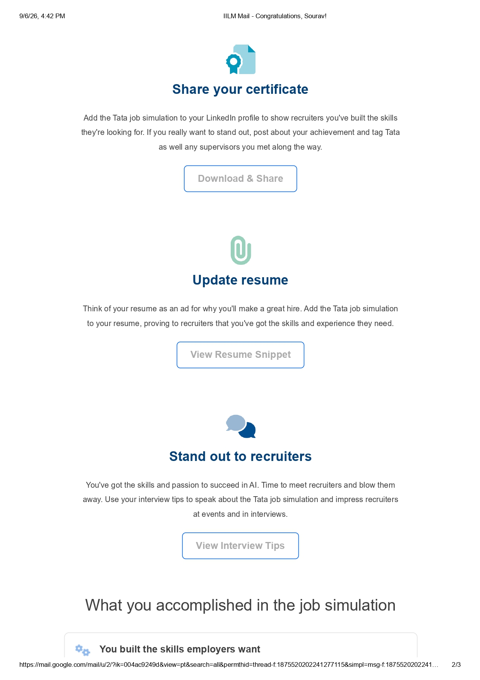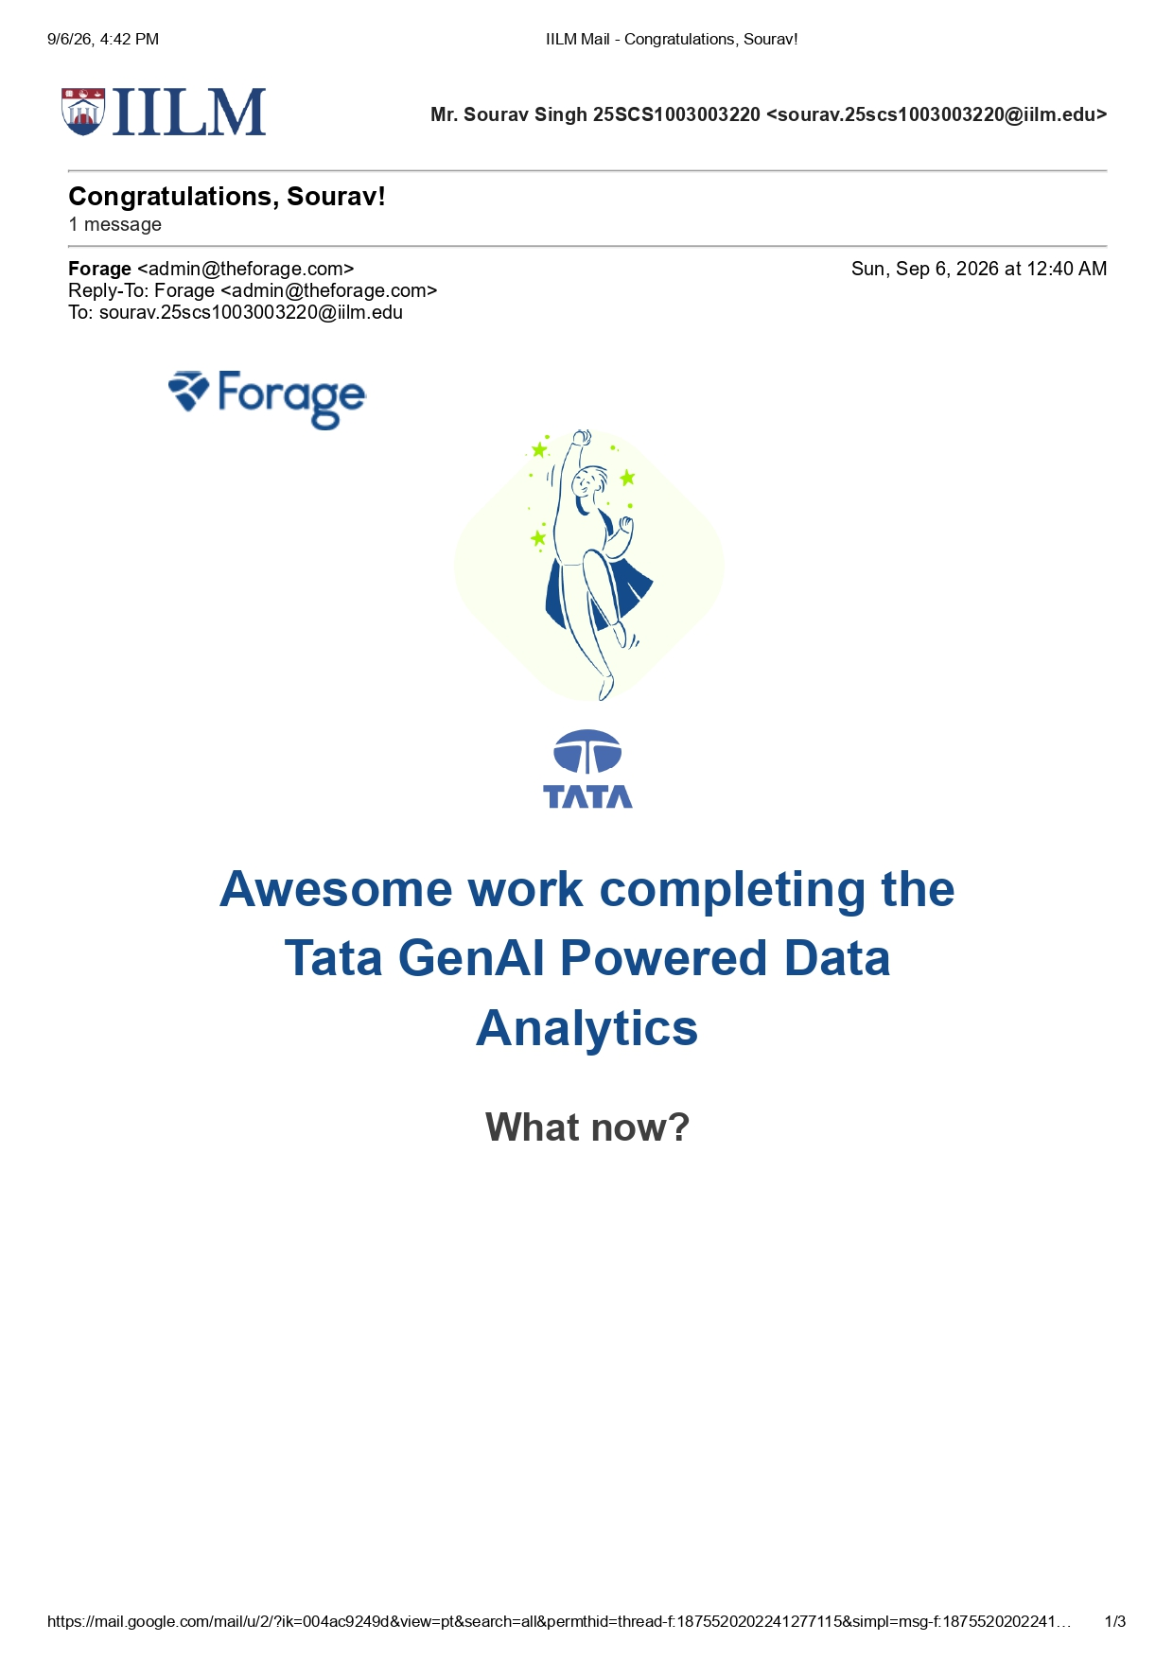

5. Bibliography/References
[1] Geldium Finance Dataset (Delinquency_prediction_dataset.xlsx). Provided via Forage Virtual Experience.
[2] Forage GenAI Powered Data Analytics Virtual Internship Course Materials.
[3] Scikit-learn Documentation: Gradient Boosting Classifiers and Predictive Modeling.
[4] Pandas Documentation: Data Analysis and Manipulation in Python.

