**Dijkstra’s Algorithm**

When a graph is weighted, to solve single source problem we need Dijkstra’s algorithm

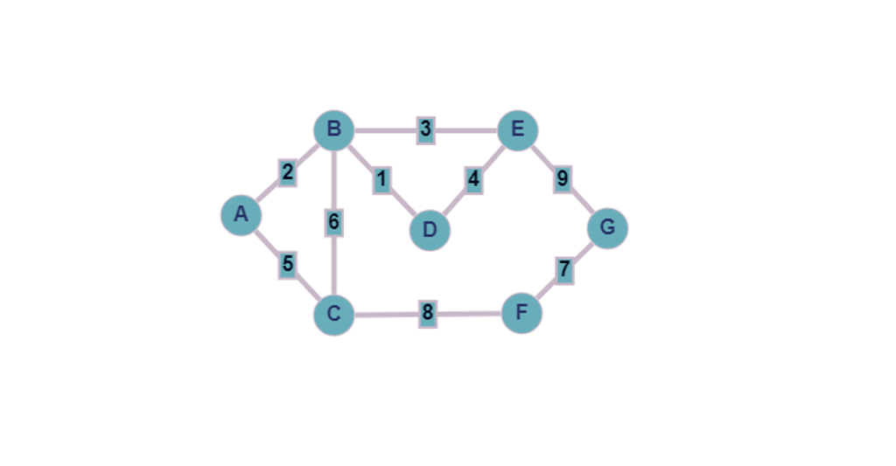

* Starting point is A, so cost of vertex A is 0 and rest are marked to infinity.
* Next unexplored neighboring points are B and C

**Final output is as shown below:**

