com
Package in package 'RESAPI'

com
Version 1.0 Phase 1.0 Proposed
LENOVO created on 05/11/2025. Last modified 05/11/2025

juaracoding
Package in package 'com'

juaracoding
Version 1.0 Phase 1.0 Proposed
LENOVO created on 05/11/2025. Last modified 05/11/2025

juaracoding diagram
Class diagram in package 'juaracoding'

juaracoding
Version 1.0
LENOVO created on 05/11/2025. Last modified 05/11/2025

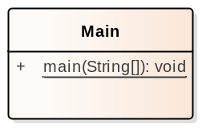

- juaracoding

config
Package in package 'juaracoding'

config
Version 1.0 Phase 1.0 Proposed
LENOVO created on 05/11/2025. Last modified 05/11/2025

config diagram
Class diagram in package 'config'

config
Version 1.0
LENOVO created on 05/11/2025. Last modified 05/11/2025

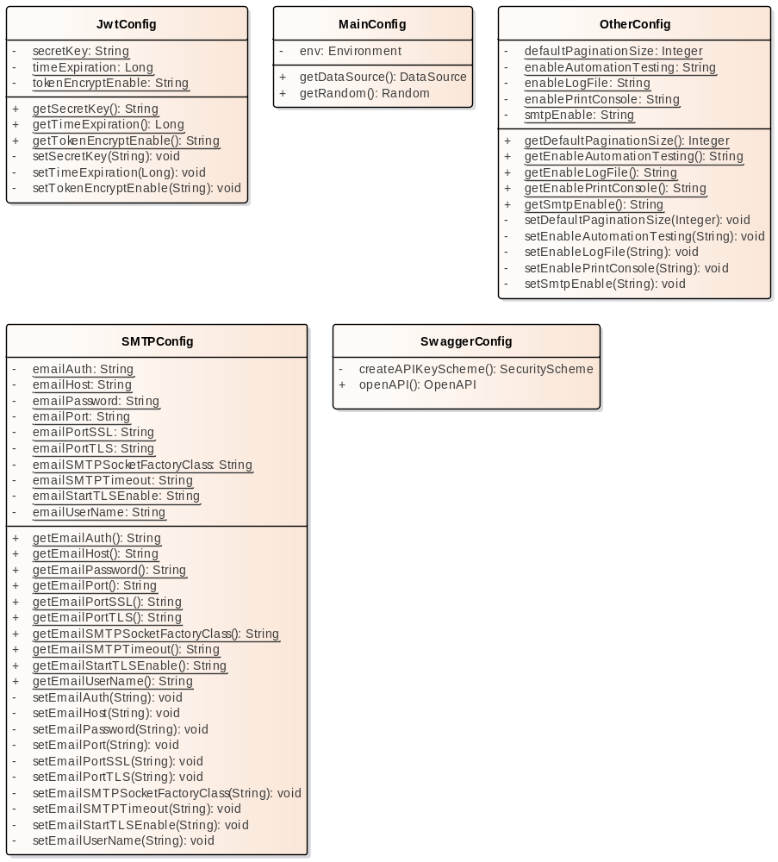

- config

JwtConfig
Class in package 'config'

JwtConfig
Version 1.0 Phase 1.0 Proposed
LENOVO created on 05/11/2025. Last modified 05/11/2025

ATTRIBUTES
secretKey : String Private
[ Is static True. Containment is Not Specified. ]

timeExpiration : Long Private
[ Is static True. Containment is Not Specified. ]

tokenEncryptEnable : String Private
[ Is static True. Containment is Not Specified. ]

OPERATIONS
getSecretKey () : String Public
[ Is static True. Is abstract False. Is return array False. Is query False. Is synchronized False. ]

getTimeExpiration () : Long Public
[ Is static True. Is abstract False. Is return array False. Is query False. Is synchronized False. ]

getTokenEncryptEnable () : String Public
[ Is static True. Is abstract False. Is return array False. Is query False. Is synchronized False. ]

setSecretKey (secretKey : String ) : void Private

Properties:
annotations = @Value("${secret.key}")
[ Is static False. Is abstract False. Is return array False. Is query False. Is synchronized False. ]

setTimeExpiration (timeExpiration : Long ) : void Private

Properties:
annotations = @Value("${time.expiration}")
[ Is static False. Is abstract False. Is return array False. Is query False. Is synchronized False. ]

setTokenEncryptEnable (tokenEncryptEnable : String ) : void Private

Properties:
annotations = @Value("${token.enable.encrypt}")
[ Is static False. Is abstract False. Is return array False. Is query False. Is synchronized False. ]

MainConfig
Class in package 'config'

MainConfig
Version 1.0 Phase 1.0 Proposed
LENOVO created on 05/11/2025. Last modified 05/11/2025

ATTRIBUTES
env : Environment Private

Properties:
annotations = @Autowired
[ Is static False. Containment is Not Specified. ]

OPERATIONS
getDataSource () : DataSource Public

Properties:
annotations = @Primary@Bean
[ Is static False. Is abstract False. Is return array False. Is query False. Is synchronized False. ]

getRandom () : Random Public

Properties:
annotations = @Bean
[ Is static False. Is abstract False. Is return array False. Is query False. Is synchronized False. ]

OtherConfig
Class in package 'config'

OtherConfig
Version 1.0 Phase 1.0 Proposed
LENOVO created on 05/11/2025. Last modified 05/11/2025

ATTRIBUTES
defaultPaginationSize : Integer Private
[ Is static True. Containment is Not Specified. ]

enableAutomationTesting : String Private
[ Is static True. Containment is Not Specified. ]

enableLogFile : String Private
[ Is static True. Containment is Not Specified. ]

enablePrintConsole : String Private
[ Is static True. Containment is Not Specified. ]

smtpEnable : String Private
[ Is static True. Containment is Not Specified. ]

OPERATIONS
getDefaultPaginationSize () : Integer Public
[ Is static True. Is abstract False. Is return array False. Is query False. Is synchronized False. ]

getEnableAutomationTesting () : String Public
[ Is static True. Is abstract False. Is return array False. Is query False. Is synchronized False. ]

getEnableLogFile () : String Public
[ Is static True. Is abstract False. Is return array False. Is query False. Is synchronized False. ]

getEnablePrintConsole () : String Public
[ Is static True. Is abstract False. Is return array False. Is query False. Is synchronized False. ]

getSmtpEnable () : String Public
[ Is static True. Is abstract False. Is return array False. Is query False. Is synchronized False. ]

setDefaultPaginationSize (defaultPaginationSize : Integer ) : void Private

Properties:
annotations = @Value("${default.pagination.size}")
[ Is static False. Is abstract False. Is return array False. Is query False. Is synchronized False. ]

setEnableAutomationTesting (enableAutomationTesting : String ) : void Private

Properties:
annotations = @Value("${enable.automation.testing}")
[ Is static False. Is abstract False. Is return array False. Is query False. Is synchronized False. ]

setEnableLogFile (enableLogFile : String ) : void Private

Properties:
annotations = @Value("${enable.log.file}")
[ Is static False. Is abstract False. Is return array False. Is query False. Is synchronized False. ]

setEnablePrintConsole (enablePrintConsole : String ) : void Private

Properties:
annotations = @Value("${enable.print.console}")
[ Is static False. Is abstract False. Is return array False. Is query False. Is synchronized False. ]

setSmtpEnable (smtpEnable : String ) : void Private

Properties:
annotations = @Value("${smtp.enable}")
[ Is static False. Is abstract False. Is return array False. Is query False. Is synchronized False. ]

SMTPConfig
Class in package 'config'

SMTPConfig
Version 1.0 Phase 1.0 Proposed
LENOVO created on 05/11/2025. Last modified 05/11/2025

ATTRIBUTES
emailAuth : String Private
[ Is static True. Containment is Not Specified. ]

emailHost : String Private
[ Is static True. Containment is Not Specified. ]

emailPassword : String Private
[ Is static True. Containment is Not Specified. ]

emailPort : String Private
[ Is static True. Containment is Not Specified. ]

emailPortSSL : String Private
[ Is static True. Containment is Not Specified. ]

emailPortTLS : String Private
[ Is static True. Containment is Not Specified. ]

emailSMTPSocketFactoryClass : String Private
[ Is static True. Containment is Not Specified. ]

emailSMTPTimeout : String Private
[ Is static True. Containment is Not Specified. ]

emailStartTLSEnable : String Private
[ Is static True. Containment is Not Specified. ]

emailUserName : String Private
[ Is static True. Containment is Not Specified. ]

OPERATIONS
getEmailAuth () : String Public
[ Is static True. Is abstract False. Is return array False. Is query False. Is synchronized False. ]

getEmailHost () : String Public
[ Is static True. Is abstract False. Is return array False. Is query False. Is synchronized False. ]

getEmailPassword () : String Public
[ Is static True. Is abstract False. Is return array False. Is query False. Is synchronized False. ]

getEmailPort () : String Public
[ Is static True. Is abstract False. Is return array False. Is query False. Is synchronized False. ]

getEmailPortSSL () : String Public
[ Is static True. Is abstract False. Is return array False. Is query False. Is synchronized False. ]

getEmailPortTLS () : String Public
[ Is static True. Is abstract False. Is return array False. Is query False. Is synchronized False. ]

getEmailSMTPSocketFactoryClass () : String Public
[ Is static True. Is abstract False. Is return array False. Is query False. Is synchronized False. ]

getEmailSMTPTimeout () : String Public
[ Is static True. Is abstract False. Is return array False. Is query False. Is synchronized False. ]

getEmailStartTLSEnable () : String Public
[ Is static True. Is abstract False. Is return array False. Is query False. Is synchronized False. ]

getEmailUserName () : String Public
[ Is static True. Is abstract False. Is return array False. Is query False. Is synchronized False. ]

setEmailAuth (emailAuth : String ) : void Private

Properties:
annotations = @Value("${email.auth}")
[ Is static False. Is abstract False. Is return array False. Is query False. Is synchronized False. ]

setEmailHost (emailHost : String ) : void Private

Properties:
annotations = @Value("${email.host}")
[ Is static False. Is abstract False. Is return array False. Is query False. Is synchronized False. ]

setEmailPassword (emailPassword : String ) : void Private

Properties:
annotations = @Value("${email.password}")
[ Is static False. Is abstract False. Is return array False. Is query False. Is synchronized False. ]

setEmailPort (emailPort : String ) : void Private

Properties:
annotations = @Value("${email.port}")
[ Is static False. Is abstract False. Is return array False. Is query False. Is synchronized False. ]

setEmailPortSSL (emailPortSSL : String ) : void Private

Properties:
annotations = @Value("${email.port.ssl}")
[ Is static False. Is abstract False. Is return array False. Is query False. Is synchronized False. ]

setEmailPortTLS (emailPortTLS : String ) : void Private

Properties:
annotations = @Value("${email.port.tls}")
[ Is static False. Is abstract False. Is return array False. Is query False. Is synchronized False. ]

setEmailSMTPSocketFactoryClass (emailSMTPSocketFactoryClass : String ) : void Private

Properties:
annotations = @Value("${email.smtp.socket.factory.class}")
[ Is static False. Is abstract False. Is return array False. Is query False. Is synchronized False. ]

setEmailSMTPTimeout (emailSMTPTimeout : String ) : void Private

Properties:
annotations = @Value("${email.smtp.timeout}")
[ Is static False. Is abstract False. Is return array False. Is query False. Is synchronized False. ]

setEmailStartTLSEnable (emailStartTLSEnable : String ) : void Private

Properties:
annotations = @Value("${email.starttls.enable}")
[ Is static False. Is abstract False. Is return array False. Is query False. Is synchronized False. ]

setEmailUserName (emailUserName : String ) : void Private

Properties:
annotations = @Value("${email.username}")
[ Is static False. Is abstract False. Is return array False. Is query False. Is synchronized False. ]

SwaggerConfig
Class in package 'config'

SwaggerConfig
Version 1.0 Phase 1.0 Proposed
LENOVO created on 05/11/2025. Last modified 05/11/2025

OPERATIONS
createAPIKeyScheme () : SecurityScheme Private
[ Is static False. Is abstract False. Is return array False. Is query False. Is synchronized False. ]

openAPI () : OpenAPI Public

DEFAULT URL Untuk mengakses SWAGGER http://localhost:8033/swagger-ui/index.html

Properties:
annotations = @Bean
[ Is static False. Is abstract False. Is return array False. Is query False. Is synchronized False. ]

controller
Package in package 'juaracoding'

controller
Version 1.0 Phase 1.0 Proposed
LENOVO created on 05/11/2025. Last modified 05/11/2025

controller diagram
Class diagram in package 'controller'

controller
Version 1.0
LENOVO created on 05/11/2025. Last modified 05/11/2025

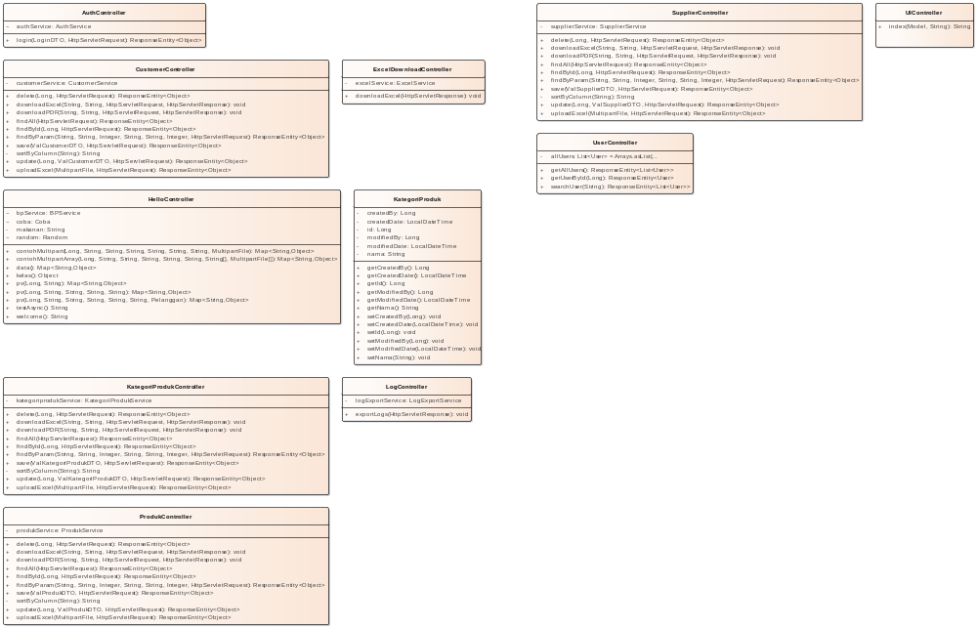

- controller

AuthController
Class in package 'controller'

auth/** auth/login auth/regis auth/forgotpassword

AuthController
Version 1.0 Phase 1.0 Proposed
LENOVO created on 05/11/2025. Last modified 05/11/2025

ATTRIBUTES
authService : AuthService Package

Properties:
annotations = @Autowired
[ Is static False. Containment is Not Specified. ]

ASSOCIATIONS
Association (direction: Source -> Destination)

Source: Public (Class) AuthController | Target: Package authService (Class) AuthService

OPERATIONS
login (loginDTO : LoginDTO , request : HttpServletRequest ) : ResponseEntity<Object> Public

Properties:
annotations = @PostMapping("/login")
[ Is static False. Is abstract False. Is return array False. Is query False. Is synchronized False. ]

CustomerController
Class in package 'controller'

CustomerController
Version 1.0 Phase 1.0 Proposed
LENOVO created on 05/11/2025. Last modified 05/11/2025

ATTRIBUTES
customerService : CustomerService Private

Properties:
annotations = @Autowired
[ Is static False. Containment is Not Specified. ]

ASSOCIATIONS
Association (direction: Source -> Destination)

Source: Public (Class) CustomerController | Target: Private customerService (Class) CustomerService

OPERATIONS
delete (id : Long , request : HttpServletRequest ) : ResponseEntity<Object> Public

Properties:
annotations = @DeleteMapping("/{id}")
[ Is static False. Is abstract False. Is return array False. Is query False. Is synchronized False. ]

downloadExcel (column : String , value : String , request : HttpServletRequest , response : HttpServletResponse ) : void Public

Properties:
annotations = @GetMapping("/download-excel")
[ Is static False. Is abstract False. Is return array False. Is query False. Is synchronized False. ]

downloadPDF (column : String , value : String , request : HttpServletRequest , response : HttpServletResponse ) : void Public

Properties:
annotations = @GetMapping("/download-pdf")
[ Is static False. Is abstract False. Is return array False. Is query False. Is synchronized False. ]

findAll (request : HttpServletRequest ) : ResponseEntity<Object> Public

Properties:
annotations = @GetMapping
[ Is static False. Is abstract False. Is return array False. Is query False. Is synchronized False. ]

findById (id : Long , request : HttpServletRequest ) : ResponseEntity<Object> Public

Properties:
annotations = @GetMapping("/{id}")
[ Is static False. Is abstract False. Is return array False. Is query False. Is synchronized False. ]

findByParam (sort : String , sortBy : String , page : Integer , column : String , value : String , size : Integer , request : HttpServletRequest ) : ResponseEntity<Object> Public

Properties:
annotations = @GetMapping("/{sort}/{sort_by}/{page}")
[ Is static False. Is abstract False. Is return array False. Is query False. Is synchronized False. ]

save (valCustomerDTO : ValCustomerDTO , request : HttpServletRequest ) : ResponseEntity<Object> Public

Properties:
annotations = @PostMapping
[ Is static False. Is abstract False. Is return array False. Is query False. Is synchronized False. ]

sortByColumn (sortBy : String ) : String Private
[ Is static False. Is abstract False. Is return array False. Is query False. Is synchronized False. ]

update (id : Long , valCustomerDTO : ValCustomerDTO , request : HttpServletRequest ) : ResponseEntity<Object> Public

Properties:
annotations = @PutMapping("/{id}")
[ Is static False. Is abstract False. Is return array False. Is query False. Is synchronized False. ]

uploadExcel (file : MultipartFile , request : HttpServletRequest ) : ResponseEntity<Object> Public

Properties:
annotations = @PostMapping("/upload")
[ Is static False. Is abstract False. Is return array False. Is query False. Is synchronized False. ]

ExcelDownloadController
Class in package 'controller'

ExcelDownloadController
Version 1.0 Phase 1.0 Proposed
LENOVO created on 05/11/2025. Last modified 05/11/2025

ATTRIBUTES
excelService : ExcelService Private

Properties:
annotations = @Autowired
[ Is static False. Containment is Not Specified. ]

ASSOCIATIONS
Association (direction: Source -> Destination)

Source: Public (Class) ExcelDownloadController | Target: Private excelService (Class) ExcelService

OPERATIONS
downloadExcel (response : HttpServletResponse ) : void Public

Properties:
annotations = @GetMapping("/download/excel")
throws = IOException
[ Is static False. Is abstract False. Is return array False. Is query False. Is synchronized False. ]

HelloController
Class in package 'controller'

HelloController
Version 1.0 Phase 1.0 Proposed
LENOVO created on 05/11/2025. Last modified 05/11/2025

ATTRIBUTES
bpService : BPService Package

Properties:
annotations = @Autowired
[ Is static False. Containment is Not Specified. ]

coba : Coba Package

Properties:
annotations = @Autowired
[ Is static False. Containment is Not Specified. ]

makanan : String Private

Properties:
annotations = @Value("${ayam.goreng}")
[ Is static False. Containment is Not Specified. ]

random : Random Package

Properties:
annotations = @Autowired
[ Is static False. Containment is Not Specified. ]

ASSOCIATIONS
Association (direction: Source -> Destination)

Source: Public (Class) HelloController | Target: Package coba (Class) Coba
Association (direction: Source -> Destination)

Source: Public (Class) HelloController | Target: Package bpService (Class) BPService

OPERATIONS
contohMultipart (id : Long , namaLengkap : String , tanggalLahir : String , tambahan : String , noHp : String , alamatLengkap : String , nilai1 : String , file : MultipartFile ) : Map<String,Object> Public

sample request : http://localhost:8080/pv/3/Paul%20Malau/1995-12-12?no_hp=08129128984&alamat_lengkap=bogor

Properties:
annotations = @PostMapping("/mp/{id}/{nama_lengkap}/{tgl_lahir}/{tambahan}")
[ Is static False. Is abstract False. Is return array False. Is query False. Is synchronized False. ]

contohMultipartArray (id : Long , namaLengkap : String , tanggalLahir : String , tambahan : String , noHp : String , alamatLengkap : String , nilai1 : String[] , file : MultipartFile[] ) : Map<String,Object> Public

Properties:
annotations = @PostMapping("/mparr/{id}/{nama_lengkap}/{tgl_lahir}/{tambahan}")
[ Is static False. Is abstract False. Is return array False. Is query False. Is synchronized False. ]

data () : Map<String,Object> Public

Properties:
annotations = @GetMapping("data")
[ Is static False. Is abstract False. Is return array False. Is query False. Is synchronized False. ]

kelas () : Object Public

Properties:
annotations = @GetMapping("kelas")
[ Is static False. Is abstract False. Is return array False. Is query False. Is synchronized False. ]

pv (id : Long , namaLengkap : String ) : Map<String,Object> Public

Properties:
annotations = @GetMapping("/pv/{id}/{nama_lengkap}")
[ Is static False. Is abstract False. Is return array False. Is query False. Is synchronized False. ]

pv (id : Long , namaLengkap : String , tanggalLahir : String , noHp : String , alamatLengkap : String ) : Map<String,Object> Public

sample request : http://localhost:8080/pv/3/Paul%20Malau/1995-12-12?no_hp=08129128984&alamat_lengkap=bogor

Properties:
annotations = @GetMapping("/pv/{id}/{nama_lengkap}/{tgl_lahir}")
[ Is static False. Is abstract False. Is return array False. Is query False. Is synchronized False. ]

pv (id : Long , namaLengkap : String , tanggalLahir : String , tambahan : String , noHp : String , alamatLengkap : String , pelanggan : Pelanggan ) : Map<String,Object> Public

sample request : http://localhost:8080/pv/3/Paul%20Malau/1995-12-12?no_hp=08129128984&alamat_lengkap=bogor

Properties:
annotations = @PostMapping("/pv/{id}/{nama_lengkap}/{tgl_lahir}/{tambahan}")
[ Is static False. Is abstract False. Is return array False. Is query False. Is synchronized False. ]

testAsync () : String Public

Properties:
annotations = @GetMapping("asink")
[ Is static False. Is abstract False. Is return array False. Is query False. Is synchronized False. ]

welcome () : String Public

Properties:
annotations = @GetMapping("welcome")
[ Is static False. Is abstract False. Is return array False. Is query False. Is synchronized False. ]

KategoriProduk
Class in package 'controller'

KategoriProduk
Version 1.0 Phase 1.0 Proposed
LENOVO created on 05/11/2025. Last modified 05/11/2025

ATTRIBUTES
createdBy : Long Private

Properties:
annotations = @Column(name = "CreatedBy",nullable = false,updatable = false)
[ Is static False. Containment is Not Specified. ]

createdDate : LocalDateTime Private

Properties:
annotations = @Column(name = "CreatedDate",nullable = false,updatable = false)
[ Is static False. Containment is Not Specified. ]

id : Long Private

Properties:
annotations = @Id@GeneratedValue(strategy = GenerationType.IDENTITY)@Column(name = "ID")
[ Is static False. Containment is Not Specified. ]

modifiedBy : Long Private

Properties:
annotations = @Column(name = "ModifiedBy",insertable = false)
[ Is static False. Containment is Not Specified. ]

modifiedDate : LocalDateTime Private

Properties:
annotations = @Column(name = "ModifiedDate",insertable = false)
[ Is static False. Containment is Not Specified. ]

nama : String Private

Properties:
annotations = @Column(name = "Nama",length = 60,nullable = false,unique = true)
[ Is static False. Containment is Not Specified. ]

OPERATIONS
getCreatedBy () : Long Public
[ Is static False. Is abstract False. Is return array False. Is query False. Is synchronized False. ]

getCreatedDate () : LocalDateTime Public
[ Is static False. Is abstract False. Is return array False. Is query False. Is synchronized False. ]

getId () : Long Public
[ Is static False. Is abstract False. Is return array False. Is query False. Is synchronized False. ]

getModifiedBy () : Long Public
[ Is static False. Is abstract False. Is return array False. Is query False. Is synchronized False. ]

getModifiedDate () : LocalDateTime Public
[ Is static False. Is abstract False. Is return array False. Is query False. Is synchronized False. ]

getNama () : String Public
[ Is static False. Is abstract False. Is return array False. Is query False. Is synchronized False. ]

setCreatedBy (createdBy : Long ) : void Public
[ Is static False. Is abstract False. Is return array False. Is query False. Is synchronized False. ]

setCreatedDate (createdDate : LocalDateTime ) : void Public
[ Is static False. Is abstract False. Is return array False. Is query False. Is synchronized False. ]

setId (id : Long ) : void Public
[ Is static False. Is abstract False. Is return array False. Is query False. Is synchronized False. ]

setModifiedBy (modifiedBy : Long ) : void Public
[ Is static False. Is abstract False. Is return array False. Is query False. Is synchronized False. ]

setModifiedDate (modifiedDate : LocalDateTime ) : void Public
[ Is static False. Is abstract False. Is return array False. Is query False. Is synchronized False. ]

setNama (nama : String ) : void Public
[ Is static False. Is abstract False. Is return array False. Is query False. Is synchronized False. ]

KategoriProdukController
Class in package 'controller'

KategoriProdukController
Version 1.0 Phase 1.0 Proposed
LENOVO created on 05/11/2025. Last modified 05/11/2025

ATTRIBUTES
kategoriprodukService : KategoriProdukService Private

Properties:
annotations = @Autowired
[ Is static False. Containment is Not Specified. ]

ASSOCIATIONS
Association (direction: Source -> Destination)

Source: Public (Class) KategoriProdukController | Target: Private kategoriprodukService (Class) KategoriProdukService

OPERATIONS
delete (id : Long , request : HttpServletRequest ) : ResponseEntity<Object> Public

Properties:
annotations = @DeleteMapping("/{id}")
[ Is static False. Is abstract False. Is return array False. Is query False. Is synchronized False. ]

downloadExcel (column : String , value : String , request : HttpServletRequest , response : HttpServletResponse ) : void Public

Properties:
annotations = @GetMapping("/download-excel")
[ Is static False. Is abstract False. Is return array False. Is query False. Is synchronized False. ]

downloadPDF (column : String , value : String , request : HttpServletRequest , response : HttpServletResponse ) : void Public

Properties:
annotations = @GetMapping("/download-pdf")
[ Is static False. Is abstract False. Is return array False. Is query False. Is synchronized False. ]

findAll (request : HttpServletRequest ) : ResponseEntity<Object> Public

Properties:
annotations = @GetMapping
[ Is static False. Is abstract False. Is return array False. Is query False. Is synchronized False. ]

findById (id : Long , request : HttpServletRequest ) : ResponseEntity<Object> Public

Properties:
annotations = @GetMapping("/{id}")
[ Is static False. Is abstract False. Is return array False. Is query False. Is synchronized False. ]

findByParam (sort : String , sortBy : String , page : Integer , column : String , value : String , size : Integer , request : HttpServletRequest ) : ResponseEntity<Object> Public

Properties:
annotations = @GetMapping("/{sort}/{sort_by}/{page}")
[ Is static False. Is abstract False. Is return array False. Is query False. Is synchronized False. ]

save (valProdukDTO : ValKategoriProdukDTO , request : HttpServletRequest ) : ResponseEntity<Object> Public

@PostMapping("/save") public ResponseEntity<Object> saveOpen(@Valid @RequestBody ValKategoriProdukDTO valProdukDTO, HttpServletRequest request){ return kategoriprodukService.save(kategoriprodukService.mapDtoToEntity(valProdukDTO),request); }

Properties:
annotations = @PostMapping
[ Is static False. Is abstract False. Is return array False. Is query False. Is synchronized False. ]

sortByColumn (sortBy : String ) : String Private
[ Is static False. Is abstract False. Is return array False. Is query False. Is synchronized False. ]

update (id : Long , valProdukDTO : ValKategoriProdukDTO , request : HttpServletRequest ) : ResponseEntity<Object> Public

Properties:
annotations = @PutMapping("/{id}")
[ Is static False. Is abstract False. Is return array False. Is query False. Is synchronized False. ]

uploadExcel (file : MultipartFile , request : HttpServletRequest ) : ResponseEntity<Object> Public

Properties:
annotations = @PostMapping("/upload")
[ Is static False. Is abstract False. Is return array False. Is query False. Is synchronized False. ]

LogController
Class in package 'controller'

LogController
Version 1.0 Phase 1.0 Proposed
LENOVO created on 05/11/2025. Last modified 05/11/2025

ATTRIBUTES
logExportService : LogExportService Private

Properties:
annotations = @Autowired
[ Is static False. Containment is Not Specified. ]

ASSOCIATIONS
Association (direction: Source -> Destination)

Source: Public (Class) LogController | Target: Private logExportService (Class) LogExportService

OPERATIONS
exportLogs (response : HttpServletResponse ) : void Public

Properties:
annotations = @GetMapping("/export/logs")
throws = IOException
[ Is static False. Is abstract False. Is return array False. Is query False. Is synchronized False. ]

ProdukController
Class in package 'controller'

ProdukController
Version 1.0 Phase 1.0 Proposed
LENOVO created on 05/11/2025. Last modified 05/11/2025

ATTRIBUTES
produkService : ProdukService Private

Properties:
annotations = @Autowired
[ Is static False. Containment is Not Specified. ]

ASSOCIATIONS
Association (direction: Source -> Destination)

Source: Public (Class) ProdukController | Target: Private produkService (Class) ProdukService

OPERATIONS
delete (id : Long , request : HttpServletRequest ) : ResponseEntity<Object> Public

Properties:
annotations = @DeleteMapping("/{id}")
[ Is static False. Is abstract False. Is return array False. Is query False. Is synchronized False. ]

downloadExcel (column : String , value : String , request : HttpServletRequest , response : HttpServletResponse ) : void Public

Properties:
annotations = @GetMapping("/download-excel")
[ Is static False. Is abstract False. Is return array False. Is query False. Is synchronized False. ]

downloadPDF (column : String , value : String , request : HttpServletRequest , response : HttpServletResponse ) : void Public

Properties:
annotations = @GetMapping("/download-pdf")
[ Is static False. Is abstract False. Is return array False. Is query False. Is synchronized False. ]

findAll (request : HttpServletRequest ) : ResponseEntity<Object> Public

Properties:
annotations = @GetMapping
[ Is static False. Is abstract False. Is return array False. Is query False. Is synchronized False. ]

findById (id : Long , request : HttpServletRequest ) : ResponseEntity<Object> Public

Properties:
annotations = @GetMapping("/{id}")
[ Is static False. Is abstract False. Is return array False. Is query False. Is synchronized False. ]

findByParam (sort : String , sortBy : String , page : Integer , column : String , value : String , size : Integer , request : HttpServletRequest ) : ResponseEntity<Object> Public

Properties:
annotations = @GetMapping("/{sort}/{sort_by}/{page}")
[ Is static False. Is abstract False. Is return array False. Is query False. Is synchronized False. ]

save (valProdukDTO : ValProdukDTO , request : HttpServletRequest ) : ResponseEntity<Object> Public

{ "nama":"Parutan", "kategori":{ "id":3 }, "list_supplier":[ { "id":1 }, { "id":2 }, { "id":3 } ] }
@return

Properties:
annotations = @PostMapping
[ Is static False. Is abstract False. Is return array False. Is query False. Is synchronized False. ]

sortByColumn (sortBy : String ) : String Private
[ Is static False. Is abstract False. Is return array False. Is query False. Is synchronized False. ]

update (id : Long , valProdukDTO : ValProdukDTO , request : HttpServletRequest ) : ResponseEntity<Object> Public

Properties:
annotations = @PutMapping("/{id}")
[ Is static False. Is abstract False. Is return array False. Is query False. Is synchronized False. ]

uploadExcel (file : MultipartFile , request : HttpServletRequest ) : ResponseEntity<Object> Public

Properties:
annotations = @PostMapping("/upload")
[ Is static False. Is abstract False. Is return array False. Is query False. Is synchronized False. ]

SupplierController
Class in package 'controller'

SupplierController
Version 1.0 Phase 1.0 Proposed
LENOVO created on 05/11/2025. Last modified 05/11/2025

ATTRIBUTES
supplierService : SupplierService Private

Properties:
annotations = @Autowired
[ Is static False. Containment is Not Specified. ]

ASSOCIATIONS
Association (direction: Source -> Destination)

Source: Public (Class) SupplierController | Target: Private supplierService (Class) SupplierService

OPERATIONS
delete (id : Long , request : HttpServletRequest ) : ResponseEntity<Object> Public

Properties:
annotations = @DeleteMapping("/{id}")
[ Is static False. Is abstract False. Is return array False. Is query False. Is synchronized False. ]

downloadExcel (column : String , value : String , request : HttpServletRequest , response : HttpServletResponse ) : void Public

Properties:
annotations = @GetMapping("/download-excel")
[ Is static False. Is abstract False. Is return array False. Is query False. Is synchronized False. ]

downloadPDF (column : String , value : String , request : HttpServletRequest , response : HttpServletResponse ) : void Public

Properties:
annotations = @GetMapping("/download-pdf")
[ Is static False. Is abstract False. Is return array False. Is query False. Is synchronized False. ]

findAll (request : HttpServletRequest ) : ResponseEntity<Object> Public

Properties:
annotations = @GetMapping
[ Is static False. Is abstract False. Is return array False. Is query False. Is synchronized False. ]

findById (id : Long , request : HttpServletRequest ) : ResponseEntity<Object> Public

Properties:
annotations = @GetMapping("/{id}")
[ Is static False. Is abstract False. Is return array False. Is query False. Is synchronized False. ]

findByParam (sort : String , sortBy : String , page : Integer , column : String , value : String , size : Integer , request : HttpServletRequest ) : ResponseEntity<Object> Public

Properties:
annotations = @GetMapping("/{sort}/{sort_by}/{page}")
[ Is static False. Is abstract False. Is return array False. Is query False. Is synchronized False. ]

save (valSupplierDTO : ValSupplierDTO , request : HttpServletRequest ) : ResponseEntity<Object> Public

Properties:
annotations = @PostMapping
[ Is static False. Is abstract False. Is return array False. Is query False. Is synchronized False. ]

sortByColumn (sortBy : String ) : String Private
[ Is static False. Is abstract False. Is return array False. Is query False. Is synchronized False. ]

update (id : Long , valSupplierDTO : ValSupplierDTO , request : HttpServletRequest ) : ResponseEntity<Object> Public

Properties:
annotations = @PutMapping("/{id}")
[ Is static False. Is abstract False. Is return array False. Is query False. Is synchronized False. ]

uploadExcel (file : MultipartFile , request : HttpServletRequest ) : ResponseEntity<Object> Public

Properties:
annotations = @PostMapping("/upload")
[ Is static False. Is abstract False. Is return array False. Is query False. Is synchronized False. ]

UIController
Class in package 'controller'

UIController
Version 1.0 Phase 1.0 Proposed
LENOVO created on 05/11/2025. Last modified 05/11/2025

OPERATIONS
index (model : Model , nama : String ) : String Public

Properties:
annotations = @GetMapping("/{nama}")
[ Is static False. Is abstract False. Is return array False. Is query False. Is synchronized False. ]

UserController
Class in package 'controller'

UserController
Version 1.0 Phase 1.0 Proposed
LENOVO created on 05/11/2025. Last modified 05/11/2025

ATTRIBUTES
allUsers : List<User> Private = Arrays.asList(
new User(1L, "Fikry","Bekasi"),
new User(2L, "Kristo","Jakarta"),
new User(3L, "Andre","Bekasi"),
new User(4L, "Budi","Bogor"),
new User(5L, "Ayu","Bogor")
)

Sample data for demonstration
[ Is static False. Containment is Not Specified. ]

ASSOCIATIONS
Association (direction: Source -> Destination)

Source: Public (Class) UserController | Target: Private allUsers (Class) User  Cardinality: [0..*]

OPERATIONS
getAllUsers () : ResponseEntity<List<User>> Public

Get all users

Properties:
annotations = @GetMapping("/users")
[ Is static False. Is abstract False. Is return array False. Is query False. Is synchronized False. ]

getUserById (id : Long ) : ResponseEntity<User> Public

Get user by ID

Properties:
annotations = @GetMapping("/{id}")
[ Is static False. Is abstract False. Is return array False. Is query False. Is synchronized False. ]

searchUser (address : String ) : ResponseEntity<List<User>> Public

Search user by name

Properties:
annotations = @GetMapping("/search")
[ Is static False. Is abstract False. Is return array False. Is query False. Is synchronized False. ]

core
Package in package 'juaracoding'

core
Version 1.0 Phase 1.0 Proposed
LENOVO created on 05/11/2025. Last modified 05/11/2025

core diagram
Class diagram in package 'core'

core
Version 1.0
LENOVO created on 05/11/2025. Last modified 05/11/2025

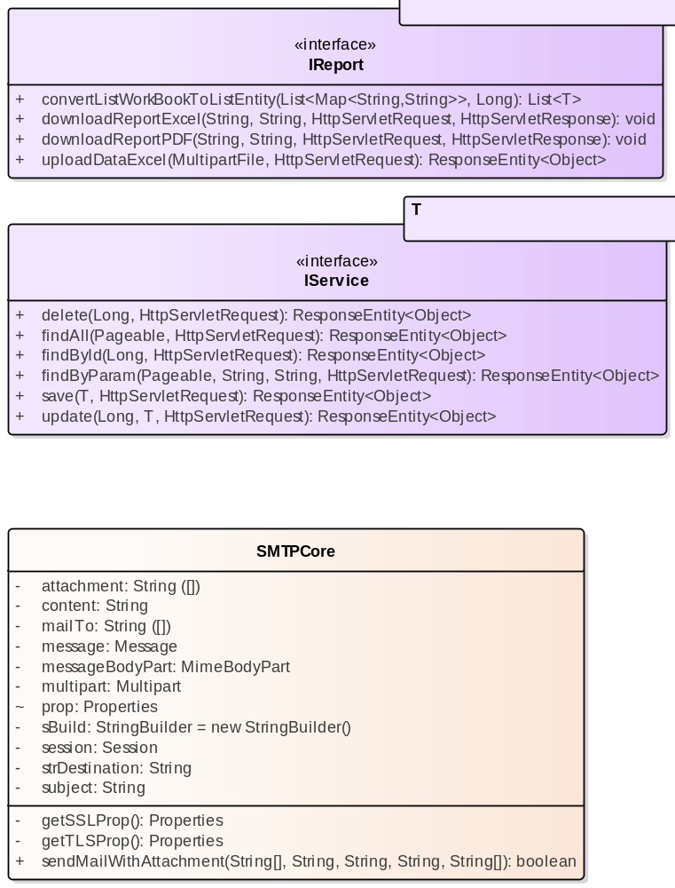

- core

SMTPCore
Class in package 'core'

SMTPCore
Version 1.0 Phase 1.0 Proposed
LENOVO created on 05/11/2025. Last modified 05/11/2025

ATTRIBUTES
attachment : String Private
[ Is static False. Containment is Not Specified. ]

content : String Private
[ Is static False. Containment is Not Specified. ]

mailTo : String Private
[ Is static False. Containment is Not Specified. ]

message : Message Private
[ Is static False. Containment is Not Specified. ]

messageBodyPart : MimeBodyPart Private
[ Is static False. Containment is Not Specified. ]

multipart : Multipart Private
[ Is static False. Containment is Not Specified. ]

prop : Properties Package
[ Is static False. Containment is Not Specified. ]

sBuild : StringBuilder Private = new StringBuilder()
[ Is static False. Containment is Not Specified. ]

session : Session Private
[ Is static False. Containment is Not Specified. ]

strDestination : String Private
[ Is static False. Containment is Not Specified. ]

subject : String Private
[ Is static False. Containment is Not Specified. ]

OPERATIONS
getSSLProp () : Properties Private
[ Is static False. Is abstract False. Is return array False. Is query False. Is synchronized False. ]

getTLSProp () : Properties Private
[ Is static False. Is abstract False. Is return array False. Is query False. Is synchronized False. ]

sendMailWithAttachment (strMailTo : String[] , strSubject : String , strContentMessage : String , strLayer : String , attachFiles : String[] ) : boolean Public
[ Is static False. Is abstract False. Is return array False. Is query False. Is synchronized False. ]

IReport
Interface in package 'core'

IReport
Version 1.0 Phase 1.0 Proposed
LENOVO created on 05/11/2025. Last modified 05/11/2025

INCOMING STRUCTURAL RELATIONSHIPS
Realization from CustomerService to IReport
[ Direction is 'Source -> Destination'. ]

Realization from ProdukService to IReport
[ Direction is 'Source -> Destination'. ]

Realization from SupplierService to IReport
[ Direction is 'Source -> Destination'. ]

Realization from KategoriProdukService to IReport
[ Direction is 'Source -> Destination'. ]

OPERATIONS
convertListWorkBookToListEntity (map : List<Map<String,String>> , id : Long ) : List<T> Public

221-230
[ Is static False. Is abstract False. Is return array False. Is query False. Is synchronized False. ]

downloadReportExcel (column : String , value : String , request : HttpServletRequest , response : HttpServletResponse ) : void Public

201-210
[ Is static False. Is abstract False. Is return array False. Is query False. Is synchronized False. ]

downloadReportPDF (column : String , value : String , request : HttpServletRequest , response : HttpServletResponse ) : void Public

211-220
[ Is static False. Is abstract False. Is return array False. Is query False. Is synchronized False. ]

uploadDataExcel (file : MultipartFile , request : HttpServletRequest ) : ResponseEntity<Object> Public
[ Is static False. Is abstract False. Is return array False. Is query False. Is synchronized False. ]

IService
Interface in package 'core'

IService
Version 1.0 Phase 1.0 Proposed
LENOVO created on 05/11/2025. Last modified 05/11/2025

INCOMING STRUCTURAL RELATIONSHIPS
Realization from SupplierService to IService
[ Direction is 'Source -> Destination'. ]

Realization from ProdukService to IService
[ Direction is 'Source -> Destination'. ]

Realization from KategoriProdukService to IService
[ Direction is 'Source -> Destination'. ]

Realization from CustomerService to IService
[ Direction is 'Source -> Destination'. ]

OPERATIONS
delete (id : Long , request : HttpServletRequest ) : ResponseEntity<Object> Public

011-020
[ Is static False. Is abstract False. Is return array False. Is query False. Is synchronized False. ]

findAll (pageable : Pageable , request : HttpServletRequest ) : ResponseEntity<Object> Public

031-040
[ Is static False. Is abstract False. Is return array False. Is query False. Is synchronized False. ]

findById (id : Long , request : HttpServletRequest ) : ResponseEntity<Object> Public

021-030
[ Is static False. Is abstract False. Is return array False. Is query False. Is synchronized False. ]

findByParam (pageable : Pageable , column : String , value : String , request : HttpServletRequest ) : ResponseEntity<Object> Public

041-050
[ Is static False. Is abstract False. Is return array False. Is query False. Is synchronized False. ]

save (t : T , request : HttpServletRequest ) : ResponseEntity<Object> Public
[ Is static False. Is abstract False. Is return array False. Is query False. Is synchronized False. ]

update (id : Long , t : T , request : HttpServletRequest ) : ResponseEntity<Object> Public

001-010
[ Is static False. Is abstract False. Is return array False. Is query False. Is synchronized False. ]

coretan
Package in package 'juaracoding'

coretan
Version 1.0 Phase 1.0 Proposed
LENOVO created on 05/11/2025. Last modified 05/11/2025

coretan diagram
Class diagram in package 'coretan'

coretan
Version 1.0
LENOVO created on 05/11/2025. Last modified 05/11/2025

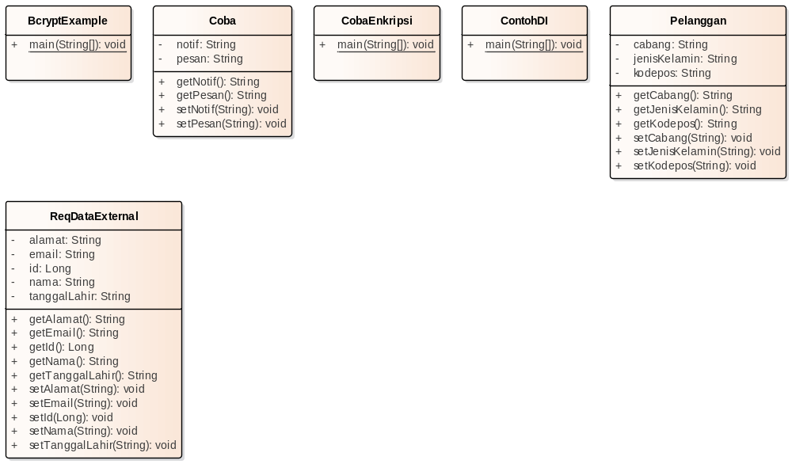

- coretan

BcryptExample
Class in package 'coretan'

BcryptExample
Version 1.0 Phase 1.0 Proposed
LENOVO created on 05/11/2025. Last modified 05/11/2025

OPERATIONS
main (args : String[] ) : void Public
[ Is static True. Is abstract False. Is return array False. Is query False. Is synchronized False. ]

Coba
Class in package 'coretan'

Coba
Version 1.0 Phase 1.0 Proposed
LENOVO created on 05/11/2025. Last modified 05/11/2025

ATTRIBUTES
notif : String Private
[ Is static False. Containment is Not Specified. ]

pesan : String Private
[ Is static False. Containment is Not Specified. ]

ASSOCIATIONS
Association (direction: Source -> Destination)

Source: Public (Class) HelloController | Target: Package coba (Class) Coba

OPERATIONS
getNotif () : String Public
[ Is static False. Is abstract False. Is return array False. Is query False. Is synchronized False. ]

getPesan () : String Public
[ Is static False. Is abstract False. Is return array False. Is query False. Is synchronized False. ]

setNotif (notif : String ) : void Public
[ Is static False. Is abstract False. Is return array False. Is query False. Is synchronized False. ]

setPesan (pesan : String ) : void Public
[ Is static False. Is abstract False. Is return array False. Is query False. Is synchronized False. ]

CobaEnkripsi
Class in package 'coretan'

IntelliJ IDEA 2024.1.4 (Ultimate Edition) Build #IU-241.18034.62, built on June 21, 2024
@Author pollc a.k.a. Paul Christian Java Developer Created on 24/10/2025 21:16
@Last Modified 24/10/2025 21:16 Version 1.0

CobaEnkripsi
Version 1.0 Phase 1.0 Proposed
LENOVO created on 05/11/2025. Last modified 05/11/2025

OPERATIONS
main (args : String[] ) : void Public
[ Is static True. Is abstract False. Is return array False. Is query False. Is synchronized False. ]

ContohDI
Class in package 'coretan'

IntelliJ IDEA 2024.1.4 (Ultimate Edition) Build #IU-241.18034.62, built on June 21, 2024
@Author pollc a.k.a. Paul Christian Java Developer Created on 22/10/2025 19:19
@Last Modified 22/10/2025 19:19 Version 1.0

ContohDI
Version 1.0 Phase 1.0 Proposed
LENOVO created on 05/11/2025. Last modified 05/11/2025

OPERATIONS
main (args : String[] ) : void Public
[ Is static True. Is abstract False. Is return array False. Is query False. Is synchronized False. ]

Pelanggan
Class in package 'coretan'

Pelanggan
Version 1.0 Phase 1.0 Proposed
LENOVO created on 05/11/2025. Last modified 05/11/2025

ATTRIBUTES
cabang : String Private
[ Is static False. Containment is Not Specified. ]

jenisKelamin : String Private

Properties:
annotations = @JsonProperty("jenis_kelamin")
[ Is static False. Containment is Not Specified. ]

kodepos : String Private

Properties:
annotations = @JsonProperty("kode_pos")
[ Is static False. Containment is Not Specified. ]

OPERATIONS
getCabang () : String Public
[ Is static False. Is abstract False. Is return array False. Is query False. Is synchronized False. ]

getJenisKelamin () : String Public
[ Is static False. Is abstract False. Is return array False. Is query False. Is synchronized False. ]

getKodepos () : String Public
[ Is static False. Is abstract False. Is return array False. Is query False. Is synchronized False. ]

setCabang (cabang : String ) : void Public
[ Is static False. Is abstract False. Is return array False. Is query False. Is synchronized False. ]

setJenisKelamin (jenisKelamin : String ) : void Public
[ Is static False. Is abstract False. Is return array False. Is query False. Is synchronized False. ]

setKodepos (kodepos : String ) : void Public
[ Is static False. Is abstract False. Is return array False. Is query False. Is synchronized False. ]

ReqDataExternal
Class in package 'coretan'

ReqDataExternal
Version 1.0 Phase 1.0 Proposed
LENOVO created on 05/11/2025. Last modified 05/11/2025

ATTRIBUTES
alamat : String Private

Properties:
annotations = @Pattern(regexp = "^[a-zA-Z0-9\\s\\/.]{5,255}$")
[ Is static False. Containment is Not Specified. ]

email : String Private

RFC_5322
[ Is static False. Containment is Not Specified. ]

id : Long Private
[ Is static False. Containment is Not Specified. ]

nama : String Private

Properties:
annotations = @Pattern(regexp = "^[a-z\\s]{6,15}$")
[ Is static False. Containment is Not Specified. ]

tanggalLahir : String Private

Properties:
annotations = @DateTimeFormat(pattern = "yyyy-MM-dd")
[ Is static False. Containment is Not Specified. ]

OPERATIONS
getAlamat () : String Public
[ Is static False. Is abstract False. Is return array False. Is query False. Is synchronized False. ]

getEmail () : String Public
[ Is static False. Is abstract False. Is return array False. Is query False. Is synchronized False. ]

getId () : Long Public
[ Is static False. Is abstract False. Is return array False. Is query False. Is synchronized False. ]

getNama () : String Public
[ Is static False. Is abstract False. Is return array False. Is query False. Is synchronized False. ]

getTanggalLahir () : String Public
[ Is static False. Is abstract False. Is return array False. Is query False. Is synchronized False. ]

setAlamat (alamat : String ) : void Public
[ Is static False. Is abstract False. Is return array False. Is query False. Is synchronized False. ]

setEmail (email : String ) : void Public
[ Is static False. Is abstract False. Is return array False. Is query False. Is synchronized False. ]

setId (id : Long ) : void Public
[ Is static False. Is abstract False. Is return array False. Is query False. Is synchronized False. ]

setNama (nama : String ) : void Public
[ Is static False. Is abstract False. Is return array False. Is query False. Is synchronized False. ]

setTanggalLahir (tanggalLahir : String ) : void Public
[ Is static False. Is abstract False. Is return array False. Is query False. Is synchronized False. ]

dto
Package in package 'juaracoding'

dto
Version 1.0 Phase 1.0 Proposed
LENOVO created on 05/11/2025. Last modified 05/11/2025

dto diagram
Class diagram in package 'dto'

dto
Version 1.0
LENOVO created on 05/11/2025. Last modified 05/11/2025

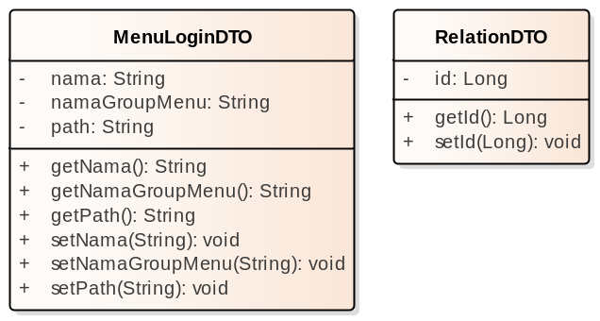

- dto

response
Package in package 'dto'

response
Version 1.0 Phase 1.0 Proposed
LENOVO created on 05/11/2025. Last modified 05/11/2025

response diagram
Class diagram in package 'response'

response
Version 1.0
LENOVO created on 05/11/2025. Last modified 05/11/2025

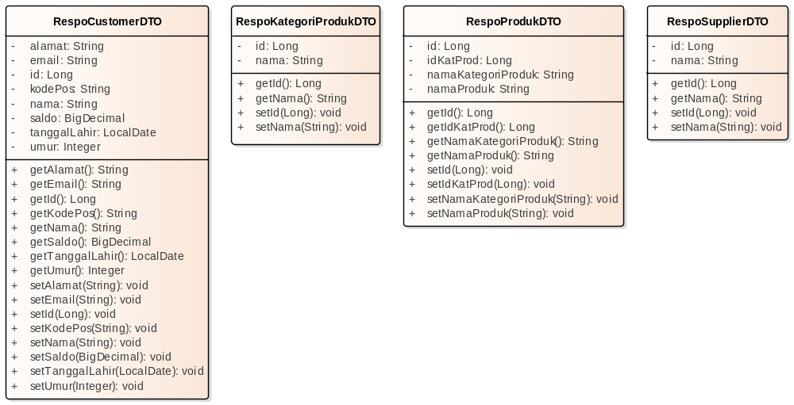

- response

RespoCustomerDTO
Class in package 'response'

RespoCustomerDTO
Version 1.0 Phase 1.0 Proposed
LENOVO created on 05/11/2025. Last modified 05/11/2025

ATTRIBUTES
alamat : String Private
[ Is static False. Containment is Not Specified. ]

email : String Private
[ Is static False. Containment is Not Specified. ]

id : Long Private
[ Is static False. Containment is Not Specified. ]

kodePos : String Private
[ Is static False. Containment is Not Specified. ]

nama : String Private
[ Is static False. Containment is Not Specified. ]

saldo : BigDecimal Private
[ Is static False. Containment is Not Specified. ]

tanggalLahir : LocalDate Private
[ Is static False. Containment is Not Specified. ]

umur : Integer Private
[ Is static False. Containment is Not Specified. ]

OPERATIONS
getAlamat () : String Public
[ Is static False. Is abstract False. Is return array False. Is query False. Is synchronized False. ]

getEmail () : String Public
[ Is static False. Is abstract False. Is return array False. Is query False. Is synchronized False. ]

getId () : Long Public
[ Is static False. Is abstract False. Is return array False. Is query False. Is synchronized False. ]

getKodePos () : String Public
[ Is static False. Is abstract False. Is return array False. Is query False. Is synchronized False. ]

getNama () : String Public
[ Is static False. Is abstract False. Is return array False. Is query False. Is synchronized False. ]

getSaldo () : BigDecimal Public
[ Is static False. Is abstract False. Is return array False. Is query False. Is synchronized False. ]

getTanggalLahir () : LocalDate Public
[ Is static False. Is abstract False. Is return array False. Is query False. Is synchronized False. ]

getUmur () : Integer Public
[ Is static False. Is abstract False. Is return array False. Is query False. Is synchronized False. ]

setAlamat (alamat : String ) : void Public
[ Is static False. Is abstract False. Is return array False. Is query False. Is synchronized False. ]

setEmail (email : String ) : void Public
[ Is static False. Is abstract False. Is return array False. Is query False. Is synchronized False. ]

setId (id : Long ) : void Public
[ Is static False. Is abstract False. Is return array False. Is query False. Is synchronized False. ]

setKodePos (kodePos : String ) : void Public
[ Is static False. Is abstract False. Is return array False. Is query False. Is synchronized False. ]

setNama (nama : String ) : void Public
[ Is static False. Is abstract False. Is return array False. Is query False. Is synchronized False. ]

setSaldo (saldo : BigDecimal ) : void Public
[ Is static False. Is abstract False. Is return array False. Is query False. Is synchronized False. ]

setTanggalLahir (tanggalLahir : LocalDate ) : void Public
[ Is static False. Is abstract False. Is return array False. Is query False. Is synchronized False. ]

setUmur (umur : Integer ) : void Public
[ Is static False. Is abstract False. Is return array False. Is query False. Is synchronized False. ]

RespoKategoriProdukDTO
Class in package 'response'

RespoKategoriProdukDTO
Version 1.0 Phase 1.0 Proposed
LENOVO created on 05/11/2025. Last modified 05/11/2025

ATTRIBUTES
id : Long Private
[ Is static False. Containment is Not Specified. ]

nama : String Private
[ Is static False. Containment is Not Specified. ]

OPERATIONS
getId () : Long Public
[ Is static False. Is abstract False. Is return array False. Is query False. Is synchronized False. ]

getNama () : String Public
[ Is static False. Is abstract False. Is return array False. Is query False. Is synchronized False. ]

setId (id : Long ) : void Public
[ Is static False. Is abstract False. Is return array False. Is query False. Is synchronized False. ]

setNama (nama : String ) : void Public
[ Is static False. Is abstract False. Is return array False. Is query False. Is synchronized False. ]

RespoProdukDTO
Class in package 'response'

RespoProdukDTO
Version 1.0 Phase 1.0 Proposed
LENOVO created on 05/11/2025. Last modified 05/11/2025

ATTRIBUTES
id : Long Private
[ Is static False. Containment is Not Specified. ]

idKatProd : Long Private
[ Is static False. Containment is Not Specified. ]

namaKategoriProduk : String Private
[ Is static False. Containment is Not Specified. ]

namaProduk : String Private
[ Is static False. Containment is Not Specified. ]

OPERATIONS
getId () : Long Public
[ Is static False. Is abstract False. Is return array False. Is query False. Is synchronized False. ]

getIdKatProd () : Long Public
[ Is static False. Is abstract False. Is return array False. Is query False. Is synchronized False. ]

getNamaKategoriProduk () : String Public
[ Is static False. Is abstract False. Is return array False. Is query False. Is synchronized False. ]

getNamaProduk () : String Public
[ Is static False. Is abstract False. Is return array False. Is query False. Is synchronized False. ]

setId (id : Long ) : void Public
[ Is static False. Is abstract False. Is return array False. Is query False. Is synchronized False. ]

setIdKatProd (idKatProd : Long ) : void Public
[ Is static False. Is abstract False. Is return array False. Is query False. Is synchronized False. ]

setNamaKategoriProduk (namaKategoriProduk : String ) : void Public
[ Is static False. Is abstract False. Is return array False. Is query False. Is synchronized False. ]

setNamaProduk (namaProduk : String ) : void Public
[ Is static False. Is abstract False. Is return array False. Is query False. Is synchronized False. ]

RespoSupplierDTO
Class in package 'response'

RespoSupplierDTO
Version 1.0 Phase 1.0 Proposed
LENOVO created on 05/11/2025. Last modified 05/11/2025

ATTRIBUTES
id : Long Private
[ Is static False. Containment is Not Specified. ]

nama : String Private
[ Is static False. Containment is Not Specified. ]

OPERATIONS
getId () : Long Public
[ Is static False. Is abstract False. Is return array False. Is query False. Is synchronized False. ]

getNama () : String Public
[ Is static False. Is abstract False. Is return array False. Is query False. Is synchronized False. ]

setId (id : Long ) : void Public
[ Is static False. Is abstract False. Is return array False. Is query False. Is synchronized False. ]

setNama (nama : String ) : void Public
[ Is static False. Is abstract False. Is return array False. Is query False. Is synchronized False. ]

validation
Package in package 'dto'

validation
Version 1.0 Phase 1.0 Proposed
LENOVO created on 05/11/2025. Last modified 05/11/2025

validation diagram
Class diagram in package 'validation'

validation
Version 1.0
LENOVO created on 05/11/2025. Last modified 05/11/2025

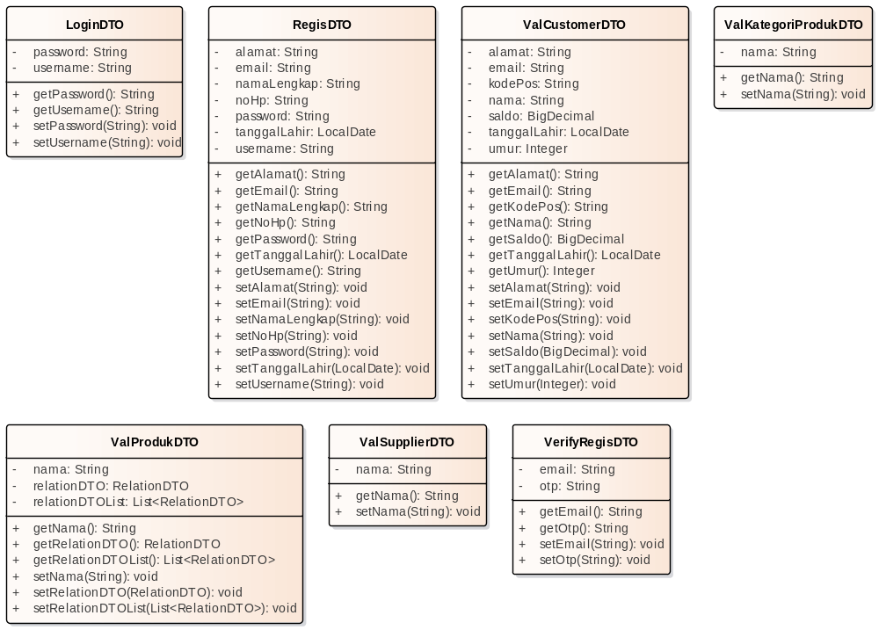

- validation

LoginDTO
Class in package 'validation'

LoginDTO
Version 1.0 Phase 1.0 Proposed
LENOVO created on 05/11/2025. Last modified 05/11/2025

ATTRIBUTES
password : String Private

Properties:
annotations = @Pattern(regexp = "^(?=.*[A-Z])(?=.*[a-z])(?=.*[0-9])(?=.*[@_#\\-$])[\\w].{8,15}$",
message = "Format Password Tidak Valid")
[ Is static False. Containment is Not Specified. ]

username : String Private

Properties:
annotations = @NotNull(message = "Username Tidak Boleh Null")@NotBlank(message = "Username Tidak Boleh Blank")@NotEmpty(message = "Username Tidak Boleh Kosong")@Pattern(regexp = "^[\\w\\.]{5,50}$",message = "Username Tidak Valid , ex : paul.123")
[ Is static False. Containment is Not Specified. ]

OPERATIONS
getPassword () : String Public
[ Is static False. Is abstract False. Is return array False. Is query False. Is synchronized False. ]

getUsername () : String Public
[ Is static False. Is abstract False. Is return array False. Is query False. Is synchronized False. ]

setPassword (password : String ) : void Public
[ Is static False. Is abstract False. Is return array False. Is query False. Is synchronized False. ]

setUsername (username : String ) : void Public
[ Is static False. Is abstract False. Is return array False. Is query False. Is synchronized False. ]

RegisDTO
Class in package 'validation'

{ "username":"paul.321", "email":"paul321@gmail.com", "noHp":"08121314151", "password":"Paul@1234", "nama-lengkap":"Paul Malau", "alamat":"Bogor Bogor Bogor Bogor Bogor ", "tanggal-lahir":"1995-12-12" }

RegisDTO
Version 1.0 Phase 1.0 Proposed
LENOVO created on 05/11/2025. Last modified 05/11/2025

ATTRIBUTES
alamat : String Private

Properties:
annotations = @Pattern(regexp = "^[\\w\\s\\.\\,]{20,255}$",
message = "Format Alamat Tidak Valid min 20 maks 255, contoh : Jln. Kenari 2B jakbar 11480")
[ Is static False. Containment is Not Specified. ]

email : String Private

field untuk email , masukkan nilai sesuai dengan dokumen RFC 5322

Properties:
annotations = @Pattern(regexp = "^(?=.{1,256})(?=.{1,64}@.{1,255}$)(?:(?![.])[a-zA-Z0-9._%+-]+(?:(?<!\\\\)[.][a-zA-Z0-9-]+)*?)@[a-zA-Z0-9.-]+(?:\\.[a-zA-Z]{2,50})+$",
message = "Format tidak valid ex : user_name123@sub.domain.com")
[ Is static False. Containment is Not Specified. ]

namaLengkap : String Private

Properties:
annotations = @Pattern(regexp = "^[a-zA-Z\\s]{4,70}$",message = "Hanya Alfabet dan spasi Minimal 4 Maksimal 70")@JsonProperty("nama-lengkap")
[ Is static False. Containment is Not Specified. ]

noHp : String Private

Properties:
annotations = @Pattern(regexp = "^(62|\\+62|0)8[0-9]{9,13}$",
message = "Format No HP Tidak Valid , min 9 max 13 setelah angka 8, contoh : (0/62/+62)81111111")@JsonProperty("no-hp")
[ Is static False. Containment is Not Specified. ]

password : String Private

Properties:
annotations = @Pattern(regexp = "^(?=.*[A-Z])(?=.*[a-z])(?=.*[0-9])(?=.*[@_#\\-$])[\\w].{8,15}$",
message = "Format minimal 1 angka, 1 huruf kecil, 1 huruf besar, 1 spesial karakter (_ \"Underscore\", - \"Hyphen\", # \"Hash\", atau $ \"Dollar\" atau @ \"At\") setelah 4 kondisi min 9 max 16 alfanumerik, contoh : aB4$12345")
[ Is static False. Containment is Not Specified. ]

tanggalLahir : LocalDate Private

Properties:
annotations = @DateTimeFormat(pattern = "yyyy-MM-dd")@JsonDeserialize(using = LocalDateDeserializer.class)@JsonSerialize(using = LocalDateSerializer.class)@JsonProperty("tanggal-lahir")
[ Is static False. Containment is Not Specified. ]

username : String Private

Properties:
annotations = @Pattern(regexp = "^([a-z0-9\\.]{8,16})$",
message = "Format Huruf kecil ,numeric dan titik saja min 8 max 16 karakter, ex : paulch.1234")
[ Is static False. Containment is Not Specified. ]

OPERATIONS
getAlamat () : String Public
[ Is static False. Is abstract False. Is return array False. Is query False. Is synchronized False. ]

getEmail () : String Public
[ Is static False. Is abstract False. Is return array False. Is query False. Is synchronized False. ]

getNamaLengkap () : String Public
[ Is static False. Is abstract False. Is return array False. Is query False. Is synchronized False. ]

getNoHp () : String Public
[ Is static False. Is abstract False. Is return array False. Is query False. Is synchronized False. ]

getPassword () : String Public
[ Is static False. Is abstract False. Is return array False. Is query False. Is synchronized False. ]

getTanggalLahir () : LocalDate Public
[ Is static False. Is abstract False. Is return array False. Is query False. Is synchronized False. ]

getUsername () : String Public
[ Is static False. Is abstract False. Is return array False. Is query False. Is synchronized False. ]

setAlamat (alamat : String ) : void Public
[ Is static False. Is abstract False. Is return array False. Is query False. Is synchronized False. ]

setEmail (email : String ) : void Public
[ Is static False. Is abstract False. Is return array False. Is query False. Is synchronized False. ]

setNamaLengkap (namaLengkap : String ) : void Public
[ Is static False. Is abstract False. Is return array False. Is query False. Is synchronized False. ]

setNoHp (noHp : String ) : void Public
[ Is static False. Is abstract False. Is return array False. Is query False. Is synchronized False. ]

setPassword (password : String ) : void Public
[ Is static False. Is abstract False. Is return array False. Is query False. Is synchronized False. ]

setTanggalLahir (tanggalLahir : LocalDate ) : void Public
[ Is static False. Is abstract False. Is return array False. Is query False. Is synchronized False. ]

setUsername (username : String ) : void Public
[ Is static False. Is abstract False. Is return array False. Is query False. Is synchronized False. ]

ValCustomerDTO
Class in package 'validation'

ValCustomerDTO
Version 1.0 Phase 1.0 Proposed
LENOVO created on 05/11/2025. Last modified 05/11/2025

ATTRIBUTES
alamat : String Private
[ Is static False. Containment is Not Specified. ]

email : String Private
[ Is static False. Containment is Not Specified. ]

kodePos : String Private
[ Is static False. Containment is Not Specified. ]

nama : String Private
[ Is static False. Containment is Not Specified. ]

saldo : BigDecimal Private
[ Is static False. Containment is Not Specified. ]

tanggalLahir : LocalDate Private
[ Is static False. Containment is Not Specified. ]

umur : Integer Private
[ Is static False. Containment is Not Specified. ]

OPERATIONS
getAlamat () : String Public
[ Is static False. Is abstract False. Is return array False. Is query False. Is synchronized False. ]

getEmail () : String Public
[ Is static False. Is abstract False. Is return array False. Is query False. Is synchronized False. ]

getKodePos () : String Public
[ Is static False. Is abstract False. Is return array False. Is query False. Is synchronized False. ]

getNama () : String Public
[ Is static False. Is abstract False. Is return array False. Is query False. Is synchronized False. ]

getSaldo () : BigDecimal Public
[ Is static False. Is abstract False. Is return array False. Is query False. Is synchronized False. ]

getTanggalLahir () : LocalDate Public
[ Is static False. Is abstract False. Is return array False. Is query False. Is synchronized False. ]

getUmur () : Integer Public
[ Is static False. Is abstract False. Is return array False. Is query False. Is synchronized False. ]

setAlamat (alamat : String ) : void Public
[ Is static False. Is abstract False. Is return array False. Is query False. Is synchronized False. ]

setEmail (email : String ) : void Public
[ Is static False. Is abstract False. Is return array False. Is query False. Is synchronized False. ]

setKodePos (kodePos : String ) : void Public
[ Is static False. Is abstract False. Is return array False. Is query False. Is synchronized False. ]

setNama (nama : String ) : void Public
[ Is static False. Is abstract False. Is return array False. Is query False. Is synchronized False. ]

setSaldo (saldo : BigDecimal ) : void Public
[ Is static False. Is abstract False. Is return array False. Is query False. Is synchronized False. ]

setTanggalLahir (tanggalLahir : LocalDate ) : void Public
[ Is static False. Is abstract False. Is return array False. Is query False. Is synchronized False. ]

setUmur (umur : Integer ) : void Public
[ Is static False. Is abstract False. Is return array False. Is query False. Is synchronized False. ]

ValKategoriProdukDTO
Class in package 'validation'

ValKategoriProdukDTO
Version 1.0 Phase 1.0 Proposed
LENOVO created on 05/11/2025. Last modified 05/11/2025

ATTRIBUTES
nama : String Private

Properties:
annotations = @Pattern(regexp = "^[\\w\\s]{10,30}$",message = "Format nama tidak sesuai")
[ Is static False. Containment is Not Specified. ]

OPERATIONS
getNama () : String Public
[ Is static False. Is abstract False. Is return array False. Is query False. Is synchronized False. ]

setNama (nama : String ) : void Public
[ Is static False. Is abstract False. Is return array False. Is query False. Is synchronized False. ]

ValProdukDTO
Class in package 'validation'

ValProdukDTO
Version 1.0 Phase 1.0 Proposed
LENOVO created on 05/11/2025. Last modified 05/11/2025

ATTRIBUTES
nama : String Private

Properties:
annotations = @Pattern(regexp = "^[\\w\\s]{4,20}$",message = "Format nama tidak sesuai")
[ Is static False. Containment is Not Specified. ]

relationDTO : RelationDTO Private

Properties:
annotations = @NotNull@JsonProperty("kategori")
[ Is static False. Containment is Not Specified. ]

relationDTOList : List<RelationDTO> Private

Properties:
annotations = @NotNull@JsonProperty("list_supplier")
[ Is static False. Containment is Not Specified. ]

ASSOCIATIONS
Association (direction: Source -> Destination)

Source: Public (Class) ValProdukDTO | Target: Private relationDTO (Class) RelationDTO
Association (direction: Source -> Destination)

Source: Public (Class) ValProdukDTO | Target: Private relationDTOList (Class) RelationDTO  Cardinality: [0..*]

OPERATIONS
getNama () : String Public
[ Is static False. Is abstract False. Is return array False. Is query False. Is synchronized False. ]

getRelationDTO () : RelationDTO Public
[ Is static False. Is abstract False. Is return array False. Is query False. Is synchronized False. ]

getRelationDTOList () : List<RelationDTO> Public
[ Is static False. Is abstract False. Is return array False. Is query False. Is synchronized False. ]

setNama (nama : String ) : void Public
[ Is static False. Is abstract False. Is return array False. Is query False. Is synchronized False. ]

setRelationDTO (relationDTO : RelationDTO ) : void Public
[ Is static False. Is abstract False. Is return array False. Is query False. Is synchronized False. ]

setRelationDTOList (relationDTOList : List<RelationDTO> ) : void Public
[ Is static False. Is abstract False. Is return array False. Is query False. Is synchronized False. ]

ValSupplierDTO
Class in package 'validation'

ValSupplierDTO
Version 1.0 Phase 1.0 Proposed
LENOVO created on 05/11/2025. Last modified 05/11/2025

ATTRIBUTES
nama : String Private

Properties:
annotations = @Pattern(regexp = "^[\\w\\s]{10,30}$",message = "Format nama tidak sesuai")
[ Is static False. Containment is Not Specified. ]

OPERATIONS
getNama () : String Public
[ Is static False. Is abstract False. Is return array False. Is query False. Is synchronized False. ]

setNama (nama : String ) : void Public
[ Is static False. Is abstract False. Is return array False. Is query False. Is synchronized False. ]

VerifyRegisDTO
Class in package 'validation'

WHY?

VerifyRegisDTO
Version 1.0 Phase 1.0 Proposed
LENOVO created on 05/11/2025. Last modified 05/11/2025

ATTRIBUTES
email : String Private

Properties:
annotations = @Pattern(regexp = "^(?=.{1,256})(?=.{1,64}@.{1,255}$)(?:(?![.])[a-zA-Z0-9._%+-]+(?:(?<!\\\\)[.][a-zA-Z0-9-]+)*?)@[a-zA-Z0-9.-]+(?:\\.[a-zA-Z]{2,50})+$",
message = "Format Tidak Valid...!!")
[ Is static False. Containment is Not Specified. ]

otp : String Private

Properties:
annotations = @Pattern(regexp = "^[0-9]{6}$",message = "Format OTP Salah !!")
[ Is static False. Containment is Not Specified. ]

OPERATIONS
getEmail () : String Public
[ Is static False. Is abstract False. Is return array False. Is query False. Is synchronized False. ]

getOtp () : String Public
[ Is static False. Is abstract False. Is return array False. Is query False. Is synchronized False. ]

setEmail (email : String ) : void Public
[ Is static False. Is abstract False. Is return array False. Is query False. Is synchronized False. ]

setOtp (otp : String ) : void Public
[ Is static False. Is abstract False. Is return array False. Is query False. Is synchronized False. ]

MenuLoginDTO
Class in package 'dto'

MenuLoginDTO
Version 1.0 Phase 1.0 Proposed
LENOVO created on 05/11/2025. Last modified 05/11/2025

ATTRIBUTES
nama : String Private
[ Is static False. Containment is Not Specified. ]

namaGroupMenu : String Private

Properties:
annotations = @JsonIgnore
[ Is static False. Containment is Not Specified. ]

path : String Private
[ Is static False. Containment is Not Specified. ]

OPERATIONS
getNama () : String Public
[ Is static False. Is abstract False. Is return array False. Is query False. Is synchronized False. ]

getNamaGroupMenu () : String Public
[ Is static False. Is abstract False. Is return array False. Is query False. Is synchronized False. ]

getPath () : String Public
[ Is static False. Is abstract False. Is return array False. Is query False. Is synchronized False. ]

setNama (nama : String ) : void Public
[ Is static False. Is abstract False. Is return array False. Is query False. Is synchronized False. ]

setNamaGroupMenu (namaGroupMenu : String ) : void Public
[ Is static False. Is abstract False. Is return array False. Is query False. Is synchronized False. ]

setPath (path : String ) : void Public
[ Is static False. Is abstract False. Is return array False. Is query False. Is synchronized False. ]

RelationDTO
Class in package 'dto'

RelationDTO
Version 1.0 Phase 1.0 Proposed
LENOVO created on 05/11/2025. Last modified 05/11/2025

ATTRIBUTES
id : Long Private
[ Is static False. Containment is Not Specified. ]

ASSOCIATIONS
Association (direction: Source -> Destination)

Source: Public (Class) ValProdukDTO | Target: Private relationDTO (Class) RelationDTO
Association (direction: Source -> Destination)

Source: Public (Class) ValProdukDTO | Target: Private relationDTOList (Class) RelationDTO  Cardinality: [0..*]

OPERATIONS
getId () : Long Public
[ Is static False. Is abstract False. Is return array False. Is query False. Is synchronized False. ]

setId (id : Long ) : void Public
[ Is static False. Is abstract False. Is return array False. Is query False. Is synchronized False. ]

handler
Package in package 'juaracoding'

handler
Version 1.0 Phase 1.0 Proposed
LENOVO created on 05/11/2025. Last modified 05/11/2025

handler diagram
Class diagram in package 'handler'

handler
Version 1.0
LENOVO created on 05/11/2025. Last modified 05/11/2025

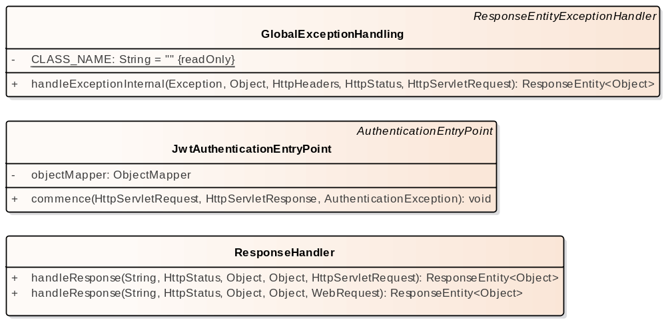

- handler

GlobalExceptionHandling
Class in package 'handler'

GlobalExceptionHandling
Version 1.0 Phase 1.0 Proposed
LENOVO created on 05/11/2025. Last modified 05/11/2025
Extends ResponseEntityExceptionHandler

ATTRIBUTES
CLASS_NAME : String Private Const = ""
[ Is static True. Containment is Not Specified. ]

OPERATIONS
handleExceptionInternal (ex : Exception , body : Object , headers : HttpHeaders , status : HttpStatus , request : HttpServletRequest ) : ResponseEntity<Object> Public
[ Is static False. Is abstract False. Is return array False. Is query False. Is synchronized False. ]

JwtAuthenticationEntryPoint
Class in package 'handler'

Response Body untuk masalah JWT / Security

JwtAuthenticationEntryPoint
Version 1.0 Phase 1.0 Proposed
LENOVO created on 05/11/2025. Last modified 05/11/2025
Extends AuthenticationEntryPoint

ATTRIBUTES
objectMapper : ObjectMapper Private

Properties:
annotations = @Autowired
[ Is static False. Containment is Not Specified. ]

OPERATIONS
commence (request : HttpServletRequest , response : HttpServletResponse , authException : AuthenticationException ) : void Public

Properties:
annotations = @Override
throws = IOException,ServletException
[ Is static False. Is abstract False. Is return array False. Is query False. Is synchronized False. ]

ResponseHandler
Class in package 'handler'

Response Body untuk masalah Bisnis Logic dan Status Berhasil

ResponseHandler
Version 1.0 Phase 1.0 Proposed
LENOVO created on 05/11/2025. Last modified 05/11/2025

OPERATIONS
handleResponse (message : String , status : HttpStatus , data : Object , errorCode : Object , request : HttpServletRequest ) : ResponseEntity<Object> Public
[ Is static False. Is abstract False. Is return array False. Is query False. Is synchronized False. ]

handleResponse (message : String , status : HttpStatus , data : Object , errorCode : Object , request : WebRequest ) : ResponseEntity<Object> Public
[ Is static False. Is abstract False. Is return array False. Is query False. Is synchronized False. ]

model
Package in package 'juaracoding'

model
Version 1.0 Phase 1.0 Proposed
LENOVO created on 05/11/2025. Last modified 05/11/2025

model diagram
Class diagram in package 'model'

model
Version 1.0
LENOVO created on 05/11/2025. Last modified 05/11/2025

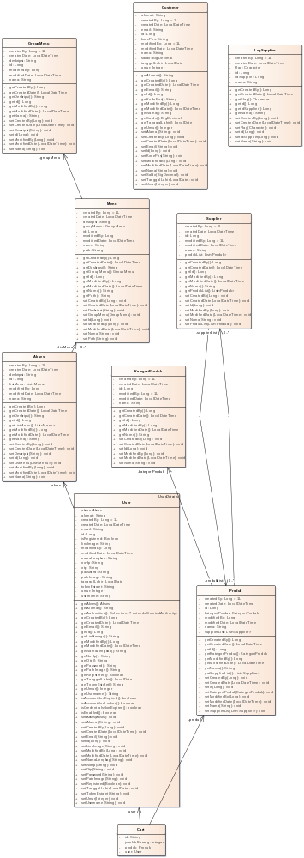

- model

Akses
Class in package 'model'

Akses
Version 1.0 Phase 1.0 Proposed
LENOVO created on 05/11/2025. Last modified 05/11/2025

ATTRIBUTES
createdBy : Long Private = 1L

Properties:
annotations = @Column(name = "CreatedBy",nullable = false,updatable = false)
[ Is static False. Containment is Not Specified. ]

createdDate : LocalDateTime Private

Properties:
annotations = @Column(name = "CreatedDate",updatable = false)@CreationTimestamp
[ Is static False. Containment is Not Specified. ]

deskripsi : String Private

Adapt when migration

Properties:
annotations = @Column(name = "Deskripsi",
nullable = false, length = 255,unique = true)
[ Is static False. Containment is Not Specified. ]

id : Long Private

Properties:
annotations = @Id@GeneratedValue(strategy = GenerationType.IDENTITY)@Column(name = "ID")
[ Is static False. Containment is Not Specified. ]

listMenu : List<Menu> Private

@ManyToMany
@JoinTable(name = "MapAksesMenu", uniqueConstraints = @UniqueConstraint(name = "unq-akses-to-menu",columnNames = {"IDAkses,IDMenu"}), joinColumns = @JoinColumn(name = "IDAkses",foreignKey = @ForeignKey(name = "fk-to-akses")), inverseJoinColumns = @JoinColumn(name = "IDMenu",foreignKey = @ForeignKey(name = "fk-to-menu")))

Properties:
annotations = @ManyToMany@JoinTable(name = "MapAksesMenu", uniqueConstraints =@UniqueConstraint(name = "unq-akses-to-menu",columnNames = {"IDAkses","IDMenu"}),
joinColumns = @JoinColumn(name = "IDAkses",foreignKey = @ForeignKey(name = "fk-toAkses")),
inverseJoinColumns = @JoinColumn(name = "IDMenu",foreignKey = @ForeignKey(name = "fk-toMenu"))
)
[ Is static False. Containment is Not Specified. ]

modifiedBy : Long Private

Properties:
annotations = @Column(name = "ModifiedBy",insertable = false)
[ Is static False. Containment is Not Specified. ]

modifiedDate : LocalDateTime Private

Properties:
annotations = @Column(name = "ModifiedDate",insertable = false)@UpdateTimestamp
[ Is static False. Containment is Not Specified. ]

nama : String Private

Properties:
annotations = @Column(name = "Nama", nullable = false,unique = true, length = 50)
[ Is static False. Containment is Not Specified. ]

ASSOCIATIONS
Association (direction: Source -> Destination)

Source: Public (Class) Akses | Target: Private listMenu (Class) Menu  Cardinality: [0..*]
Association (direction: Source -> Destination)

Source: Public (Class) User | Target: Private akses (Class) Akses

OPERATIONS
getCreatedBy () : Long Public
[ Is static False. Is abstract False. Is return array False. Is query False. Is synchronized False. ]

getCreatedDate () : LocalDateTime Public
[ Is static False. Is abstract False. Is return array False. Is query False. Is synchronized False. ]

getDeskripsi () : String Public
[ Is static False. Is abstract False. Is return array False. Is query False. Is synchronized False. ]

getId () : Long Public
[ Is static False. Is abstract False. Is return array False. Is query False. Is synchronized False. ]

getListMenu () : List<Menu> Public
[ Is static False. Is abstract False. Is return array False. Is query False. Is synchronized False. ]

getModifiedBy () : Long Public
[ Is static False. Is abstract False. Is return array False. Is query False. Is synchronized False. ]

getModifiedDate () : LocalDateTime Public
[ Is static False. Is abstract False. Is return array False. Is query False. Is synchronized False. ]

getNama () : String Public
[ Is static False. Is abstract False. Is return array False. Is query False. Is synchronized False. ]

setCreatedBy (createdBy : Long ) : void Public
[ Is static False. Is abstract False. Is return array False. Is query False. Is synchronized False. ]

setCreatedDate (createdDate : LocalDateTime ) : void Public
[ Is static False. Is abstract False. Is return array False. Is query False. Is synchronized False. ]

setDeskripsi (deskripsi : String ) : void Public
[ Is static False. Is abstract False. Is return array False. Is query False. Is synchronized False. ]

setId (id : Long ) : void Public
[ Is static False. Is abstract False. Is return array False. Is query False. Is synchronized False. ]

setListMenu (listMenu : List<Menu> ) : void Public
[ Is static False. Is abstract False. Is return array False. Is query False. Is synchronized False. ]

setModifiedBy (modifiedBy : Long ) : void Public
[ Is static False. Is abstract False. Is return array False. Is query False. Is synchronized False. ]

setModifiedDate (modifiedDate : LocalDateTime ) : void Public
[ Is static False. Is abstract False. Is return array False. Is query False. Is synchronized False. ]

setNama (nama : String ) : void Public
[ Is static False. Is abstract False. Is return array False. Is query False. Is synchronized False. ]

Cart
Class in package 'model'

Cart
Version 1.0 Phase 1.0 Proposed
LENOVO created on 05/11/2025. Last modified 05/11/2025

ATTRIBUTES
id : String Private

Properties:
annotations = @Id@GeneratedValue(strategy = GenerationType.AUTO)
[ Is static False. Containment is Not Specified. ]

jumlahBarang : Integer Private

Properties:
annotations = @Column(name = "JumlahBarang")
[ Is static False. Containment is Not Specified. ]

produk : Produk Private

Properties:
annotations = @ManyToOne@JoinColumn(name = "IDProduk")
[ Is static False. Containment is Not Specified. ]

user : User Private

Properties:
annotations = @ManyToOne@JoinColumn(name = "IDUser")
[ Is static False. Containment is Not Specified. ]

ASSOCIATIONS
Association (direction: Source -> Destination)

Source: Public (Class) Cart | Target: Private user (Class) User
Association (direction: Source -> Destination)

Source: Public (Class) Cart | Target: Private produk (Class) Produk

Customer
Class in package 'model'

Customer
Version 1.0 Phase 1.0 Proposed
LENOVO created on 05/11/2025. Last modified 05/11/2025

ATTRIBUTES
alamat : String Private

Properties:
annotations = @Column(name = "Alamat",nullable = false)
[ Is static False. Containment is Not Specified. ]

createdBy : Long Private = 1L

Properties:
annotations = @Column(name = "CreatedBy",nullable = false,updatable = false)
[ Is static False. Containment is Not Specified. ]

createdDate : LocalDateTime Private

Properties:
annotations = @Column(name = "CreatedDate",nullable = false,updatable = false)@CreationTimestamp
[ Is static False. Containment is Not Specified. ]

email : String Private

Properties:
annotations = @Column(name = "Email",length =64,nullable = false,unique = true)
[ Is static False. Containment is Not Specified. ]

id : Long Private

Properties:
annotations = @Id@GeneratedValue(strategy = GenerationType.IDENTITY)@Column(name = "ID")
[ Is static False. Containment is Not Specified. ]

kodePos : String Private

change script when migration

Properties:
annotations = @Column(name = "KodePos",length = 5,nullable = false ,columnDefinition = "CHAR(5)")
[ Is static False. Containment is Not Specified. ]

modifiedBy : Long Private = 1L

Properties:
annotations = @Column(name = "ModifiedBy",insertable = false)
[ Is static False. Containment is Not Specified. ]

modifiedDate : LocalDateTime Private

Properties:
annotations = @UpdateTimestamp@Column(name = "ModifiedDate",insertable = false)
[ Is static False. Containment is Not Specified. ]

nama : String Private

Properties:
annotations = @Column(name = "Nama",length =70,nullable = false)
[ Is static False. Containment is Not Specified. ]

saldo : BigDecimal Private

Properties:
annotations = @Column(name = "Saldo" ,precision = 10,scale = 2)
[ Is static False. Containment is Not Specified. ]

tanggalLahir : LocalDate Private

Properties:
annotations = @Column(name = "TanggalLahir")
[ Is static False. Containment is Not Specified. ]

umur : Integer Private

Properties:
annotations = @Transient
[ Is static False. Containment is Not Specified. ]

OPERATIONS
getAlamat () : String Public
[ Is static False. Is abstract False. Is return array False. Is query False. Is synchronized False. ]

getCreatedBy () : Long Public
[ Is static False. Is abstract False. Is return array False. Is query False. Is synchronized False. ]

getCreatedDate () : LocalDateTime Public
[ Is static False. Is abstract False. Is return array False. Is query False. Is synchronized False. ]

getEmail () : String Public
[ Is static False. Is abstract False. Is return array False. Is query False. Is synchronized False. ]

getId () : Long Public
[ Is static False. Is abstract False. Is return array False. Is query False. Is synchronized False. ]

getKodePos () : String Public
[ Is static False. Is abstract False. Is return array False. Is query False. Is synchronized False. ]

getModifiedBy () : Long Public
[ Is static False. Is abstract False. Is return array False. Is query False. Is synchronized False. ]

getModifiedDate () : LocalDateTime Public
[ Is static False. Is abstract False. Is return array False. Is query False. Is synchronized False. ]

getNama () : String Public
[ Is static False. Is abstract False. Is return array False. Is query False. Is synchronized False. ]

getSaldo () : BigDecimal Public
[ Is static False. Is abstract False. Is return array False. Is query False. Is synchronized False. ]

getTanggalLahir () : LocalDate Public
[ Is static False. Is abstract False. Is return array False. Is query False. Is synchronized False. ]

getUmur () : Integer Public
[ Is static False. Is abstract False. Is return array False. Is query False. Is synchronized False. ]

setAlamat (alamat : String ) : void Public
[ Is static False. Is abstract False. Is return array False. Is query False. Is synchronized False. ]

setCreatedBy (createdBy : Long ) : void Public
[ Is static False. Is abstract False. Is return array False. Is query False. Is synchronized False. ]

setCreatedDate (createdDate : LocalDateTime ) : void Public
[ Is static False. Is abstract False. Is return array False. Is query False. Is synchronized False. ]

setEmail (email : String ) : void Public
[ Is static False. Is abstract False. Is return array False. Is query False. Is synchronized False. ]

setId (id : Long ) : void Public
[ Is static False. Is abstract False. Is return array False. Is query False. Is synchronized False. ]

setKodePos (kodePos : String ) : void Public
[ Is static False. Is abstract False. Is return array False. Is query False. Is synchronized False. ]

setModifiedBy (modifiedBy : Long ) : void Public
[ Is static False. Is abstract False. Is return array False. Is query False. Is synchronized False. ]

setModifiedDate (modifiedDate : LocalDateTime ) : void Public
[ Is static False. Is abstract False. Is return array False. Is query False. Is synchronized False. ]

setNama (nama : String ) : void Public
[ Is static False. Is abstract False. Is return array False. Is query False. Is synchronized False. ]

setSaldo (saldo : BigDecimal ) : void Public
[ Is static False. Is abstract False. Is return array False. Is query False. Is synchronized False. ]

setTanggalLahir (tanggalLahir : LocalDate ) : void Public
[ Is static False. Is abstract False. Is return array False. Is query False. Is synchronized False. ]

setUmur (umur : Integer ) : void Public
[ Is static False. Is abstract False. Is return array False. Is query False. Is synchronized False. ]

GroupMenu
Class in package 'model'

GroupMenu
Version 1.0 Phase 1.0 Proposed
LENOVO created on 05/11/2025. Last modified 05/11/2025

ATTRIBUTES
createdBy : Long Private = 1L

Properties:
annotations = @Column(name = "CreatedBy",nullable = false,updatable = false)
[ Is static False. Containment is Not Specified. ]

createdDate : LocalDateTime Private

Properties:
annotations = @Column(name = "CreatedDate",updatable = false)@CreationTimestamp
[ Is static False. Containment is Not Specified. ]

deskripsi : String Private

Properties:
annotations = @Column(name = "Deskripsi", nullable = false, length = 255,unique = true)
[ Is static False. Containment is Not Specified. ]

id : Long Private

Properties:
annotations = @Id@GeneratedValue(strategy = GenerationType.IDENTITY)@Column(name = "ID")
[ Is static False. Containment is Not Specified. ]

modifiedBy : Long Private

Properties:
annotations = @Column(name = "ModifiedBy",insertable = false)
[ Is static False. Containment is Not Specified. ]

modifiedDate : LocalDateTime Private

Properties:
annotations = @Column(name = "ModifiedDate",insertable = false)@UpdateTimestamp
[ Is static False. Containment is Not Specified. ]

nama : String Private

Properties:
annotations = @Column(name = "Nama", nullable = false, length = 50,unique = true)
[ Is static False. Containment is Not Specified. ]

ASSOCIATIONS
Association (direction: Source -> Destination)

Source: Public (Class) Menu | Target: Private groupMenu (Class) GroupMenu

OPERATIONS
getCreatedBy () : Long Public
[ Is static False. Is abstract False. Is return array False. Is query False. Is synchronized False. ]

getCreatedDate () : LocalDateTime Public
[ Is static False. Is abstract False. Is return array False. Is query False. Is synchronized False. ]

getDeskripsi () : String Public
[ Is static False. Is abstract False. Is return array False. Is query False. Is synchronized False. ]

getId () : Long Public
[ Is static False. Is abstract False. Is return array False. Is query False. Is synchronized False. ]

getModifiedBy () : Long Public
[ Is static False. Is abstract False. Is return array False. Is query False. Is synchronized False. ]

getModifiedDate () : LocalDateTime Public
[ Is static False. Is abstract False. Is return array False. Is query False. Is synchronized False. ]

getNama () : String Public
[ Is static False. Is abstract False. Is return array False. Is query False. Is synchronized False. ]

setCreatedBy (createdBy : Long ) : void Public
[ Is static False. Is abstract False. Is return array False. Is query False. Is synchronized False. ]

setCreatedDate (createdDate : LocalDateTime ) : void Public
[ Is static False. Is abstract False. Is return array False. Is query False. Is synchronized False. ]

setDeskripsi (deskripsi : String ) : void Public
[ Is static False. Is abstract False. Is return array False. Is query False. Is synchronized False. ]

setId (id : Long ) : void Public
[ Is static False. Is abstract False. Is return array False. Is query False. Is synchronized False. ]

setModifiedBy (modifiedBy : Long ) : void Public
[ Is static False. Is abstract False. Is return array False. Is query False. Is synchronized False. ]

setModifiedDate (modifiedDate : LocalDateTime ) : void Public
[ Is static False. Is abstract False. Is return array False. Is query False. Is synchronized False. ]

setNama (nama : String ) : void Public
[ Is static False. Is abstract False. Is return array False. Is query False. Is synchronized False. ]

KategoriProduk
Class in package 'model'

platform code : SLS modul code : 01

KategoriProduk
Version 1.0 Phase 1.0 Proposed
LENOVO created on 05/11/2025. Last modified 05/11/2025

ATTRIBUTES
createdBy : Long Private = 1L

Properties:
annotations = @Column(name = "CreatedBy",nullable = false,updatable = false)
[ Is static False. Containment is Not Specified. ]

createdDate : LocalDateTime Private

Properties:
annotations = @Column(name = "CreatedDate",nullable = false,updatable = false)@CreationTimestamp
[ Is static False. Containment is Not Specified. ]

id : Long Private

Properties:
annotations = @Id@GeneratedValue(strategy = GenerationType.IDENTITY)@Column(name = "ID")
[ Is static False. Containment is Not Specified. ]

modifiedBy : Long Private = 1L

Properties:
annotations = @Column(name = "ModifiedBy",insertable = false)
[ Is static False. Containment is Not Specified. ]

modifiedDate : LocalDateTime Private

Properties:
annotations = @Column(name = "ModifiedDate",insertable = false)@UpdateTimestamp
[ Is static False. Containment is Not Specified. ]

nama : String Private

Properties:
annotations = @Column(name = "Nama",length = 60,nullable = false,unique = true)
[ Is static False. Containment is Not Specified. ]

ASSOCIATIONS
Association (direction: Source -> Destination)

Source: Public (Class) Produk | Target: Private kategoriProduk (Class) KategoriProduk

OPERATIONS
getCreatedBy () : Long Public
[ Is static False. Is abstract False. Is return array False. Is query False. Is synchronized False. ]

getCreatedDate () : LocalDateTime Public
[ Is static False. Is abstract False. Is return array False. Is query False. Is synchronized False. ]

getId () : Long Public
[ Is static False. Is abstract False. Is return array False. Is query False. Is synchronized False. ]

getModifiedBy () : Long Public
[ Is static False. Is abstract False. Is return array False. Is query False. Is synchronized False. ]

getModifiedDate () : LocalDateTime Public
[ Is static False. Is abstract False. Is return array False. Is query False. Is synchronized False. ]

getNama () : String Public
[ Is static False. Is abstract False. Is return array False. Is query False. Is synchronized False. ]

setCreatedBy (createdBy : Long ) : void Public
[ Is static False. Is abstract False. Is return array False. Is query False. Is synchronized False. ]

setCreatedDate (createdDate : LocalDateTime ) : void Public
[ Is static False. Is abstract False. Is return array False. Is query False. Is synchronized False. ]

setId (id : Long ) : void Public
[ Is static False. Is abstract False. Is return array False. Is query False. Is synchronized False. ]

setModifiedBy (modifiedBy : Long ) : void Public
[ Is static False. Is abstract False. Is return array False. Is query False. Is synchronized False. ]

setModifiedDate (modifiedDate : LocalDateTime ) : void Public
[ Is static False. Is abstract False. Is return array False. Is query False. Is synchronized False. ]

setNama (nama : String ) : void Public
[ Is static False. Is abstract False. Is return array False. Is query False. Is synchronized False. ]

LogSupplier
Class in package 'model'

LogSupplier
Version 1.0 Phase 1.0 Proposed
LENOVO created on 05/11/2025. Last modified 05/11/2025

ATTRIBUTES
createdBy : Long Private = 1L

Properties:
annotations = @Column(name = "CreatedBy",nullable = false,updatable = false)
[ Is static False. Containment is Not Specified. ]

createdDate : LocalDateTime Private

Properties:
annotations = @Column(name = "CreatedDate",nullable = false,updatable = false)@CreationTimestamp
[ Is static False. Containment is Not Specified. ]

flag : Character Private

Properties:
annotations = @Column(name = "Activity",nullable = false,updatable = false)
[ Is static False. Containment is Not Specified. ]

id : Long Private

Properties:
annotations = @Id@GeneratedValue(strategy = GenerationType.IDENTITY)@Column(name = "ID")
[ Is static False. Containment is Not Specified. ]

idSupplier : Long Private

Properties:
annotations = @Column(name = "IDSupplier",nullable = false)
[ Is static False. Containment is Not Specified. ]

nama : String Private

Properties:
annotations = @Column(name = "Nama",length = 50)
[ Is static False. Containment is Not Specified. ]

OPERATIONS
getCreatedBy () : Long Public
[ Is static False. Is abstract False. Is return array False. Is query False. Is synchronized False. ]

getCreatedDate () : LocalDateTime Public
[ Is static False. Is abstract False. Is return array False. Is query False. Is synchronized False. ]

getFlag () : Character Public
[ Is static False. Is abstract False. Is return array False. Is query False. Is synchronized False. ]

getId () : Long Public
[ Is static False. Is abstract False. Is return array False. Is query False. Is synchronized False. ]

getIdSupplier () : Long Public
[ Is static False. Is abstract False. Is return array False. Is query False. Is synchronized False. ]

getNama () : String Public
[ Is static False. Is abstract False. Is return array False. Is query False. Is synchronized False. ]

setCreatedBy (createdBy : Long ) : void Public
[ Is static False. Is abstract False. Is return array False. Is query False. Is synchronized False. ]

setCreatedDate (createdDate : LocalDateTime ) : void Public
[ Is static False. Is abstract False. Is return array False. Is query False. Is synchronized False. ]

setFlag (flag : Character ) : void Public
[ Is static False. Is abstract False. Is return array False. Is query False. Is synchronized False. ]

setId (id : Long ) : void Public
[ Is static False. Is abstract False. Is return array False. Is query False. Is synchronized False. ]

setIdSupplier (idSupplier : Long ) : void Public
[ Is static False. Is abstract False. Is return array False. Is query False. Is synchronized False. ]

setNama (nama : String ) : void Public
[ Is static False. Is abstract False. Is return array False. Is query False. Is synchronized False. ]

Menu
Class in package 'model'

Menu
Version 1.0 Phase 1.0 Proposed
LENOVO created on 05/11/2025. Last modified 05/11/2025

ATTRIBUTES
createdBy : Long Private = 1L

Properties:
annotations = @Column(name = "CreatedBy",nullable = false,updatable = false)
[ Is static False. Containment is Not Specified. ]

createdDate : LocalDateTime Private

Properties:
annotations = @Column(name = "CreatedDate",updatable = false)@CreationTimestamp
[ Is static False. Containment is Not Specified. ]

deskripsi : String Private

Properties:
annotations = @Column(name = "Deskripsi", nullable = false, length = 255,unique = true)
[ Is static False. Containment is Not Specified. ]

groupMenu : GroupMenu Private

Properties:
annotations = @ManyToOne(fetch = FetchType.LAZY)@JoinColumn(name = "IDGroupMenu",foreignKey = @ForeignKey(name = "fk-to-groupmenu"))
[ Is static False. Containment is Not Specified. ]

id : Long Private

Properties:
annotations = @Id@GeneratedValue(strategy = GenerationType.IDENTITY)@Column(name = "ID")
[ Is static False. Containment is Not Specified. ]

modifiedBy : Long Private

Properties:
annotations = @Column(name = "ModifiedBy",insertable = false)
[ Is static False. Containment is Not Specified. ]

modifiedDate : LocalDateTime Private

Properties:
annotations = @Column(name = "ModifiedDate",insertable = false)@UpdateTimestamp
[ Is static False. Containment is Not Specified. ]

nama : String Private

Properties:
annotations = @Column(name = "Nama", nullable = false,unique = true, length = 50)
[ Is static False. Containment is Not Specified. ]

path : String Private

Properties:
annotations = @Column(name = "Path", nullable = false,unique = true, length = 50)
[ Is static False. Containment is Not Specified. ]

ASSOCIATIONS
Association (direction: Source -> Destination)

Source: Public (Class) Menu | Target: Private groupMenu (Class) GroupMenu
Association (direction: Source -> Destination)

Source: Public (Class) Akses | Target: Private listMenu (Class) Menu  Cardinality: [0..*]

OPERATIONS
getCreatedBy () : Long Public
[ Is static False. Is abstract False. Is return array False. Is query False. Is synchronized False. ]

getCreatedDate () : LocalDateTime Public
[ Is static False. Is abstract False. Is return array False. Is query False. Is synchronized False. ]

getDeskripsi () : String Public
[ Is static False. Is abstract False. Is return array False. Is query False. Is synchronized False. ]

getGroupMenu () : GroupMenu Public
[ Is static False. Is abstract False. Is return array False. Is query False. Is synchronized False. ]

getId () : Long Public
[ Is static False. Is abstract False. Is return array False. Is query False. Is synchronized False. ]

getModifiedBy () : Long Public
[ Is static False. Is abstract False. Is return array False. Is query False. Is synchronized False. ]

getModifiedDate () : LocalDateTime Public
[ Is static False. Is abstract False. Is return array False. Is query False. Is synchronized False. ]

getNama () : String Public
[ Is static False. Is abstract False. Is return array False. Is query False. Is synchronized False. ]

getPath () : String Public
[ Is static False. Is abstract False. Is return array False. Is query False. Is synchronized False. ]

setCreatedBy (createdBy : Long ) : void Public
[ Is static False. Is abstract False. Is return array False. Is query False. Is synchronized False. ]

setCreatedDate (createdDate : LocalDateTime ) : void Public
[ Is static False. Is abstract False. Is return array False. Is query False. Is synchronized False. ]

setDeskripsi (deskripsi : String ) : void Public
[ Is static False. Is abstract False. Is return array False. Is query False. Is synchronized False. ]

setGroupMenu (groupMenu : GroupMenu ) : void Public
[ Is static False. Is abstract False. Is return array False. Is query False. Is synchronized False. ]

setId (id : Long ) : void Public
[ Is static False. Is abstract False. Is return array False. Is query False. Is synchronized False. ]

setModifiedBy (modifiedBy : Long ) : void Public
[ Is static False. Is abstract False. Is return array False. Is query False. Is synchronized False. ]

setModifiedDate (modifiedDate : LocalDateTime ) : void Public
[ Is static False. Is abstract False. Is return array False. Is query False. Is synchronized False. ]

setNama (nama : String ) : void Public
[ Is static False. Is abstract False. Is return array False. Is query False. Is synchronized False. ]

setPath (path : String ) : void Public
[ Is static False. Is abstract False. Is return array False. Is query False. Is synchronized False. ]

Produk
Class in package 'model'

Produk
Version 1.0 Phase 1.0 Proposed
LENOVO created on 05/11/2025. Last modified 05/11/2025

ATTRIBUTES
createdBy : Long Private = 1L

Properties:
annotations = @Column(name = "CreatedBy",nullable = false,updatable = false)
[ Is static False. Containment is Not Specified. ]

createdDate : LocalDateTime Private

Properties:
annotations = @Column(name = "CreatedDate",nullable = false,updatable = false)@CreationTimestamp
[ Is static False. Containment is Not Specified. ]

id : Long Private

Properties:
annotations = @Id@GeneratedValue(strategy = GenerationType.IDENTITY)@Column(name = "ID")
[ Is static False. Containment is Not Specified. ]

kategoriProduk : KategoriProduk Private

change script when migration

Properties:
annotations = @ManyToOne(fetch = FetchType.LAZY)@JoinColumn(name = "IDKategoriProduk",foreignKey = @ForeignKey(name = "fk-to-kategori",foreignKeyDefinition = "FOREIGN KEY ([IDKategoriProduk]) REFERENCES [projectz].[MstKategori] ([ID]) ON UPDATE CASCADE ON DELETE CASCADE"))
[ Is static False. Containment is Not Specified. ]

modifiedBy : Long Private

Properties:
annotations = @Column(name = "ModifiedBy",insertable = false)
[ Is static False. Containment is Not Specified. ]

modifiedDate : LocalDateTime Private

Properties:
annotations = @UpdateTimestamp@Column(name = "ModifiedDate",insertable = false)
[ Is static False. Containment is Not Specified. ]

nama : String Private

Properties:
annotations = @Column(name = "Nama",length = 60,nullable = false,unique = true)
[ Is static False. Containment is Not Specified. ]

supplierList : List<Supplier> Private

Properties:
annotations = @ManyToMany@JoinTable(name = "ProdukSupplier",
uniqueConstraints = @UniqueConstraint(name = "unq-produk-supplier",columnNames = {"IDProduk","IDSupplier"}),
joinColumns = @JoinColumn(name = "IDProduk",foreignKey = @ForeignKey(name = "fk-map-produk")),
inverseJoinColumns = @JoinColumn(name = "IDSupplier",foreignKey = @ForeignKey(name = "fk-map-supplier"))
)
[ Is static False. Containment is Not Specified. ]

ASSOCIATIONS
Association (direction: Source -> Destination)

Source: Public (Class) Produk | Target: Private supplierList (Class) Supplier  Cardinality: [0..*]
Association (direction: Source -> Destination)

Source: Public (Class) Produk | Target: Private kategoriProduk (Class) KategoriProduk
Association (direction: Source -> Destination)

Source: Public (Class) Supplier | Target: Private produkList (Class) Produk  Cardinality: [0..*]
Association (direction: Source -> Destination)

Source: Public (Class) Cart | Target: Private produk (Class) Produk

OPERATIONS
getCreatedBy () : Long Public
[ Is static False. Is abstract False. Is return array False. Is query False. Is synchronized False. ]

getCreatedDate () : LocalDateTime Public
[ Is static False. Is abstract False. Is return array False. Is query False. Is synchronized False. ]

getId () : Long Public
[ Is static False. Is abstract False. Is return array False. Is query False. Is synchronized False. ]

getKategoriProduk () : KategoriProduk Public
[ Is static False. Is abstract False. Is return array False. Is query False. Is synchronized False. ]

getModifiedBy () : Long Public
[ Is static False. Is abstract False. Is return array False. Is query False. Is synchronized False. ]

getModifiedDate () : LocalDateTime Public
[ Is static False. Is abstract False. Is return array False. Is query False. Is synchronized False. ]

getNama () : String Public
[ Is static False. Is abstract False. Is return array False. Is query False. Is synchronized False. ]

getSupplierList () : List<Supplier> Public
[ Is static False. Is abstract False. Is return array False. Is query False. Is synchronized False. ]

setCreatedBy (createdBy : Long ) : void Public
[ Is static False. Is abstract False. Is return array False. Is query False. Is synchronized False. ]

setCreatedDate (createdDate : LocalDateTime ) : void Public
[ Is static False. Is abstract False. Is return array False. Is query False. Is synchronized False. ]

setId (id : Long ) : void Public
[ Is static False. Is abstract False. Is return array False. Is query False. Is synchronized False. ]

setKategoriProduk (kategoriProduk : KategoriProduk ) : void Public
[ Is static False. Is abstract False. Is return array False. Is query False. Is synchronized False. ]

setModifiedBy (modifiedBy : Long ) : void Public
[ Is static False. Is abstract False. Is return array False. Is query False. Is synchronized False. ]

setModifiedDate (modifiedDate : LocalDateTime ) : void Public
[ Is static False. Is abstract False. Is return array False. Is query False. Is synchronized False. ]

setNama (nama : String ) : void Public
[ Is static False. Is abstract False. Is return array False. Is query False. Is synchronized False. ]

setSupplierList (supplierList : List<Supplier> ) : void Public
[ Is static False. Is abstract False. Is return array False. Is query False. Is synchronized False. ]

Supplier
Class in package 'model'

platform code : SLS modul code : 02

Supplier
Version 1.0 Phase 1.0 Proposed
LENOVO created on 05/11/2025. Last modified 05/11/2025

ATTRIBUTES
createdBy : Long Private = 1L

Properties:
annotations = @Column(name = "CreatedBy",nullable = false,updatable = false)
[ Is static False. Containment is Not Specified. ]

createdDate : LocalDateTime Private

Properties:
annotations = @Column(name = "CreatedDate",nullable = false,updatable = false)@CreationTimestamp
[ Is static False. Containment is Not Specified. ]

id : Long Private

Properties:
annotations = @Id@GeneratedValue(strategy = GenerationType.IDENTITY)@Column(name = "ID")
[ Is static False. Containment is Not Specified. ]

modifiedBy : Long Private = 1L

Properties:
annotations = @Column(name = "ModifiedBy",insertable = false)
[ Is static False. Containment is Not Specified. ]

modifiedDate : LocalDateTime Private

Properties:
annotations = @UpdateTimestamp@Column(name = "ModifiedDate",insertable = false)
[ Is static False. Containment is Not Specified. ]

nama : String Private

Properties:
annotations = @Column(name = "Nama",length = 50,unique = true)
[ Is static False. Containment is Not Specified. ]

produkList : List<Produk> Private

Properties:
annotations = @ManyToMany(mappedBy = "supplierList")
[ Is static False. Containment is Not Specified. ]

ASSOCIATIONS
Association (direction: Source -> Destination)

Source: Public (Class) Supplier | Target: Private produkList (Class) Produk  Cardinality: [0..*]
Association (direction: Source -> Destination)

Source: Public (Class) Produk | Target: Private supplierList (Class) Supplier  Cardinality: [0..*]

OPERATIONS
getCreatedBy () : Long Public
[ Is static False. Is abstract False. Is return array False. Is query False. Is synchronized False. ]

getCreatedDate () : LocalDateTime Public
[ Is static False. Is abstract False. Is return array False. Is query False. Is synchronized False. ]

getId () : Long Public

@ManyToMany
@JsonBackReference List<Produk> produkList ;
[ Is static False. Is abstract False. Is return array False. Is query False. Is synchronized False. ]

getModifiedBy () : Long Public
[ Is static False. Is abstract False. Is return array False. Is query False. Is synchronized False. ]

getModifiedDate () : LocalDateTime Public
[ Is static False. Is abstract False. Is return array False. Is query False. Is synchronized False. ]

getNama () : String Public
[ Is static False. Is abstract False. Is return array False. Is query False. Is synchronized False. ]

getProdukList () : List<Produk> Public
[ Is static False. Is abstract False. Is return array False. Is query False. Is synchronized False. ]

setCreatedBy (createdBy : Long ) : void Public
[ Is static False. Is abstract False. Is return array False. Is query False. Is synchronized False. ]

setCreatedDate (createdDate : LocalDateTime ) : void Public
[ Is static False. Is abstract False. Is return array False. Is query False. Is synchronized False. ]

setId (id : Long ) : void Public
[ Is static False. Is abstract False. Is return array False. Is query False. Is synchronized False. ]

setModifiedBy (modifiedBy : Long ) : void Public
[ Is static False. Is abstract False. Is return array False. Is query False. Is synchronized False. ]

setModifiedDate (modifiedDate : LocalDateTime ) : void Public
[ Is static False. Is abstract False. Is return array False. Is query False. Is synchronized False. ]

setNama (nama : String ) : void Public
[ Is static False. Is abstract False. Is return array False. Is query False. Is synchronized False. ]

setProdukList (produkList : List<Produk> ) : void Public
[ Is static False. Is abstract False. Is return array False. Is query False. Is synchronized False. ]

User
Class in package 'model'

User
Version 1.0 Phase 1.0 Proposed
LENOVO created on 05/11/2025. Last modified 05/11/2025
Extends UserDetails

ATTRIBUTES
akses : Akses Private

Properties:
annotations = @ManyToOne(fetch = FetchType.LAZY)@JoinColumn(name = "IDAkses",foreignKey = @ForeignKey(name = "fk-user-to-akses"))
[ Is static False. Containment is Not Specified. ]

alamat : String Private

Properties:
annotations = @Column(name = "Alamat",length = 255,nullable = false)
[ Is static False. Containment is Not Specified. ]

createdBy : Long Private = 1L

Properties:
annotations = @Column(name = "CreatedBy",nullable = false,updatable = false)
[ Is static False. Containment is Not Specified. ]

createdDate : LocalDateTime Private

Properties:
annotations = @Column(name = "CreatedDate",updatable = false)@CreationTimestamp
[ Is static False. Containment is Not Specified. ]

email : String Private

Properties:
annotations = @Column(name = "Email",length = 256,nullable = false, unique = true)
[ Is static False. Containment is Not Specified. ]

id : Long Private

Properties:
annotations = @Id@GeneratedValue(strategy = GenerationType.IDENTITY)@Column(name = "ID")
[ Is static False. Containment is Not Specified. ]

isRegistered : Boolean Private

Properties:
annotations = @Column(name = "IsRegistered")
[ Is static False. Containment is Not Specified. ]

linkImage : String Private

Properties:
annotations = @Column(name = "LinkImage", length = 256)
[ Is static False. Containment is Not Specified. ]

modifiedBy : Long Private

Properties:
annotations = @Column(name = "ModifiedBy",insertable = false)
[ Is static False. Containment is Not Specified. ]

modifiedDate : LocalDateTime Private

Properties:
annotations = @Column(name = "ModifiedDate",insertable = false)@UpdateTimestamp
[ Is static False. Containment is Not Specified. ]

namaLengkap : String Private

Properties:
annotations = @Column(name = "NamaLengkap",
length = 70,//panjang 70 karakter
nullable = false//wajib diisi,
)
[ Is static False. Containment is Not Specified. ]

noHp : String Private

Properties:
annotations = @Column(name = "NoHp",length = 18,nullable = false,unique = true)
[ Is static False. Containment is Not Specified. ]

otp : String Private

Properties:
annotations = @Column(name = "OTP",length = 64)
[ Is static False. Containment is Not Specified. ]

password : String Private

Properties:
annotations = @Column(name = "Password",length = 64,nullable = false)
[ Is static False. Containment is Not Specified. ]

pathImage : String Private

Properties:
annotations = @Column(name = "PathImage",length = 256)
[ Is static False. Containment is Not Specified. ]

tanggalLahir : LocalDate Private

Properties:
annotations = @Column(name = "TanggalLahir",nullable = false)
[ Is static False. Containment is Not Specified. ]

tokenEstafet : String Private

Properties:
annotations = @Column(name = "TokenEstafet",length = 64)
[ Is static False. Containment is Not Specified. ]

umur : Integer Private

Properties:
annotations = @Transient
[ Is static False. Containment is Not Specified. ]

username : String Private

Properties:
annotations = @Column(name = "Username" , length = 16, nullable = false, unique = true)
[ Is static False. Containment is Not Specified. ]

ASSOCIATIONS
Association (direction: Source -> Destination)

Source: Public (Class) User | Target: Private akses (Class) Akses
Association (direction: Source -> Destination)

Source: Public (Class) Cart | Target: Private user (Class) User

OPERATIONS
getAkses () : Akses Public
[ Is static False. Is abstract False. Is return array False. Is query False. Is synchronized False. ]

getAlamat () : String Public
[ Is static False. Is abstract False. Is return array False. Is query False. Is synchronized False. ]

getAuthorities () : Collection<? extends GrantedAuthority> Public

disini letak role dari user nya yang akan di baca di API nanti

Properties:
annotations = @Override
[ Is static False. Is abstract False. Is return array False. Is query False. Is synchronized False. ]

getCreatedBy () : Long Public
[ Is static False. Is abstract False. Is return array False. Is query False. Is synchronized False. ]

getCreatedDate () : LocalDateTime Public
[ Is static False. Is abstract False. Is return array False. Is query False. Is synchronized False. ]

getEmail () : String Public
[ Is static False. Is abstract False. Is return array False. Is query False. Is synchronized False. ]

getId () : Long Public
[ Is static False. Is abstract False. Is return array False. Is query False. Is synchronized False. ]

getLinkImage () : String Public
[ Is static False. Is abstract False. Is return array False. Is query False. Is synchronized False. ]

getModifiedBy () : Long Public
[ Is static False. Is abstract False. Is return array False. Is query False. Is synchronized False. ]

getModifiedDate () : LocalDateTime Public
[ Is static False. Is abstract False. Is return array False. Is query False. Is synchronized False. ]

getNamaLengkap () : String Public
[ Is static False. Is abstract False. Is return array False. Is query False. Is synchronized False. ]

getNoHp () : String Public
[ Is static False. Is abstract False. Is return array False. Is query False. Is synchronized False. ]

getOtp () : String Public
[ Is static False. Is abstract False. Is return array False. Is query False. Is synchronized False. ]

getPassword () : String Public
[ Is static False. Is abstract False. Is return array False. Is query False. Is synchronized False. ]

getPathImage () : String Public
[ Is static False. Is abstract False. Is return array False. Is query False. Is synchronized False. ]

getRegistered () : Boolean Public
[ Is static False. Is abstract False. Is return array False. Is query False. Is synchronized False. ]

getTanggalLahir () : LocalDate Public
[ Is static False. Is abstract False. Is return array False. Is query False. Is synchronized False. ]

getTokenEstafet () : String Public
[ Is static False. Is abstract False. Is return array False. Is query False. Is synchronized False. ]

getUmur () : Integer Public
[ Is static False. Is abstract False. Is return array False. Is query False. Is synchronized False. ]

getUsername () : String Public
[ Is static False. Is abstract False. Is return array False. Is query False. Is synchronized False. ]

isAccountNonExpired () : boolean Public

Properties:
annotations = @Override
[ Is static False. Is abstract False. Is return array False. Is query False. Is synchronized False. ]

isAccountNonLocked () : boolean Public

Properties:
annotations = @Override
[ Is static False. Is abstract False. Is return array False. Is query False. Is synchronized False. ]

isCredentialsNonExpired () : boolean Public

Properties:
annotations = @Override
[ Is static False. Is abstract False. Is return array False. Is query False. Is synchronized False. ]

isEnabled () : boolean Public

Properties:
annotations = @Override
[ Is static False. Is abstract False. Is return array False. Is query False. Is synchronized False. ]

setAkses (akses : Akses ) : void Public
[ Is static False. Is abstract False. Is return array False. Is query False. Is synchronized False. ]

setAlamat (alamat : String ) : void Public
[ Is static False. Is abstract False. Is return array False. Is query False. Is synchronized False. ]

setCreatedBy (createdBy : Long ) : void Public
[ Is static False. Is abstract False. Is return array False. Is query False. Is synchronized False. ]

setCreatedDate (createdDate : LocalDateTime ) : void Public
[ Is static False. Is abstract False. Is return array False. Is query False. Is synchronized False. ]

setEmail (email : String ) : void Public
[ Is static False. Is abstract False. Is return array False. Is query False. Is synchronized False. ]

setId (id : Long ) : void Public
[ Is static False. Is abstract False. Is return array False. Is query False. Is synchronized False. ]

setLinkImage (linkImage : String ) : void Public
[ Is static False. Is abstract False. Is return array False. Is query False. Is synchronized False. ]

setModifiedBy (modifiedBy : Long ) : void Public
[ Is static False. Is abstract False. Is return array False. Is query False. Is synchronized False. ]

setModifiedDate (modifiedDate : LocalDateTime ) : void Public
[ Is static False. Is abstract False. Is return array False. Is query False. Is synchronized False. ]

setNamaLengkap (namaLengkap : String ) : void Public
[ Is static False. Is abstract False. Is return array False. Is query False. Is synchronized False. ]

setNoHp (noHp : String ) : void Public
[ Is static False. Is abstract False. Is return array False. Is query False. Is synchronized False. ]

setOtp (otp : String ) : void Public
[ Is static False. Is abstract False. Is return array False. Is query False. Is synchronized False. ]

setPassword (password : String ) : void Public
[ Is static False. Is abstract False. Is return array False. Is query False. Is synchronized False. ]

setPathImage (pathImage : String ) : void Public
[ Is static False. Is abstract False. Is return array False. Is query False. Is synchronized False. ]

setRegistered (registered : Boolean ) : void Public
[ Is static False. Is abstract False. Is return array False. Is query False. Is synchronized False. ]

setTanggalLahir (tanggalLahir : LocalDate ) : void Public
[ Is static False. Is abstract False. Is return array False. Is query False. Is synchronized False. ]

setTokenEstafet (tokenEstafet : String ) : void Public
[ Is static False. Is abstract False. Is return array False. Is query False. Is synchronized False. ]

setUmur (umur : Integer ) : void Public
[ Is static False. Is abstract False. Is return array False. Is query False. Is synchronized False. ]

setUsername (username : String ) : void Public
[ Is static False. Is abstract False. Is return array False. Is query False. Is synchronized False. ]

repo
Package in package 'juaracoding'

repo
Version 1.0 Phase 1.0 Proposed
LENOVO created on 05/11/2025. Last modified 05/11/2025

repo diagram
Class diagram in package 'repo'

repo
Version 1.0
LENOVO created on 05/11/2025. Last modified 05/11/2025

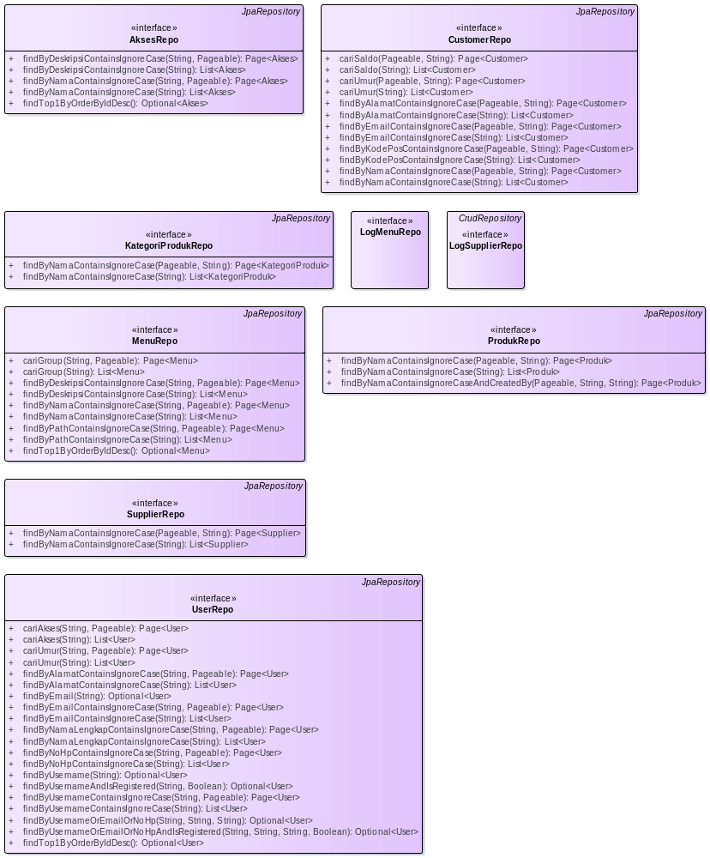

- repo

AksesRepo
Interface in package 'repo'

AksesRepo
Version 1.0 Phase 1.0 Proposed
LENOVO created on 05/11/2025. Last modified 05/11/2025
Extends JpaRepository

OPERATIONS
findByDeskripsiContainsIgnoreCase (nama : String , pageable : Pageable ) : Page<Akses> Public
[ Is static False. Is abstract False. Is return array False. Is query False. Is synchronized False. ]

findByDeskripsiContainsIgnoreCase (nama : String ) : List<Akses> Public
[ Is static False. Is abstract False. Is return array False. Is query False. Is synchronized False. ]

findByNamaContainsIgnoreCase (nama : String , pageable : Pageable ) : Page<Akses> Public

SELECT * FROM MstAkses Where toLower(Nama) LIKE '%toLower(?)%'
[ Is static False. Is abstract False. Is return array False. Is query False. Is synchronized False. ]

findByNamaContainsIgnoreCase (nama : String ) : List<Akses> Public

public Page<Akses> findByDeskripsiContainsIgnoreCaseAndDiv(String nama,String divisi, Pageable pageable);
[ Is static False. Is abstract False. Is return array False. Is query False. Is synchronized False. ]

findTop1ByOrderByIdDesc () : Optional<Akses> Public
[ Is static False. Is abstract False. Is return array False. Is query False. Is synchronized False. ]

CustomerRepo
Interface in package 'repo'

CustomerRepo
Version 1.0 Phase 1.0 Proposed
LENOVO created on 05/11/2025. Last modified 05/11/2025
Extends JpaRepository

ASSOCIATIONS
Association (direction: Source -> Destination)

Source: Public (Class) CustomerService | Target: Private customerRepo (Interface) CustomerRepo

OPERATIONS
cariSaldo (page : Pageable , value : String ) : Page<Customer> Public

Properties:
annotations = @Query(value = "SELECT c FROM Customer c WHERE CAST(c.saldo AS STRING) LIKE CONCAT('%',?1,'%') ")
[ Is static False. Is abstract False. Is return array False. Is query False. Is synchronized False. ]

cariSaldo (value : String ) : List<Customer> Public

Properties:
annotations = @Query(value = "SELECT c FROM Customer c WHERE CAST(c.saldo AS STRING) LIKE CONCAT('%',?1,'%') ")
[ Is static False. Is abstract False. Is return array False. Is query False. Is synchronized False. ]

cariUmur (page : Pageable , value : String ) : Page<Customer> Public

JPQL

Properties:
annotations = @Query(value = "SELECT c FROM Customer c WHERE CAST(DATEDIFF(year,c.tanggalLahir,CURRENT_TIMESTAMP) AS STRING) LIKE CONCAT('%',?1,'%') ")
[ Is static False. Is abstract False. Is return array False. Is query False. Is synchronized False. ]

cariUmur (value : String ) : List<Customer> Public

Properties:
annotations = @Query(value = "SELECT c FROM Customer c WHERE CAST(DATEDIFF(year,c.tanggalLahir,CURRENT_TIMESTAMP) AS STRING) LIKE CONCAT('%',?1,'%') ")
[ Is static False. Is abstract False. Is return array False. Is query False. Is synchronized False. ]

findByAlamatContainsIgnoreCase (page : Pageable , value : String ) : Page<Customer> Public
[ Is static False. Is abstract False. Is return array False. Is query False. Is synchronized False. ]

findByAlamatContainsIgnoreCase (value : String ) : List<Customer> Public
[ Is static False. Is abstract False. Is return array False. Is query False. Is synchronized False. ]

findByEmailContainsIgnoreCase (page : Pageable , value : String ) : Page<Customer> Public
[ Is static False. Is abstract False. Is return array False. Is query False. Is synchronized False. ]

findByEmailContainsIgnoreCase (value : String ) : List<Customer> Public
[ Is static False. Is abstract False. Is return array False. Is query False. Is synchronized False. ]

findByKodePosContainsIgnoreCase (page : Pageable , value : String ) : Page<Customer> Public
[ Is static False. Is abstract False. Is return array False. Is query False. Is synchronized False. ]

findByKodePosContainsIgnoreCase (value : String ) : List<Customer> Public
[ Is static False. Is abstract False. Is return array False. Is query False. Is synchronized False. ]

findByNamaContainsIgnoreCase (page : Pageable , value : String ) : Page<Customer> Public
[ Is static False. Is abstract False. Is return array False. Is query False. Is synchronized False. ]

findByNamaContainsIgnoreCase (value : String ) : List<Customer> Public
[ Is static False. Is abstract False. Is return array False. Is query False. Is synchronized False. ]

KategoriProdukRepo
Interface in package 'repo'

KategoriProdukRepo
Version 1.0 Phase 1.0 Proposed
LENOVO created on 05/11/2025. Last modified 05/11/2025
Extends JpaRepository

ASSOCIATIONS
Association (direction: Source -> Destination)

Source: Public (Class) KategoriProdukService | Target: Private kategoriProdukRepo (Interface) KategoriProdukRepo

OPERATIONS
findByNamaContainsIgnoreCase (page : Pageable , value : String ) : Page<KategoriProduk> Public
[ Is static False. Is abstract False. Is return array False. Is query False. Is synchronized False. ]

findByNamaContainsIgnoreCase (value : String ) : List<KategoriProduk> Public
[ Is static False. Is abstract False. Is return array False. Is query False. Is synchronized False. ]

LogMenuRepo
Interface in package 'repo'

IntelliJ IDEA 2022.3.1 (Community Edition) Build #IC-223.8214.52, built on December 20, 2022
@Author LENOVO a.k.a. M Muchib Zainul Fikry Java Developer Created on 03/11/2025 19:04
@Last Modified 03/11/2025 19:04 Version 1.0

LogMenuRepo
Version 1.0 Phase 1.0 Proposed
LENOVO created on 05/11/2025. Last modified 05/11/2025

LogSupplierRepo
Interface in package 'repo'

LogSupplierRepo
Version 1.0 Phase 1.0 Proposed
LENOVO created on 05/11/2025. Last modified 05/11/2025
Extends CrudRepository

ASSOCIATIONS
Association (direction: Source -> Destination)

Source: Public (Class) SupplierService | Target: Private logSupplierRepo (Interface) LogSupplierRepo

MenuRepo
Interface in package 'repo'

MenuRepo
Version 1.0 Phase 1.0 Proposed
LENOVO created on 05/11/2025. Last modified 05/11/2025
Extends JpaRepository

OPERATIONS
cariGroup (nama : String , pageable : Pageable ) : Page<Menu> Public

Properties:
annotations = @Query("SELECT x FROM Menu x WHERE lower(x.groupMenu.nama) LIKE lower(concat('%',?1,'%') )")
[ Is static False. Is abstract False. Is return array False. Is query False. Is synchronized False. ]

cariGroup (nama : String ) : List<Menu> Public

Properties:
annotations = @Query("SELECT x FROM Menu x WHERE lower(x.groupMenu.nama) LIKE lower(concat('%',?1,'%') )")
[ Is static False. Is abstract False. Is return array False. Is query False. Is synchronized False. ]

findByDeskripsiContainsIgnoreCase (nama : String , pageable : Pageable ) : Page<Menu> Public
[ Is static False. Is abstract False. Is return array False. Is query False. Is synchronized False. ]

findByDeskripsiContainsIgnoreCase (nama : String ) : List<Menu> Public
[ Is static False. Is abstract False. Is return array False. Is query False. Is synchronized False. ]

findByNamaContainsIgnoreCase (nama : String , pageable : Pageable ) : Page<Menu> Public
[ Is static False. Is abstract False. Is return array False. Is query False. Is synchronized False. ]

findByNamaContainsIgnoreCase (nama : String ) : List<Menu> Public
[ Is static False. Is abstract False. Is return array False. Is query False. Is synchronized False. ]

findByPathContainsIgnoreCase (nama : String , pageable : Pageable ) : Page<Menu> Public
[ Is static False. Is abstract False. Is return array False. Is query False. Is synchronized False. ]

findByPathContainsIgnoreCase (nama : String ) : List<Menu> Public
[ Is static False. Is abstract False. Is return array False. Is query False. Is synchronized False. ]

findTop1ByOrderByIdDesc () : Optional<Menu> Public
[ Is static False. Is abstract False. Is return array False. Is query False. Is synchronized False. ]

ProdukRepo
Interface in package 'repo'

public interface ProdukRepo extends CrudRepository<Produk,Long> {

ProdukRepo
Version 1.0 Phase 1.0 Proposed
LENOVO created on 05/11/2025. Last modified 05/11/2025
Extends JpaRepository

ASSOCIATIONS
Association (direction: Source -> Destination)

Source: Public (Class) ProdukService | Target: Private produkRepo (Interface) ProdukRepo

OPERATIONS
findByNamaContainsIgnoreCase (page : Pageable , value : String ) : Page<Produk> Public

SELECT p.* FROM MstProduk p WHERE Lower(p.nama) LIKE '%Lower(?)%'
[ Is static False. Is abstract False. Is return array False. Is query False. Is synchronized False. ]

findByNamaContainsIgnoreCase (value : String ) : List<Produk> Public

Query Buat di File
[ Is static False. Is abstract False. Is return array False. Is query False. Is synchronized False. ]

findByNamaContainsIgnoreCaseAndCreatedBy (page : Pageable , value : String , value2 : String ) : Page<Produk> Public

SELECT p.* FROM MstProduk p WHERE Lower(p.nama) LIKE '%Lower(?)%' AND p.CreatedBy = ?
[ Is static False. Is abstract False. Is return array False. Is query False. Is synchronized False. ]

SupplierRepo
Interface in package 'repo'

SupplierRepo
Version 1.0 Phase 1.0 Proposed
LENOVO created on 05/11/2025. Last modified 05/11/2025
Extends JpaRepository

ASSOCIATIONS
Association (direction: Source -> Destination)

Source: Public (Class) SupplierService | Target: Private supplierRepo (Interface) SupplierRepo

OPERATIONS
findByNamaContainsIgnoreCase (page : Pageable , value : String ) : Page<Supplier> Public
[ Is static False. Is abstract False. Is return array False. Is query False. Is synchronized False. ]

findByNamaContainsIgnoreCase (value : String ) : List<Supplier> Public
[ Is static False. Is abstract False. Is return array False. Is query False. Is synchronized False. ]

UserRepo
Interface in package 'repo'

UserRepo
Version 1.0 Phase 1.0 Proposed
LENOVO created on 05/11/2025. Last modified 05/11/2025
Extends JpaRepository

ASSOCIATIONS
Association (direction: Source -> Destination)

Source: Public (Class) AuthService | Target: Private userRepo (Interface) UserRepo

OPERATIONS
cariAkses (akses : String , pageable : Pageable ) : Page<User> Public

Properties:
annotations = @Query(value = "SELECT x FROM User x WHERE lower(x.akses.nama) LIKE lower(CONCAT('%',?1,'%')) ")
[ Is static False. Is abstract False. Is return array False. Is query False. Is synchronized False. ]

cariAkses (akses : String ) : List<User> Public

Properties:
annotations = @Query(value = "SELECT x FROM User x WHERE lower(x.akses.nama) LIKE lower(CONCAT('%',?1,'%')) ")
[ Is static False. Is abstract False. Is return array False. Is query False. Is synchronized False. ]

cariUmur (umur : String , pageable : Pageable ) : Page<User> Public

Properties:
annotations = @Query(value = "SELECT x FROM User x WHERE CAST(DATEDIFF(year ,x.tanggalLahir,CURRENT_TIMESTAMP)AS STRING) LIKE CONCAT('%',?1,'%') ")
[ Is static False. Is abstract False. Is return array False. Is query False. Is synchronized False. ]

cariUmur (umur : String ) : List<User> Public

Properties:
annotations = @Query(value = "SELECT x FROM User x WHERE CAST(DATEDIFF(year,x.tanggalLahir,current_timestamp) AS STRING ) LIKE CONCAT('%',?1,'%') ")
[ Is static False. Is abstract False. Is return array False. Is query False. Is synchronized False. ]

findByAlamatContainsIgnoreCase (nama : String , pageable : Pageable ) : Page<User> Public
[ Is static False. Is abstract False. Is return array False. Is query False. Is synchronized False. ]

findByAlamatContainsIgnoreCase (nama : String ) : List<User> Public
[ Is static False. Is abstract False. Is return array False. Is query False. Is synchronized False. ]

findByEmail (email : String ) : Optional<User> Public

Derivered Query SELECT x.* FROM MstUser x WHERE x.Email = ?
[ Is static False. Is abstract False. Is return array False. Is query False. Is synchronized False. ]

findByEmailContainsIgnoreCase (nama : String , pageable : Pageable ) : Page<User> Public
[ Is static False. Is abstract False. Is return array False. Is query False. Is synchronized False. ]

findByEmailContainsIgnoreCase (nama : String ) : List<User> Public
[ Is static False. Is abstract False. Is return array False. Is query False. Is synchronized False. ]

findByNamaLengkapContainsIgnoreCase (nama : String , pageable : Pageable ) : Page<User> Public
[ Is static False. Is abstract False. Is return array False. Is query False. Is synchronized False. ]

findByNamaLengkapContainsIgnoreCase (nama : String ) : List<User> Public

public Page<User> findByTanggalLahirContainsIgnoreCase(String nama, Pageable pageable);
[ Is static False. Is abstract False. Is return array False. Is query False. Is synchronized False. ]

findByNoHpContainsIgnoreCase (nama : String , pageable : Pageable ) : Page<User> Public
[ Is static False. Is abstract False. Is return array False. Is query False. Is synchronized False. ]

findByNoHpContainsIgnoreCase (nama : String ) : List<User> Public
[ Is static False. Is abstract False. Is return array False. Is query False. Is synchronized False. ]

findByUsername (username : String ) : Optional<User> Public
[ Is static False. Is abstract False. Is return array False. Is query False. Is synchronized False. ]

findByUsernameAndIsRegistered (username : String , valid : Boolean ) : Optional<User> Public
[ Is static False. Is abstract False. Is return array False. Is query False. Is synchronized False. ]

findByUsernameContainsIgnoreCase (nama : String , pageable : Pageable ) : Page<User> Public
[ Is static False. Is abstract False. Is return array False. Is query False. Is synchronized False. ]

findByUsernameContainsIgnoreCase (nama : String ) : List<User> Public
[ Is static False. Is abstract False. Is return array False. Is query False. Is synchronized False. ]

findByUsernameOrEmailOrNoHp (username : String , email : String , noHp : String ) : Optional<User> Public
[ Is static False. Is abstract False. Is return array False. Is query False. Is synchronized False. ]

findByUsernameOrEmailOrNoHpAndIsRegistered (username : String , email : String , noHp : String , valid : Boolean ) : Optional<User> Public
[ Is static False. Is abstract False. Is return array False. Is query False. Is synchronized False. ]

findTop1ByOrderByIdDesc () : Optional<User> Public

public List<User> findByTanggalLahirContainsIgnoreCase(String nama);
[ Is static False. Is abstract False. Is return array False. Is query False. Is synchronized False. ]

security
Package in package 'juaracoding'

security
Version 1.0 Phase 1.0 Proposed
LENOVO created on 05/11/2025. Last modified 05/11/2025

security diagram
Class diagram in package 'security'

security
Version 1.0
LENOVO created on 05/11/2025. Last modified 05/11/2025

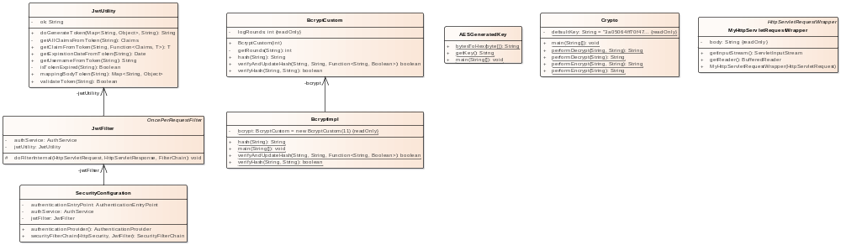

- security

AESGeneratedKey
Class in package 'security'

AESGeneratedKey
Version 1.0 Phase 1.0 Proposed
LENOVO created on 05/11/2025. Last modified 05/11/2025

OPERATIONS
bytesToHex (bytes : byte[] ) : String Public

Helper method untuk mengubah byte array menjadi string heksadesimal
[ Is static True. Is abstract False. Is return array False. Is query False. Is synchronized False. ]

getKey () : String Public
[ Is static True. Is abstract False. Is return array False. Is query False. Is synchronized False. ]

main (args : String[] ) : void Public

Properties:
throws = NoSuchAlgorithmException
[ Is static True. Is abstract False. Is return array False. Is query False. Is synchronized False. ]

BcryptCustom
Class in package 'security'

BcryptCustom
Version 1.0 Phase 1.0 Proposed
LENOVO created on 05/11/2025. Last modified 05/11/2025

ATTRIBUTES
logRounds : int Private Const
[ Is static False. Containment is Not Specified. ]

ASSOCIATIONS
Association (direction: Source -> Destination)

Source: Public (Class) BcryptImpl | Target: Private bcrypt (Class) BcryptCustom

OPERATIONS
BcryptCustom (logRounds : int ) : Public
[ Is static False. Is abstract False. Is return array False. Is query False. Is synchronized False. ]

getRounds (salt : String ) : int Private
[ Is static False. Is abstract False. Is return array False. Is query False. Is synchronized False. ]

hash (password : String ) : String Public
[ Is static False. Is abstract False. Is return array False. Is query False. Is synchronized False. ]

verifyAndUpdateHash (password : String , hash : String , updateFunc : Function<String, Boolean> ) : boolean Public
[ Is static False. Is abstract False. Is return array False. Is query False. Is synchronized False. ]

verifyHash (password : String , hash : String ) : boolean Public
[ Is static False. Is abstract False. Is return array False. Is query False. Is synchronized False. ]

BcryptImpl
Class in package 'security'

BcryptImpl
Version 1.0 Phase 1.0 Proposed
LENOVO created on 05/11/2025. Last modified 05/11/2025

ATTRIBUTES
bcrypt : BcryptCustom Private Const = new BcryptCustom(11)
[ Is static True. Containment is Not Specified. ]

ASSOCIATIONS
Association (direction: Source -> Destination)

Source: Public (Class) BcryptImpl | Target: Private bcrypt (Class) BcryptCustom

OPERATIONS
hash (password : String ) : String Public
[ Is static True. Is abstract False. Is return array False. Is query False. Is synchronized False. ]

main (args : String[] ) : void Public
[ Is static True. Is abstract False. Is return array False. Is query False. Is synchronized False. ]

verifyAndUpdateHash (password : String , hash : String , updateFunc : Function<String, Boolean> ) : boolean Public
[ Is static True. Is abstract False. Is return array False. Is query False. Is synchronized False. ]

verifyHash (password : String , hash : String ) : boolean Public
[ Is static True. Is abstract False. Is return array False. Is query False. Is synchronized False. ]

Crypto
Class in package 'security'

Crypto
Version 1.0 Phase 1.0 Proposed
LENOVO created on 05/11/2025. Last modified 05/11/2025

ATTRIBUTES
defaultKey : String Private Const = "3a05064ff70f47e8addb2d0b2be94f5e6434a1980ba124e914e5ee89902aec09"

private static final String defaultKey = "4d05ac36ce72f080dc9e29af7d03bf0dd15a530305415c811a6a64767108145d"; private static final String defaultKey = "c953245d42feab21959733db0300bb2c296f54fc4fc7f1c150776b7800d27365"; private static final String defaultKey = "28e0d502a6db943d67be50a16d3641869f1d1f31088708f3a6677bdae1b06bc3";
[ Is static True. Containment is Not Specified. ]

OPERATIONS
main (args : String[] ) : void Public
[ Is static True. Is abstract False. Is return array False. Is query False. Is synchronized False. ]

performDecrypt (keyText : String , cryptoText : String ) : String Public
[ Is static True. Is abstract False. Is return array False. Is query False. Is synchronized False. ]

performDecrypt (cryptoText : String ) : String Public
[ Is static True. Is abstract False. Is return array False. Is query False. Is synchronized False. ]

performEncrypt (keyText : String , plainText : String ) : String Public
[ Is static True. Is abstract False. Is return array False. Is query False. Is synchronized False. ]

performEncrypt (cryptoText : String ) : String Public
[ Is static True. Is abstract False. Is return array False. Is query False. Is synchronized False. ]

JwtFilter
Class in package 'security'

JwtFilter
Version 1.0 Phase 1.0 Proposed
LENOVO created on 05/11/2025. Last modified 05/11/2025
Extends OncePerRequestFilter

ATTRIBUTES
authService : AuthService Private

Properties:
annotations = @Autowired
[ Is static False. Containment is Not Specified. ]

jwtUtility : JwtUtility Private

Properties:
annotations = @Autowired
[ Is static False. Containment is Not Specified. ]

ASSOCIATIONS
Association (direction: Source -> Destination)

Source: Public (Class) JwtFilter | Target: Private jwtUtility (Class) JwtUtility
Association (direction: Source -> Destination)

Source: Public (Class) JwtFilter | Target: Private authService (Class) AuthService
Association (direction: Source -> Destination)

Source: Public (Class) SecurityConfiguration | Target: Private jwtFilter (Class) JwtFilter

OPERATIONS
doFilterInternal (request : HttpServletRequest , response : HttpServletResponse , filterChain : FilterChain ) : void Protected

Properties:
annotations = @Override
throws = ServletException,IOException
[ Is static False. Is abstract False. Is return array False. Is query False. Is synchronized False. ]

JwtUtility
Class in package 'security'

class untuk fungsional Json Web Token

JwtUtility
Version 1.0 Phase 1.0 Proposed
LENOVO created on 05/11/2025. Last modified 05/11/2025

ATTRIBUTES
ok : String Private

variable untuk menentukan OK
[ Is static False. Containment is Not Specified. ]

ASSOCIATIONS
Association (direction: Source -> Destination)

Source: Public (Class) JwtFilter | Target: Private jwtUtility (Class) JwtUtility
Association (direction: Source -> Destination)

Source: Public (Class) AuthService | Target: Private jwtUtility (Class) JwtUtility

OPERATIONS
doGenerateToken (claims : Map<String, Object> , subject : String ) : String Public

fungsi ini dipanggil saat login , untuk pembentukan token JWT
[ Is static False. Is abstract False. Is return array False. Is query False. Is synchronized False. ]

getAllClaimsFromToken (token : String ) : Claims Private
[ Is static False. Is abstract False. Is return array False. Is query False. Is synchronized False. ]

getClaimFromToken (token : String , claimsResolver : Function<Claims, T> ) : T Public

Properties:
generic = <T>
[ Is static False. Is abstract False. Is return array False. Is query False. Is synchronized False. ]

getExpirationDateFromToken (token : String ) : Date Public
[ Is static False. Is abstract False. Is return array False. Is query False. Is synchronized False. ]

getUsernameFromToken (token : String ) : String Public
[ Is static False. Is abstract False. Is return array False. Is query False. Is synchronized False. ]

isTokenExpired (token : String ) : Boolean Private
[ Is static False. Is abstract False. Is return array False. Is query False. Is synchronized False. ]

mappingBodyToken (token : String ) : Map<String, Object> Public

variable untuk menentukan OK
[ Is static False. Is abstract False. Is return array False. Is query False. Is synchronized False. ]

validateToken (token : String ) : Boolean Public
[ Is static False. Is abstract False. Is return array False. Is query False. Is synchronized False. ]

MyHttpServletRequestWrapper
Class in package 'security'

Data stream servlet saat sudah dipanggil akan hilang prose override pada class ini untuk membuat object penampung data nya dengan tujuan agar data nya dapat digunakan di class lain.

MyHttpServletRequestWrapper
Version 1.0 Phase 1.0 Proposed
LENOVO created on 05/11/2025. Last modified 05/11/2025
Extends HttpServletRequestWrapper

ATTRIBUTES
body : String Private Const
[ Is static False. Containment is Not Specified. ]

OPERATIONS
getInputStream () : ServletInputStream Public

Properties:
annotations = @Override
[ Is static False. Is abstract False. Is return array False. Is query False. Is synchronized False. ]

getReader () : BufferedReader Public

Properties:
annotations = @Override
[ Is static False. Is abstract False. Is return array False. Is query False. Is synchronized False. ]

MyHttpServletRequestWrapper (request : HttpServletRequest ) : Public
[ Is static False. Is abstract False. Is return array False. Is query False. Is synchronized False. ]

SecurityConfiguration
Class in package 'security'

SecurityConfiguration
Version 1.0 Phase 1.0 Proposed
LENOVO created on 05/11/2025. Last modified 05/11/2025

ATTRIBUTES
authenticationEntryPoint : AuthenticationEntryPoint Private

Properties:
annotations = @Autowired@Qualifier("customAuthenticationEntryPoint")
[ Is static False. Containment is Not Specified. ]

authService : AuthService Private

Properties:
annotations = @Autowired
[ Is static False. Containment is Not Specified. ]

jwtFilter : JwtFilter Private

Properties:
annotations = @Autowired
[ Is static False. Containment is Not Specified. ]

ASSOCIATIONS
Association (direction: Source -> Destination)

Source: Public (Class) SecurityConfiguration | Target: Private jwtFilter (Class) JwtFilter
Association (direction: Source -> Destination)

Source: Public (Class) SecurityConfiguration | Target: Private authService (Class) AuthService

OPERATIONS
authenticationProvider () : AuthenticationProvider Public

401 -> Otentikasi 403 -> Forbiden / Otorisasi

Properties:
annotations = @Bean
[ Is static False. Is abstract False. Is return array False. Is query False. Is synchronized False. ]

securityFilterChain (http : HttpSecurity , filter : JwtFilter ) : SecurityFilterChain Public

Properties:
annotations = @Bean
throws = Exception
[ Is static False. Is abstract False. Is return array False. Is query False. Is synchronized False. ]

service
Package in package 'juaracoding'

service
Version 1.0 Phase 1.0 Proposed
LENOVO created on 05/11/2025. Last modified 05/11/2025

service diagram
Class diagram in package 'service'

service
Version 1.0
LENOVO created on 05/11/2025. Last modified 05/11/2025

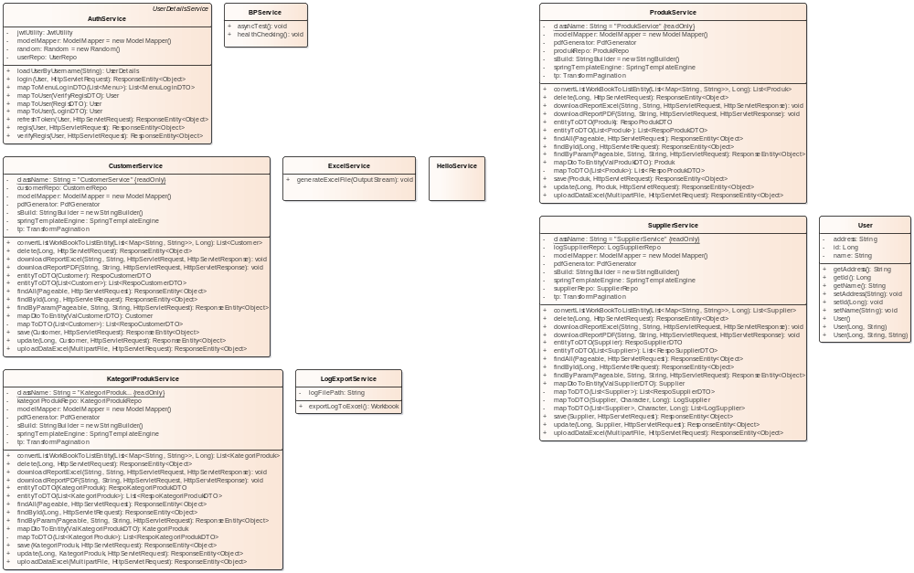

- service

AuthService
Class in package 'service'

Kode Platform / Aplikasi : 001 atau AUT Kode Modul : 00 Kode Validation / Error : FV - FE

AuthService
Version 1.0 Phase 1.0 Proposed
LENOVO created on 05/11/2025. Last modified 05/11/2025
Extends UserDetailsService

ATTRIBUTES
jwtUtility : JwtUtility Private

Properties:
annotations = @Autowired
[ Is static False. Containment is Not Specified. ]

modelMapper : ModelMapper Private = new ModelMapper()
[ Is static False. Containment is Not Specified. ]

random : Random Private = new Random()
[ Is static False. Containment is Not Specified. ]

userRepo : UserRepo Private

Properties:
annotations = @Autowired
[ Is static False. Containment is Not Specified. ]

ASSOCIATIONS
Association (direction: Source -> Destination)

Source: Public (Class) AuthService | Target: Private jwtUtility (Class) JwtUtility
Association (direction: Source -> Destination)

Source: Public (Class) AuthService | Target: Private userRepo (Interface) UserRepo
Association (direction: Source -> Destination)

Source: Public (Class) AuthController | Target: Package authService (Class) AuthService
Association (direction: Source -> Destination)

Source: Public (Class) SecurityConfiguration | Target: Private authService (Class) AuthService
Association (direction: Source -> Destination)

Source: Public (Class) JwtFilter | Target: Private authService (Class) AuthService

OPERATIONS
loadUserByUsername (username : String ) : UserDetails Public

Properties:
annotations = @Override
throws = UsernameNotFoundException
[ Is static False. Is abstract False. Is return array False. Is query False. Is synchronized False. ]

login (user : User , request : HttpServletRequest ) : ResponseEntity<Object> Public

021-030
[ Is static False. Is abstract False. Is return array False. Is query False. Is synchronized False. ]

mapToMenuLoginDTO (ltMenu : List<Menu> ) : List<MenuLoginDTO> Public
[ Is static False. Is abstract False. Is return array False. Is query False. Is synchronized False. ]

mapToUser (verifyRegisDTO : VerifyRegisDTO ) : User Public
[ Is static False. Is abstract False. Is return array False. Is query False. Is synchronized False. ]

mapToUser (regisDTO : RegisDTO ) : User Public
[ Is static False. Is abstract False. Is return array False. Is query False. Is synchronized False. ]

mapToUser (loginDTO : LoginDTO ) : User Public
[ Is static False. Is abstract False. Is return array False. Is query False. Is synchronized False. ]

refreshToken (user : User , request : HttpServletRequest ) : ResponseEntity<Object> Public
[ Is static False. Is abstract False. Is return array False. Is query False. Is synchronized False. ]

regis (user : User , request : HttpServletRequest ) : ResponseEntity<Object> Public

001-010
[ Is static False. Is abstract False. Is return array False. Is query False. Is synchronized False. ]

verifyRegis (user : User , request : HttpServletRequest ) : ResponseEntity<Object> Public

011-020
[ Is static False. Is abstract False. Is return array False. Is query False. Is synchronized False. ]

BPService
Class in package 'service'

BPService
Version 1.0 Phase 1.0 Proposed
LENOVO created on 05/11/2025. Last modified 05/11/2025

ASSOCIATIONS
Association (direction: Source -> Destination)

Source: Public (Class) HelloController | Target: Package bpService (Class) BPService

OPERATIONS
asyncTest () : void Public

Properties:
annotations = @Async
[ Is static False. Is abstract False. Is return array False. Is query False. Is synchronized False. ]

healthChecking () : void Public

Properties:
annotations = @Scheduled(fixedRate = 60000)
[ Is static False. Is abstract False. Is return array False. Is query False. Is synchronized False. ]

CustomerService
Class in package 'service'

platform code : SLS modul code : XX

CustomerService
Version 1.0 Phase 1.0 Proposed
LENOVO created on 05/11/2025. Last modified 05/11/2025

OUTGOING STRUCTURAL RELATIONSHIPS
Realization from CustomerService to IReport
[ Direction is 'Source -> Destination'. ]

Realization from CustomerService to IService
[ Direction is 'Source -> Destination'. ]

ATTRIBUTES
className : String Private Const = "CustomerService"
[ Is static True. Containment is Not Specified. ]

customerRepo : CustomerRepo Private

Properties:
annotations = @Autowired
[ Is static False. Containment is Not Specified. ]

modelMapper : ModelMapper Private = new ModelMapper()
[ Is static False. Containment is Not Specified. ]

pdfGenerator : PdfGenerator Private

Properties:
annotations = @Autowired
[ Is static False. Containment is Not Specified. ]

sBuild : StringBuilder Private = new StringBuilder()
[ Is static False. Containment is Not Specified. ]

springTemplateEngine : SpringTemplateEngine Private

Properties:
annotations = @Autowired
[ Is static False. Containment is Not Specified. ]

tp : TransformPagination Private

Properties:
annotations = @Autowired
[ Is static False. Containment is Not Specified. ]

ASSOCIATIONS
Association (direction: Source -> Destination)

Source: Public (Class) CustomerService | Target: Private tp (Class) TransformPagination
Association (direction: Source -> Destination)

Source: Public (Class) CustomerService | Target: Private customerRepo (Interface) CustomerRepo
Association (direction: Source -> Destination)

Source: Public (Class) CustomerService | Target: Private pdfGenerator (Class) PdfGenerator
Association (direction: Source -> Destination)

Source: Public (Class) CustomerController | Target: Private customerService (Class) CustomerService

OPERATIONS
convertListWorkBookToListEntity (listData : List<Map<String, String>> , userId : Long ) : List<Customer> Public

Properties:
annotations = @Override
[ Is static False. Is abstract False. Is return array False. Is query False. Is synchronized False. ]

delete (id : Long , request : HttpServletRequest ) : ResponseEntity<Object> Public

Properties:
annotations = @Override
[ Is static False. Is abstract False. Is return array False. Is query False. Is synchronized False. ]

downloadReportExcel (column : String , value : String , request : HttpServletRequest , response : HttpServletResponse ) : void Public

Properties:
annotations = @Override
[ Is static False. Is abstract False. Is return array False. Is query False. Is synchronized False. ]

downloadReportPDF (column : String , value : String , request : HttpServletRequest , response : HttpServletResponse ) : void Public

Properties:
annotations = @Override
[ Is static False. Is abstract False. Is return array False. Is query False. Is synchronized False. ]

entityToDTO (customer : Customer ) : RespoCustomerDTO Public
[ Is static False. Is abstract False. Is return array False. Is query False. Is synchronized False. ]

entityToDTO (customer : List<Customer> ) : List<RespoCustomerDTO> Public
[ Is static False. Is abstract False. Is return array False. Is query False. Is synchronized False. ]

findAll (pageable : Pageable , request : HttpServletRequest ) : ResponseEntity<Object> Public

Properties:
annotations = @Override
[ Is static False. Is abstract False. Is return array False. Is query False. Is synchronized False. ]

findById (id : Long , request : HttpServletRequest ) : ResponseEntity<Object> Public

Properties:
annotations = @Override
[ Is static False. Is abstract False. Is return array False. Is query False. Is synchronized False. ]

findByParam (pageable : Pageable , column : String , value : String , request : HttpServletRequest ) : ResponseEntity<Object> Public

Properties:
annotations = @Override
[ Is static False. Is abstract False. Is return array False. Is query False. Is synchronized False. ]

mapDtoToEntity (valCustomerDTO : ValCustomerDTO ) : Customer Public
[ Is static False. Is abstract False. Is return array False. Is query False. Is synchronized False. ]

mapToDTO (l : List<Customer> ) : List<RespoCustomerDTO> Private
[ Is static False. Is abstract False. Is return array False. Is query False. Is synchronized False. ]

save (customer : Customer , request : HttpServletRequest ) : ResponseEntity<Object> Public

Properties:
annotations = @Override
[ Is static False. Is abstract False. Is return array False. Is query False. Is synchronized False. ]

update (id : Long , customer : Customer , request : HttpServletRequest ) : ResponseEntity<Object> Public

Properties:
annotations = @Override
[ Is static False. Is abstract False. Is return array False. Is query False. Is synchronized False. ]

uploadDataExcel (file : MultipartFile , request : HttpServletRequest ) : ResponseEntity<Object> Public

Properties:
annotations = @Override
[ Is static False. Is abstract False. Is return array False. Is query False. Is synchronized False. ]

ExcelService
Class in package 'service'

ExcelService
Version 1.0 Phase 1.0 Proposed
LENOVO created on 05/11/2025. Last modified 05/11/2025

ASSOCIATIONS
Association (direction: Source -> Destination)

Source: Public (Class) ExcelDownloadController | Target: Private excelService (Class) ExcelService

OPERATIONS
generateExcelFile (outputStream : OutputStream ) : void Public

Metode ini membuat Workbook POI dan menulisnya ke OutputStream. OutputStream ini akan menjadi output HTTP response di controller.

Properties:
throws = IOException
[ Is static False. Is abstract False. Is return array False. Is query False. Is synchronized False. ]

HelloService
Class in package 'service'

HelloService
Version 1.0 Phase 1.0 Proposed
LENOVO created on 05/11/2025. Last modified 05/11/2025

KategoriProdukService
Class in package 'service'

platform code : SLS modul code : 01

KategoriProdukService
Version 1.0 Phase 1.0 Proposed
LENOVO created on 05/11/2025. Last modified 05/11/2025

OUTGOING STRUCTURAL RELATIONSHIPS
Realization from KategoriProdukService to IService
[ Direction is 'Source -> Destination'. ]

Realization from KategoriProdukService to IReport
[ Direction is 'Source -> Destination'. ]

ATTRIBUTES
className : String Private Const = "KategoriProdukService"
[ Is static True. Containment is Not Specified. ]

kategoriProdukRepo : KategoriProdukRepo Private

Properties:
annotations = @Autowired
[ Is static False. Containment is Not Specified. ]

modelMapper : ModelMapper Private = new ModelMapper()
[ Is static False. Containment is Not Specified. ]

pdfGenerator : PdfGenerator Private

Properties:
annotations = @Autowired
[ Is static False. Containment is Not Specified. ]

sBuild : StringBuilder Private = new StringBuilder()
[ Is static False. Containment is Not Specified. ]

springTemplateEngine : SpringTemplateEngine Private

Properties:
annotations = @Autowired
[ Is static False. Containment is Not Specified. ]

tp : TransformPagination Private

Properties:
annotations = @Autowired
[ Is static False. Containment is Not Specified. ]

ASSOCIATIONS
Association (direction: Source -> Destination)

Source: Public (Class) KategoriProdukService | Target: Private tp (Class) TransformPagination
Association (direction: Source -> Destination)

Source: Public (Class) KategoriProdukService | Target: Private kategoriProdukRepo (Interface) KategoriProdukRepo
Association (direction: Source -> Destination)

Source: Public (Class) KategoriProdukService | Target: Private pdfGenerator (Class) PdfGenerator
Association (direction: Source -> Destination)

Source: Public (Class) KategoriProdukController | Target: Private kategoriprodukService (Class) KategoriProdukService

OPERATIONS
convertListWorkBookToListEntity (listData : List<Map<String, String>> , userId : Long ) : List<KategoriProduk> Public

Properties:
annotations = @Override
[ Is static False. Is abstract False. Is return array False. Is query False. Is synchronized False. ]

delete (id : Long , request : HttpServletRequest ) : ResponseEntity<Object> Public

Properties:
annotations = @Override
[ Is static False. Is abstract False. Is return array False. Is query False. Is synchronized False. ]

downloadReportExcel (column : String , value : String , request : HttpServletRequest , response : HttpServletResponse ) : void Public

Properties:
annotations = @Override
[ Is static False. Is abstract False. Is return array False. Is query False. Is synchronized False. ]

downloadReportPDF (column : String , value : String , request : HttpServletRequest , response : HttpServletResponse ) : void Public

Properties:
annotations = @Override
[ Is static False. Is abstract False. Is return array False. Is query False. Is synchronized False. ]

entityToDTO (kategoriProduk : KategoriProduk ) : RespoKategoriProdukDTO Public
[ Is static False. Is abstract False. Is return array False. Is query False. Is synchronized False. ]

entityToDTO (kategoriProduk : List<KategoriProduk> ) : List<RespoKategoriProdukDTO> Public
[ Is static False. Is abstract False. Is return array False. Is query False. Is synchronized False. ]

findAll (pageable : Pageable , request : HttpServletRequest ) : ResponseEntity<Object> Public

Properties:
annotations = @Override
[ Is static False. Is abstract False. Is return array False. Is query False. Is synchronized False. ]

findById (id : Long , request : HttpServletRequest ) : ResponseEntity<Object> Public

Properties:
annotations = @Override
[ Is static False. Is abstract False. Is return array False. Is query False. Is synchronized False. ]

findByParam (pageable : Pageable , column : String , value : String , request : HttpServletRequest ) : ResponseEntity<Object> Public

Properties:
annotations = @Override
[ Is static False. Is abstract False. Is return array False. Is query False. Is synchronized False. ]

mapDtoToEntity (valKategoriProdukDTO : ValKategoriProdukDTO ) : KategoriProduk Public
[ Is static False. Is abstract False. Is return array False. Is query False. Is synchronized False. ]

mapToDTO (l : List<KategoriProduk> ) : List<RespoKategoriProdukDTO> Private
[ Is static False. Is abstract False. Is return array False. Is query False. Is synchronized False. ]

save (kategoriProduk : KategoriProduk , request : HttpServletRequest ) : ResponseEntity<Object> Public

Properties:
annotations = @Override
[ Is static False. Is abstract False. Is return array False. Is query False. Is synchronized False. ]

update (id : Long , kategoriProduk : KategoriProduk , request : HttpServletRequest ) : ResponseEntity<Object> Public

Properties:
annotations = @Override
[ Is static False. Is abstract False. Is return array False. Is query False. Is synchronized False. ]

uploadDataExcel (file : MultipartFile , request : HttpServletRequest ) : ResponseEntity<Object> Public

Properties:
annotations = @Override
[ Is static False. Is abstract False. Is return array False. Is query False. Is synchronized False. ]

LogExportService
Class in package 'service'

LogExportService
Version 1.0 Phase 1.0 Proposed
LENOVO created on 05/11/2025. Last modified 05/11/2025

ATTRIBUTES
logFilePath : String Private

Properties:
annotations = @Value("${logging.file.name:logs/app.log}")
[ Is static False. Containment is Not Specified. ]

ASSOCIATIONS
Association (direction: Source -> Destination)

Source: Public (Class) LogController | Target: Private logExportService (Class) LogExportService

OPERATIONS
exportLogToExcel () : Workbook Public

Properties:
throws = IOException
[ Is static False. Is abstract False. Is return array False. Is query False. Is synchronized False. ]

ProdukService
Class in package 'service'

platform code : SLS modul code : 03

ProdukService
Version 1.0 Phase 1.0 Proposed
LENOVO created on 05/11/2025. Last modified 05/11/2025

OUTGOING STRUCTURAL RELATIONSHIPS
Realization from ProdukService to IService
[ Direction is 'Source -> Destination'. ]

Realization from ProdukService to IReport
[ Direction is 'Source -> Destination'. ]

ATTRIBUTES
className : String Private Const = "ProdukService"
[ Is static True. Containment is Not Specified. ]

modelMapper : ModelMapper Private = new ModelMapper()
[ Is static False. Containment is Not Specified. ]

pdfGenerator : PdfGenerator Private

Properties:
annotations = @Autowired
[ Is static False. Containment is Not Specified. ]

produkRepo : ProdukRepo Private

Properties:
annotations = @Autowired
[ Is static False. Containment is Not Specified. ]

sBuild : StringBuilder Private = new StringBuilder()
[ Is static False. Containment is Not Specified. ]

springTemplateEngine : SpringTemplateEngine Private

Properties:
annotations = @Autowired
[ Is static False. Containment is Not Specified. ]

tp : TransformPagination Private

Properties:
annotations = @Autowired
[ Is static False. Containment is Not Specified. ]

ASSOCIATIONS
Association (direction: Source -> Destination)

Source: Public (Class) ProdukService | Target: Private pdfGenerator (Class) PdfGenerator
Association (direction: Source -> Destination)

Source: Public (Class) ProdukService | Target: Private tp (Class) TransformPagination
Association (direction: Source -> Destination)

Source: Public (Class) ProdukService | Target: Private produkRepo (Interface) ProdukRepo
Association (direction: Source -> Destination)

Source: Public (Class) ProdukController | Target: Private produkService (Class) ProdukService

OPERATIONS
convertListWorkBookToListEntity (listData : List<Map<String, String>> , userId : Long ) : List<Produk> Public

Properties:
annotations = @Override
[ Is static False. Is abstract False. Is return array False. Is query False. Is synchronized False. ]

delete (id : Long , request : HttpServletRequest ) : ResponseEntity<Object> Public

Properties:
annotations = @Override
[ Is static False. Is abstract False. Is return array False. Is query False. Is synchronized False. ]

downloadReportExcel (column : String , value : String , request : HttpServletRequest , response : HttpServletResponse ) : void Public

Properties:
annotations = @Override
[ Is static False. Is abstract False. Is return array False. Is query False. Is synchronized False. ]

downloadReportPDF (column : String , value : String , request : HttpServletRequest , response : HttpServletResponse ) : void Public

Properties:
annotations = @Override
[ Is static False. Is abstract False. Is return array False. Is query False. Is synchronized False. ]

entityToDTO (produk : Produk ) : RespoProdukDTO Public
[ Is static False. Is abstract False. Is return array False. Is query False. Is synchronized False. ]

entityToDTO (produk : List<Produk> ) : List<RespoProdukDTO> Public
[ Is static False. Is abstract False. Is return array False. Is query False. Is synchronized False. ]

findAll (pageable : Pageable , request : HttpServletRequest ) : ResponseEntity<Object> Public

Properties:
annotations = @Override
[ Is static False. Is abstract False. Is return array False. Is query False. Is synchronized False. ]

findById (id : Long , request : HttpServletRequest ) : ResponseEntity<Object> Public

Properties:
annotations = @Override
[ Is static False. Is abstract False. Is return array False. Is query False. Is synchronized False. ]

findByParam (pageable : Pageable , column : String , value : String , request : HttpServletRequest ) : ResponseEntity<Object> Public

public ResponseEntity<Object> findAll(Pageable pageable, HttpServletRequest request) { Page<Produk> page=null; List<RespoProdukDTO> listDTO = null; Page<RespoProdukDTO> pageRespo=null; Map<String,Object> data = null; try { page = produkRepo.findAll(pageable); if(page.isEmpty()){ return new ResponseHandler().handleResponse("Data Tidak Ditemukan", HttpStatus.NOT_FOUND,null,"SLS03FV041",request); } listDTO = entityToDTO(page.getContent());//List<Produk> -> List<RespoProduk> data = tp.transformPagination(listDTO,page,"id",""); }catch (Exception e){ LoggingFile.logException(className,"findAll(Pageable pageable, HttpServletRequest request) "+ RequestCapture.allRequest(request),e); return new ResponseHandler().handleResponse("Internal Server Error", HttpStatus.INTERNAL_SERVER_ERROR,null,"SLS03FE041",request); } return new ResponseHandler().handleResponse("Data Ditemukan", HttpStatus.OK,data,null,request); }

Properties:
annotations = @Override
[ Is static False. Is abstract False. Is return array False. Is query False. Is synchronized False. ]

mapDtoToEntity (valProdukDTO : ValProdukDTO ) : Produk Public
[ Is static False. Is abstract False. Is return array False. Is query False. Is synchronized False. ]

mapToDTO (l : List<Produk> ) : List<RespoProdukDTO> Private
[ Is static False. Is abstract False. Is return array False. Is query False. Is synchronized False. ]

save (produk : Produk , request : HttpServletRequest ) : ResponseEntity<Object> Public

Properties:
annotations = @Override
[ Is static False. Is abstract False. Is return array False. Is query False. Is synchronized False. ]

update (id : Long , produk : Produk , request : HttpServletRequest ) : ResponseEntity<Object> Public

Properties:
annotations = @Override
[ Is static False. Is abstract False. Is return array False. Is query False. Is synchronized False. ]

uploadDataExcel (file : MultipartFile , request : HttpServletRequest ) : ResponseEntity<Object> Public

Properties:
annotations = @Override
[ Is static False. Is abstract False. Is return array False. Is query False. Is synchronized False. ]

SupplierService
Class in package 'service'

platform code : SLS modul code : 02

SupplierService
Version 1.0 Phase 1.0 Proposed
LENOVO created on 05/11/2025. Last modified 05/11/2025

OUTGOING STRUCTURAL RELATIONSHIPS
Realization from SupplierService to IService
[ Direction is 'Source -> Destination'. ]

Realization from SupplierService to IReport
[ Direction is 'Source -> Destination'. ]

ATTRIBUTES
className : String Private Const = "SupplierService"
[ Is static True. Containment is Not Specified. ]

logSupplierRepo : LogSupplierRepo Private

Properties:
annotations = @Autowired
[ Is static False. Containment is Not Specified. ]

modelMapper : ModelMapper Private = new ModelMapper()
[ Is static False. Containment is Not Specified. ]

pdfGenerator : PdfGenerator Private

Properties:
annotations = @Autowired
[ Is static False. Containment is Not Specified. ]

sBuild : StringBuilder Private = new StringBuilder()
[ Is static False. Containment is Not Specified. ]

springTemplateEngine : SpringTemplateEngine Private

Properties:
annotations = @Autowired
[ Is static False. Containment is Not Specified. ]

supplierRepo : SupplierRepo Private

Properties:
annotations = @Autowired
[ Is static False. Containment is Not Specified. ]

tp : TransformPagination Private

Properties:
annotations = @Autowired
[ Is static False. Containment is Not Specified. ]

ASSOCIATIONS
Association (direction: Source -> Destination)

Source: Public (Class) SupplierService | Target: Private supplierRepo (Interface) SupplierRepo
Association (direction: Source -> Destination)

Source: Public (Class) SupplierService | Target: Private pdfGenerator (Class) PdfGenerator
Association (direction: Source -> Destination)

Source: Public (Class) SupplierService | Target: Private tp (Class) TransformPagination
Association (direction: Source -> Destination)

Source: Public (Class) SupplierService | Target: Private logSupplierRepo (Interface) LogSupplierRepo
Association (direction: Source -> Destination)

Source: Public (Class) SupplierController | Target: Private supplierService (Class) SupplierService

OPERATIONS
convertListWorkBookToListEntity (listData : List<Map<String, String>> , userId : Long ) : List<Supplier> Public

Properties:
annotations = @Override
[ Is static False. Is abstract False. Is return array False. Is query False. Is synchronized False. ]

delete (id : Long , request : HttpServletRequest ) : ResponseEntity<Object> Public

Properties:
annotations = @Override
[ Is static False. Is abstract False. Is return array False. Is query False. Is synchronized False. ]

downloadReportExcel (column : String , value : String , request : HttpServletRequest , response : HttpServletResponse ) : void Public

Properties:
annotations = @Override
[ Is static False. Is abstract False. Is return array False. Is query False. Is synchronized False. ]

downloadReportPDF (column : String , value : String , request : HttpServletRequest , response : HttpServletResponse ) : void Public

Properties:
annotations = @Override
[ Is static False. Is abstract False. Is return array False. Is query False. Is synchronized False. ]

entityToDTO (supplier : Supplier ) : RespoSupplierDTO Public
[ Is static False. Is abstract False. Is return array False. Is query False. Is synchronized False. ]

entityToDTO (supplier : List<Supplier> ) : List<RespoSupplierDTO> Public
[ Is static False. Is abstract False. Is return array False. Is query False. Is synchronized False. ]

findAll (pageable : Pageable , request : HttpServletRequest ) : ResponseEntity<Object> Public

Properties:
annotations = @Override
[ Is static False. Is abstract False. Is return array False. Is query False. Is synchronized False. ]

findById (id : Long , request : HttpServletRequest ) : ResponseEntity<Object> Public

Properties:
annotations = @Override
[ Is static False. Is abstract False. Is return array False. Is query False. Is synchronized False. ]

findByParam (pageable : Pageable , column : String , value : String , request : HttpServletRequest ) : ResponseEntity<Object> Public

Properties:
annotations = @Override
[ Is static False. Is abstract False. Is return array False. Is query False. Is synchronized False. ]

mapDtoToEntity (valSupplierDTO : ValSupplierDTO ) : Supplier Public

Map untuk request
[ Is static False. Is abstract False. Is return array False. Is query False. Is synchronized False. ]

mapToDTO (l : List<Supplier> ) : List<RespoSupplierDTO> Private
[ Is static False. Is abstract False. Is return array False. Is query False. Is synchronized False. ]

mapToDTO (supplier : Supplier , flag : Character , userId : Long ) : LogSupplier Private
[ Is static False. Is abstract False. Is return array False. Is query False. Is synchronized False. ]

mapToDTO (listSupplier : List<Supplier> , flag : Character , userId : Long ) : List<LogSupplier> Private
[ Is static False. Is abstract False. Is return array False. Is query False. Is synchronized False. ]

save (supplier : Supplier , request : HttpServletRequest ) : ResponseEntity<Object> Public

Properties:
annotations = @Override
[ Is static False. Is abstract False. Is return array False. Is query False. Is synchronized False. ]

update (id : Long , supplier : Supplier , request : HttpServletRequest ) : ResponseEntity<Object> Public

Properties:
annotations = @Override
[ Is static False. Is abstract False. Is return array False. Is query False. Is synchronized False. ]

uploadDataExcel (file : MultipartFile , request : HttpServletRequest ) : ResponseEntity<Object> Public

Properties:
annotations = @Override
[ Is static False. Is abstract False. Is return array False. Is query False. Is synchronized False. ]

User
Class in package 'service'

IntelliJ IDEA 2022.3.1 (Community Edition) Build #IC-223.8214.52, built on December 20, 2022
@Author LENOVO a.k.a. M Muchib Zainul Fikry Java Developer Created on 22/10/2025 20:06
@Last Modified 22/10/2025 20:06 Version 1.0

User
Version 1.0 Phase 1.0 Proposed
LENOVO created on 05/11/2025. Last modified 05/11/2025

ATTRIBUTES
address : String Private
[ Is static False. Containment is Not Specified. ]

id : Long Private
[ Is static False. Containment is Not Specified. ]

name : String Private
[ Is static False. Containment is Not Specified. ]

ASSOCIATIONS
Association (direction: Source -> Destination)

Source: Public (Class) UserController | Target: Private allUsers (Class) User  Cardinality: [0..*]

OPERATIONS
getAddress () : String Public
[ Is static False. Is abstract False. Is return array False. Is query False. Is synchronized False. ]

getId () : Long Public
[ Is static False. Is abstract False. Is return array False. Is query False. Is synchronized False. ]

getName () : String Public
[ Is static False. Is abstract False. Is return array False. Is query False. Is synchronized False. ]

setAddress (address : String ) : void Public
[ Is static False. Is abstract False. Is return array False. Is query False. Is synchronized False. ]

setId (id : Long ) : void Public
[ Is static False. Is abstract False. Is return array False. Is query False. Is synchronized False. ]

setName (name : String ) : void Public
[ Is static False. Is abstract False. Is return array False. Is query False. Is synchronized False. ]

User () : Public
[ Is static False. Is abstract False. Is return array False. Is query False. Is synchronized False. ]

User (id : Long , name : String ) : Public
[ Is static False. Is abstract False. Is return array False. Is query False. Is synchronized False. ]

User (id : Long , name : String , address : String ) : Public
[ Is static False. Is abstract False. Is return array False. Is query False. Is synchronized False. ]

util
Package in package 'juaracoding'

util
Version 1.0 Phase 1.0 Proposed
LENOVO created on 05/11/2025. Last modified 05/11/2025

util diagram
Class diagram in package 'util'

util
Version 1.0
LENOVO created on 05/11/2025. Last modified 05/11/2025

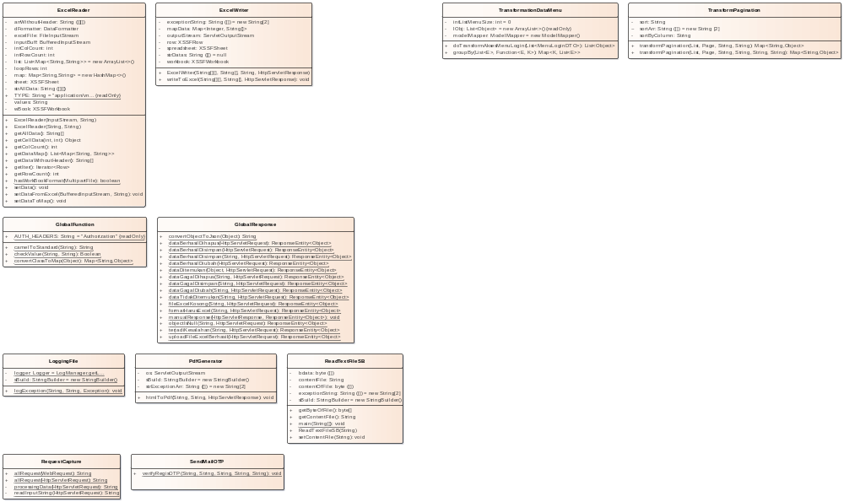

- util

ExcelReader
Class in package 'util'

ExcelReader
Version 1.0 Phase 1.0 Proposed
LENOVO created on 05/11/2025. Last modified 05/11/2025

ATTRIBUTES
arrWithoutHeader : String Private
[ Is static False. Containment is Not Specified. ]

dFormatter : DataFormatter Private
[ Is static False. Containment is Not Specified. ]

excelFile : FileInputStream Private
[ Is static False. Containment is Not Specified. ]

inputBuff : BufferedInputStream Private
[ Is static False. Containment is Not Specified. ]

intColCount : int Private
[ Is static False. Containment is Not Specified. ]

intRowCount : int Private
[ Is static False. Containment is Not Specified. ]

list : List<Map<String,String>> Private = new ArrayList<>()
[ Is static False. Containment is Not Specified. ]

loopRows : int Private
[ Is static False. Containment is Not Specified. ]

map : Map<String,String> Private = new HashMap<>()
[ Is static False. Containment is Not Specified. ]

sheet : XSSFSheet Private
[ Is static False. Containment is Not Specified. ]

strAllData : String Private
[ Is static False. Containment is Not Specified. ]

TYPE : String Public Const = "application/vnd.openxmlformats-officedocument.spreadsheetml.sheet"
[ Is static True. Containment is Not Specified. ]

values : String Private
[ Is static False. Containment is Not Specified. ]

wBook : XSSFWorkbook Private
[ Is static False. Containment is Not Specified. ]

OPERATIONS
ExcelReader (inputStream : InputStream , sheetName : String ) : Public

kalau mau coba file langsung dari controller
[ Is static False. Is abstract False. Is return array False. Is query False. Is synchronized False. ]

ExcelReader (excelPath : String , sheetName : String ) : Public

kalau mau coba langsung dari file di active directory
[ Is static False. Is abstract False. Is return array False. Is query False. Is synchronized False. ]

getAllData () : String Public

if you want to get all data and proceed it from two dimension String array object, using this method
[ Is static False. Is abstract False. Is return array True. Is query False. Is synchronized False. ]

getCellData (rowNum : int , colNum : int ) : Object Public

GET SPECIFIC DATA USING ROW NUMBER AND COLUMN NUMBER
[ Is static False. Is abstract False. Is return array False. Is query False. Is synchronized False. ]

getColCount () : int Public
[ Is static False. Is abstract False. Is return array False. Is query False. Is synchronized False. ]

getDataMap () : List<Map<String, String>> Public
[ Is static False. Is abstract False. Is return array False. Is query False. Is synchronized False. ]

getDataWithoutHeader () : String Public
[ Is static False. Is abstract False. Is return array True. Is query False. Is synchronized False. ]

getIter () : Iterator<Row> Public

if you want to handle manual the loops of all data in another method , you can use this method
[ Is static False. Is abstract False. Is return array False. Is query False. Is synchronized False. ]

getRowCount () : int Public
[ Is static False. Is abstract False. Is return array False. Is query False. Is synchronized False. ]

hasWorkBookFormat (file : MultipartFile ) : boolean Public
[ Is static True. Is abstract False. Is return array False. Is query False. Is synchronized False. ]

setData () : void Public
[ Is static False. Is abstract False. Is return array False. Is query False. Is synchronized False. ]

setDataFromExcel (inputBuff : BufferedInputStream , sheetName : String ) : void Public

Properties:
throws = IOException
[ Is static False. Is abstract False. Is return array False. Is query False. Is synchronized False. ]

setDataToMap () : void Public
[ Is static False. Is abstract False. Is return array False. Is query False. Is synchronized False. ]

ExcelWriter
Class in package 'util'

ExcelWriter
Version 1.0 Phase 1.0 Proposed
LENOVO created on 05/11/2025. Last modified 05/11/2025

ATTRIBUTES
exceptionString : String Private = new String[2]
[ Is static False. Containment is Not Specified. ]

mapData : Map<Integer, String[]> Private
[ Is static False. Containment is Not Specified. ]

outputStream : ServletOutputStream Private
[ Is static False. Containment is Not Specified. ]

row : XSSFRow Private
[ Is static False. Containment is Not Specified. ]

spreadsheet : XSSFSheet Private
[ Is static False. Containment is Not Specified. ]

strDatas : String Private = null
[ Is static False. Containment is Not Specified. ]

workbook : XSSFWorkbook Private
[ Is static False. Containment is Not Specified. ]

OPERATIONS
ExcelWriter (datas : String[][] , header : String[] , sheetName : String , response : HttpServletResponse ) : Public

SELECT LIST FROM RESULT SQL STATEMENT SELECT FROM DATABASE
[ Is static False. Is abstract False. Is return array False. Is query False. Is synchronized False. ]

writeToExcel (datas : String[][] , header : String[] , response : HttpServletResponse ) : void Public
[ Is static False. Is abstract False. Is return array False. Is query False. Is synchronized False. ]

GlobalFunction
Class in package 'util'

IntelliJ IDEA 2024.1.4 (Ultimate Edition) Build #IU-241.18034.62, built on June 21, 2024
@Author pollc a.k.a. Paul Christian Java Developer Created on 29/10/2025 22:01
@Last Modified 29/10/2025 22:01 Version 1.0

GlobalFunction
Version 1.0 Phase 1.0 Proposed
LENOVO created on 05/11/2025. Last modified 05/11/2025

ATTRIBUTES
AUTH_HEADERS : String Public Const = "Authorization"
[ Is static True. Containment is Not Specified. ]

OPERATIONS
camelToStandard (camel : String ) : String Public
[ Is static True. Is abstract False. Is return array False. Is query False. Is synchronized False. ]

checkValue (value : String , pattern : String ) : Boolean Public
[ Is static True. Is abstract False. Is return array False. Is query False. Is synchronized False. ]

convertClassToMap (object : Object ) : Map<String,Object> Public
[ Is static True. Is abstract False. Is return array False. Is query False. Is synchronized False. ]

GlobalResponse
Class in package 'util'

GlobalResponse
Version 1.0 Phase 1.0 Proposed
LENOVO created on 05/11/2025. Last modified 05/11/2025

OPERATIONS
convertObjectToJson (object : Object ) : String Public

Properties:
throws = JsonProcessingException
[ Is static True. Is abstract False. Is return array False. Is query False. Is synchronized False. ]

dataBerhasilDihapus (request : HttpServletRequest ) : ResponseEntity<Object> Public
[ Is static True. Is abstract False. Is return array False. Is query False. Is synchronized False. ]

dataBerhasilDisimpan (request : HttpServletRequest ) : ResponseEntity<Object> Public
[ Is static True. Is abstract False. Is return array False. Is query False. Is synchronized False. ]

dataBerhasilDisimpan (message : String , request : HttpServletRequest ) : ResponseEntity<Object> Public
[ Is static True. Is abstract False. Is return array False. Is query False. Is synchronized False. ]

dataBerhasilDiubah (request : HttpServletRequest ) : ResponseEntity<Object> Public
[ Is static True. Is abstract False. Is return array False. Is query False. Is synchronized False. ]

dataDitemukan (data : Object , request : HttpServletRequest ) : ResponseEntity<Object> Public
[ Is static True. Is abstract False. Is return array False. Is query False. Is synchronized False. ]

dataGagalDihapus (errorCode : String , request : HttpServletRequest ) : ResponseEntity<Object> Public
[ Is static True. Is abstract False. Is return array False. Is query False. Is synchronized False. ]

dataGagalDisimpan (errorCode : String , request : HttpServletRequest ) : ResponseEntity<Object> Public
[ Is static True. Is abstract False. Is return array False. Is query False. Is synchronized False. ]

dataGagalDiubah (errorCode : String , request : HttpServletRequest ) : ResponseEntity<Object> Public
[ Is static True. Is abstract False. Is return array False. Is query False. Is synchronized False. ]

dataTidakDitemukan (errorCode : String , request : HttpServletRequest ) : ResponseEntity<Object> Public
[ Is static True. Is abstract False. Is return array False. Is query False. Is synchronized False. ]

fileExcelKosong (errorCode : String , request : HttpServletRequest ) : ResponseEntity<Object> Public
[ Is static True. Is abstract False. Is return array False. Is query False. Is synchronized False. ]

formatHarusExcel (errorCode : String , request : HttpServletRequest ) : ResponseEntity<Object> Public
[ Is static True. Is abstract False. Is return array False. Is query False. Is synchronized False. ]

manualResponse (response : HttpServletResponse , resObject : ResponseEntity<Object> ) : void Public
[ Is static True. Is abstract False. Is return array False. Is query False. Is synchronized False. ]

objectIsNull (errorCode : String , request : HttpServletRequest ) : ResponseEntity<Object> Public
[ Is static True. Is abstract False. Is return array False. Is query False. Is synchronized False. ]

terjadiKesalahan (errorCode : String , request : HttpServletRequest ) : ResponseEntity<Object> Public
[ Is static True. Is abstract False. Is return array False. Is query False. Is synchronized False. ]

uploadFileExcelBerhasil (request : HttpServletRequest ) : ResponseEntity<Object> Public
[ Is static True. Is abstract False. Is return array False. Is query False. Is synchronized False. ]

LoggingFile
Class in package 'util'

LoggingFile
Version 1.0 Phase 1.0 Proposed
LENOVO created on 05/11/2025. Last modified 05/11/2025

ATTRIBUTES
logger : Logger Private = LogManager.getLogger(LoggingFile.class)
[ Is static True. Containment is Not Specified. ]

sBuild : StringBuilder Private = new StringBuilder()
[ Is static True. Containment is Not Specified. ]

OPERATIONS
logException (strClass : String , strMethod : String , ex : Exception ) : void Public
[ Is static True. Is abstract False. Is return array False. Is query False. Is synchronized False. ]

PdfGenerator
Class in package 'util'

Untuk Generate dari HTML (Thymeleaf) ke PDF

PdfGenerator
Version 1.0 Phase 1.0 Proposed
LENOVO created on 05/11/2025. Last modified 05/11/2025

ATTRIBUTES
os : ServletOutputStream Private
[ Is static False. Containment is Not Specified. ]

sBuild : StringBuilder Private = new StringBuilder()
[ Is static False. Containment is Not Specified. ]

strExceptionArr : String Private = new String[2]
[ Is static False. Containment is Not Specified. ]

ASSOCIATIONS
Association (direction: Source -> Destination)

Source: Public (Class) ProdukService | Target: Private pdfGenerator (Class) PdfGenerator
Association (direction: Source -> Destination)

Source: Public (Class) SupplierService | Target: Private pdfGenerator (Class) PdfGenerator
Association (direction: Source -> Destination)

Source: Public (Class) KategoriProdukService | Target: Private pdfGenerator (Class) PdfGenerator
Association (direction: Source -> Destination)

Source: Public (Class) CustomerService | Target: Private pdfGenerator (Class) PdfGenerator

OPERATIONS
htmlToPdf (html : String , prefixFile : String , response : HttpServletResponse ) : void Public
[ Is static False. Is abstract False. Is return array False. Is query False. Is synchronized False. ]

ReadTextFileSB
Class in package 'util'

ReadTextFileSB
Version 1.0 Phase 1.0 Proposed
LENOVO created on 05/11/2025. Last modified 05/11/2025

ATTRIBUTES
bdata : byte Private
[ Is static False. Containment is Not Specified. ]

contentFile : String Private
[ Is static False. Containment is Not Specified. ]

contentOfFile : byte Private
[ Is static False. Containment is Not Specified. ]

exceptionString : String Private = new String[2]
[ Is static False. Containment is Not Specified. ]

sBuild : StringBuilder Private = new StringBuilder()
[ Is static False. Containment is Not Specified. ]

OPERATIONS
getByteOfFile () : byte Public
[ Is static False. Is abstract False. Is return array True. Is query False. Is synchronized False. ]

getContentFile () : String Public
[ Is static False. Is abstract False. Is return array False. Is query False. Is synchronized False. ]

main (args : String[] ) : void Public

Properties:
throws = Exception
[ Is static True. Is abstract False. Is return array False. Is query False. Is synchronized False. ]

ReadTextFileSB (pathFiles : String ) : Public

Properties:
throws = Exception
[ Is static False. Is abstract False. Is return array False. Is query False. Is synchronized False. ]

setContentFile (fileName : String ) : void Public

Properties:
throws = Exception
[ Is static False. Is abstract False. Is return array False. Is query False. Is synchronized False. ]

RequestCapture
Class in package 'util'

RequestCapture
Version 1.0 Phase 1.0 Proposed
LENOVO created on 05/11/2025. Last modified 05/11/2025

OPERATIONS
allRequest (webRequest : WebRequest ) : String Public
[ Is static True. Is abstract False. Is return array False. Is query False. Is synchronized False. ]

allRequest (requestx : HttpServletRequest ) : String Public
[ Is static True. Is abstract False. Is return array False. Is query False. Is synchronized False. ]

processingData (request : HttpServletRequest ) : String Private
[ Is static True. Is abstract False. Is return array False. Is query False. Is synchronized False. ]

readInputString (request : HttpServletRequest ) : String Private
[ Is static True. Is abstract False. Is return array False. Is query False. Is synchronized False. ]

SendMailOTP
Class in package 'util'

SendMailOTP
Version 1.0 Phase 1.0 Proposed
LENOVO created on 05/11/2025. Last modified 05/11/2025

OPERATIONS
verifyRegisOTP (subject : String , nama : String , email : String , token : String , fileHtml : String ) : void Public
[ Is static True. Is abstract False. Is return array False. Is query False. Is synchronized False. ]

TransformPagination
Class in package 'util'

TransformPagination
Version 1.0 Phase 1.0 Proposed
LENOVO created on 05/11/2025. Last modified 05/11/2025

ATTRIBUTES
sort : String Private

disortir berdasarkan apa ? Desc atau Asc
[ Is static False. Containment is Not Specified. ]

sortArr : String Package = new String [2]
[ Is static False. Containment is Not Specified. ]

sortByColumn : String Private

disortir berdasarkan kolom apa?
[ Is static False. Containment is Not Specified. ]

ASSOCIATIONS
Association (direction: Source -> Destination)

Source: Public (Class) KategoriProdukService | Target: Private tp (Class) TransformPagination
Association (direction: Source -> Destination)

Source: Public (Class) CustomerService | Target: Private tp (Class) TransformPagination
Association (direction: Source -> Destination)

Source: Public (Class) SupplierService | Target: Private tp (Class) TransformPagination
Association (direction: Source -> Destination)

Source: Public (Class) ProdukService | Target: Private tp (Class) TransformPagination

OPERATIONS
transformPagination (ls : List , page : Page , column : String , value : String ) : Map<String,Object> Public
[ Is static False. Is abstract False. Is return array False. Is query False. Is synchronized False. ]

transformPagination (ls : List , page : Page , column : String , value : String , dateFrom : String , dateTp : String ) : Map<String,Object> Public
[ Is static False. Is abstract False. Is return array False. Is query False. Is synchronized False. ]

TransformationDataMenu
Class in package 'util'

TransformationDataMenu
Version 1.0 Phase 1.0 Proposed
LENOVO created on 05/11/2025. Last modified 05/11/2025

ATTRIBUTES
intListMenuSize : int Private = 0
[ Is static False. Containment is Not Specified. ]

lObj : List<Object> Private Const = new ArrayList<>()
[ Is static False. Containment is Not Specified. ]

modelMapper : ModelMapper Private = new ModelMapper()
[ Is static False. Containment is Not Specified. ]

OPERATIONS
doTransformAksesMenuLogin (z : List<MenuLoginDTO> ) : List<Object> Public
[ Is static False. Is abstract False. Is return array False. Is query False. Is synchronized False. ]

groupBy (list : List<E> , keyFunction : Function<E, K> ) : Map<K, List<E>> Public

Properties:
generic = <E, K>
[ Is static False. Is abstract False. Is return array False. Is query False. Is synchronized False. ]

Main
Class in package 'juaracoding'

Main
Version 1.0 Phase 1.0 Proposed
LENOVO created on 05/11/2025. Last modified 05/11/2025

OPERATIONS
main (args : String[] ) : void Public
[ Is static True. Is abstract False. Is return array False. Is query False. Is synchronized False. ]

