PHQ-9 Symptom Labels: Deep Analysis (All 7 Labels)
Based on 30 model runs across 611 test memes. Each label includes F1 breakdown, explanation coverage, 3 case studies, and recommendations.

1. Feeling Down (FD)

Per-condition F1
Condition | GPT-4o-mini | Mistral-L3 | Mistral-S | Llama-4 | Gemini
Deva Img-Only | 0.5799 | 0.6578 | 0.6501 | 0.6613 | -
Eng Img-Only | 0.6498 | 0.6741 | 0.6617 | 0.6401 | -
Deva Expl-Only | 0.6404 | 0.6549 | 0.6541 | 0.7062 | 0.6943
Eng Expl-Only | 0.6448 | 0.6735 | 0.6332 | 0.6647 | -
Deva Img+Deva Expl | 0.6606 | 0.6507 | 0.6444 | 0.6983 | 0.6887
Eng Img+Eng Expl | 0.6480 | 0.6716 | 0.6329 | 0.6538 | -
Deva Img+Eng Expl | 0.6533 | 0.6704 | 0.6412 | 0.6510 | -
Feeling Down is the most frequent label and generally achieves the highest F1. Failures often involve co-label memes where models tag a secondary symptom but miss FD, or substitute LSE/CP when sadness is implied indirectly.

Explanation coverage (275 gold FD memes)
English explicit: 217/275 | English substitute: 46/275 | Hindi explicit: 242/275 | Both miss/substitute: 17/275

Case studies

Case A - Persistent miss, explanations miss (FD, TE-632)
LANGUAGE_DEPENDENT | Gold: Feeling Down, Lack of Interest
Original (English):
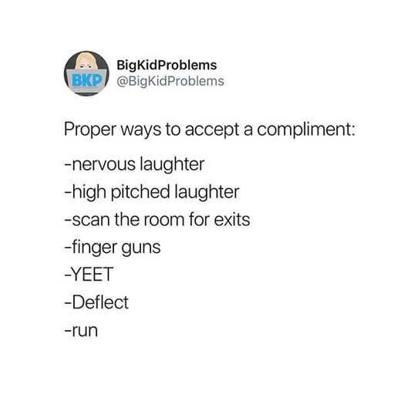
Translated (Devanagari):
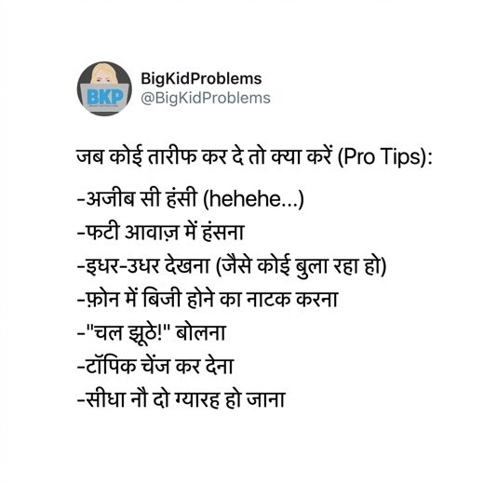
Original OCR: BigkidProblems BKP @BigKidProblems Proper ways to accept a compliment: -nervous laughter -high pitched laughter -scan the room for exits -finger guns -YEET -Deflect -run ...
English explanation (mistral_large3/eng):
This meme employs the "BigKidProblems" template, featuring a simple, cartoonish avatar of a child’s face within a circular logo alongside the account handle
Hindi explanation (gpt4o_mini/deva):
यह मेम एक ट्विटर पोस्ट का स्क्रीनशॉट है, जिसमें "BigKidProblems" नामक अकाउंट द्वारा एक मज़ेदार तरीके से तारीफ का सामना करने के अलग-अलग तरीकों को बताया गया है। इसमें विभिन्न सुझाव दिए गए हैं जैसे "अजीब सी हंसी" और "फोन में बिजी होने का नाटक करना", जो हल्के-फुल्के और हास्यपूर्ण अंदाज़ में सामाजिक असहजता को दर्शाते हैं। भावनात्मक संदर्भ में, यह मेम हंसी-मज़ाक के माध्यम से असहजता और आत्म-संदेह को छिपाने का प्रयास करता है, जो लोग अक्सर तारीफ के समय महसूस करते हैं। क्लिनिकल संदर्भ में, इसे मानसिक स्वास्थ्य के नजरिये से समझा जाए तो यह सामाजिक चिंता (Social Anxiety) और आत्म-निनदा (Low Self-Esteem) जैसे लक्षणों को दर्शाता है, क्योंकि इसमें महसूस की गई असुविधा और अलग-थलग होने की भावना की ओर संकेत मिलता है।
FD predictions (0/30 hits):
gemini deva_expl_only: FD=0
gemini deva_img_deva_expl: FD=0
gpt4o_mini deva_expl_only: FD=0
gpt4o_mini deva_image_only: FD=0
gpt4o_mini deva_img_deva_expl: FD=0
gpt4o_mini deva_img_eng_expl: FD=0
gpt4o_mini eng_expl_only: FD=0
gpt4o_mini eng_image_only: FD=0
gpt4o_mini eng_img_eng_expl: FD=0
llama4 deva_expl_only: FD=0
llama4 deva_image_only: FD=0
llama4 deva_img_deva_expl: FD=0
llama4 deva_img_eng_expl: FD=0
llama4 eng_expl_only: FD=0
llama4 eng_image_only: FD=0
llama4 eng_img_eng_expl: FD=0
mistral_large3 deva_expl_only: FD=0
mistral_large3 deva_image_only: FD=0
mistral_large3 deva_img_deva_expl: FD=0
mistral_large3 deva_img_eng_expl: FD=0
mistral_large3 eng_expl_only: FD=0
mistral_large3 eng_image_only: FD=0
mistral_large3 eng_img_eng_expl: FD=0
mistral_small_2503 deva_expl_only: FD=0
mistral_small_2503 deva_image_only: FD=0
mistral_small_2503 deva_img_deva_expl: FD=0
mistral_small_2503 deva_img_eng_expl: FD=0
mistral_small_2503 eng_expl_only: FD=0
mistral_small_2503 eng_image_only: FD=0
mistral_small_2503 eng_img_eng_expl: FD=0
Analysis:
• English explanation does not signal Feeling Down.
• Hindi explanation emphasizes a related symptom, not Feeling Down.
• Image-only: 0/8 correct
• Explanation-only: 0/9 correct
• Image + explanation: 0/13 correct
• Gemini (Deva Expl Only): predicted no positive label
• Gemini (Deva Img Deva Expl): predicted no positive label
• GPT-4o-mini (Deva Expl Only): predicted Low Self-Esteem
• GPT-4o-mini (Deva Image Only): predicted no positive label
• GPT-4o-mini (Deva Img Deva Expl): predicted Low Self-Esteem
• GPT-4o-mini (Deva Img Eng Expl): predicted Low Self-Esteem
• GPT-4o-mini (Eng Expl Only): predicted Low Self-Esteem
• GPT-4o-mini (Eng Image Only): predicted Low Self-Esteem
• Explanation pipeline failure: neither language surfaces the target symptom, so explanation-only and multimodal runs inherit the wrong clinical framing.
• Image-only failure: Feeling Down is not visually or OCR-explicit in the Devanagari meme.
• Co-labeling with Lack of Interest: salient cues for the co-label may satisfy models before the subtler Feeling Down dimension is tagged.
• Models often substitute Low Self-Esteem (24/30 misses), which overlaps semantically with Feeling Down in meme text or explanations.

Case B - Co-label with Lack of Interest, partial confusion (FD, TE-146)
UNIVERSAL_HUMAN | Gold: Feeling Down, Lack of Interest
Original (English):
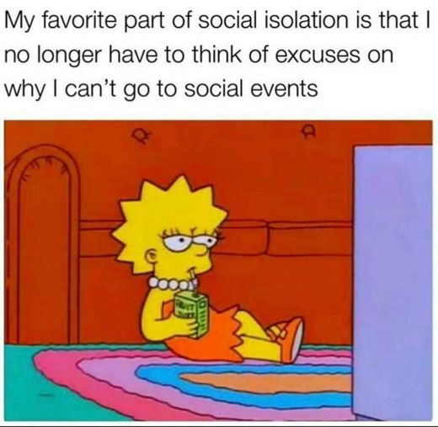
Translated (Devanagari):
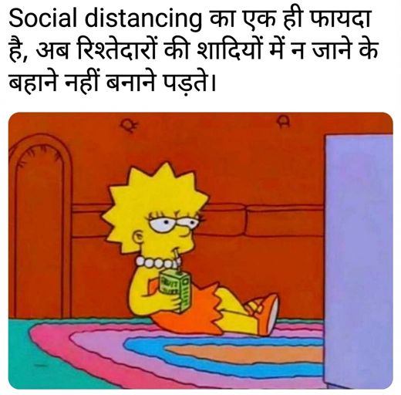
Original OCR: My favorite part of social isolation is that I no longer have to think of excuses on why I can't go to social events ...
English explanation (mistral_large3/eng):
This meme utilizes a well-known image of Lisa Simpson from *The Simpsons*, depicted lounging on a floating inflatable device in a pool while holding a drink, a visual often associated with relaxation or escapism. The accompanying text humorously states, "My favorite part of social isolation is that I no longer have to think of excuses on why I can’t go to social events," framing solitude as a relief rather than a burden. Emotionally, the meme conveys a sense of resignation or even subtle satisfaction with avoiding social interaction, masking potential discomfort or anxiety about engagement behind a veneer of dark humor. Clinically, the content aligns most closely with *Lack of Interest*, as it reflects anhedonia or avoidance of social activities, though it does not explicitly indicate deeper distress such as *Feeling Down* or *Low Self-Esteem* without additional context.
Hindi explanation (gpt4o_mini/deva):
इस मेम में लिसा सिम्पसन का एक प्रसिद्ध दृश्य दिखाया गया है, जिसमें वह आराम से बैठकर एक दूध की पैकेट पी रही है, जबकि टीवी की तरफ देख रही है। मेम का पाठ कहता है, "Social distancing का एक ही फायदा है, अब रिश्तेदारों की शादियों में न जाने के बहाने नहीं बनाने पड़ते।" इस चित्रण में लिसा की ऊब और उदासीनता का अहसास होता है, जो कि सामाजिक दूरी के संदर्भ में एक हल्के-फुल्के मजाक के जरिए व्यक्त होता है। भावनात्मक तौर पर, यह स्थिति कुछ हद तक "लैख इंटरेस्ट" के लक्षणों को दर्शाती है, क्योंकि लिसा का मजाकिया व्यवहार भी उसके अंदर की अनिच्छा और सामाजिक संपर्क से बचने की इच्छा को उजागर करता है।
FD predictions (2/30 hits):
gemini deva_expl_only: FD=0
gemini deva_img_deva_expl: FD=0
gpt4o_mini deva_expl_only: FD=0
gpt4o_mini deva_image_only: FD=0
gpt4o_mini deva_img_deva_expl: FD=0
gpt4o_mini deva_img_eng_expl: FD=0
gpt4o_mini eng_expl_only: FD=0
gpt4o_mini eng_image_only: FD=1
gpt4o_mini eng_img_eng_expl: FD=0
llama4 deva_expl_only: FD=0
llama4 deva_image_only: FD=0
llama4 deva_img_deva_expl: FD=0
llama4 deva_img_eng_expl: FD=0
llama4 eng_expl_only: FD=0
llama4 eng_image_only: FD=0
llama4 eng_img_eng_expl: FD=0
mistral_large3 deva_expl_only: FD=1
mistral_large3 deva_image_only: FD=0
mistral_large3 deva_img_deva_expl: FD=0
mistral_large3 deva_img_eng_expl: FD=0
mistral_large3 eng_expl_only: FD=0
mistral_large3 eng_image_only: FD=0
mistral_large3 eng_img_eng_expl: FD=0
mistral_small_2503 deva_expl_only: FD=0
mistral_small_2503 deva_image_only: FD=0
mistral_small_2503 deva_img_deva_expl: FD=0
mistral_small_2503 deva_img_eng_expl: FD=0
mistral_small_2503 eng_expl_only: FD=0
mistral_small_2503 eng_image_only: FD=0
mistral_small_2503 eng_img_eng_expl: FD=0
Analysis:
• English explanation names Feeling Down.
• Hindi explanation names Feeling Down.
• Image-only: 1/8 correct
• Explanation-only: 1/9 correct
• Image + explanation: 0/13 correct
• Gemini (Deva Expl Only): predicted Lack of Interest
• Gemini (Deva Img Deva Expl): predicted Lack of Interest
• GPT-4o-mini (Deva Expl Only): predicted Lack of Interest
• GPT-4o-mini (Deva Image Only): predicted no positive label
• GPT-4o-mini (Deva Img Deva Expl): predicted Lack of Interest
• GPT-4o-mini (Deva Img Eng Expl): predicted Lack of Interest
• GPT-4o-mini (Eng Expl Only): predicted Lack of Interest
• GPT-4o-mini (Eng Img Eng Expl): predicted Lack of Interest
• Explanation-classifier gap: English text mentions Feeling Down but many runs still output FD=0.
• Co-labeling with Lack of Interest: salient cues for the co-label may satisfy models before the subtler Feeling Down dimension is tagged.
• Models often substitute Lack of Interest (21/28 misses), which overlaps semantically with Feeling Down in meme text or explanations.

Case C - Models largely succeed (FD, TE-197)
CULTURAL_REFERENCE_DEPENDENT | Gold: Feeling Down, Self-Harm
Original (English):

Translated (Devanagari):
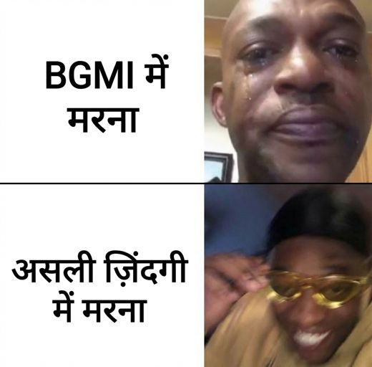
Original OCR: Dying in Minecraft Dying in real life ...
English explanation (mistral_large3/eng):
This meme employs a comparative template to juxtapose two forms of distress through visual and textual elements. The top panel, labeled "Dying in Minecraft," features a pixelated, exaggerated facial expression from the popular video game, where death is a temporary and often humorous setback with no lasting consequences. Below, labeled "Dying in real life," the image shifts to a blurred, close-up photograph of a person’s face contorted in apparent physical or emotional agony, emphasizing the stark contrast between the trivialized in-game experience and the visceral, enduring pain of real-world suffering. Emotionally, the meme conveys a sense of dark humor and irony, masking an underlying expression of hopelessness or despair by framing personal anguish as something far more isolating and permanent than the sanitized, reversible failures of digital environments. Clinically, the content aligns most closely with *Feeling Down* and *Self-Harm*, as it implicitly references emotional pain and the concept of death in a manner that blends gallows humor with a potential cry for recognition of real-life suffering.
Hindi explanation (gpt4o_mini/deva):
इस मेमे में एक व्यक्ति का चेहरा दिख रहा है, जो आंसू बहा रहा है, जबकि ऊपर और नीचे दो टेक्स्ट बॉक्स हैं। पहले टेक्स्ट में लिखा है "BGMI में मरना", और नीचे लिखा है "असली ज़िंदगी में मरना"। इस मेमे का भावनात्मक संदर्भ व्यक्त करता है कि यह व्यक्ति खेल में असफलता या हानि के कारण दुखी है, जो उसकी मानसिक स्थिति को दर्शाता है। यह मेमे संभवतः आत्म-हानि (Self-Harm) के संकेत दे रहा है, क्योंकि यह जीवन की वास्तविक कठिनाइयों और गेमिंग के बीच के अंतर को रेखांकित कर रहा है, जिससे एक प्रकार की निराशा और अवसादित मनोदशा प्रकट होती है।
FD predictions (24/30 hits):
gemini deva_expl_only: FD=1
gemini deva_img_deva_expl: FD=0
gpt4o_mini deva_expl_only: FD=1
gpt4o_mini deva_image_only: FD=1
gpt4o_mini deva_img_deva_expl: FD=1
gpt4o_mini deva_img_eng_expl: FD=0
gpt4o_mini eng_expl_only: FD=0
gpt4o_mini eng_image_only: FD=0
gpt4o_mini eng_img_eng_expl: FD=0
llama4 deva_expl_only: FD=1
llama4 deva_image_only: FD=1
llama4 deva_img_deva_expl: FD=1
llama4 deva_img_eng_expl: FD=1
llama4 eng_expl_only: FD=1
llama4 eng_image_only: FD=1
llama4 eng_img_eng_expl: FD=1
mistral_large3 deva_expl_only: FD=1
mistral_large3 deva_image_only: FD=1
mistral_large3 deva_img_deva_expl: FD=1
mistral_large3 deva_img_eng_expl: FD=1
mistral_large3 eng_expl_only: FD=1
mistral_large3 eng_image_only: FD=1
mistral_large3 eng_img_eng_expl: FD=1
mistral_small_2503 deva_expl_only: FD=1
mistral_small_2503 deva_image_only: FD=1
mistral_small_2503 deva_img_deva_expl: FD=1
mistral_small_2503 deva_img_eng_expl: FD=1
mistral_small_2503 eng_expl_only: FD=1
mistral_small_2503 eng_image_only: FD=0
mistral_small_2503 eng_img_eng_expl: FD=1
Analysis:
• English explanation names Feeling Down.
• Hindi explanation names Feeling Down.
• Image-only: 6/8 correct
• Explanation-only: 8/9 correct
• Image + explanation: 10/13 correct
• Gemini (Deva Img Deva Expl): predicted Self-Harm
• GPT-4o-mini (Deva Img Eng Expl): predicted Self-Harm
• GPT-4o-mini (Eng Expl Only): predicted Self-Harm
• GPT-4o-mini (Eng Image Only): predicted no positive label
• GPT-4o-mini (Eng Img Eng Expl): predicted Self-Harm
• Mistral-S (Eng Image Only): predicted no positive label
• Hindi explanation names Feeling Down but some Devanagari runs still miss, possibly due to transliterated-label noise or co-occurring symptom confusion.
• Co-labeling with Self-Harm: salient cues for the co-label may satisfy models before the subtler Feeling Down dimension is tagged.
• Models often substitute Self-Harm (4/6 misses), which overlaps semantically with Feeling Down in meme text or explanations.
• Most runs succeed when explanations or images make Feeling Down explicit; remaining misses cluster on image-only or substitute-symptom inputs.

Recommendations
• Distinguish transient sadness from clinical low mood in explanation prompts; avoid collapsing all negative affect into Feeling Down.
• Report Feeling Down co-labeled memes separately; sadness cues often satisfy models before subtler labels are tagged.
• Use explanation text that names mood decline explicitly rather than generic distress vocabulary.

2. Lack of Interest (LOI)

Per-condition F1
Condition | GPT-4o-mini | Mistral-L3 | Mistral-S | Llama-4 | Gemini
Deva Img-Only | 0.2591 | 0.3117 | 0.3452 | 0.3750 | -
Eng Img-Only | 0.3351 | 0.4236 | 0.4574 | 0.4234 | -
Deva Expl-Only | 0.4348 | 0.4053 | 0.3636 | 0.3549 | 0.4432
Eng Expl-Only | 0.4238 | 0.4206 | 0.3646 | 0.4156 | -
Deva Img+Deva Expl | 0.4249 | 0.4066 | 0.3636 | 0.3655 | 0.4565
Eng Img+Eng Expl | 0.4249 | 0.4223 | 0.3696 | 0.4221 | -
Deva Img+Eng Expl | 0.4317 | 0.4219 | 0.3686 | 0.4235 | -
LOI scores lowest overall. Image-only inputs rarely surface anhedonia; explanation pipelines often substitute Feeling Down. Classifiers sometimes ignore explicit LOI mentions in explanation text.

Explanation coverage (92 gold LOI memes)
English explicit: 55/92 | English substitute: 34/92 | Hindi explicit: 47/92 | Both miss/substitute: 21/92

Case studies

Case A - Persistent miss, explanations miss (LOI, TE-516)
UNIVERSAL_HUMAN | Gold: Lack of Interest
Original (English):
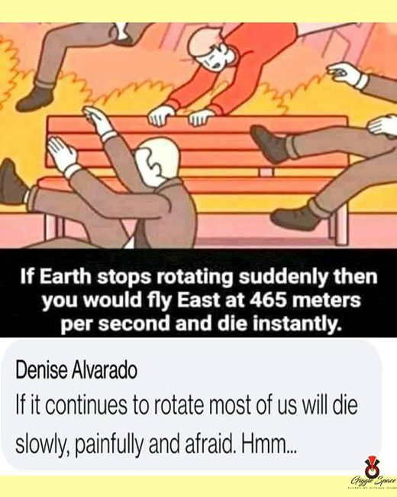
Translated (Devanagari):
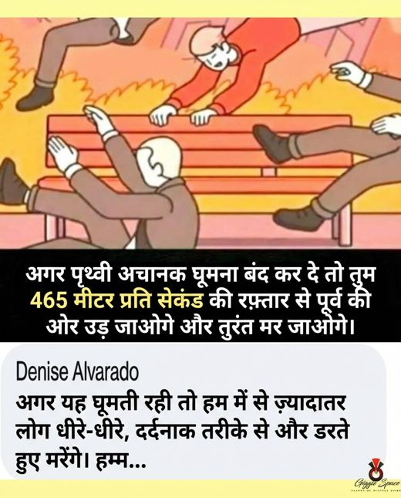
Original OCR: If Earth stops rotating suddenly then you would fly East at 465 meters per second and die instantly. Denise Alvarado If it continues to rotate most of us will die slowly, painfully and afraid. Hmm.. G...
English explanation (mistral_large3/eng):
This meme employs a simple, exaggerated cartoon illustration depicting several figures being violently propelled off a bench, visually reinforcing the humorous yet alarming scenario described in the text. The template, often used for absurdist or hyperbolic commentary, presents two contrasting outcomes: if the Earth were to stop rotating suddenly, individuals would be flung eastward at an extreme velocity and die instantly, while if it continues rotating, most people would instead face a prolonged, distressing demise marked by fear and suffering. The emotional tone blends dark humor with a sense of existential dread, using irony to underscore a bleak outlook on survival and inevitability. While the content does not explicitly evidence specific symptoms from the Clinical Reference Glossary, the underlying sentiment aligns with themes of hopelessness and fatalistic resignation, which may indirectly reflect feelings of emotional pain or despair in a culturally coded, comedic form.
Hindi explanation (gpt4o_mini/deva):
इस मीम में एक रंगीन चित्र है जिसमें लोग एक बेंच पर बैठे हैं, कुछ लोग अचानक गिरते हुए दिखाई दे रहे हैं। शीर्ष पर लिखा है, "अगर पृथ्वी अचानक घूमना बंद कर दे तो तुम 465 मीटर प्रति सेकंड की रफ्तार से पूर्व की ओर उड़ जाओगे और तुरंत मर जाओगे।" नीचे एक टिप्पणी है, "अगर यह घूमती रही तो हम में से ज्यादातर लोग धीरे-धीरे, दर्दनाक तरीके से और डरते हुए मरेंगे।" इस मीम का भावनात्मक संदर्भ निराशा और डर को दर्शाता है, जहां लोग जीवन की अनिश्चितता और इसके खतरों के प्रति चिंतित हैं। चिकित्सीय संदर्भ के अनुसार, यह स्व-हानि के संकेतों को स्पष्ट रूप से प्रस्तुत करता है, खासकर टिप्पणी में व्यक्ति की मृत्यु की संकल्पना और डर को लेकर।
LOI predictions (0/30 hits):
gemini deva_expl_only: LOI=0
gemini deva_img_deva_expl: LOI=0
gpt4o_mini deva_expl_only: LOI=0
gpt4o_mini deva_image_only: LOI=0
gpt4o_mini deva_img_deva_expl: LOI=0
gpt4o_mini deva_img_eng_expl: LOI=0
gpt4o_mini eng_expl_only: LOI=0
gpt4o_mini eng_image_only: LOI=0
gpt4o_mini eng_img_eng_expl: LOI=0
llama4 deva_expl_only: LOI=0
llama4 deva_image_only: LOI=0
llama4 deva_img_deva_expl: LOI=0
llama4 deva_img_eng_expl: LOI=0
llama4 eng_expl_only: LOI=0
llama4 eng_image_only: LOI=0
llama4 eng_img_eng_expl: LOI=0
mistral_large3 deva_expl_only: LOI=0
mistral_large3 deva_image_only: LOI=0
mistral_large3 deva_img_deva_expl: LOI=0
mistral_large3 deva_img_eng_expl: LOI=0
mistral_large3 eng_expl_only: LOI=0
mistral_large3 eng_image_only: LOI=0
mistral_large3 eng_img_eng_expl: LOI=0
mistral_small_2503 deva_expl_only: LOI=0
mistral_small_2503 deva_image_only: LOI=0
mistral_small_2503 deva_img_deva_expl: LOI=0
mistral_small_2503 deva_img_eng_expl: LOI=0
mistral_small_2503 eng_expl_only: LOI=0
mistral_small_2503 eng_image_only: LOI=0
mistral_small_2503 eng_img_eng_expl: LOI=0
Analysis:
• English explanation substitutes Lack of Interest with a related symptom.
• Hindi explanation emphasizes a related symptom, not Lack of Interest.
• Image-only: 0/8 correct
• Explanation-only: 0/9 correct
• Image + explanation: 0/13 correct
• Gemini (Deva Expl Only): predicted Feeling Down, Self-Harm
• Gemini (Deva Img Deva Expl): predicted Feeling Down, Self-Harm
• GPT-4o-mini (Deva Expl Only): predicted Feeling Down, Self-Harm
• GPT-4o-mini (Deva Image Only): predicted no positive label
• GPT-4o-mini (Deva Img Deva Expl): predicted Feeling Down, Self-Harm, Low Self-Esteem
• GPT-4o-mini (Deva Img Eng Expl): predicted Feeling Down, Self-Harm, Low Self-Esteem
• GPT-4o-mini (Eng Expl Only): predicted Feeling Down, Self-Harm, Low Self-Esteem
• GPT-4o-mini (Eng Image Only): predicted no positive label
• Gold is LOI-only with no co-labels, so models cannot borrow cues from adjacent symptoms.
• Explanation pipeline failure: neither language surfaces the target symptom, so explanation-only and multimodal runs inherit the wrong clinical framing.
• Image-only failure: Lack of Interest is not visually or OCR-explicit in the Devanagari meme.
• Models often substitute Feeling Down (26/30 misses), which overlaps semantically with Lack of Interest in meme text or explanations.
• Models often substitute Self-Harm (16/30 misses), which overlaps semantically with Lack of Interest in meme text or explanations.

Case B - Co-label with Feeling Down, partial confusion (LOI, TE-358)
UNIVERSAL_HUMAN | Gold: Feeling Down, Lack of Interest
Original (English):
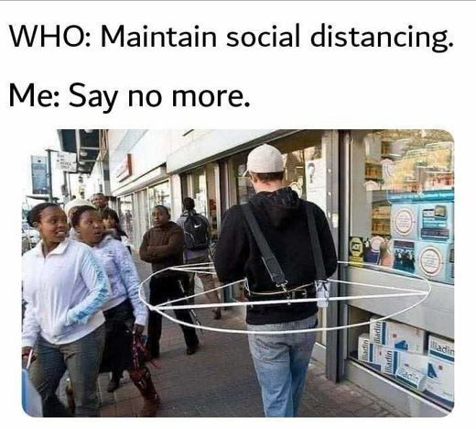
Translated (Devanagari):
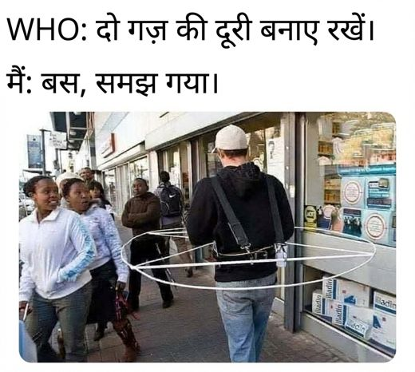
Original OCR: WHO: Maintain social distancing. Me: Say no more. adin Tadin Wliadin ujperm ...
English explanation (mistral_large3/eng):
This meme employs a two-part structure combining text and image to convey a resigned acceptance of public health guidelines. The top text reads, "WHO: Maintain social distancing," followed by the response, "Me: Say no more," paired with a photograph of a person walking outdoors while encircled by a physical hoop-like device, presumably designed to enforce distance from others, as a group of people stands nearby on what appears to be a city street. The emotional tone of the meme leans toward dark humor and weary compliance, reflecting the fatigue and mild frustration many individuals experienced during prolonged adherence to pandemic-related restrictions. Clinically, the content does not explicitly evidence symptoms from the provided glossary, as it primarily captures a culturally shared sentiment of exhaustion rather than personal distress, though it may indirectly resonate with those experiencing *feeling down* or *lack of interest* due to the isolating effects of social distancing measures.
Hindi explanation (gpt4o_mini/deva):
इस मीम में एक आदमी को देखा जा सकता है, जिसने अपने शरीर के चारों ओर एक बड़ा धातु का रिंग पहना हुआ है, संभवतः दूसरों से सामाजिक दूरी बनाए रखने के लिए। इसमें ऊपर लिखा है, "WHO: दो गज़ की दूरी बनाएं रखें। मैं: बस, समझ गया।" यह मीम एक मजेदार व्यंग्य प्रस्तुत करता है, जिसमें सामाजिक स्वास्थ्य दिशा-निर्देशों को हास्यपूर्वक दर्शाया गया है। भावनात्मक रूप से, यह एक हल्का-फुल्का और ख़ुशनुमा तरीका है, जिसमें एक समस्या का सरल समाधान प्रदर्शित किया गया है, जिससे कोई भी दबाव महसूस नहीं कर रहा है। चिकित्सा संदर्भ के अनुसार, इसमें स्पष्ट रूप से किसी भी नैदानिक लक्षणों का संकेत नहीं है, लेकिन यह सामाजिक अलगाव के संदर्भ में हल्के तनाव या चिंता का पता लगाने के लिए एक मजेदार प्रयास हो सकता है।
LOI predictions (2/30 hits):
gemini deva_expl_only: LOI=0
gemini deva_img_deva_expl: LOI=0
gpt4o_mini deva_expl_only: LOI=0
gpt4o_mini deva_image_only: LOI=0
gpt4o_mini deva_img_deva_expl: LOI=0
gpt4o_mini deva_img_eng_expl: LOI=0
gpt4o_mini eng_expl_only: LOI=0
gpt4o_mini eng_image_only: LOI=0
gpt4o_mini eng_img_eng_expl: LOI=0
llama4 deva_expl_only: LOI=0
llama4 deva_image_only: LOI=0
llama4 deva_img_deva_expl: LOI=0
llama4 deva_img_eng_expl: LOI=0
llama4 eng_expl_only: LOI=0
llama4 eng_image_only: LOI=0
llama4 eng_img_eng_expl: LOI=0
mistral_large3 deva_expl_only: LOI=1
mistral_large3 deva_image_only: LOI=0
mistral_large3 deva_img_deva_expl: LOI=1
mistral_large3 deva_img_eng_expl: LOI=0
mistral_large3 eng_expl_only: LOI=0
mistral_large3 eng_image_only: LOI=0
mistral_large3 eng_img_eng_expl: LOI=0
mistral_small_2503 deva_expl_only: LOI=0
mistral_small_2503 deva_image_only: LOI=0
mistral_small_2503 deva_img_deva_expl: LOI=0
mistral_small_2503 deva_img_eng_expl: LOI=0
mistral_small_2503 eng_expl_only: LOI=0
mistral_small_2503 eng_image_only: LOI=0
mistral_small_2503 eng_img_eng_expl: LOI=0
Analysis:
• English explanation names Lack of Interest.
• Hindi explanation omits Lack of Interest cues.
• Image-only: 0/8 correct
• Explanation-only: 1/9 correct
• Image + explanation: 1/13 correct
• Gemini (Deva Expl Only): predicted no positive label
• Gemini (Deva Img Deva Expl): predicted no positive label
• GPT-4o-mini (Deva Expl Only): predicted no positive label
• GPT-4o-mini (Deva Image Only): predicted no positive label
• GPT-4o-mini (Deva Img Deva Expl): predicted no positive label
• GPT-4o-mini (Deva Img Eng Expl): predicted no positive label
• GPT-4o-mini (Eng Expl Only): predicted no positive label
• GPT-4o-mini (Eng Image Only): predicted no positive label
• Explanation-classifier gap: English text mentions Lack of Interest but many runs still output LOI=0.
• Image-only failure: Lack of Interest is not visually or OCR-explicit in the Devanagari meme.
• Co-labeling with Feeling Down: salient cues for the co-label may satisfy models before the subtler Lack of Interest dimension is tagged.

Case C - Models largely succeed (LOI, TE-374)
CULTURAL_REFERENCE_DEPENDENT | Gold: Lack of Energy, Lack of Interest
Original (English):
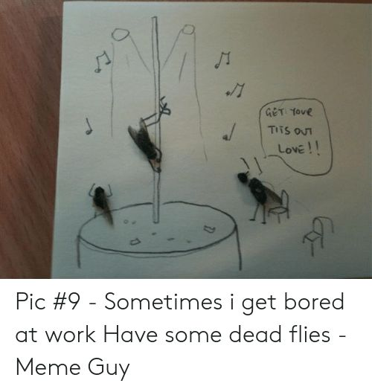
Translated (Devanagari):
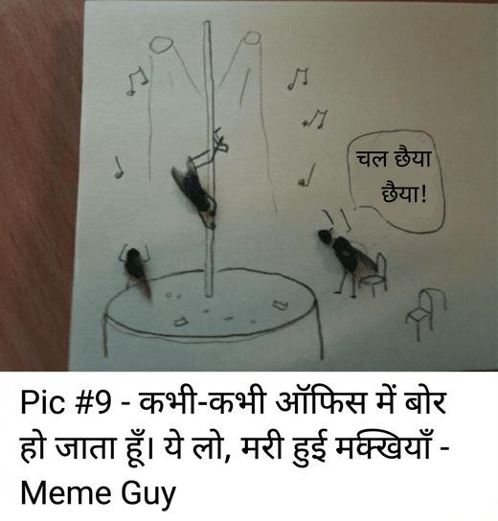
Original OCR: GET YOvR TITS OUT LovE!! Pic #9 - Sometimes i get bored at work Have some dead flies - Meme Guy ...
English explanation (mistral_large3/eng):
This meme employs a simple, hand-drawn illustration on lined paper, depicting a makeshift fly trap composed of a cup, a piece of paper rolled into a funnel, and several musical notes drawn to suggest bait, alongside a cluster of sketched flies both inside and outside the trap. The accompanying text, written in a casual, conversational tone, reads, *"Sometimes i get bored at work Have some dead flies - Meme Guy,"* with an additional speech bubble stating, *"GET YOUR TITS OUT LOVE!!"*, a phrase likely included for absurd or provocative humor. The emotional tone conveyed is one of listless monotony and disengagement, reflecting a sense of understimulation and apathy, as the creator turns to darkly comedic and mundane distractions to cope with boredom. Clinically, the meme aligns most closely with *Lack of Interest* and *Concentration Problem*, as it visually and textually illustrates an inability to find fulfillment in routine tasks and a struggle to maintain focus, though it does not explicitly evidence deeper distress or additional symptoms from the Clinical Reference Glossary.
Hindi explanation (gpt4o_mini/deva):
इस मेमे में एक चित्रित पृष्ठभूमि है जिसमें एक पोल है जिस पर एक मक्खी चढ़ रही है, जबकि अन्य मक्खियाँ नीचे बैठकर देख रही हैं। आस-पास संगीत के नोट्स और एक संवाद लिखा है, "चल छेया छेया!" फोटो का शीर्षक बताता है कि कभी-कभी ऑफिस में बोरियत हो जाती है, और इसे मज़ाक के रूप में प्रस्तुत किया गया है। इस मेमे का अंतर्विरोधी भाव हास्य के रूप में है, लेकिन यह दिखाता है कि कई लोग कार्यस्थल पर बोरियत और व्याकुलता का सामना करते हैं, जो "उदासी" और "रुचि की कमी" जैसे लक्षणों की ओर इंगित करता है।
LOI predictions (24/30 hits):
gemini deva_expl_only: LOI=0
gemini deva_img_deva_expl: LOI=0
gpt4o_mini deva_expl_only: LOI=1
gpt4o_mini deva_image_only: LOI=0
gpt4o_mini deva_img_deva_expl: LOI=1
gpt4o_mini deva_img_eng_expl: LOI=1
gpt4o_mini eng_expl_only: LOI=1
gpt4o_mini eng_image_only: LOI=0
gpt4o_mini eng_img_eng_expl: LOI=1
llama4 deva_expl_only: LOI=1
llama4 deva_image_only: LOI=1
llama4 deva_img_deva_expl: LOI=1
llama4 deva_img_eng_expl: LOI=1
llama4 eng_expl_only: LOI=1
llama4 eng_image_only: LOI=1
llama4 eng_img_eng_expl: LOI=1
mistral_large3 deva_expl_only: LOI=0
mistral_large3 deva_image_only: LOI=1
mistral_large3 deva_img_deva_expl: LOI=1
mistral_large3 deva_img_eng_expl: LOI=1
mistral_large3 eng_expl_only: LOI=1
mistral_large3 eng_image_only: LOI=1
mistral_large3 eng_img_eng_expl: LOI=1
mistral_small_2503 deva_expl_only: LOI=1
mistral_small_2503 deva_image_only: LOI=0
mistral_small_2503 deva_img_deva_expl: LOI=1
mistral_small_2503 deva_img_eng_expl: LOI=1
mistral_small_2503 eng_expl_only: LOI=1
mistral_small_2503 eng_image_only: LOI=1
mistral_small_2503 eng_img_eng_expl: LOI=1
Analysis:
• English explanation names Lack of Interest.
• Hindi explanation names Lack of Interest.
• Image-only: 5/8 correct
• Explanation-only: 7/9 correct
• Image + explanation: 12/13 correct
• Gemini (Deva Expl Only): predicted Concentration Problem
• Gemini (Deva Img Deva Expl): predicted Concentration Problem
• GPT-4o-mini (Deva Image Only): predicted no positive label
• GPT-4o-mini (Eng Image Only): predicted no positive label
• Mistral-L3 (Deva Expl Only): predicted Feeling Down, Concentration Problem
• Mistral-S (Deva Image Only): predicted no positive label
• Hindi explanation names Lack of Interest but some Devanagari runs still miss, possibly due to transliterated-label noise or co-occurring symptom confusion.
• Co-labeling with Lack of Energy: salient cues for the co-label may satisfy models before the subtler Lack of Interest dimension is tagged.
• Models often substitute Concentration Problem (3/6 misses), which overlaps semantically with Lack of Interest in meme text or explanations.
• Most runs succeed when explanations or images make Lack of Interest explicit; remaining misses cluster on image-only or substitute-symptom inputs.

Recommendations
• Separate PHQ-9 item 1 (Feeling Down) from item 2 (LOI) with an explicit anhedonia check in explanation prompts.
• Report LOI-only subset separately; image-only baselines underperform when anhedonia is not visually explicit.
• Use Eng explanation + Deva image when Hindi OCR reads as generic sadness.

3. Self-Harm (SH)

Per-condition F1
Condition | GPT-4o-mini | Mistral-L3 | Mistral-S | Llama-4 | Gemini
Deva Img-Only | 0.4837 | 0.4950 | 0.5167 | 0.5223 | -
Eng Img-Only | 0.5988 | 0.6332 | 0.6300 | 0.6409 | -
Deva Expl-Only | 0.5278 | 0.5223 | 0.4099 | 0.6082 | 0.7245
Eng Expl-Only | 0.6699 | 0.6220 | 0.6243 | 0.7045 | -
Deva Img+Deva Expl | 0.5490 | 0.5223 | 0.5257 | 0.5965 | 0.7282
Eng Img+Eng Expl | 0.6701 | 0.6471 | 0.6180 | 0.7079 | -
Deva Img+Eng Expl | 0.6837 | 0.6391 | 0.6517 | 0.7011 | -
Self-Harm F1 is mid-range but volatile. Dark humor and existential memes cause false positives; subtle self-harm gold labels are missed when explanations emphasize sadness instead.

Explanation coverage (93 gold SH memes)
English explicit: 61/93 | English substitute: 29/93 | Hindi explicit: 37/93 | Both miss/substitute: 25/93

Case studies

Case A - Persistent miss, explanations miss (SH, TE-181)
UNIVERSAL_HUMAN | Gold: Feeling Down, Self-Harm
Original (English):
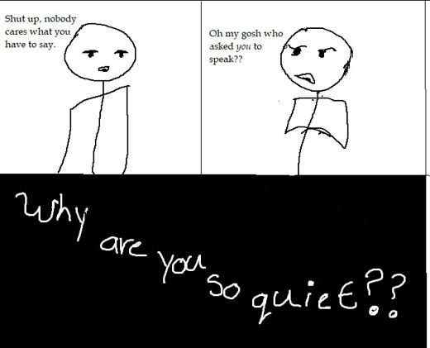
Translated (Devanagari):
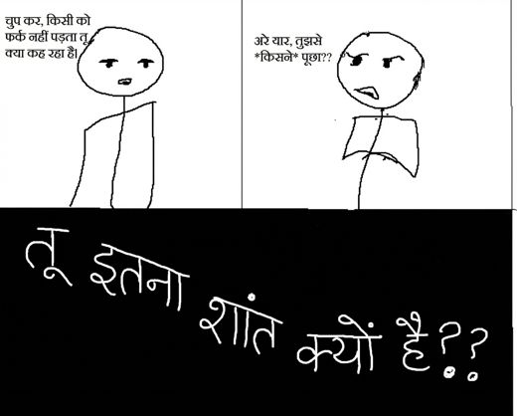
Original OCR: Shut up, nobody cares what you have to say. Oh my gosh who asked you to speak?? why are you so quic€?? ...
English explanation (mistral_large3/eng):
This meme employs a two-panel comic template featuring a simple, childlike drawing of a stick-figure character to convey a shift in emotional expression through exaggerated visual and textual cues. In the first panel, the figure stands with arms crossed and a defiant frown, accompanied by the dismissive text, "Shut up, nobody cares what you have to say," projecting an outward display of indifference or hostility. The second panel contrasts sharply, showing the same figure hunched over with a distressed expression, sweating, and the text, "Oh my gosh who asked you to speak??" paired with the overlaid question in bold, "Why are you so quiet??," which underscores the tension between external defensiveness and internal vulnerability. While the meme does not explicitly evidence symptoms from the Clinical Reference Glossary, it visually and thematically captures the emotional conflict of *low self-esteem*, particularly the fear of judgment or rejection, and may reflect underlying social anxiety or feelings of inadequacy, where perceived apathy masks deeper discomfort or insecurity.
Hindi explanation (gpt4o_mini/deva):
यह मीम एक सरल रेखाचित्र में दो पात्रों को दिखाता है। बाएं पात्र के बोलने के दौरान लिखा है "चुप कर, किसी को फर्क नहीं पड़ता तू क्या कह रहा है।" और दाएं पात्र का उत्तर है "अरे यार, तुझसे *किसने* पूछा??" नीचे एक गहरे रंग के बैकग्राउंड में लिखा हुआ है "तु इतना शांत क्यों है??" इस मीम का भावनात्मक संदर्भ निराशा और अनदेखी की स्थिति को दर्शाता है, जहाँ एक पात्र अपनी भावनाओं को साझा करने के बावजूद उदासीनता का सामना कर रहा है। क्लिनिकल संदर्भ में, यह "लो सेल्फ-एस्टीम" और "फीलिंग डाउन" के लक्षणों को दर्शाता है, क्योंकि एक पात्र की अंदरूनी व्यथा और निराशा स्पष्ट रूप से झलकती है, जबकि दूसरे द्वारा उसे कमतर समझा जाता है।
SH predictions (0/30 hits):
gemini deva_expl_only: SH=0
gemini deva_img_deva_expl: SH=0
gpt4o_mini deva_expl_only: SH=0
gpt4o_mini deva_image_only: SH=0
gpt4o_mini deva_img_deva_expl: SH=0
gpt4o_mini deva_img_eng_expl: SH=0
gpt4o_mini eng_expl_only: SH=0
gpt4o_mini eng_image_only: SH=0
gpt4o_mini eng_img_eng_expl: SH=0
llama4 deva_expl_only: SH=0
llama4 deva_image_only: SH=0
llama4 deva_img_deva_expl: SH=0
llama4 deva_img_eng_expl: SH=0
llama4 eng_expl_only: SH=0
llama4 eng_image_only: SH=0
llama4 eng_img_eng_expl: SH=0
mistral_large3 deva_expl_only: SH=0
mistral_large3 deva_image_only: SH=0
mistral_large3 deva_img_deva_expl: SH=0
mistral_large3 deva_img_eng_expl: SH=0
mistral_large3 eng_expl_only: SH=0
mistral_large3 eng_image_only: SH=0
mistral_large3 eng_img_eng_expl: SH=0
mistral_small_2503 deva_expl_only: SH=0
mistral_small_2503 deva_image_only: SH=0
mistral_small_2503 deva_img_deva_expl: SH=0
mistral_small_2503 deva_img_eng_expl: SH=0
mistral_small_2503 eng_expl_only: SH=0
mistral_small_2503 eng_image_only: SH=0
mistral_small_2503 eng_img_eng_expl: SH=0
Analysis:
• English explanation substitutes Self-Harm with a related symptom.
• Hindi explanation emphasizes a related symptom, not Self-Harm.
• Image-only: 0/8 correct
• Explanation-only: 0/9 correct
• Image + explanation: 0/13 correct
• Gemini (Deva Expl Only): predicted Feeling Down, Low Self-Esteem
• Gemini (Deva Img Deva Expl): predicted Feeling Down, Low Self-Esteem
• GPT-4o-mini (Deva Expl Only): predicted Feeling Down, Low Self-Esteem
• GPT-4o-mini (Deva Image Only): predicted no positive label
• GPT-4o-mini (Deva Img Deva Expl): predicted Feeling Down, Low Self-Esteem
• GPT-4o-mini (Deva Img Eng Expl): predicted Low Self-Esteem, Concentration Problem
• GPT-4o-mini (Eng Expl Only): predicted Low Self-Esteem, Concentration Problem
• GPT-4o-mini (Eng Image Only): predicted Low Self-Esteem
• Explanation pipeline failure: neither language surfaces the target symptom, so explanation-only and multimodal runs inherit the wrong clinical framing.
• Image-only failure: Self-Harm is not visually or OCR-explicit in the Devanagari meme.
• Co-labeling with Feeling Down: salient cues for the co-label may satisfy models before the subtler Self-Harm dimension is tagged.
• Models often substitute Low Self-Esteem (28/30 misses), which overlaps semantically with Self-Harm in meme text or explanations.
• Models often substitute Feeling Down (20/30 misses), which overlaps semantically with Self-Harm in meme text or explanations.

Case B - Co-label with Feeling Down, partial confusion (SH, TE-393)
UNIVERSAL_HUMAN | Gold: Feeling Down, Self-Harm
Original (English):
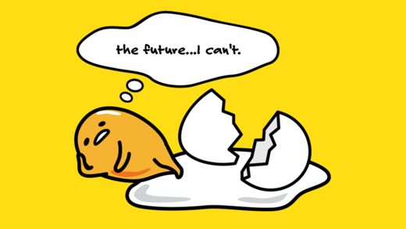
Translated (Devanagari):
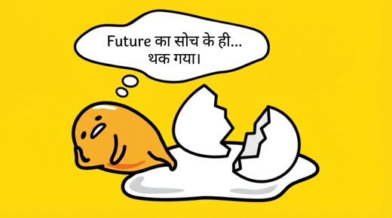
Original OCR: the future...l can't. ...
English explanation (mistral_large3/eng):
This meme employs a minimalist, cartoon-style illustration featuring two anthropomorphic food items, a dejected, wide-eyed potato with a small frown and a partially eaten piece of bread with a jagged, uneven edge, set against a bright yellow background. The accompanying text in a speech bubble reads, "the future... I can't," suggesting an incomplete or abandoned thought that conveys resignation or emotional paralysis. Visually, the meme draws on the "distracted boyfriend" template’s ironic humor but replaces human figures with food, amplifying a sense of absurdity while underscoring feelings of inadequacy or existential dread. Clinically, the imagery and text align most closely with *feeling down* and *lack of interest*, as the fragmented expression of hopelessness about the future and the personified food’s defeated posture evoke a sense of emotional exhaustion and disengagement rather than explicit self-harm or disordered eating behaviors.
Hindi explanation (gpt4o_mini/deva):
इस मीम में एक पीला पृष्ठभूमि है, जिसमें एक गोल और साधारण आकृति है जो एक नकारात्मक रूप में दिख रहा है। इस आकृति के ऊपर एक शब्दBubble है जिसमें लिखा है "Future का सोच के ही... थक गया।" इसके पास एक टूटी हुई अंडे का शेल है। इस चित्र में दर्शाई गई भावनात्मक स्थिति अप्रसन्नता और असहायता का अहसास कराती है, जैसे कि भविष्य की चिंता से थक जाना। इसे देखते हुए मनोवैज्ञानिक संदर्भ में, यह मुख्य रूप से "Feeling Down" और "Low Self-Esteem" के लक्षण दर्शाता है, क्योंकि यह व्यक्ति के भीतर की निराशा और अभाव की भावना को उजागर करता है।
SH predictions (0/30 hits):
gemini deva_expl_only: SH=0
gemini deva_img_deva_expl: SH=0
gpt4o_mini deva_expl_only: SH=0
gpt4o_mini deva_image_only: SH=0
gpt4o_mini deva_img_deva_expl: SH=0
gpt4o_mini deva_img_eng_expl: SH=0
gpt4o_mini eng_expl_only: SH=0
gpt4o_mini eng_image_only: SH=0
gpt4o_mini eng_img_eng_expl: SH=0
llama4 deva_expl_only: SH=0
llama4 deva_image_only: SH=0
llama4 deva_img_deva_expl: SH=0
llama4 deva_img_eng_expl: SH=0
llama4 eng_expl_only: SH=0
llama4 eng_image_only: SH=0
llama4 eng_img_eng_expl: SH=0
mistral_large3 deva_expl_only: SH=0
mistral_large3 deva_image_only: SH=0
mistral_large3 deva_img_deva_expl: SH=0
mistral_large3 deva_img_eng_expl: SH=0
mistral_large3 eng_expl_only: SH=0
mistral_large3 eng_image_only: SH=0
mistral_large3 eng_img_eng_expl: SH=0
mistral_small_2503 deva_expl_only: SH=0
mistral_small_2503 deva_image_only: SH=0
mistral_small_2503 deva_img_deva_expl: SH=0
mistral_small_2503 deva_img_eng_expl: SH=0
mistral_small_2503 eng_expl_only: SH=0
mistral_small_2503 eng_image_only: SH=0
mistral_small_2503 eng_img_eng_expl: SH=0
Analysis:
• English explanation names Self-Harm.
• Hindi explanation emphasizes a related symptom, not Self-Harm.
• Image-only: 0/8 correct
• Explanation-only: 0/9 correct
• Image + explanation: 0/13 correct
• Gemini (Deva Expl Only): predicted Feeling Down, Concentration Problem, Sleeping Disorder
• Gemini (Deva Img Deva Expl): predicted Feeling Down, Concentration Problem, Sleeping Disorder
• GPT-4o-mini (Deva Expl Only): predicted Feeling Down, Low Self-Esteem
• GPT-4o-mini (Deva Image Only): predicted Feeling Down
• GPT-4o-mini (Deva Img Deva Expl): predicted Feeling Down, Low Self-Esteem
• GPT-4o-mini (Deva Img Eng Expl): predicted Feeling Down, Lack of Interest
• GPT-4o-mini (Eng Expl Only): predicted Feeling Down, Lack of Interest
• GPT-4o-mini (Eng Image Only): predicted Feeling Down, Low Self-Esteem
• Explanation-classifier gap: English text mentions Self-Harm but many runs still output SH=0.
• Image-only failure: Self-Harm is not visually or OCR-explicit in the Devanagari meme.
• Co-labeling with Feeling Down: salient cues for the co-label may satisfy models before the subtler Self-Harm dimension is tagged.
• Models often substitute Feeling Down (30/30 misses), which overlaps semantically with Self-Harm in meme text or explanations.
• Models often substitute Concentration Problem (14/30 misses), which overlaps semantically with Self-Harm in meme text or explanations.

Case C - Models largely succeed (SH, TE-123)
UNIVERSAL_HUMAN | Gold: Feeling Down, Self-Harm
Original (English):
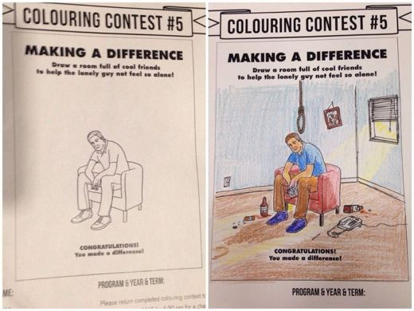
Translated (Devanagari):
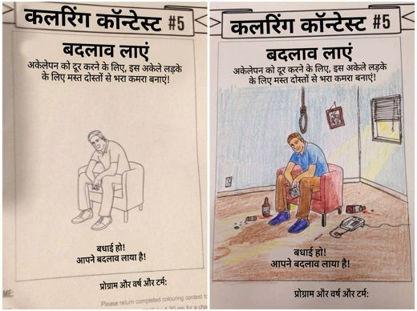
Original OCR: COLOURING CONTEST #5 COLOURING CONTEST #5 MAKING A DIFFERENCE MAKING A DIFFERENCE Draw a room full of cool friends to help the lonely guy not feel so alone! Draw a room full of cool friends to help th...
English explanation (mistral_large3/eng):
This meme employs a split-image "coloring contest" template, a format commonly used in internet humor to juxtapose bleak scenarios with ostensibly uplifting resolutions. On the left, a line drawing depicts a solitary figure sitting dejectedly on a chair, accompanied by text instructing viewers to "draw a room full of cool friends to help the lonely guy not feel so alone," while the right side shows the completed, colored version of the scene, now featuring the same individual in a dimly lit room, still alone, surrounded by discarded items, a beer bottle, and a noose hanging ominously in the background, with the ironic caption "Congratulations! You made a difference!" The emotional tone underscores a stark contrast between the intent of social connection and the grim reality of isolation, conveying profound loneliness and despair beneath a veneer of dark humor. Clinically, the imagery aligns most closely with *Feeling Down* and *Self-Harm*, as it visually and thematically references hopelessness and suicidal ideation, though it does so through absurdist exaggeration rather than explicit personal disclosure.
Hindi explanation (gpt4o_mini/deva):
इस मीम में दो चित्र हैं: बाईं ओर एक खाली छवि है जिसमें एक युवक उदासीनता के साथ एक कुर्सी पर बैठा है, जबकि दाईं ओर रंगभेदित चित्र में वह युवक अधिक गंभीर स्थिति में है, जिससे उसके चारों ओर बिखरे हुए शराब की बोतलें और एक लटकता हुआ फंदा दिखाई दे रहा है। शीर्षक में लिखा है, "बदलाव लाएं" और नीचे "आपने बदलाव लाया है!" यह मीम अकेलेपन और अवसाद को दर्शाता है, जहां व्यक्ति की भावनात्मक स्थिति बेहद गंभीर और निराशाजनक लगती है। यह "फीलिंग डाउन" और "सेल्फ-हार्म" जैसे लक्षणों को स्पष्ट रूप से दर्शाता है, जो कि मानसिक स्वास्थ्य के दृष्टिकोण से चिंताजनक हैं।
SH predictions (24/30 hits):
gemini deva_expl_only: SH=1
gemini deva_img_deva_expl: SH=1
gpt4o_mini deva_expl_only: SH=1
gpt4o_mini deva_image_only: SH=1
gpt4o_mini deva_img_deva_expl: SH=1
gpt4o_mini deva_img_eng_expl: SH=1
gpt4o_mini eng_expl_only: SH=1
gpt4o_mini eng_image_only: SH=1
gpt4o_mini eng_img_eng_expl: SH=1
llama4 deva_expl_only: SH=1
llama4 deva_image_only: SH=0
llama4 deva_img_deva_expl: SH=1
llama4 deva_img_eng_expl: SH=0
llama4 eng_expl_only: SH=0
llama4 eng_image_only: SH=0
llama4 eng_img_eng_expl: SH=0
mistral_large3 deva_expl_only: SH=0
mistral_large3 deva_image_only: SH=1
mistral_large3 deva_img_deva_expl: SH=1
mistral_large3 deva_img_eng_expl: SH=1
mistral_large3 eng_expl_only: SH=1
mistral_large3 eng_image_only: SH=1
mistral_large3 eng_img_eng_expl: SH=1
mistral_small_2503 deva_expl_only: SH=1
mistral_small_2503 deva_image_only: SH=1
mistral_small_2503 deva_img_deva_expl: SH=1
mistral_small_2503 deva_img_eng_expl: SH=1
mistral_small_2503 eng_expl_only: SH=1
mistral_small_2503 eng_image_only: SH=1
mistral_small_2503 eng_img_eng_expl: SH=1
Analysis:
• English explanation names Self-Harm.
• Hindi explanation names Self-Harm.
• Image-only: 6/8 correct
• Explanation-only: 7/9 correct
• Image + explanation: 11/13 correct
• Llama-4 (Deva Image Only): predicted Feeling Down, Lack of Interest, Low Self-Esteem, Concentration Problem
• Llama-4 (Deva Img Eng Expl): predicted Feeling Down, Lack of Interest, Low Self-Esteem
• Llama-4 (Eng Expl Only): predicted Feeling Down, Lack of Interest, Low Self-Esteem
• Llama-4 (Eng Image Only): predicted Feeling Down, Lack of Interest
• Llama-4 (Eng Img Eng Expl): predicted Feeling Down, Lack of Interest, Low Self-Esteem
• Mistral-L3 (Deva Expl Only): predicted Feeling Down, Lack of Interest
• Hindi explanation names Self-Harm but some Devanagari runs still miss, possibly due to transliterated-label noise or co-occurring symptom confusion.
• Co-labeling with Feeling Down: salient cues for the co-label may satisfy models before the subtler Self-Harm dimension is tagged.
• Models often substitute Feeling Down (6/6 misses), which overlaps semantically with Self-Harm in meme text or explanations.
• Models often substitute Lack of Interest (6/6 misses), which overlaps semantically with Self-Harm in meme text or explanations.
• Most runs succeed when explanations or images make Self-Harm explicit; remaining misses cluster on image-only or substitute-symptom inputs.

Recommendations
• Add a dark-humor vs genuine self-harm disambiguation step; memes with death jokes often trigger false Self-Harm positives.
• Audit Hindi explanations for over-assignment of Self-Harm on existential or humorous content.
• Require explicit suicidal/self-injury language before assigning Self-Harm in explanation generation.

4. Eating Disorder (ED)

Per-condition F1
Condition | GPT-4o-mini | Mistral-L3 | Mistral-S | Llama-4 | Gemini
Deva Img-Only | 0.5714 | 0.6626 | 0.7229 | 0.7239 | -
Eng Img-Only | 0.7205 | 0.8177 | 0.7738 | 0.7882 | -
Deva Expl-Only | 0.7226 | 0.6395 | 0.6577 | 0.6846 | 0.8068
Eng Expl-Only | 0.7811 | 0.8506 | 0.6968 | 0.8171 | -
Deva Img+Deva Expl | 0.6980 | 0.6259 | 0.7097 | 0.6957 | 0.8156
Eng Img+Eng Expl | 0.7765 | 0.8391 | 0.7296 | 0.8256 | -
Deva Img+Eng Expl | 0.7904 | 0.8457 | 0.7296 | 0.8187 | -
Eating Disorder has low support (~90 gold memes) and moderate F1. Models confuse ED with Feeling Down or LSE when food imagery is absent and explanations describe generic distress.

Explanation coverage (87 gold ED memes)
English explicit: 73/87 | English substitute: 10/87 | Hindi explicit: 44/87 | Both miss/substitute: 9/87

Case studies

Case A - Persistent miss, explanations miss (ED, TE-213)
POP_CULTURE_DEPENDENT | Gold: Eating Disorder
Original (English):
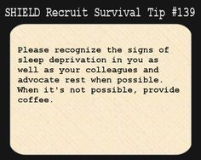
Translated (Devanagari):
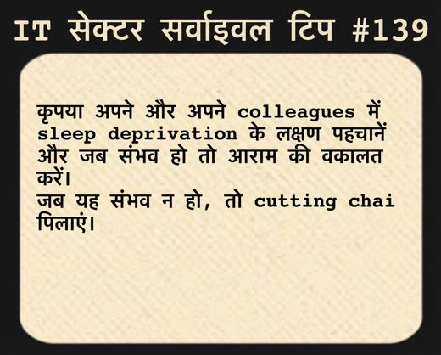
Original OCR: SHIELD Recruit Survival Tip #139 Please recognize the signs of sleep deprivation in you as well as your colleagues and advocate rest when possible. When it's not possible, provide coffee. ...
English explanation (mistral_large3/eng):
This meme employs the "SHIELD Recruit Survival Tip" template, a format often used humorously to mimic instructional or advisory content, typically associated with the Marvel Cinematic Universe’s S.H.I.E.L.D. organization. The image features block text instructing viewers to "recognize the signs of sleep deprivation in you as well as your colleagues and subordinates," followed by the sarcastic caveat, "Request when possible. When it’s not possible, provide coffee." The visual and textual tone blends workplace exhaustion with dark humor, underscoring the normalization of chronic fatigue in high-pressure or overworked environments. Clinically, the meme reflects symptoms aligned with *Sleeping Disorder*, as it highlights persistent exhaustion and reliance on stimulants like coffee to cope, while also subtly conveying *Concentration Problem* through the implication of impaired functioning in professional settings. The underlying emotional state suggests resignation and gallows humor, common in internet culture as a way to articulate shared struggles with systemic or unrelenting stress.
Hindi explanation (gpt4o_mini/deva):
यह मेम एक साधारण पृष्ठभूमि पर आधारित है जिसमें "IT सेक्टर सर्विसवाल टिप #139" शीर्षक है। इसके भीतर लिखा गया है कि कृपया अपने और अपने सहयोगियों में नींद की कमी के लक्षण पहचानें और जब संभव हो तो आराम करें। यदि यह संभव न हो, तो 'कटिंग चाय' पेश करने का सुझाव दिया गया है। इस मेम का भावनात्मक संदर्भ एक हल्की-फुल्की चेतावनी के रूप में प्रस्तुत किया गया है, जो कार्यस्थल पर नींद की कमी और तनाव को दर्शाता है। यह स्पष्ट रूप से 'नींद संबंधी विकार' को इंगित करता है, क्योंकि यह सुनने में आता है कि लोग अपनी नींद की कमी को पहचानकर आराम करने की आवश्यकता महसूस करते हैं। इसके साथ ही, यह 'एकाग्रता की समस्या' का भी संकेत देता है, जब लोग अपनी उत्पादकता को बनाए रखने के लिए चाय जैसी चीज़ों पर भरोसा करते हैं।
ED predictions (0/30 hits):
gemini deva_expl_only: ED=0
gemini deva_img_deva_expl: ED=0
gpt4o_mini deva_expl_only: ED=0
gpt4o_mini deva_image_only: ED=0
gpt4o_mini deva_img_deva_expl: ED=0
gpt4o_mini deva_img_eng_expl: ED=0
gpt4o_mini eng_expl_only: ED=0
gpt4o_mini eng_image_only: ED=0
gpt4o_mini eng_img_eng_expl: ED=0
llama4 deva_expl_only: ED=0
llama4 deva_image_only: ED=0
llama4 deva_img_deva_expl: ED=0
llama4 deva_img_eng_expl: ED=0
llama4 eng_expl_only: ED=0
llama4 eng_image_only: ED=0
llama4 eng_img_eng_expl: ED=0
mistral_large3 deva_expl_only: ED=0
mistral_large3 deva_image_only: ED=0
mistral_large3 deva_img_deva_expl: ED=0
mistral_large3 deva_img_eng_expl: ED=0
mistral_large3 eng_expl_only: ED=0
mistral_large3 eng_image_only: ED=0
mistral_large3 eng_img_eng_expl: ED=0
mistral_small_2503 deva_expl_only: ED=0
mistral_small_2503 deva_image_only: ED=0
mistral_small_2503 deva_img_deva_expl: ED=0
mistral_small_2503 deva_img_eng_expl: ED=0
mistral_small_2503 eng_expl_only: ED=0
mistral_small_2503 eng_image_only: ED=0
mistral_small_2503 eng_img_eng_expl: ED=0
Analysis:
• English explanation does not signal Eating Disorder.
• Hindi explanation omits Eating Disorder cues.
• Image-only: 0/8 correct
• Explanation-only: 0/9 correct
• Image + explanation: 0/13 correct
• Gemini (Deva Expl Only): predicted Sleeping Disorder
• Gemini (Deva Img Deva Expl): predicted Sleeping Disorder
• GPT-4o-mini (Deva Expl Only): predicted Concentration Problem, Sleeping Disorder
• GPT-4o-mini (Deva Image Only): predicted Sleeping Disorder
• GPT-4o-mini (Deva Img Deva Expl): predicted Concentration Problem, Sleeping Disorder
• GPT-4o-mini (Deva Img Eng Expl): predicted Sleeping Disorder
• GPT-4o-mini (Eng Expl Only): predicted Sleeping Disorder
• GPT-4o-mini (Eng Image Only): predicted Sleeping Disorder
• Gold is ED-only with no co-labels, so models cannot borrow cues from adjacent symptoms.
• Explanation pipeline failure: neither language surfaces the target symptom, so explanation-only and multimodal runs inherit the wrong clinical framing.
• Image-only failure: Eating Disorder is not visually or OCR-explicit in the Devanagari meme.
• Models often substitute Sleeping Disorder (30/30 misses), which overlaps semantically with Eating Disorder in meme text or explanations.
• Models often substitute Concentration Problem (13/30 misses), which overlaps semantically with Eating Disorder in meme text or explanations.

Case B - Co-label with Feeling Down, partial confusion (ED, TE-627)
UNIVERSAL_HUMAN | Gold: Eating Disorder, Feeling Down
Original (English):
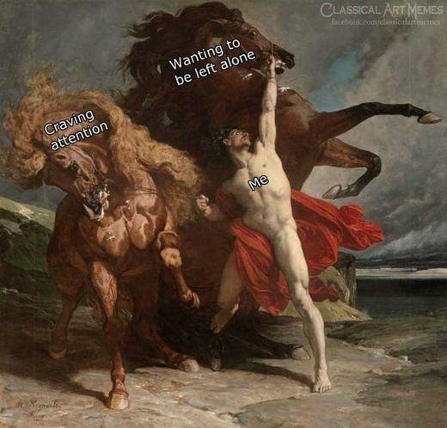
Translated (Devanagari):
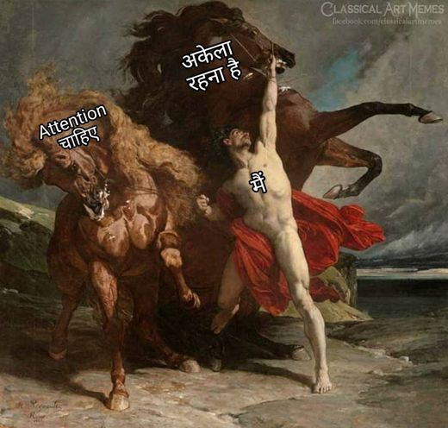
Original OCR: Wanting to be left alone CLASSICAL ART MEMES fitcebook.com/clasicalartmemen Craving attention Me ...
English explanation (mistral_large3/eng):
This meme repurposes a classical painting, likely from the Romantic or mythological tradition, depicting three figures on horseback in a dynamic, emotionally charged scene set against a stormy landscape. The original artwork is overlaid with modern text that humorously anthropomorphizes the horses and the central human figure: the two horses are labeled "Craving attention" and "Wanting to be left alone," while the person clinging to one of the horses is labeled "Me," framing a relatable internal conflict through exaggerated, contrasting desires. Emotionally, the meme captures a sense of ambivalence and social exhaustion, using dark humor to externalize the tension between seeking connection and desiring isolation, a common experience in contemporary digital culture where interpersonal demands often feel overwhelming. Clinically, the meme aligns most closely with themes of *low self-esteem* and *lack of interest*, as it reflects a self-deprecating acknowledgment of perceived social inadequacy and a withdrawal from engagement, though it does not explicitly evidence more severe symptoms like self-harm or disordered eating.
Hindi explanation (gpt4o_mini/deva):
यह मेम एक ऐतिहासिक चित्र को दिखाता है जिसमें एक व्यक्ति एक घोड़े से लड़ रहा है। चित्र में व्यक्ति लाल चोगा पहने हुए है और उसने घोड़े को दुश्मन की तरह पकड़ा हुआ है। मेम पर लिखे पाठ में "Attention चाहिए", "अकेला रहना है", और "मैं" शामिल हैं, जो कि अलग-अलग भावनाओं को प्रकट करते हैं। यह मेम अकेलेपन और ध्यान की जरूरत को दर्शाता है, जो दुःख और उदासी की भावनाओं को भी उजागर करता है। संदर्भित क्लिनिकल टर्मिनोलॉजी के अनुसार, यह "Feeling Down" और "Low Self-Esteem" के रूप में पहचाना जा सकता है, जो व्यक्ति द्वारा अपने अनुभवों का मूल्यांकन करते समय सामने आते हैं।
ED predictions (0/30 hits):
gemini deva_expl_only: ED=0
gemini deva_img_deva_expl: ED=0
gpt4o_mini deva_expl_only: ED=0
gpt4o_mini deva_image_only: ED=0
gpt4o_mini deva_img_deva_expl: ED=0
gpt4o_mini deva_img_eng_expl: ED=0
gpt4o_mini eng_expl_only: ED=0
gpt4o_mini eng_image_only: ED=0
gpt4o_mini eng_img_eng_expl: ED=0
llama4 deva_expl_only: ED=0
llama4 deva_image_only: ED=0
llama4 deva_img_deva_expl: ED=0
llama4 deva_img_eng_expl: ED=0
llama4 eng_expl_only: ED=0
llama4 eng_image_only: ED=0
llama4 eng_img_eng_expl: ED=0
mistral_large3 deva_expl_only: ED=0
mistral_large3 deva_image_only: ED=0
mistral_large3 deva_img_deva_expl: ED=0
mistral_large3 deva_img_eng_expl: ED=0
mistral_large3 eng_expl_only: ED=0
mistral_large3 eng_image_only: ED=0
mistral_large3 eng_img_eng_expl: ED=0
mistral_small_2503 deva_expl_only: ED=0
mistral_small_2503 deva_image_only: ED=0
mistral_small_2503 deva_img_deva_expl: ED=0
mistral_small_2503 deva_img_eng_expl: ED=0
mistral_small_2503 eng_expl_only: ED=0
mistral_small_2503 eng_image_only: ED=0
mistral_small_2503 eng_img_eng_expl: ED=0
Analysis:
• English explanation names Eating Disorder.
• Hindi explanation emphasizes a related symptom, not Eating Disorder.
• Image-only: 0/8 correct
• Explanation-only: 0/9 correct
• Image + explanation: 0/13 correct
• Gemini (Deva Expl Only): predicted no positive label
• Gemini (Deva Img Deva Expl): predicted no positive label
• GPT-4o-mini (Deva Expl Only): predicted Feeling Down, Low Self-Esteem
• GPT-4o-mini (Deva Image Only): predicted no positive label
• GPT-4o-mini (Deva Img Deva Expl): predicted Feeling Down, Low Self-Esteem
• GPT-4o-mini (Deva Img Eng Expl): predicted Feeling Down, Low Self-Esteem
• GPT-4o-mini (Eng Expl Only): predicted Feeling Down, Low Self-Esteem
• GPT-4o-mini (Eng Image Only): predicted no positive label
• Explanation-classifier gap: English text mentions Eating Disorder but many runs still output ED=0.
• Image-only failure: Eating Disorder is not visually or OCR-explicit in the Devanagari meme.
• Co-labeling with Feeling Down: salient cues for the co-label may satisfy models before the subtler Eating Disorder dimension is tagged.
• Models often substitute Low Self-Esteem (22/30 misses), which overlaps semantically with Eating Disorder in meme text or explanations.
• Models often substitute Feeling Down (17/30 misses), which overlaps semantically with Eating Disorder in meme text or explanations.

Case C - Models largely succeed (ED, TE-477)
UNIVERSAL_HUMAN | Gold: Eating Disorder
Original (English):
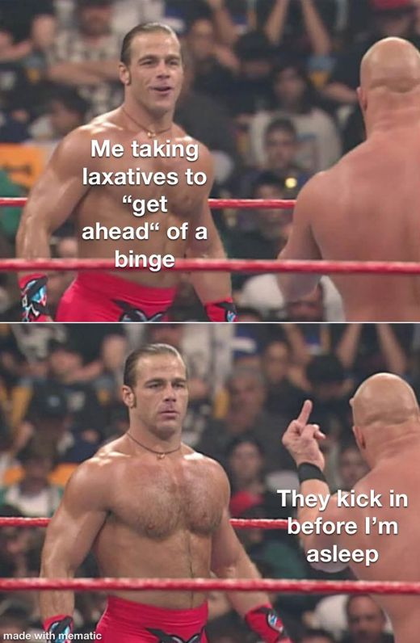
Translated (Devanagari):
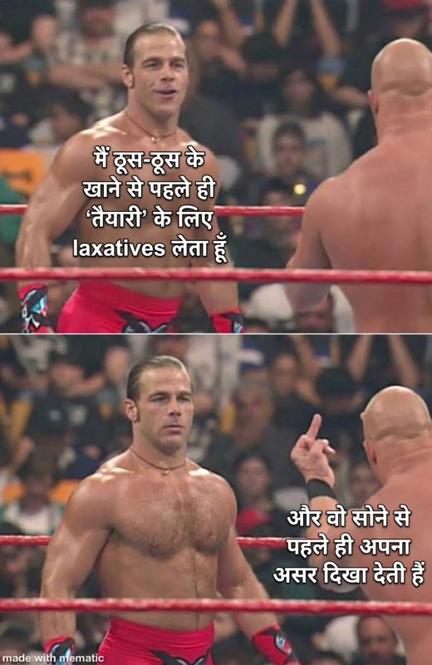
Original OCR: Me taking laxatives to "get ahead“ of a binge They kick in before l'm asleep made with mematic ...
English explanation (mistral_large3/eng):
This meme employs a two-panel format featuring a professional wrestler standing in the ring, utilizing the "Is This a Pigeon?" template to humorously reframe disordered behaviors as strategic coping mechanisms. The top panel shows the wrestler shirtless with the caption, "Me taking laxatives to 'get ahead' of a binge," while the bottom panel depicts him pointing upward with the text, "They kick in before I’m asleep," presenting a cycle of compensatory behavior as a calculated, almost triumphant, plan. Visually, the wrestler’s confident posture contrasts sharply with the underlying emotional state of desperation and control-seeking, reflecting an attempt to mask distress through dark humor. Clinically, the meme explicitly evidences symptoms of an **Eating Disorder** by referencing bingeing and laxative misuse, while also hinting at a **Sleeping Disorder** through the implication of disrupted rest, though these are framed in a way that normalizes or trivializes the severity of such behaviors within internet culture.
Hindi explanation (gpt4o_mini/deva):
यह मेम एक कुश्ती के मुकाबले का दृश्य प्रस्तुत करता है, जिसमें एक पहलवान अपनी मांसल संरचना के साथ खड़ा है, जबकि दूसरा पहलवान उसके सामने उंगली दिखा रहा है। शीर्ष पर लिखा है, "मैं थूथू के खाने से पहले ही 'तैयारी' के लिए laxatives लेता हूँ," और निचले भाग में है, "और वो सोने से पहले ही अपना असर दिखाती हैं।" इस मेम में एक विद्रूपता है, जो खाद्य विकार (Eating Disorder) की ओर इशारा कर सकती है, क्योंकि यह एक व्यक्ति को तौला जाने और अपनी शरीर की आकृति के बारे में तिरस्कारपूर्ण और व्यंग्यात्मक ढंग से सोचते हुए दर्शाता है। यह विडंबना भरा हास्य एक अंतर्दृष्टि दिखाता है कि कैसे लोग अपने शरीर की छवि और आहार के प्रति नकारात्मक सोच विकसित कर सकते हैं, जो मानसिक स्वास्थ्य से संबंधित समस्याओं की ओर संकेत करता है।
ED predictions (24/30 hits):
gemini deva_expl_only: ED=1
gemini deva_img_deva_expl: ED=1
gpt4o_mini deva_expl_only: ED=1
gpt4o_mini deva_image_only: ED=1
gpt4o_mini deva_img_deva_expl: ED=1
gpt4o_mini deva_img_eng_expl: ED=1
gpt4o_mini eng_expl_only: ED=1
gpt4o_mini eng_image_only: ED=1
gpt4o_mini eng_img_eng_expl: ED=1
llama4 deva_expl_only: ED=1
llama4 deva_image_only: ED=1
llama4 deva_img_deva_expl: ED=1
llama4 deva_img_eng_expl: ED=0
llama4 eng_expl_only: ED=0
llama4 eng_image_only: ED=0
llama4 eng_img_eng_expl: ED=0
mistral_large3 deva_expl_only: ED=0
mistral_large3 deva_image_only: ED=1
mistral_large3 deva_img_deva_expl: ED=0
mistral_large3 deva_img_eng_expl: ED=1
mistral_large3 eng_expl_only: ED=1
mistral_large3 eng_image_only: ED=1
mistral_large3 eng_img_eng_expl: ED=1
mistral_small_2503 deva_expl_only: ED=1
mistral_small_2503 deva_image_only: ED=1
mistral_small_2503 deva_img_deva_expl: ED=1
mistral_small_2503 deva_img_eng_expl: ED=1
mistral_small_2503 eng_expl_only: ED=1
mistral_small_2503 eng_image_only: ED=1
mistral_small_2503 eng_img_eng_expl: ED=1
Analysis:
• English explanation names Eating Disorder.
• Hindi explanation names Eating Disorder.
• Image-only: 7/8 correct
• Explanation-only: 7/9 correct
• Image + explanation: 10/13 correct
• Llama-4 (Deva Img Eng Expl): predicted Sleeping Disorder
• Llama-4 (Eng Expl Only): predicted Sleeping Disorder
• Llama-4 (Eng Image Only): predicted Sleeping Disorder
• Llama-4 (Eng Img Eng Expl): predicted Sleeping Disorder
• Mistral-L3 (Deva Expl Only): predicted Low Self-Esteem
• Mistral-L3 (Deva Img Deva Expl): predicted Low Self-Esteem, Sleeping Disorder
• Gold is ED-only with no co-labels, so models cannot borrow cues from adjacent symptoms.
• Hindi explanation names Eating Disorder but some Devanagari runs still miss, possibly due to transliterated-label noise or co-occurring symptom confusion.
• Models often substitute Sleeping Disorder (5/6 misses), which overlaps semantically with Eating Disorder in meme text or explanations.
• Models often substitute Low Self-Esteem (2/6 misses), which overlaps semantically with Eating Disorder in meme text or explanations.
• Most runs succeed when explanations or images make Eating Disorder explicit; remaining misses cluster on image-only or substitute-symptom inputs.

Recommendations
• Prompt explanations to look for appetite, restriction, binge, or body-image cues rather than generic stress eating.
• ED is rare in the test set; treat low support as a driver of unstable F1 across conditions.
• Cross-check image text for food/body references when explanation-only runs miss ED.

5. Low Self-Esteem (LSE)

Per-condition F1
Condition | GPT-4o-mini | Mistral-L3 | Mistral-S | Llama-4 | Gemini
Deva Img-Only | 0.3977 | 0.3549 | 0.4766 | 0.3927 | -
Eng Img-Only | 0.4010 | 0.4108 | 0.4878 | 0.4103 | -
Deva Expl-Only | 0.3689 | 0.4180 | 0.4377 | 0.4100 | 0.5122
Eng Expl-Only | 0.4253 | 0.4289 | 0.4430 | 0.4305 | -
Deva Img+Deva Expl | 0.3837 | 0.4127 | 0.4514 | 0.4011 | 0.5082
Eng Img+Eng Expl | 0.4081 | 0.4360 | 0.4390 | 0.4262 | -
Deva Img+Eng Expl | 0.4187 | 0.4371 | 0.4334 | 0.4149 | -
Low Self-Esteem sits in the mid F1 band. Self-deprecating meme formats frequently pull predictions toward LSE even when gold is another label, and vice versa when gold is LSE but text reads as sadness.

Explanation coverage (112 gold LSE memes)
English explicit: 88/112 | English substitute: 19/112 | Hindi explicit: 34/112 | Both miss/substitute: 19/112

Case studies

Case A - Persistent miss, explanations miss (LSE, TE-259)
LANGUAGE_DEPENDENT | Gold: Feeling Down, Low Self-Esteem
Original (English):
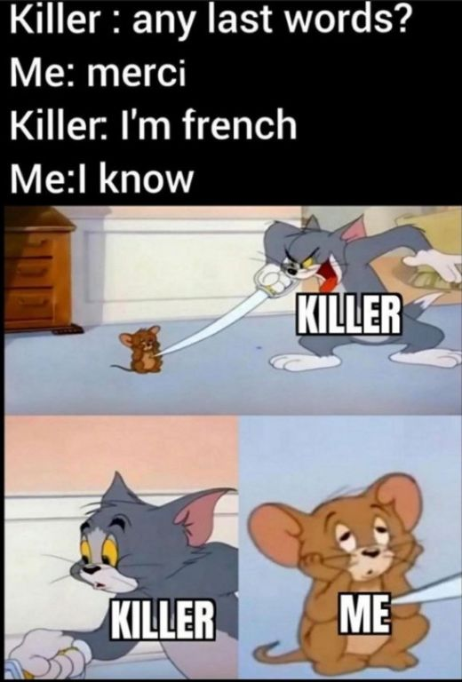
Translated (Devanagari):
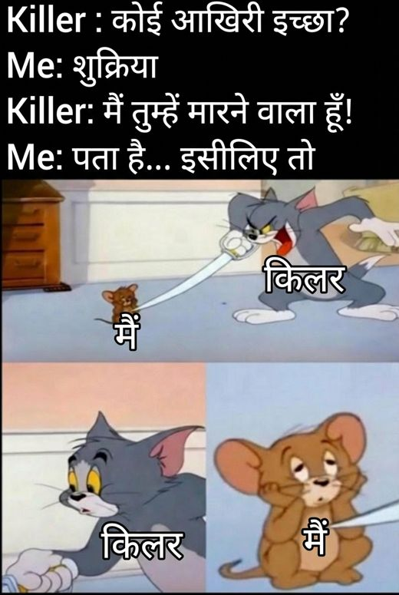
Original OCR: Killer : any last words? Me: merci Killer: I'm french Me:l know KILLER KILLER ME ...
English explanation (mistral_large3/eng):
This meme employs a classic two-panel format featuring characters from the animated series *Tom and Jerry*, repurposed to depict a darkly comedic exchange. The top panel shows the mouse (labeled "Me") facing the cat (labeled "Killer"), with the text overlay presenting a grim scenario: the killer asks for last words, to which the mouse responds, "merci," prompting the killer to reveal they are French, followed by the mouse’s resigned acknowledgment, "I know." Visually, the characters are positioned in a tense standoff, amplifying the absurdity of the dialogue’s macabre humor. Emotionally, the meme conveys a sense of resigned acceptance or gallows humor, masking underlying feelings of powerlessness or existential dread with irony. Clinically, while the content playfully references mortality, it does not explicitly evidence symptoms from the Clinical Reference Glossary, though its reliance on dark humor may reflect a coping mechanism for latent stress or anxiety rather than a direct manifestation of a specific disorder.
Hindi explanation (gpt4o_mini/deva):
इस मीम में, एक लोकप्रिय कार्टून टेम्पलेट का उपयोग किया गया है जिसमें टॉम और जेरी के पात्र हैं। चित्र में "किलर" और "मैं" के बीच संवाद हो रहा है, जिसमें किलर कहता है, "कोई आखिरी इच्छा?" और "मैं तुम्हें मारने वाला हूँ!" जबकि "मैं" प्रतिक्रिया देता है, "पता है... इसलिए!"। यह दृश्य हल्के फुल्के तरीके से खतरे और बचाव के तत्वों को प्रस्तुत करता है। भावनात्मक रूप से, इस मीम में एक आत्म-परिहास की भावना देखी जा सकती है, जो नकारात्मक परिस्थितियों का सामना करने के लिए उपयोग की गई है। क्लीनिकल संदर्भ में, यह मीम आत्म-हानि (Self-Harm) के संकेत देता है, क्योंकि इसमें जीवन के अंत के विषय का संदर्भ है, हालांकि इसे हास्य के रूप में प्रस्तुत किया गया है।
LSE predictions (1/30 hits):
gemini deva_expl_only: LSE=0
gemini deva_img_deva_expl: LSE=0
gpt4o_mini deva_expl_only: LSE=0
gpt4o_mini deva_image_only: LSE=0
gpt4o_mini deva_img_deva_expl: LSE=0
gpt4o_mini deva_img_eng_expl: LSE=0
gpt4o_mini eng_expl_only: LSE=0
gpt4o_mini eng_image_only: LSE=0
gpt4o_mini eng_img_eng_expl: LSE=0
llama4 deva_expl_only: LSE=0
llama4 deva_image_only: LSE=0
llama4 deva_img_deva_expl: LSE=0
llama4 deva_img_eng_expl: LSE=0
llama4 eng_expl_only: LSE=0
llama4 eng_image_only: LSE=0
llama4 eng_img_eng_expl: LSE=0
mistral_large3 deva_expl_only: LSE=0
mistral_large3 deva_image_only: LSE=0
mistral_large3 deva_img_deva_expl: LSE=0
mistral_large3 deva_img_eng_expl: LSE=0
mistral_large3 eng_expl_only: LSE=0
mistral_large3 eng_image_only: LSE=0
mistral_large3 eng_img_eng_expl: LSE=0
mistral_small_2503 deva_expl_only: LSE=0
mistral_small_2503 deva_image_only: LSE=0
mistral_small_2503 deva_img_deva_expl: LSE=1
mistral_small_2503 deva_img_eng_expl: LSE=0
mistral_small_2503 eng_expl_only: LSE=0
mistral_small_2503 eng_image_only: LSE=0
mistral_small_2503 eng_img_eng_expl: LSE=0
Analysis:
• English explanation does not signal Low Self-Esteem.
• Hindi explanation omits Low Self-Esteem cues.
• Image-only: 0/8 correct
• Explanation-only: 0/9 correct
• Image + explanation: 1/13 correct
• Gemini (Deva Expl Only): predicted Feeling Down, Lack of Interest, Self-Harm
• Gemini (Deva Img Deva Expl): predicted Lack of Interest, Self-Harm
• GPT-4o-mini (Deva Expl Only): predicted Self-Harm
• GPT-4o-mini (Deva Image Only): predicted no positive label
• GPT-4o-mini (Deva Img Deva Expl): predicted Self-Harm
• GPT-4o-mini (Deva Img Eng Expl): predicted Self-Harm
• GPT-4o-mini (Eng Expl Only): predicted Self-Harm
• GPT-4o-mini (Eng Image Only): predicted no positive label
• Explanation pipeline failure: neither language surfaces the target symptom, so explanation-only and multimodal runs inherit the wrong clinical framing.
• Image-only failure: Low Self-Esteem is not visually or OCR-explicit in the Devanagari meme.
• Co-labeling with Feeling Down: salient cues for the co-label may satisfy models before the subtler Low Self-Esteem dimension is tagged.
• Models often substitute Self-Harm (11/29 misses), which overlaps semantically with Low Self-Esteem in meme text or explanations.

Case B - Co-label with Feeling Down, partial confusion (LSE, TE-459)
UNIVERSAL_HUMAN | Gold: Low Self-Esteem, Feeling Down, Lack of Energy
Original (English):
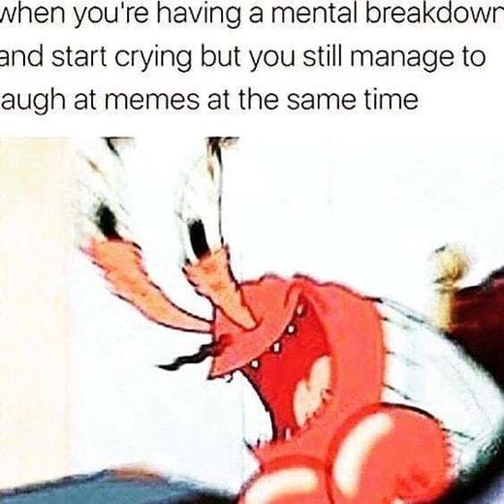
Translated (Devanagari):
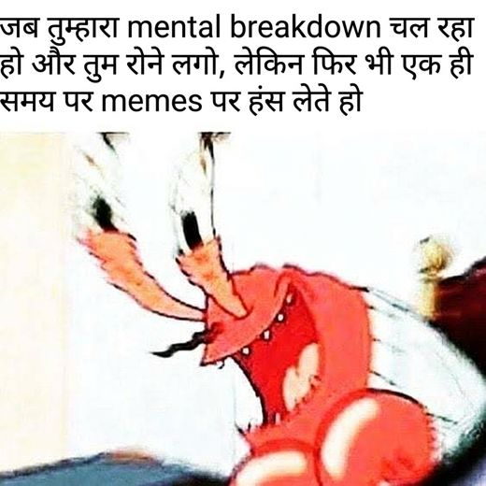
Original OCR: when you're having a mental breakdown and start crying but you still manage to augh at memes at the same time ...
English explanation (mistral_large3/eng):
This meme employs the visual template of *Mr. Krabs "Imagination"* from the animated series *SpongeBob SquarePants*, where the character is depicted in a distorted, exaggerated pose with a wide-open mouth, typically used to humorously represent absurd or extreme emotional reactions. The accompanying text reads, "when you're having a mental breakdown and start crying but you still manage to laugh at memes at the same time," framing a contradictory emotional experience that blends distress with fleeting amusement. Culturally, the meme reflects a coping mechanism often observed in online spaces, where individuals acknowledge their emotional turmoil while simultaneously engaging in humor as a form of temporary relief or distraction. Clinically, the described emotional state aligns with elements of *Feeling Down*, as evidenced by the explicit mention of crying and a mental breakdown, though it does not meet the threshold for other specific symptoms in the glossary, such as *Self-Harm* or *Low Self-Esteem*, as the focus remains on the juxtaposition of pain and momentary levity rather than deeper psychological despair.
Hindi explanation (gpt4o_mini/deva):
यह मेम एक प्रसिद्ध एनीमेशन चरित्र का उपयोग करता है, जिसमें एक लाल क्रैब (केंकड़ा) जोर से चिल्लाते हुए दिख रहा है। ऊपर के पाठ में लिखा है, "जब तुम्हारा mental breakdown चल रहा हो और तुम रोने लगो, लेकिन फिर भी एक ही समय पर memes पर हंस लेते हो।" इस मेम में वर्णित स्थिति मानसिक संकट के दौरान के दोहराए गए अनुभवों को दर्शाती है, जहां व्यक्ति अपनी परेशानी के बावजूद कुछ क्षणों के लिए हास्य का सहारा लेता है। यह भावनात्मक रूप से तनाव, असंतोष और हंसी के बीच की जुझारू संतुलन को प्रकट करता है। यह भावनात्मक संदर्भ "Feeling Down" और "Lack of Interest" जैसे लक्षणों का संकेत देता है, क्योंकि यह स्पष्ट रूप से मानसिक दबाव और हंसी के बीच का संघर्ष दर्शाता है।
LSE predictions (2/30 hits):
gemini deva_expl_only: LSE=0
gemini deva_img_deva_expl: LSE=0
gpt4o_mini deva_expl_only: LSE=0
gpt4o_mini deva_image_only: LSE=0
gpt4o_mini deva_img_deva_expl: LSE=0
gpt4o_mini deva_img_eng_expl: LSE=0
gpt4o_mini eng_expl_only: LSE=0
gpt4o_mini eng_image_only: LSE=1
gpt4o_mini eng_img_eng_expl: LSE=0
llama4 deva_expl_only: LSE=0
llama4 deva_image_only: LSE=0
llama4 deva_img_deva_expl: LSE=0
llama4 deva_img_eng_expl: LSE=0
llama4 eng_expl_only: LSE=0
llama4 eng_image_only: LSE=0
llama4 eng_img_eng_expl: LSE=0
mistral_large3 deva_expl_only: LSE=0
mistral_large3 deva_image_only: LSE=1
mistral_large3 deva_img_deva_expl: LSE=0
mistral_large3 deva_img_eng_expl: LSE=0
mistral_large3 eng_expl_only: LSE=0
mistral_large3 eng_image_only: LSE=0
mistral_large3 eng_img_eng_expl: LSE=0
mistral_small_2503 deva_expl_only: LSE=0
mistral_small_2503 deva_image_only: LSE=0
mistral_small_2503 deva_img_deva_expl: LSE=0
mistral_small_2503 deva_img_eng_expl: LSE=0
mistral_small_2503 eng_expl_only: LSE=0
mistral_small_2503 eng_image_only: LSE=0
mistral_small_2503 eng_img_eng_expl: LSE=0
Analysis:
• English explanation names Low Self-Esteem.
• Hindi explanation emphasizes a related symptom, not Low Self-Esteem.
• Image-only: 2/8 correct
• Explanation-only: 0/9 correct
• Image + explanation: 0/13 correct
• Gemini (Deva Expl Only): predicted Feeling Down
• Gemini (Deva Img Deva Expl): predicted Feeling Down
• GPT-4o-mini (Deva Expl Only): predicted Feeling Down, Lack of Interest
• GPT-4o-mini (Deva Image Only): predicted no positive label
• GPT-4o-mini (Deva Img Deva Expl): predicted Feeling Down, Lack of Interest
• GPT-4o-mini (Deva Img Eng Expl): predicted Feeling Down, Concentration Problem
• GPT-4o-mini (Eng Expl Only): predicted Feeling Down, Concentration Problem
• GPT-4o-mini (Eng Img Eng Expl): predicted Feeling Down, Concentration Problem
• Explanation-classifier gap: English text mentions Low Self-Esteem but many runs still output LSE=0.
• Co-labeling with Feeling Down, Lack of Energy: salient cues for the co-label may satisfy models before the subtler Low Self-Esteem dimension is tagged.
• Models often substitute Feeling Down (27/28 misses), which overlaps semantically with Low Self-Esteem in meme text or explanations.

Case C - Models largely succeed (LSE, TE-209)
UNIVERSAL_HUMAN | Gold: Feeling Down, Low Self-Esteem
Original (English):
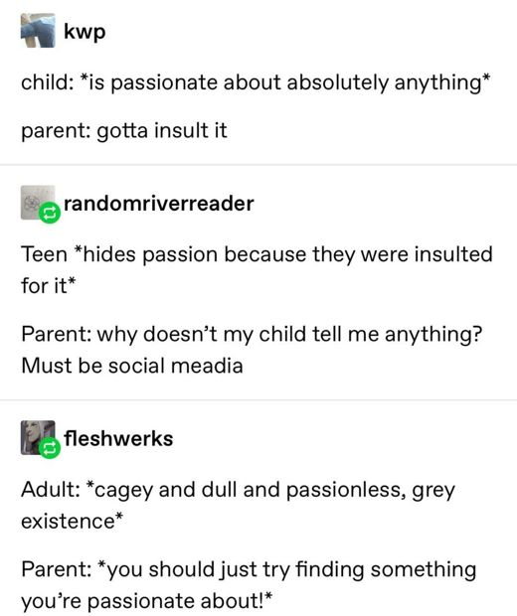
Translated (Devanagari):
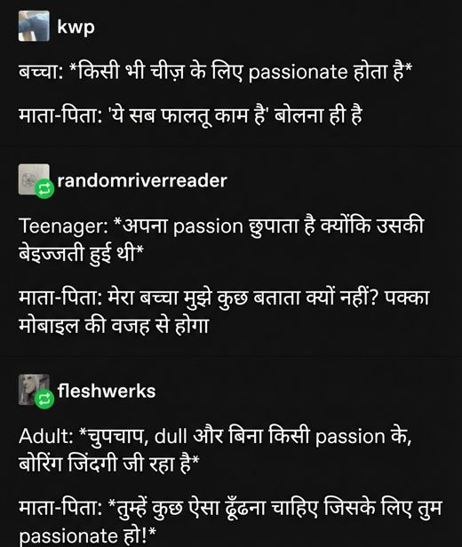
Original OCR: kwp child: *is passionate about absolutely anything* parent: gotta insult it randomriverreader Teen *hides passion because they were insulted for it* Parent: why doesn't my child tell me anything? Mus...
English explanation (mistral_large3/eng):
This meme employs a three-panel format to illustrate the erosion of passion across different life stages, using simple, monochrome illustrations and concise text to underscore its message. Visually, it depicts a child exuberantly expressing enthusiasm, a teenager concealing their interests after facing ridicule, and an adult trapped in a monotonous, unfulfilling existence, all while parental figures respond with dismissive or unhelpful remarks. The emotional tone conveys a sense of gradual emotional suppression, where initial joy and curiosity are stifled by criticism, leading to a resigned, passionless adulthood marked by disconnection and apathy. Clinically, the meme reflects themes of *Lack of Interest* and *Low Self-Esteem*, as the progression highlights how repeated invalidation may contribute to anhedonia and a diminished sense of self-worth, though it does not explicitly evidence other symptoms from the Clinical Reference Glossary.
Hindi explanation (gpt4o_mini/deva):
इस मेमे में तीन व्यक्ति के संवाद प्रदर्शित किए गए हैं, जिनमें माता-पिता के साथ बच्चों और किशोरों की बात की गई है। पहले संवाद में बच्चा passion के बारे में बात करता है, जिसके जवाब में माता-पिता इसे 'फालतू काम' बताते हैं। दूसरे संवाद में एक किशोर अपनी passion को छुपाने की बात करता है और उसे बेइज्जती का अनुभव होता है। तीसरे संवाद में एक वयस्क अपनी बिना किसी passion वाली जीवन शैली को 'बोरिंग' बताते हैं, जबकि माता-पिता उनसे कहते हैं कि उन्हें एक ऐसा रास्ता खोजना चाहिए जिसमें वे passionate हों। इस मेमे में उन भावनाओं का चित्रण है जो माता-पिता के अस्वीकार और बच्चों के अंदरूनी संघर्ष को दर्शाते हैं, जैसे कि रुचियों की कमी (Lack of Interest) और आत्म-सम्मान में कमी (Low Self-Esteem), जिन्हें संवाद के माध्यम से स्पष्ट रूप से प्रदर्शित किया गया है।
LSE predictions (24/30 hits):
gemini deva_expl_only: LSE=0
gemini deva_img_deva_expl: LSE=0
gpt4o_mini deva_expl_only: LSE=1
gpt4o_mini deva_image_only: LSE=1
gpt4o_mini deva_img_deva_expl: LSE=1
gpt4o_mini deva_img_eng_expl: LSE=1
gpt4o_mini eng_expl_only: LSE=0
gpt4o_mini eng_image_only: LSE=1
gpt4o_mini eng_img_eng_expl: LSE=1
llama4 deva_expl_only: LSE=0
llama4 deva_image_only: LSE=1
llama4 deva_img_deva_expl: LSE=0
llama4 deva_img_eng_expl: LSE=1
llama4 eng_expl_only: LSE=1
llama4 eng_image_only: LSE=1
llama4 eng_img_eng_expl: LSE=1
mistral_large3 deva_expl_only: LSE=1
mistral_large3 deva_image_only: LSE=0
mistral_large3 deva_img_deva_expl: LSE=1
mistral_large3 deva_img_eng_expl: LSE=1
mistral_large3 eng_expl_only: LSE=1
mistral_large3 eng_image_only: LSE=1
mistral_large3 eng_img_eng_expl: LSE=1
mistral_small_2503 deva_expl_only: LSE=1
mistral_small_2503 deva_image_only: LSE=1
mistral_small_2503 deva_img_deva_expl: LSE=1
mistral_small_2503 deva_img_eng_expl: LSE=1
mistral_small_2503 eng_expl_only: LSE=1
mistral_small_2503 eng_image_only: LSE=1
mistral_small_2503 eng_img_eng_expl: LSE=1
Analysis:
• English explanation names Low Self-Esteem.
• Hindi explanation names Low Self-Esteem.
• Image-only: 7/8 correct
• Explanation-only: 6/9 correct
• Image + explanation: 11/13 correct
• Gemini (Deva Expl Only): predicted Feeling Down, Lack of Interest
• Gemini (Deva Img Deva Expl): predicted Feeling Down, Lack of Interest
• GPT-4o-mini (Eng Expl Only): predicted Feeling Down, Lack of Interest
• Llama-4 (Deva Expl Only): predicted Feeling Down, Lack of Interest
• Llama-4 (Deva Img Deva Expl): predicted Feeling Down, Lack of Interest
• Mistral-L3 (Deva Image Only): predicted Feeling Down, Lack of Interest
• Hindi explanation names Low Self-Esteem but some Devanagari runs still miss, possibly due to transliterated-label noise or co-occurring symptom confusion.
• Co-labeling with Feeling Down: salient cues for the co-label may satisfy models before the subtler Low Self-Esteem dimension is tagged.
• Models often substitute Feeling Down (6/6 misses), which overlaps semantically with Low Self-Esteem in meme text or explanations.
• Models often substitute Lack of Interest (6/6 misses), which overlaps semantically with Low Self-Esteem in meme text or explanations.
• Most runs succeed when explanations or images make Low Self-Esteem explicit; remaining misses cluster on image-only or substitute-symptom inputs.

Recommendations
• Separate self-deprecation humor from clinical low self-worth in prompts; many memes use self-mockery without LSE gold.
• Co-label confusion with Feeling Down is common; require explicit worthlessness/inadequacy language.
• Explanation-only runs help when memes verbalize self-criticism rather than show it visually.

6. Concentration Problem (CP)

Per-condition F1
Condition | GPT-4o-mini | Mistral-L3 | Mistral-S | Llama-4 | Gemini
Deva Img-Only | 0.4314 | 0.5036 | 0.5792 | 0.5305 | -
Eng Img-Only | 0.4953 | 0.6560 | 0.5842 | 0.6100 | -
Deva Expl-Only | 0.5714 | 0.5224 | 0.5429 | 0.5779 | 0.6250
Eng Expl-Only | 0.5409 | 0.5556 | 0.5603 | 0.5603 | -
Deva Img+Deva Expl | 0.5496 | 0.5314 | 0.5404 | 0.5606 | 0.6250
Eng Img+Eng Expl | 0.5487 | 0.5498 | 0.5603 | 0.5619 | -
Deva Img+Eng Expl | 0.5429 | 0.5467 | 0.5625 | 0.5537 | -
Concentration Problem F1 is moderate. Rumination and overthinking meme templates help when named in explanations; failures cluster on memes where worry reads as Feeling Down or sleep fatigue.

Explanation coverage (96 gold CP memes)
English explicit: 78/96 | English substitute: 17/96 | Hindi explicit: 44/96 | Both miss/substitute: 14/96

Case studies

Case A - Persistent miss, explanations miss (CP, TE-337)
UNIVERSAL_HUMAN | Gold: Concentration Problem, Feeling Down, Self-Harm
Original (English):
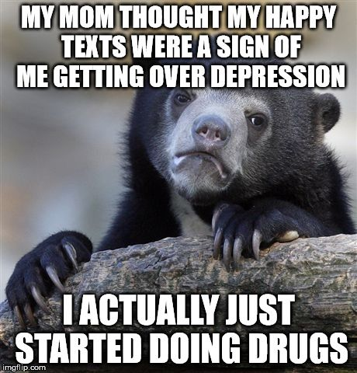
Translated (Devanagari):
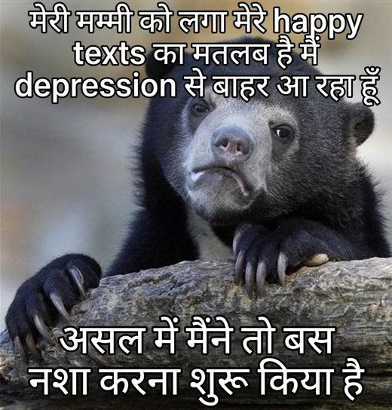
Original OCR: MY MOM THOUGHT MY HAPPY TEXTS WERE A SIGN OF ME GETTING OVER DEPRESSION I ACTUALLY JUST STARTED DOING DRUGS imgflip.com ...
English explanation (mistral_large3/eng):
This meme employs a widely recognized image macro format featuring a bear cub resting its head on a rock, its expression appearing contemplative or weary, which visually reinforces themes of vulnerability or emotional exhaustion. The superimposed text reads, "My mom thought my happy texts were a sign of me getting over depression. I actually just started doing drugs," using dark humor to juxtapose perceived recovery with self-destructive coping mechanisms. Emotionally, the meme conveys a sense of disconnection between outward appearances and internal struggle, highlighting the isolation and frustration of individuals whose efforts to signal improvement are misinterpreted by others. Clinically, the content aligns with elements of *feeling down* and *low self-esteem*, as it reflects a disconnect between surface-level behavior and deeper distress, though it does not explicitly evidence specific symptoms from the glossary beyond the implied reliance on maladaptive coping strategies.
Hindi explanation (gpt4o_mini/deva):
इस मीम में एक भालू की क्लोज-अप तस्वीर है, जिसके पंजे एक लकड़ी के तख्ते पर रखे हुए हैं। चित्र के ऊपर और नीचे दो टेक्स्ट हैं: "मेरी मम्मी को लगा मेरे happy texts वाकई हैं" और "असल में मैंने तो बस नशा करना शुरू किया है।" यह मीम एक गहरी उदासी और आत्म-हीनता की भावना को उजागर करता है। यहाँ "Feeling Down" और "Low Self-Esteem" जैसे लक्षण नज़र आते हैं, क्योंकि व्यक्ति अपनी भावनाओं को छुपाने के लिए झूठे संदेशों का सहारा ले रहा है, जबकि असल में वह नशा करने की ओर अग्रसर है, जो इस तनाव और दर्द को कम करने का एक तरीका हो सकता है।
CP predictions (0/30 hits):
gemini deva_expl_only: CP=0
gemini deva_img_deva_expl: CP=0
gpt4o_mini deva_expl_only: CP=0
gpt4o_mini deva_image_only: CP=0
gpt4o_mini deva_img_deva_expl: CP=0
gpt4o_mini deva_img_eng_expl: CP=0
gpt4o_mini eng_expl_only: CP=0
gpt4o_mini eng_image_only: CP=0
gpt4o_mini eng_img_eng_expl: CP=0
llama4 deva_expl_only: CP=0
llama4 deva_image_only: CP=0
llama4 deva_img_deva_expl: CP=0
llama4 deva_img_eng_expl: CP=0
llama4 eng_expl_only: CP=0
llama4 eng_image_only: CP=0
llama4 eng_img_eng_expl: CP=0
mistral_large3 deva_expl_only: CP=0
mistral_large3 deva_image_only: CP=0
mistral_large3 deva_img_deva_expl: CP=0
mistral_large3 deva_img_eng_expl: CP=0
mistral_large3 eng_expl_only: CP=0
mistral_large3 eng_image_only: CP=0
mistral_large3 eng_img_eng_expl: CP=0
mistral_small_2503 deva_expl_only: CP=0
mistral_small_2503 deva_image_only: CP=0
mistral_small_2503 deva_img_deva_expl: CP=0
mistral_small_2503 deva_img_eng_expl: CP=0
mistral_small_2503 eng_expl_only: CP=0
mistral_small_2503 eng_image_only: CP=0
mistral_small_2503 eng_img_eng_expl: CP=0
Analysis:
• English explanation substitutes Concentration Problem with a related symptom.
• Hindi explanation emphasizes a related symptom, not Concentration Problem.
• Image-only: 0/8 correct
• Explanation-only: 0/9 correct
• Image + explanation: 0/13 correct
• Gemini (Deva Expl Only): predicted Feeling Down
• Gemini (Deva Img Deva Expl): predicted Feeling Down
• GPT-4o-mini (Deva Expl Only): predicted Feeling Down, Low Self-Esteem
• GPT-4o-mini (Deva Image Only): predicted Feeling Down, Low Self-Esteem
• GPT-4o-mini (Deva Img Deva Expl): predicted Feeling Down, Low Self-Esteem
• GPT-4o-mini (Deva Img Eng Expl): predicted Feeling Down, Self-Harm, Low Self-Esteem
• GPT-4o-mini (Eng Expl Only): predicted Feeling Down, Self-Harm, Low Self-Esteem
• GPT-4o-mini (Eng Image Only): predicted no positive label
• Explanation pipeline failure: neither language surfaces the target symptom, so explanation-only and multimodal runs inherit the wrong clinical framing.
• Image-only failure: Concentration Problem is not visually or OCR-explicit in the Devanagari meme.
• Co-labeling with Feeling Down, Self-Harm: salient cues for the co-label may satisfy models before the subtler Concentration Problem dimension is tagged.
• Models often substitute Feeling Down (27/30 misses), which overlaps semantically with Concentration Problem in meme text or explanations.
• Models often substitute Low Self-Esteem (15/30 misses), which overlaps semantically with Concentration Problem in meme text or explanations.

Case B - Co-label with Feeling Down, partial confusion (CP, TE-390)
UNIVERSAL_HUMAN | Gold: Concentration Problem, Feeling Down
Original (English):
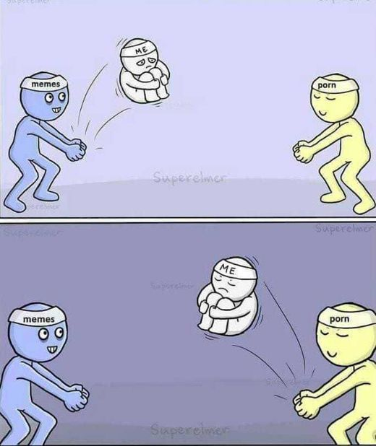
Translated (Devanagari):
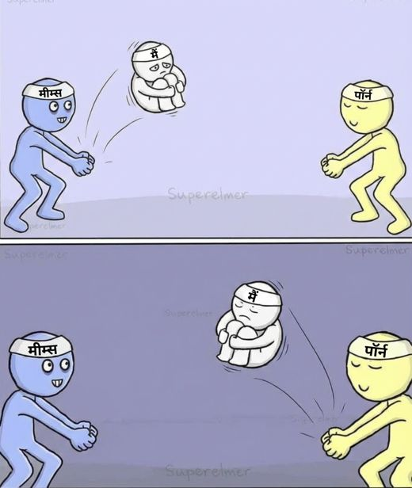
Original OCR: ME memes porn Superelmer Superelmer ME memes porn Supercinor ...
English explanation (mistral_large3/eng):
This meme employs a three-panel comic template labeled "Supercelmer," depicting a cyclical interaction between three anthropomorphic characters representing "memes," "me," and "porn." Visually, the "memes" character initiates engagement by offering content to the central figure labeled "me," who appears emotionally withdrawn, sitting with arms crossed and a despondent expression, while the "porn" character eagerly steps in to replace the interaction, only for the cycle to repeat with "me" ultimately returning to the "memes" character in a similarly distressed state. The underlying emotional tone conveys a sense of compulsive distraction, emotional numbness, and an inability to derive sustained satisfaction from any activity, oscillating between passive consumption and fleeting relief. Clinically, the imagery aligns most closely with *Lack of Interest* and *Concentration Problem*, as it illustrates anhedonia and a fragmented attention span driven by repetitive, unfulfilling behaviors rather than explicit self-harm or acute emotional distress.
Hindi explanation (gpt4o_mini/deva):
इस मीम में दो रंगीन पात्र दिखाई दे रहे हैं, एक नीला और एक पीला, जो एक छोटे सफेद पात्र को उछाल रहे हैं। नीले पात्र के सिर पर "मीत्स" और पीले पात्र के सिर पर "पॉर्न" लिखा है। ऊपरी भाग में, सफेद पात्र कूड़ता हुआ दिख रहा है, जबकि नीचे के भाग में वह उदास होकर अपने पैरों को थामे बैठा है। इस मीम में भावनात्मक संदर्भ की बात करें तो यह आत्म-सम्मान की कमी और निराशा का संकेत देता है, जो कि "अपने प्रति नकारात्मकता" और "उदासी" का प्रतिनिधित्व कर रहा है। यह प्रतीत होता है कि सफेद पात्र अपने अस्तित्व या स्थिति से असंतुष्ट है, जिससे कि "उदासी" और "आत्म-सम्मान की कमी" के लक्षण स्पष्ट होते हैं।
CP predictions (12/30 hits):
gemini deva_expl_only: CP=1
gemini deva_img_deva_expl: CP=1
gpt4o_mini deva_expl_only: CP=0
gpt4o_mini deva_image_only: CP=0
gpt4o_mini deva_img_deva_expl: CP=0
gpt4o_mini deva_img_eng_expl: CP=0
gpt4o_mini eng_expl_only: CP=0
gpt4o_mini eng_image_only: CP=0
gpt4o_mini eng_img_eng_expl: CP=0
llama4 deva_expl_only: CP=0
llama4 deva_image_only: CP=0
llama4 deva_img_deva_expl: CP=0
llama4 deva_img_eng_expl: CP=1
llama4 eng_expl_only: CP=1
llama4 eng_image_only: CP=0
llama4 eng_img_eng_expl: CP=1
mistral_large3 deva_expl_only: CP=0
mistral_large3 deva_image_only: CP=1
mistral_large3 deva_img_deva_expl: CP=0
mistral_large3 deva_img_eng_expl: CP=1
mistral_large3 eng_expl_only: CP=1
mistral_large3 eng_image_only: CP=0
mistral_large3 eng_img_eng_expl: CP=1
mistral_small_2503 deva_expl_only: CP=0
mistral_small_2503 deva_image_only: CP=0
mistral_small_2503 deva_img_deva_expl: CP=0
mistral_small_2503 deva_img_eng_expl: CP=1
mistral_small_2503 eng_expl_only: CP=1
mistral_small_2503 eng_image_only: CP=0
mistral_small_2503 eng_img_eng_expl: CP=1
Analysis:
• English explanation names Concentration Problem.
• Hindi explanation emphasizes a related symptom, not Concentration Problem.
• Image-only: 1/8 correct
• Explanation-only: 4/9 correct
• Image + explanation: 7/13 correct
• GPT-4o-mini (Deva Expl Only): predicted Feeling Down, Low Self-Esteem
• GPT-4o-mini (Deva Image Only): predicted Feeling Down, Low Self-Esteem
• GPT-4o-mini (Deva Img Deva Expl): predicted Feeling Down, Low Self-Esteem
• GPT-4o-mini (Deva Img Eng Expl): predicted Lack of Interest, Low Self-Esteem
• GPT-4o-mini (Eng Expl Only): predicted Lack of Interest, Low Self-Esteem
• GPT-4o-mini (Eng Image Only): predicted Feeling Down, Lack of Interest, Low Self-Esteem
• GPT-4o-mini (Eng Img Eng Expl): predicted Lack of Interest, Low Self-Esteem
• Llama-4 (Deva Expl Only): predicted Feeling Down
• Explanation-classifier gap: English text mentions Concentration Problem but many runs still output CP=0.
• Co-labeling with Feeling Down: salient cues for the co-label may satisfy models before the subtler Concentration Problem dimension is tagged.
• Models often substitute Feeling Down (13/18 misses), which overlaps semantically with Concentration Problem in meme text or explanations.
• Models often substitute Low Self-Esteem (13/18 misses), which overlaps semantically with Concentration Problem in meme text or explanations.

Case C - Models largely succeed (CP, TE-452)
UNIVERSAL_HUMAN | Gold: Concentration Problem
Original (English):
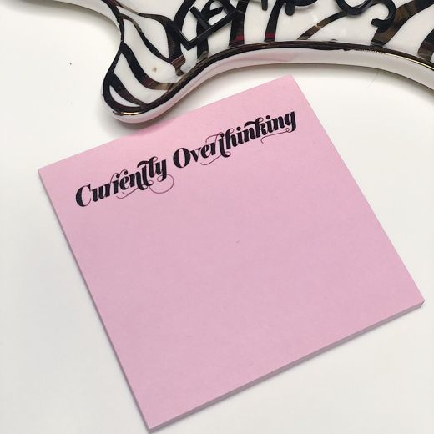
Translated (Devanagari):
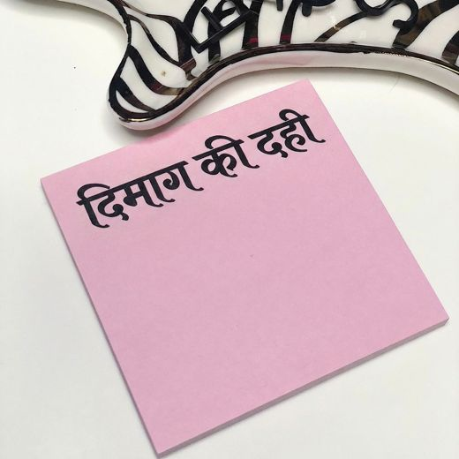
Original OCR: Curféntly Overthinking ...
English explanation (mistral_large3/eng):
This meme employs a widely recognized visual template featuring a decorative, cursive "2023" sign, often used in home décor to mark the new year, which here serves as a backdrop for a handwritten note on pink paper reading "Currently Overthinking." The juxtaposition of the cheerful, festive aesthetic with the introspective and slightly anxious text creates a contrast that underscores the internal tension between outward appearances and inner experience. Emotionally, the meme conveys a sense of rumination or mental preoccupation, capturing the relatable feeling of being trapped in one’s own thoughts, which may resonate with individuals experiencing stress or mild psychological distress. Clinically, while the content does not explicitly evidence symptoms from the Clinical Reference Glossary such as self-harm, low self-esteem, or eating disorders, it does subtly align with *Concentration Problem*, as overthinking can reflect difficulties in mental clarity or persistent, intrusive cognitive patterns that disrupt focus.
Hindi explanation (gpt4o_mini/deva):
यह चित्र एक गुलाबी नोट पेपर का है जिसमें काली लिखावट में "दिमाग की दही" लिखा हुआ है। इस अभिव्यक्ति में प्रतीकात्मकता है, जो मानसिक थकान या निराशा को दर्शाती है, जैसे कि कोई अपने विचारों की स्थिरता को खो चुका हो। सामाजिक संदर्भ में, यह वाक्यांश सामान्यतः तनाव और अवसाद के समय में इस्तेमाल होता है, जिससे यह संकेत मिलता है कि व्यक्ति भावनात्मक रूप से थका हुआ या हताश महसूस कर रहा है। इस अभिव्यक्ति को ध्यान में रखते हुए, यह "Feeling Down" और "Concentration Problem" जैसे लक्षणों की ओर इशारा करता है, क्योंकि यह मन की स्थिति को दर्शाते हुए चिंता और अक्षम्यता का संकेत देता है।
CP predictions (24/30 hits):
gemini deva_expl_only: CP=1
gemini deva_img_deva_expl: CP=1
gpt4o_mini deva_expl_only: CP=1
gpt4o_mini deva_image_only: CP=0
gpt4o_mini deva_img_deva_expl: CP=1
gpt4o_mini deva_img_eng_expl: CP=1
gpt4o_mini eng_expl_only: CP=1
gpt4o_mini eng_image_only: CP=0
gpt4o_mini eng_img_eng_expl: CP=1
llama4 deva_expl_only: CP=1
llama4 deva_image_only: CP=1
llama4 deva_img_deva_expl: CP=1
llama4 deva_img_eng_expl: CP=1
llama4 eng_expl_only: CP=1
llama4 eng_image_only: CP=1
llama4 eng_img_eng_expl: CP=1
mistral_large3 deva_expl_only: CP=0
mistral_large3 deva_image_only: CP=0
mistral_large3 deva_img_deva_expl: CP=0
mistral_large3 deva_img_eng_expl: CP=1
mistral_large3 eng_expl_only: CP=1
mistral_large3 eng_image_only: CP=1
mistral_large3 eng_img_eng_expl: CP=1
mistral_small_2503 deva_expl_only: CP=1
mistral_small_2503 deva_image_only: CP=0
mistral_small_2503 deva_img_deva_expl: CP=1
mistral_small_2503 deva_img_eng_expl: CP=1
mistral_small_2503 eng_expl_only: CP=1
mistral_small_2503 eng_image_only: CP=1
mistral_small_2503 eng_img_eng_expl: CP=1
Analysis:
• English explanation names Concentration Problem.
• Hindi explanation names Concentration Problem.
• Image-only: 4/8 correct
• Explanation-only: 8/9 correct
• Image + explanation: 12/13 correct
• GPT-4o-mini (Deva Image Only): predicted no positive label
• GPT-4o-mini (Eng Image Only): predicted no positive label
• Mistral-L3 (Deva Expl Only): predicted Feeling Down, Lack of Interest
• Mistral-L3 (Deva Image Only): predicted no positive label
• Mistral-L3 (Deva Img Deva Expl): predicted Feeling Down, Lack of Interest
• Mistral-S (Deva Image Only): predicted Feeling Down
• Gold is CP-only with no co-labels, so models cannot borrow cues from adjacent symptoms.
• Hindi explanation names Concentration Problem but some Devanagari runs still miss, possibly due to transliterated-label noise or co-occurring symptom confusion.
• Models often substitute Feeling Down (3/6 misses), which overlaps semantically with Concentration Problem in meme text or explanations.
• Models often substitute Lack of Interest (2/6 misses), which overlaps semantically with Concentration Problem in meme text or explanations.
• Most runs succeed when explanations or images make Concentration Problem explicit; remaining misses cluster on image-only or substitute-symptom inputs.

Recommendations
• Differentiate rumination/overthinking (CP) from sadness (Feeling Down) and fatigue (Sleeping Disorder) in prompts.
• Memes about procrastination or brain fog often map to CP only when text mentions focus or mental overload.
• Multimodal runs benefit when explanation names unproductive fixation explicitly.

7. Sleeping Disorder (SD)

Per-condition F1
Condition | GPT-4o-mini | Mistral-L3 | Mistral-S | Llama-4 | Gemini
Deva Img-Only | 0.7633 | 0.7478 | 0.7595 | 0.8019 | -
Eng Img-Only | 0.8073 | 0.8087 | 0.7982 | 0.8186 | -
Deva Expl-Only | 0.8168 | 0.7295 | 0.8213 | 0.8259 | 0.7879
Eng Expl-Only | 0.8473 | 0.7965 | 0.8365 | 0.8696 | -
Deva Img+Deva Expl | 0.8223 | 0.7243 | 0.8286 | 0.8155 | 0.7879
Eng Img+Eng Expl | 0.8515 | 0.8034 | 0.8093 | 0.8654 | -
Deva Img+Eng Expl | 0.8416 | 0.8103 | 0.8286 | 0.8599 | -
Sleeping Disorder achieves relatively strong F1 when insomnia or exhaustion is explicit in text. Failures occur on memes where tiredness is comedic or co-labeled with LOI/FD.

Explanation coverage (96 gold SD memes)
English explicit: 92/96 | English substitute: 3/96 | Hindi explicit: 73/96 | Both miss/substitute: 3/96

Case studies

Case A - Persistent miss, explanations miss (SD, TE-104)
BRAND_DEPENDENT | Gold: Sleeping Disorder, Feeling Down
Original (English):
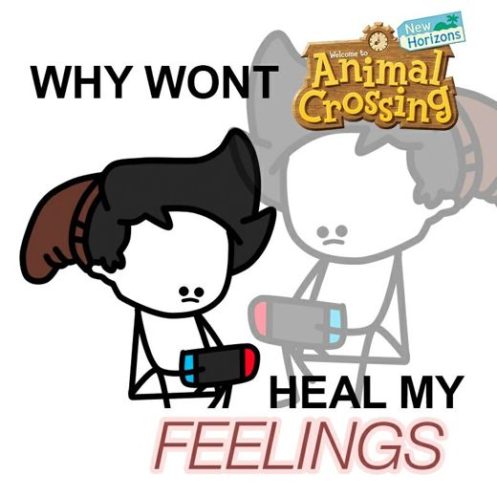
Translated (Devanagari):
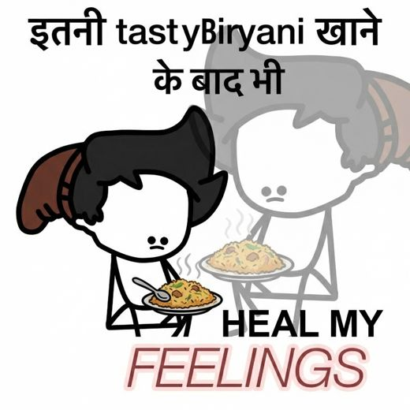
Original OCR: New Horizons WHY WONT Animal Crossing Welcome to HEAL MY FEELINGS ...
English explanation (mistral_large3/eng):
This meme employs a visual template from the video game *Animal Crossing: New Horizons*, featuring two anthropomorphic animal characters, one resembling a horse with a dejected expression and the other a white, blank-faced villager, both holding Nintendo Switch controllers while appearing emotionally distressed. The superimposed text reads, "Why won’t Animal Crossing heal my feelings," framed as a rhetorical plea that humorously underscores a disconnect between the expectation of emotional relief through gaming and the persistence of underlying distress. The emotional tone conveys a sense of disappointment and resignation, reflecting a reliance on escapism or hobbies as a coping mechanism that ultimately fails to address deeper emotional pain. Clinically, the meme aligns most closely with *Lack of Interest* (anhedonia) and *Feeling Down*, as it illustrates the inability to derive lasting comfort from activities once enjoyed, alongside an implicit acknowledgment of unmet emotional needs, though it does not explicitly evidence other symptoms from the glossary.
Hindi explanation (gpt4o_mini/deva):
इस मेमे में एक सरल चित्र है जिसमें एक व्यक्ति बिरयानी का थाल लिए बैठा है, जबकि उसके चेहरे पर उदासी और निराशा का भाव है। ऊपर लिखा है "इतनी tasty Biryani खाने के बाद भी" और नीचे "HEAL MY FEELINGS" लिखा है, जो खाने का आनंद उठाने की जगह एक गहरे भावनात्मक स्थान को दर्शाता है। इस चित्र के माध्यम से व्यक्त की गई भावनाएं दुःख और भावनात्मक पीड़ा की संकेत करती हैं, जो कि फीलिंग डाउन के लक्षणों के अंतर्गत आती हैं। यह मेमे खाने का उपयोग भावनाओं को दूर करने के प्रयास के रूप में दिखाता है, जो कि भावनात्मक स्थिति का संकेत है कि व्यक्ति आनंद नहीं ले पा रहा है, जो कि अपनी भावनाओं से बचने का संकेत हो सकता है।
SD predictions (0/30 hits):
gemini deva_expl_only: SD=0
gemini deva_img_deva_expl: SD=0
gpt4o_mini deva_expl_only: SD=0
gpt4o_mini deva_image_only: SD=0
gpt4o_mini deva_img_deva_expl: SD=0
gpt4o_mini deva_img_eng_expl: SD=0
gpt4o_mini eng_expl_only: SD=0
gpt4o_mini eng_image_only: SD=0
gpt4o_mini eng_img_eng_expl: SD=0
llama4 deva_expl_only: SD=0
llama4 deva_image_only: SD=0
llama4 deva_img_deva_expl: SD=0
llama4 deva_img_eng_expl: SD=0
llama4 eng_expl_only: SD=0
llama4 eng_image_only: SD=0
llama4 eng_img_eng_expl: SD=0
mistral_large3 deva_expl_only: SD=0
mistral_large3 deva_image_only: SD=0
mistral_large3 deva_img_deva_expl: SD=0
mistral_large3 deva_img_eng_expl: SD=0
mistral_large3 eng_expl_only: SD=0
mistral_large3 eng_image_only: SD=0
mistral_large3 eng_img_eng_expl: SD=0
mistral_small_2503 deva_expl_only: SD=0
mistral_small_2503 deva_image_only: SD=0
mistral_small_2503 deva_img_deva_expl: SD=0
mistral_small_2503 deva_img_eng_expl: SD=0
mistral_small_2503 eng_expl_only: SD=0
mistral_small_2503 eng_image_only: SD=0
mistral_small_2503 eng_img_eng_expl: SD=0
Analysis:
• English explanation substitutes Sleeping Disorder with a related symptom.
• Hindi explanation emphasizes a related symptom, not Sleeping Disorder.
• Image-only: 0/8 correct
• Explanation-only: 0/9 correct
• Image + explanation: 0/13 correct
• Gemini (Deva Expl Only): predicted Feeling Down, Lack of Interest
• Gemini (Deva Img Deva Expl): predicted Feeling Down, Lack of Interest
• GPT-4o-mini (Deva Expl Only): predicted Feeling Down, Lack of Interest, Eating Disorder, Low Self-Esteem
• GPT-4o-mini (Deva Image Only): predicted Feeling Down, Lack of Interest
• GPT-4o-mini (Deva Img Deva Expl): predicted Feeling Down, Lack of Interest
• GPT-4o-mini (Deva Img Eng Expl): predicted Feeling Down, Lack of Interest
• GPT-4o-mini (Eng Expl Only): predicted Feeling Down, Lack of Interest
• GPT-4o-mini (Eng Image Only): predicted Feeling Down, Lack of Interest, Low Self-Esteem, Concentration Problem
• Explanation pipeline failure: neither language surfaces the target symptom, so explanation-only and multimodal runs inherit the wrong clinical framing.
• Image-only failure: Sleeping Disorder is not visually or OCR-explicit in the Devanagari meme.
• Co-labeling with Feeling Down: salient cues for the co-label may satisfy models before the subtler Sleeping Disorder dimension is tagged.
• Models often substitute Feeling Down (30/30 misses), which overlaps semantically with Sleeping Disorder in meme text or explanations.
• Models often substitute Lack of Interest (23/30 misses), which overlaps semantically with Sleeping Disorder in meme text or explanations.

Case B - Co-label with Feeling Down, partial confusion (SD, TE-474)
UNIVERSAL_HUMAN | Gold: Sleeping Disorder, Feeling Down
Original (English):
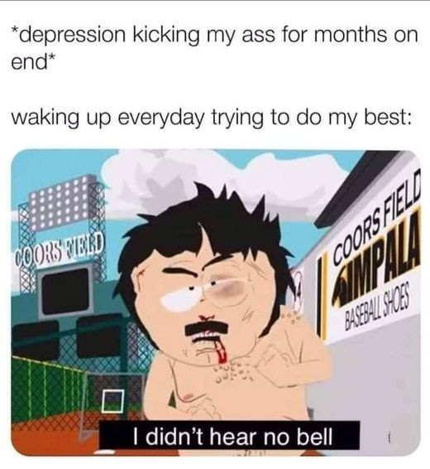
Translated (Devanagari):
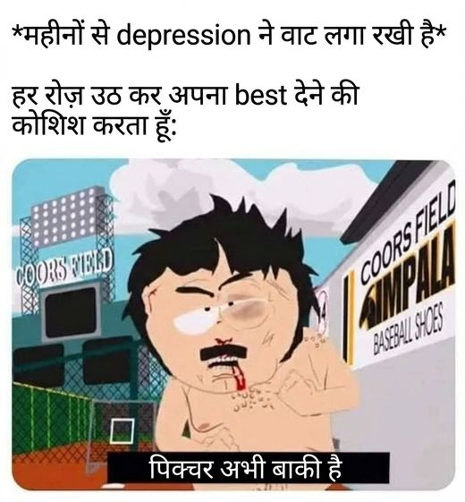
Original OCR: *depression kicking my ass for months on end* waking up everyday trying to do my best: COORS FIERD SIMPALA BASBAL SHCS COORS FIELLD I didn't hear no bell ...
English explanation (mistral_large3/eng):
This meme employs the "I didn’t hear no bell" template, featuring a distressed anime-style character with exaggerated facial expressions, bloodshot eyes, tears, and a visible wound, set against the backdrop of Coors Field, a baseball stadium, with additional text referencing baseball shoes. The accompanying caption expresses prolonged emotional exhaustion, describing depression as an unrelenting struggle despite daily efforts to persevere, which visually and textually underscores a sense of defeat and persistent emotional pain. Emotionally, the meme conveys a raw, weary frustration and helplessness, reflecting the internal conflict of battling mental health challenges while attempting to maintain normalcy. Clinically, the content aligns with several symptoms from the glossary, including *Feeling Down*, evidenced by explicit expressions of sadness and despair, *Lack of Interest* through the implication of diminished engagement in once-familiar settings like a stadium, and *Low Self-Esteem* in the self-deprecating tone of being overpowered by depression.
Hindi explanation (gpt4o_mini/deva):
इस मेमे में एक कार्टून पात्र एक बेसबॉल स्टेडियम के सामने खड़ा है, जिसमें उसका चेहरा धुंधला किया गया है। उपर का टेक्स्ट कहता है, "*महिनों से depression ने वाट लगा रखी है*" और नीचे लिखा है, "हर रोज़ उठ कर अपना best देने की कोशिश करता हूँ: पिक्चर अभी बाकी है।" दृश्य में पात्र का निराश, थका हुआ लुक दिखता है, जो उसके भावनात्मक संघर्ष को प्रदर्शित करता है। यह मेमे अवसाद (depression) की स्थिति को दर्शाता है, जिसमें व्यक्ति बार-बार अपने बेहतरीन प्रयासों के बावजूद मानसिक तकलीफ का सामना कर रहा है, जो कि "फ़ीलिंग डाउन" और "लैक ऑफ़ इंटरेस्ट" जैसे लक्षणों का संकेत है।
SD predictions (2/30 hits):
gemini deva_expl_only: SD=0
gemini deva_img_deva_expl: SD=0
gpt4o_mini deva_expl_only: SD=0
gpt4o_mini deva_image_only: SD=0
gpt4o_mini deva_img_deva_expl: SD=0
gpt4o_mini deva_img_eng_expl: SD=0
gpt4o_mini eng_expl_only: SD=0
gpt4o_mini eng_image_only: SD=0
gpt4o_mini eng_img_eng_expl: SD=0
llama4 deva_expl_only: SD=0
llama4 deva_image_only: SD=0
llama4 deva_img_deva_expl: SD=0
llama4 deva_img_eng_expl: SD=0
llama4 eng_expl_only: SD=0
llama4 eng_image_only: SD=0
llama4 eng_img_eng_expl: SD=0
mistral_large3 deva_expl_only: SD=1
mistral_large3 deva_image_only: SD=0
mistral_large3 deva_img_deva_expl: SD=1
mistral_large3 deva_img_eng_expl: SD=0
mistral_large3 eng_expl_only: SD=0
mistral_large3 eng_image_only: SD=0
mistral_large3 eng_img_eng_expl: SD=0
mistral_small_2503 deva_expl_only: SD=0
mistral_small_2503 deva_image_only: SD=0
mistral_small_2503 deva_img_deva_expl: SD=0
mistral_small_2503 deva_img_eng_expl: SD=0
mistral_small_2503 eng_expl_only: SD=0
mistral_small_2503 eng_image_only: SD=0
mistral_small_2503 eng_img_eng_expl: SD=0
Analysis:
• English explanation names Sleeping Disorder.
• Hindi explanation emphasizes a related symptom, not Sleeping Disorder.
• Image-only: 0/8 correct
• Explanation-only: 1/9 correct
• Image + explanation: 1/13 correct
• Gemini (Deva Expl Only): predicted Feeling Down
• Gemini (Deva Img Deva Expl): predicted Feeling Down
• GPT-4o-mini (Deva Expl Only): predicted Feeling Down, Lack of Interest
• GPT-4o-mini (Deva Image Only): predicted Feeling Down, Lack of Interest, Low Self-Esteem
• GPT-4o-mini (Deva Img Deva Expl): predicted Feeling Down, Lack of Interest, Low Self-Esteem
• GPT-4o-mini (Deva Img Eng Expl): predicted Feeling Down, Self-Harm, Low Self-Esteem
• GPT-4o-mini (Eng Expl Only): predicted Feeling Down, Self-Harm
• GPT-4o-mini (Eng Image Only): predicted Feeling Down, Low Self-Esteem
• Explanation-classifier gap: English text mentions Sleeping Disorder but many runs still output SD=0.
• Image-only failure: Sleeping Disorder is not visually or OCR-explicit in the Devanagari meme.
• Co-labeling with Feeling Down: salient cues for the co-label may satisfy models before the subtler Sleeping Disorder dimension is tagged.
• Models often substitute Feeling Down (28/28 misses), which overlaps semantically with Sleeping Disorder in meme text or explanations.
• Models often substitute Low Self-Esteem (14/28 misses), which overlaps semantically with Sleeping Disorder in meme text or explanations.

Case C - Models largely succeed (SD, TE-610)
UNIVERSAL_HUMAN | Gold: Sleeping Disorder
Original (English):
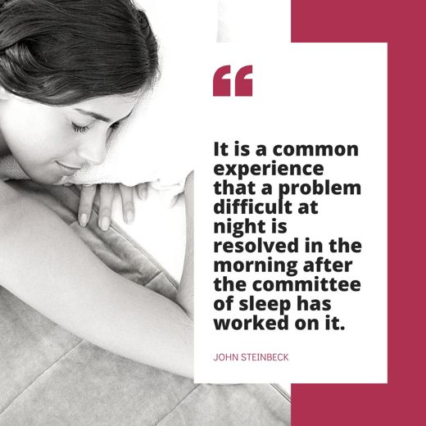
Translated (Devanagari):
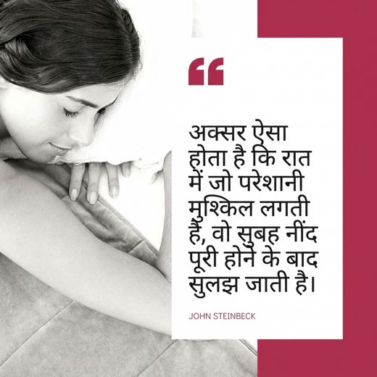
Original OCR: It is a common experience that a problem difficult at night is resolved in the morning after the committee of sleep has worked on it. JOHN STEINBECK ...
English explanation (mistral_large3/eng):
This meme features a black-and-white photograph of a person lying in bed with their hands clasped near their face, appearing deep in thought or distressed, which aligns with a widely recognized template often used to humorously depict overthinking or existential dread. The accompanying text, attributed to John Steinbeck, reads: *"It is a common experience that a problem difficult at night is resolved in the morning after the committee of sleep has worked on it,"* framing the act of sleeping as a coping mechanism for unresolved stress or anxiety. Visually and thematically, the meme conveys a sense of temporary relief or avoidance, suggesting an underlying emotional state of fatigue, mental preoccupation, or the struggle to disengage from intrusive thoughts. While the content does not explicitly evidence clinical symptoms from the provided glossary, it subtly reflects themes associated with *Concentration Problems* and *Sleeping Disorder*, as it highlights the challenge of quieting one’s mind and the reliance on sleep as a means of emotional regulation.
Hindi explanation (gpt4o_mini/deva):
इस मेम में एक महिला की तस्वीर है, जिसके चेहरे का एक हिस्सा धुंधला किया गया है और वह एक बिस्तर पर लेटी हुई है। इसके बगल में एक उद्धरण है, जिसमें कहा गया है, "अक्सर ऐसा होता है कि रात में जो परेशानियां मुश्किल लगती हैं, वो सुबह नींद पूरी होने के बाद सुलझ जाती है।" इस उद्धरण को जॉन स्टीनबैक के नाम से श्रेय दिया गया है। भावनात्मक रूप से, यह मेम तनाव और चिंता के भाव को दर्शाता है, जिससे लोग रात के समय अधिक परेशान होते हैं, लेकिन सुबह की रोशनी में समस्याओं का समाधान निकलता है। नैदानिक संदर्भ में, यह नींद के विकारों और भावनात्मक दर्द की प्रतिक्रिया को दर्शाता है, विशेषकर रात के समय मानसिक स्वास्थ्य से संबंधित समस्याओं का सामना करना।
SD predictions (24/30 hits):
gemini deva_expl_only: SD=0
gemini deva_img_deva_expl: SD=0
gpt4o_mini deva_expl_only: SD=1
gpt4o_mini deva_image_only: SD=1
gpt4o_mini deva_img_deva_expl: SD=1
gpt4o_mini deva_img_eng_expl: SD=1
gpt4o_mini eng_expl_only: SD=1
gpt4o_mini eng_image_only: SD=0
gpt4o_mini eng_img_eng_expl: SD=1
llama4 deva_expl_only: SD=1
llama4 deva_image_only: SD=1
llama4 deva_img_deva_expl: SD=1
llama4 deva_img_eng_expl: SD=0
llama4 eng_expl_only: SD=1
llama4 eng_image_only: SD=0
llama4 eng_img_eng_expl: SD=1
mistral_large3 deva_expl_only: SD=1
mistral_large3 deva_image_only: SD=1
mistral_large3 deva_img_deva_expl: SD=1
mistral_large3 deva_img_eng_expl: SD=1
mistral_large3 eng_expl_only: SD=1
mistral_large3 eng_image_only: SD=1
mistral_large3 eng_img_eng_expl: SD=1
mistral_small_2503 deva_expl_only: SD=1
mistral_small_2503 deva_image_only: SD=1
mistral_small_2503 deva_img_deva_expl: SD=1
mistral_small_2503 deva_img_eng_expl: SD=1
mistral_small_2503 eng_expl_only: SD=1
mistral_small_2503 eng_image_only: SD=0
mistral_small_2503 eng_img_eng_expl: SD=1
Analysis:
• English explanation names Sleeping Disorder.
• Hindi explanation names Sleeping Disorder.
• Image-only: 5/8 correct
• Explanation-only: 8/9 correct
• Image + explanation: 11/13 correct
• Gemini (Deva Expl Only): predicted no positive label
• Gemini (Deva Img Deva Expl): predicted no positive label
• GPT-4o-mini (Eng Image Only): predicted no positive label
• Llama-4 (Deva Img Eng Expl): predicted Concentration Problem
• Llama-4 (Eng Image Only): predicted Concentration Problem
• Mistral-S (Eng Image Only): predicted Concentration Problem
• Gold is SD-only with no co-labels, so models cannot borrow cues from adjacent symptoms.
• Hindi explanation names Sleeping Disorder but some Devanagari runs still miss, possibly due to transliterated-label noise or co-occurring symptom confusion.
• Models often substitute Concentration Problem (3/6 misses), which overlaps semantically with Sleeping Disorder in meme text or explanations.
• Most runs succeed when explanations or images make Sleeping Disorder explicit; remaining misses cluster on image-only or substitute-symptom inputs.

Recommendations
• Distinguish tiredness/zoom-meme humor from clinical sleep disturbance in explanation prompts.
• Insomnia wording in Devanagari OCR is a strong signal; image-only runs miss when fatigue is implied visually only.
• Avoid mapping all low-energy memes to Sleeping Disorder when gold is LOI or Feeling Down.

