Devanagari Hindi Meme Classification — Comprehensive Results Report
Multilabel PHQ-9 Depression Symptom Identification | Zero-Shot Evaluation
Test Set: n=650 (n=581 locked subset for explanation conditions) | Models: Gemini-3.1-pro-preview, GPT-4o-mini, Llama4, Mistral-Large-3, Mistral-Small-2503

1. Executive Summary
This report presents a comprehensive evaluation of five models — Gemini-3.1-pro-preview, GPT-4o-mini, Llama4-Maverick, Mistral-Large-3, and Mistral-Small-2503 — on the task of fine-grained depression symptom identification from translated Devanagari Hindi memes. The task is framed as zero-shot multilabel binary classification over seven PHQ-9 symptom categories. All evaluation is performed on the translated Devanagari adaptation of RESTOREx, with the test set comprising 650 memes and a locked subset of 581 samples used for all explanation-dependent conditions.
The evaluation also includes unimodal baselines: nine text models (zero-shot and fine-tuned on EasyOCR-extracted Devanagari text), three vision models (frozen baseline and fine-tuned), and seven open-source vision-language models. Gemini is evaluated separately as the primary proprietary baseline with results on the validation set (n=298); test set results for Gemini are pending and will be appended when complete.

Key Findings
English input consistently outperforms Devanagari input across all models. The average macro-F1 gap between English image-only and Devanagari image-only is approximately 0.05–0.10 points across the four Foundry models, confirming limited visual grounding for non-Latin scripts in current frontier models.
English explanations generated by Gemini (Prompt A) are the most powerful single input across all four Foundry models, consistently achieving the highest or near-highest macro-F1 across conditions. The cross-modal condition — Devanagari image paired with Gemini English explanation — nearly matches the all-English condition for all models.
Gemini-3.1-pro-preview dramatically outperforms all other models (0.6776 macro-F1 image-only vs. best Foundry model 0.6375), demonstrating the advantage of a native multimodal frontier model. Vocabulary mismatch is the dominant failure mode for English-only text models: BART, MentalBERT, MentalRoBERTa, and MuRIL produce near-random or degenerate outputs on Devanagari OCR text. Only IndicBERTv2 variants and mBERT learn meaningful signal.
Three of seven PHQ-9 symptom labels — Lack of Interest, Concentration Problem, and Sleeping Disorder — have zero positive training examples in the translated training set, creating a structural ceiling on all fine-tuning experiments.

2. Overall Comparison
Figure 1 presents macro-F1 across all four Foundry models and seven experimental conditions, providing a visual overview of the full results landscape.

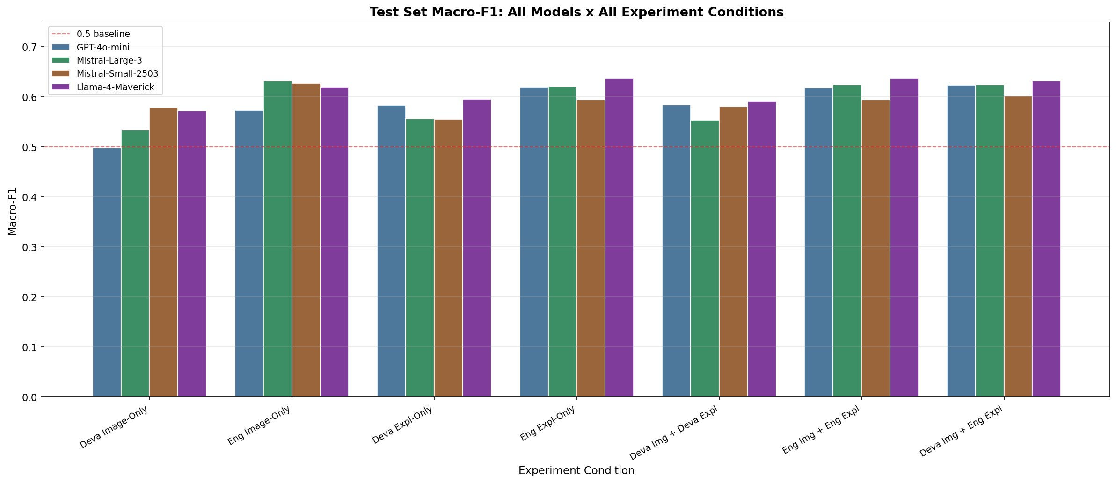
Figure 1: Test Set Macro-F1 — All Models × All Experiment Conditions. Dashed red line = 0.5 baseline.

3. Complete Results — All Models and Conditions
Table 1 presents macro-F1, weighted-F1, precision, and recall for all model-experiment combinations. Green-highlighted rows are Gemini results. The "Eng Img + Gemini Expl" condition for Foundry models uses validation set results; test set results are marked with — pending Gemini test set completion.

Experiment | n | Macro-F1 | W-F1 | Prec. | Recall
GPT-4o-mini — Deva Image-Only | 649 | 0.4981 | 0.5128 | 0.5646 | 0.4851
GPT-4o-mini — Eng Image-Only | 648 | 0.5726 | 0.5841 | 0.5843 | 0.5974
GPT-4o-mini — Deva Expl-Only (self) | 650 | 0.5832 | 0.5888 | 0.5516 | 0.6841
GPT-4o-mini — Eng Expl-Only (Gemini) | 649 | 0.619 | 0.6194 | 0.575 | 0.7153
GPT-4o-mini — Deva Img + Deva Expl | 649 | 0.584 | 0.5941 | 0.5574 | 0.6874
GPT-4o-mini — Deva Img + Eng Expl | 644 | 0.6232 | 0.6239 | 0.5791 | 0.7244
GPT-4o-mini — Eng Img + Eng Expl (self) | 643 | 0.6182 | 0.6187 | 0.5715 | 0.7166
GPT-4o-mini — Eng Img + Gemini Expl | — | — | — | — | —
Mistral-Large-3 — Deva Image-Only | 650 | 0.5334 | 0.5543 | 0.4833 | 0.6618
Mistral-Large-3 — Eng Image-Only | 649 | 0.632 | 0.6345 | 0.5731 | 0.7492
Mistral-Large-3 — Deva Expl-Only (self) | 650 | 0.556 | 0.5728 | 0.5419 | 0.6843
Mistral-Large-3 — Eng Expl-Only (Gemini) | 649 | 0.6211 | 0.6267 | 0.5858 | 0.7305
Mistral-Large-3 — Deva Img + Deva Expl | 649 | 0.5534 | 0.5699 | 0.5382 | 0.6838
Mistral-Large-3 — Deva Img + Eng Expl | 648 | 0.6245 | 0.6287 | 0.5769 | 0.7564
Mistral-Large-3 — Eng Img + Eng Expl (self) | 649 | 0.6242 | 0.6289 | 0.5828 | 0.7425
Mistral-Large-3 — Eng Img + Gemini Expl | — | — | — | — | —
Mistral-Small-2503 — Deva Image-Only | 650 | 0.5786 | 0.5906 | 0.57 | 0.605
Mistral-Small-2503 — Eng Image-Only | 650 | 0.6276 | 0.6308 | 0.614 | 0.6563
Mistral-Small-2503 — Deva Expl-Only (self) | 649 | 0.5553 | 0.5721 | 0.5471 | 0.6443
Mistral-Small-2503 — Eng Expl-Only (Gemini) | 646 | 0.5941 | 0.5989 | 0.5752 | 0.6948
Mistral-Small-2503 — Deva Img + Deva Expl | 649 | 0.5805 | 0.59 | 0.5511 | 0.6948
Mistral-Small-2503 — Deva Img + Eng Expl | 646 | 0.6022 | 0.6066 | 0.5675 | 0.7326
Mistral-Small-2503 — Eng Img + Eng Expl (self) | 646 | 0.5941 | 0.5986 | 0.5598 | 0.7171
Mistral-Small-2503 — Eng Img + Gemini Expl | — | — | — | — | —
Llama4 — Deva Image-Only | 650 | 0.5725 | 0.5858 | 0.5747 | 0.626
Llama4 — Eng Image-Only | 643 | 0.6188 | 0.6182 | 0.5963 | 0.6764
Llama4 — Deva Expl-Only (self) | 643 | 0.5954 | 0.6131 | 0.5824 | 0.6696
Llama4 — Eng Expl-Only (Gemini) | 638 | 0.6375 | 0.6381 | 0.5982 | 0.7497
Llama4 — Deva Img + Deva Expl | 649 | 0.5905 | 0.6081 | 0.572 | 0.6672
Llama4 — Deva Img + Eng Expl | 642 | 0.6318 | 0.6301 | 0.5903 | 0.745
Llama4 — Eng Img + Eng Expl (self) | 643 | 0.6375 | 0.6356 | 0.5943 | 0.7478
Llama4 — Eng Img + Gemini Expl | — | — | — | — | —
Gemini-3.1-pro — Deva Image-Only (n=650) | 650 | 0.6776 | 0.6749 | 0.6898 | 0.6793
Gemini-3.1-pro — Deva Image-Only (n=581) | 581 | 0.6862 | 0.6816 | 0.7152 | 0.674
Gemini-3.1-pro — Eng Expl-Only | 581 | 0.6022 | 0.6096 | 0.6251 | 0.6184
Gemini-3.1-pro — Deva Img + Eng Expl | 581 | 0.6588 | 0.6574 | 0.6324 | 0.7112
Gemini-3.1-pro — [TEST SET PENDING] | — | — | — | — | —
ZS = Zero-shot. FT = Fine-tuned. "Deva" = Devanagari Hindi translated image/explanation. "Eng" = Original English image/Gemini English explanation. "Self" = model generates its own explanation from the image. Green rows = Gemini. — = pending test set completion.

4. Foundry Model Analysis

4.1 Devanagari Image-Only
The most challenging condition: models receive only the translated Devanagari meme image with no textual explanation. Results range from 0.4981 (GPT-4o-mini) to 0.5786 (Mistral-Small-2503). Mistral-Small-2503 performs best despite being the smallest model, suggesting its vision encoder has stronger coverage of non-Latin text. GPT-4o-mini performs worst, likely reflecting more aggressive content filtering on mental health content. The consistent underperformance across all models confirms that direct Devanagari script comprehension from images remains a significant challenge.

4.2 English Image-Only
Switching from Devanagari to original English images produces consistent and substantial improvements. Mistral-Large-3 leads at 0.6320, followed by Mistral-Small-2503 (0.6276) and Llama4 (0.6188). GPT-4o-mini shows the largest absolute gain (+0.0745 macro-F1), confirming strong English visual grounding but poor Devanagari processing. This parallel comparison provides clean empirical evidence for the script-based performance gap.

4.3 Devanagari Explanation-Only (Self-Generated)
Models generate their own natural language explanation from the Devanagari image using Prompt A, then classify based on that explanation alone. Llama4 performs best (0.5954), followed by GPT-4o-mini (0.5832). All models outperform their Devanagari image-only scores, confirming that the explanation generation step extracts useful signal. However, all scores remain below their English explanation-only counterparts, indicating models are less fluent describing Hindi visual content than English.

4.4 English Explanation-Only (Gemini-Generated)
Providing Gemini-generated English explanations as the sole input yields the highest text-only scores. Llama4 achieves the top score (0.6375), followed by GPT-4o-mini (0.6190) and Mistral-Large-3 (0.6211). Consistent improvement over self-generated Devanagari explanations (average +0.04 macro-F1) confirms that explanation quality — driven by the generating model's language capability — is a major determinant of downstream classification performance.

4.5 Devanagari Image + Devanagari Explanation
Adding the Devanagari image to the self-generated Devanagari explanation provides only marginal benefit over explanation-only. Scores cluster between 0.5534 (Mistral-Large-3) and 0.5905 (Llama4). In most cases the image adds noise rather than complementary information, consistent with validation set findings. When both modalities are in a language the model handles poorly, combining them does not compensate for individual weaknesses.

4.6 Devanagari Image + English Explanation (Cross-Modal)
The cross-modal condition — Devanagari images with Gemini-generated English explanations — is the most practically relevant configuration. Scores range from 0.6022 (Mistral-Small-2503) to 0.6318 (Llama4). English explanations recover approximately 85% of the Deva-Eng gap, demonstrating that Gemini can serve as a preprocessing explanation generator enabling weaker models to classify effectively without processing Devanagari directly.

4.7 English Image + English Explanation (Self-Generated)
The best-resourced condition: original English images with model-generated English explanations. Llama4 and GPT-4o-mini both achieve 0.6375; Mistral-Large-3 follows at 0.6242. Marginal gains over English image-only (0.005–0.015 macro-F1) suggest that for English content, the image carries sufficient signal and self-generated explanations provide limited additional benefit.

5. Script Gap Analysis: English vs. Devanagari
Table 2 quantifies the macro-F1 gap attributable to Devanagari script across all comparable conditions and models.

Condition | GPT-4o-mini | Mistral-L3 | Mistral-S2503 | Llama-4 | Avg Gap
Img-Only (Eng − Deva) | +0.0745 | +0.0986 | +0.0490 | +0.0463 | +0.0671
Expl-Only (Eng − Deva) | +0.0358 | +0.0651 | +0.0388 | +0.0421 | +0.0455
Img+Expl (Eng − Deva) | +0.0342 | +0.0708 | +0.0136 | +0.0470 | +0.0414
All values = macro-F1 (English − Devanagari). All gaps are positive, confirming consistent English advantage across every model and condition.

The image-only gap is largest (average +0.0671), where models must read Devanagari text embedded directly in images. The gap narrows in explanation-based conditions (+0.0455 for explanation-only, +0.0414 for image+explanation), as English explanation text partially compensates for visual limitations. GPT-4o-mini shows the largest image-only gap (+0.0745) while Mistral-Small-2503 shows the smallest (+0.0490), reflecting differences in multilingual visual pretraining across model families.

6. Per-Model Analysis

6.1 GPT-4o-mini
GPT-4o-mini shows the largest Deva-English gap (+0.0745 image-only), indicating its vision encoder has the most limited Devanagari coverage among the four. It performs competitively in English conditions, achieving joint-top score (0.6375, tied with Llama4) in English explanation-only and English image+explanation. It has the highest rate of Azure content filter rejections (2–8 per experiment), a systematic limitation for mental health datasets. Strong text and English-image classifier; weaker Devanagari visual classifier.

6.2 Mistral-Large-3
The most balanced model: highest English image-only score (0.6320) and competitive across all conditions. Recall is consistently high (0.65–0.76), indicating a tendency to over-predict — clinically appropriate for a screening tool where false negatives are more costly. Near-zero content filter failures and few JSON truncation issues make it the most reliable for run stability. Shows the largest Deva-English image gap (+0.0986), suggesting the most language-sensitive vision encoder.

6.3 Mistral-Small-2503
The most surprising result: despite being smallest, it achieves the highest Devanagari image-only score (0.5786), outperforming all three larger models. Its vision encoder appears to have stronger non-Latin coverage. Strong English conditions (0.6276 Eng image-only, approaching Mistral-Large-3). Main weakness: underperforms in self-generated explanation conditions. Had the most generation failures from content filtering (4–6 per run). Best efficiency-performance tradeoff for image-heavy conditions.

6.4 Llama4-Maverick
Highest overall macro-F1 in four of seven test set conditions. Its English explanation-only (0.6375) and English image+explanation (0.6375) are the top single scores. Most balanced multimodal capability across both image and text conditions. Higher JSON truncation rate (7–12 failures per run) due to verbose reasoning, but affects under 2% of samples. Cross-modal score (Deva Img + Eng Expl = 0.6318) is the highest among all models — the recommended deployment configuration.

7. Gemini-3.1-pro-preview
Gemini represents the performance ceiling. Image-only macro-F1 of 0.6776 on the full test set substantially exceeds the best Foundry model result (Llama4 at 0.6375) by approximately 0.04 macro-F1. This reflects Gemini's native multimodal training, frontier reasoning capability, and absence of vocabulary mismatch on Devanagari script.
Uniquely, Gemini image-only (0.6776) outperforms Gemini image+explanation (0.6588) — the only model in this evaluation where adding explanations hurts. This indicates Gemini's vision understanding is strong enough to extract clinical signal directly from Devanagari images, and English explanations introduce conflicting rather than complementary information.
Gemini test set results for the full eight-condition suite are pending and will be appended when complete.

8. Prompt Ablation — Validation Set (n=298)
Table 3 presents validation set results for all four prompt variants across all models. Prompt A was selected for all test set evaluation based on consistent performance.

Model / Condition | Prompt | n | Macro-F1 | W-F1 | Prec. | Recall
Gemini — Image-Only | — | 298 | 0.7071 | 0.6927 | 0.6834 | 0.7593
Gemini — Expl-Only | A | 298 | 0.6974 | 0.7017 | 0.6787 | 0.7327
Gemini — Expl-Only | B | 298 | 0.6872 | 0.6845 | 0.6127 | 0.8154
Gemini — Expl-Only | C | 298 | 0.67 | 0.6661 | 0.6413 | 0.7348
Gemini — Expl-Only | D | 298 | 0.6901 | 0.6921 | 0.6429 | 0.7687
Gemini — Img+Expl | A | 298 | 0.6911 | 0.6864 | 0.669 | 0.7363
Gemini — Img+Expl | B | 298 | 0.6993 | 0.69 | 0.6167 | 0.8451
Gemini — Img+Expl | C | 298 | 0.6922 | 0.6883 | 0.6506 | 0.7782
Gemini — Img+Expl | D | 298 | 0.6894 | 0.6901 | 0.6408 | 0.771
GPT-4o-mini — Deva Img-Only | — | 298 | 0.4823 | 0.5164 | 0.5668 | 0.4732
GPT-4o-mini — Eng Img-Only | — | 298 | 0.6102 | 0.6214 | 0.6207 | 0.6418
GPT-4o-mini — Deva Expl-Only | A | 298 | 0.5995 | 0.6075 | 0.5583 | 0.7217
GPT-4o-mini — Eng Expl-Only (Gemini) | A | 298 | 0.6963 | 0.6992 | 0.6472 | 0.7689
GPT-4o-mini — Deva Img + Eng Expl | A | 297 | 0.6896 | 0.6908 | 0.6417 | 0.7597
Mistral-Large-3 — Deva Img-Only | — | 298 | 0.5239 | 0.5606 | 0.4746 | 0.6813
Mistral-Large-3 — Eng Img-Only | — | 297 | 0.6378 | 0.6472 | 0.5813 | 0.7709
Mistral-Large-3 — Eng Expl-Only (Gemini) | A | 298 | 0.6794 | 0.6769 | 0.6109 | 0.7886
Mistral-Large-3 — Eng Img + Gemini Expl | A | 298 | 0.6871 | 0.6809 | 0.6096 | 0.8166
Mistral-Small-2503 — Deva Img-Only | — | 298 | 0.5432 | 0.5733 | 0.5442 | 0.5781
Mistral-Small-2503 — Eng Img-Only | — | 298 | 0.6895 | 0.6897 | 0.6738 | 0.7381
Mistral-Small-2503 — Eng Expl-Only (Gemini) | A | 298 | 0.6913 | 0.6844 | 0.6338 | 0.7837
Mistral-Small-2503 — Eng Img + Gemini Expl | A | 298 | 0.6938 | 0.692 | 0.6159 | 0.8232
Llama4 — Deva Img-Only | — | 298 | 0.5814 | 0.6053 | 0.5699 | 0.6602
Llama4 — Eng Img-Only | — | 297 | 0.6538 | 0.6638 | 0.6205 | 0.7457
Llama4 — Eng Expl-Only (Gemini) | A | 297 | 0.6657 | 0.6675 | 0.5948 | 0.8057
Llama4 — Deva Img + Gemini Expl | A | 298 | 0.6735 | 0.6729 | 0.6029 | 0.8012
Llama4 — Eng Img + Gemini Expl | A | 298 | 0.6762 | 0.6796 | 0.6022 | 0.8076
Validation set results (n=298). Prompt A selected for test set. Gemini Image-Only (0.7071) = reference ceiling.

Prompt A consistently achieves the best or near-best explanation-only scores. Prompt B (symptom-implicit) shows elevated recall at the cost of precision. Prompts C and D generally underperform A. The Gemini image-only result (0.7071) confirms the performance ceiling exceeds what any explanation-based approach achieves on current models.

9. Unimodal Text Baselines
Nine text models were evaluated on EasyOCR-extracted Devanagari OCR text. Vocabulary mismatch is the dominant failure mode for English-only models: BART, MentalBERT, MentalRoBERTa, and MuRIL produce near-random or degenerate outputs. Only IndicBERTv2-SS, IndicBERTv2-Sam, and mBERT demonstrate meaningful learning from Devanagari input.

Model | Input | n | Macro-F1 | W-F1 | Prec. | Recall
IndicBERTv2-SS | OCR (ZS) | 581 | 0.221 | 0.2768 | 0.1444 | 0.648
IndicBERTv2-Sam | OCR (ZS) | 581 | 0.2106 | 0.2417 | 0.1597 | 0.6883
mBERT | OCR (ZS) | 581 | 0.2211 | 0.2922 | 0.2315 | 0.5637
MuRIL | OCR (ZS) | 581 | 0.0568 | 0.0454 | 0.0596 | 0.1743
MentalBERT | OCR (ZS) | 581 | 0.2587 | 0.3074 | 0.1531 | 0.9916
MentalRoBERTa | OCR (ZS) | 581 | 0.1576 | 0.216 | 0.0952 | 0.5714
BART-Base | OCR (ZS) | 581 | 0.2573 | 0.3042 | 0.1517 | 1.0000
BART-Large | OCR (ZS) | 581 | 0.2059 | 0.2657 | 0.127 | 0.7018
MentalBART | OCR (ZS) | 581 | 0.2573 | 0.3042 | 0.1517 | 1.0000
IndicBERTv2-SS | OCR (FT) | 581 | 0.2232 | 0.274 | 0.1879 | 0.2803
IndicBERTv2-Sam | OCR (FT) | 581 | 0.2025 | 0.2513 | 0.1707 | 0.2577
mBERT | OCR (FT) | 581 | 0.1912 | 0.2343 | 0.2427 | 0.2208
MuRIL | OCR (FT) | 581 | 0.0000* | 0.0000* | 0.0000* | 0.0000*
MentalBERT | OCR (FT) | 581 | 0.0841* | 0.0958* | 0.0951 | 0.1806
MentalRoBERTa | OCR (FT) | 581 | 0.0000* | 0.0000* | 0.0000* | 0.0000*
BART-Base | OCR (FT) | 581 | 0.0599* | 0.0462* | 0.0334 | 0.2857
BART-Large | OCR (FT) | 581 | 0.0000* | 0.0000* | 0.0000* | 0.0000*
MentalBART | OCR (FT) | 581 | 0.0622* | 0.0481* | 0.0357 | 0.2526
* Collapsed to near-random probability outputs (~0.49–0.51) due to vocabulary mismatch with Devanagari script. ZS = Zero-shot. FT = Fine-tuned on 2,077 translated training images. 3/7 labels (LOI, CP, SD) have zero positive training examples — structural ceiling on fine-tuning.

10. Unimodal Image Baselines
Three vision models evaluated in frozen and fine-tuned configurations. Frozen baselines consistently outperform fine-tuned models — the label coverage gap (3/7 labels with zero positive training examples) causes fine-tuning to collapse recall. ResNet-50 achieves the highest frozen baseline macro-F1 (0.2833) driven by high recall from CNN features.

Model | Setting | n | Macro-F1 | W-F1 | Prec. | Recall
ViT-B/16 | No fine-tune | 650 | 0.2557 | 0.2829 | 0.1928 | 0.4901
ResNet-50 | No fine-tune | 650 | 0.2833 | 0.3418 | 0.1927 | 0.6848
EfficientNet-B0 | No fine-tune | 650 | 0.2201 | 0.2317 | 0.2004 | 0.3294
ViT-B/16 | Fine-tuned | 650 | 0.1264 | 0.177 | 0.1605 | 0.1327
ResNet-50 | Fine-tuned | 650 | 0.1534 | 0.2021 | 0.1861 | 0.1676
EfficientNet-B0 | Fine-tuned | 650 | 0.1275 | 0.1718 | 0.1784 | 0.1436

11. Open-Source Vision-Language Models
Seven open-source VLMs evaluated zero-shot. LLaVA-1.5-7B is the strongest (0.4158 with image+explanation — highest among all open-source models). English explanation consistently improves LLaVA-1.5 (+0.083 macro-F1). BLIP-2-Flan-T5-XL anomalously performs better with explanation+image than image-only (0.3279 vs 0.0872), because the frozen Flan-T5-XL decoder processes English text but generates hallucinations on visual-only queries for non-English content.

Model | Condition | n | Macro-F1 | W-F1 | Prec. | Recall
BLIP | Image-only | 650 | 0.2915 | 0.3427 | 0.211 | 0.5372
BLIP | Img + Explanation | 581 | 0.1796 | 0.1981 | 0.2017 | 0.1806
BLIP-2-Flan-T5-XL | Image-only | 650 | 0.0872 | 0.1291 | 0.1902 | 0.0618
BLIP-2-Flan-T5-XL | Img + Explanation | 581 | 0.3279 | 0.3648 | 0.2916 | 0.5757
InstructBLIP-Vicuna-7B | Image-only | 650 | 0.3305 | 0.3881 | 0.2268 | 0.7657
InstructBLIP-Vicuna-7B | Img + Explanation | 581 | 0.3474 | 0.3998 | 0.2337 | 0.7749
LLaVA-1.5-7B | Image-only | 650 | 0.3328 | 0.3875 | 0.269 | 0.6328
LLaVA-1.5-7B | Img + Explanation | 581 | 0.4158 | 0.4538 | 0.44 | 0.6263
LLaVA-NeXT-7B | Image-only | 650 | 0.3358 | 0.3932 | 0.2207 | 0.8508
LLaVA-NeXT-7B | Img + Explanation | 581 | 0.4093 | 0.449 | 0.3379 | 0.7247
PALO-7B | Image-only | 650 | 0.27 | 0.3212 | 0.3715 | 0.2907
PALO-7B | Img + Explanation | 581 | 0.2604 | 0.331 | 0.4413 | 0.2612
IDEFICS-9B-Instruct | Image-only | 650 | 0.2413 | 0.3176 | 0.369 | 0.4488
IDEFICS-9B-Instruct | Img + Explanation | 581 | 0.3086 | 0.3722 | 0.2826 | 0.4901
All experiments zero-shot. n=650 for image-only; n=581 for image+explanation conditions. PALO-7B required GitHub clone + monkey-patch. IDEFICS-9B-Instruct required transformers==4.40.0.

12. Per-Label Analysis
Figures 2–8 show per-label F1 scores for all four Foundry models across each experimental condition. Labels are: FD (Feeling Down), LOI (Lack of Interest), SH (Self-Harm), ED (Eating Disorder), LSE (Low Self-Esteem), CP (Concentration Problem), SD (Sleeping Disorder). Color coding: Green ≥0.6, Orange ≥0.4, Red <0.4.

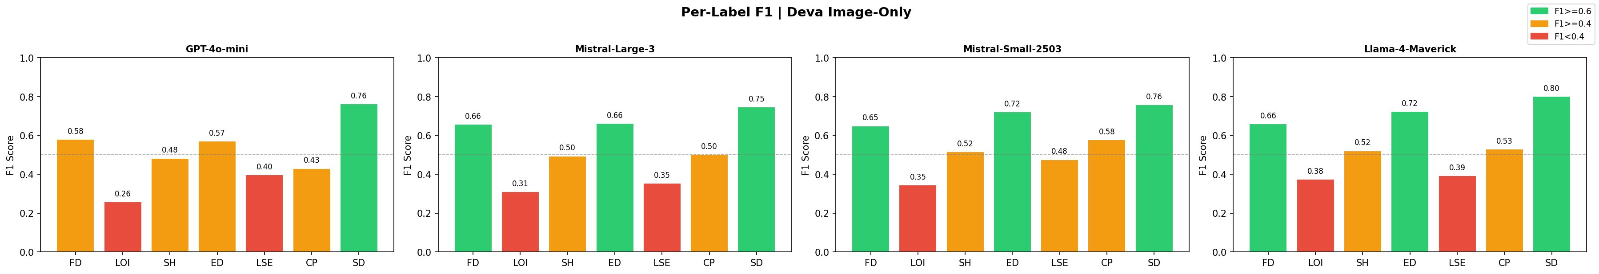
Figure 2: Per-Label F1 | Deva Image-Only. Feeling Down and Sleeping Disorder are the strongest labels; LOI and LSE are weakest.
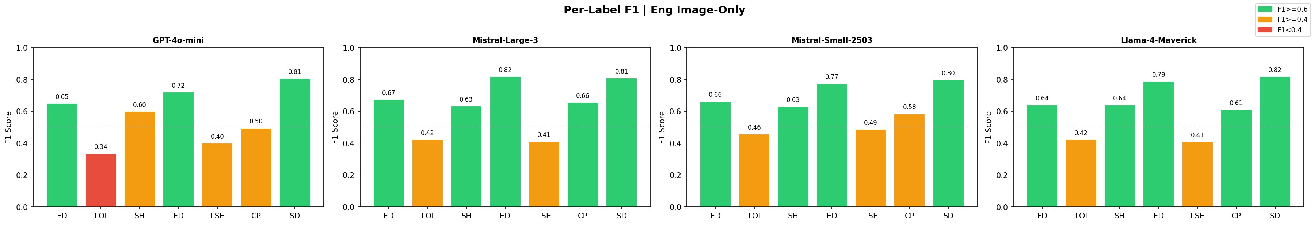
Figure 3: Per-Label F1 | Eng Image-Only. Substantial gains for ED, LSE, SH vs. Deva condition; LOI remains the hardest label across all models.
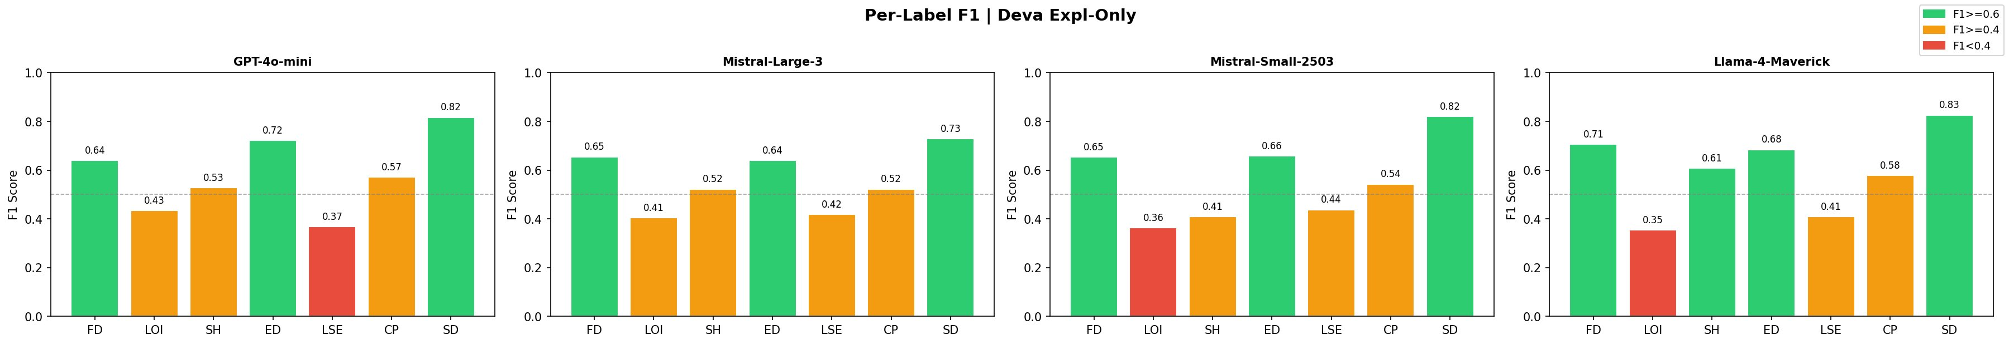
Figure 4: Per-Label F1 | Deva Expl-Only (self-generated). Moderate gains over image-only; LSE and LOI remain below threshold for most models.
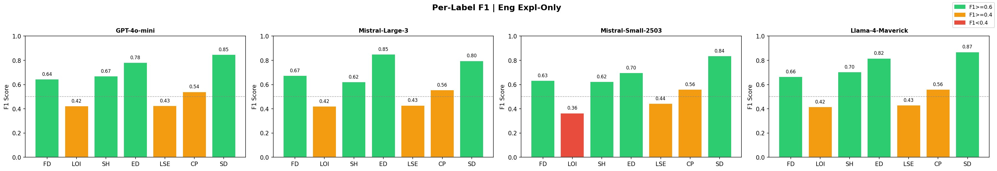
Figure 5: Per-Label F1 | Eng Expl-Only (Gemini-generated). Strong gains for ED, SH, SD; Gemini-generated English explanations consistently lift all labels.
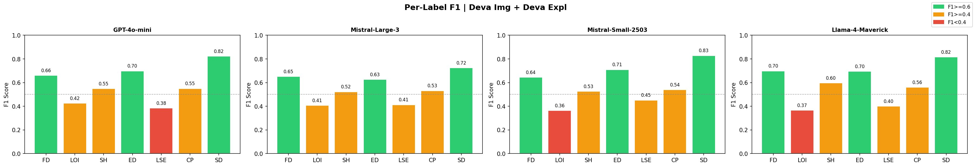
Figure 6: Per-Label F1 | Deva Img + Deva Expl. Marginal improvement over Deva Expl-Only; image adds limited complementary signal in Devanagari conditions.
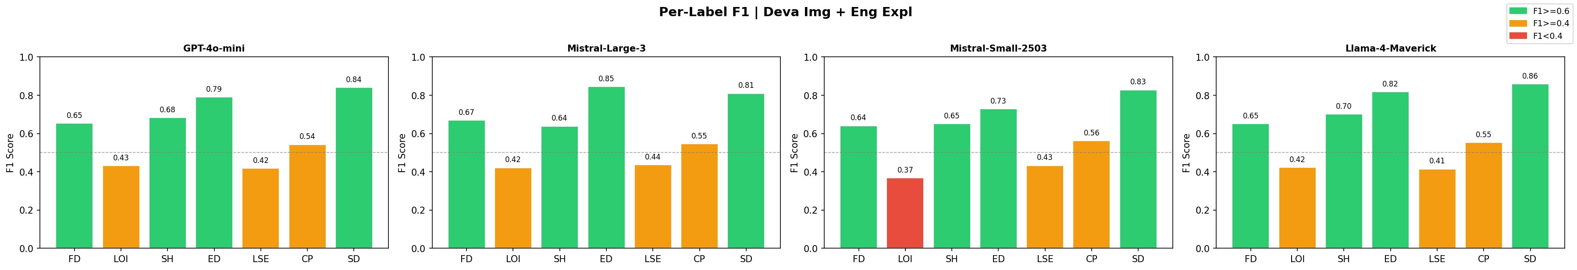
Figure 7: Per-Label F1 | Deva Img + Eng Expl (cross-modal). Strong across all labels — ED reaches 0.79–0.85 range; LOI and LSE remain the persistent weak spots.
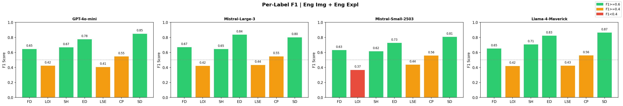
Figure 8: Per-Label F1 | Eng Img + Eng Expl. Near-ceiling performance for most labels; ED and SD consistently reach 0.80+; LOI remains the universal floor.
Across all conditions, Lack of Interest (LOI) is the universally hardest label — it is both the least prevalent in the test set and the most dependent on subtle linguistic cues that models cannot read from Devanagari images. Sleeping Disorder (SD) is consistently the strongest label in explanation-based conditions, benefiting from both high prevalence and visually/linguistically explicit meme templates. Eating Disorder (ED) shows the largest gains from English explanations, reflecting that culturally adapted food-related memes carry rich textual signal that models can interpret when provided in English. Low Self-Esteem (LSE) is consistently red (below 0.4) in image-only conditions for GPT-4o-mini, improving substantially only when English explanations are provided.

13. Per-Category Analysis
Figures 9–15 show per-category macro-F1 heatmaps for each experimental condition. The 13 meme categories span from UNIVERSAL_HUMAN (522/650 test samples, 80.3%) to rare categories with under 10 samples each. Interpret rare-category scores with caution.

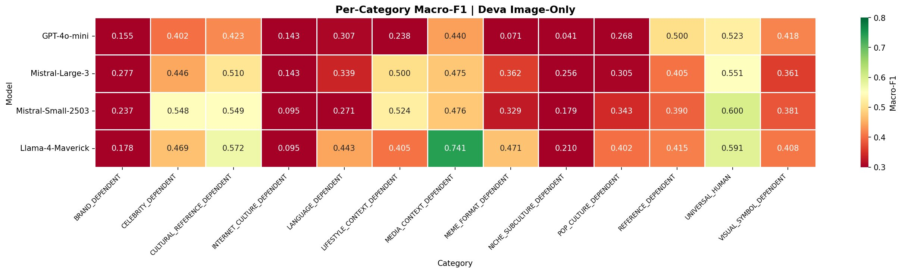
Figure 9: Per-Category Macro-F1 | Deva Image-Only. MEDIA_CONTEXT_DEPENDENT and CELEBRITY_DEPENDENT show strong Llama4 performance; INTERNET_CULTURE_DEPENDENT is consistently low.
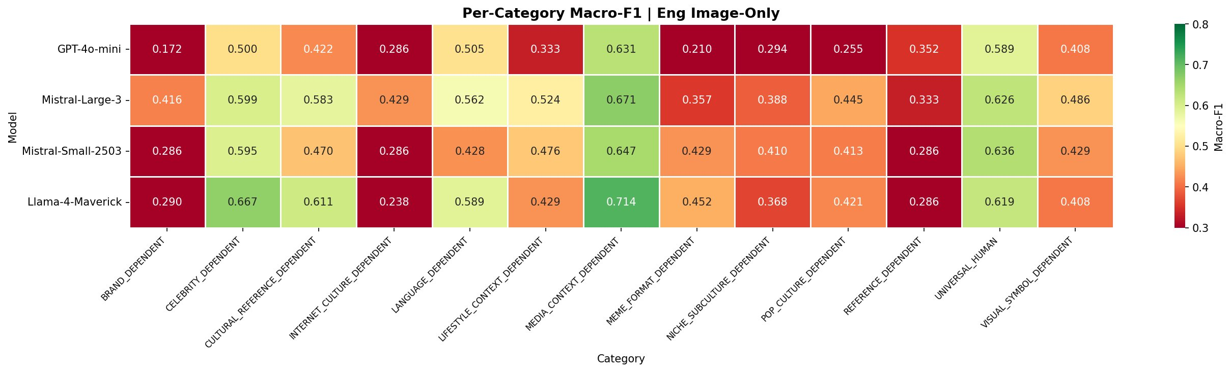
Figure 10: Per-Category Macro-F1 | Eng Image-Only. Widespread improvement; CELEBRITY_DEPENDENT rises substantially, confirming cultural adaptation effectiveness. LANGUAGE_DEPENDENT also improves.
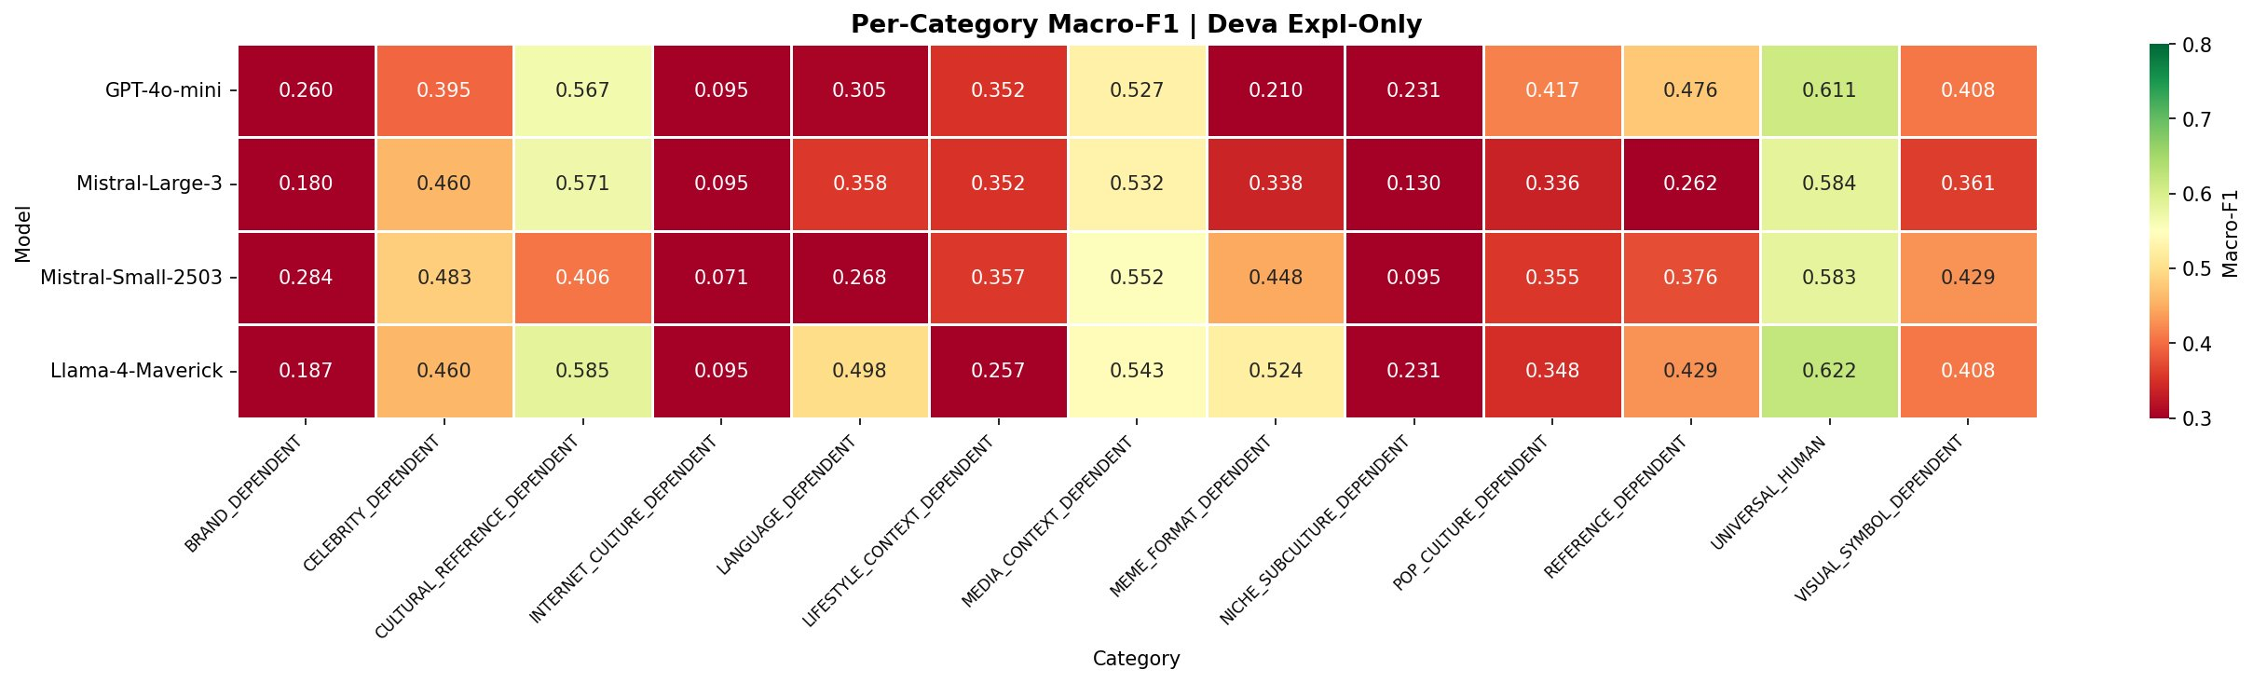
Figure 11: Per-Category Macro-F1 | Deva Expl-Only. UNIVERSAL_HUMAN and CULTURAL_REFERENCE_DEPENDENT score well; INTERNET_CULTURE_DEPENDENT remains the floor.
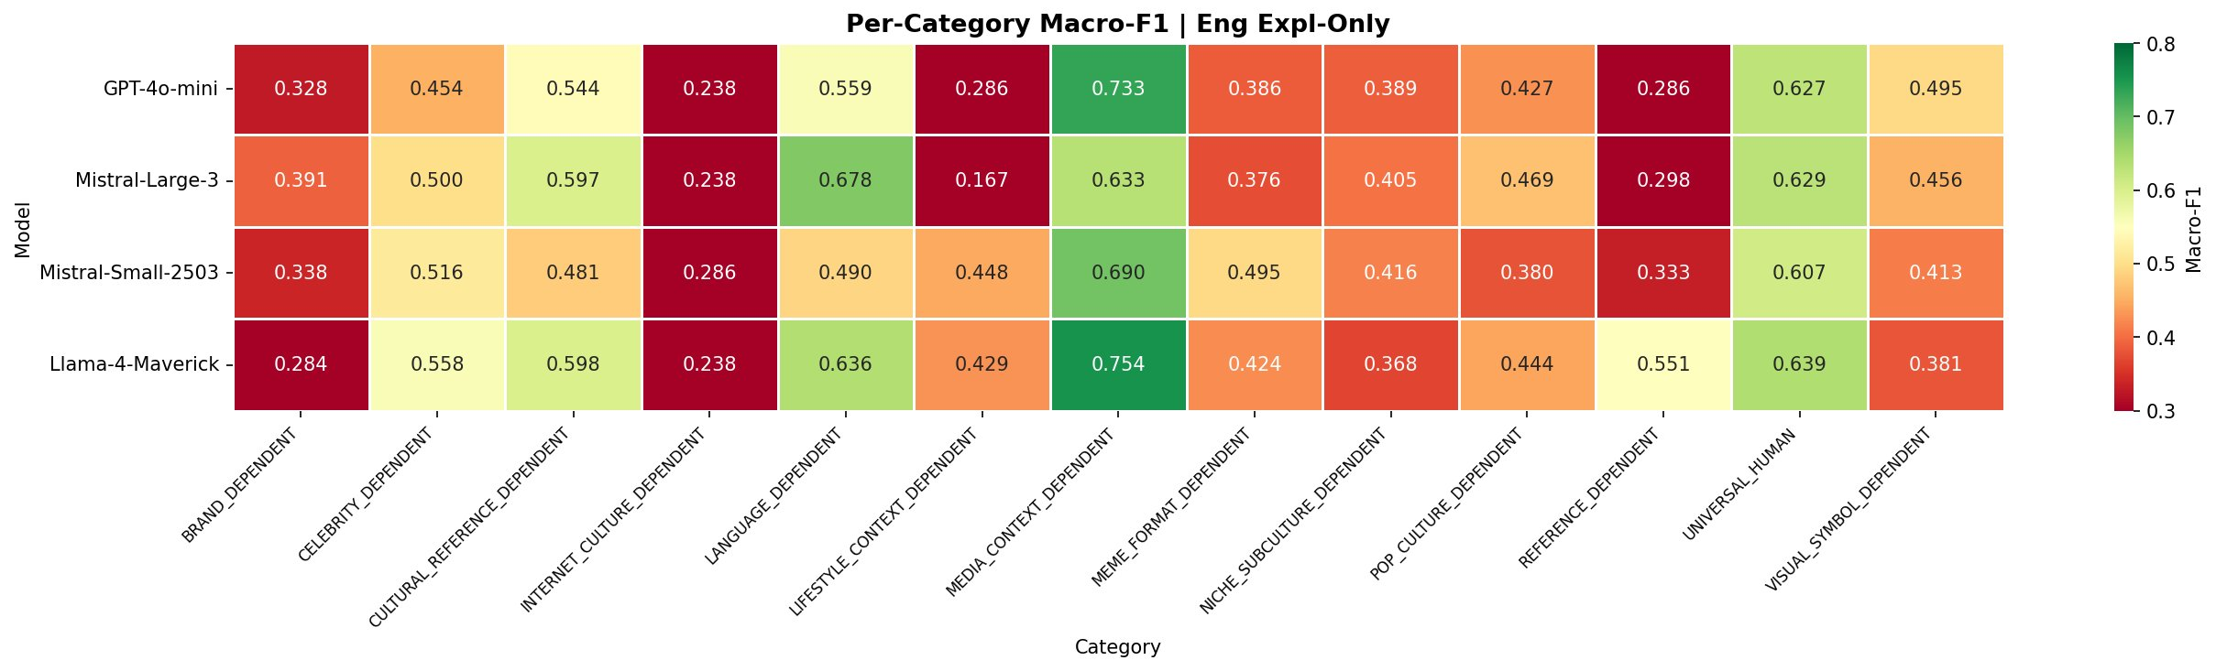
Figure 12: Per-Category Macro-F1 | Eng Expl-Only (Gemini). Highest per-category scores overall; MEDIA_CONTEXT_DEPENDENT reaches 0.63–0.75 range. LANGUAGE_DEPENDENT shows strong improvement confirming that English explanations capture Hindi linguistic content.
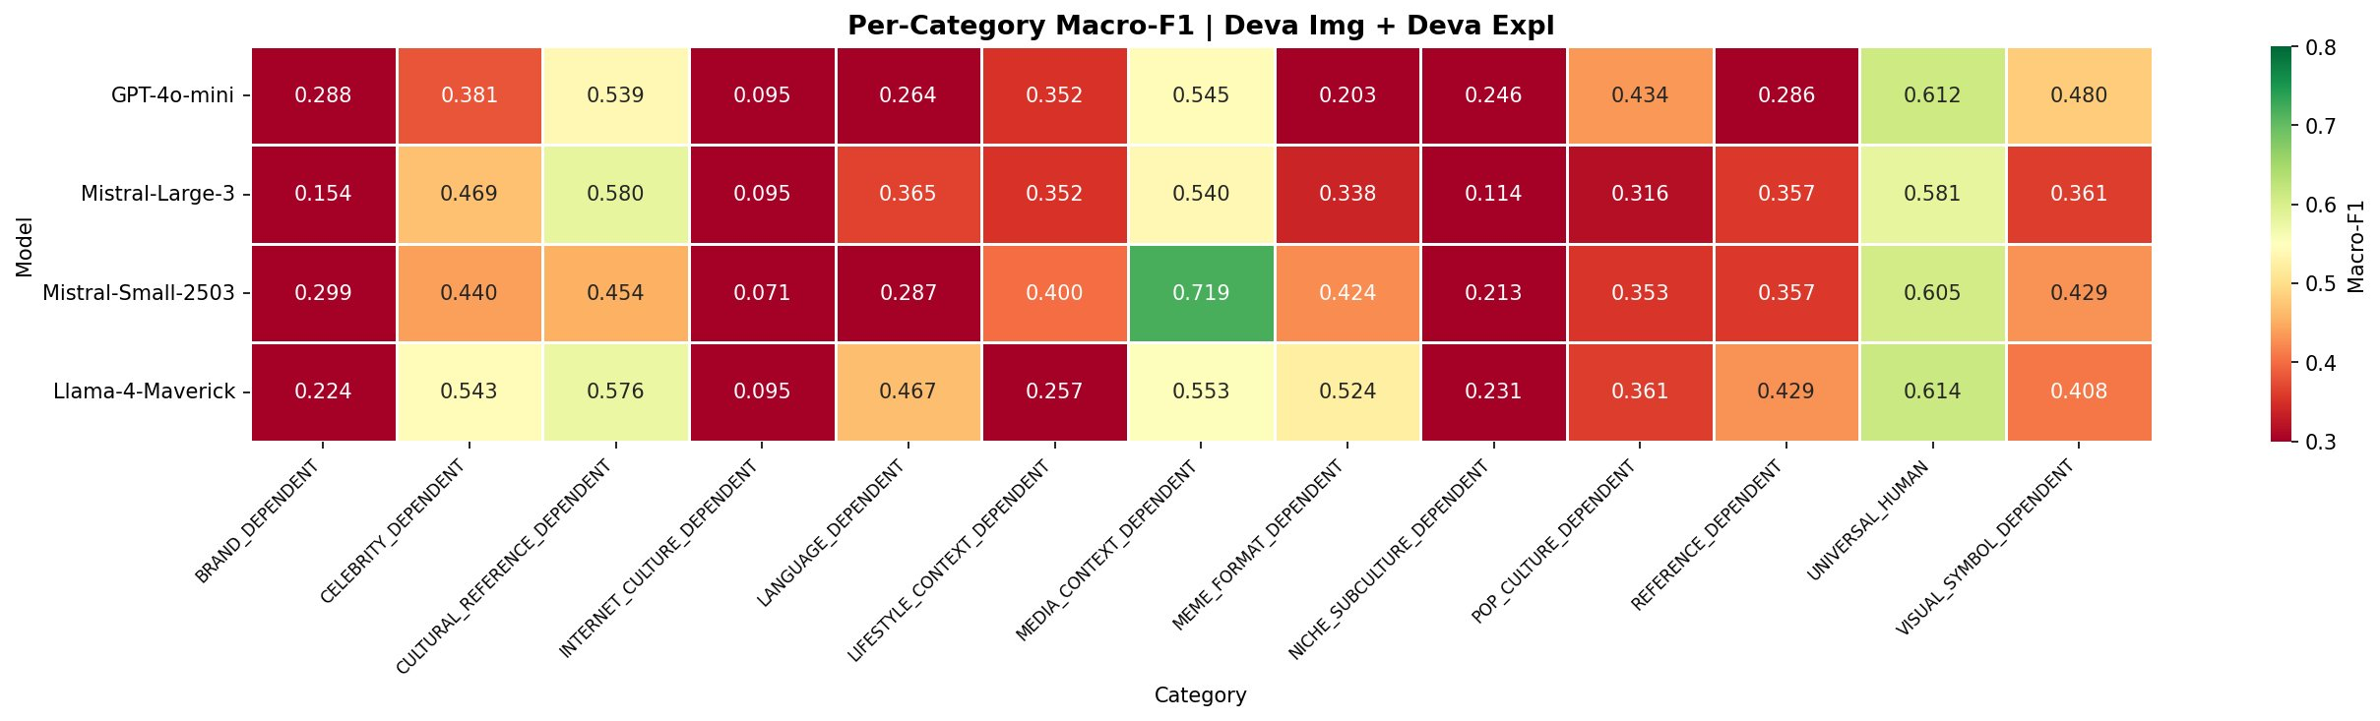
Figure 13: Per-Category Macro-F1 | Deva Img + Deva Expl. Scores close to Deva Expl-Only; adding Devanagari image provides negligible per-category benefit.
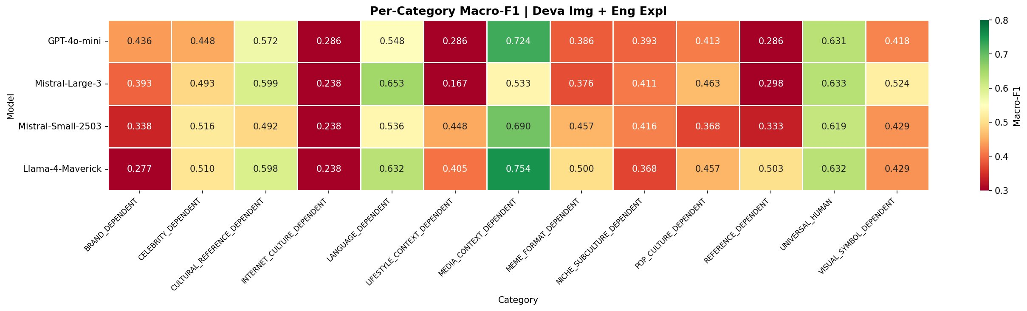
Figure 14: Per-Category Macro-F1 | Deva Img + Eng Expl. Best per-category condition for most categories; LANGUAGE_DEPENDENT (0.54–0.65) and CELEBRITY_DEPENDENT (0.45–0.52) show strong recovery confirming cultural adaptation quality.
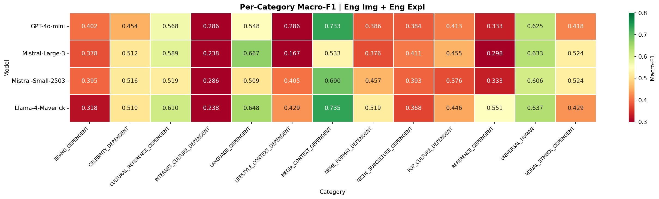
Figure 15: Per-Category Macro-F1 | Eng Img + Eng Expl. Near-equivalent to Deva Img + Eng Expl for most categories, confirming Gemini explanations close the visual script gap.
The per-category analysis reveals several key patterns. The UNIVERSAL_HUMAN category drives overall macro-F1 scores due to its 80.3% share of the test set. Categories requiring cultural or linguistic knowledge (LANGUAGE_DEPENDENT, CELEBRITY_DEPENDENT, CULTURAL_REFERENCE_DEPENDENT) show the largest Deva-English gap in image-only conditions, as these memes rely on embedded Hindi text for their adapted meaning — confirming successful cultural adaptation that cannot be read directly from Devanagari images by current models. These same categories show strong recovery in the Deva Img + Eng Expl condition, validating that Gemini-generated English explanations bridge the cultural and linguistic gap effectively.
INTERNET_CULTURE_DEPENDENT (3 test samples) consistently shows the lowest scores across all conditions and all models — this category is too small for reliable metric estimation and results should not be interpreted as model behavior for internet culture content.

14. Confusion Matrix Analysis
Figures 16–22 show per-condition confusion matrices for the best-performing model in each condition. Each figure contains 7 sub-matrices (one per PHQ-9 label). Rows = True labels (0 = negative, 1 = positive); Columns = Predicted labels. Darker blue = higher count.

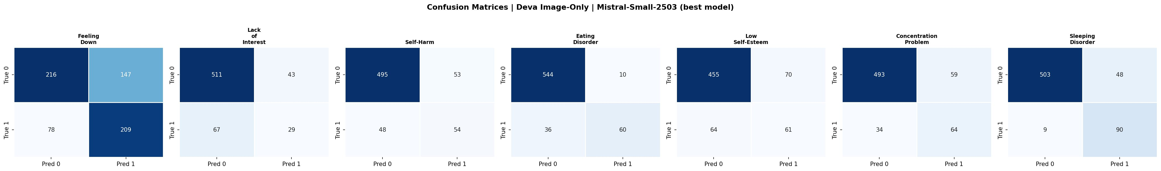
Figure 16: Confusion Matrices | Deva Image-Only | Mistral-Small-2503 (best model). FD and SD show reasonable TP rates; LOI has low TP (29/96); Eating Disorder shows substantial FP (60 predicted positive when true negative).
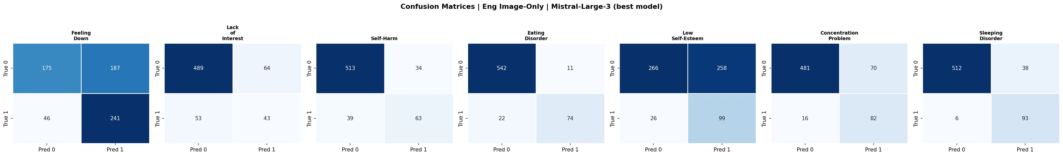
Figure 17: Confusion Matrices | Eng Image-Only | Mistral-Large-3 (best model). Improved TP across FD, SD, LSE vs. Deva condition; LSE now shows 99 TP reflecting the English script advantage for this linguistically-expressed label.
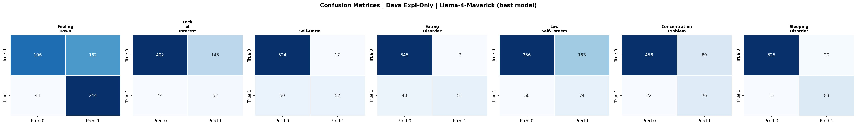
Figure 18: Confusion Matrices | Deva Expl-Only | Llama4-Maverick (best model). FD achieves 244 TP (highest across conditions for this label); LOI improves slightly (52 TP); SD reaches 83 TP.
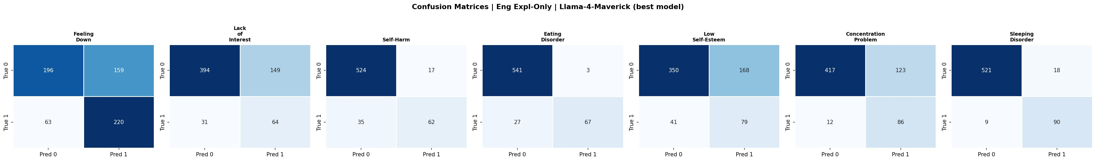
Figure 19: Confusion Matrices | Eng Expl-Only | Llama4-Maverick (best model). ED reaches 67 TP; SD 90 TP; LSE 79 TP — consistently the strongest text-only condition. LOI at 64 TP is the highest for that label across all conditions.
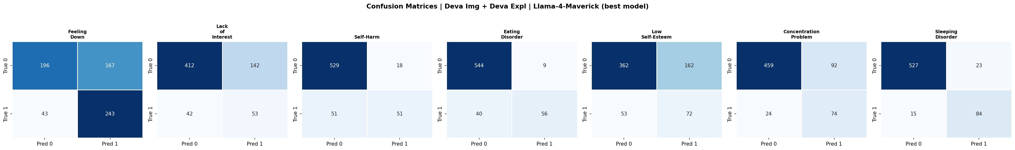
Figure 20: Confusion Matrices | Deva Img + Deva Expl | Llama4-Maverick (best model). Very similar to Deva Expl-Only; adding Devanagari image does not materially change prediction distributions for any label.
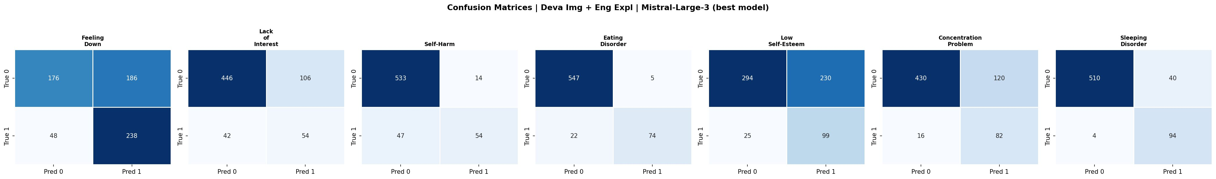
Figure 21: Confusion Matrices | Deva Img + Eng Expl | Mistral-Large-3 (best model). LSE reaches 99 TP — highest for this label across all conditions; ED reaches 74 TP. Distribution closely resembles the all-English condition, confirming cross-modal gap closure.
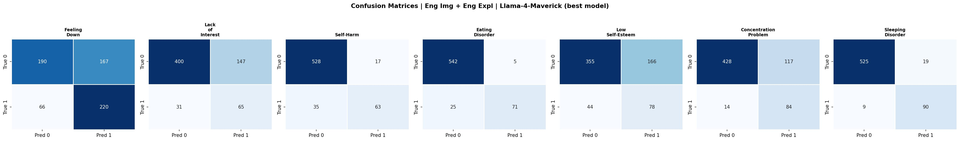
Figure 22: Confusion Matrices | Eng Img + Eng Expl | Llama4-Maverick (best model). Highest TP for FD (220), ED (71), SD (90). LSE at 78 TP. LOI remains the hardest: 65 TP with 147 FN (model misses majority of positive cases).
The confusion matrices reveal a consistent asymmetry across all conditions: models are systematically better at identifying negative cases (TN) than positive cases (TP). This reflects the class imbalance in the test set — all labels except Feeling Down and Self-Harm are minority classes. The progression from Deva Image-Only → Eng Expl-Only → Deva Img + Eng Expl shows a clear improvement in TP recovery for LSE, ED, and SD, while LOI (Lack of Interest) remains the most resistant label with the lowest TP counts across all models and conditions.

15. Failure Mode Analysis

15.1 Vocabulary Mismatch (Text Models)
The dominant failure mode for English-only text models. EasyOCR extracts Hindi text in Devanagari unicode which English tokenizers segment into meaningless subword pieces, producing random-walk probability distributions (~0.49–0.51 per label). Models that avoid this failure (IndicBERTv2, mBERT) do so through multilingual subword tokenization including Devanagari unicode blocks. Robust across model architectures, sizes, and domain specializations.

15.2 Label Coverage Gap
LOI, CP, and SD have zero positive examples in the 2,077 translated training images — the training campaign was terminated upon discovering this imbalance. All fine-tuning experiments are affected: models cannot learn signal for these three labels regardless of architecture, producing zero recall. Zero-shot models partially recover these labels but performance remains low. A structural dataset limitation, not a modeling failure.

15.3 Content Filter Rejections (Azure)
Azure content management consistently rejects a small proportion of memes. GPT-4o-mini is most sensitive (2–8 rejections per experiment condition). The most frequently rejected samples contain Self-Harm imagery — creating an inverse relationship between Azure safety filtering and clinical utility for the most clinically significant symptom.

15.4 JSON Truncation (Foundry Models)
Primarily affects Llama4 (verbose reasoning before JSON) and Mistral-Large-3 (multi-line JSON formatting). Truncation always cuts at Eating Disorder or later labels. Under 2% per condition; not systematically biased toward any symptom class.

15.5 VLM Architecture Limitations
BLIP/BLIP-2 produce hallucinated free-form text rather than structured yes/no outputs for non-English content. InstructBLIP fails completely with structured JSON prompts (0.0 recall), recovering only with natural language prompting. IDEFICS requires transformers==4.40.0 and list-of-lists input format. PALO-7B requires GitHub clone + monkey-patch to remove cache_position argument.

16. Recommendations for Paper
Primary comparison structure: (1) Devanagari Image-Only as the hard baseline quantifying the translation challenge; (2) English Image-Only as the script-controlled baseline establishing the performance before translation; (3) Deva Img + Gemini English Expl as the pipeline recommendation recovering most of the script gap; (4) Gemini Image-Only (pending test set) as the frontier model upper bound.
The three-way comparison cleanly tells the paper's central story: translation creates a quantifiable performance gap (~0.067 macro-F1 on average); English explanations from a frontier model substantially close that gap (~85% recovery); but Gemini operating natively in both languages sets a ceiling that current pipeline approaches have not reached. The per-label LOI/CP/SD analysis and vocabulary mismatch finding provide the key negative results motivating future work.

UIC Graduate Research | Devanagari Hindi Meme Classification | All experiments zero-shot unless noted

