**SOURIM DAS**

1. Genuine/Imposter Score distribution for System 1

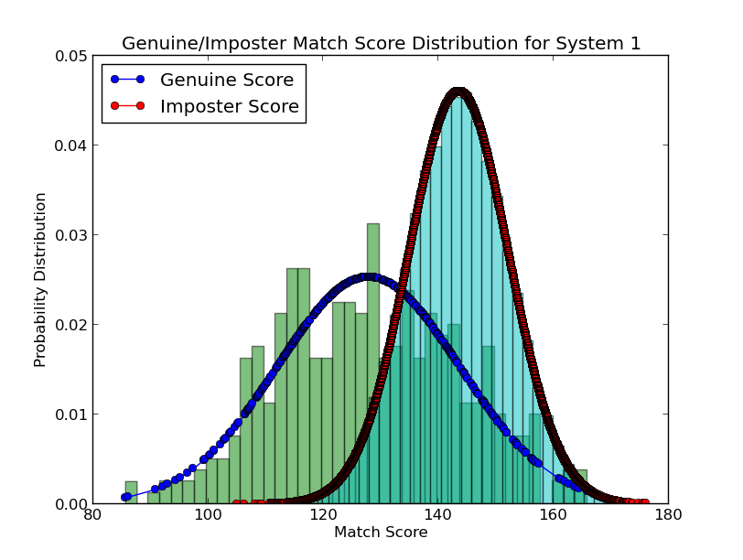

Genuine/Imposter Score for System 2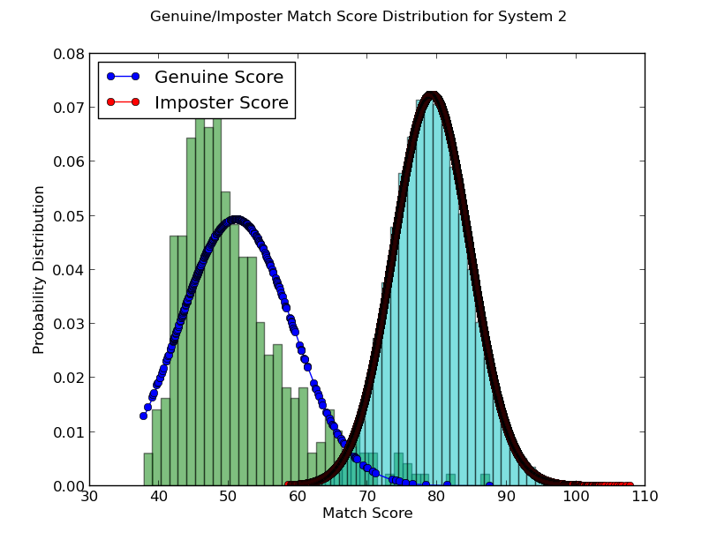

1. CMC curves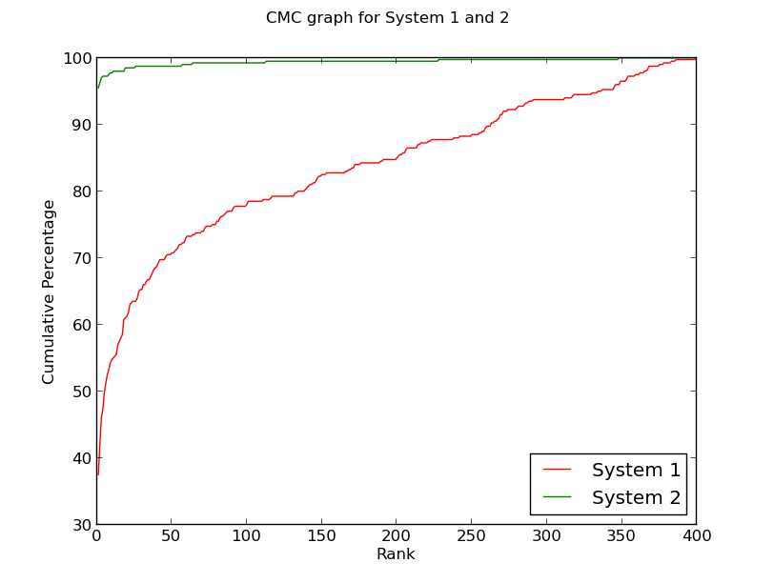
2. d’ for System 1 = 1.22988466291

d’ for System 2 = 4.07085641966

1. System 1- 200

System 2- 1

1. DET Curves for System 1 and System 2

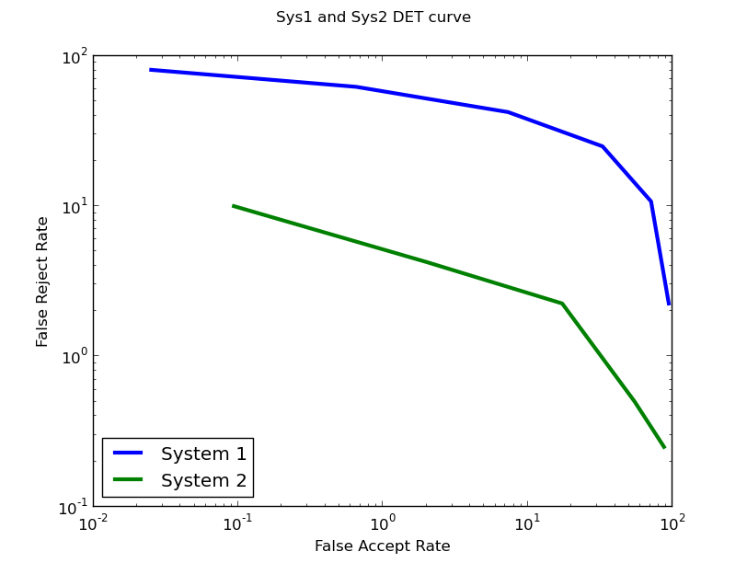

1. 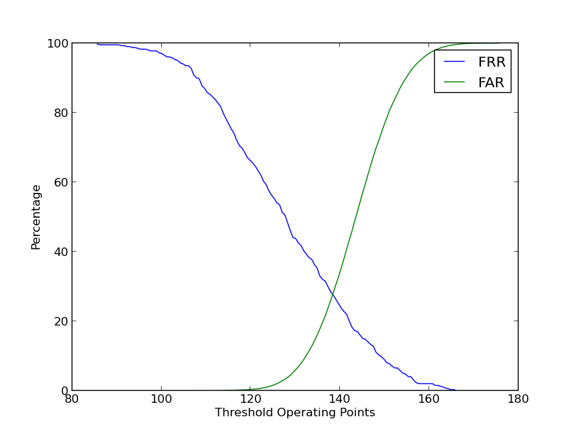

Equal Error Rate in System 1 → 28.142

Operating Point for EER in System 1 → 138.467

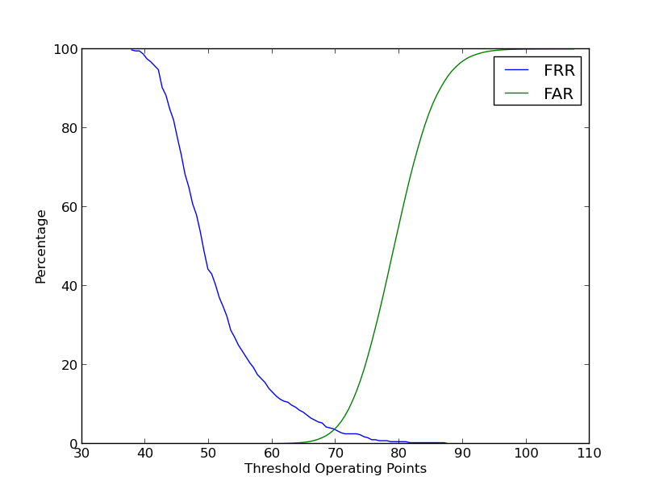

Equal Error Rate in System 2 → 3.437

Operating Point for EER in System 2 → 69.64

1. System 1 FAR vs FRR error rates

|  |  |
| --- | --- |
| FAR | FRR |
| 1 | 58.75 |
| 5 | 44.75 |
| 10 | 39.25 |
| 20 | 31.75 |

System 2 FAR vs FRR error rates

|  |  |
| --- | --- |
| FAR | FRR |
| 1 | 5.5 |
| 5 | 3.25 |
| 10 | 2.5 |
| 20 | 1.5 |

1. I consider System 2 better performing than System 1 because of the following reasons:-
2. d’ value of system 2 is greater than that of system 1 which implies that overlapping region of imposter scores and genuine scores is less in the former resulting in lesser FARs and FRRs for optimally chosen operating threshold.
3. EER in System 2 is lesser than that of System 1 which again implies that an operating point can be chosen which will give much lesser FAR and FRR values in comparison to System 1.
4. From the CMC curve, Rank 1 recognition rate in system 2 is approximately 97% where as in system 1 it is 38%