1. Eigen Faces.

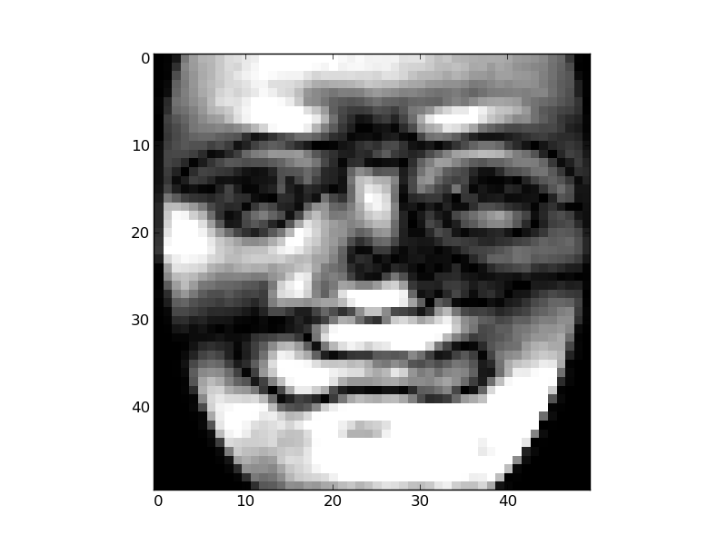 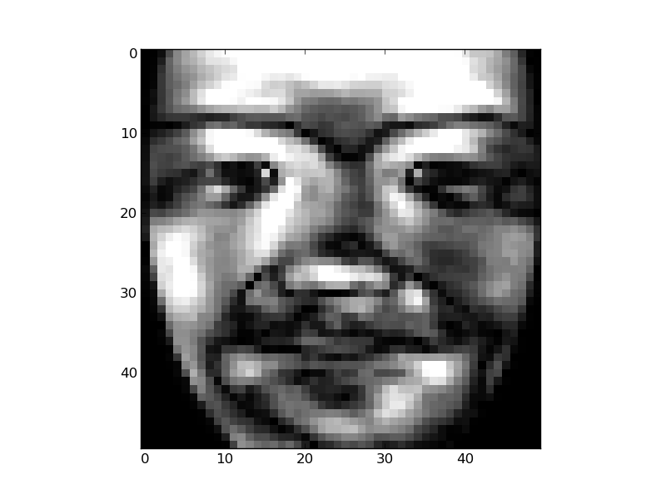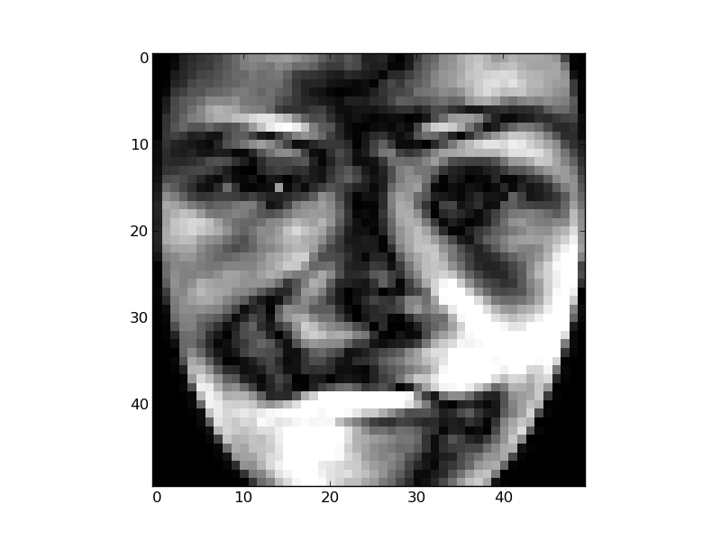 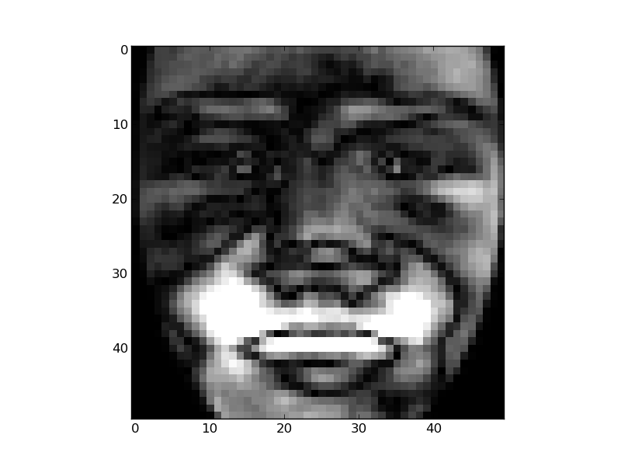 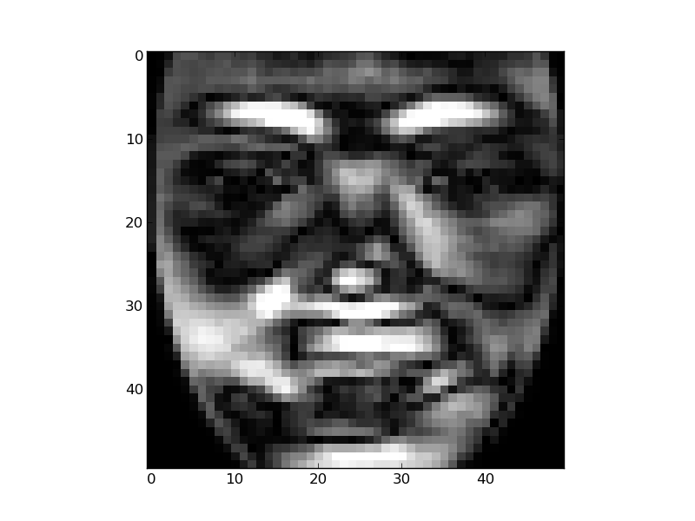 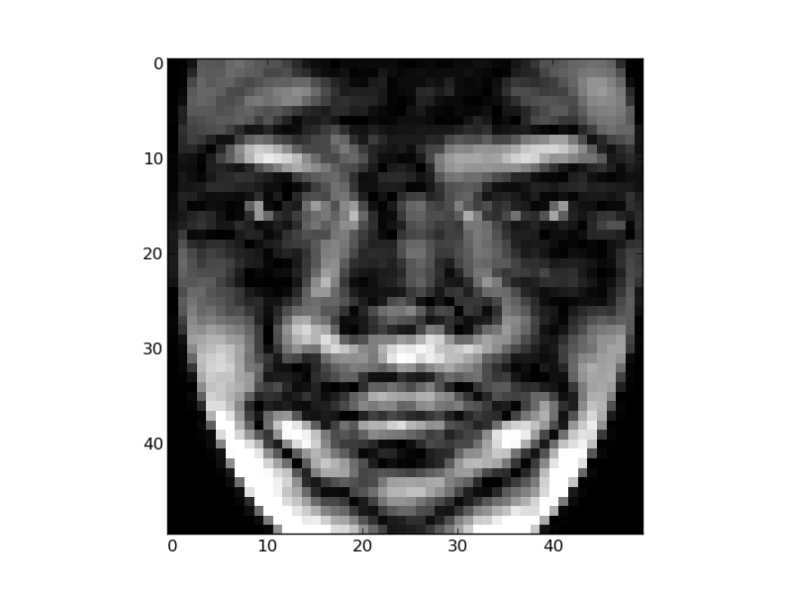

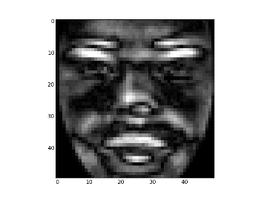 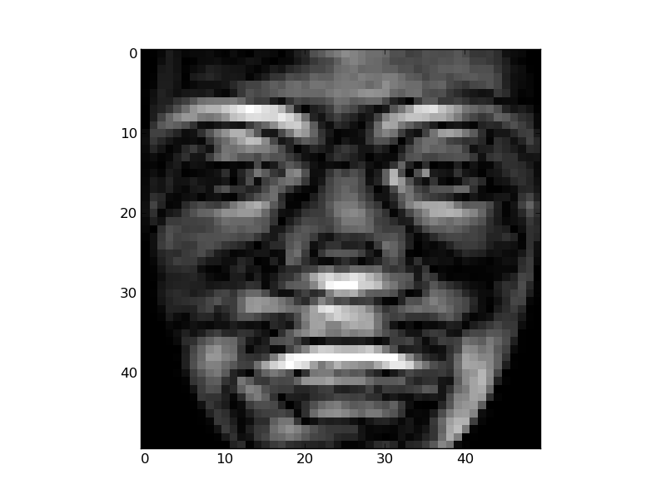 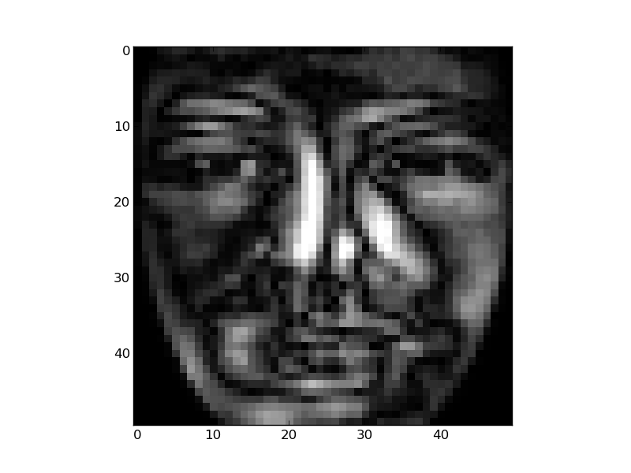

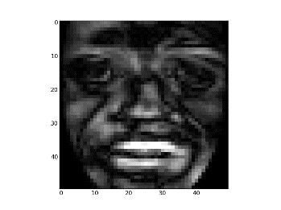

1. ROC and EER using Euclidean Distance. EER is 9.83%S

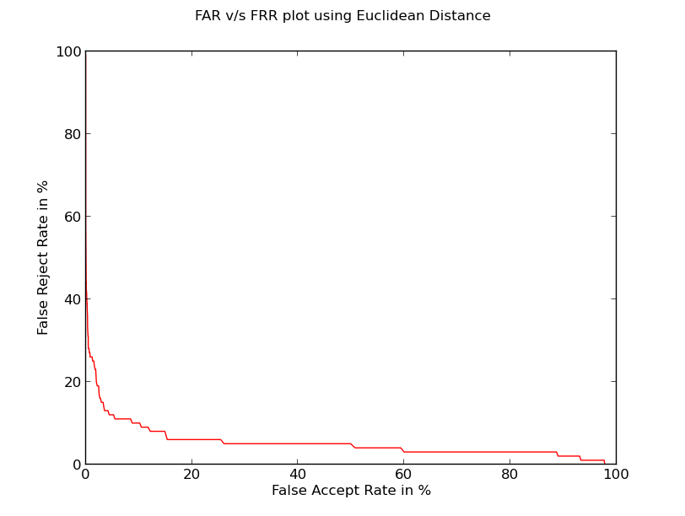

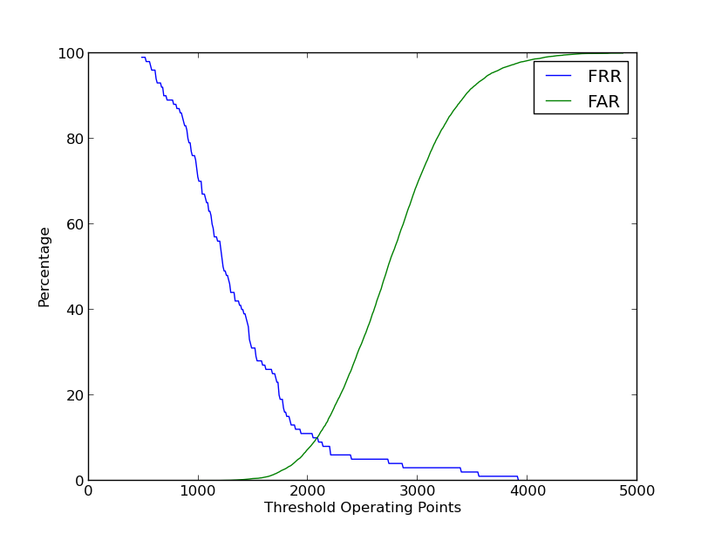

ROC and EER using Manhattan Distance. EER = 8.525%

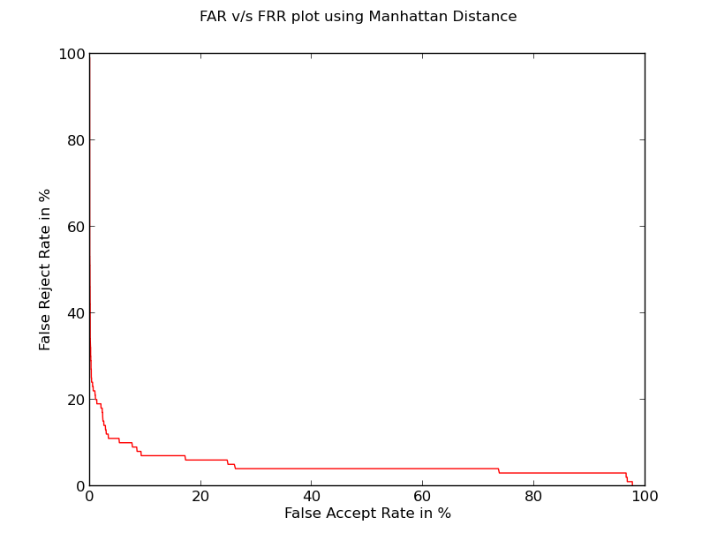

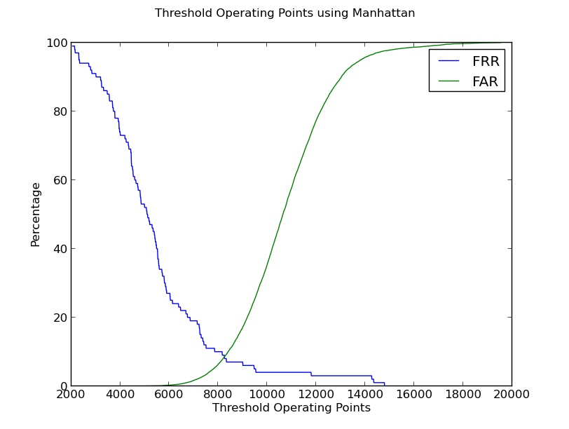

ROC and EER using Chebyshev’s Distance. EER=19.081%

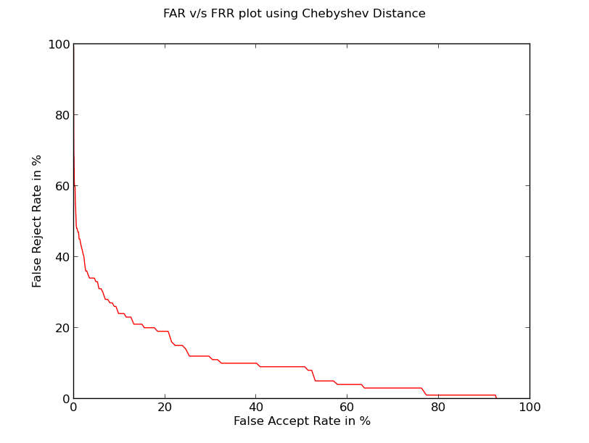

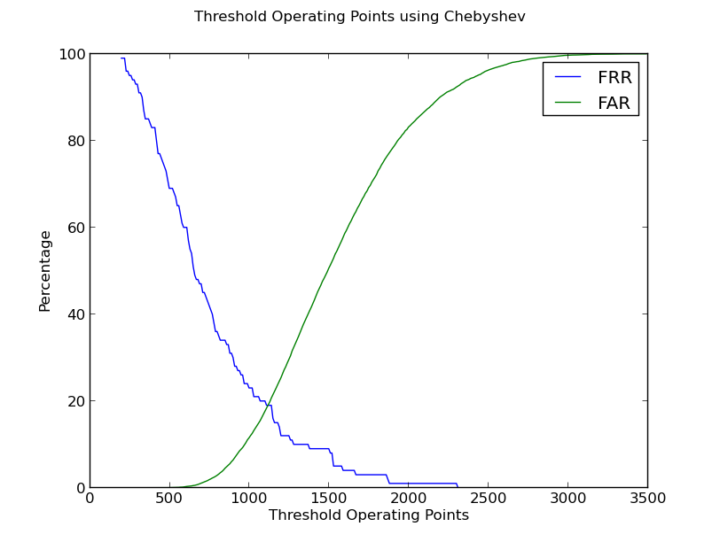

ROC and EER using Minkowski’s 3rd Order Distance. EER = 11.20%

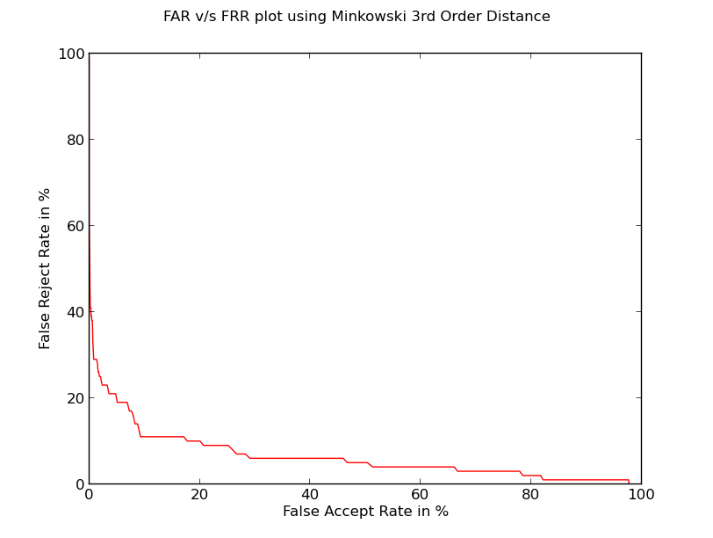

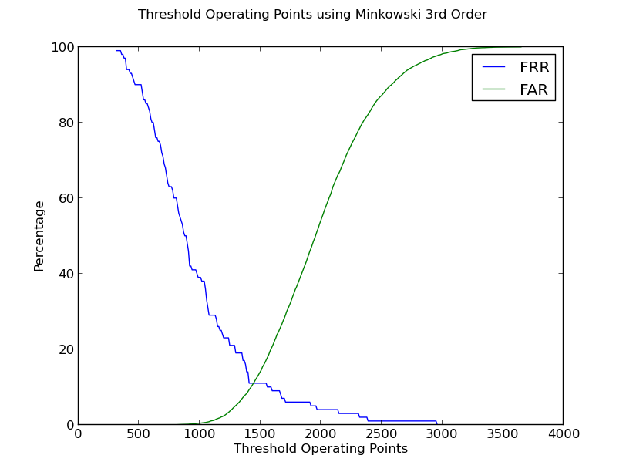

1. CMC graph using Euclidean Distance Measure

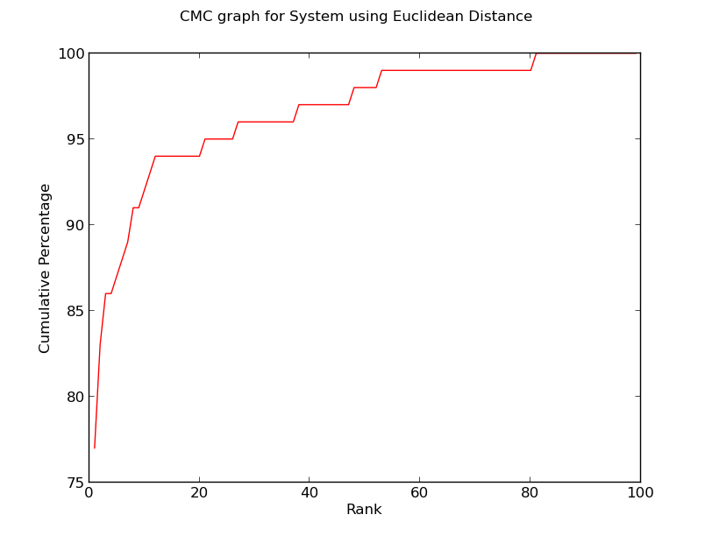

CMC graph using Manhattan Distance Measure

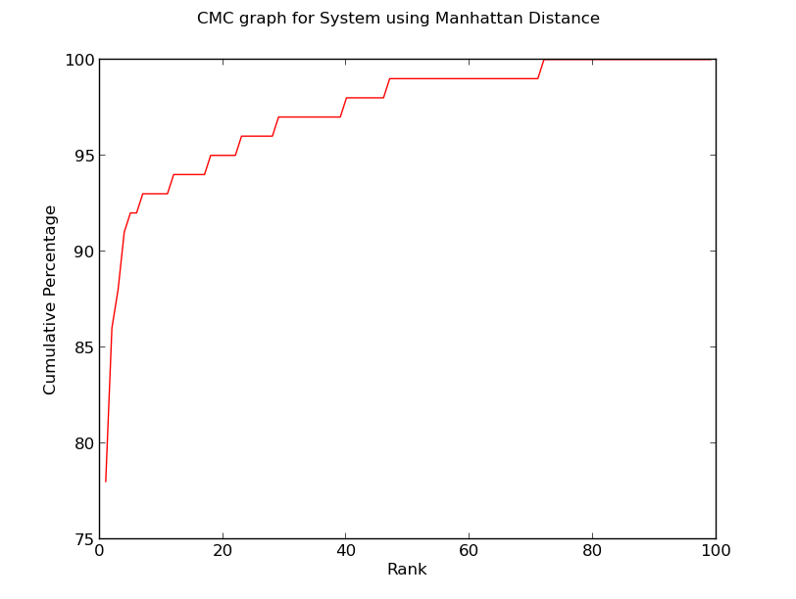

CMC graph using Chebyshev’s Distance Measure

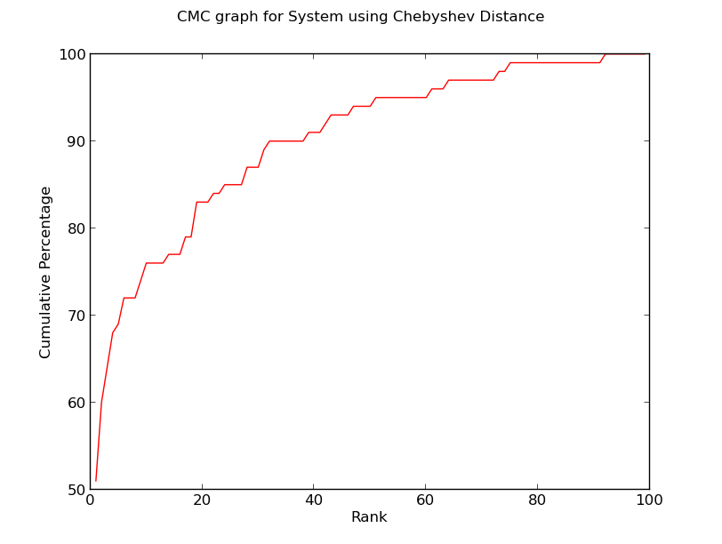

CMC graph using Minkowski’s 3rd Order Distance Measure

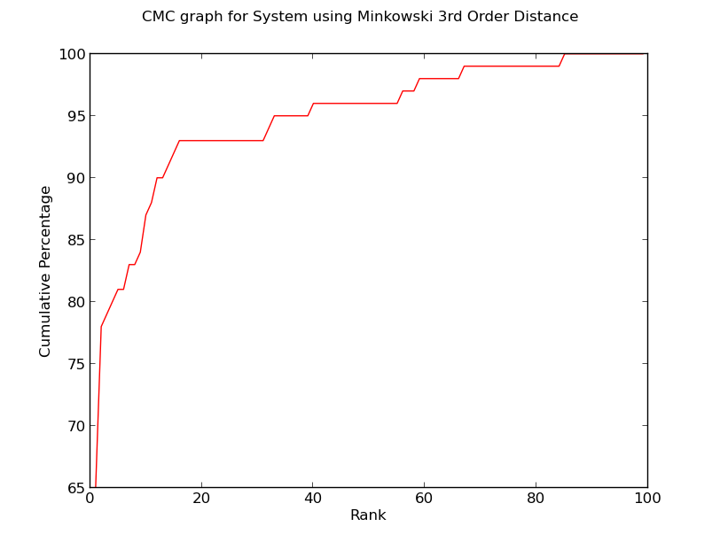

1. Number of Eigen Vectors used v/s Rank 1 Recognition Rate

Using Euclidean Distance Rank 1 Recognition rate last increased when 70 top eigen vectors were used

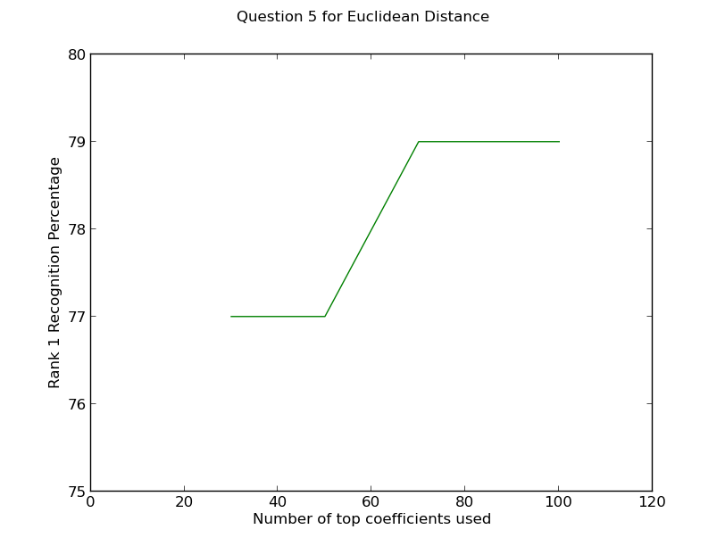

Using Manhattan Distance, Rank 1 recognition rate last increased when 90 top eigen vectors were used

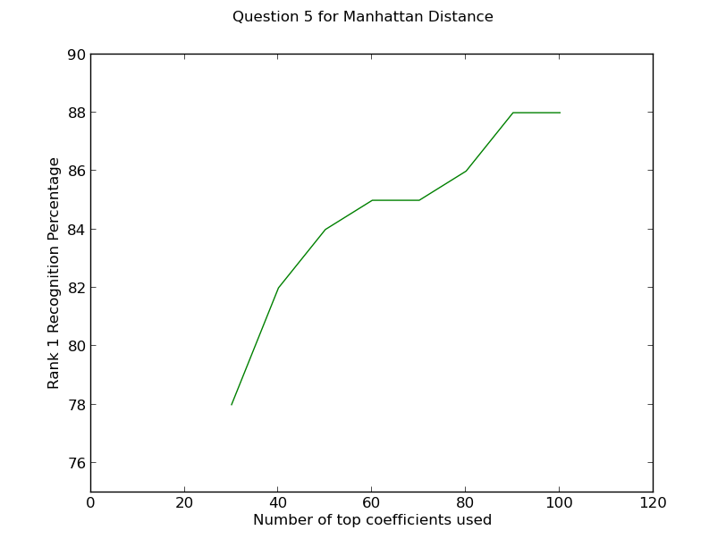

Using Minkowski’s 3rd Order Distance Measure, Rank 1 recognition rate last increased when 60 top eigen vectors were used.

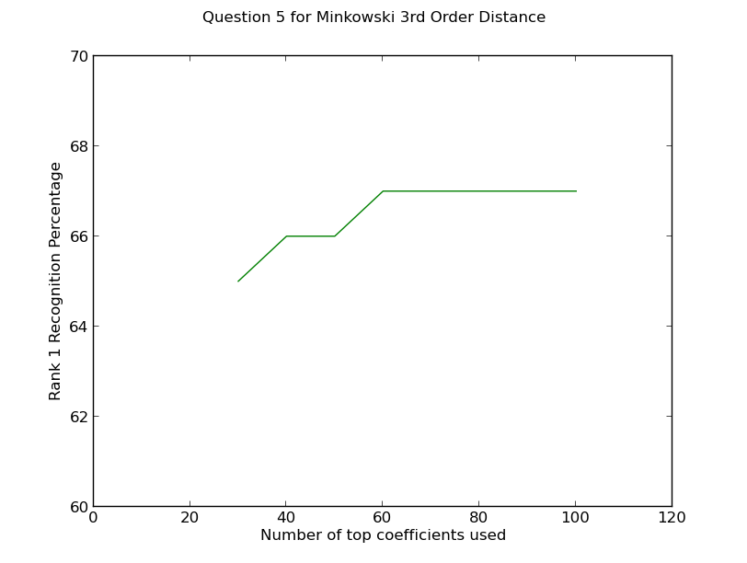

Using Chebyshev’s Distance Measure, Rank 1 recognition rate last increased when 30 top eigen vectors were used.

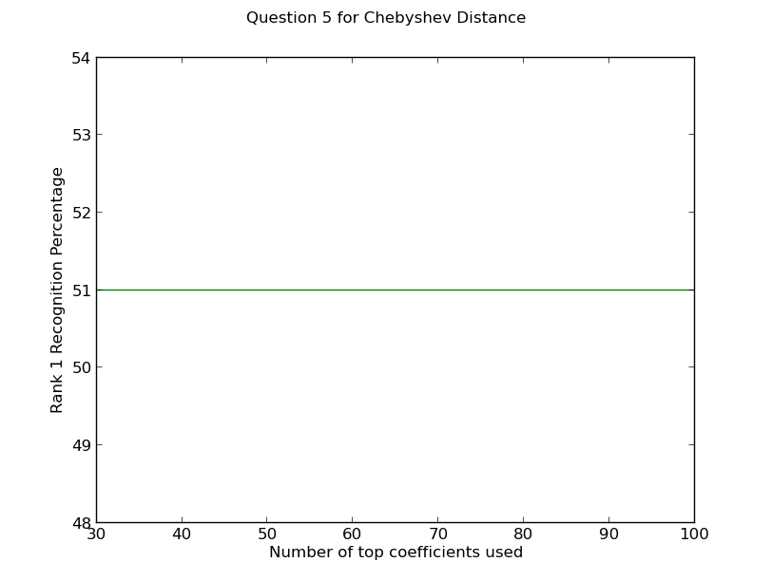

In my opinion Manhattan Distance Measure is the best because its EER is lowest at 8.525% and Highest Rank 1 recognition rate which is at 77%. The second best is Euclid Distance measure with EER 9.83% and rank 1 recognition rate 76%.