Navigate to this link: <https://github.com/sourkrouse/ePortfolio/blob/main/WeightTrackerApp/app-debug.apk>

Open the extension “APKOnline”

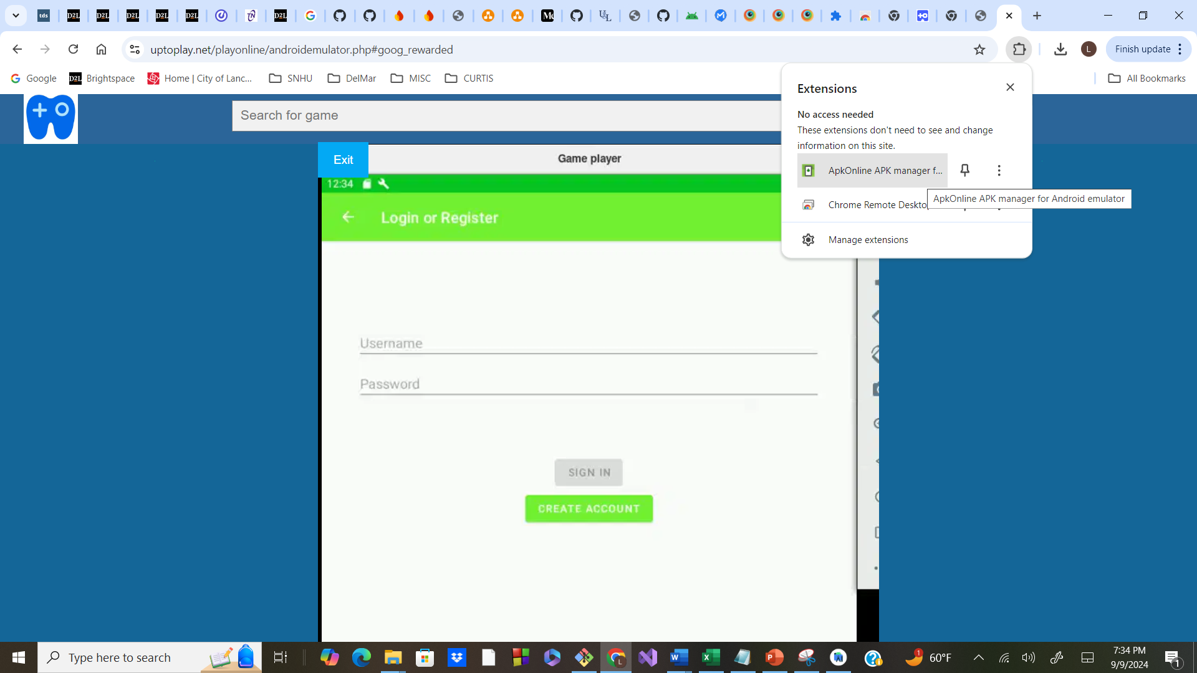

The extension should detect the APK file:

Click the “>Run_APK” link

Click “Start Emulator”

Then click “Enter” after the emulator starts

Result – the app should be interactive

