Report — Cyber-Physical Systems and IoT Security
Reference paper: Parrot, a software-only anti-spoofing defense system for the CAN bus.
Authors: Jose Rivera and Daniel Carrasco Moreno.
Testbed: custom bit-level CAN simulator (Python). Code: https://github.com/sournachos/parrot

Objectives
We implement and evaluate Parrot, a software-only defense that ejects a spoofing node from the CAN bus by exploiting CAN's own error-handling, rather than by adding cryptography or changing the bus. Because the defense operates entirely in the data-link layer — arbitration, bit monitoring, the Transmit/Receive Error Counters (TEC/REC) and the bus-off state — which SocketCAN's vcan0 (used in the ICSim lab) does not model, we first built a bit-level CAN simulator to serve as the testbed. Our concrete objectives were:
- reproduce a CAN masquerade/spoofing attack on an unauthenticated bus;
- implement Parrot's detect-and-contend reaction on the legitimate owner of an ID;
- measure whether and how quickly it forces the attacker to bus-off, at what cost to the defender, and whether it produces false positives on legitimate traffic.

System Setup
Testbed (custom-made, described per the template's instructions). A discrete, bit-time model of one CAN segment at 500 kbit/s using standard 11-bit data frames, written from scratch in Python. We did not use vcan0 precisely because it forwards frames without modeling arbitration, error counters or bus-off, so Parrot's mechanism is invisible on it.
The simulator implements: the wired-AND bus (dominant 0 wins over recessive 1); full frame encoding (SOF, ID, RTR, control, data, CRC-15 with polynomial 0x4599, delimiters, ACK, EOF) with bit stuffing; bit-wise arbitration; bit monitoring (a transmitter that drives a recessive bit but reads back a dominant one loses arbitration inside the arbitration field, or detects a bit error after it); and the per-node error-counter state machine — TEC += 8 on a transmit error, TEC -= 1 on success, with thresholds TEC > 127 → error-passive and TEC > 255 → bus-off (ISO 11898-1).
Nodes. EcuNode owns an ID and transmits a payload periodically; with the defense enabled it also runs Parrot. Attacker injects spoofed frames carrying a victim's ID at a fixed rate.
Parrot reaction. When a defended owner observes a frame carrying its own ID that it did not originate, it contends for that ID in the same bus slot with an all-dominant payload. Since it wins every data-bit contention, the spoofer reads back a dominant bit where it drove a recessive one, takes a bit error, and its TEC rises by 8 per contested injection.
Validation. A self-test asserts 13 properties of the layer before any result is trusted — including bus-off after exactly 32 transmit errors, error-passive at TEC = 128, bit stuffing never permitting six equal bits, lower ID winning arbitration, and an all-dominant owner beating a spoofer in the data field. All 13 pass. Well-known tools used: Python 3 and matplotlib (figures only).

Experiments
The code accompanies this report and is available at https://github.com/sournachos/parrot: experiments.py runs every scenario and writes the CSV traces and summary.json; make_plots.py renders the figures; selftest.py validates the layer. The scenarios were:
- E1 — Baseline, no defense. Owner 0x120 transmits periodically; attacker spoofs 0x120.
- E2 — Parrot ON. Same configuration with the defense enabled.
- E3 — Naive mirror. The owner echoes, but both colliding transmitters take the error — to show why a naive echo is insufficient.
- E4 — Injection-rate sweep. Time-to-bus-off as the attacker's injection rate varies from 83 to 1250 frames/s.
- E5 — False positives. Three legitimate ECUs, Parrot active on each, no attacker.

Results and Discussion
Scenario | Defense | Spoofs reaching the bus | Attacker | Defender
E1 — baseline | none | 100 (all land) | healthy | —
E2 — Parrot | Parrot | 0 | bus-off @ ~94 ms | TEC ≈ 0
E3 — naive mirror | echo (both error) | 0 | bus-off | driven to ~240 TEC (error-passive)
E5 — false-positive | Parrot, no attacker | — | — | no bus-off, max TEC = 0

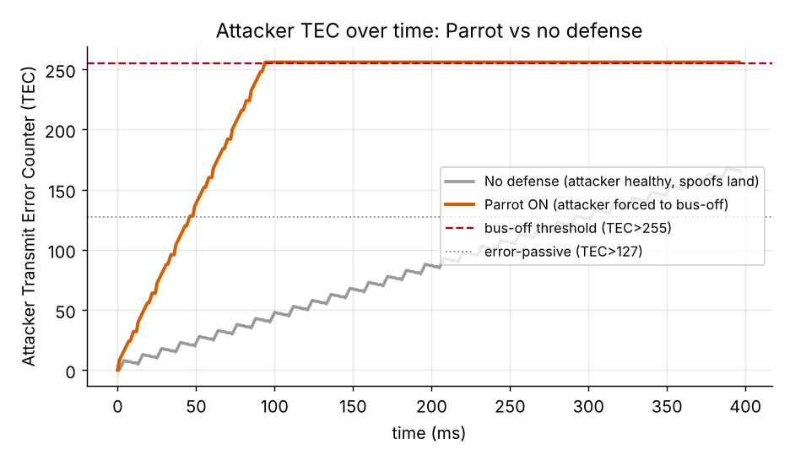
Figure 1. Attacker TEC over time. With Parrot the counter rises 8 per contested injection and crosses the bus-off threshold after 32 injections (~94 ms); without a defense it stays healthy.
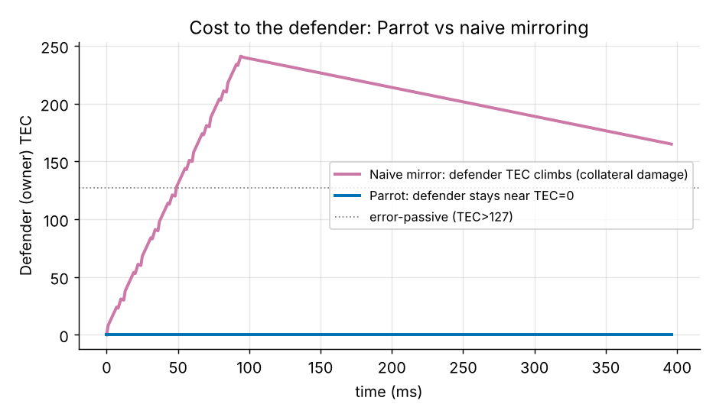
Figure 2. Cost to the defender. Parrot keeps the owner near TEC = 0, whereas a naive mirror drags it to ~240 TEC (error-passive, near bus-off) as collateral damage.
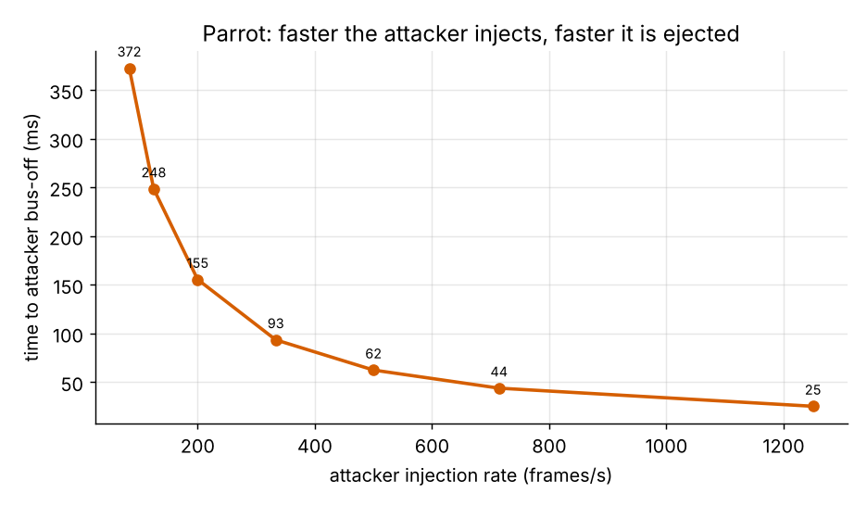
Figure 3. Time-to-bus-off versus injection rate. It scales as ~32 / rate: a more aggressive attacker is ejected faster.
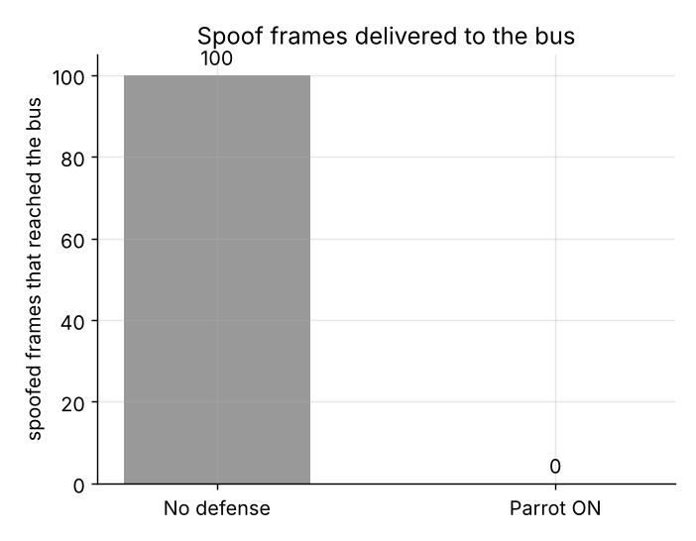
Figure 4. Spoofed frames delivered to the bus: 100 without a defense, 0 with Parrot.

Discussion
The attack works without the defense (E1). 100 spoofed frames reach the bus and the attacker remains healthy — the direct consequence of CAN having no source authentication. This is the same missing property that makes the ICSim replay lab succeed.
Parrot ejects the attacker (E2, Figure 1). The attacker reaches bus-off after exactly 32 contested injections (~94 ms) and zero spoofed frames are delivered. The count matches first principles: ceil(256 / 8) = 32.
Parrot protects the defender; naive mirroring does not (Figure 2). Under Parrot the defender's TEC stays near zero because it wins each exchange (a successful transmit). A naive echo instead drives the defender to ~240 TEC — deep into error-passive — which is why the reaction must be asymmetric. This contrast is the core design insight.
Rate scaling (E4, Figure 3) and false positives (E5). Time-to-bus-off scales as ~32 / injection-rate, so the defense scales against its worst case, while injections-to-bus-off stays fixed at 32. With legitimate-only traffic and Parrot active on every ECU, no node ever reaches bus-off and all TECs remain 0 — Parrot reacts only to a foreign frame on an ID it owns.
Why spoofing/replay worked at all. No authentication, no source address, no freshness — the same properties raised in the ICSim lab's discussion questions. A MAC with a freshness value (AUTOSAR SecOC) would defeat the spoof outright but imposes per-frame computation and payload overhead; Parrot needs no bus changes, which is the point of it being 'software-only.'

Limitations and critical evaluation
- Error frames are represented by their counter effect, not emitted bit-for-bit. This is a standard testbed simplification and does not change the TEC/REC dynamics that cause bus-off.
- The per-collision TEC bookkeeping is an explicit, tunable model (CollisionModel, with parrot and strict_both modes and adjustable deltas). The exact accounting must be reconciled with the reference paper's error-handling analysis; we expose it as a single parameter rather than hiding the assumption.
- Timing is event-level (frame plus inter-frame space, in bit-times), not analog CAN-H/CAN-L waveforms — appropriate for counter and bus-off dynamics, not for physical-layer effects.
- Per the course guidance, these are testbed-quality limitations rather than defects: the mechanism, the thresholds and the scaling all match first-principles CAN behaviour, and the self-test suite confirms the layer before any result is read.

