INVSTO ASSIGNMENT
Stock Return Prediction Pipeline for Quant Scientist
by Souradeep Roy
email:souro26.ju@gmail.com

Executive Summary (for stakeholders)
This project looks at whether past stock price and volume data can be used to predict where a stock will move the next day. I tested this across 14 stocks from 6 different sectors, using 5 years of data from 2019 to 2024.
I built two models and compared them against the simplest possible benchmark, which is to just predict zero movement every day. Neither model did better than that benchmark in any consistent way. This is not surprising. When information is already reflected in stock prices, looking at past prices tells you very little about what happens next.
What was useful is seeing where the models struggled more and where they struggled less. Stable sectors like healthcare and consumer goods were slightly more predictable. High volatility sectors like semiconductors were almost impossible to predict from price data alone because their big moves come from news and events, not from any pattern in the past.
Data and Methodology.
Data
I pulled daily price and volume data for 14 stocks across 6 sectors from Yahoo Finance, covering January 2019 to December 2024. The sectors were tech, finance, energy, consumer, semiconductors, and healthcare, with 2 to 3 stocks per sector to allow cross sector comparison. Each stock gave me around 1,500 trading days of data.
Cleaning
The data came in clean with no missing values, duplicate dates, or corrupt rows, which is expected from Yahoo Finance with dividend and split adjustments applied. The more important finding from the data checks was that stock prices are non-stationary. They trend over time and have no fixed mean. This means predicting raw prices is not meaningful. So I predicted next day returns, which are stationary and comparable across stocks.
Features
For the machine learning model, I built 9 features from the raw price and volume data. I lagged returns at 1, 5, 10, and 20 days to capture short and medium term momentum. Rolling volatility over 5 and 20 days captured how much the stock has been moving recently. The volume ratio compared today's volume against the recent 5 day average to flag unusual activity. A moving average crossover between the 5 and 20 day averages captured whether the stock was in a short term uptrend. Finally, RSI over 14 days captured whether the stock is overbought or oversold.
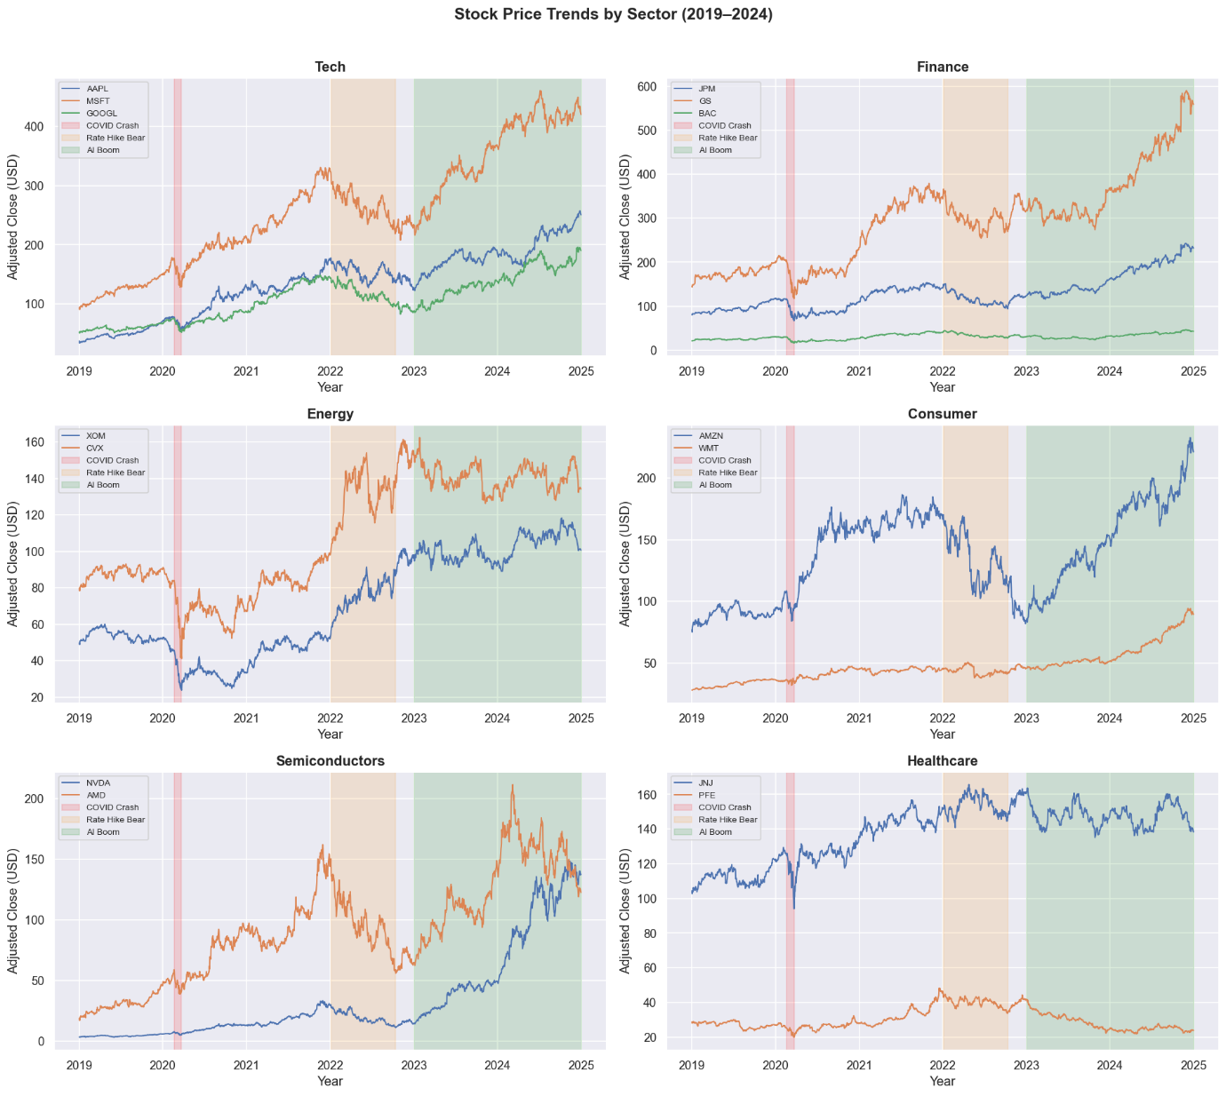
Exploratory Data Analysis
Looking at price trends from 2019 to 2024, different sectors told very different stories. NVDA ended the period at a completely different level than everything else. Tech and consumer stocks grew steadily. Energy held up in 2022 when most other sectors fell. Healthcare barely moved over the full 5 years. Every stock showed that big moves happened more often than they should. This means the data behaves differently from what most standard models assume, and those models become inaccurate when markets move the most.
Volatility was not stable over time. It jumped during the COVID crash in 2020, calmed down, then rose again in 2022 when interest rates were rising fast. Semiconductors stayed fluctuating the longest. Healthcare and energy were the calmest. Finance stocks moved similarly. Energy and tech had the least in common, driven by completely different factors. No two stocks moved in opposite directions consistently.

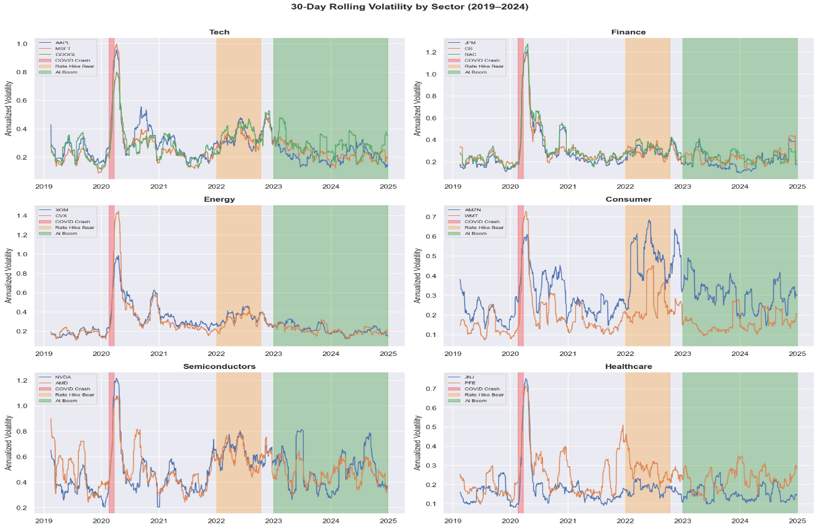
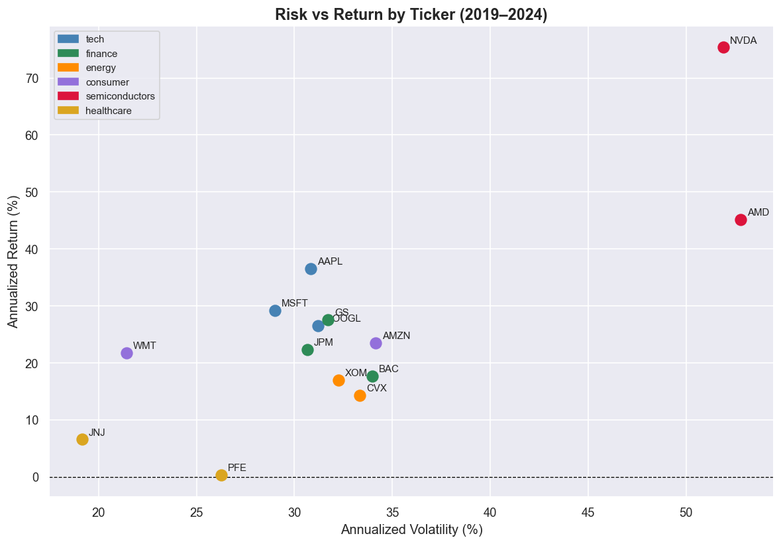

ARIMA Results
ARIMA is a classical time series model that tries to predict future values based on patterns in past values. Before fitting the model, I checked whether any pattern existed in past returns that the model could learn from, but I found almost none. Returns from yesterday carry almost no information about returns today. This is the core problem ARIMA faces on stock data.
Even with the best possible parameter settings I found through a search, the model did no better than just predicting zero every day. On a one step ahead forecast, ARIMA's error was actually slightly worse than the naive baseline. On a 30 day forward forecast, the model flatlined immediately, predicting the same near-zero number every single day regardless of what the market was doing.
The residual analysis confirmed why. The errors were not random. Big prediction errors clustered together, meaning when the model was wrong by a lot one day, it tended to be wrong by a lot the next day too. This volatility clustering is something ARIMA cannot model because it assumes the size of errors stays constant over time.
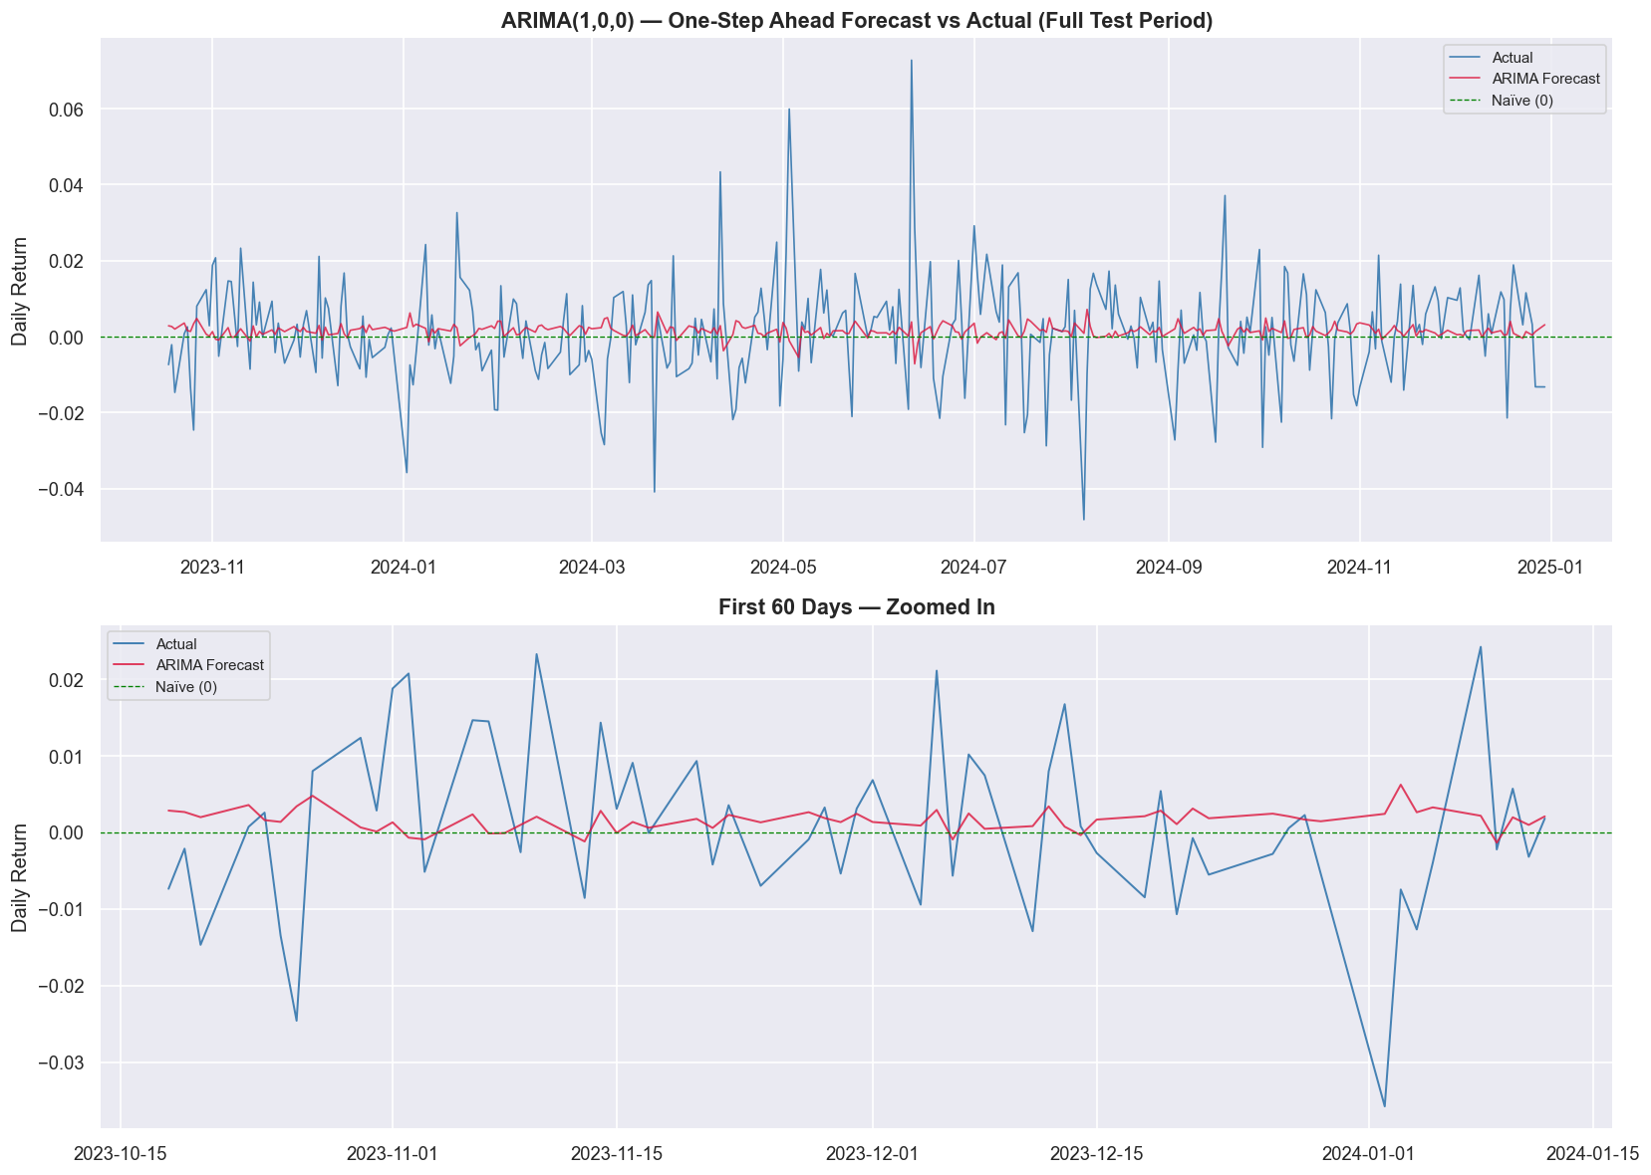

XGBoost Results
Unlike ARIMA, XGBoost can learn from multiple input features at once and does not assume any particular pattern in the data. This makes it better suited for stock returns, which as we saw are noisy, have fat tails, and show no consistent linear structure. The model was trained on all 14 stocks using the 9 features we built, then tested on data from October 2023 to December 2024. After tuning, it marginally matched the naive baseline but did not beat it convincingly. The forecast line tells us the same thing that ARIMA does, that it stays close to zero while actual returns swing around it.
Where XGBoost added real value was in the feature importance. Rolling volatility was the most important feature by a large margin, followed by short term lagged returns. The model is picking up on risk more than direction, meaning how much a stock has been moving recently is more useful than which way it moved. Performance varied across sectors. Tech, finance, consumer, and healthcare all showed small improvement over the naive baseline. Energy and semiconductors did not. Semiconductors were the hardest to predict because big moves in NVDA and AMD came from news and announcements, not anything visible in past price data.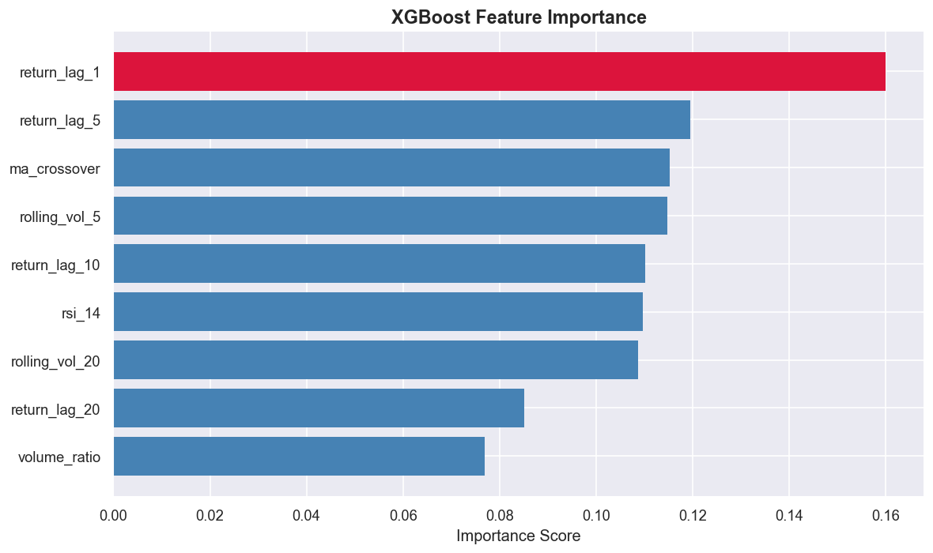
Model Comparison and Next Steps.
Both models told the same story. Neither one beat just predicting zero every day, and the margins were small enough that they do not matter in practice. ARIMA had almost nothing to learn from because stock returns do not follow a consistent pattern from one day to the next. XGBoost had more to work with but still could not find a clear enough signal to act on.
The honest takeaway is that 5 years of price and volume data for 14 stocks is not enough to predict where a stock goes tomorrow. That is not a flaw in the models. It is what the data is telling us. If I were to take this further, the first thing I would do is bring in different data. Not more price features, but things like earnings news, analyst updates, or broader market conditions. Those carry information that prices do not. The second thing I would look at is predicting over a longer horizon. One day ahead is the hardest version of this problem. A week or a month gives signals more room to play out.
