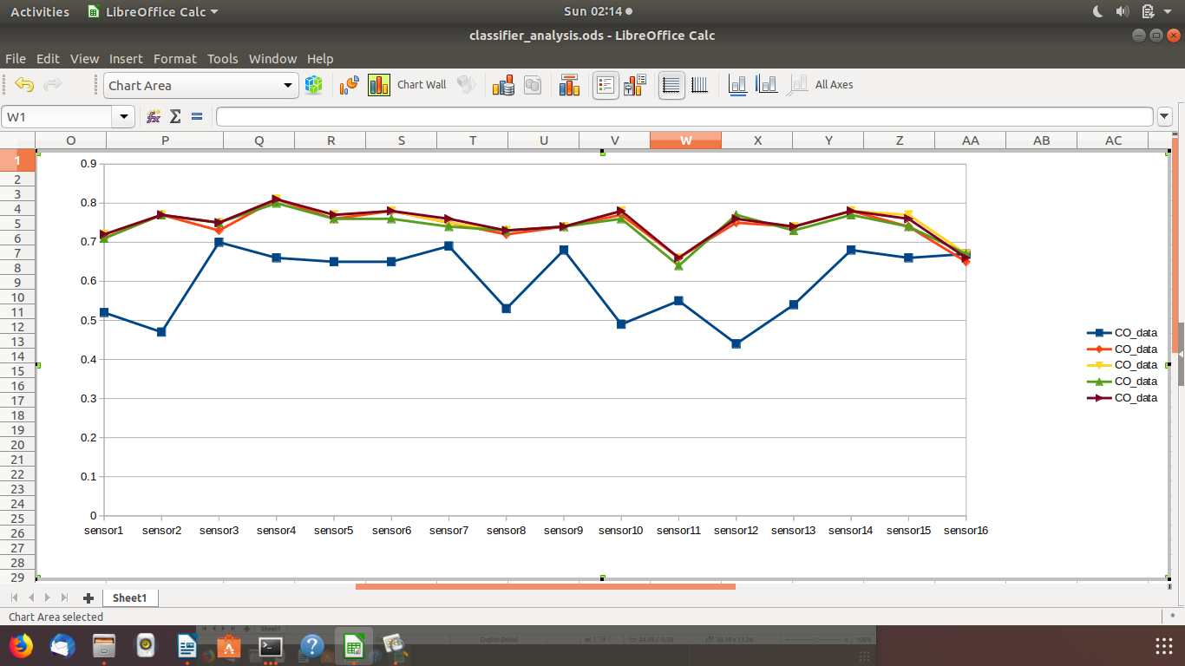

Fig 1:CO gas sensing accuracy from a series of sensors with different classifiers

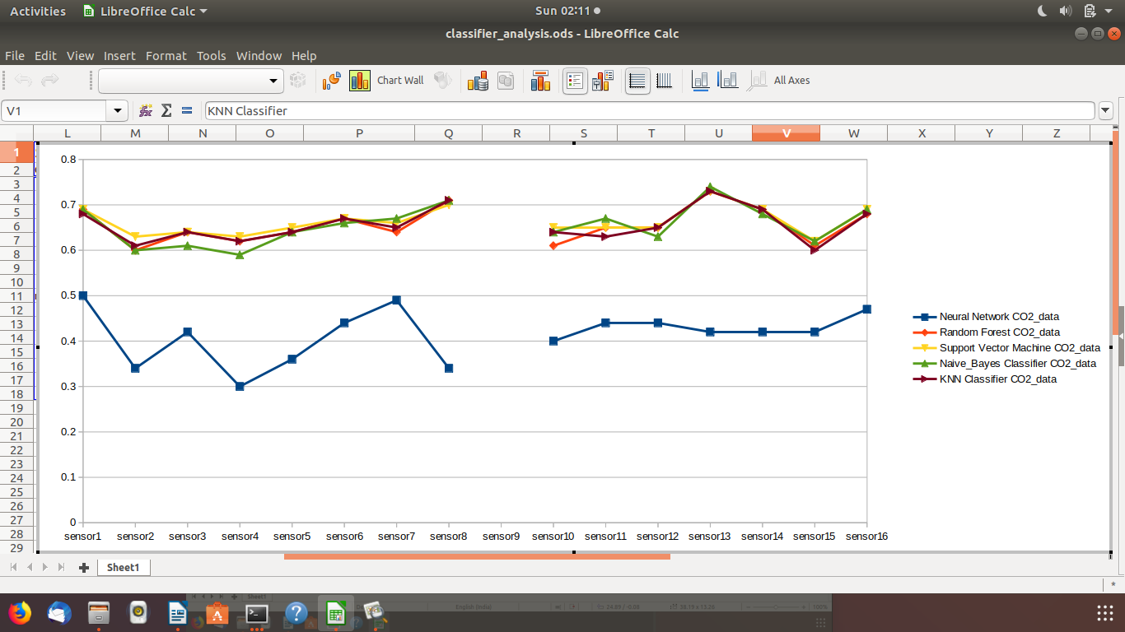

Fig2:CO2 gas sensing accuracy from a series of sensors with different classifiers

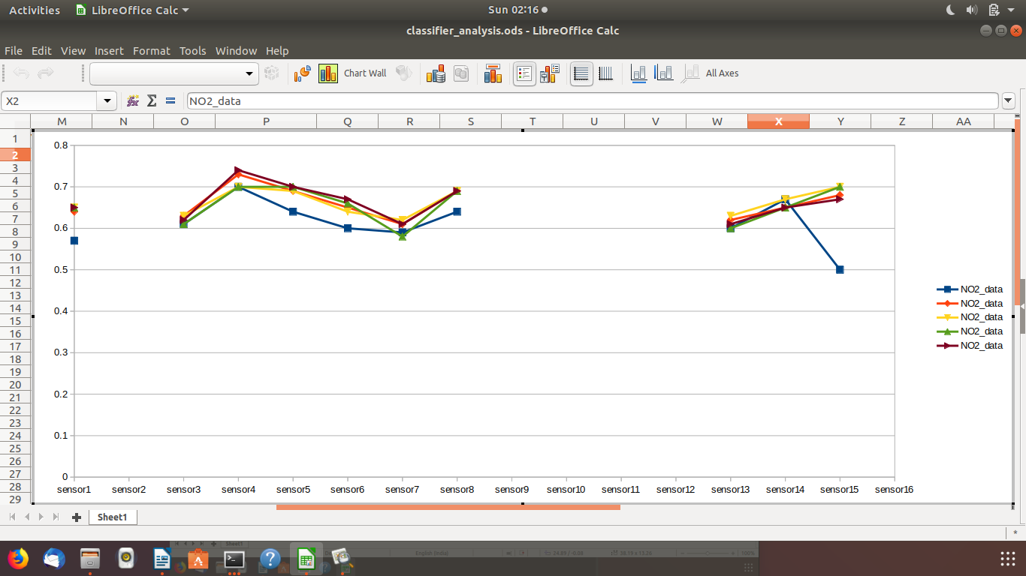
Fig3:NO2 gas sensing accuracy from a series of sensors with different classifiers

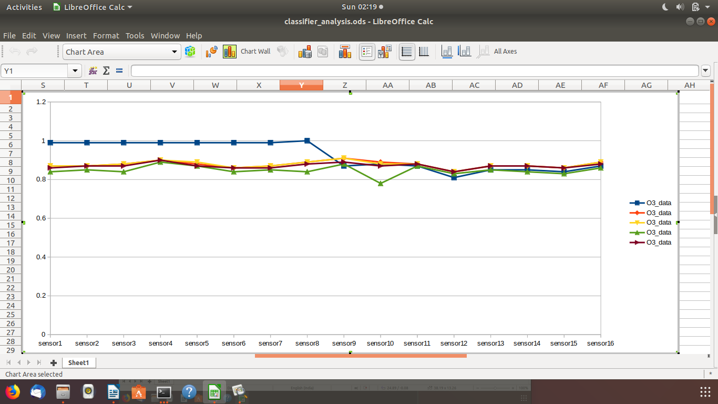

Fig4:O3 gas sensing accuracy from a series of sensors with different classifiers

In these four pictures about four sensing gases the each color line indicates the performance or accuracy of each classifiersmentioned in the assignment.

Blue line:-> Neural_network
Red line :-> KNN classifier
Orange line:-> Random Forest
Yellow line:-> SVM classifier
Green line :-> Bayes classifier

The neural network model that i created performs worst with CO and CO2 sensing but at per with other classifiers in NO2 sensing and outperform other classifiers in O3 sensing.

Among this 5 classifiers apart from neural network model other four classifiers works same with eachother very minute difference.

The accuracy score of measuring CO is highest for KNN among the proposed classifiers which is 0.76 but less than the article prescribed Random Forest Regression model which R2 score is 0.91.

The accuracy score of measuring CO2 is highest for svm among the proposed classifiers which is 0.65 but less than the article prescribed Random Forest Regression model which R2 score is 0.85 but much more than the R2 score of LAB and MLR.

The accuracy score of measuring NO2 is highest for svm among the proposed classifiers which is 0.68 which is greater than the article prescribed Random Forest Regression model which R2 score is 0.62.

The accuracy score of measuring O3 is highest for Neural Network classifier among the proposed classifiers which is 0.9 which is greater than the article prescribed Random Forest Regression model which R2 score is 0.86.

So overall, conclusion is a mixture of these classifiers and RF model Regressor is optimum for RAMP model as all are performing little bit ups and down for sensing different gases.

