**MD. SAZZAD AZIZ SOUROVE**

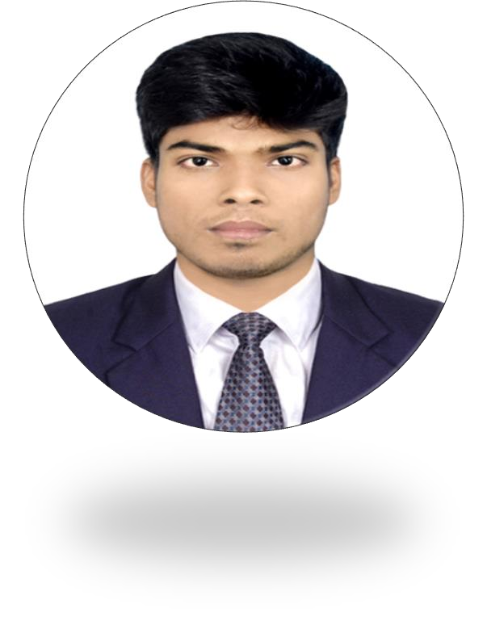

Diploma In Computer Engineering



CAREER OBJECTIVE

R E S U M E

Mailing Add:

C/O: Md. Azizur Rahaman

Vill: Nijampur, Post: Bajnahar, P.S: Birol, Dist: Dinajpur.

CONTECT:

Mailing Add:

.

☎ +88 01785 42 18 35

Vill: Nijampur, Post: Bajnahar,



[mdsourovekhankhan@gmail.com](mailto:mdsamiuli103@gmail.com)

Language:

English: Excellent Bangla: Mother Tonged

# To work in a dynamic, intensive environment, where the creativity and interest can be found to develop the skills as well as the career with a strong emphasis on sustained growth and development.

Academic Records

## Diploma-in-Engineering

* + Degree **:** Diploma-In-Computer- Engineering.
  + Department **:** Computer Science & Technology
  + Institute Name **:** Dinajpur Polytechnic Institute.
  + Board **:** Bangladesh Technical Education Board (BTEB), Dhaka.
  + Duration of Course **:** Four Years
  + Passing Year 2022

 CGPA **:** 3.81 (out of 4.00)

## Secondary School Certificate

* + Name of Institution **:** Birol Pilot Model High School.
  + Board **:** Dinajpur.
  + Passing Year 2018

 GPA **:** 4.11 (out of 5.00)

 Group **:** Science



Hobbies:

* READING
* WRITTING
* LEARNING

Industrial Tours:

**Organization Name:** Creative IT Institute **Venue:**

Dhaka.

## Duration:

Three Months

Personal Details

# Name **:** Md. Sazzad Aziz Sourove

* Father’s Name **:** Md. Azizur Rahman
* Mother’s Name **:** Mst. Shahanaj Pervin
* Permanent Address: Vill: Nijampur, Post: Bajnahar,

P.S: Birol, Dist: Dinajpur.

* Gender **:** Male
* Marital Status **:** Single
* Height **:** 5’-5”
* Weight **:** 60 kg
* Religion **:** Islam
* Blood Group **:** B+
* Nationality **:** Bangladeshi
* Date Of Birth : 29th Dec 2001
* Nid Number : 5563078764

REFERENCES:

|  |  |
| --- | --- |
| **1. Md. Jakaria Islam**  Sub. Assistant Engineer (PGCB)  Cell: +88 01785552462  Gmail: [300jakaria@gmail.com](mailto:300jakaria@gmail.com) | **2. Misbah Ur Rahman**  **(Misbah)**  Assistant Engineer, Electrical. MRT line-5 Nothern route. DMTCL.  Cell: +88 01622108010 |

Course Completed

## Microsoft Office

## Programming

## Web Design

sourav signature.jpg

Md. Sazzad Aziz Sourove

Date:............................