ENGINEERING DEVELOPMENT PLAN

RTL Design and
UVM Verification
  - A RISC-V-controlled accelerator data-movement subsystem
Revision / date: 0.1 / 05 September 2026
Audience: An engineer with RTL experience who is beginning structured verification
Planning assumption: One engineer, 20 focused hours per week; no simulator license or FPGA board assumed available
Build a dependable DMA and shared-memory subsystem, verify it independently, integrate a small processor and compute client, and then investigate one measured performance bottleneck.

The first useful release
- Two DMA channels, a banked SRAM subsystem, a simple compute client, and software control through an existing Ibex core.
- Reusable UVM agents, a specification-derived reference model, transaction scoreboards, assertions, coverage, and repeatable regressions.
- A qualified configuration on one FPGA target, with documented operating limits and integration evidence.

How to use the plan
Complete milestones in dependency order. Treat exit evidence as the gate; calendar estimates are for planning. Keep unsupported features explicit, retain an unchanged upstream baseline, and add one difficult feature at a time.
Expected duration: First FPGA-qualified release: approximately 5-8 months including a 25% planning reserve. Including an advanced extension and research campaign: approximately 7-12 months at 20 hours/week.
Claim boundary: This is a proposed project plan. It does not claim that RTL has been implemented, verified, or made ready for ASIC tapeout.

1. Freeze a bounded first release
The following values are proposed project limits, not AXI limits or an assertion that an upstream configuration already matches them. Confirm their feasibility in M0 before freezing the release profile.
Item | Proposed baseline
Control interface | 32-bit AXI4-Lite registers; aligned accesses and defined byte-strobe behavior.
Data interface | 64-bit AXI4 data, 32-bit addresses, INCR bursts; maximum 16 beats per burst.
Channels and outstanding work | One channel in M2; two channels in M4. M3 adds a bounded credit/ID scheme, initially up to four outstanding read bursts globally.
Transfers | Linear, 8-byte-aligned source/destination and byte length divisible by eight. Split at burst limits and 4 KiB boundaries.
Scratchpad | Proposed 32 KiB total across four 64-bit banks; exact mapping and access latency frozen in M0.
Compute client | Signed INT8 dot product, length 1-256, signed 32-bit result; fully specified packing and launch/completion behavior.
Clock and memory model | One functional clock domain. Uncached, non-coherent shared buffers with explicit software ownership.
Platform | Simulation first; FPGA RAM for the first hardware memory endpoint. External DDR is a later option.

Ownership and unsupported requests
- Reject zero-length DMA commands, unsupported alignment/length, address wrap, and overlapping source/destination ranges before issuing data traffic.
- Software owns buffer allocation. Active DMA and compute jobs use disjoint write regions; input buffers remain stable until their consumers finish. The testbench enforces this contract.
- Source/destination alias races across clients, cache coherence, atomics, Linux, a DDR controller, and a full neural-network accelerator are outside this first release.
- CDC, unaligned transfers, scatter/gather, 2D transfers, and new CPU microarchitecture are separately specified extensions.

2. RTL architecture and ownership
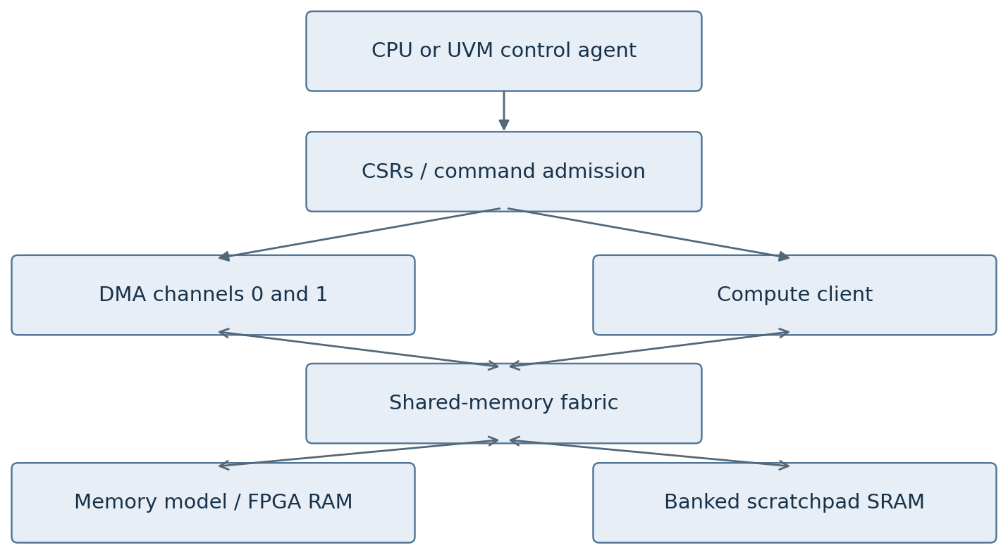
Figure 1. Control enters through registers. DMA and compute share the memory fabric; bidirectional arrows represent requests and responses. Interfaces require adapters where their widths or protocols differ.
Ownership | Responsibility
Reuse and pin | Selected PULP iDMA backend, applicable PULP AXI components, and an unchanged supported Ibex configuration. [S1-S3]
Develop and verify | Command frontend, channel scheduler, completion accounting, scratchpad integration, compute client, performance counters, and all new glue logic.
Replace deliberately | Implement one bounded existing block when a learning or measured performance objective justifies replacement; keep the prior implementation for comparison.
Package separately | Portable RTL and interfaces; upstream dependencies; verification; software; target-specific FPGA wrappers and constraints.

Initial leaf contracts should cover command queues, address/burst generation, credit tracking, response association, arbitration, memory-bank decoding, interrupt state, and the compute datapath. Each contract specifies accepted inputs, output meaning, latency/throughput, reset, errors, and parameter limits.

3. Verification architecture
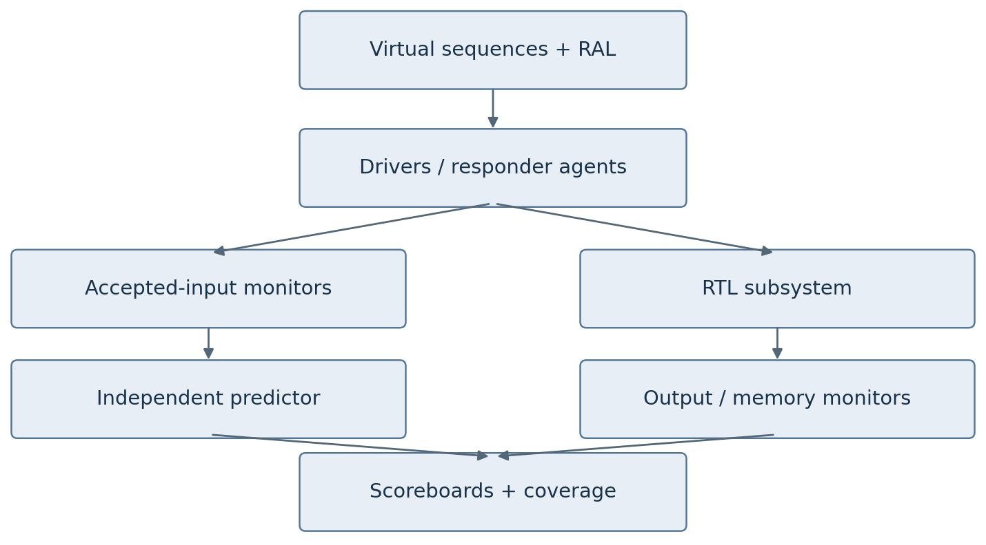
Figure 2. Prediction is driven by observed accepted inputs and specified behavior. Output monitors feed comparison independently. Protocol assertions bind to the relevant interfaces and internal invariants.
Component | What it checks or provides
Agents and RAL | AXI-Lite control, AXI memory response behavior, competing-client traffic, clock/reset, and interrupt monitoring. Register prediction observes bus effects.
Reference models | Independent byte-addressable memory/transfer model; simple integer compute oracle; later CPU ISS only if core behavior is being verified.
Scoreboards | Track descriptor/channel/ID context, permitted ordering, data conservation, destination results, errors, and terminal status.
Assertions and coverage | Handshake stability, resource accounting, routing and state invariants; requirement-linked functional coverage and reviewed code coverage.

Use OpenTitan as a methodology reference, not as code that can be copied unchanged onto AXI. The upstream processor, DMA, and the new subsystem have distinct verification boundaries. [S4]

4. Tools required at the start
Tool | Purpose / access decision
Full Questa One Sim / QuestaSim | Primary SV/UVM, randomization, SVA, DPI-C, coverage and debug. Confirm enabled license features in M0. PULP iDMA documents a native Questa simulation flow. [S1, S5]
SystemVerilog + UVM | Choose a simulator-supported UVM library and lock it. UVM 1.2 is a practical compatibility baseline for studying existing Ibex DV; do not casually upgrade borrowed environments. [S3, S11]
Git | Version RTL, specifications, scripts and dependency locks. Keep the unchanged baseline and each milestone reproducible.
Python + virtual environment | Reference models, stimulus files, regression orchestration and results analysis. Follow the pinned upstream Python requirements.
Make, Tcl, C/C++ compiler | Batch builds, simulator control, later DPI-C reference functions and software tests.
Bender / upstream build flow | Use PULP dependency manifests and locks for iDMA/AXI. Preserve upstream scripts and orchestrate them through thin project wrappers. [S1]
Verible and Verilator | Formatting/style and secondary RTL lint or selected smoke simulations. Qualify each supported flow; do not assume Verilator reproduces the complete upstream UVM regression. [S1, S7]

M0 capability probe
Run a tiny constrained-random UVM test, sample and report a covergroup, deliberately fail an SVA property, call a small DPI-C function, save and merge two coverage runs, and verify that a batch regression reports pass/fail correctly. Record the simulator, library and license-feature versions.
If no full simulator is available: Use EDA Playground with Riviera-PRO for small UVM exercises while arranging sustainable local/server access. Its hosted limits make it a learning bridge. [S6]
Edition distinction: The Altera FPGA/Starter edition does not provide the advanced verification features required here. Full non-FPGA Questa with appropriate features is the intended simulator. [S12]

5. Later tools, workstation and hardware
When | Tool / purpose
M2-M6: leaf formal | Questa Verify Property if licensed; alternatively SymbiYosys/Yosys for supported leaf RTL and properties. Prove small contracts first. Frontend support for SV/SVA varies. [S8, S9]
M7: processor integration | FuseSoC plus RISC-V GCC/binutils for the Ibex flow. Keep it separate from Bender dependency ownership. Spike/riscv-dv are additional tools if the core itself is studied or modified. [S3]
M7: FPGA qualification | Use the selected board vendor tools: synthesis, place-and-route, static timing and an embedded logic analyzer. Reuse an available suitable board.
M8: clock crossings | Structural CDC analysis and explicit synchronizer/FIFO constraints. Simulation assertions alone cannot establish metastability robustness.
M9: experiments | Python data analysis and plots; optional board power measurement or a qualified vendor power-estimation flow when making energy claims.

Workstation planning estimates
- Start on an existing 64-bit workstation. 16 GB RAM can support small exercises; 32 GB RAM and an SSD are a useful subsystem target. More RAM helps parallel regressions and FPGA implementation.
- A GPU is unnecessary for this project. Use an operating system supported by the actual commercial tool release; a supported Linux workstation/server is a practical default. Do not assume WSL is vendor-supported.
- A normal virtual environment is sufficient for Python. Containerization is optional and is not a project prerequisite.

Select a board after an early synthesis estimate
Check BRAM for the scratchpad plus CPU program/data memory, LUT/DSP headroom, supported clocking, JTAG, and UART. Start with FPGA RAM as the external-memory endpoint. Do not buy a board merely to begin UVM work. Hardware procurement and license lead times are calendar dependencies outside the active-hour estimates.
Spending order: Simulator access first; use existing compute hardware; select FPGA hardware at M7 readiness; add formal licenses or measurement equipment only for a defined gate or experiment.

6. Milestones and planning estimates
ID | Milestone | Hours | Exit artifact
M0 | Scope and baseline | 20-30 | Pinned build, capability probe, scope and ownership contracts
M1 | Reusable UVM foundations | 30-50 | Independent checking on a small project leaf; injected bugs detected
M2 | Single-channel DMA | 50-70 | Aligned transfers, burst splitting and byte-correct results
M3 | Outstanding work and recovery | 50-80 | ID tracking, errors, stop/drain, completions and reset contract
M4 | Two channels and shared SRAM | 50-80 | Contention, routing, bank conflicts and fairness checks
M5 | Compute client | 30-50 | Numerical agreement and DMA/compute ownership tests
M6 | Subsystem qualification | 50-80 | Requirements, coverage, assertions, selected formal and release candidate
M7 | Ibex and FPGA integration | 60-100 | Software workload, timing closure and sustained hardware tests
M8 | One advanced extension | 60-120 | Separately qualified CDC or 2D-transfer capability
M9 | Research campaign | 80-160 | Credible baseline comparisons and measured tradeoffs

Dependencies: M0 through M7 form the first-release path. M8 and M9 follow M7, but research need not depend on M8 if the chosen experiment uses the existing baseline. A second advanced extension receives its own estimate.
Outcome | Active effort | At 20 h/week, with 25% reserve
Standalone subsystem, M0-M6 | 280-440 h | About 18-28 weeks
FPGA-qualified first release, M0-M7 | 340-540 h | About 22-34 weeks (roughly 5-8 months)
One extension plus research, M0-M9 | 480-820 h | About 30-52 weeks (roughly 7-12 months)

These are engineering planning estimates for selective reuse and one engineer who already knows RTL. They include learning while implementing and debugging. Rewriting the complete AXI backend, learning a new board family, adding cache coherence, or pursuing ASIC signoff requires a new estimate. Reforecast after M1 and M3 using actual hours.

7. M0-M1: establish a trustworthy workflow

M0 - Scope and baseline
Effort: 20-30 hours
Make the intended system and toolchain concrete before expanding the RTL.
Build and learn: Choose one upstream iDMA configuration and dependency revision. Reproduce its native simulation. Record reused versus owned modules; freeze address ranges, alignment, burst limits, resource bounds, ownership, reset scope, command acceptance and error semantics. Identify the controlling Arm AXI specification and supported subset. [S1, S10]
Exit evidence: A clean-checkout build and known transfer run; successful simulator capability probe; tool/dependency lock file; architecture and interface draft; requirements with stable IDs; first testplan and open-issue list.

M1 - Reusable UVM foundations
Effort: 30-50 hours
Learn UVM on a small leaf that will remain in the project, such as a command queue with a CSR wrapper.
Build and learn: Create transaction classes, sequencer, driver, passive monitor, agent configuration, scoreboard and test. Add a register model where applicable. Exercise backpressure, reset and simultaneous push/pop behavior. Make the checker consume observed handshakes and independent expected results.
Exit evidence: Directed and constrained-random tests pass; boundary cases are covered; intentional data corruption and missing/duplicate events are detected. A reproducible failing seed and waveform explain each injected bug. Log UVM_ERROR/UVM_FATAL outcomes as regression failures.

Working habits to establish now
- Write a short behavior contract before modifying a module. Develop the checker from that contract.
- Keep smoke tests quick; add deeper tests when a feature creates a specific risk.
- Use a bug journal: symptom, minimal reproducer, root cause, fix, missing check and regression test.
- Review specification, RTL and DV at separate times; use an independent reviewer for gate closure when available.

8. M2-M3: transfers, ordering and recovery

M2 - Single-channel DMA
Effort: 50-70 hours
Deliver byte-correct aligned transfers with a comprehensible end-to-end checker.
Build and learn: Integrate the chosen backend and implement the command frontend, burst segmentation and buffer/control wrappers. Support 4 KiB splitting and the selected maximum burst length. Start with one outstanding operation and full-width beats. Specify command rejection and reserve terminal-result capacity before accepting work.
Exit evidence: Check minimum/maximum lengths, page/burst boundaries, source/destination limits, random delays and backpressure. Verify exact destination data and untouched surrounding memory. Inject a wrong address, lost beat and premature completion; show that independent checks fail.

M3 - Outstanding work and recovery
Effort: 50-80 hours
Add concurrency without losing transaction identity or protocol obligations.
Build and learn: Introduce bounded credits and IDs. Define read-response association and write-address/data ordering. Add read/write error handling, completion status, interrupt/W1C races, graceful STOP and coordinated reset. Keep success dependent on all required responses, including write responses.
Exit evidence: Exercise legal interleaving/reordering across IDs and required ordering within an ID; exhaust credits; delay responses; inject errors; stop at issue/data/response boundaries. Prove no premature success, orphaned accepted transaction or duplicate terminal event during ordinary operation.

Recovery semantics to specify explicitly
STOP stops new issuance and drains accepted transactions before reporting a stopped/partial result. A failed write response can leave destination data uncertain; no rollback is promised. Mark the affected destination range invalid for use until software repairs it. A stalled endpoint may prevent drain completion; a watchdog can report the fault but cannot make accepted AXI traffic disappear.
The baseline supports coordinated reset of all transaction participants. Reset invalidates in-flight work and unread results through a visible reset epoch; it is an explicit exception to ordinary exactly-once completion. Independently resetting a live DMA requires a later isolation/drain design.

9. M4-M5: shared resources and computation

M4 - Two channels and shared SRAM
Effort: 50-80 hours
Make simultaneous clients contend for resources while preserving correctness.
Build and learn: Add channel scheduling, scratchpad banks, response routing, and contention/stall counters. Define the baseline arbitration policy and tie breaking. Run concurrent jobs on disjoint buffers. Extend the scoreboard to track channel/descriptor/ID context and memory visibility.
Exit evidence: Cover simultaneous submission, same-bank and different-bank access, queue/credit saturation, stalled clients, error plus contention, and interrupt races. Verify routing and data preservation. Check fairness only under declared downstream service assumptions; preserve all M2-M3 regressions.

M5 - Deterministic compute client
Effort: 30-50 hours
Use a small workload to connect memory behavior with useful computation.
Build and learn: Implement signed INT8 dot products of 1-256 elements with a signed 32-bit result. Specify lane packing, source addresses, legal length, accumulator initialization, destination/result visibility and ownership transitions. Use the scratchpad; DMA moves data while computation uses other owned buffers.
Exit evidence: Compare against an independent integer Python/C model using zero, extrema, alternating signs and random operands. Maximum product sums for this length fit signed 32 bits. Test DMA/compute overlap on disjoint buffers, illegal launch, reset and delayed memory. Record task latency, stalls and resource use.

Define the software-visible job lifecycle
Software prepares inputs and descriptors, publishes a command, waits for terminal status, and then consumes valid outputs. An interrupt indicates a status condition, not unconditional success. Reserve completion storage before command acceptance, define acknowledgement behavior, and retain failure details until software reads or clears them.
The numerical oracle should model arithmetic, not the compute pipeline. The memory scoreboard should verify observable data movement, not duplicate the chosen arbiter schedule. Keep these checks independent so one shared assumption cannot mask both kinds of error.

10. M6-M7: qualification and FPGA integration

M6 - Qualify the standalone subsystem
Effort: 50-80 hours
Create evidence for one frozen configuration and its declared environment.
Build and learn: Close the requirements-to-test/checker/coverage map. Review functional and structural coverage gaps, assertions and lint. Apply formal to tractable leaves: queue conservation, one-hot grants, response routing and resource bounds. Check assertion antecedents to avoid vacuous passes. Package simulation, models, scripts, limits and known issues.
Exit evidence: All planned tests pass or have reviewed justified exclusions; no unexplained checker/assertion failures or critical lint issues. Each major invariant has an effective checker. Selected injected faults are caught; formal results state assumptions and bounds. A clean checkout reproduces the release candidate.

M7 - Ibex and FPGA integration
Effort: 60-100 hours
Demonstrate the subsystem under software control on one physical target.
Build and learn: Integrate an unchanged selected Ibex configuration with a protocol/width adapter, program/data memory, timer and UART. Use uncached shared memory with explicit buffer ownership. Preserve the Ibex FuseSoC flow and PULP build flow behind project scripts. Add C driver tests, clock/reset constraints and hardware counters. [S3]
Exit evidence: Software submits jobs, handles errors and verifies results. Synthesis/place-and-route close timing at a declared target; clocks and relevant paths are constrained, with reviewed exceptions. Repeat known-answer and sustained mixed-workload runs; archive logs, versions, resource reports and board configuration.

An FPGA-qualified release is a scoped claim
The release describes one parameter set, one tool profile, one target and tested operating conditions. ASIC adoption would additionally require technology-specific physical implementation, DFT, power/reset analysis and product-level qualification. Reusing a proven CPU does not transfer its verification evidence to changed glue logic or a new subsystem configuration.

11. M8-M9: extension and research

M8 - One advanced extension
Effort: 60-120 hours
Choose CDC or 2D transfers based on the next application need.
Build and learn: For CDC: introduce a second domain, asynchronous queues, reset/flush coordination, clock-stop behavior and physical synchronizer constraints. For 2D: specify rows, strides, address arithmetic, overflow rejection and row/burst/page splitting. Give the new feature its own requirement and verification matrix.
Exit evidence: New cases pass without weakening old checks. CDC receives structural review and reset/clock-ratio stress; 2D results match an independently generated memory image. Update supported configurations and limits. A second extension is separately budgeted.

M9 - Research campaign
Effort: 80-160 hours
Investigate predictable data movement under competing traffic, or another measured bottleneck.
Build and learn: Profile the baseline first. Select one hypothesis such as lower urgent-transfer tail latency with acceptable bulk-throughput and area cost. Compare the unchanged baseline, credible tuned alternatives, and the proposed design. Study prior work before claiming novelty. Use identical workloads, interface limits and implementation conditions.
Exit evidence: Publish reproducible data and scripts for throughput, latency distribution, stalls, resources, frequency and complete-task time. Include adverse cases and negative results. Explain the improvement, its cost and where it fails. Run correctness regressions on every candidate before performance comparison.

Candidate experiments
- Scheduling that reduces urgent-transfer delay while bulk DMA is active.
- Bank mapping or buffering that reduces scratchpad conflicts for a specific access pattern.
- Transfer scheduling matched to a compute client's data-consumption pattern.
- Improved fault isolation or diagnosis with bounded overhead and tested recovery semantics.
A measured tail-latency improvement is not a proof of a worst-case bound. A bound needs explicit service assumptions and appropriate analysis/proof. Energy claims need credible measurement or estimation; FPGA resource counts alone are insufficient.

12. What verification closure means here

Requirements and checking
- Every supported feature has a requirement ID, a behavior statement, a test or proof, a checker and an evidence reference.
- Data, routing, accepted-transaction counts, ordering, completion and reset semantics are independently checked. Protocol compliance is reviewed against the selected Arm specification. [S10]
- Known-answer tests and deliberate faults validate the oracle/checker path. Successful loopback alone is insufficient.

Coverage and progress
- Track requirement-linked coverpoints and selected crosses: channel count x burst boundary; outstanding depth x response delay; bank conflict x client mix; error type x job state; stop/reset x outstanding work.
- Review branch/FSM/toggle coverage and assertion coverage. Explain unreachable or unsupported bins. A percentage or seed count alone is not the release gate.
- Use progress properties only under stated environment assumptions. Keep safety checks valid even when the environment stalls indefinitely.

Release evidence package
Artifact | Minimum content
Specifications | Architecture, ports, registers, legal parameters, ownership, errors, stop/reset, performance envelope.
Verification | DV architecture, testplan, models, assertions, coverage report/exclusions, regression seeds and issue closure.
Implementation | RTL/dependency tags, tools, licenses/attribution inventory, timing/resource reports, constraints and reviewed exceptions.
Integration | Driver examples, build/run instructions, hardware logs, known limitations and reproducible benchmark procedure.

Review each release as a product configuration. A green upstream badge, successful synthesis, or a large randomized run count does not establish closure for your changes. Maintain a short signed or dated gate-review note stating the evidence reviewed and remaining exclusions.

13. First four weeks and working structure
At 20 hours/week, the first four weeks target M0-M1 and readiness to start M2. Do not expect a complete DMA subsystem in this interval.
Wk | Main work | Concrete result
1 | Confirm simulator access; run the capability probe; select upstream revision; reproduce smoke simulation. | Tool manifest, saved log, dependency lock and baseline tag.
2 | Map data/control flow; write scope and reset/ownership rules; draft requirement and test IDs. | Architecture sketch, module ownership list and reviewed first-leaf contract.
3 | Build UVM agent, monitor and independent scoreboard around the selected queue/CSR leaf. | Directed and random tests with reproducible pass/fail handling.
4 | Add assertions, functional coverage and reset/backpressure cases; inject bugs; review time spent. | M1 evidence, bug journal, revised M2 estimate and first DMA testplan.

Repository organization
Directory | Contents
docs/ | Architecture, specifications, testplan, decisions, milestones, release notes.
rtl/ and third_party/ | Owned RTL and pinned upstream code/manifests, clearly separated.
dv/ | Interfaces, agents, env, models, tests, assertions, formal harnesses and coverage.
sw/ and fpga/ | Drivers and workloads; target wrappers, constraints and build scripts.
scripts/ and results/ | Build/regression/report commands; small evidence summaries and artifact pointers.

Weekly rhythm: Approximately 3 h specification/review, 7 h RTL/integration, 7 h verification/debug and 3 h analysis/documentation. Shift more time to DV during closure.
Regression policy: Small deterministic smoke suite for every change; deeper seed/configuration runs on the licensed workstation/server. Preserve failing seeds and minimal reproducers; exclude giant wave databases from ordinary Git history.

14. Risks and decisions that control scope
Risk | Project response
Simulator or license gap | Resolve in M0 through actual feature probes. Use hosted tools for exercises only; do not base the full plan on unavailable functionality.
Excessive reuse or excessive rewriting | Name owned blocks. Reuse protocol infrastructure initially; replace a bounded block only for a specific learning or performance goal.
Reference model shares RTL mistakes | Derive behavior separately, observe handshakes, use independent known-answer vectors and targeted fault injection.
Ambiguous memory races | Use explicit noncoherent ownership and disjoint write regions. Define visibility and forbidden overlap before testing concurrency.
Stop/reset corrupts transactions | Drain accepted traffic on STOP; coordinate reset; invalidate partial output and reset-era jobs according to the contract.
Performance tuning breaks correctness | Run baseline regressions on each candidate before collecting performance data. Compare equal hardware/traffic constraints.
Board or DDR integration dominates | Select hardware after synthesis estimates; use FPGA RAM first; reserve DDR and new board ports for later work.
Feature expansion prevents release | Freeze M0-M7 scope. Put CDC, 2D, coherence, CPU changes and major security features behind separate milestones.

Decisions to record at M0
Simulator edition and actual features; UVM library; upstream commits; owning modules; AXI specification revision; supported parameter matrix; address map and SRAM bank mapping; accepted-command/result-capacity rules; stop/error/reset semantics; buffer ownership; weekly available hours. FPGA selection can remain open until M7 preparation.

How research becomes useful to others
Make the subsystem easy to reproduce and integrate. Present the workload, baseline, problem, improvement, cost, verification evidence and limitations together. A reusable verified block, a well-characterized fix, or a reproducible benchmark can be valuable outcomes even before a novel architecture emerges. Company adoption and patentable novelty are separate assessments, not promised milestones.

15. Primary references and usage
Sources checked for this plan on 05 September 2026. Upstream documents and tool capabilities change; pin the actual revisions and confirm the target configuration at M0. Proposed scope and effort estimates are this plan's engineering judgments.
S1 PULP iDMA: architecture, prerequisites and native simulation
Use the selected frontend/midend/backend configuration and its own dependencies; upstream tests do not replace new subsystem verification.
S2 PULP AXI: SystemVerilog communication components
Reference for applicable routing/adaptation components and native utilities.
S3 Ibex requirements and integration
Preserve upstream tool and UVM compatibility; qualify the selected processor integration.
S4 OpenTitan design-verification methodology
Reference for independent checking, layered DV, testplans and coverage discipline.
S5 Siemens Questa One Sim
Confirm the licensed verification, debug and coverage features needed by the project.
S6 EDA Playground FAQ
Hosted simulator access and resource limits for introductory exercises.
S7 Verilator language support
Review the pinned release's SystemVerilog, assertion and coverage support.
S8 Questa Verify Property
Commercial formal option; separate access may be required.
S9 SymbiYosys documentation
Open formal flow; full SV/SVA frontend capabilities are not implied by the free base installation.
S10 Arm AMBA AXI specification
Normative basis for the selected AXI interfaces; record the edition and supported subset.
S11 Accellera UVM distributions
Select a compatible standard library and freeze its version.
S12 Altera support: verification feature restrictions
Distinguish FPGA/Starter simulation from the full advanced-verification feature set.

