Laboratorial Work

Inverse Dynamics with Multivariable Control

The robot manipulators illustrated in the following two figures are equivalent to a SCARA configuration (RRP). This manipulator has three joints: the first two are revolute, and the other one is prismatic. As you can see in the two images, the only difference is the orientation of the manipulator relative to the inertial coordinate frame.

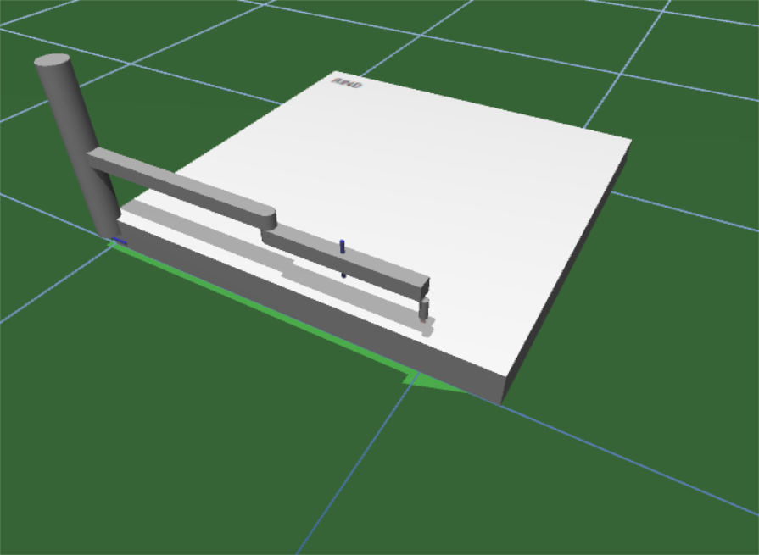 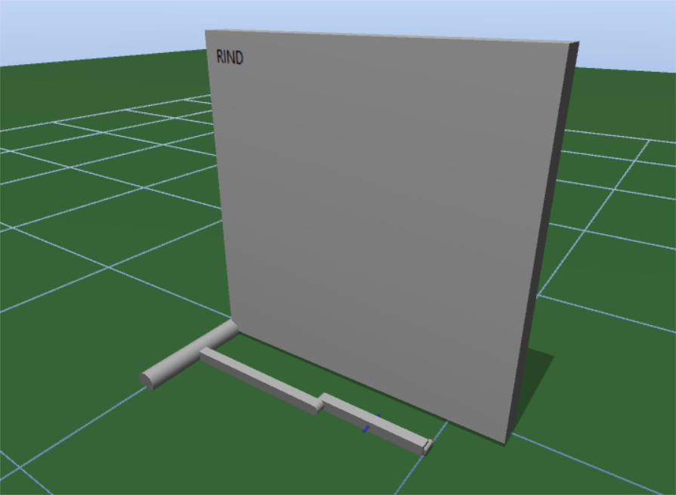

The main objective of this laboratory work is to implement the inverse dynamics control loop on the SCARA manipulators shown in the previous two figures. The manipulators are simulated in the SimTwo simulation environment.

Note that a practical application of inverse dynamics for the SCARA configuration is already exemplified in the slides presented in the theoretical class (and available in SIGARRA). Please review these slides before elaborating the laboratory work.

1. Analyze the code already implemented in SimTwo. There are functions available to compute the matrices and vectors require to implement the characteristic control loops of inverse dynamics.
2. Implement the inverse dynamics for the Horizontal SCARA (illustrated in the left image).
   1. Check if the orientation of the manipulator relative to the inertial frame is correct:
      1. Config > Control > Axis > RotUp: change the value in the right text box to 0 > SetRef.
      2. Sheet: change the value in the cell right next to *Vertical* to 0.
   2. Implement the inverse dynamics in the Control procedure (check the notes present in the code).
   3. Test the inverse dynamics:
      1. Sheet: Click button ID > Change Ref, Wn > Set
   4. Change the value of wn and observe the differences in terms of tracking error and transient response.

**Outer control loop: $a_{q}=-K_{0}q-K_{1}\dot{q}+r$** , where $r={\ddot{q}}^{d}+K_{0}q^{d}+K_{1}{\dot{q}}^{d}$

**Note:** we will set ${\ddot{q}}^{d}$ and ${\dot{q}}^{d}$ to 0 because we are only evaluating the inverse dynamics for set-point

**Inner control loop: $u=M\left(q\right)a_{q}+C\left(q,\dot{q}\right)\dot{q}+B\dot{q}+ϕ\left(q\right)$**

Useful SimTwo functions:

* Add two matrices $A+B$: MAdd( A: Matrix, B: Matrix): Matrix
* Subtract one matrix to another $A-B$: MSub( A: Matrix, B: Matrix): Matrix
* Multiply two matrices $A⋅B$: MMult(A: Matrix, B: Matrix): Matrix

1. Implement the inverse dynamics for the Vertical SCARA (illustrated in the right image).
   1. Change the orientation of the manipulator:
      1. Config > Control > Axis > RotUp: change the value in the right text box to 90 > SetRef.
      2. Sheet: change the value in the cell right next to *Vertical* to 1.
   2. Implement the inverse dynamics in the Control procedure (check the notes present in the code).
   3. Test the inverse dynamics.
   4. Change the value of wn and observe the differences in terms of tracking error and transient response.

Check the slides presented in the theoretical slides to know the impact of changing the orientation of the manipulator relative to the inertial coordinate frame.

1. Change the inner control loop to only consider the compensation of the gravity effect. Observe the behavior of the robot manipulators (horizontal and vertical orientations) when you interact directly with the links.

**Inner control loop: $u=ϕ\left(q\right)$**