PDEEC - TRP presentation and discussion - Ricardo Barbosa Sousa

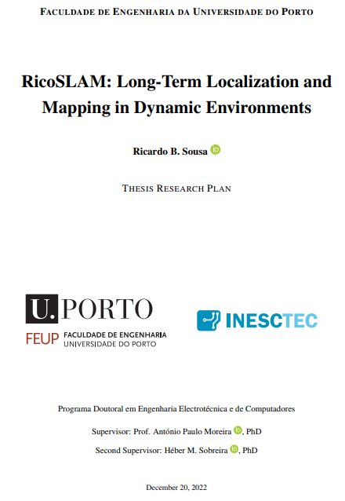

January 12th, at 3:30 p.m. (Portugal time) - zoom meeting

Supervisory Committee:
PDEEC Scientific Committee: Prof. Luis Miguel Pinho de Almeida
Supervisor: Prof. António Paulo Gomes Mendes Moreira – FEUP/DEEC
Co-supervisor: Doutor Héber Miguel Sobreira – INESC TEC
FEUP member: Prof. Paulo José Cerqueira Gomes da Costa
External member: Dr. Rob Deaves – Dyson (UK)

Overview: The document is very well structured and written! GREAT WORK!
For impact of the research would an image sensor + AI be useful to identify dynamic objects and label them as static / dynamic before the dynamic behaviour is observed? This could be an enhancement later!
Should the research focus on finding static objects that are good for localisation … and then use sensor to re-observe everything else? Just a thought!
- The labelling referred is already present in the literature by using networks such as YOLO to identify the semantic classes of objects (e.g., cars, poles, pedestrian, cyclist, etc.), and then, assume the dynamics properties of those classes between static or dynamic
- However, those same methods have the limitation of not recognizing if a dynamic object is indeed dynamic, in the sense that, if it remains in the same position temporarily, may be used for the localization also temporarily but the methods ignore that possibility
- This PhD proposal does not assume prior knowledge on dynamic properties of the objects. But yes, using AI could be an interesting way to achieve the goal of determining the dynamics of the environment
- As for image sensors, we also consider them in the sense of obtaining range and bearing data, given that data is less affected by appearance variance of the environment (lighting conditions, weather and seasonal changes), especially indoors. The focus of this work is on dealing with changing elements in the scene

ID: #1
Document Position: Abstract
Comment: You can buy commercial products, e.g. the Dyson 360Heurist, that can deal with long-term mapping in the home. How is the research extending this?
- Dyson 360 Heurist (https://www.dyson.co.uk/vacuum-cleaners/robot-vacuums/dyson-360-heurist/dyson-360-heurist-overview)
  - Intelligent SLAM vision system
  - Seems to be feature-based, with corners + edges home environment in terms of walls plus semantic features in terms of objects (furniture, objects, etc.)?
  - From my understanding, and reading the Dyson Robotics Lab project, it has research on object-level SLAM, but the long-term mapping is in terms of assuming that shoes, chairs are dynamic objects, and tables are more “static”?
- First, this PhD proposal does not focus only on vision sensors, this thesis intends to explore other sensor modalities such as 2D/3D lasers
- As for this proposal, if you are saying that 360 Heurist defines certain semantic classes as dynamic and others as static, the goal is what about using the shoe observation temporarily? If the shoe remains static in the same location for consecutive days, the localization may leverage on the respective observations to try to improve its accuracy

ID: #2
Document Position: Content
Comment: The document is well written and structured. I especially like defining the ‘Thesis Statement’! This is often missing from PhDs these days!!
- The statement was a way to not only for the readers but also for ourselves, me and the supervisors, to understand better the problem at hand and trying to formulate it formally. Although in the literature review certain gaps were identified, the statement allowed a focus of the proposal on a certain problem that is improving the long-term autonomy of mobile robotic systems in dynamic indoor environments by estimating the dynamics of the environment and incorporate them in the localization and mapping processes
- However, the statement is expected to be refined throughout the thesis, by being more comfortable on the topic of SLAM and specially on the perception and estimation of the environment dynamics

ID: #3
Document Position: Introduction, Page 2
Comment: The single pass statement … theoretically, the sensor/platform noise have to be low to get a good map in a single pass!
Theoretically, after the ‘single pass’ is this truly SLAM? Or is it Localisation?
- That statement is only theoretical. From a theoretical point-of-view, without considering sensor noise and limited resolution, the robot would only need a single pass in a static environment to map the different scene elements and then perform localization continuously throughout time, given that the map would not change in a static environment
- In that hypothetical case, indeed would not even be considered SLAM, would be the more traditional case of AMR systems in today’s industrial applications in which an operator only performs SLAM a single time to obtain a map, and then is localization-only

ID: #4
Document Position: Introduction, Page 2
Comment: Computational load … are we looking at on-board processing only?
- Yes, the ever-growing problem identified in the introduction – context is more evident considering only processing resources on-board of the mobile robot
- However, even if considered cloud and edge devices for outsourcing of computational tasks, the problem would still exist, with the map continuously growing even though the robot is passing through the same environment and, possibly, with few modifications
- This problem is more evident in pose graph formulations of the SLAM problem. While in occupancy grid-based implementations there is a fixed size map (of course, with its own limitations) the map can be updated several times but its size remains constant, pose graph updates must either add a node to the graph for new observations, or change existent nodes, but it is more difficult to control the graph size in terms of why do I add this node and remove the other one? Is it because of outdated information or redundant information?
- The case of feature-based maps may also occur in the sense that the mapping algorithms may not be able to determine if a new feature is unique and not present in the current map, adding features to the map representation increasing its respective size
- But yes, cloud and/or edge computational resources reduce the importance of this problem (ever-growing map)

ID: #5
Document Position: Introduction, Page 3
Comment: Interesting point here … do you just keep key frames from the static map for localisation … everything else static/dynamic can be re-observed with sensor?
- Yes, the idea would be the map saves the static features and maintains a temporally sliding window for the current features (that may be static or dynamic ones), and only the static features would be used for localization
- In a sliding window approach, dynamic features can be perceived by having velocity (different global positions in the window frames) – e.g., dynamic detection through geometric verification between different frames –, occlusions, etc.
- (side note) not entirely comfortable with the keyframe framework, but in keyframe SLAM, a keyframe is the perceived features at a certain time instant. The co-visibility graph defines the co-observability of the same features between different keyframes. And then, there is also the feature map, in which the mapped features (also defined as landmarks when these are represented in the map) may be, e.g., features present in 3 or more keyframes

ID: #6
Document Position: Introduction, Page 4
Comment: For some environments … e.g. industrial plants, what about introducing artificial/identifiable features!
- One possibility could be, e.g., ArUcOs or similar technologies put onto the plant floor
- However, the feedback obtained from industrial partners is that introducing artificial features have several maintenance and installation costs. The laser reflectors features are the most popular ones, but for virtual warehousing strategies, those features would decrease the flexibility in changing at any time the storing areas, limits, etc.
- Although ArUcOs could be a possibility, due to the dust and dirty environment characteristics of some industries such as logistics and automotive, the reliability could not be high (dirty onto the marker, heavy robots and vehicles passing on top of the markers may degrade them, etc.)…
- Thus, the need to leveraging the observations on temporary static features on industrial environments in addition to the more static and reliable ones given by the walls and pillars of the warehouses / factories

ID: #7
Document Position: Introduction, Page 4
Comment: Great to see sustainable goals in there! As well as 8, 9, 12. I think robotics can play a part in others as well, e.g. 13 Climate Action … robots supporting this: Q-Bot!
- Given the time frame of a PhD thesis, in our case we foresee three years, we thought it was important to frame the thesis not only on internal goals (in terms of the host institution, INESC TEC), but also on more global ones, not only the sustainable goals from Agenda 2030 but also on the SRIDA agenda elaborated by several European institutions associated to AI and robotics fields
- In the specific case of Agenda 2030, this PhD thesis falls under those 3 goals, 8, 9, and 12
- But yes, the Q-bot, by improving house insulation, can reduce the energy consumption on housing (for heating management), and thus, play a part on climate action
- Also, thanks of course for your note, I did not know this robot prior to your suggestion

ID: #8
Document Position: Introduction, Page 5, Figure 1.2
Comment: There may be more dotted lines here!
- Dotted lines in what sense? Optional steps?
- The figure was adapted from Peffers’ work on a design science research methodology for information systems research
- Although the figure defines a sequential methodology, the original work states indeed that the researches are not always obligated to always proceed sequentially from the first (Identify Problem & Motivate) to sixth (Communication) activity. The researchers may enter the methodology at any activity and then move forward

ID: #9
Document Position: Literature Review, Page 8
Comment: It was great to go through the literature review a few weeks ago! Is that part of the TRP? I really like the systematic approach to searching. Is there a risk of missing something useful outside the ‘key words’?
- If the query is not appropriate to the topic at hand, yes there is a risk of the obtained results may only be a percentage of the ones obtained with the right query or through exhaustive searching
- In our case, we tried to reduce that risk by not formulating a very specific query (e.g., not using WITHIN or PRE – proximity search operators –, use of the * wildcard)
- Given the topic of long-term localization and mapping, first, we tried by a first literature analysis knowing synonyms for long-term in the context of SLAM / localization and mapping. Then, although we refer several times in the review and in the TRP the term robot, we know there are other synonyms, that is why the possibility in the query for searching by the robot and vehicle words and possible variants (robotics, robots, vehicles, etc.)
- One possibility we also tried was not considering the “locali* AND map*”. Why? Because some works may focus only on the localization process, and similar for the mapping process. However, we given some stats here:
  - Query: (robot* OR vehicle*) AND ((locali* AND map*) OR "slam") AND ("long term" OR "life long" OR lifelong)
    - #results in Scopus: 580 results
  - Query: (robot* OR vehicle*) AND ((locali* OR map*) OR "slam") AND ("long term" OR "life long" OR lifelong)
    - #results in Scopus: 2669 results
  - Date: January 10, 2023
  - Extensive number of results in the second case, and possible, if the authors did not referred localization and mapping in TITLE-ABS-KEY or not indexed, probably, the work would not be interesting
- So, the risk exists but, at least, with a systematic methodology, we can infer the limitations of the methodology and the scope of the results. With an exhaustive method, by reading works and searching the cited references, when would we know that enough is enough?
- Also, by not limiting the year range, we also think that reduces that risk
- The SLR is put as an appendix to the TRP. Only a link is put on the appendix because then the TRP would have more than 100 pages. So, the link is there if anyone is interested in the preprint version of the review

ID: #10
Document Position: Literature Review, Page 8
Comment: It was great to go through the literature review a few weeks ago! Is that part of the TRP? I really like the systematic approach to searching. Is there a risk of missing something useful outside the ‘key words’?
(repeated)

ID: #11
Document Position: Literature Review, Page 10, Figure 2.2
Comment: There are a lot more conferences and publications in 2022 than in 2002. Would a normalised view be useful?
- Although there are more conferences and journals in 2022 than in 2002, that difference does not mean that the authors
- Especially in robotics, the most popular conferences are still IROS (since 1988) and ICRA (1984), evident in the conference statistics presented in the SLR (systematic literature review)
- Although not presented in the TRP, given that only includes the 142 works analyzed in the SLR, the evolution of those 142 works throughout time is still approximately linear
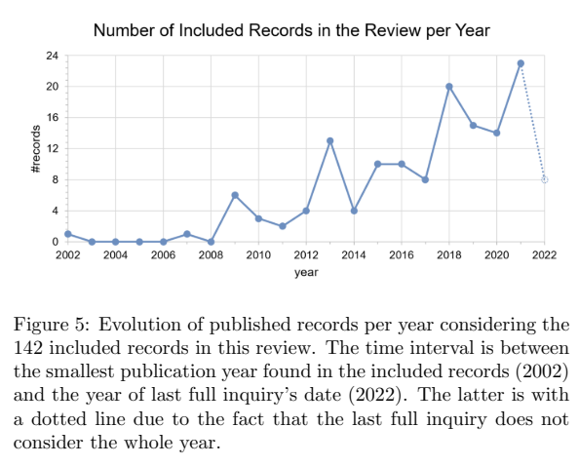
- This figure, even though it is not normalized, still follows the same linear trend noted in the TRP
- As for the number of publications being greater in 2022 than in 2002, yes that is true and very influenced by the academic indexes based on h-index and similar required for
- But still, figure 5 presented in the SLR tries to reduce that influence by ignoring the duplicated works or ones that were the base for an extension article
- Note: we did not include this figure in the TRP given that we thought that the date of the last fully inquiry, in May 2022, was a little outdated relative to the TRP submission (December 2022), so, we preferred to formulate an unfiltered figure as presented in the TRP

ID: #12
Document Position: Literature Review, Page 11, Figure 2.3
Comment: Where there any multiple-hypothesis schemes also?
- The schemes presented in Figure 2.3 is the more general formulations of the problem, in terms of the SLAM estimation tries to compute the whole robot trajectory (full) or only the current pose
- The multiple-hypothesis schemes may be the particle filter implementation of the full SLAM problem, in which each particle maintains a hypothesis on the robot’s trajectory, features correspondences, etc., and its probability may increase in time or not depending on the control inputs and sensor observations through time

ID: #13
Document Position: Research Questions, Page 28
Comment: Parametrising could get rid of calibration or reduce it or detect when calibration is lost due to knocks, repair (re-seating a sensor), damages also!
- Parametrizing? Did not fully understand the context of this question

ID: #14
Document Position: Research Questions, Page 29
Comment: Do you need to observe dynamic behaviour to know that it is dynamic! DenseSLAM with AI would allow you identify say shoes (dynamic) and door frame (static) without them moving!
- But in that case you are assuming the shoes will be dynamic observations. What if the shoes remain in the same place for consecutive days? Why not use the respective sensor observations on the shoe for localization?

ID: #15
Document Position: Research Questions, Page 29 / 30
Comment: Being Bayesian … is there any priors to static/dynamic objects? If I look upwards (vertically) in the home I see the ceiling, room corners etc… static, if I look horizontally I see chair legs etc … more dynamic!
Should this be in the model?
- I do not think the Bayesian term is directly referred in the thesis statement, the mathematical formulation yes is based on the Bayesian conditional probability
- One possible prior we foresee that could be interesting is given by the operator. For example, if the operator knows that certain areas / volume spaces are predicted to be more dynamic, he /she could input that prior information into the model

ID: #16
Document Position: Preliminary Developments, Page 33
Comment: Could we detect dirt on a visor / lens!
- The topic of sensor failure detection / status supervision is not considered in this PhD proposal, although yes it may happen, but we assume other modules in the AMR system should detect that

ID: #17
Document Position: Research Plan, Page 42
Comment: Should you include Industrial Dissemination … presentation on-line/off-line?
- Although not very clearly stated in the dissemination section (it is stated in 5.1 Tasks and Timeline), this PhD thesis proposal has also a close relation with the GreenAuto project from the European Union (EU) Recovery and Resilience Plan, in which INESC TEC participates in for the topic of long-term SLAM
- So, we expect to proliferate the results of this PhD thesis in the industrial context through the GreenAuto project (https://transparencia.gov.pt/pt/fundos-europeus/prr/beneficiarios-projetos/projeto/02-C05-i01.02-2022.PC644867037-00000013) that also has a subsidiary of Stellantis group (PEUGEOT CITRÖEN AUTOMÓVEIS PORTUGAL, S.A.) as a financial beneficiary
- Possibly, other future partnerships may be formulated as a consequence of the results obtained in this PhD thesis proposal, not only industrial but also academic ones, but, for now, the GreenAuto project is the more important industrial dissemination platform related to this thesis

ID: #18
Document Position: Research Plan, Page 44
Comment: Don’t become a slave to the plan!! Don’t be afraid to review it regularly and adapt/change it if required!!
- We know that the plan is an intention, but several unforeseen events or other factors may result in its alteration
- The fact that the plan itself is formulated to three years instead of two is one of those reasons, to try to accommodate possible unforeseen circumstances or even possible failures in certain research lines

Thank you very much Rob for your notes, very interesting and good discussion!

