HRMOS Spectra Simulator
ESPRESSO to HRMOS Translator

Sérgio G. Sousa – March 2025
Table of Contents
Introduction 3
Goal 3
Short description 3
Assumptions used for the scripts 3
Spectra Data Format 4
Radial Velocity Tests 5
ESPRESSO test data 5
Results on HRMOS spectra 5
SNR Peak at 100 6
SNR peak at 50 7

Introduction

Goal
The goal of this scripts was to simulate HRMOS spectra for testing purposes. The tests have two fundamental goals:
- Checking the RV precision that we could obtain from HRMOS like spectra using the CCF technique
- Be able to create test data with RV signals that could be used for exoplanet detection simulations

Short description
The code is divided into three main scripts:
- spectra translator: Currently being able to translate ESPRESSO HR observations to HRMOS like spectra with lower SNR and Resolution ~80000
- spectra synthetic: Currently being able to create HRMOS like spectra starting from a synthetic input spectrum and introducing an RV shift.
- calculate ccf radial velocity: Uses HRMOS like spectra and the CCF technique similar to the ESPRESSO DRP procedure to calculate precise radial velocities

Assumptions used for the scripts
There are a list of several assumptions done in this first draft of the scripts. The most important are the following:
- Spectral resolution, R ~ 80000
- Spectral pixel sampling ~ 2.7 (considered as the average value for each spectral band)
- Spectral bands are covering the following ranges:
  - B band: 383-417 nm
  - G band: 498-542 nm
  - R1 band: 556-604 nm (optional band)
  - R2 band: 623- 677 nm

Spectra Data Format
The HRMOS like spectra is stored in a fits file with 5 extensions:
Index | Name | Data Type | Description
0 | Primary | Empty Image | Stores the original ESPRESSO header keywords
1 | B | Binary Table | HRMOS fits table for the blue band
2 | G | Binary Table | HRMOS fits table for the green band
3 | R1 | Binary Table | HRMOS fits table for the red band
4 | R2 | Binary Table | HRMOS fits table for the red band (alternative red band)

The HRMOS fits table has the following columns:
- wavelength: in Angstroms, following the defined pixel sampling of ~ 2.7 (adjustable by the script)
- flux: the flux counting, assuming a resolution of ~ 80000 (adjustable by the script)
- error: the error of the flux which is assumed to come only from photon counting and computed from the SNR
- blaze: The assumed blaze function model for the spectra
- dll: The individual wavelength dispersion pixel content
- quality: A quality flag (currently zero by default)

Radial Velocity Tests

ESPRESSO test data
This test was done by randomly selecting 9 exposures taken with ESPRESSO in HR mode of the tau Ceti star. This is a well know benchmark star for RV surveys which shows very small RV amplitude. The spectra translator works with S1D reduced spectrum. The following data was used here:
dfits *.fits | fitsort "HIERARCH ESO INS MODE" OBJECT EXPTIME
FILE HIERARCH ESO INS MODE OBJECT EXPTIME
r.ESPRE.2023-01-04T01:23:43.489_S1D_A.fits SINGLEHR tau Cet 40.
r.ESPRE.2023-01-08T01:26:34.892_S1D_A.fits SINGLEHR tau Cet 40.
r.ESPRE.2023-01-08T01:30:19.668_S1D_A.fits SINGLEHR tau Cet 40.
r.ESPRE.2023-01-08T01:34:03.694_S1D_A.fits SINGLEHR tau Cet 40.
r.ESPRE.2023-01-14T01:37:01.620_S1D_A.fits SINGLEHR tau Cet 40.
r.ESPRE.2023-01-21T01:03:30.978_S1D_A.fits SINGLEHR tau Cet 40.
r.ESPRE.2023-01-21T01:07:16.109_S1D_A.fits SINGLEHR tau Cet 40.
r.ESPRE.2023-01-21T01:09:46.219_S1D_A.fits SINGLEHR tau Cet 40.
r.ESPRE.2023-02-03T01:25:43.775_S1D_A.fits SINGLEHR tau Cet 40.

Results on HRMOS spectra
There were two sets of translations with different peak SNR done to access the effect on the precision on RV with HRMOS data using the standard CCF technique.
The SNR peak distribution for each band is adapted from the information provided by the HRMOS ETC for a G2 star, V=9, observed for 3600s:
Band | SNR Peak
B | 680
G | 1080
R1 | 1200
R2 | 1328

The RV is computed only using three bands in this test (B, G, and R2).
The CCF curve is a co-addition of the individual CCF for each of the bands.
The mask used for the CCF computation is the same one used in ESPRESSO (ESPRESSO_G2.fits).

SNR Peak at 100
The following table shows the results for the RV obtained assuming the peak SNR at 100:
peak SNRs for each band are 51, 81, 90, 100 respectively.
This shows the results of the RV calculation for the test data using bands B, G and R2:
File | RV_hrmos | eRV_hrmos | RVo | eRVo
r.HRMOS.2023-01-21T01:03:30.978.fits | -16.56096 | 0.00355 | -16.66292 | 0.00011
r.HRMOS.2023-01-21T01:07:16.109.fits | -16.55880 | 0.00356 | -16.66284 | 0.00013
r.HRMOS.2023-01-14T01:37:01.620.fits | -16.55885 | 0.00352 | -16.66368 | 0.00011
r.HRMOS.2023-02-03T01:25:43.775.fits | -16.55892 | 0.00358 | -16.66209 | 0.00014
r.HRMOS.2023-01-08T01:26:34.892.fits | -16.56061 | 0.00354 | -16.66418 | 0.00010
r.HRMOS.2023-01-04T01:23:43.489.fits | -16.55931 | 0.00354 | -16.66421 | 0.00011
r.HRMOS.2023-01-08T01:30:19.668.fits | -16.56090 | 0.00356 | -16.66418 | 0.00010
r.HRMOS.2023-01-21T01:09:46.219.fits | -16.56499 | 0.00356 | -16.66290 | 0.00014
r.HRMOS.2023-01-08T01:34:03.694.fits | -16.55944 | 0.00355 | -16.66418 | 0.00010

Summary:
RV std: 1.8 m/s
error RV average: 3.6 m/s
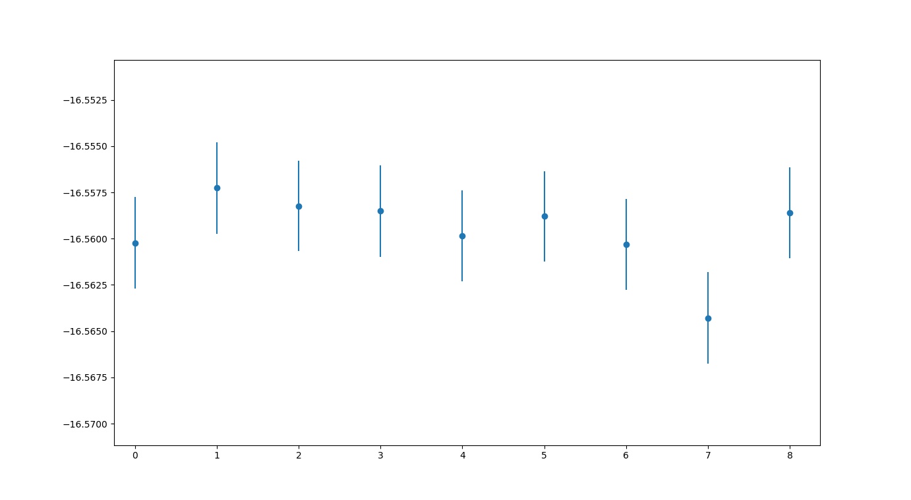

SNR peak at 50
The following table shows the results for the RV obtained assuming the peak SNR at 50:
peak SNRs for each band are 25, 40, 45, and 50 respectively.
This shows the results of the RV calculation for the test data using bands B, G and R2:
File | RV_hrmos | eRV_hrmos | RVo | eRVo
r.HRMOS.2023-01-21T01:03:30.978.fits | -16.56236 | 0.00709 | -16.66292 | 0.00011
r.HRMOS.2023-01-21T01:07:16.109.fits | -16.56839 | 0.00714 | -16.66284 | 0.00013
r.HRMOS.2023-01-14T01:37:01.620.fits | -16.56285 | 0.00705 | -16.66368 | 0.00011
r.HRMOS.2023-02-03T01:25:43.775.fits | -16.55774 | 0.00714 | -16.66209 | 0.00014
r.HRMOS.2023-01-08T01:26:34.892.fits | -16.56196 | 0.00711 | -16.66418 | 0.00010
r.HRMOS.2023-01-04T01:23:43.489.fits | -16.57022 | 0.00709 | -16.66421 | 0.00011
r.HRMOS.2023-01-08T01:30:19.668.fits | -16.55744 | 0.00710 | -16.66418 | 0.00010
r.HRMOS.2023-01-21T01:09:46.219.fits | -16.56082 | 0.00711 | -16.66290 | 0.00014
r.HRMOS.2023-01-08T01:34:03.694.fits | -16.57320 | 0.00707 | -16.66418 | 0.00010
Summary:
RV std: 5.2 m/s
error RV average: 7.1 m/s
