💳 Family Expense Tracker
Frontend UI Wireframes

Version 1.0 | April 2026 | React 18 + TypeScript + Tailwind CSS
SRD Reference: Family Expense Tracker SRD v1.0
Screens | 6 key screens covered
Stack | React 18 · TypeScript · Tailwind CSS · Zustand · Recharts
Scope | Login, Monthly View, Add Expense, Dashboard, Settings, CSV Import
Status | Draft — for developer review

Screen 1: Login Page
Authentication screen — entry point for all users. Supports email/password login only. Ref: NFR-08.
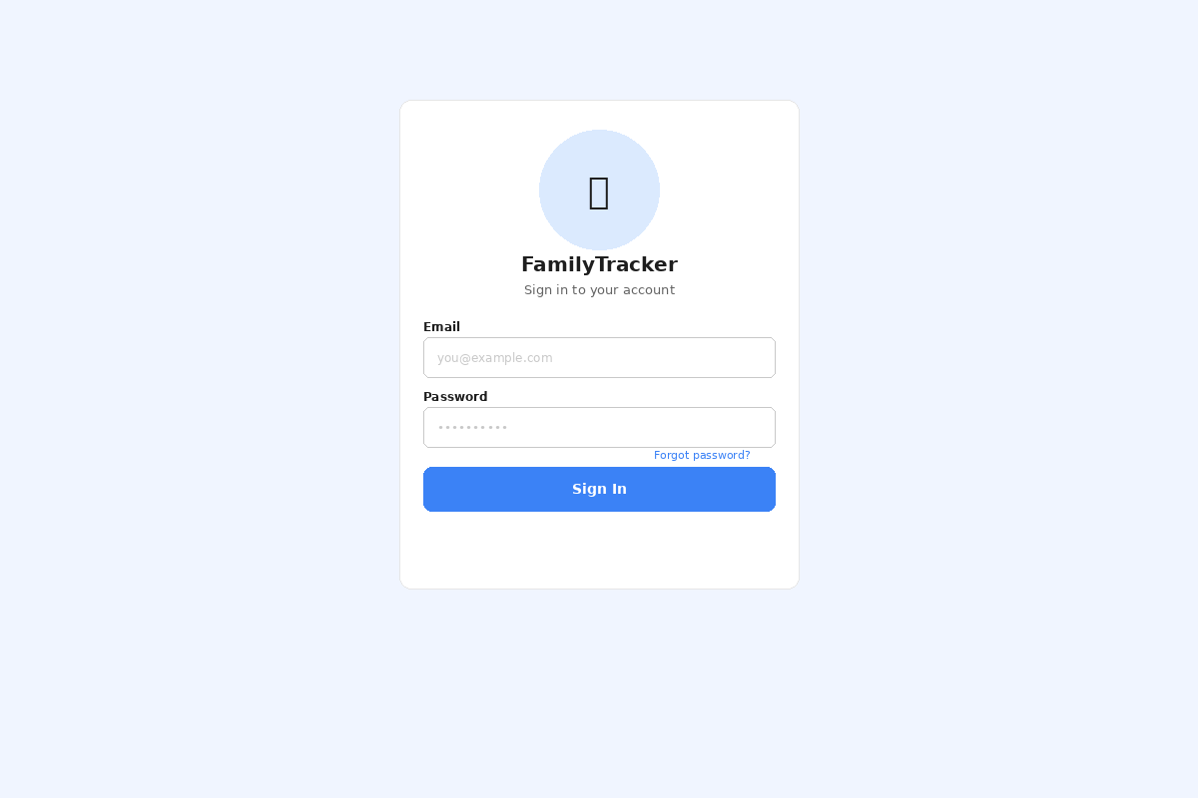
Element | Description / Requirement
App Logo / Title | Centred branding panel with app icon and name. Sets the household context immediately.
Email Field | Standard text input; validated as EmailStr on submit. Pre-fills if browser has saved credentials.
Password Field | Masked input; Show/Hide toggle. Field cleared on auth failure.
Forgot Password | Link to trigger a password-reset flow via email. Positioned above the Sign In button.
Sign In Button | Primary CTA; triggers POST /auth/login. Shows spinner during request.
Error Banner | Inline error displayed below form on 401 response — no toast that auto-hides financial errors.

Screen 2: Monthly View
Primary working screen. Displays all transactions for the selected month, summary totals, and the settlement result. Ref: FR-06, FR-07, FR-08, FR-09.
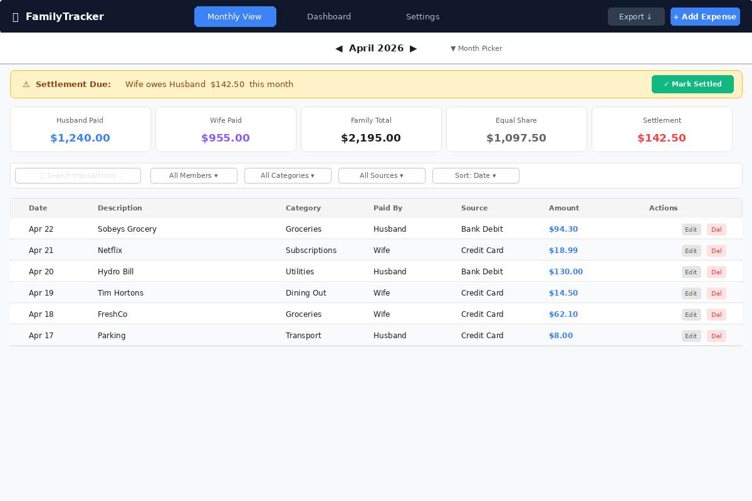
Element | Description / Requirement
Top Navigation | Persistent nav bar with links to Monthly View, Dashboard, Settings. Add Expense and Export buttons always visible.
Month Picker | Previous/Next chevrons + month-year label. Click label opens calendar picker. Ref: FR-08.
Settlement Banner | Amber alert shows who owes whom and the exact amount. 'Mark Settled' button opens note modal. Ref: FR-09, FR-12.
Summary Cards | Five metric cards: Husband Paid, Wife Paid, Family Total, Equal Share, Settlement Amount. Updates in real time (< 500ms). Ref: FR-07, FR-11, NFR-05.
Filter Row | Search box + dropdowns for Member, Category, Source, Sort. Client-side filtering; no extra API calls.
Transaction Table | Sortable columns: Date, Description, Category, Paid By, Source, Amount. Edit & Delete inline actions per row. Ref: FR-02, FR-03, FR-06.
Pagination | Load-more / paginated footer when > 50 transactions. Ref: NFR-04.

Screen 3: Add Expense Modal
Full-screen overlay for creating a new transaction. Accessible from the persistent nav bar on any screen. Ref: FR-01, NFR-02.
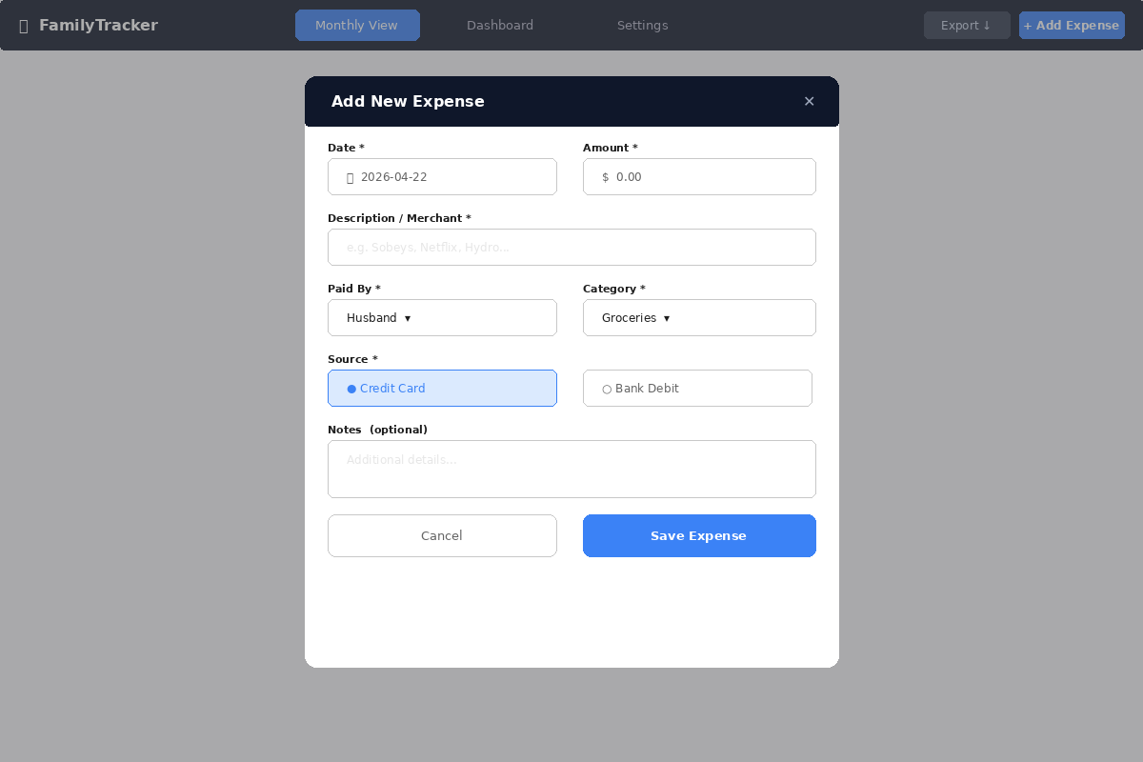
Element | Description / Requirement
Date Field | Date-picker input, defaults to today. Ref: FR-01.
Amount Field | Numeric input with currency prefix. Pydantic validator enforces amount > 0. Ref: FR-01, TransactionCreate schema.
Description | Free-text field; maps to VARCHAR(255) in DB. Ref: FR-01.
Paid By | Dropdown listing the two member names (loaded from settingsSlice). Ref: FR-01, FR-05.
Category | Dropdown from household category list (loaded from settingsSlice). Ref: FR-01, FR-13.
Source | Radio toggle: Credit Card / Bank Debit. Maps to ENUM('CREDIT_CARD','BANK_DEBIT'). Ref: FR-01, transactions schema.
Notes | Optional multi-line text. Maps to TEXT DEFAULT NULL. Ref: FR-01.
Optimistic Update | On Save, Zustand transactionsSlice is updated immediately before API response. Ref: FR-11, NFR-05.

Screen 4: Dashboard
Graphical analytics screen with five chart types, global date-range filter, and member/category filters. Ref: FR-15, FR-16, FR-17.
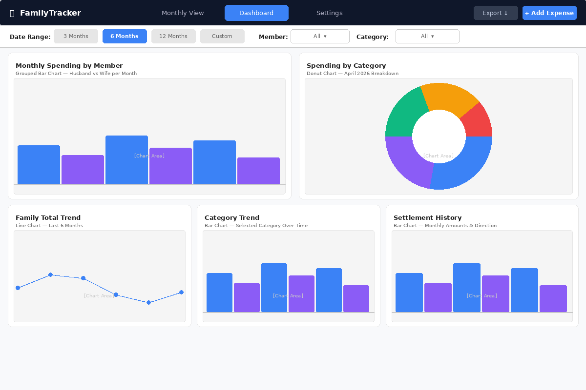
Element | Description / Requirement
Date Range Filter | Preset buttons (3M, 6M, 12M) + custom date-range picker. State stored in dashboardSlice. Ref: FR-16.
Member / Category Filters | Dropdowns to narrow all charts. Passed as query params to GET /api/dashboard. Ref: FR-17.
Spending by Member | Grouped Recharts BarChart — blue (Husband) vs purple (Wife) bars per month. Ref: FR-15.
Category Pie / Donut | Recharts PieChart with innerRadius — shows breakdown for selected month. Ref: FR-15.
Family Total Trend | Recharts LineChart — total family spend last 6 or 12 months. Ref: FR-15.
Category Trend | Recharts BarChart / LineChart — selected category spend over time. Ref: FR-15.
Settlement History | Recharts BarChart — settlement amounts per month, colour-coded by debtor direction. Ref: FR-15.

Screen 5: Settings Page
Household configuration screen for member names, currency, and category management. Ref: FR-05, FR-13, FR-14.
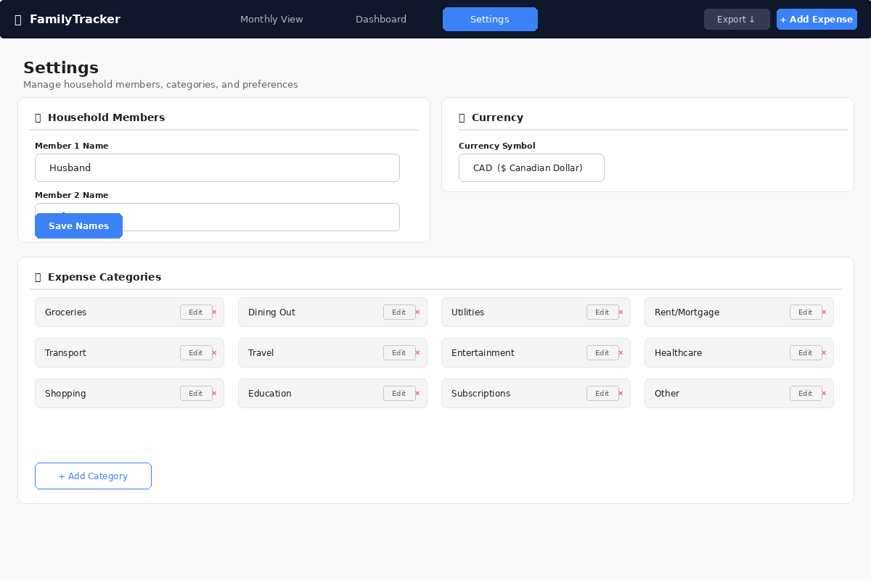
Element | Description / Requirement
Member Names | Two text inputs for display names (Member 1 / Member 2). Saved via PUT /api/settings → HouseholdSettings schema. Ref: FR-05.
Currency | Single dropdown for ISO 4217 currency code. Stored in household.currency (CHAR 3). Ref: Assumptions §6.
Category List | Grid of all categories with Edit and Delete (✕) buttons per row. Default categories show is_default badge. Ref: FR-13, FR-14.
Delete Guard | Delete blocked if category is in use by any transaction; CategoryService._guard_in_use() returns HTTP 409. Ref: FR-14.
Add Category | Inline text field + Add button; calls POST /api/categories. Ref: FR-14.

Screen 6: CSV Import Modal
Bulk transaction import from bank/credit card CSV exports. Includes column mapping UI and validation feedback. Ref: FR-04.
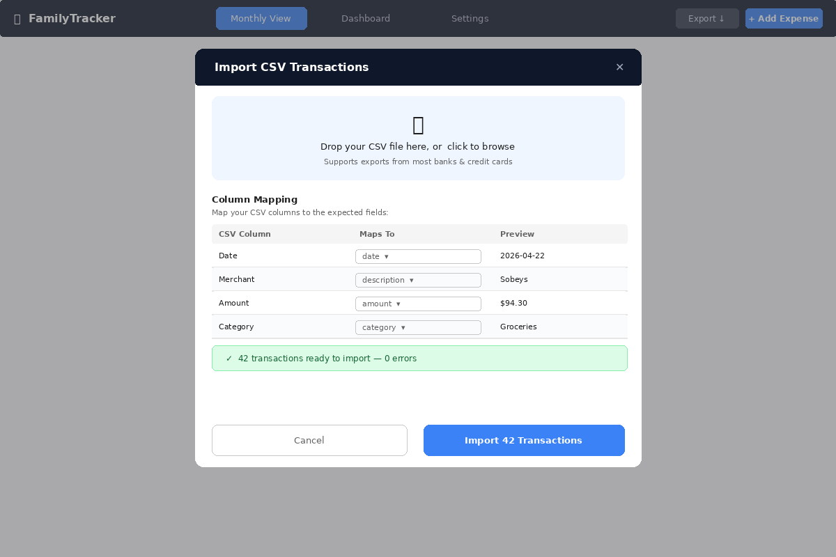
Element | Description / Requirement
Drop Zone | File drag-and-drop or click-to-browse. Accepts .csv files. Parsed client-side with csv.DictReader pattern.
Column Mapping | Auto-detect or manual dropdown mapping of CSV columns to: date, description, amount, category, source. Ref: FR-04.
Validation Status | Real-time count of valid / error rows shown before import. Errors listed with row numbers.
Import Button | Calls POST /api/import/csv with multipart upload. TransactionService.bulk_import() handles atomic rollback on error. Ref: FR-04.
Atomic Import | All rows imported in a single DB transaction; partial failures roll back entirely. Ref: FR-04, NFR-07.

