💳 Family Expense Tracker
Frontend UI Wireframes

Version 1.1 | April 2026 | React 18 + TypeScript + Tailwind CSS
SRD Reference: Family Expense Tracker SRD v1.0
Screens | 8 screens covered (incl. 2-step registration)
Stack | React 18 · TypeScript · Tailwind CSS · Zustand · Recharts
Scope | Login, Registration Steps 1 & 2, Monthly View, Add Expense, Dashboard, Settings, CSV Import
Status | Draft — for developer review
Changes in v1.1 | Added user registration flow (Screens 2a & 2b). Removed OAuth social login. Updated login screen with Register CTA.

Screen 1: Login Page
Authentication screen — entry point for returning users. Includes a prominent Register button for new users. Social login removed. Ref: NFR-08.
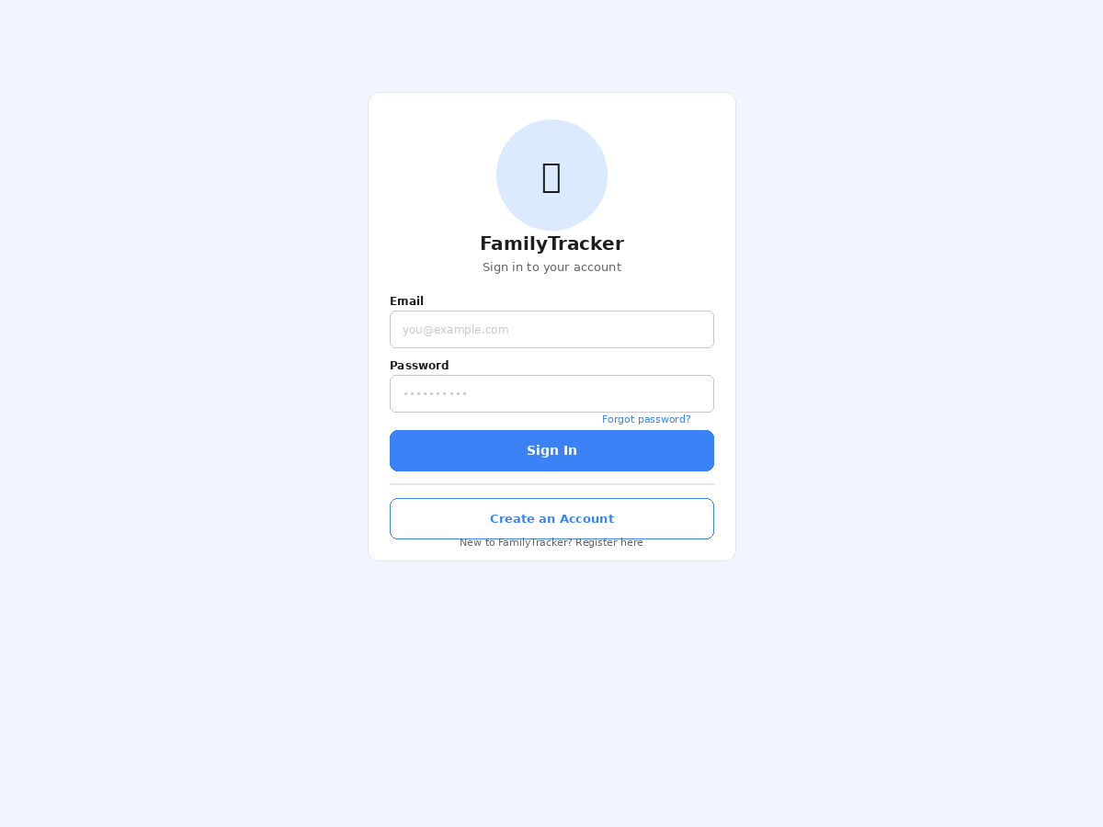
Element | Description / Requirement
App Logo / Title | Centred branding panel with app icon and name.
Email Field | Standard text input; validated as EmailStr on submit.
Password Field | Masked input; Show/Hide toggle. Cleared on auth failure.
Forgot Password | Link to trigger a password-reset flow via email.
Sign In Button | Primary CTA; triggers POST /auth/login. Shows spinner during request.
Create an Account | Secondary outlined button — navigates to Screen 2a (Registration Step 1). Visible to all unauthenticated users.
Error Banner | Inline error displayed below form on 401 response.

Screen 2a: Registration — Step 1: Account Details
New user self-registration. Collects name, email, and password. Step 1 of a 2-step onboarding flow. Ref: NFR-08.
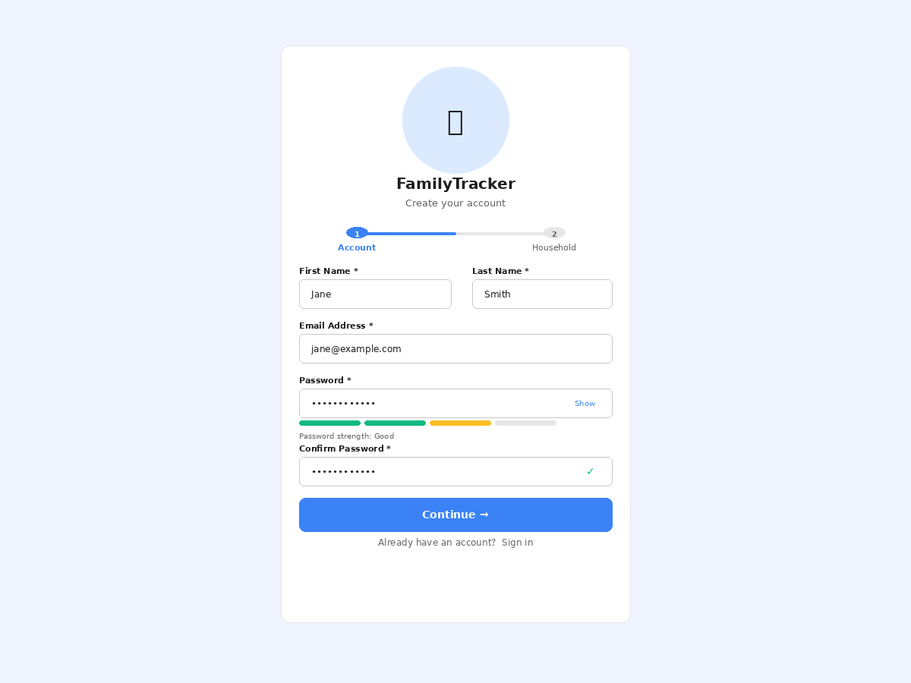
Element | Description / Requirement
Step Indicator | 2-step progress bar (Account → Household). Active step in blue; upcoming step greyed out.
First & Last Name | Side-by-side inputs. Used as the default display name for Member 1. Ref: FR-05.
Email Address | Validated as EmailStr. Becomes the login credential. Server returns HTTP 409 on duplicate email.
Password | Min 8 characters. Real-time strength meter (Weak / Fair / Good / Strong) updates as the user types.
Confirm Password | Must match the Password field. Green tick shown on match; red warning on mismatch. Prevents typos.
Continue Button | Validates all fields client-side (React Hook Form + Zod), then advances to Step 2. No API call yet — data held in local state.
Sign In Link | "Already have an account? Sign in" — navigates back to Screen 1 (Login).

Screen 2b: Registration — Step 2: Household Setup
Configures the shared household on first registration. Sets member names, optionally invites partner, and selects currency. Ref: FR-05, Assumptions §6.
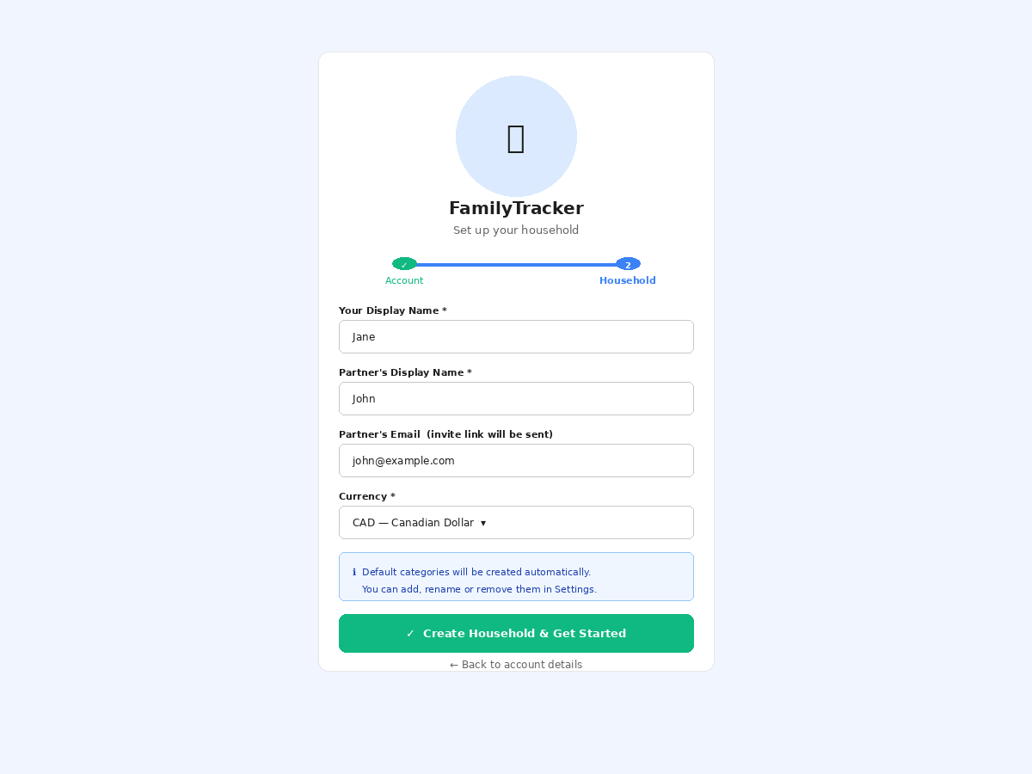
Element | Description / Requirement
Step Indicator | Step 1 shows a green tick (complete). Step 2 is highlighted blue as the active step.
Your Display Name | Pre-filled from First Name in Step 1. Editable. Stored as member1_name in the household table.
Partner Display Name | Free-text display name for the second household member. Stored as member2_name. Ref: FR-05.
Partner Email | Optional invite field. If provided, the app sends an invitation email so the partner can register and join the household.
Currency | Dropdown of ISO 4217 codes (CAD, USD, GBP, etc.). Stored as household.currency CHAR(3). Ref: Assumptions §6.
Info Banner | Informs the user that 12 default categories are seeded automatically and are manageable in Settings. Ref: FR-13.
Create Household | Primary green CTA. Submits both steps: POST /auth/register (creates user) then POST /api/household. Redirects to Monthly View on success.
Back Link | Returns to Step 1 without losing data — form state preserved in React component state.

Screen 3: Monthly View
Primary working screen. Displays all transactions for the selected month, summary totals, and the settlement result. Ref: FR-06, FR-07, FR-08, FR-09.
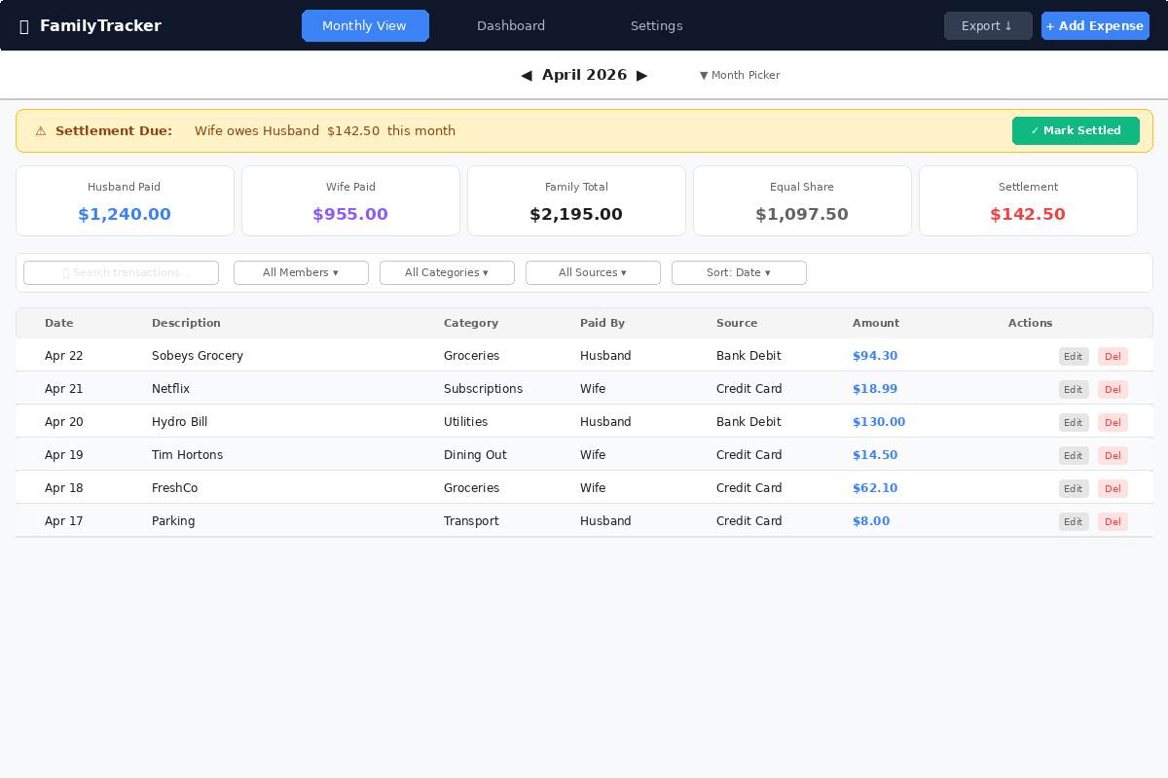
Element | Description / Requirement
Top Navigation | Persistent nav bar with links to Monthly View, Dashboard, Settings. Add Expense and Export buttons always visible.
Month Picker | Previous/Next chevrons + month-year label. Click label opens calendar picker. Ref: FR-08.
Settlement Banner | Amber alert shows who owes whom and the exact amount. 'Mark Settled' button opens note modal. Ref: FR-09, FR-12.
Summary Cards | Five metric cards: Member 1 Paid, Member 2 Paid, Family Total, Equal Share, Settlement Amount. Updates in real time. Ref: FR-07, FR-11, NFR-05.
Filter Row | Search box + dropdowns for Member, Category, Source, Sort. Client-side filtering. Ref: FR-06.
Transaction Table | Sortable columns: Date, Description, Category, Paid By, Source, Amount. Edit & Delete inline actions. Ref: FR-02, FR-03, FR-06.
Pagination | Load-more / paginated footer when > 50 transactions. Ref: NFR-04.

Screen 4: Add Expense Modal
Full-screen overlay for creating a new transaction. Accessible from the persistent nav bar on any screen. Ref: FR-01, NFR-02.
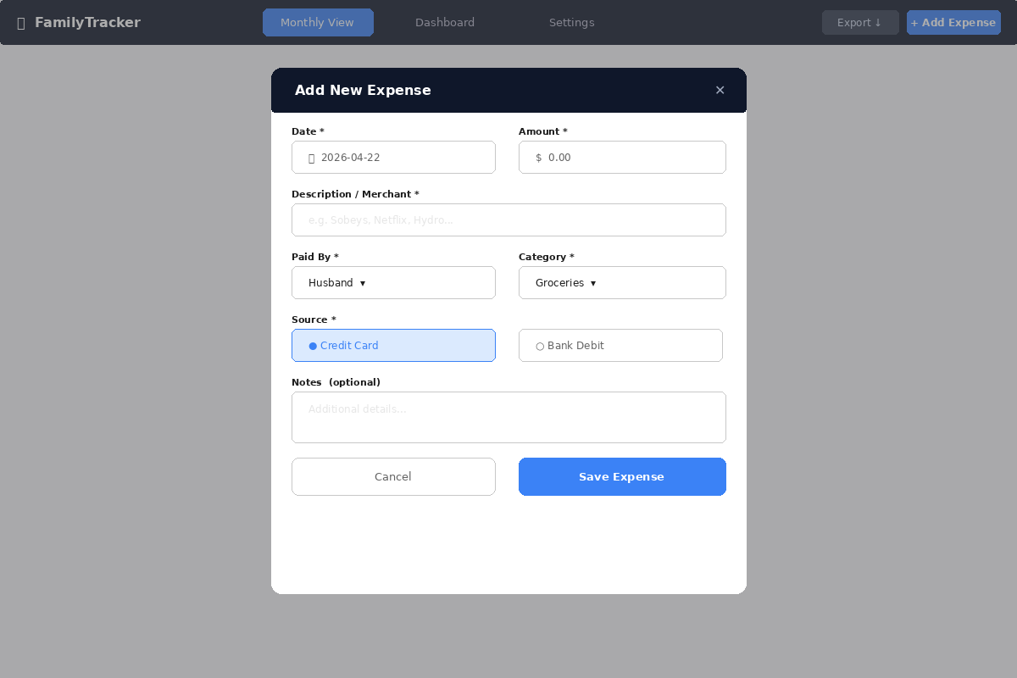
Element | Description / Requirement
Date Field | Date-picker input, defaults to today. Ref: FR-01.
Amount Field | Numeric input with currency prefix. Validator enforces amount > 0. Ref: FR-01.
Description | Free-text field; maps to VARCHAR(255) in DB. Ref: FR-01.
Paid By | Dropdown listing the two member names (loaded from settingsSlice). Ref: FR-01, FR-05.
Category | Dropdown from household category list. Ref: FR-01, FR-13.
Source | Radio toggle: Credit Card / Bank Debit. Maps to ENUM. Ref: FR-01.
Notes | Optional multi-line text. Maps to TEXT DEFAULT NULL. Ref: FR-01.
Optimistic Update | Zustand transactionsSlice updated immediately before API response. Ref: FR-11, NFR-05.

Screen 5: Dashboard
Graphical analytics screen with five chart types, global date-range filter, and member/category filters. Ref: FR-15, FR-16, FR-17.
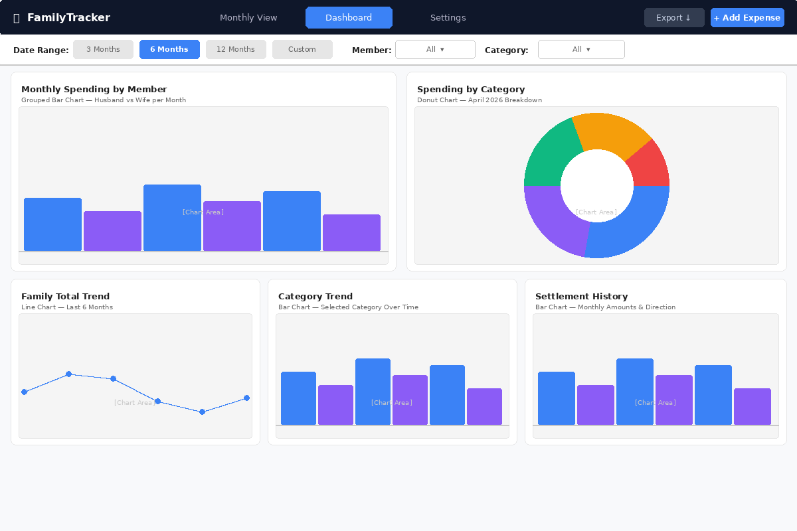
Element | Description / Requirement
Date Range Filter | Preset buttons (3M, 6M, 12M) + custom date-range picker. Stored in dashboardSlice. Ref: FR-16.
Member / Category Filters | Dropdowns to narrow all charts. Query params to GET /api/dashboard. Ref: FR-17.
Spending by Member | Grouped Recharts BarChart — Member 1 vs Member 2 per month. Ref: FR-15.
Category Pie / Donut | Recharts PieChart — breakdown for selected month. Ref: FR-15.
Family Total Trend | Recharts LineChart — total family spend over 6 or 12 months. Ref: FR-15.
Category Trend | Recharts BarChart / LineChart — selected category spend over time. Ref: FR-15.
Settlement History | Recharts BarChart — settlement amounts per month, colour-coded by debtor. Ref: FR-15.

Screen 6: Settings Page
Household configuration screen for member names, currency, and category management. Ref: FR-05, FR-13, FR-14.
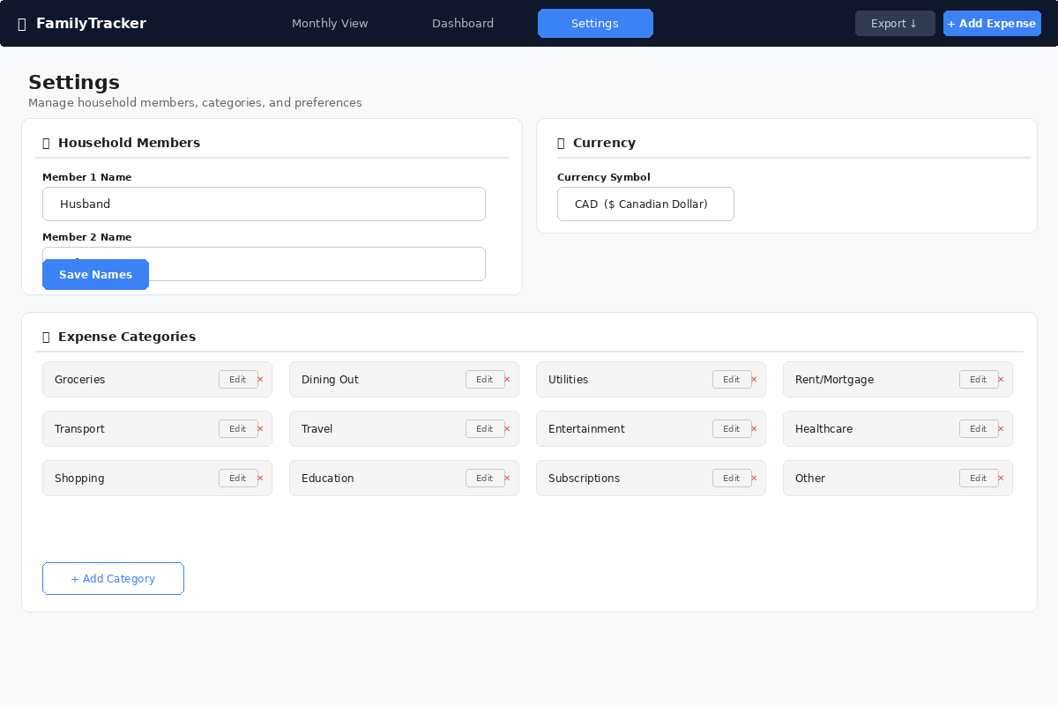
Element | Description / Requirement
Member Names | Two text inputs for display names. Saved via PUT /api/settings. Ref: FR-05.
Currency | ISO 4217 dropdown. Stored as household.currency CHAR(3). Ref: Assumptions §6.
Category List | Grid with Edit and Delete (✕) per row. Default categories show is_default badge. Ref: FR-13, FR-14.
Delete Guard | Delete blocked if category is in use; CategoryService._guard_in_use() returns HTTP 409. Ref: FR-14.
Add Category | Inline field + Add button; calls POST /api/categories. Ref: FR-14.

Screen 7: CSV Import Modal
Bulk transaction import from bank/credit card CSV exports. Includes column mapping UI and validation feedback. Ref: FR-04.
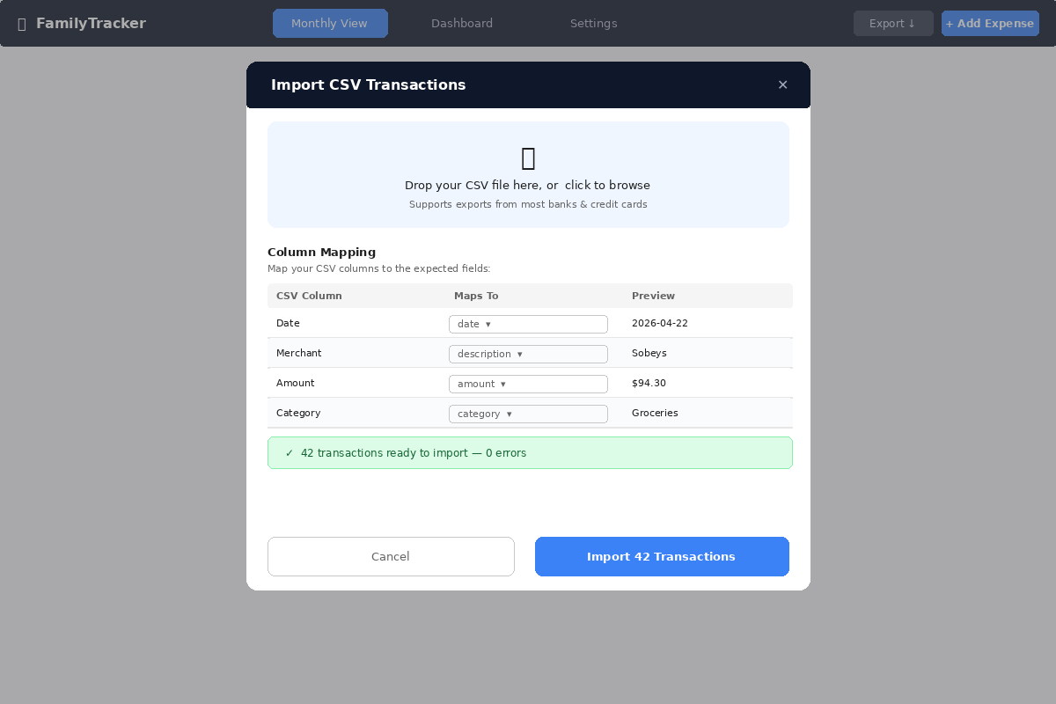
Element | Description / Requirement
Drop Zone | File drag-and-drop or click-to-browse. Accepts .csv files. Ref: FR-04.
Column Mapping | Auto-detect or manual dropdown mapping to: date, description, amount, category, source. Ref: FR-04.
Validation Status | Real-time count of valid / error rows before import. Errors listed with row numbers.
Import Button | POST /api/import/csv multipart upload. TransactionService.bulk_import() handles atomic rollback. Ref: FR-04.
Atomic Import | All rows in a single DB transaction; partial failures roll back entirely. Ref: FR-04, NFR-07.

