
COMMUNICATION AND INTERNAL POSITIONING
  - Communications Fundamentals
  - Sample campaign advertisement
  - Message House

Communication fundamentals

High impact, two-way communication with employees, managers and stakeholders will be vital to ensuring a supportive returner environment. Communications should aim to engage employees in the program and encourage them to build a personal stake in owning solutions.
The communications principles below may serve as useful guides to engagement.

1. REPETITION AND CLARITY
Employees will not always have the time or inclination to stop, think and internalise messaging about new business initiatives. It is important not to lose sight of what it’s like to hear the message for the first time.

2. SIMPLE AND MEMORABLE MESSAGING
Although hiring returners has clear societal benefits, the program must be positioned as a talent strategy, rather than a corporate social responsibility scheme. Language for the program should be simple and memorable, and focused on building the credibility of the Returner.

3. BALANCE ‘TELLING’ WITH ‘ASKING’
Programs are more likely to be successful if managers and employees feel they have a personal stake in the program success. Where possible, seek views and opinions from employees when preparing the program. Ensure ideas and thoughts are reflected in the final plan.

4. REINFORCE MESSAGING THROUGH MULTIPLE CHANNELS
Go broad when you consider the potential communications channels. Leaders and influencers (identified through your network mapping) will support you in delivering information through the business in a way that is real and human. Other avenues for consideration include speeches, print, and the intranet.

Sample Campaign Advertisement


Message house

Use the message house (below) to structure your message for employees, communicating the what, why and how of your returner program.
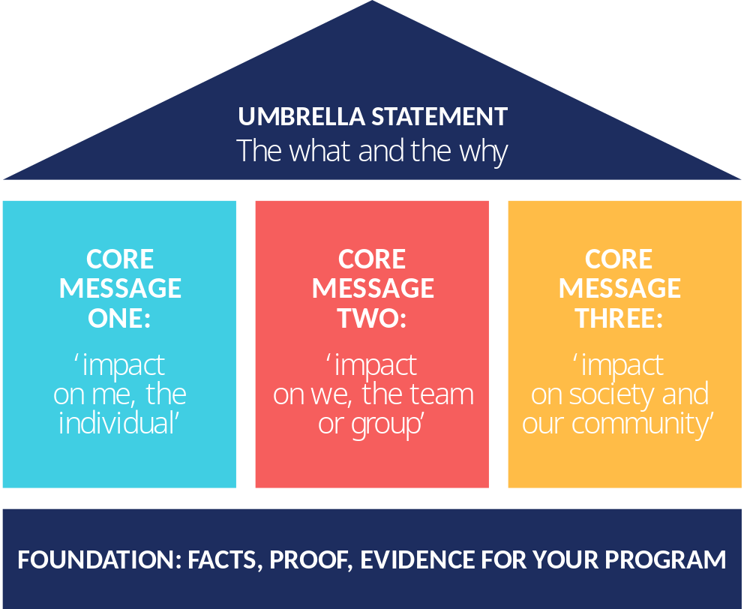

UMBRELLA STATEMENT:
The what and the why

CORE MESSAGE ONE:
‘impact on me, the individual’

CORE MESSAGE TWO:
‘impact on we, the team or group’

CORE MESSAGE THREE:
‘impact on society and our community’

FOUNDATION:
FACTS, PROOF, EVIDENCE FOR YOUR PROGRAM

