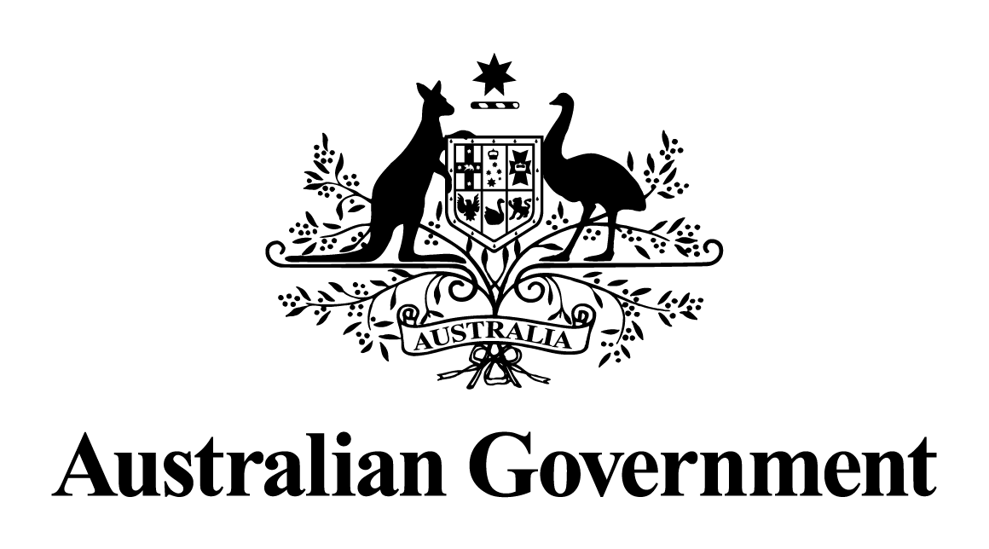

# Australian Government response to the Education and Employment References Committee report:

# *Corporate Avoidance of the Fair Work Act 2009*

JULY 2024

## Acknowledgement

The Australian Government commends the Senate Education and Employment References Committee on its work to bring to light the incidence of, and trends in, corporate avoidance of the Fair Work Act 2009. The Government particularly acknowledges the valuable submissions to the inquiry made by 212 individuals and organisations and evidence provided in 9 public hearings.

## Response

The Government **notes** all recommendations made in the Report. Since May 2022, the Government has been working to deliver secure jobs, better wages and a fairer workplace relations system.

As a result of the passage of time since the report was tabled and the action taken by the Government to respond to key issues raised in the Report, outlined below, a substantive Government response is no longer appropriate. Many of the Government’s reforms have been informed by the work and evidence of this Committee, and directly address the Report’s recommendations.

### Outline of reforms relevant to the Report’s recommendations

The *Fair Work Legislation Amendment (Secure Jobs, Better Pay) Act 2022* includes a suite of measures to reinvigorate the bargaining framework, including by ensuring the process for agreement terminations is fit for purpose and can no longer be used as an unfair bargaining tactic.

The *Fair Work Legislation Amendment (Closing Loopholes) Act 2023* introduces a criminal offence for intentional wage theft of employees’ wages and certain entitlements, and prevents labour hire arrangements from being used to undercut agreed rates of pay. This legislation also enhances the rights and protections for workplace delegates when carrying out their duties to represent union members.

The *Fair Work Legislation Amendment (Closing Loopholes No. 2) Act 2024* establishes a fair and objective definition of “casual employee”, reflecting the practical reality of the employment relationship, and gives casual employees a clear and simple pathway to permanency. It also amends right of entry provisions to enhance the ability of entry permit holders to enter a workplace to investigate suspected underpayments, increases maximum penalties for standard and serious contraventions of certain civil remedy provisions in the Fair Work Act for bodies corporate that are not small business employers, and empowers the Fair Work Commission to set minimum standards for employee-like workers in the gig economy. In addition to increasing penalties for misrepresenting employment as an independent contracting arrangement (sham contracting), the Act also changes the defence to a claim for sham contracting from a test of “recklessness” to a more objective test of “reasonableness”. Additionally, the Act sets a fairer test for determining whether a person is an independent contractor or an employee.

The Government is currently progressing, in conjunction with states and territories, a harmonised approach to national labour hire regulation. This will help protect labour hire workers from exploitation and establish an even playing field for business, irrespective of where a labour hire provider operates.

Through Safe Work Australia, the Government is also contributing to projects to develop a national policy approach to workers compensation and the gig economy and ensure the primary duty of care under work health and safety laws applies effectively to modern work arrangements, including the gig economy. This work is being progressed through Safe Work Australia’s tripartite processes involving worker and employer representatives, in addition to state and territory governments.

Alongside these reforms, the Government has taken targeted action to combat migrant worker exploitation. It has implemented many of the recommendations of the Migrant Workers’ Taskforce Report (MWT Report) – a number of which engage with issues raised by the Committee – and is committed to implementing these recommendations in full. The Government will give consideration to relevant findings of the Committee in addressing the remaining recommendations of the MWT Report.

The Government secured the passage of amendments to the employment and migration frameworks, through the *Fair Work Legislation Amendment (Protecting Worker Entitlements) Act 2023* and *Migration Amendment (Strengthening Employer Compliance) Act 2024*, to ensure that employers cannot argue that a migrant worker is not entitled to the same workplace protections as other workers in Australia because of their immigration status or right to work.

It is also delivering a dedicated package of measures, announced in 2023, to address migrant worker exploitation. The Government is co-designing pilots, with unions, businesses and civil society, which are intended to address barriers to reporting of exploitation and pursuing workplace claims, such as a fear of visa cancellation or an expiring visa. It has also allocated $3.9 million over two years to the Fair Work Ombudsman (FWO) in the 2023-24 MYEFO to support the FWO’s role in the pilots, thus bolstering its role in assisting vulnerable workers, including those from migrant and culturally diverse backgrounds.