

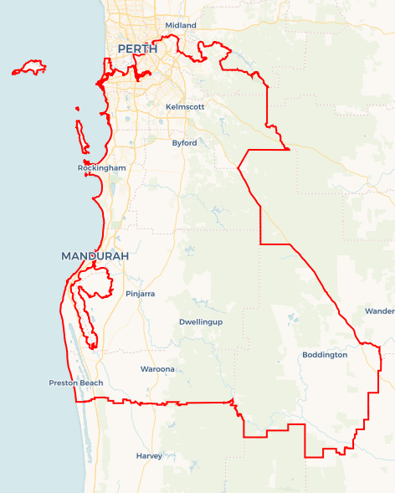Local Jobs Plan

Perth South ****Employment Region**** | WA | ****October 2023****

Workforce Australia Local Jobs (Local Jobs) is a program that supports tailored approaches to accelerate   
reskilling, upskilling and employment pathways in response to current and emerging local workforce needs.

## Local Jobs elements

### Local Jobs Plan

The Local Jobs Plan sets out the skills and employment challenges and priorities of the region, and associated strategies that will drive the design and implementation of activities to be implemented to address these challenges.

### Employment Facilitators

Employment Facilitators and Support Officers support the delivery of the program by bringing together key stakeholders including businesses, employment services providers, higher education and training organisations.

### Local Jobs and Skills Taskforce

Each Employment Region has its own Taskforce. Representatives include local stakeholders who have demonstrated experience in upskilling, reskilling, and an ability to represent, connect and collaborate with others in the region to meet labour market needs.

### Local Recovery and National Priority Funds

The Local Recovery Fund supports projects that meet the priorities identified in the Local Jobs Plan. The National Priority Fund provides funding for innovative local solutions to address structural barriers to employment.

Explore labour market insights for the  
[Perth South](https://www.jobsandskills.gov.au/data/employment-region-dashboards-and-profiles/monthly-labour-market-dashboards) Employment Region

## Local labour market challenges in the region

* There are skills and people shortages across main employing industries in the Perth South Employment Region such as healthcare and social assistance including the care sector, construction, education and training, mining, manufacturing, accommodation and food services, transport and logistics.
* Lack of affordable housing and accommodation is impacting current and future labour supply.
* Low unemployment and the prevalence of fly-in fly-out roles creates a challenge to connect people to jobs in the region.
* Where some people live is not where suitable jobs, training opportunities and industries are. There is also limited public transport in some suburbs including Waroona, Boddington and Forrestdale.
* Over representation of First Nations people, female, culturally and linguistically diverse, mature age, disability, as well as a growing rate of disengaged youth who are not in work.

## Local jobs and skills priorities and strategies in the region

### Priority 1 – Engage with industry to articulate the needs of employers and individuals and inform the development of strategies which maximise sustainable and meaningful local job placements

#### What are our challenges and opportunities?

Perth South Employment Region is experiencing skills and people shortages across main employing industries such as healthcare and social assistance including the care sector, construction, education and training, mining, manufacturing, accommodation and food services, transport, and logistics.

#### How are we responding?

* We are running targeted recruitment round tables for business, contractors, and sub-contractors to showcase employment opportunities to local individuals seeking employment.
* We are identifying key construction projects, meeting business and/or organisations and identifying vacancies and opportunities.
* We are identifying skills shortages and gaps in the care, construction, mining, accommodation and food services, manufacturing, transport, and logistics sectors and mapping current skills of participants to meet training requirements and upskilling opportunities.
* We are identifying opportunities to transition retrenched workers in the Perth South Employment Region and ensuring skill shortage areas are met from this labour source.
* We are collaborating with the Department of Training and Workforce Development (WA Government), TAFEs, Jobs and Skills Centres, and Registered Training Organisations to implement training to meet operational requirements and needs.
* We are engaging with local Registered Training Organisations to connect with industry and stakeholders.

### Priority 2 – Promote positions for individuals looking for employment including apprenticeships and traineeships and ensure that locals are adequately skilled, prepared and supported for current and upcoming employment opportunities and projects

#### What are our challenges and opportunities?

The Perth South Employment Region has a growing rate of disengaged youth. There is an opportunity to engage youth in the Net Zero Economy industries including but not limited to renewable energy.

#### How are we responding?

* We have created a Taskforce working group for construction and civil ‘try a trade opportunities’ to expose youth to trades for apprenticeships and traineeship pathway opportunities for current and future skill needs.
* We are working with business to assist with upskilling existing staff to create pathways for entry level opportunities.
* We are creating industry exposure events for young people to learn about the types of jobs and industries that are available to them.
* We are building, strengthening, and sustaining ongoing relationships with Australian Apprenticeship Support Networks and assisting business to navigate how to engage young people into apprenticeship and traineeship pathways.

### Priority 3 – Leverage existing Australian and Western Australian government programs to create pathways into local growth industries. Broker employment and education opportunities for socially disadvantaged and priority groups including culturally and linguistically diverse, mature age, persons identifying as female, Aboriginal and Torres Strait Islander peoples and young people not participating in the labour market

#### What are our challenges and opportunities?

Over representation of individuals not in work from Aboriginal and Torres Strait Islander peoples, female, culturally and linguistically diverse, mature age, disability, as well as a growing rate of disengaged youth.

#### How are we responding?

* We are identifying and collaborating with appropriate community, social organisations and businesses that address the barriers people are experiencing.
* We are promoting the use of JobTrainer funded skill set training programs to support transition of individuals seeking employment into occupations that are in local demand.
* We are hosting regular monthly information sessions to inform and educate Workforce Australia Employment Services Providers and offer business the opportunity to showcase current vacancies in industry‑specific forums.
* We have created a platform for Australian Government program representatives to showcase new and existing initiatives to Perth South stakeholders and Workforce Australia Employment Service Providers.
* We will work with the Construction Training Fund to create cohort specific industry tours of the Construction Training Futures Centre.
* We are supporting individuals and businesses to build entrepreneurial capability and innovate in response to new and emerging economic opportunities in the region.

### Priority 4 – Engage with and understand the needs of individuals with the capacity to work, and the under employed, with an individualised and holistic approach to assist into training, and meaningful, sustainable employment

#### What are our challenges and opportunities?

Training pathways and upskilling, as well as support into employment can be lacking on a localised level.

#### How are we responding?

* We are facilitating connections and linkages between local stakeholders for collaboration on employment opportunities and training pathways.
* We are identifying local training organisations that deliver JobTrainer funded skill sets and connecting to business and Workforce Australia Employment Services providers.
* We are identifying gaps and opportunities to connect stakeholders across community and supports in the region.
* We are collaborating with the Department of Training and Workforce Development (WA Government), TAFE and Jobs and Skill Centres to encourage flexible training options and locations.
* We have created a platform for Australian Government program representatives to showcase new and existing initiatives to Perth South stakeholders and Workforce Australia Employment Services Providers to assist with training and upskilling.
* We are collaborating with organisations that support licensing opportunities to assist mobility amongst disadvantaged individuals.

## Want to know more?

* Contact: Rosie Hegarty, Perth South Employment Facilitator: [facilitator@pslocaljobs.com.au](mailto:facilitator@pslocaljobs.com.au)
* Visit: [Local Jobs](https://www.dewr.gov.au/local-jobs) or [Workforce Australia](https://www.workforceaustralia.gov.au/)