

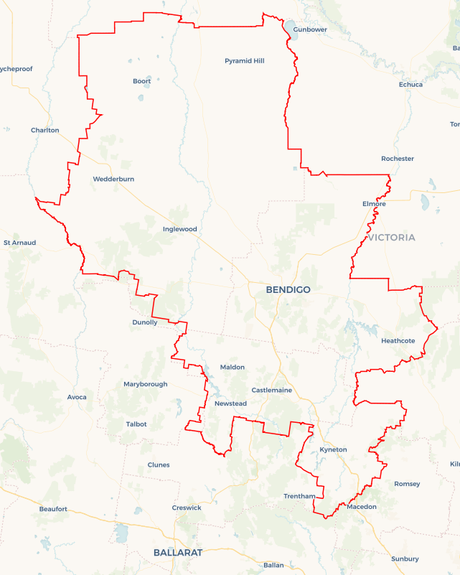Local Jobs Plan

Bendigo ****Employment Region**** | VIC | ****February 2024****

Workforce Australia Local Jobs (Local Jobs) is a program that supports tailored approaches to accelerate   
reskilling, upskilling and employment pathways in response to current and emerging local workforce needs.

## Local Jobs elements

### Local Jobs Plan

The Local Jobs Plan sets out the skills and employment challenges and priorities of the region, and associated strategies that will drive the design and implementation of activities to be implemented to address these challenges.

### Employment Facilitators

Employment Facilitators and Support Officers support the delivery of the program by bringing together key stakeholders including businesses, employment services providers, higher education and training organisations.

### Local Jobs and Skills Taskforce

Each Employment Region has its own Taskforce. Representatives include local stakeholders who have demonstrated experience in upskilling, reskilling, and an ability to represent, connect and collaborate with others in the region to meet labour market needs.

### Local Recovery and National Priority Funds

The Local Recovery Fund supports projects that meet the priorities identified in the Local Jobs Plan. The National Priority Fund provides funding for innovative local solutions to address structural barriers to employment.

Explore labour market insights for the  
[Bendigo](https://www.jobsandskills.gov.au/work/employment-region-dashboards-and-profiles/monthly-labour-market-dashboards) Employment Region

## Local labour market challenges in the region

* A high proportion of participants in employment services have been receiving assistance or more than 12 months and face complex barriers to employment.
* Youth unemployment in this region remains high.
* Labour and skills shortages result in businesses being unable to find suitable workers to operate and grow their business.
* Transitioning to a net zero economy will require new skills and jobs in traditional and emerging sectors.

## Local jobs and skills priorities and strategies in the region

### Priority 1 – Long term participants in employment services

#### What are our challenges and opportunities?

The proportion of participants receiving assistance from employment services providers for more than 12 months is significant and these participants face complex barriers to employment such as transport challenges, health conditions, homelessness, lack of education, poor financial literacy and low self-esteem. Place based, tailored approaches are needed to prepare participants to enter and re-enter the workforce and retain employment.

#### How are we responding?

* Engaging with employment services providers regularly to understand the needs of participants and co-design place-based resources, activities and events that assist individuals to progress towards employment.
* Building the capacity of individuals to enter or re-enter the workforce through activities that address barriers to employment, build confidence, create aspiration, provide relevant skill sets and introduce individuals to local businesses with current employment opportunities.
* Collaborating with businesses, training organisations and other stakeholders to hold employment expos, site tours, open days and other events that are easily accessible to employment services providers and individuals.
* Assisting local businesses to make employment opportunities more accessible to individuals by increasing their capacity to recruit, onboard and retain new employees from disadvantaged cohorts. We will do this by providing resources and events that promote inclusion and diversity in the workplace and educate businesses to provide peer support and mentoring to individuals with barriers to employment.

### Priority 2 – Youth unemployment

#### What are our challenges and opportunities?

Youth unemployment rates remain significantly higher than the total unemployment rate (people aged 15 and over) in the Bendigo Employment Region. Occupations with higher skill levels have strong forecasted growth to 2025 in the Bendigo Employment Region – many of which require apprenticeship or traineeship qualifications. There are opportunities to broker employment for young people to be engaged or re-engaged in the care and support, manufacturing, retail and hospitality industries as the demand for entry level and skilled workers grows.

#### How are we responding?

* Connecting businesses with entry level, apprenticeship and traineeship employment opportunities to employment services providers and other stakeholders who support young people to enter and re-enter the labour force. This is done by collaborating with business and other stakeholders to hold open days, information sessions and employment expos that are easily accessible and appealing to young people.
* Raising awareness of the supports available to employment services providers and other stakeholders so that information can be shared with young people to increase engagement in the local labour market and relevant training or pathway to employment programs.
* Assisting local businesses to make employment opportunities more accessible to people aged 15-24 by increasing their capacity to recruit, onboard and retain younger employees. We will do this by providing resources and events that educate businesses to conduct relevant recruiting strategies, provide peer support and mentoring to younger employees and provide opportunities for younger employees to upskill on the job.
* Engaging with local businesses to address barriers to employment faced by young people. Providing additional transport solutions, mental health services and more flexible working conditions will increase participation of young people in the labour force.
* Raising the awareness of the benefits of apprenticeships and traineeships to businesses, employment services providers and younger participants to build a skilled workforce for the future with more secure employment opportunities for young people. The campaign will target those involved in the care and support, retail, hospitality and tourism industries to increase participation and completion of apprenticeships and traineeships in the Bendigo Employment Region.

### Priority 3 – Occupations in demand

#### What are our challenges and opportunities?

Local businesses have ongoing unmet labour market demand for entry level and skilled roles. Many are unable to grow their business due to the lack of suitable applicants.

#### How are we responding?

* Connecting businesses with current and upcoming recruitment needs to employment services providers, training organisations, and other initiatives that support individuals to engage in the labour force. This is done by promoting training and employment opportunities through monthly videoconferencing events, email networks and social media.
* Collaborating with businesses, training organisations and other stakeholders in the industry to hold employment expos, site tours and open days that are easily accessible to employment services providers and individuals.
* Promoting funded initiatives that create pathways into employment in occupations with skills shortages and forecasted high growth to employment services providers and individuals.
* Engaging with businesses who have difficulty recruiting due to their remote location to provide transport solutions and other initiatives that increase the accessibility of employment opportunities to individuals.
* Assisting local businesses to make employment opportunities more accessible to participants by increasing their capacity to recruit, onboard and retain new employees. We will do this by providing resources and events that promote inclusion and diversity in the workplace and educate businesses to provide peer support and mentoring to participants with barriers to employment.

### Priority 4 – Skills for the future

#### What are our challenges and opportunities?

#### Skills shortages are most common in occupations requiring an apprenticeship or traineeship. Jobs growth is expected to be highest across service industries and in jobs requiring higher level qualifications. The green economy and technologies provide cutting-edge opportunities requiring additional skills, new credentials and new occupations. Apprenticeships and traineeships provide an opportunity to equip individuals with the skills needed for many net zero carbon and green economy occupations.

#### How are we responding?

* Engaging with industry to identify the employment opportunities available and the skills needed then sharing this information with employment services providers and other stakeholders.
* Collaborating with industry, employment services providers and education and training providers to leverage existing training, upskilling and pathway to employment programs and promote these to individuals to increase referrals and support higher completion rates.
* Strengthening connections between businesses, employment services providers, training organisations and other industry stakeholders by collaborating on employment expos. Building these relationships will streamline pathways into employment opportunities and increase participation in upskilling initiatives.
* Raising the awareness of the benefits of apprenticeships and traineeships to businesses and individuals as these employment opportunities provide training and skill development for occupations with strong forecasted demand.

## Want to know more?

* Contact: Christopher Booth, Bendigo Employment Facilitator: Chris.Booth@localjobsfacilitator.org
* Visit: [Local Jobs](https://www.dewr.gov.au/local-jobs) or [Workforce Australia](https://www.workforceaustralia.gov.au/)