

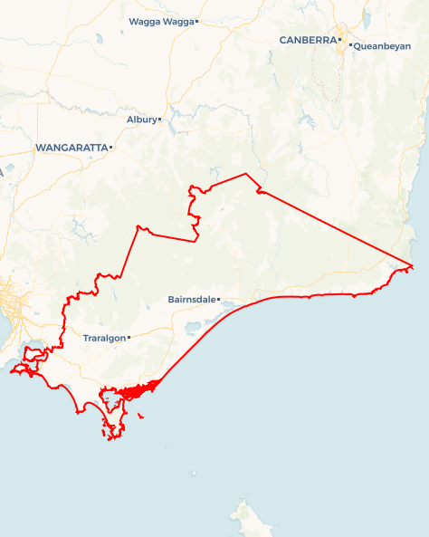Local Jobs Plan

Gippsland ****Employment Region**** | VIC |****July 2024****

Workforce Australia Local Jobs (Local Jobs) is a program that supports tailored approaches to accelerate   
reskilling, upskilling and employment pathways in response to current and emerging local workforce needs.

## Local Jobs elements

### Local Jobs Plan

The Local Jobs Plan sets out the skills and employment challenges and priorities of the region, and associated strategies that will drive the design and implementation of activities to be implemented to address these challenges.

### Employment Facilitators

Employment Facilitators and Support Officers support the delivery of the program by bringing together key stakeholders including businesses, employment services providers, higher education and training organisations.

### Local Jobs and Skills Taskforce

Each Employment Region has its own Taskforce. Representatives include local stakeholders who have demonstrated experience in upskilling, reskilling, and an ability to represent, connect and collaborate with others in the region to meet labour market needs.

### Local Recovery and National Priority Funds

The Local Recovery Fund supports projects that meet the priorities identified in the Local Jobs Plan. The National Priority Fund provides funding for innovative local solutions to address structural barriers to employment.

Explore labour market insights for the   
[Gippsland Employment Region](https://www.jobsandskills.gov.au/data/employment-region-dashboards-and-profiles/monthly-labour-market-dashboards)

## Local labour market challenges in the region

* Low labour force participation rate.
* Significant level of long-term unemployment.
* High level of early school leavers and low completion rate of higher education.
* First Nations people in the region experience higher rates of unemployment.
* An ageing population in the region is affecting demand in the health care and social assistance industries - one third of our population is over 65.
* Growing workforce shortages in the care and support sector.
* Industry is transitioning from traditional sectors such as mining and forestry, impacting on existing workforces .
* Large geographical region with limited access to suitable public transport
* High level of people without drivers licenses or access to private transport
* Prominent housing and childcare shortages.
* Shortage of skilled and professional workers to meet the demand for Gippsland workforce requirements.

## Local jobs and skills priorities and strategies in the region

### Priority 1 – Create and improve pathways into local employment

#### What are our challenges and opportunities?

Limited awareness about how to access and participate in government and non-government programs, training, and job opportunities. There are opportunities to effectively promote these programs to create pathways into local industries such as healthcare, social assistance, construction, and food and agriculture.

#### How are we responding?

* Working with local stakeholders and industries to create, design, enhance and advertise pre-employment and training programs. Tailoring to each individual’s needs at various stages of their job search.
* Partnering with employment service providers to ensure individuals are connected to appropriate programs, helping providers to engage with and develop   
  pre-employment activities like pre-accredited and accredited training.

### Priority 2 – Help community improve skills to meet future workforce demand

#### What are our challenges and opportunities?

Gippsland still faces significant skill shortages in its workforce. The demand for skilled and professional labour is increasing. There's a need for tailored training programs to support the demands of local businesses and upcoming industries for example, transitioning to Net Zero.

#### How are we responding?

* Collaborating with industries to understand their future workforce needs.
* Partnering with training and education providers to enhance training options aligned with demand.
* Working with employment services providers and training institutions to connect individuals with available courses and pre-employment programs for skill development.

**Priority 3 –** **Promotion of existing training and employment opportunities**

#### What are our challenges and opportunities?

Limited awareness about current training and job opportunities in Gippsland. Dedicated employment-focused training programs are not attracting adequate numbers of participants or run at a reduced capacity. There is an opportunity to raise awareness about employment pathway training that leads to ongoing employment opportunities within local industries.

#### How are we responding?

* Working with businesses to promote opportunities and attract individuals, using local job expos, networking events, information sessions, and connections with other local stakeholders.
* Engaging with local businesses to facilitate referrals from all employment service providers and community groups.
* Developing and managing online promotional resources for training programs and businesses such as the Gippsland Local Jobs Program - Training Notice Board and social media platforms.

**Priority 4 – Supporting opportunities for youth skill development and employment**

#### What are our challenges and opportunities?

Students are leaving school in Gippsland at a higher rate than the state and national rate. There is a high level of disengagement from services, education, training and employment. Limited awareness exists of training and employment pathways for both youth and guardians. Significant opportunity to work with local youth organisations to support referrals and engagement into other services, employment or training.

#### How are we responding?

* Promoting current youth pathways into employment, training, and services.
* Collaborating with local businesses to identify suitable entry level opportunities and vocational pathways.
* Increasing awareness of apprenticeship and traineeship providers and linking them with local business and projects.

**Priority 5 – Boosting employment and training among First Nations people**

#### What are our challenges and opportunities?

First Nations people can experience higher levels of unemployment and lower economic participation rates. Awareness of dedicated employment program opportunities and services for First Nations people are limited.

#### How are we responding?

* Supporting local First Nations organisations to develop local networks and utilise existing employment and training programs or develop new tailored programs.
* Developing partnerships with local First Nations organisations and traditional land owners to support strategies that increase engagement of individuals in these training and employment opportunities.
* Engaging local industries to highlight the importance of cross-cultural training to create culturally safe environments to increase participation rates of First Nations people.

**Priority 6 – Supporting individuals and transitioning workers**

#### What are our challenges and opportunities?

Gippsland is currently transitioning and/or preparing to transition multiple major industries such as native timber, white paper manufacturing, brown coal fired power industry, and oil and gas. Gippsland experiences significant natural events such as bushfires and floods which impacts the local economy.

#### How are we responding?

* Engaging local transition services and working groups to connect transitioning workers to services and vocational pathways.
* Promoting local health organisations that can support with counselling services and support programs.
* Coordinating local events and activities in impacted areas to promote and connect local opportunities and services.

**Priority 7 – Promote opportunities to priority cohorts to create vocational pathways**

#### What are our challenges and opportunities?

Gippsland consists of several priority cohorts such as First Nations people, people living with disability, mature aged individuals, youth, women, intergenerationally unemployed, culturally and linguistically diverse, and the LGBTIQA+ community. A significant amount of people within these cohorts face long term unemployment. Priority cohorts are impacted by the lack of suitable entry level employment opportunities and need support to engage with programs and services.

#### How are we responding?

* Promoting career counselling services and programs.
* Supporting employment service providers to increase engagement with priority cohorts in an appropriate setting.
* Collaborating with businesses to educate and promote the benefits of recruiting a diverse workforce and providing tools to attract this cohort.

## Want to know more?

* Contact: Darren Beggs, Gippsland Employment Facilitator: [Darren.beggs@gippslandfacilitator.org.au](mailto:Darren.beggs@gippslandfacilitator.org.au) or Luke Arber, Regional Workforce Transition Officer: GippslandVIC.AGEF@dewr.gov.au
* Visit: [Local Jobs](https://www.dewr.gov.au/local-jobs) or [Workforce Australia](https://www.workforceaustralia.gov.au/)
* The Regional Workforce Transition Officer works collaboratively with the Employment Facilitator in your region to support the positive and orderly transition to a Net Zero economy. For further information please refer to the [Australian Government Employment Facilitator’s Supporting Workforce Transition to a Net Zero Economy](https://www.dewr.gov.au/local-jobs/resources/gippsland-supporting-workforce-transition-net-zero-economy).